OKIES User Manual
Completion Report – Form 1002A

Accessing the Completion Report
You can access a completion report if you have the permissions below:
Security Permissions
Access to submit a completion report is only available to those with the security permissions below.
• Organization Admin – Ability to Create, Read, Update, and Delete
• Organization All Forms Submitter – Ability to Create, Read, Update
• Organization Read Access – Ability to Read (All new users will default to Read Access)
Tip: When updating a user from Read Access, take care to uncheck Read Access as it will override any selection made in conjunction with.
The Admin is the only person who can view or edit security permissions. To view Security Permissions:
• Click on My Organization
• Click on Summary
• Click on People
• Click on the hyperlinked name of the person you would like to review
• Click on Summary
• Click on Security
• Check permissions that apply and click Save
Open a Completion Report Form:
To access the completion form for submission you can:
1. Select “Forms”
2. Select “Online Forms”
3. Select “Well Completion Report”
OR
1. Enter the API Number in the search field located in the top right corner of the navigation pane and select a search category.
2. Click on the hyperlinked API Number to open the Well Summary page.
3. Select “Actions” 4. Select “Start Well Completion (1002A)”.

Step 1: Form Information Fields and Functions:
Form Name: Will default to the form you have selected.
Organization: Will default to the Organization you are signed in under.
Form Type: When filling out a completion report choose “Completion” or “Amended Completion”.
Type of Completion: Select the option that describes the work that took place.
API: Select the API of the well you are filing the completion report for if it does not default to the correct API.
Type of Well: Select the option that describes the well category.
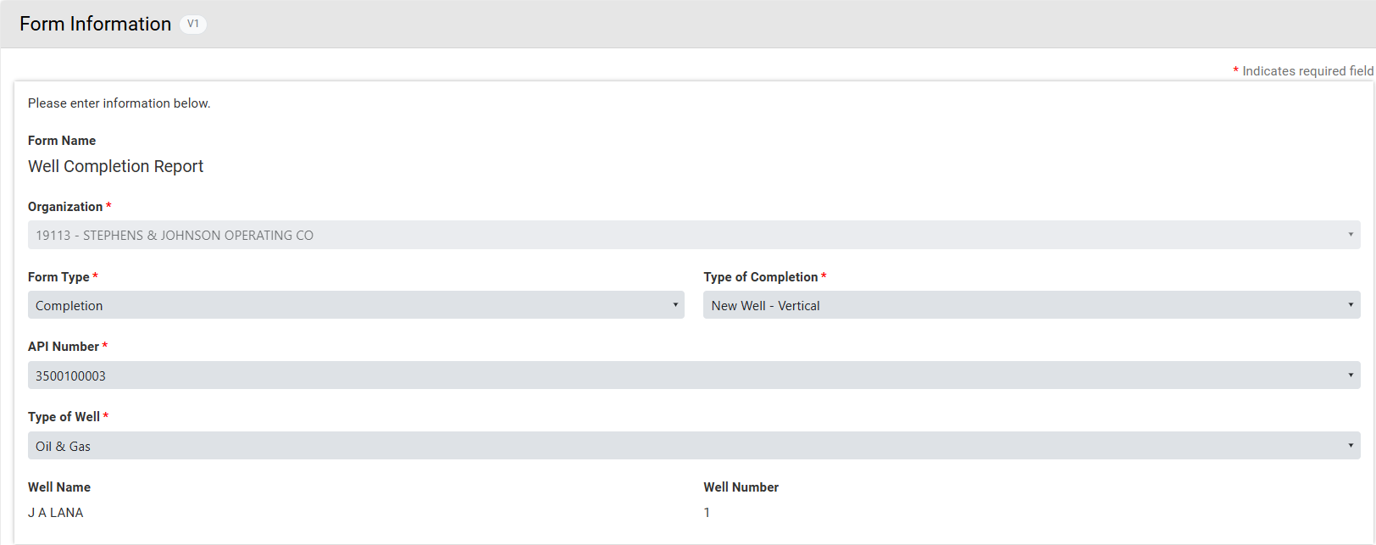
Step 2: Operator Information
The Operator Information page is used to designate contacts for the filing.
By default, the person who is logged in and submitting the completion report will be displayed in the “Contacts” grid. By clicking the “Actions” button and selecting “Add Contact”, additional contacts can be associated with the completion report. Review the operator information displayed at the top of the form to ensure the correct organization has been selected.
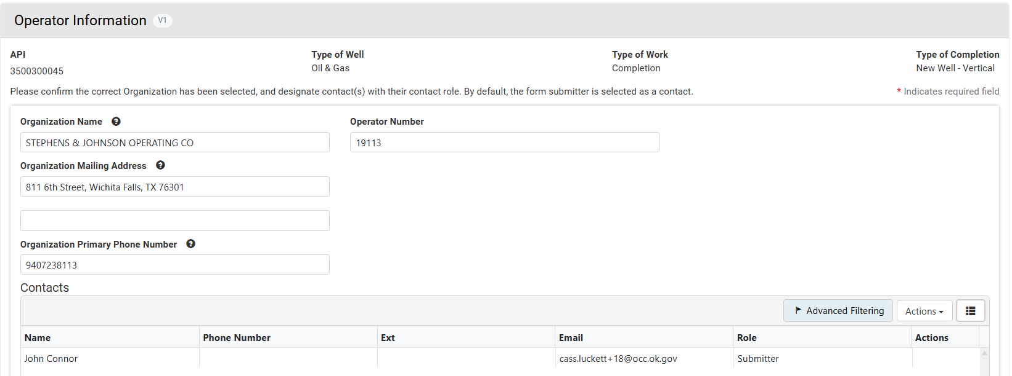

Step 3: Well Information
The Well Information step is used to give wellhead information.
• Verify the information appears correct.
• Add the information as necessary then click “Save” to continue.
Tip: The “Review BTW” button can be used to derive the value, upon clicking the button a map will zoom to the location per the GPS coordinates entered on the completion report. To place a “Pin” on the map, the coordinates will need to be entered again. Once entered, hit enter and click on the “Pin”. Your BTW value will appear.

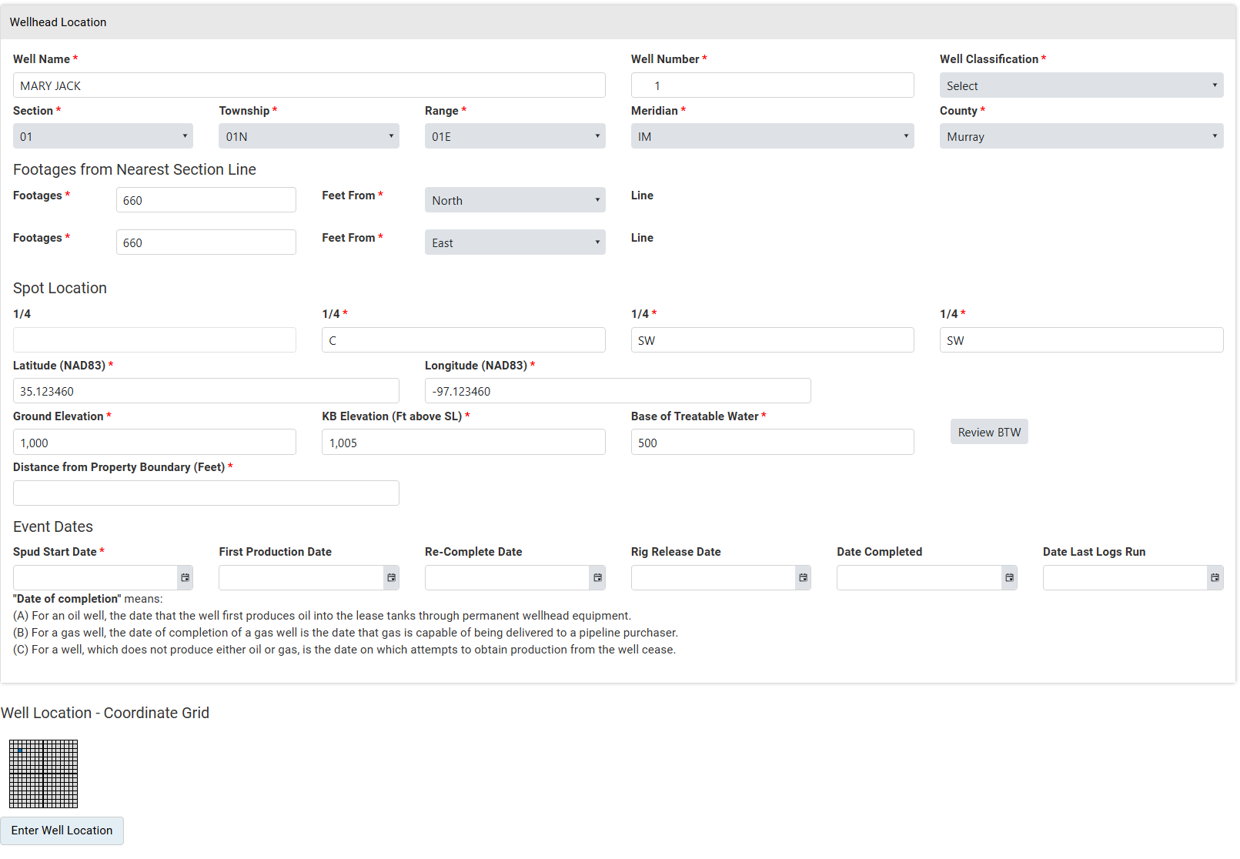
Step 4: Geologic Information
This section is used to provide information on types of electric or other logs that were run as well as zones encountered or completed.
Check the “Yes” or “No” box to the right of the logs to indicate which logs were run. The “Confidential” box can be checked simultaneously; this is to indicate if the logs are being held confidential. A form 1002B is still required to be submitted to formalize the confidential request.

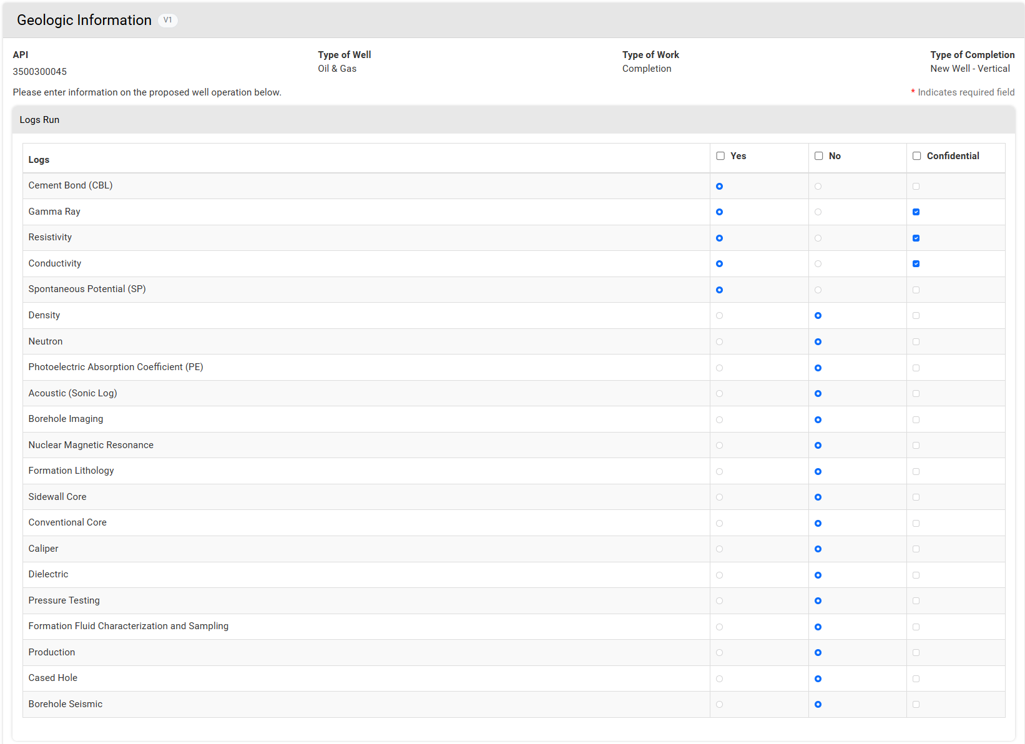
If the permit was approved in OKIES, “Zones of Significance” will be populated:
1. Click on “Actions” at the right of each zone and edit
2. Update the record from “Estimated” to “Actual”
3. Change the estimated depth to the actual depth

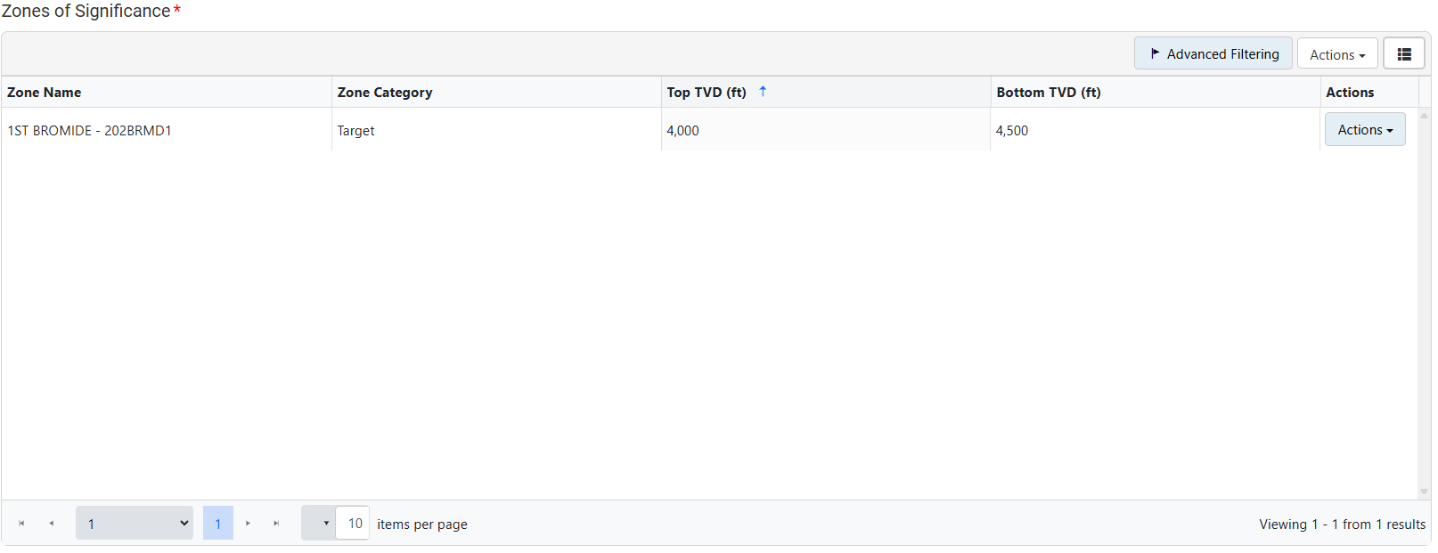
If the permit was issued prior to OKIES and converted over zones will not populate:
1. Click on “Actions” to add zones
2. Enter all Zones of Significance
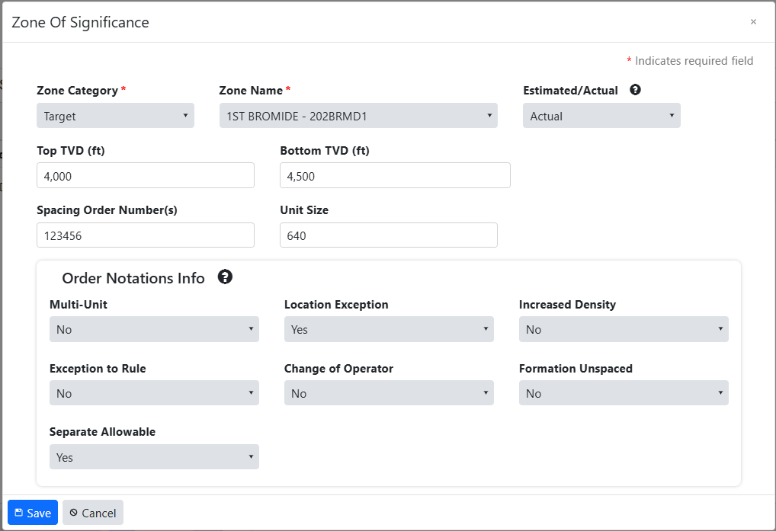
3. Indicate if the well has any associated OCC orders

Step 5: Order Notations
If you answered “Yes” to any of the “Order Notations Info” within the Zone of Significance modal, order specific details will be required for that specific application.
Location Exception
• CD number
• Current order number
• Type of order (order status)
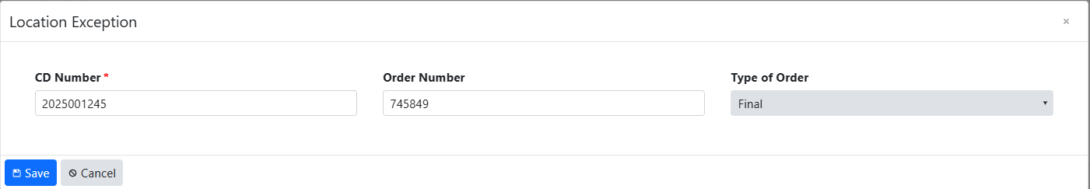

Multiunit
• CD number
• Current order number
• Type of order (order status)
• Legal description
• Allowable percentage per unit
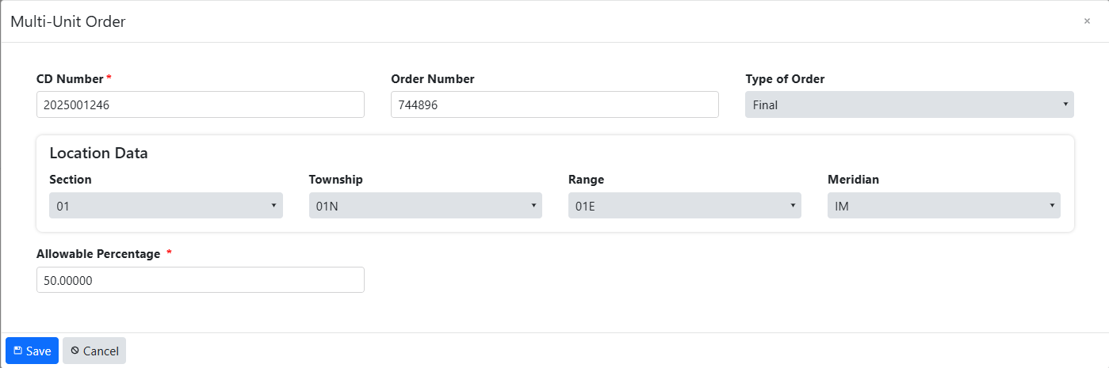

Change of Operator Exception to Rule
• CD number • CD number
• Current order number • Current order number
• Type of order (order status) • Type of order (order status)

Increased Density Separate Allowable
• CD number • CD number
• Current order number • Current order number
• Type of order (order status) • Type of order (order status)
• Legal description

Unspaced
If you answered “Yes” to the “Formation Unspaced” dropdown within the Zone of Significance modal, the following information will be required:
• Unspaced formation(s)
• Leased acreage size
• Legal description of spaced acreage (spot location)
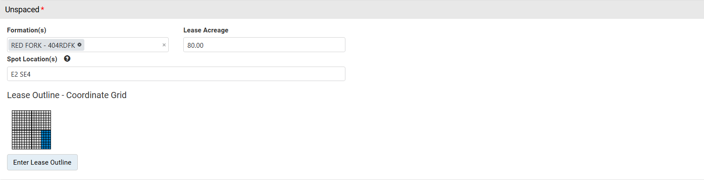

Select your lease outline on the coordinate grid with the options to the right or trace the lease by clicking and dragging your cursor.
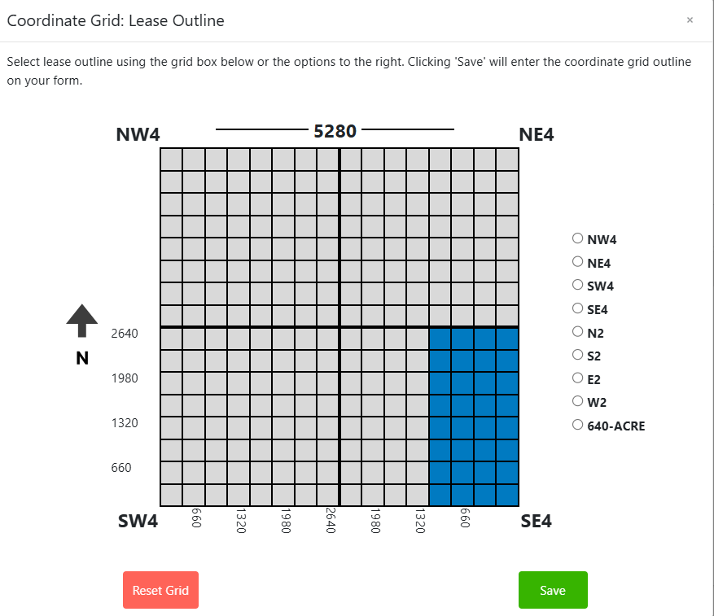

Step 8: Features and Cement
Under Features & Cement, the wellbores will appear as they were permitted. For each wellbore, you will need to select “Actions” – “Edit Wellbore” in order to update the information from the permitted values to the actual values. Take care to adjust the “Wellbore Construction Status” to the applicable status.

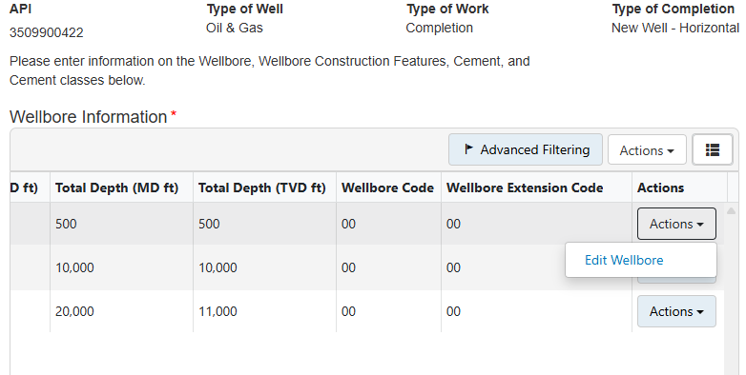
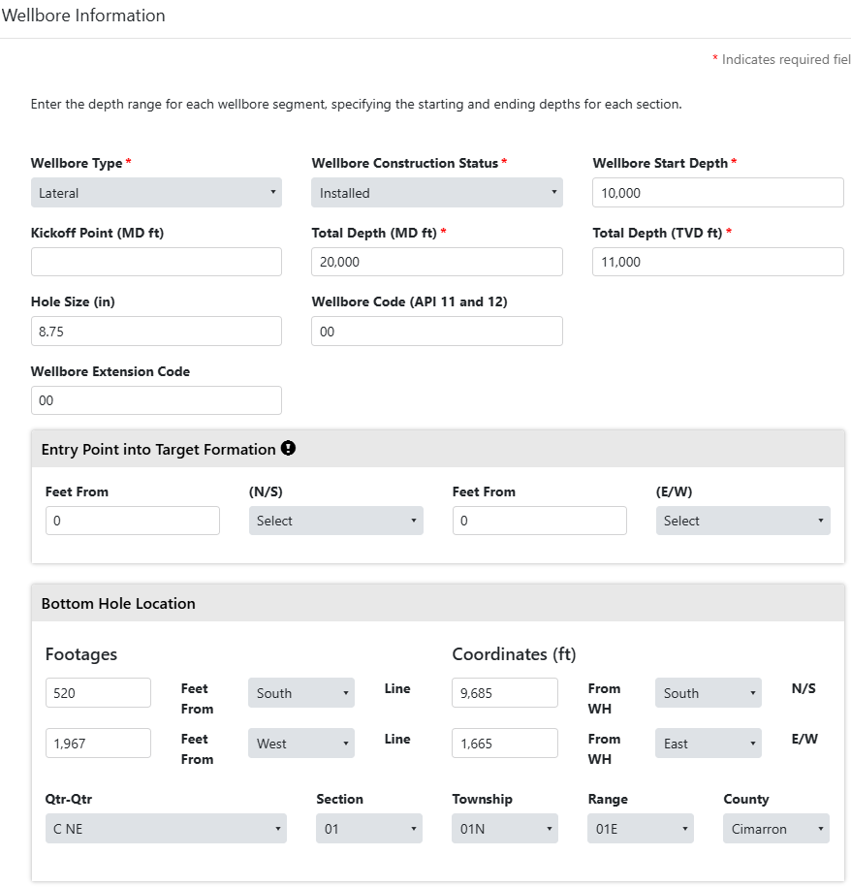

You will follow the same procedure with the casing and cement information. After selecting “Actions” and “Edit Feature”, you will be able to enter the actual values.
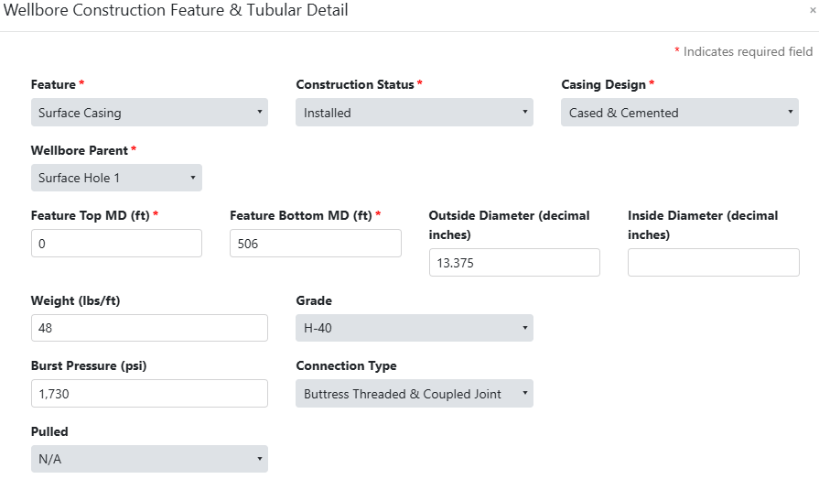

This information will mirror the form 1002C.
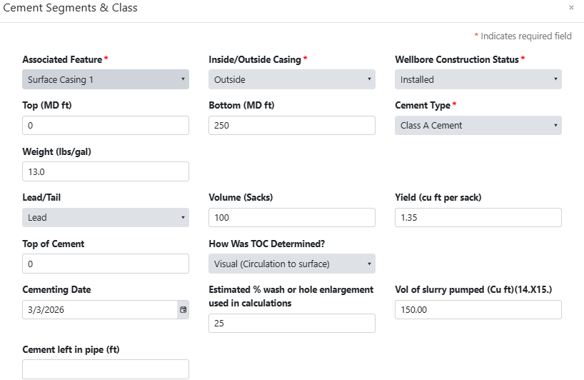

If the permit was issued prior to OKIES, the populated entry will appear as such. Start with the first entry, if there are multiple, and build out your wellbore i.e. vertical wells – Surface Hole, Vertical Hole (only Vertical Hole if alternate casing); horizontal wells – Surface Hole, Vertical Hole (if intermediate casing will be set prior to kickoff point), Vertical and Curve, Lateral.
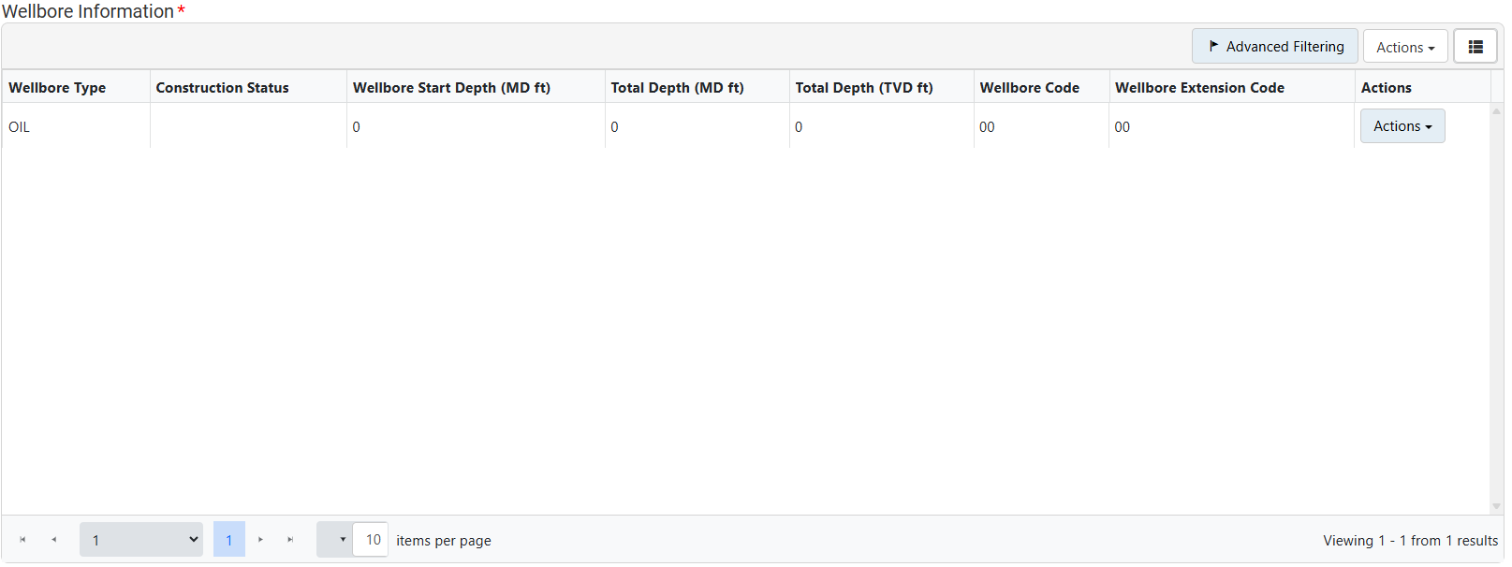

Step 9: Completion & Perforation
Completion Interval
This step builds off the Wellbore Information modal in the Features and Cement section, all wellbores entered will be available for selection in the “Wellbore” dropdown. Pick the wellbore(s) that is associated with the completion interval. Enter the completion interval (first perf to last perf) along with interval type and construction status.
• Single Zone – Completion and production of a single zone in a vertical well and more than one zone in a horizontal well.
• Multiple Zone – Completion and production of more than one zone that is segregated.
• Commingle – Completion and production or more than one zone that is not segregated.
The take points are horizontal well specific and should include the first and last perf information within each unit, or section. If multiple units exist within one section, explain in the “Description” box at the bottom of the modal. Multiple laterals should be accounted for with multiple completion intervals
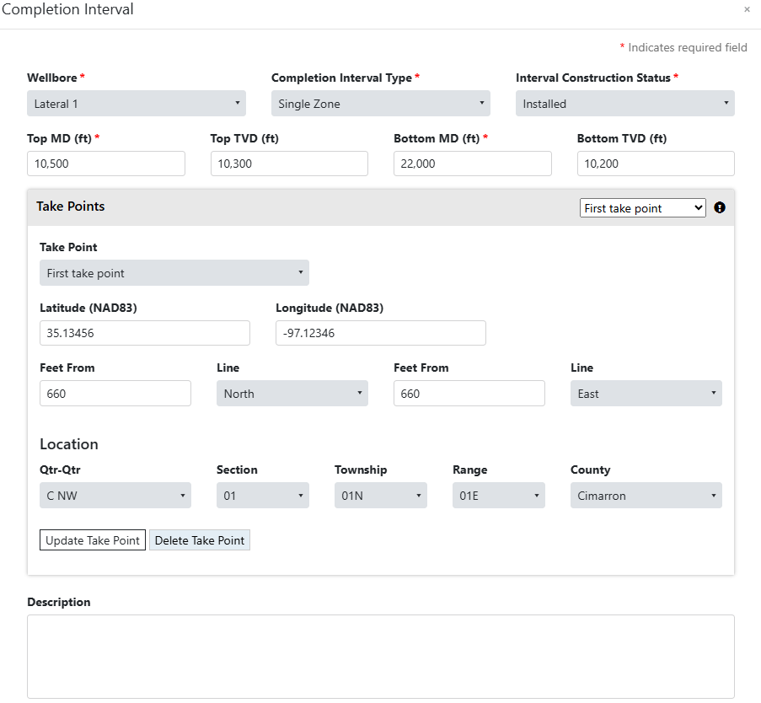

Completion Open Hole or Perforation
This step builds off the Completion Interval modal above, all completion intervals entered will be available for selection in the “Associated Completion Interval” dropdown.
Enter the construction status and type of completion along with the detailed perforation record. If multiple zones are completed within the wellbore, create a record for each formation.
Tip: The “Open Hole” selection in the “Type” dropdown is reserved for true open hole completions, no casing in the wellbore. For a “Packers Plus” system choose “Uncemented Liner”. In both instances, the Top MD will be equal to the last casing string that is cemented and the Bottom MD equal to the terminus of the wellbore.

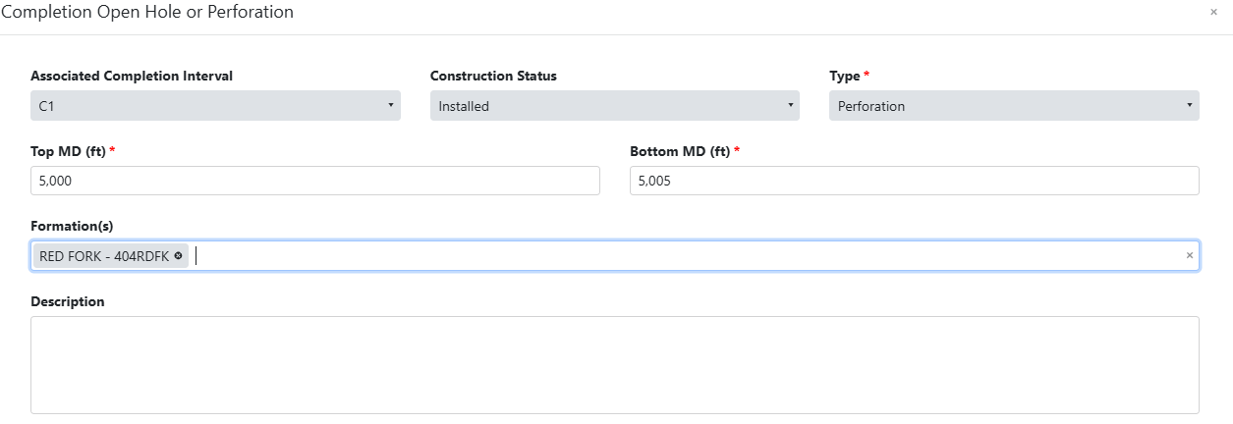

Step 10: Stimulations and Tests
Enter information for stimulations and tests if applicable.
• Initial Production Test – All new drill, re-entered, and recompleted wells with a classification of oil or gas.
• Production Test – All wells other than new drill, re-entered, and recompleted wells with a classification of oil or gas
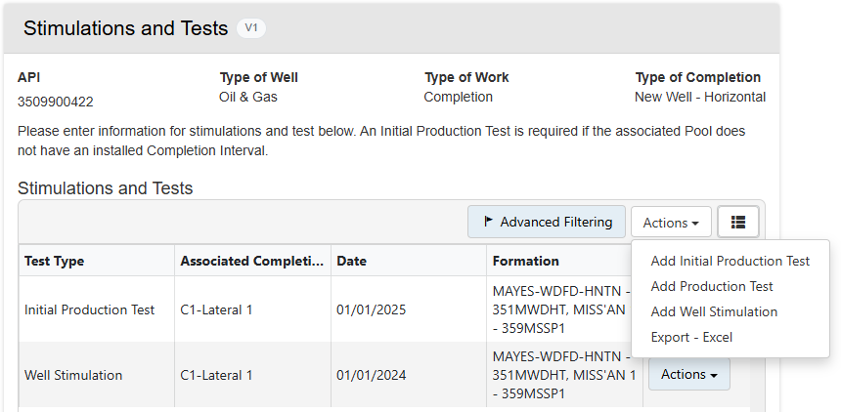

A FracFocus disclosure is required 60 days after the conclusion of hydraulic fracturing operations. To confirm submittal, a link to the disclosure can be found using the “View Well” button.
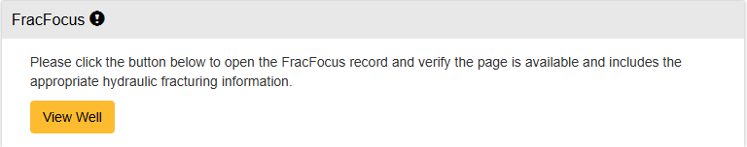

Step 11: Completed Work
Any additional work performed or details that were not captured throughout the completion report will be entered here.
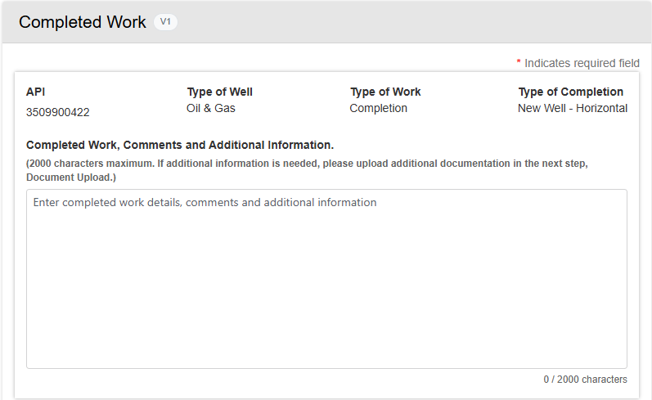

Step 12: Document Upload
Any additional documents that are required, i.e., as-drilled plat, can be uploaded in this section.
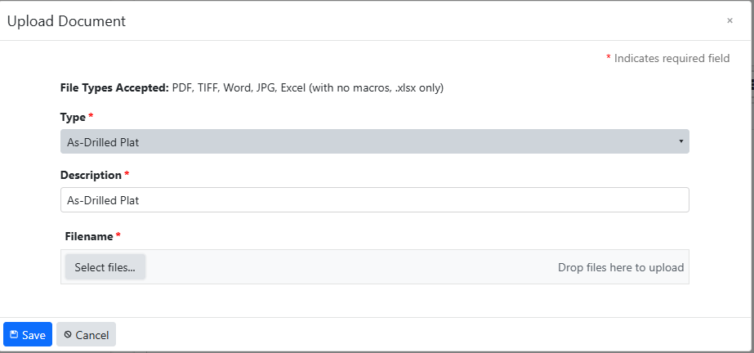
Step 13: Form Submit
To submit the form, check the box next to the acknowledgement statement, confirm all sections have been completed (check mark vs “X”) and click the “Submit” button at the bottom of the page. Prior to submittal, a draft copy is available using the “Download Draft PDF” button.
