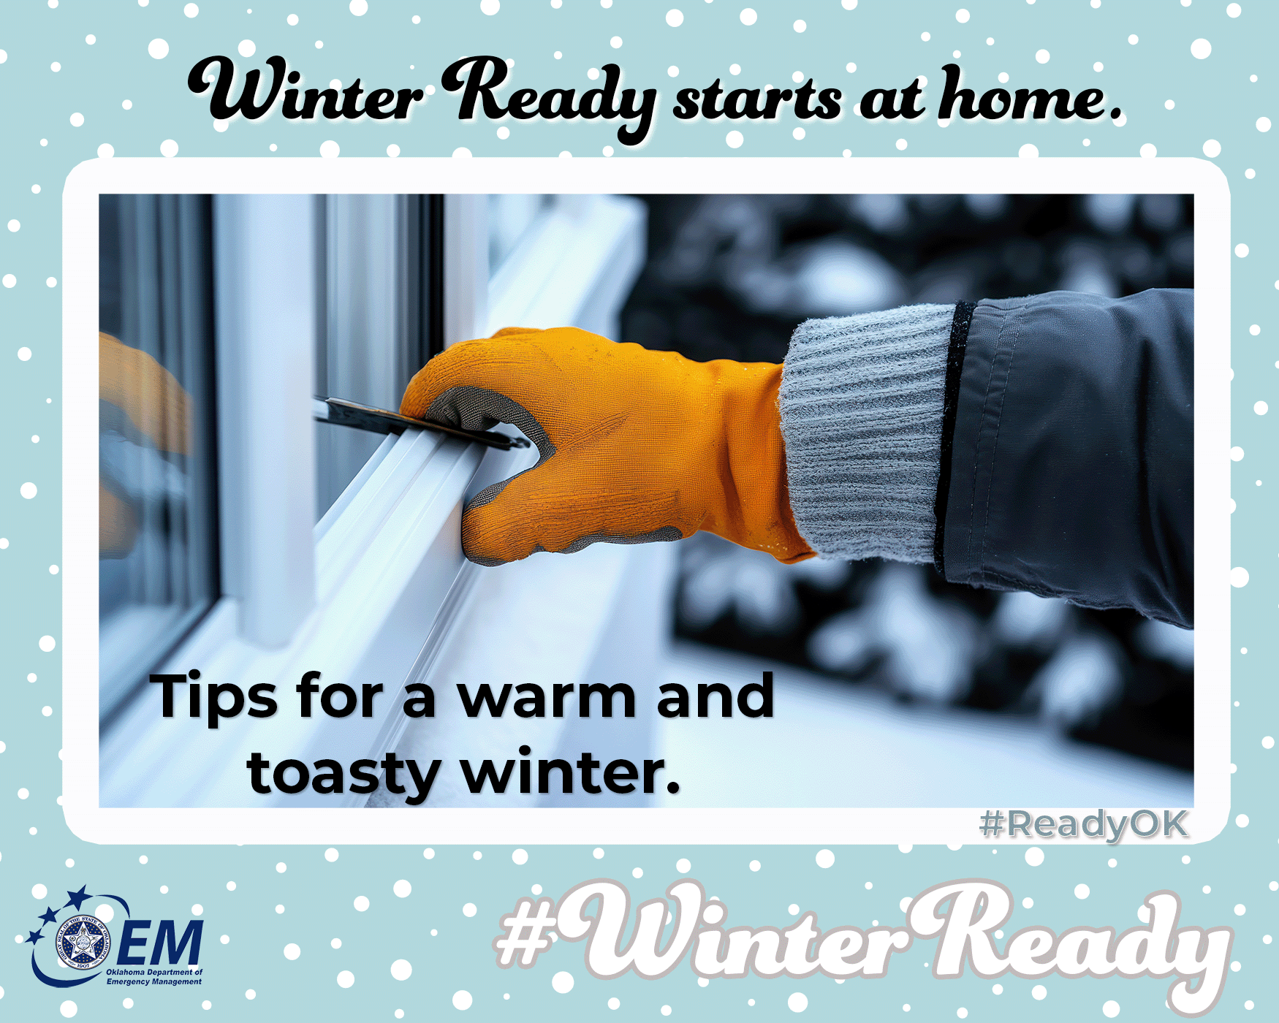
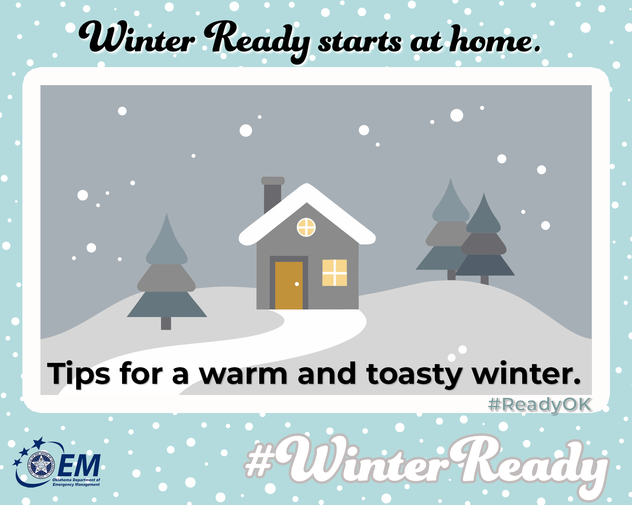

Brr, it's getting chilly! 🌨️ Don't forget to winterize your home.
Winter storms can roll in fast — with ice, bitter cold, and dangerous travel conditions. Now’s the time to get your home storm-ready:
Seal drafts around windows and doors, insulate pipes to prevent freezing, and check your heating system. A little prep goes a long way!
How to winterize safely:
🪟 Use weatherstripping or caulk on doors/windows.
🏠 Wrap outdoor faucets
✅ Wrap exposed pipes with foam insulation or heat tape.
👨‍🔧Have furnace serviced yearly; replace filters.
🔋 Check flashlights + batteries
⚠️ Install carbon monoxide detectors and test monthly.
🔥Keep flammable items 3 feet from heat sources.
📦 Stock 3 days of essentials
Preparation is cozy comfort ✨
Be winter-wise before the weather arrives.
For more information on preparing for winter, go to https://oklahoma.gov/oem/readyok/be-aware/winter-weather.html.
#WinterReady #ReadyOK #EmergencyPreparedness

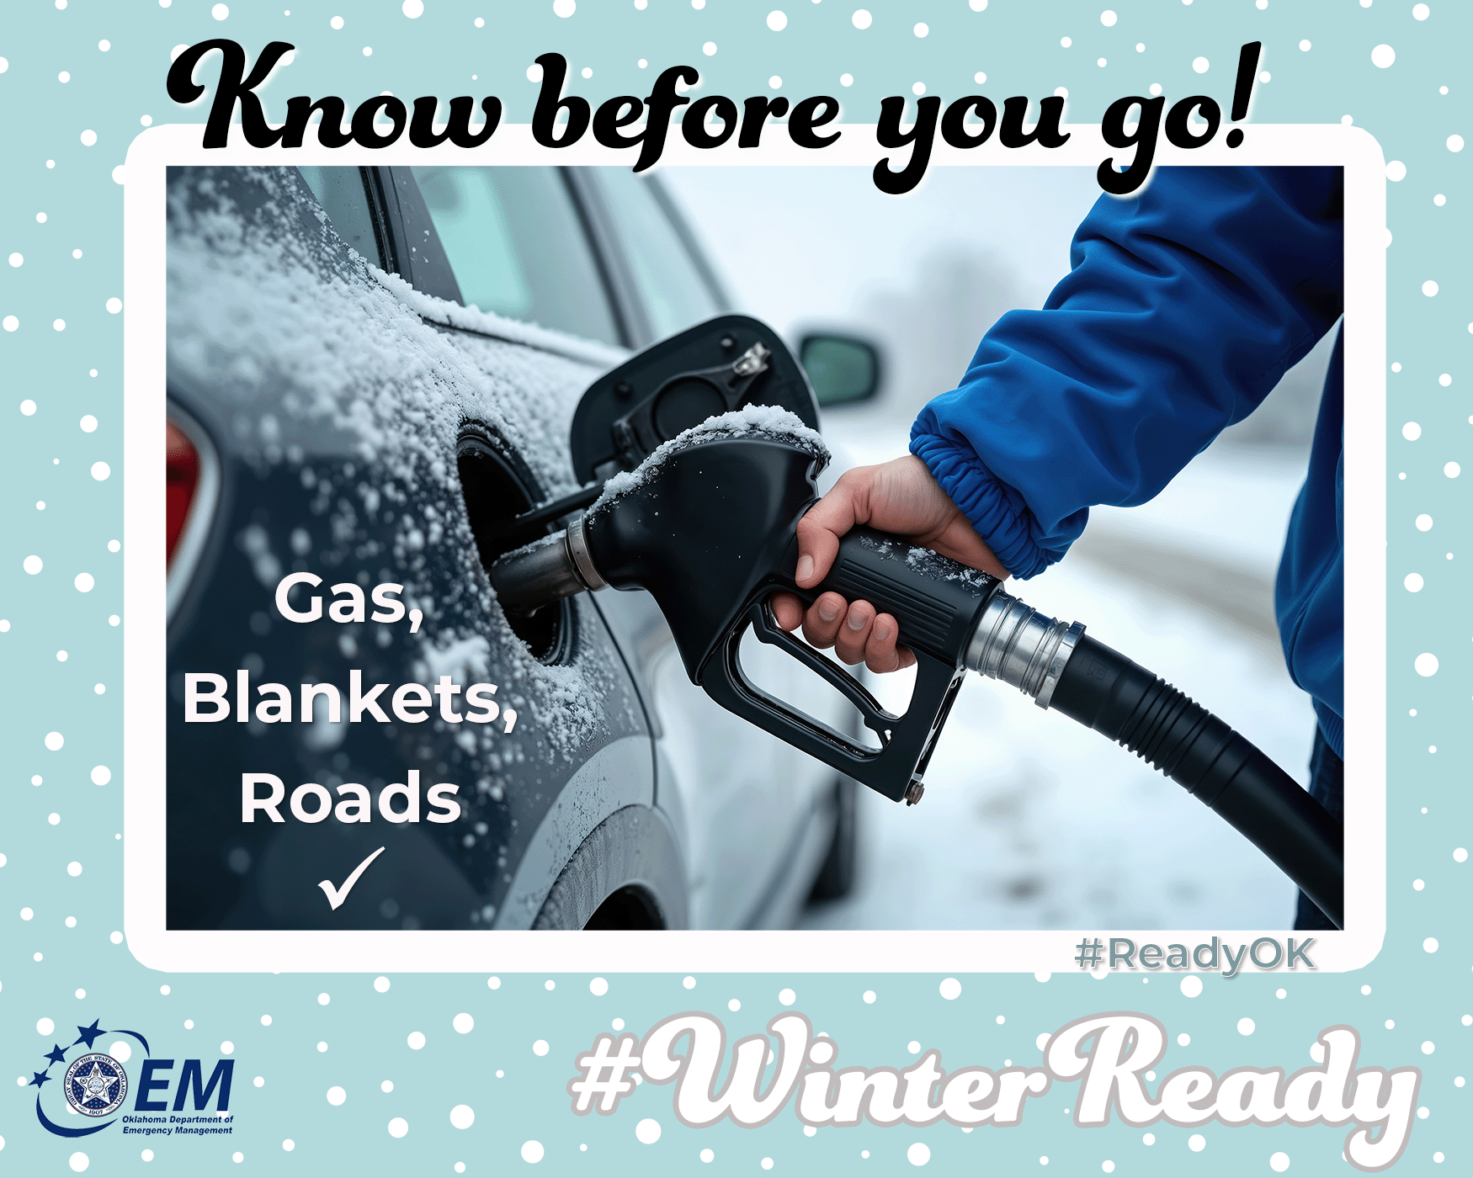
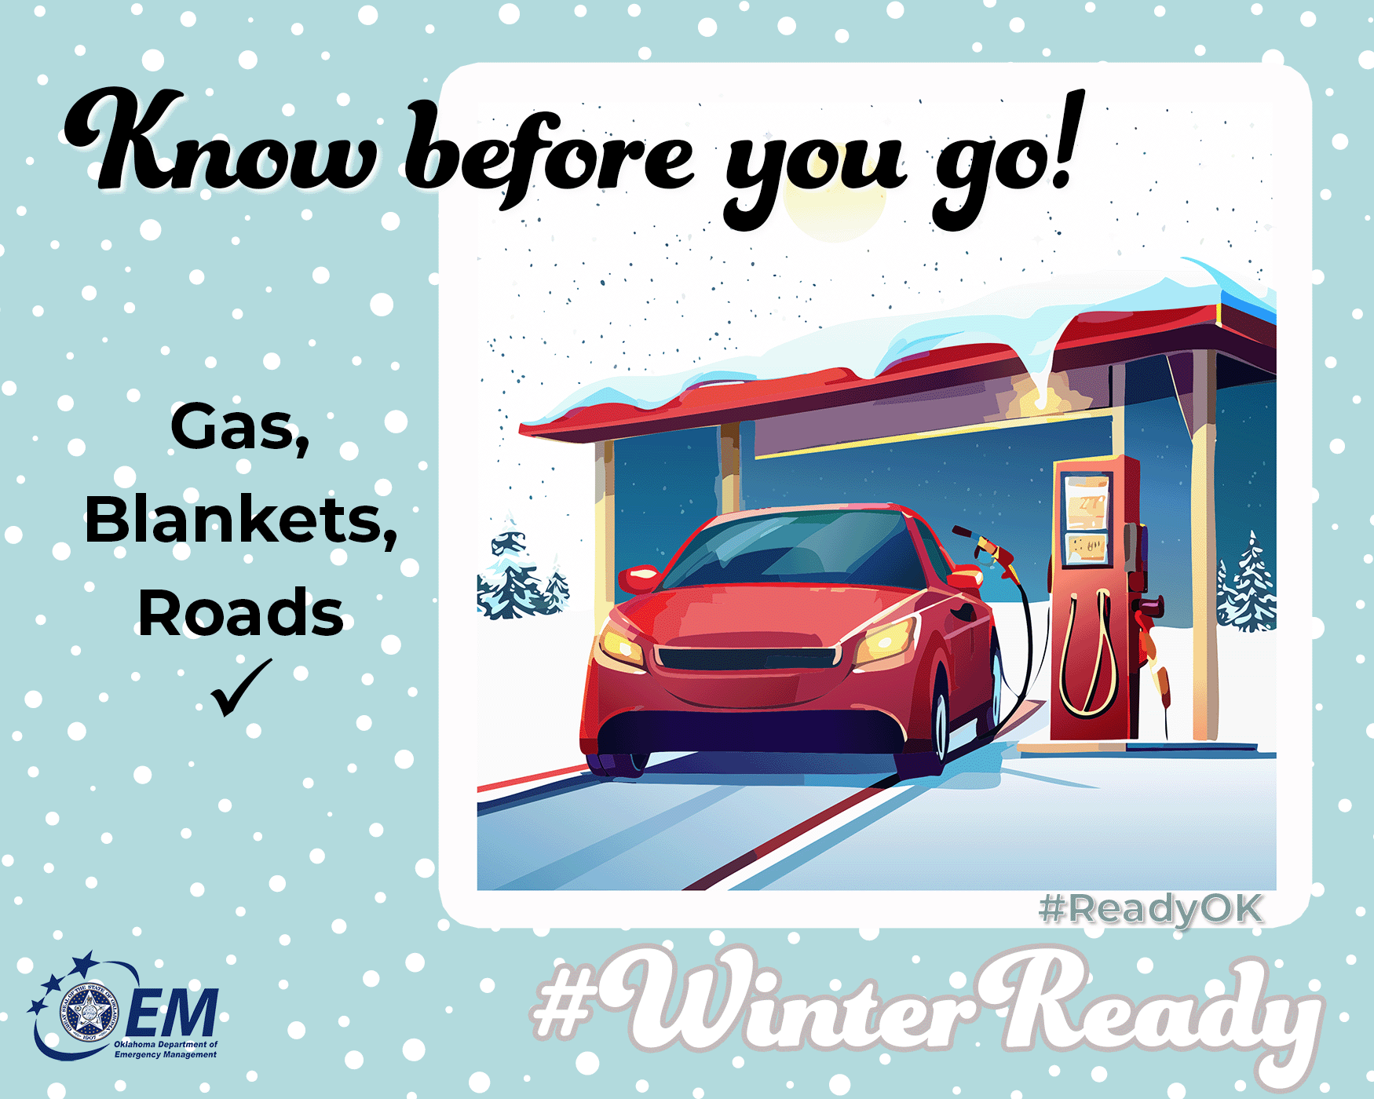

Know Before You Go
Winter roads can turn slick in seconds. If you must travel:
🚗 Keep your gas tank at least half full
🧤 Pack blankets, 🍪🥨snacks, and ⚡a phone charger
📱 Check weather and road conditions before leaving
👀 Let someone know your route and ⌚ arrival time
Safety doesn’t take snow days ❄️🚗
Plan smart. Drive safe!
For more information on preparing for winter, go to https://oklahoma.gov/oem/readyok/be-aware/winter-weather.html.
#WinterReady #ReadyOK #TravelPrepared

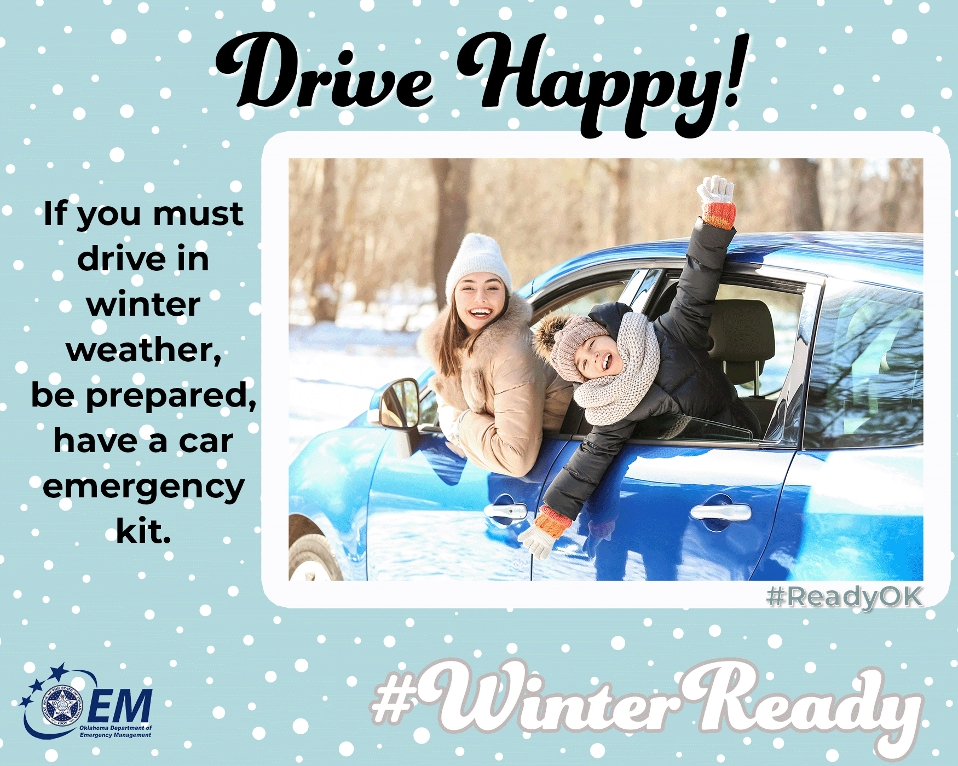
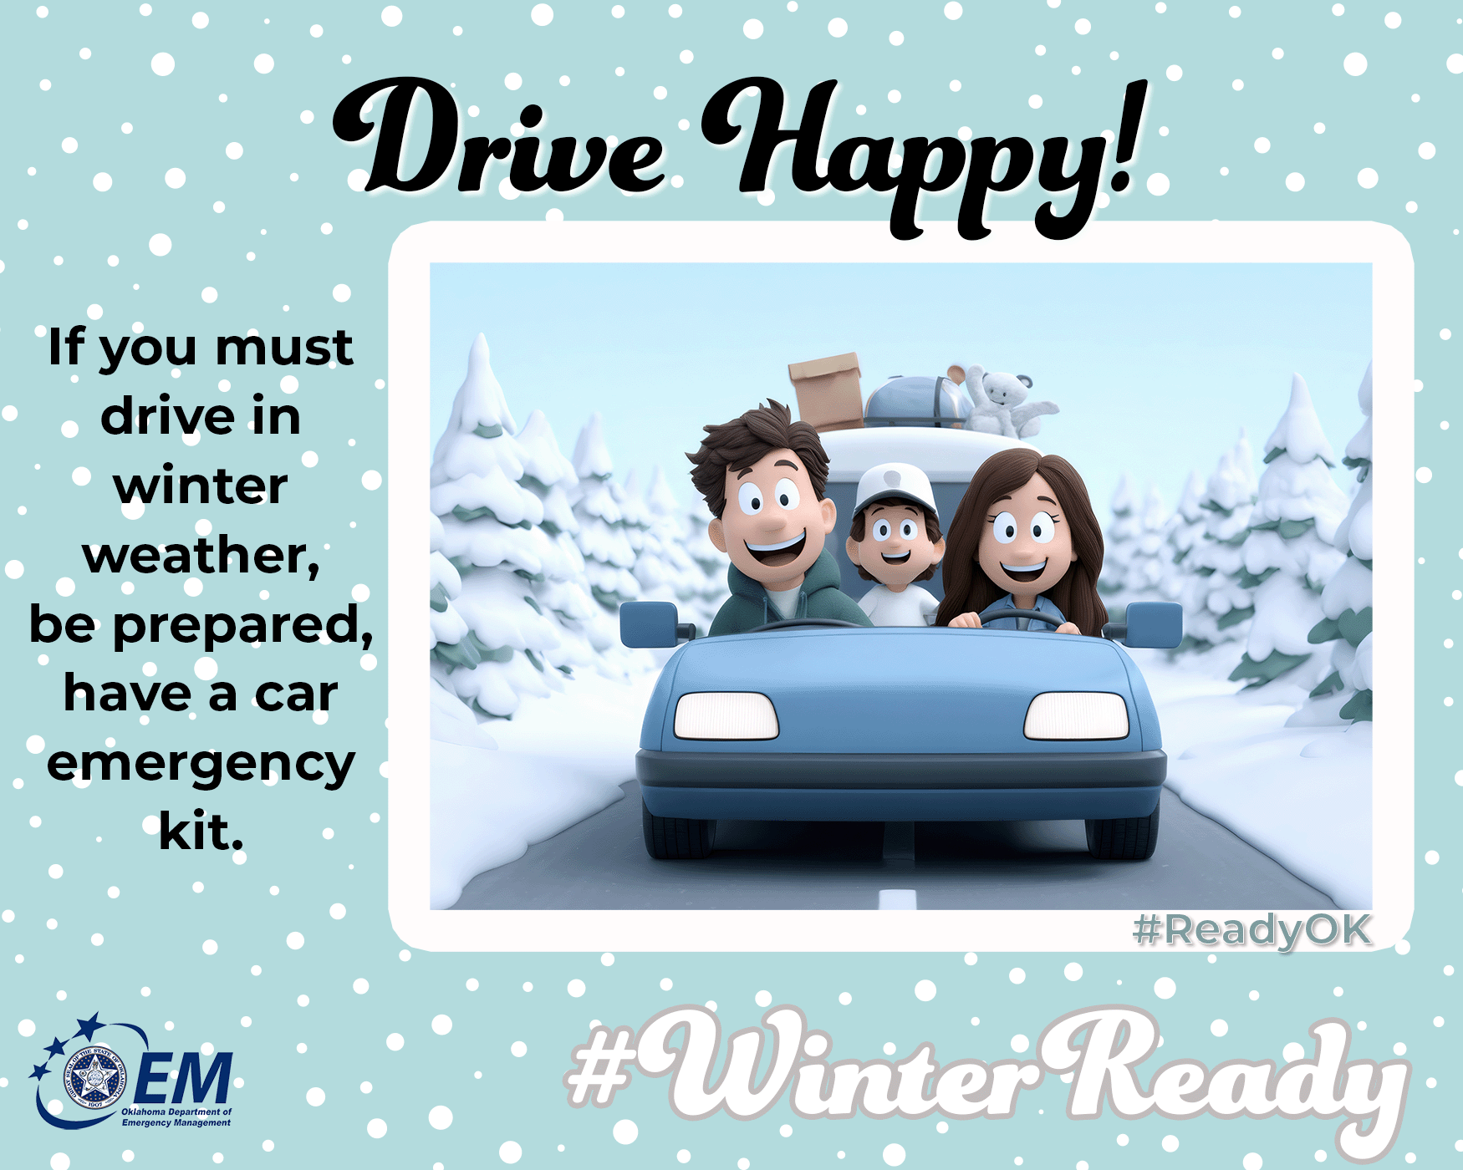
Driving in snow? No problem if you're prepared!
🚗 Keep an emergency kit in your car with blankets, snacks and water, a flashlight, and ice scraper. And remember, slow down on icy roads — better safe than sorry!
How to drive safely:
❄️ Clear ALL snow/ice from windows, lights, roof.
🚗 🚙 Increase following distance to 8–10 seconds.
🚘 Brake gently; avoid sudden moves.
⛽️ Keep gas tank at least half full.
🛑If stranded, stay in car, run engine 10 min/hour, crack window for air.

Hypothermia symptoms & treatment:
Signs: Uncontrollable shivering, memory loss, disorientation, exhaustion.
Act fast: Stay in car, wrap in blankets, sip warm liquids from kit, use body heat with others, avoid sleeping—seek rescue.
Safety doesn’t take snow days ❄️🚗
Plan smart. Drive safe!
For more information on preparing for winter, go to https://oklahoma.gov/oem/readyok/be-aware/winter-weather.html.
#WinterReady #ReadyOK #WinterDriving #SafeTravels

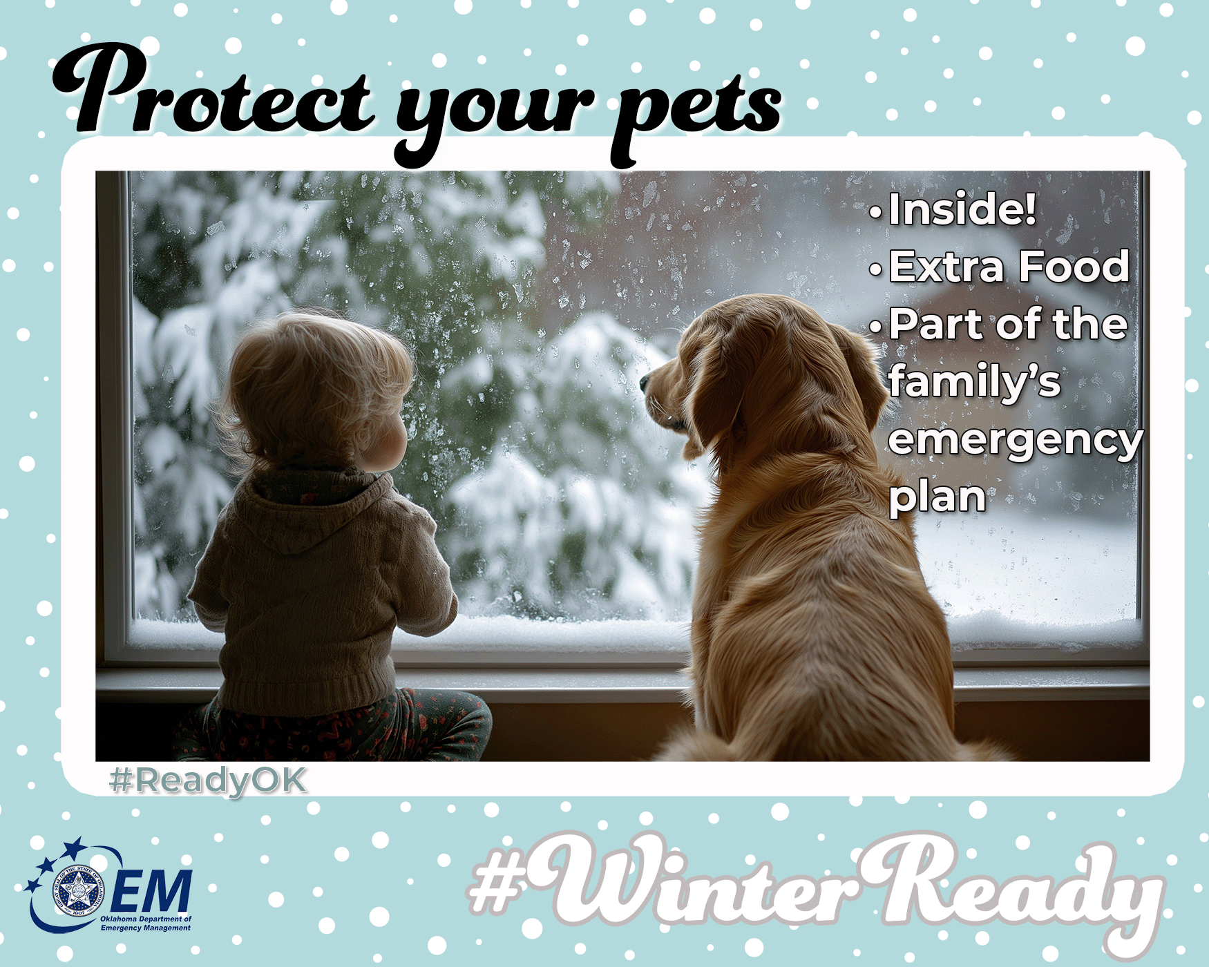
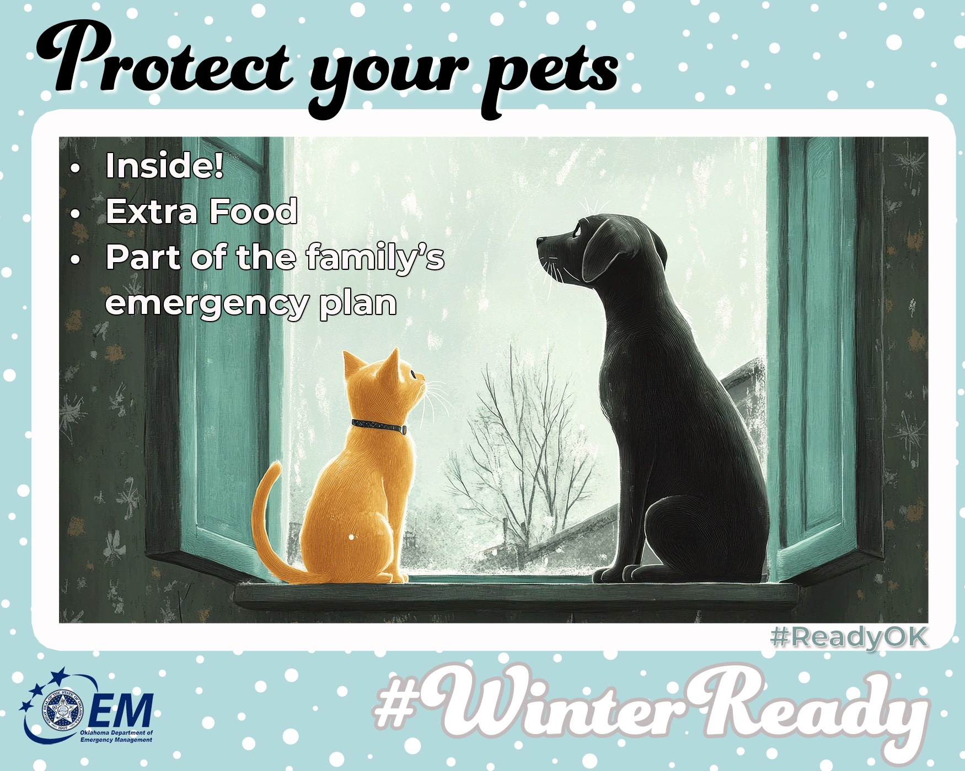
Pets feel the cold too!
If it’s too cold for you…it’s too cold for them! 🐾🐶🐱 Bring them inside during freezing temps, provide warm bedding, and protect their paws from salt/ice with booties. Let's keep our furry friends safe and snuggly this winter!
🥶 Bring pets indoors during freezing temps.
⏱️🐾 Keep outdoor time short and paws protected.
🥩 Store extra pet food, meds and water.
🐶🐱 Add your pets to your emergency plan.
🐾Wipe paws after walks—salt/chemicals irritate.
🐕Use pet-safe de-icer on walkways.
🚘Check under car hood—cats seek engine warmth.
Hypothermia symptoms & treatment (for pets):
Signs: Shivering, lethargy, weak cry, cold ears/paws, stiff body.
Act fast: Wrap in warm towels, use lukewarm (not hot) water bottles, offer warm fluids, contact vet—pets can’t shiver long.
Pets’ safety depends on you — keep those furry family members warm and safe this winter!
For more information on preparing for winter, go to https://oklahoma.gov/oem/readyok/be-aware/winter-weather.html.
#WinterReady #ReadyOK #PetPreparedness

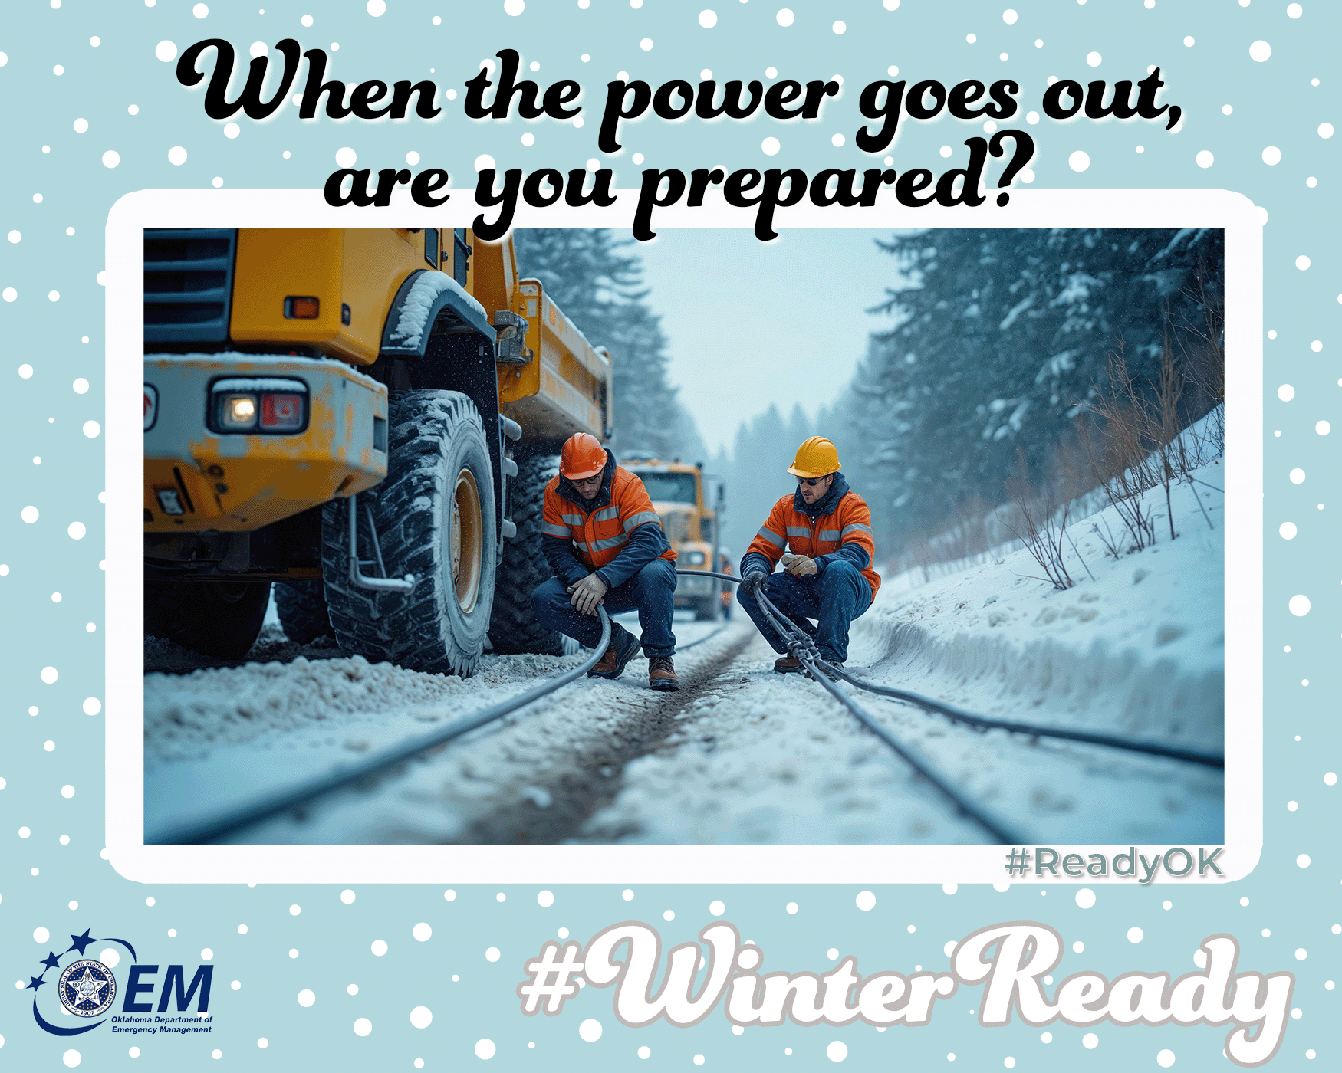
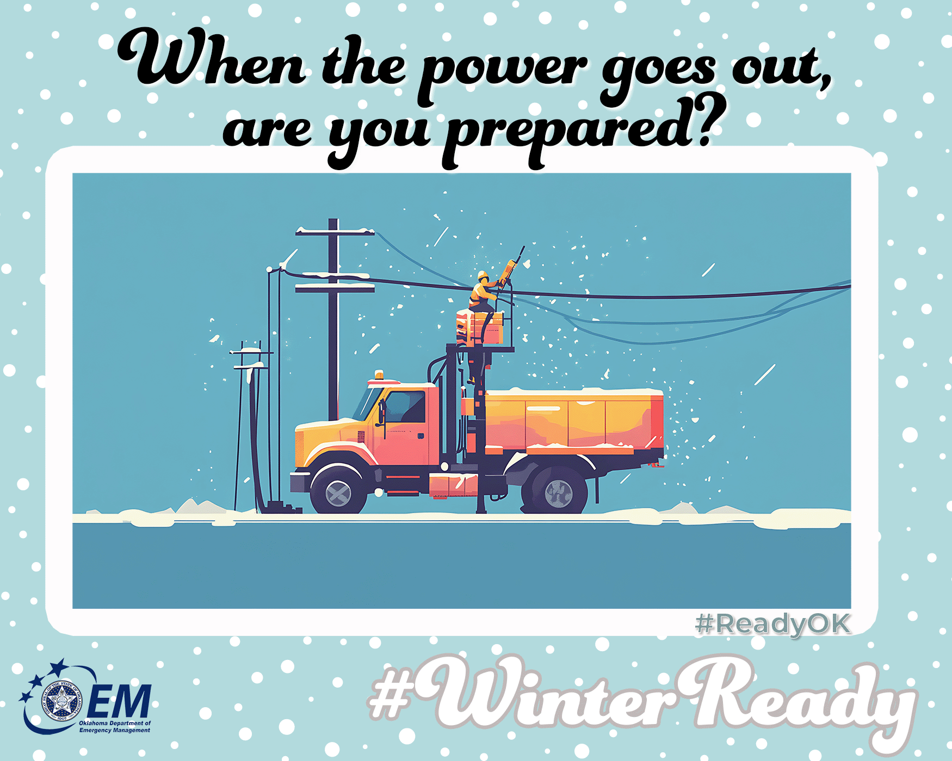
When the Power Goes Out
Cold weather can lead to power outages — but you can be ready:
🔦 Have flashlights (not candles) handy.
🎛️ Know how to safely operate generators — outdoors only!
☠️ Do not use a gas stove or oven to heat your home
🥫 Keep shelf-stable food in your kit.
📱 Charge devices before the storm hits.
⛪️ Go to a community location with power if the cold is extreme and you can’t heat your home.
Stay warm, stay safe, and stay informed. ❄️
For more information on preparing for winter, go to https://oklahoma.gov/oem/readyok/be-aware/winter-weather.html.
#WinterReady #ReadyOK #PowerOutagePrep #EmergencyPreparedness

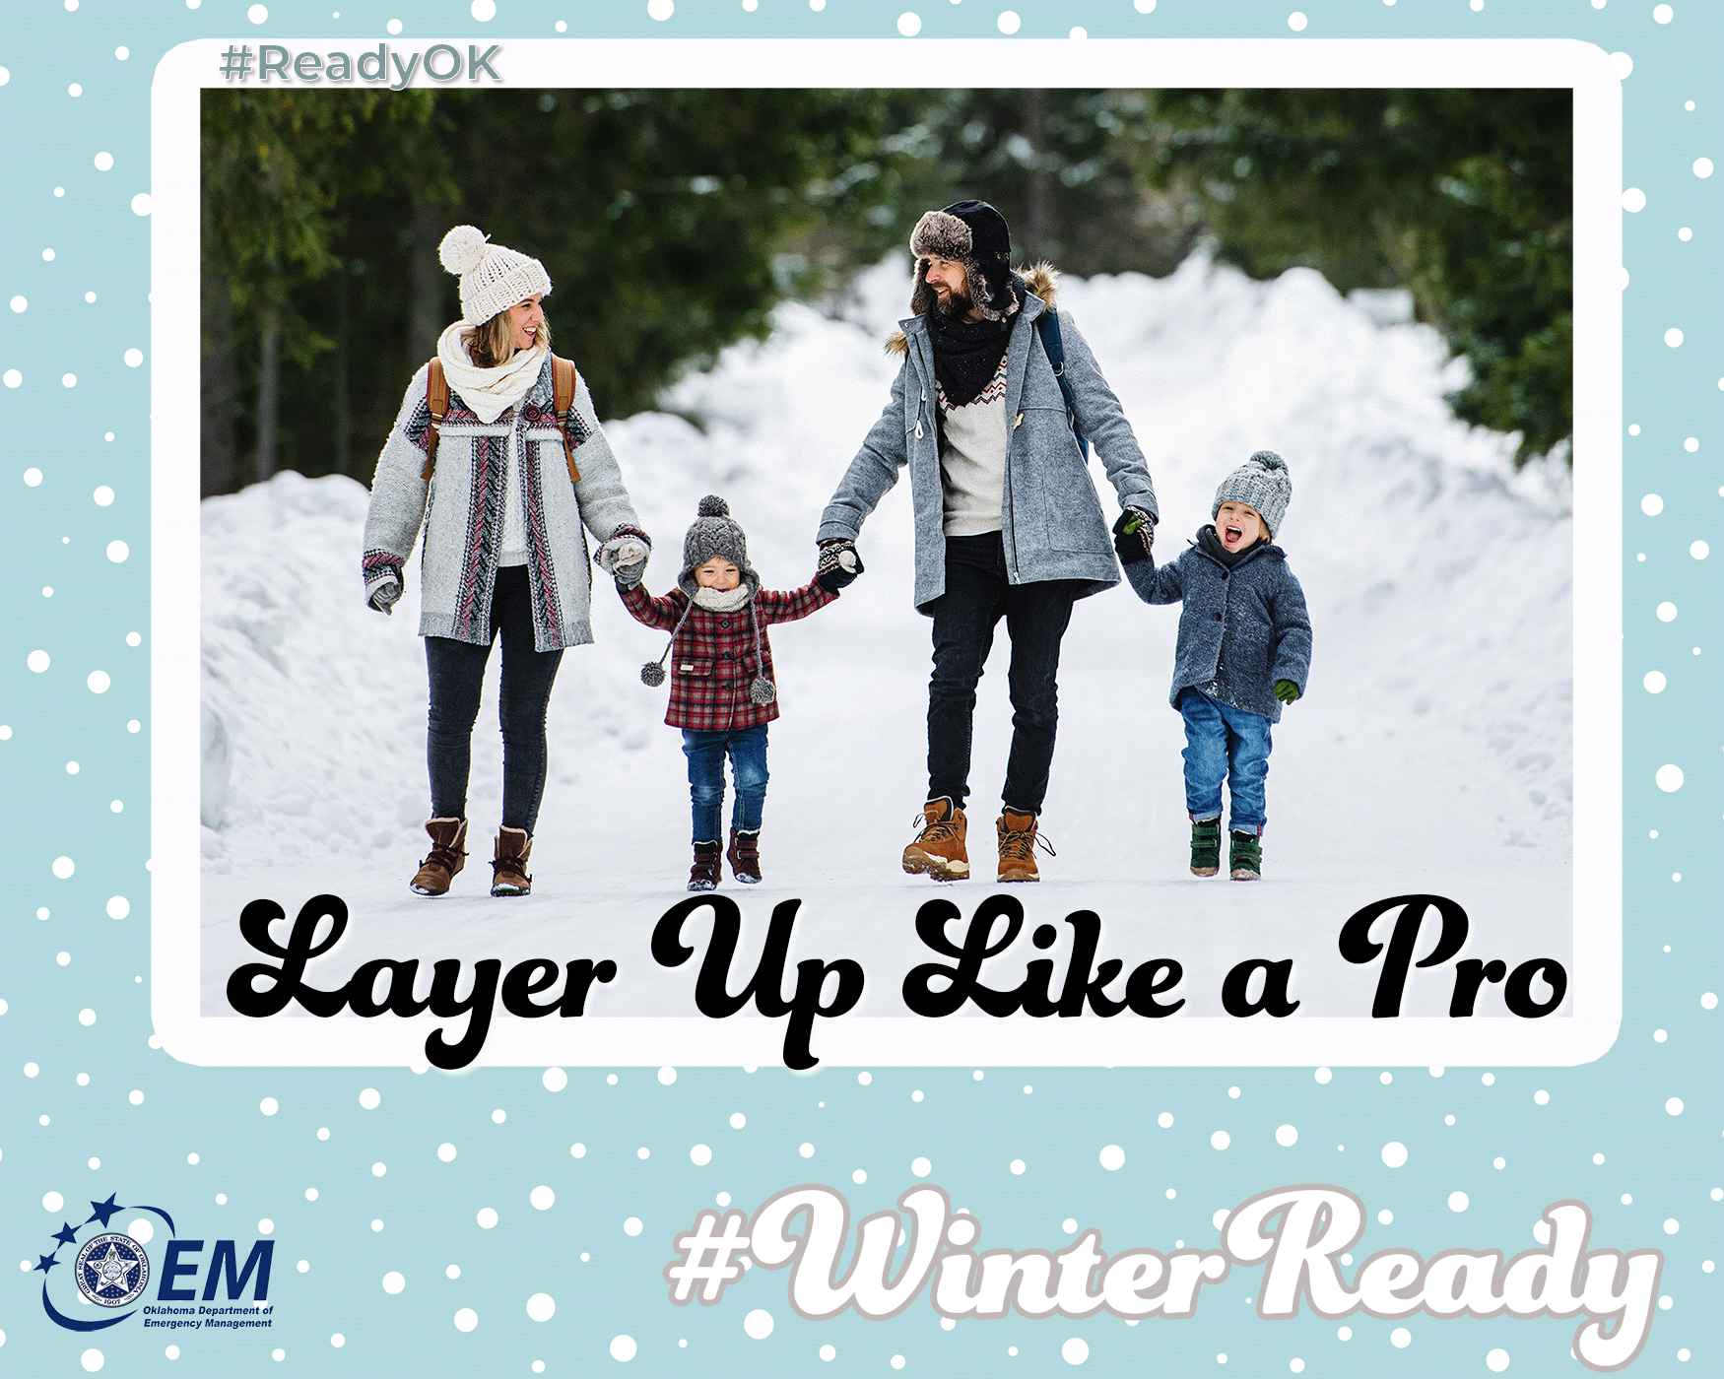
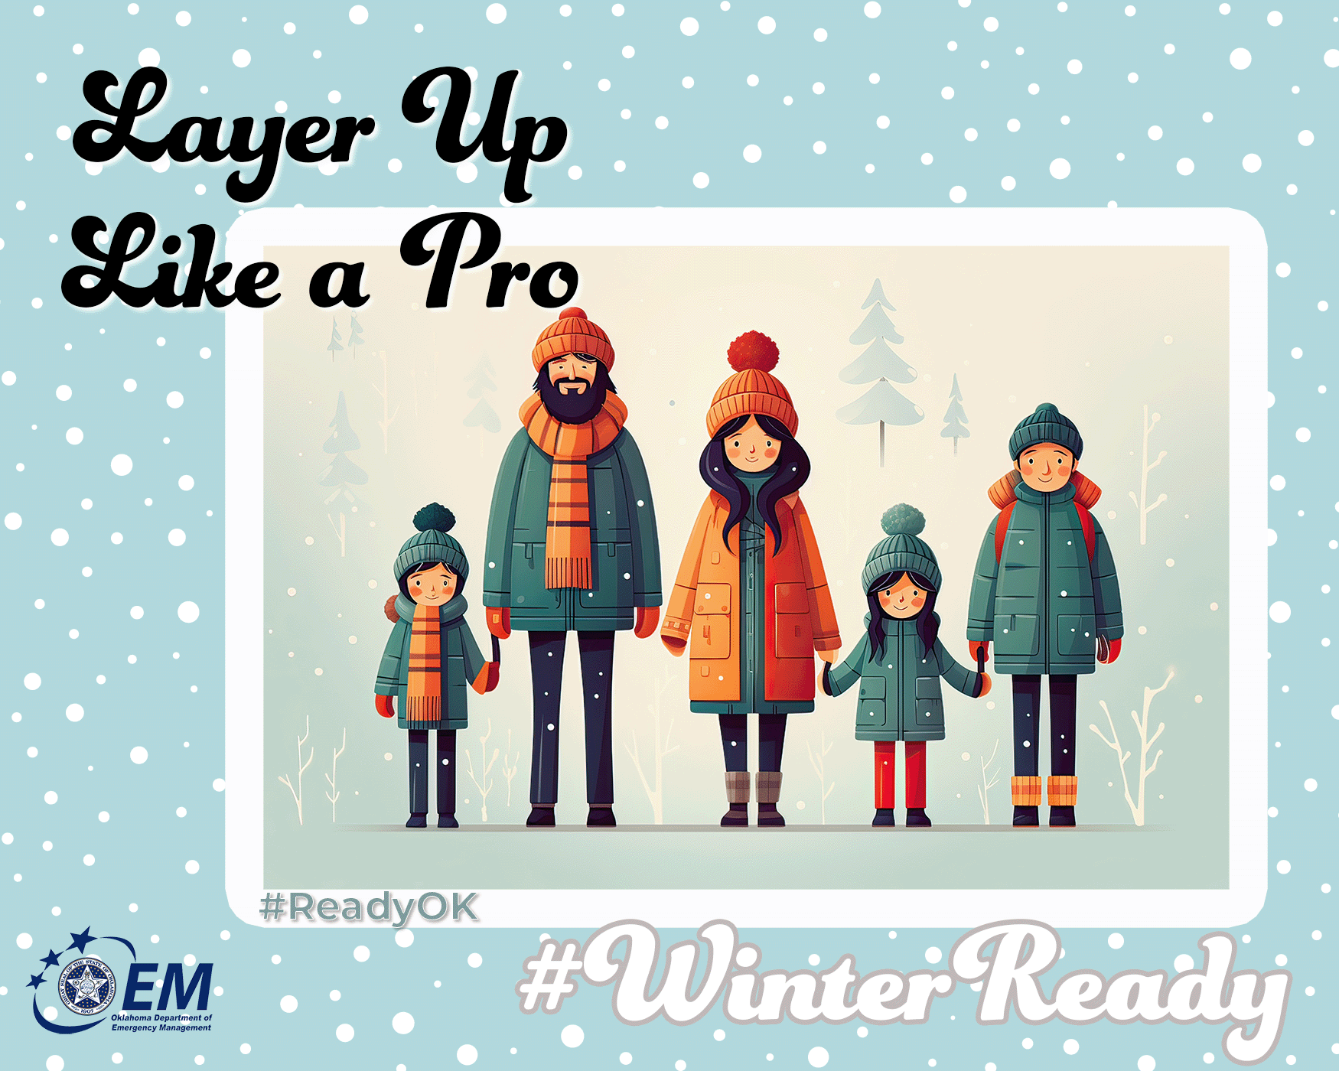
Layer Up Like a Pro
Cold temps can be dangerous — especially with wind chills! Layer your clothes: base layer for warmth, mid for insulation, outer for wind/rain protection. Stay cozy and safe out there bundle up the right way:
🧥 Outer layer: wind + water resistant.
🧣 Middle layer: warm + insulating (fleece or down).
👕 Base layer: moisture-wicking (no cotton—try wool or synthetics).
🧤 Cover head, hands and neck—most heat escapes here!
💦Change wet layers ASAP to avoid hypothermia.
Hypothermia symptoms & treatment:
Signs: Shivering, confusion, slurred speech, slow breathing, weak pulse.
Act fast: Get indoors, remove wet clothes, wrap in warm blankets, drink warm (non-alcoholic) fluids, seek medical help if severe.
❄️ Winter's knocking—time to bundle up!
For more information on preparing for winter, go to https://oklahoma.gov/oem/readyok/be-aware/winter-weather.html.
#WinterReady #ReadyOK #LayerUpOK

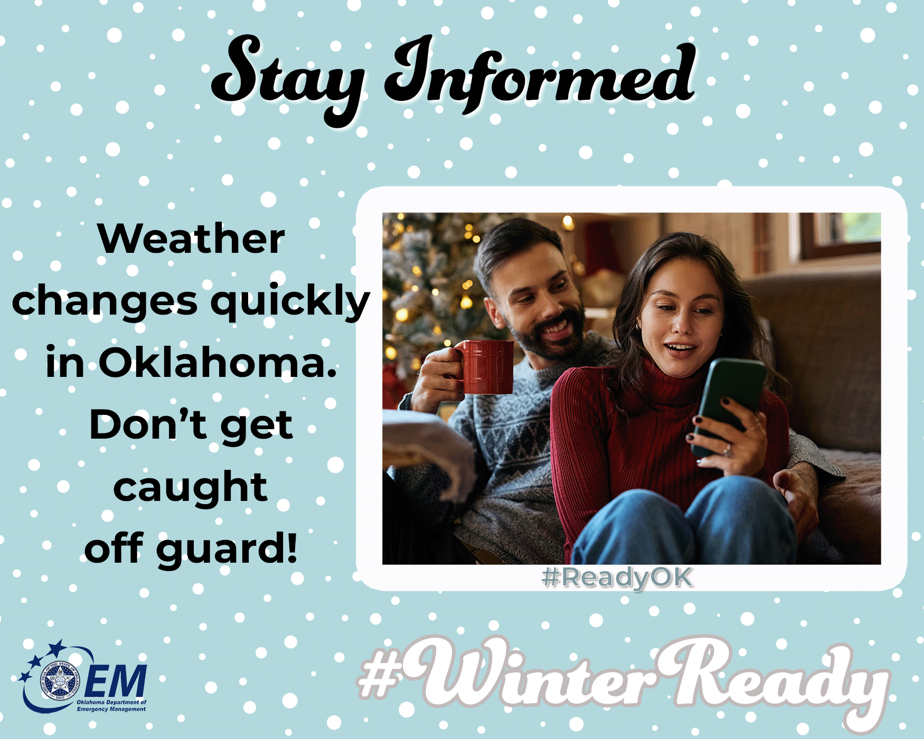
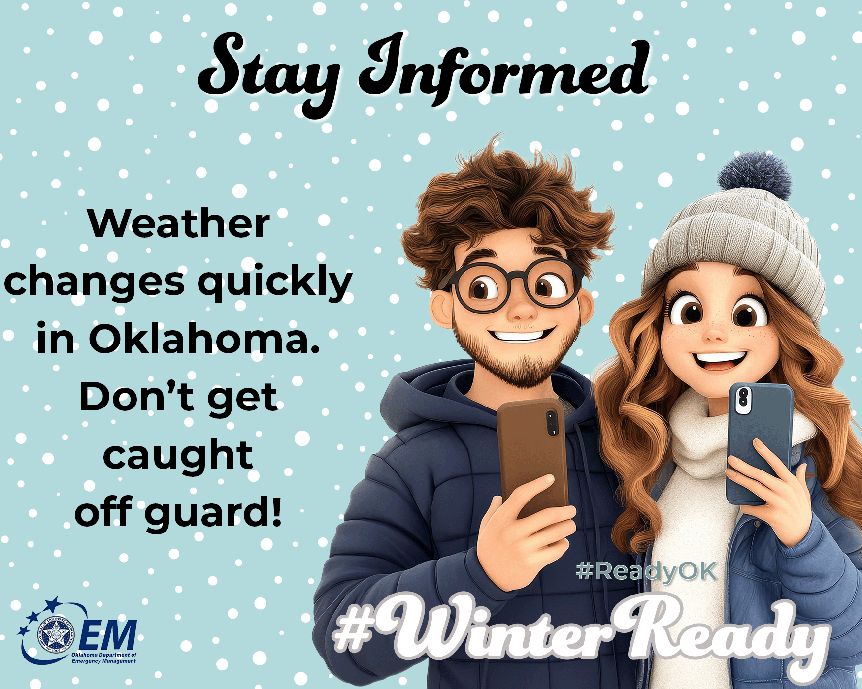
Stay Informed
Weather changes quickly in Oklahoma. Don’t get caught off guard!
📲 Sign up for local emergency alerts.
📻 Keep a battery-powered weather radio.
❄️ Watch wind chill and freezing rain updates.
🚫 Avoid travel when warnings are issued
A few minutes of awareness = a lot of safety.
For more information on preparing for winter, go to https://oklahoma.gov/oem/readyok/be-aware/winter-weather.html.
#WinterReady #ReadyOK #BeInformed #WinterWeatherUpdates

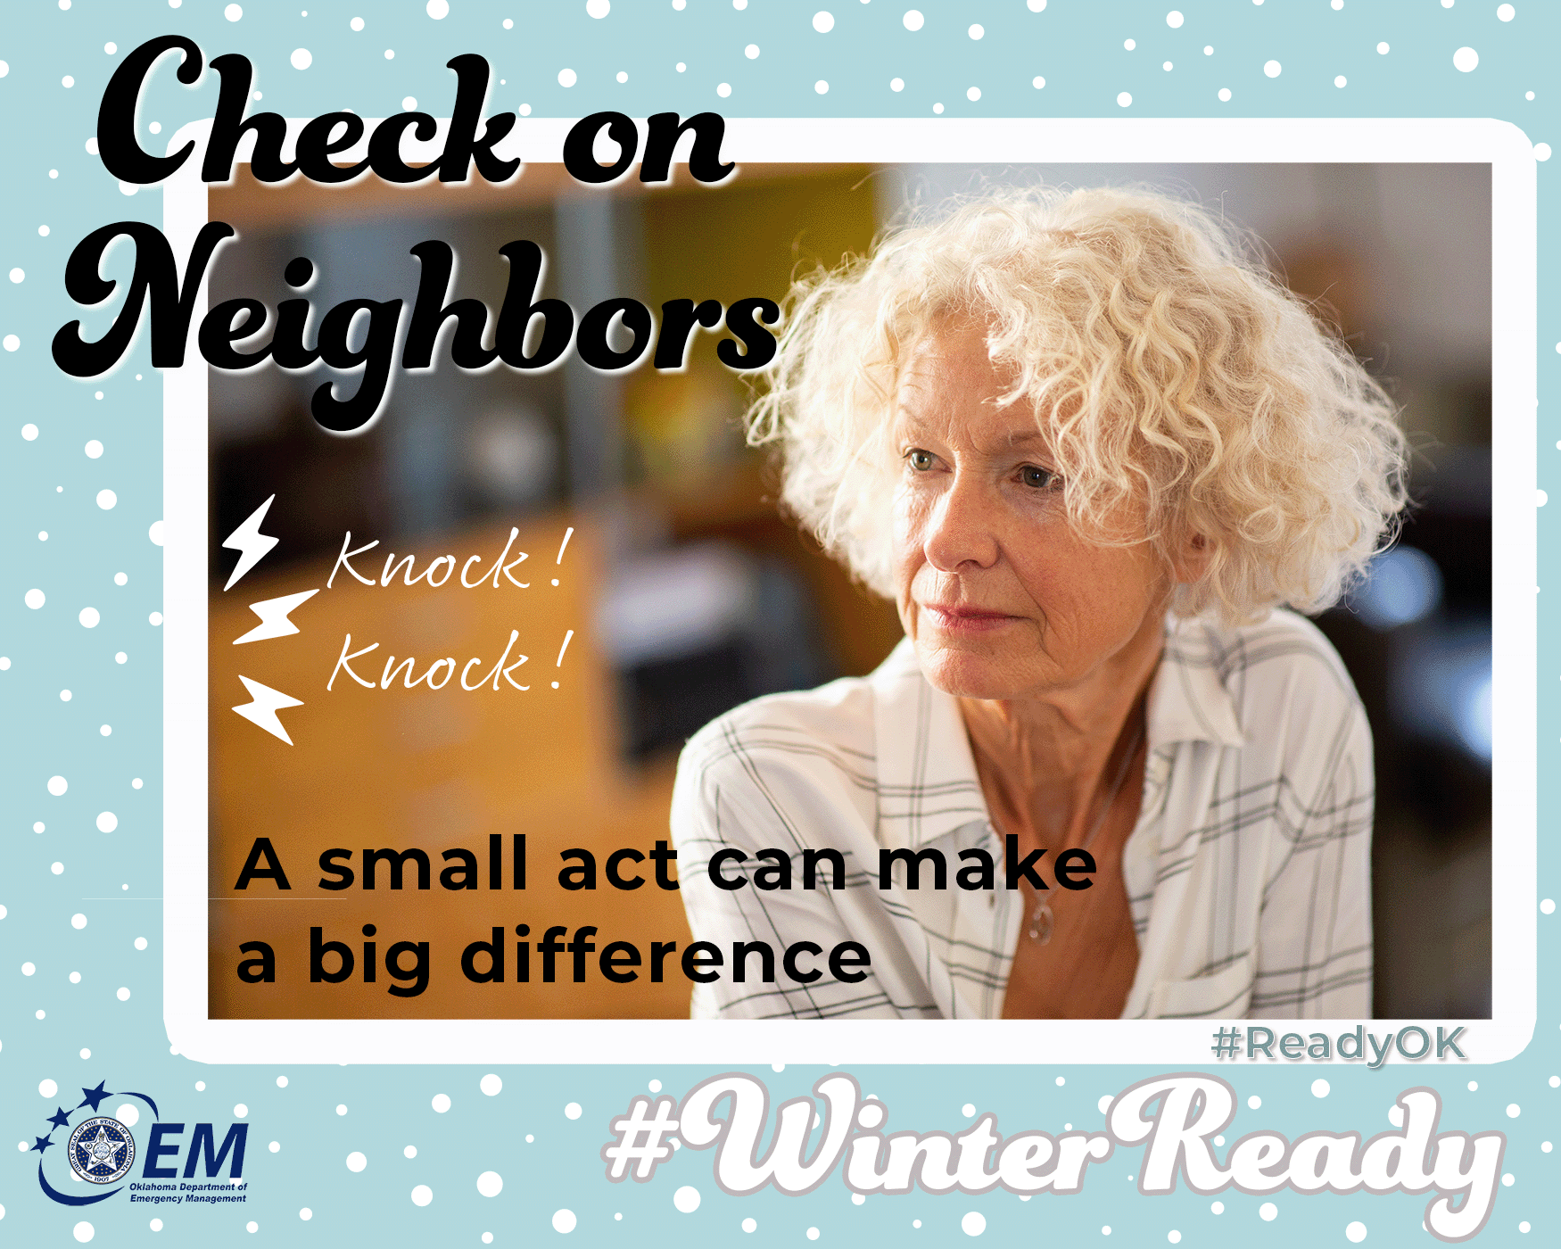
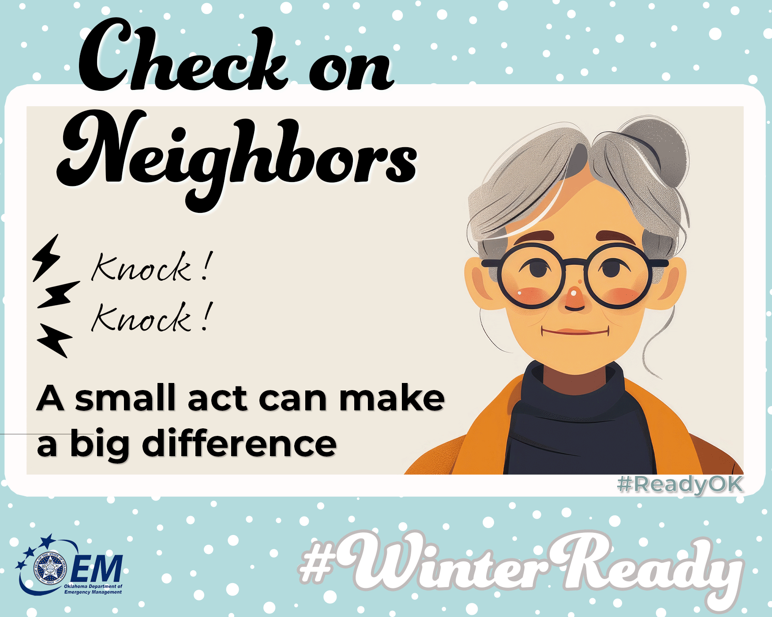

Check on Neighbors
A quick call or visit can make all the difference. Community care keeps us all warm! A small act can make a big difference:
👵 Check on older adults. Call daily during extreme cold.
🏠 Ensure everyone has heat
🐾 Look out for pets outdoors
🤝 Offer help where you can. Connect with local senior services for backup.
Hypothermia symptoms & treatment (elderly are at higher risk):
Signs: Cold skin (even under clothes), puffy face, slow speech, no shivering.
Act fast: Warm room slowly, use blankets (no direct heat), give warm drinks if alert, call 911—seniors lose heat fast.
Winter is safer — and warmer — when we look out for each other. ❤️
For more information on preparing for winter, go to https://oklahoma.gov/oem/readyok/be-aware/winter-weather.html.
#WinterReady #ReadyOK #CommunityPreparedness #OklahomaStrong

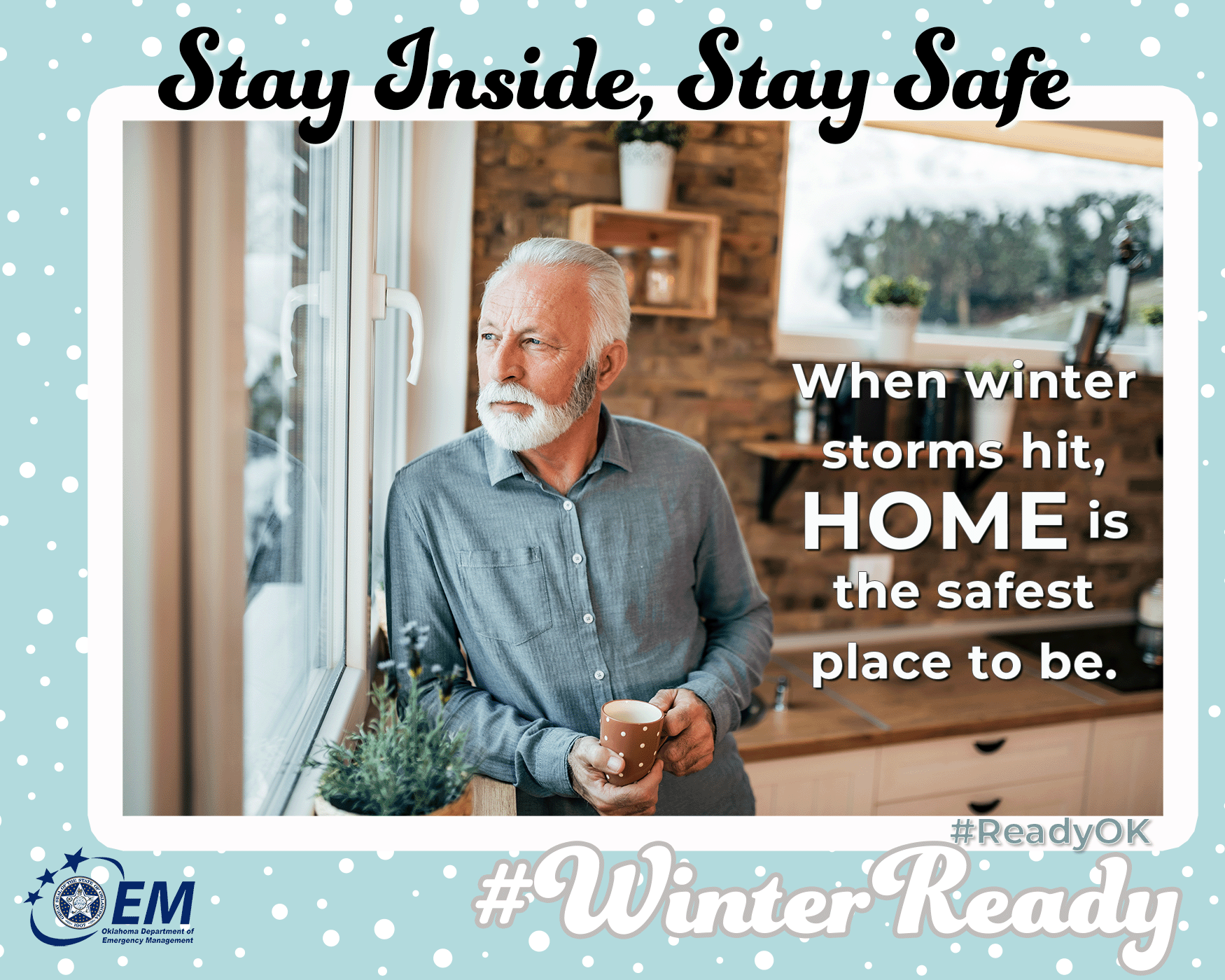
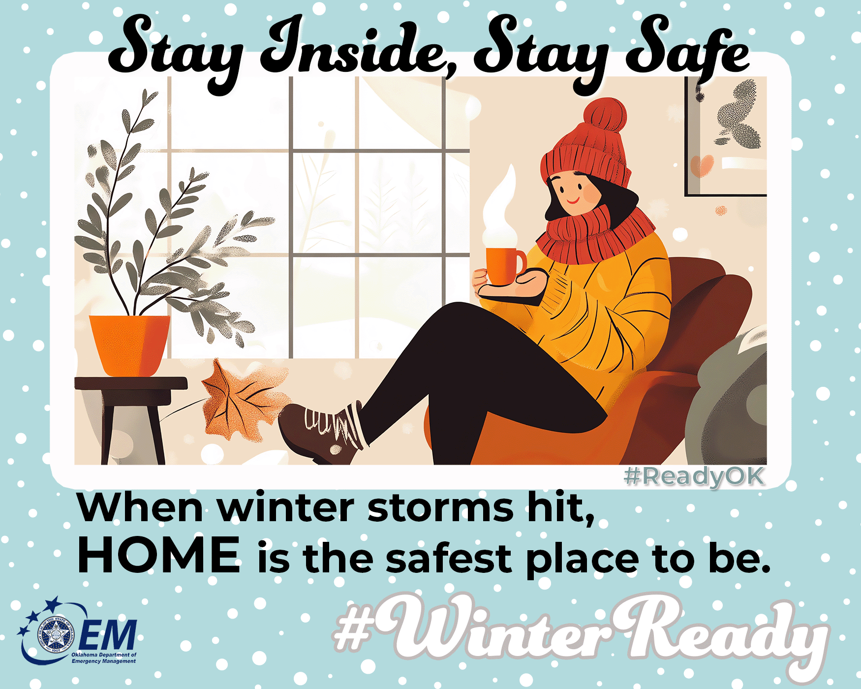
❄️ “Stay Inside, Stay Safe”
Baby, it’s FREEZING outside! 🥶
When winter storms hit, HOME is the safest place to be. ✅
🍿 Binge those shows
🥤 Sip something warm
📚 Catch up on reading
🐕 Bring in the pets
🏠 Most importantly — stay off icy roads
Emergency crews are out doing the hard work — let’s not make their job harder.
Keep the slippers on and the keys on the hook. 🧦🚫🛻
For more information on preparing for winter, go to https://oklahoma.gov/oem/readyok/be-aware/winter-weather.html.
#WinterReady #ReadyOK #SnowDayRules #EmergencyPreparedness
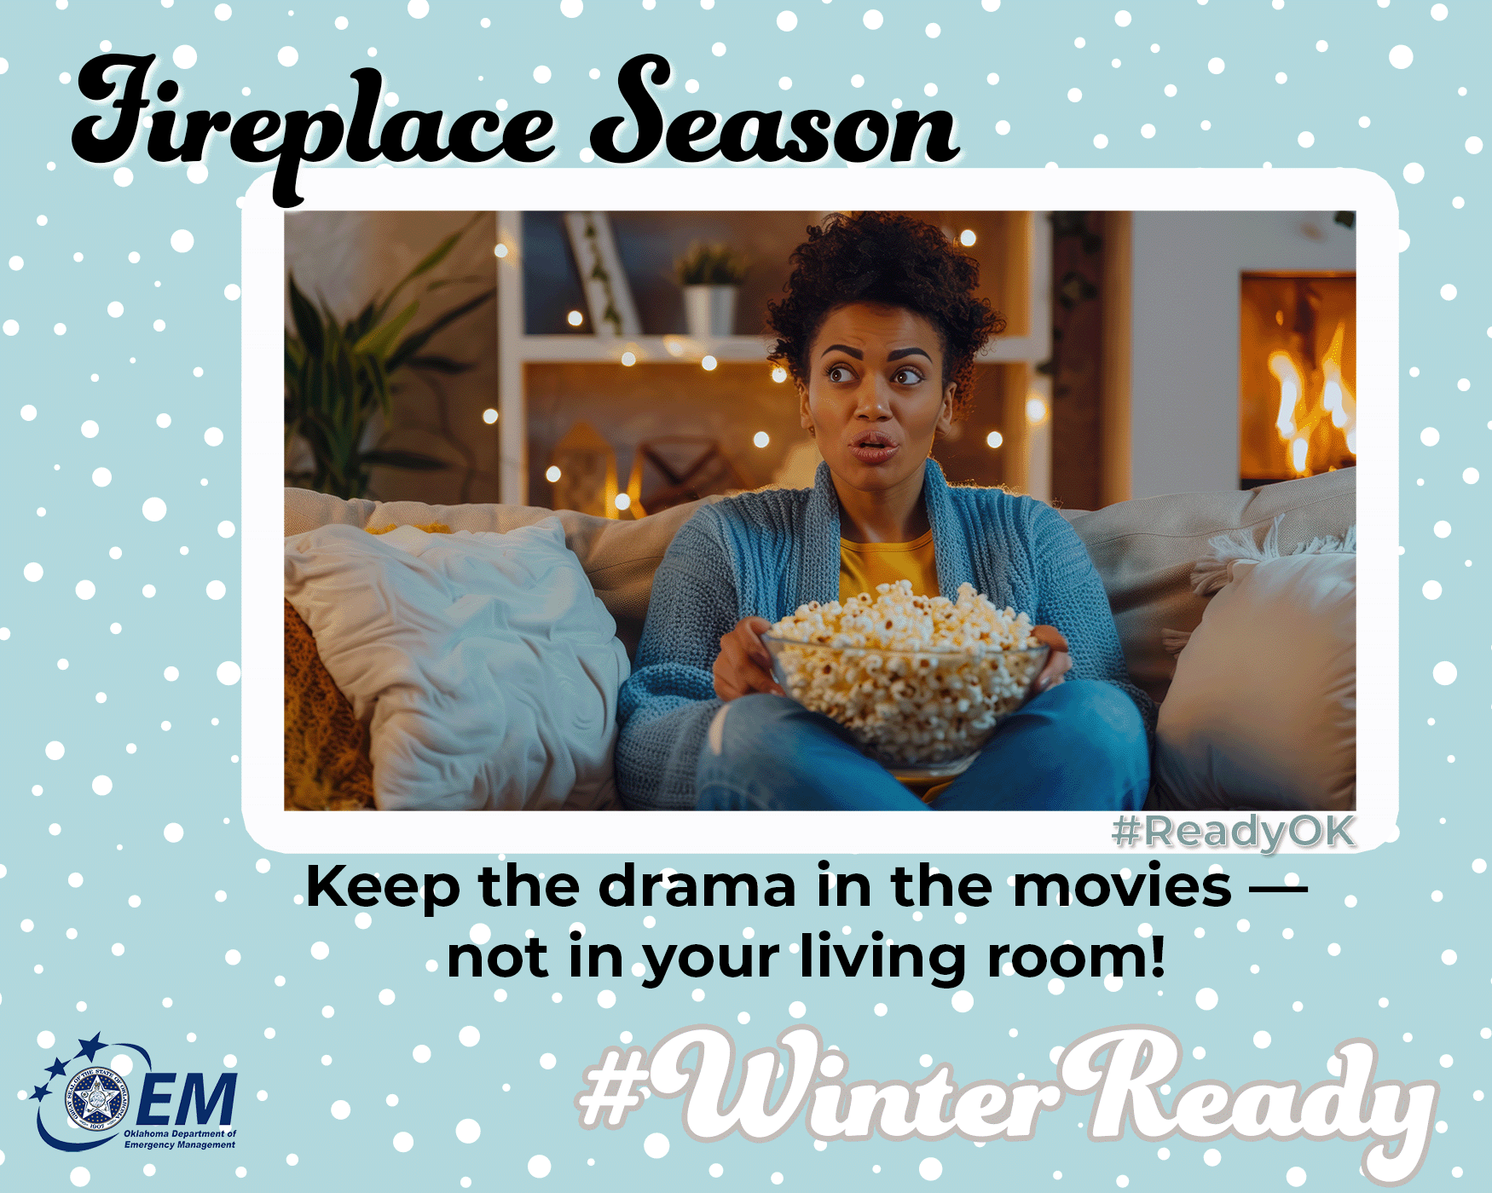
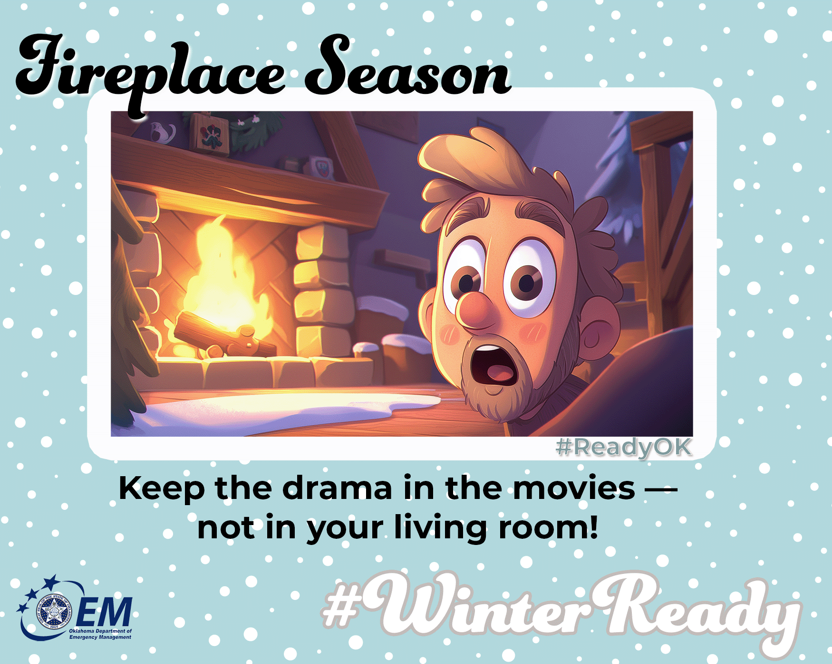

🔥 Fireplace Season = Safety Season
Nothing says winter like a cozy fire… 🔥
But let’s keep the drama in the movies — not in your living room!
🧱 Open that chimney flue (smoke is a vibe… but not indoors)
🛋️ Keep furniture and holiday decorations far, far away from sparks
🪵 Only burn dry wood (no, wrapping paper isn’t fuel 😅)
🔥 Never leave fires unattended — even if s’mores are calling
Be warm. Be cozy. Be smart.
Your fireplace should glow, not cause a three-alarm 🚨.
For more information on preparing for winter, go to https://oklahoma.gov/oem/readyok/be-aware/winter-weather.html.
#WinterReady #ReadyOK #FireplaceSafety #CozyAndCareful

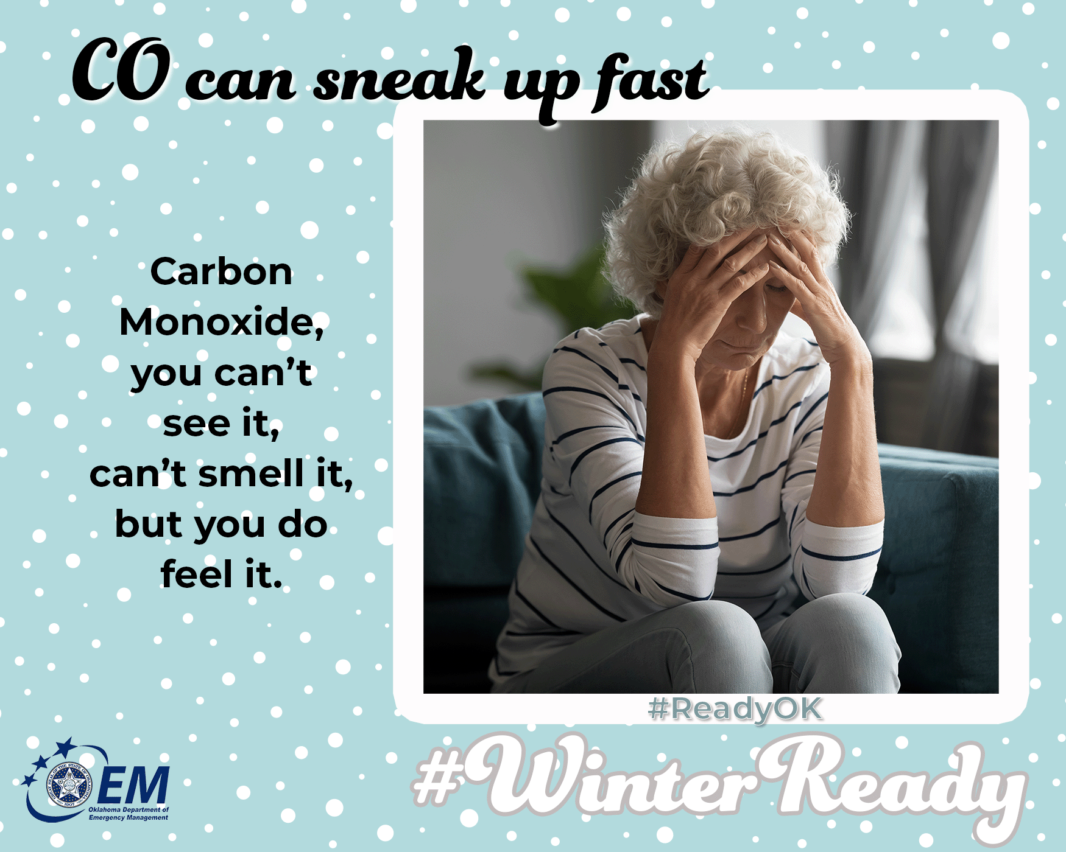
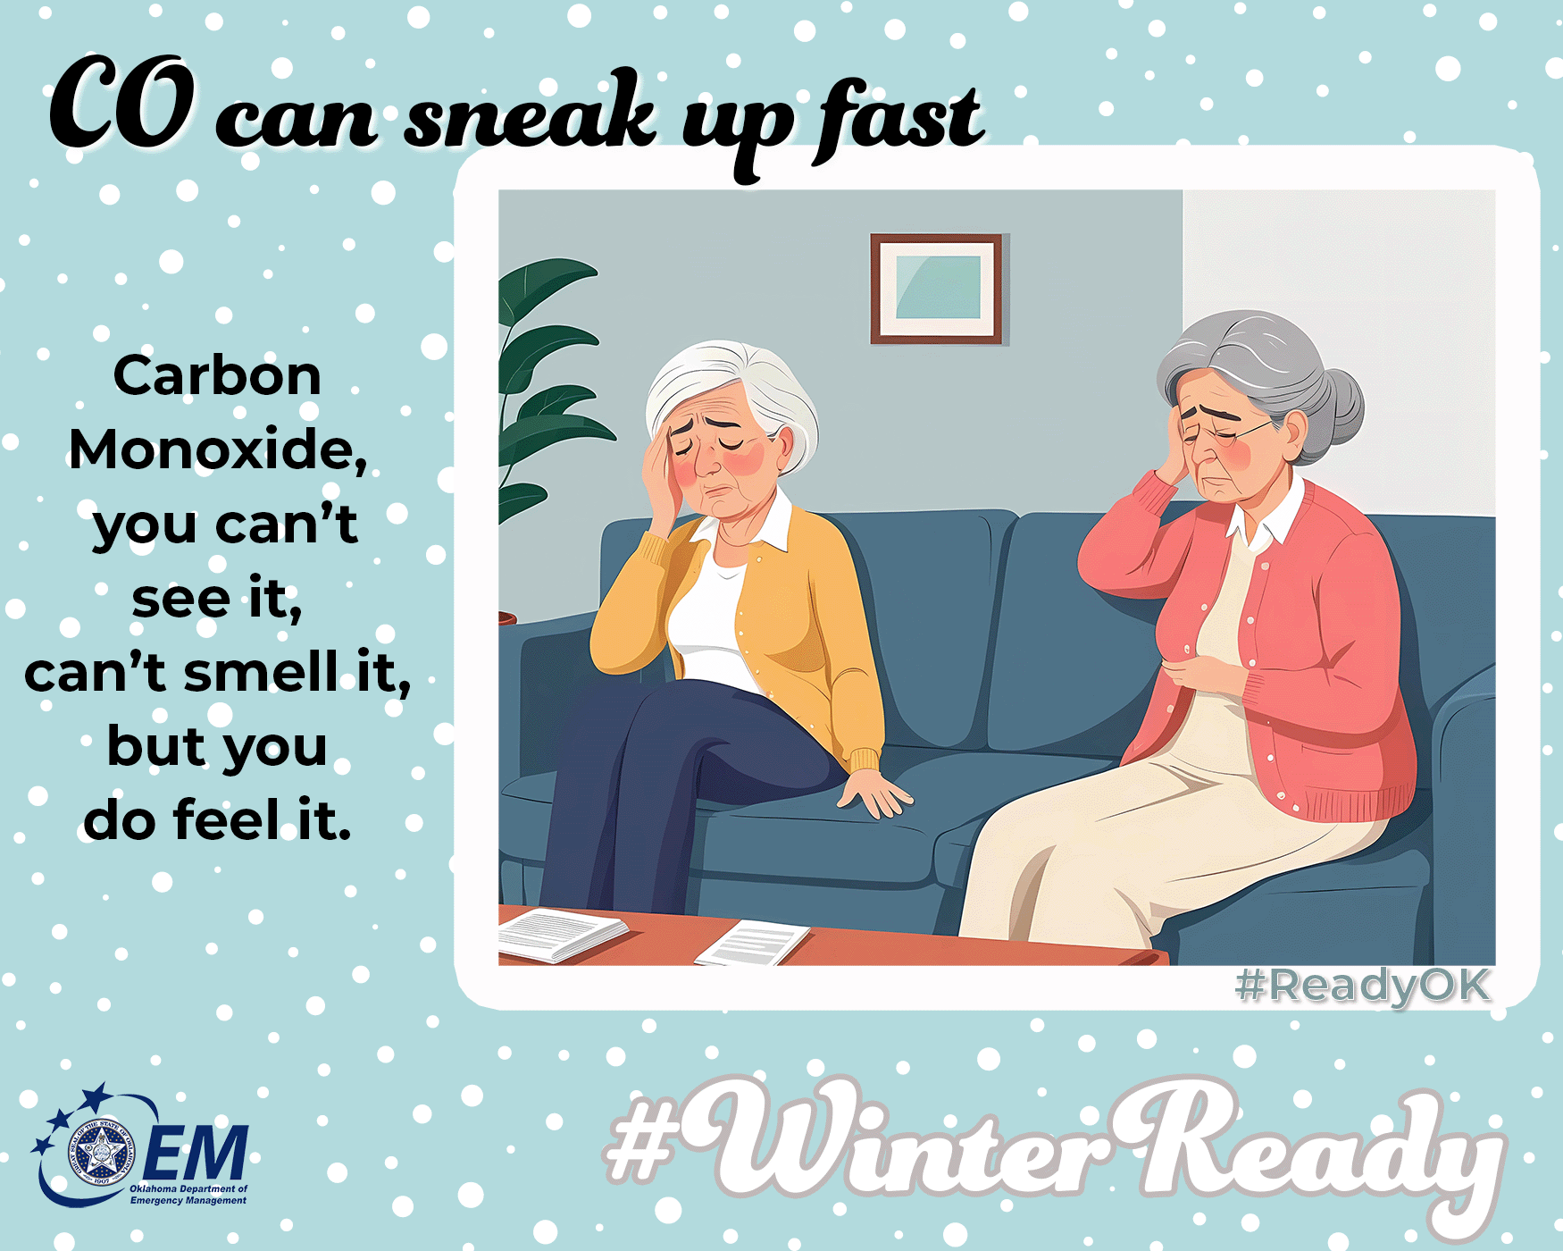
☠️ The Invisible Danger You Can’t Smell or See
You can’t smell it. You can’t see it. But carbon monoxide (CO) can sneak up fast — and it’s no joke!
🔥 When using heaters, fireplaces, or generators:
💨 Keep generators vented — never run them indoors or in garages
🛏️ Install CO alarms near bedrooms
✅ Check batteries twice a year
🚨 If your alarm beeps — get out and call 911
Stay warm, not woozy.
Let’s keep cozy nights safe and sound! 🏠❤️
For more information on preparing for winter, go to https://oklahoma.gov/oem/readyok/be-aware/winter-weather.html.
#WinterReady #ReadyOK #CarbonMonoxideSafety #SilentKiller

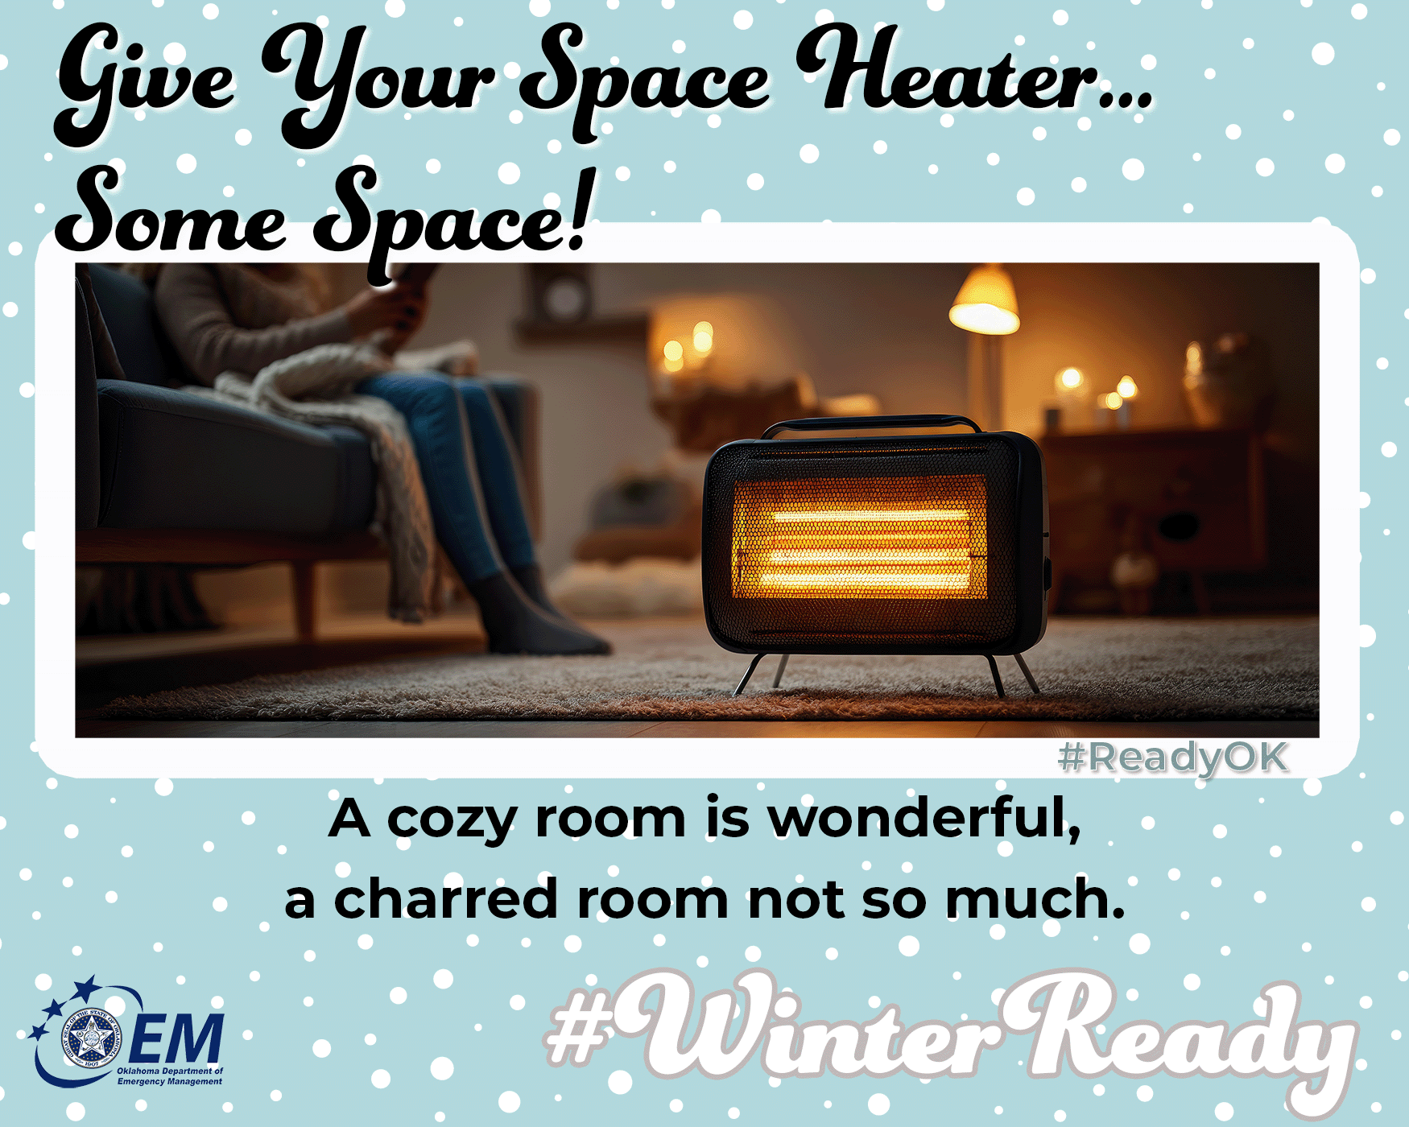
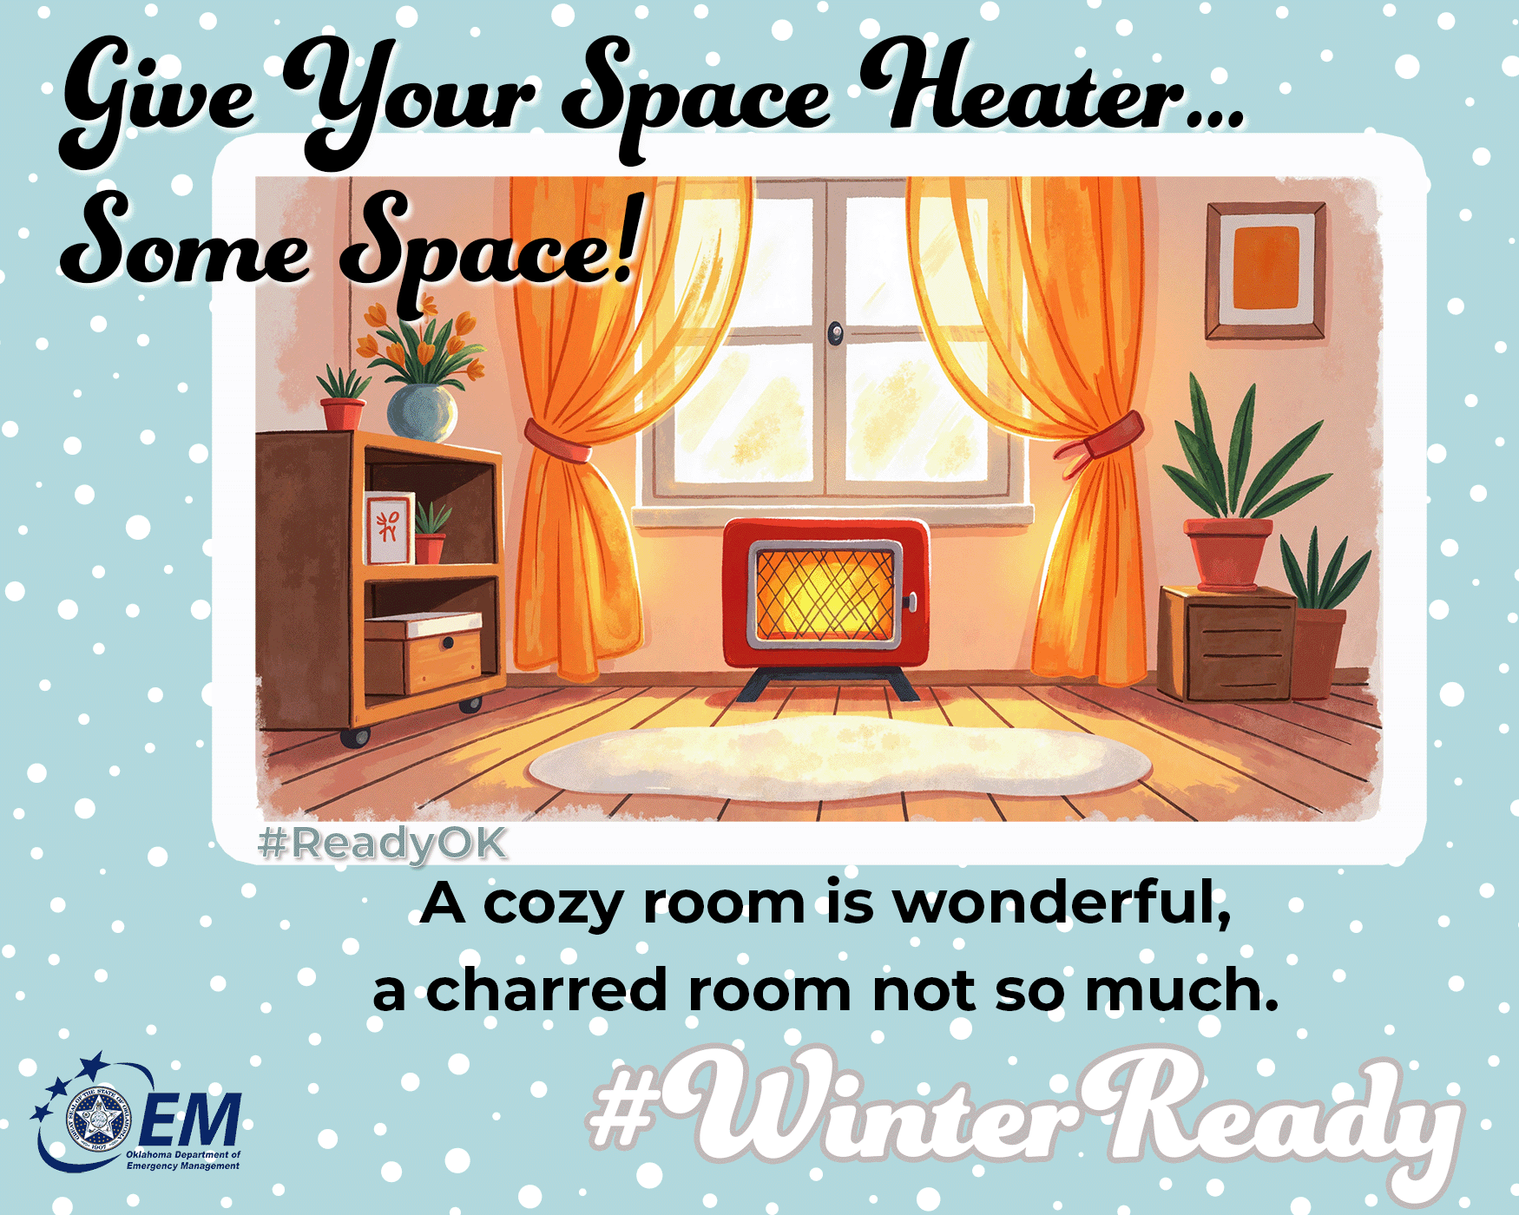

🔌🔥 Give Your Space Heater… Some Space!
Space heaters are great — until they get too cozy. 😬
Let’s avoid accidental bonfires, shall we?
🚫 Keep 3 feet of “no-touchy” zone around it especially if you have little or furry ones
🛏️ No blankets, curtains, or pets snuggling up
🔌 Plug directly into the wall — no extension cords
😴 Turn it off before bedtime (even if heating your bedroom).
A warm room is wonderful.
A toasty living room rug? Not so much. 🔥🚫
For more information on preparing for winter, go to https://oklahoma.gov/oem/readyok/be-aware/winter-weather.html.
#WinterReady #ReadyOK #SpaceHeaterSafety #KeepYourDistance
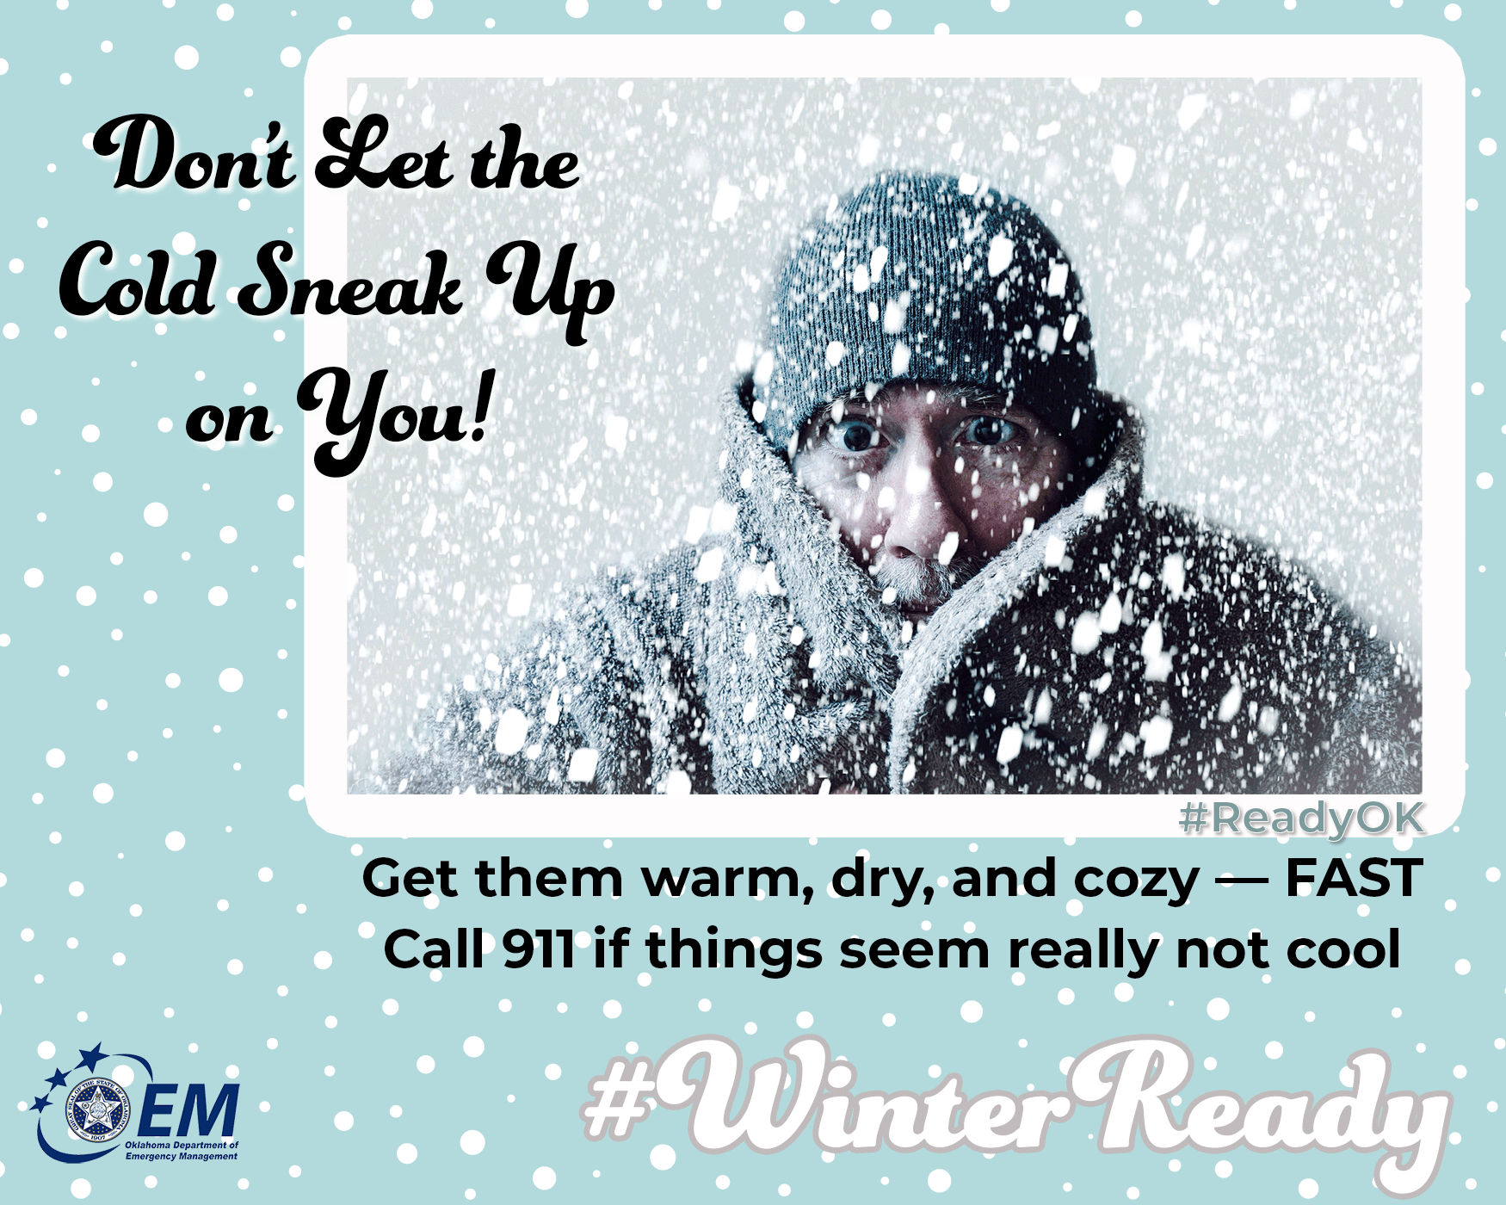
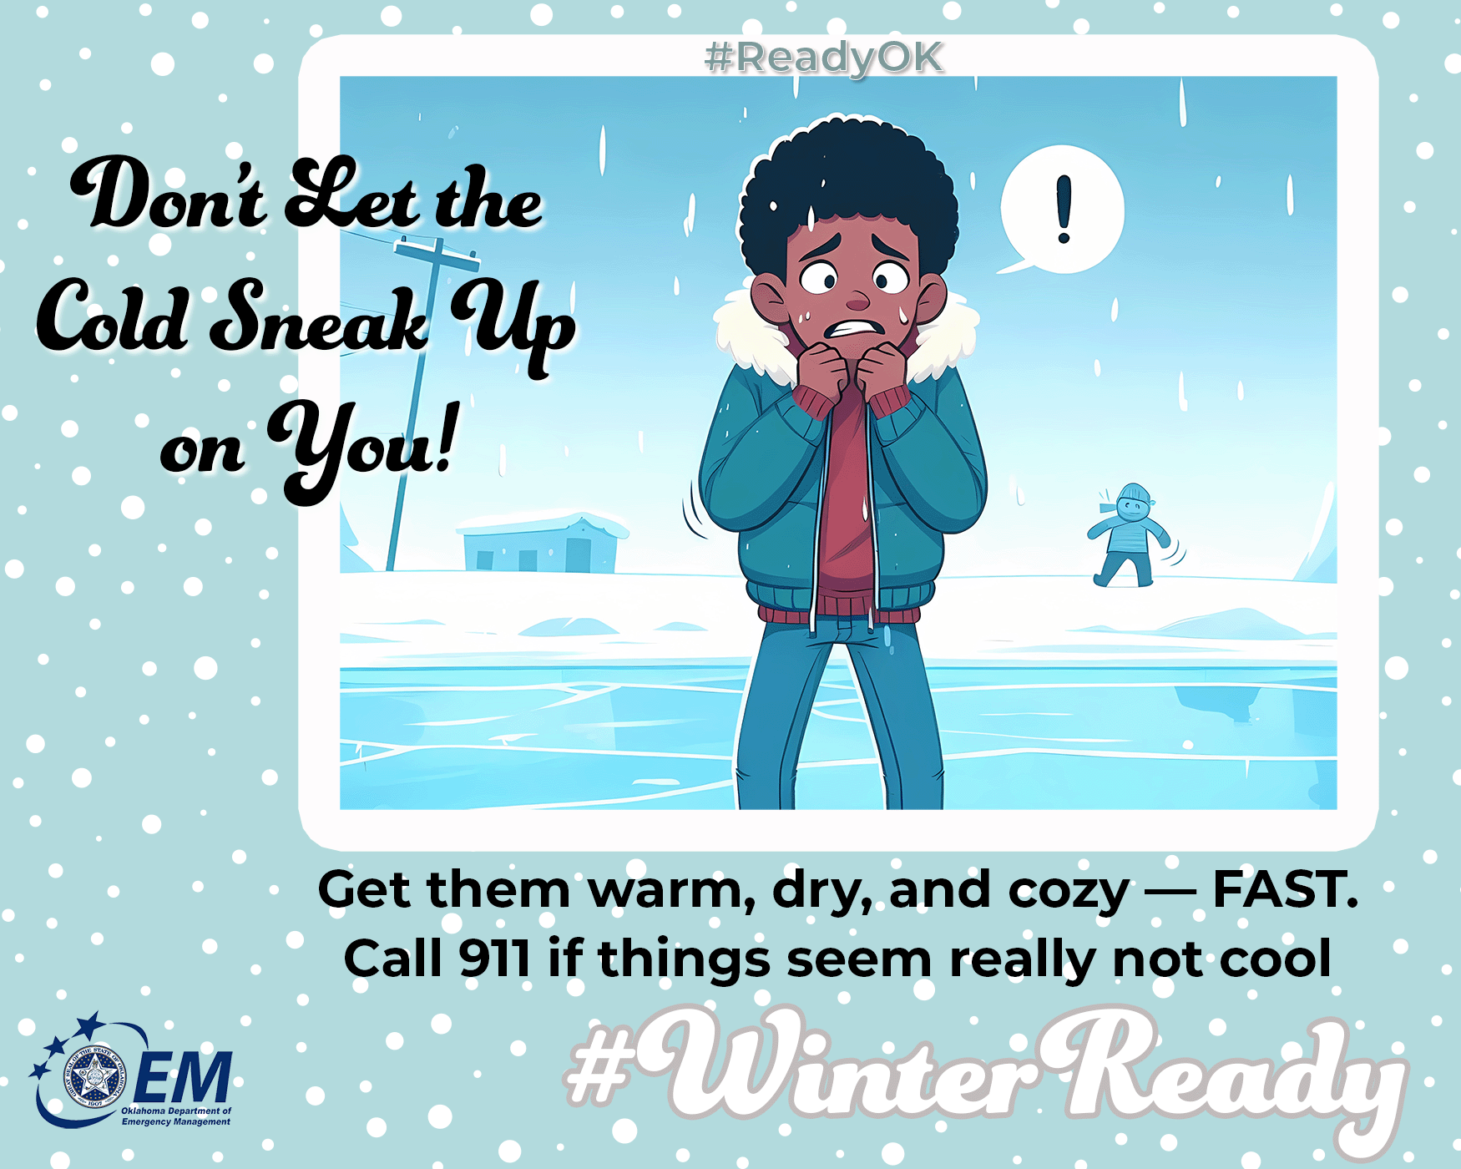

❄️🥶 BRRR! Don’t Let the Cold Sneak Up on You!
As temperatures drop, it’s important to recognize the signs of hypothermia — a dangerous drop in body temperature. It doesn’t take hours outdoors… it can happen in minutes in extreme cold.
✅ Watch for these warning signs:
🌀 Uncontrollable shivering
🗣️ Confusion or slurred speech
🚶🏿Clumsiness or stumbling
😴 Drowsiness or low energy
🥶Pale or cold skin
🚑 If you suspect hypothermia:
👉 Get them warm, dry, and cozy — FAST
👉 Wrap in blankets or warm layers
👉 Warm drinks if they’re awake and alert
👉 Call 911 if things seem really not cool
💙 Let’s look out for one another — check on neighbors, especially older adults and those without reliable heating. Together, we can keep our community safe and warm this winter!
For more information on preparing for winter, go to https://oklahoma.gov/oem/readyok/be-aware/winter-weather.html.
#WinterReady #ReadyOK #HypothermiaAwareness
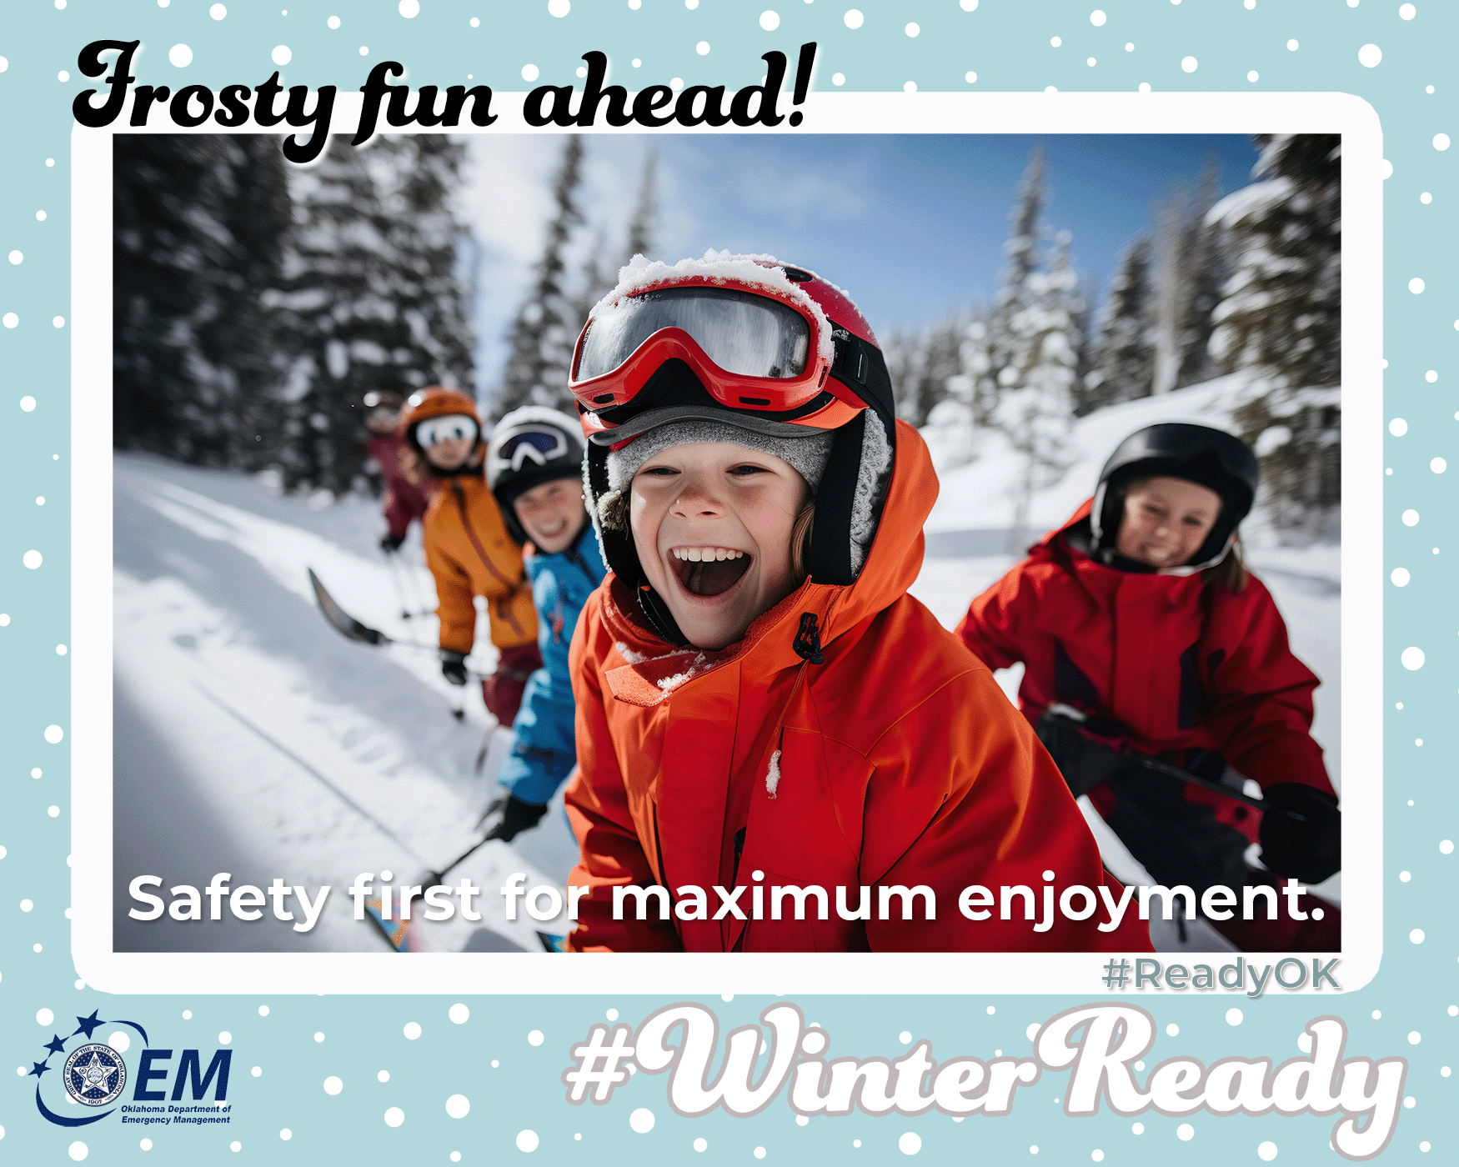
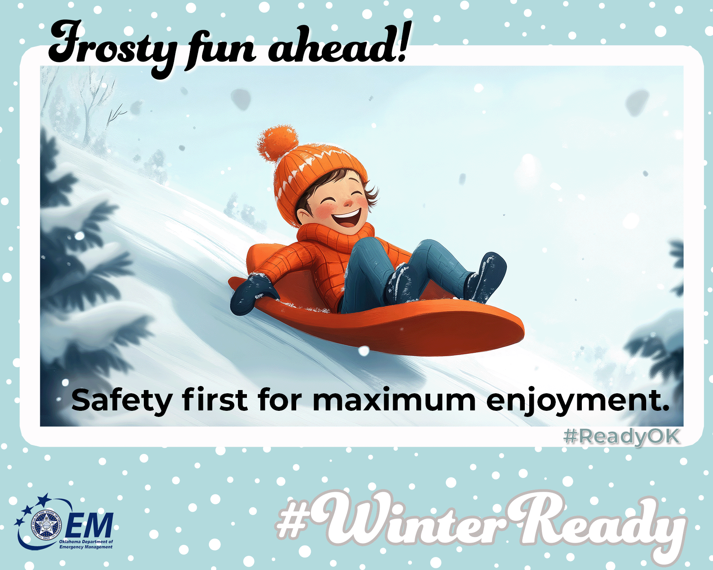

Frosty fun ahead! ⛄ But if you're heading outdoors to play or sled … Safety first!
Dress in bright colors for visibility, wear a helmet, and know your limits. Safety first for maximum enjoyment!
How to play safely:
🥽 Helmet + goggles for all snow sports.
🦺 Bright/reflective clothing if near roads.
🎿 Sled in open areas, feet-first, away from trees/roads.
❄️ Take breaks to warm up—frostbite starts fast.
⌚ Tell someone your plans + expected return time.
Hypothermia symptoms and treatment:
- Signs: Shivering, numbness, clumsiness, poor judgment.
- Act fast: Head indoors, remove wet gear, warm with dry layers, drink warm fluids, monitor—stop activity at first signs.
For more information on preparing for winter, go to https://oklahoma.gov/oem/readyok/be-aware/winter-weather.html.
#WinterReady #ReadyOK #OutdoorFun #WinterAdventures
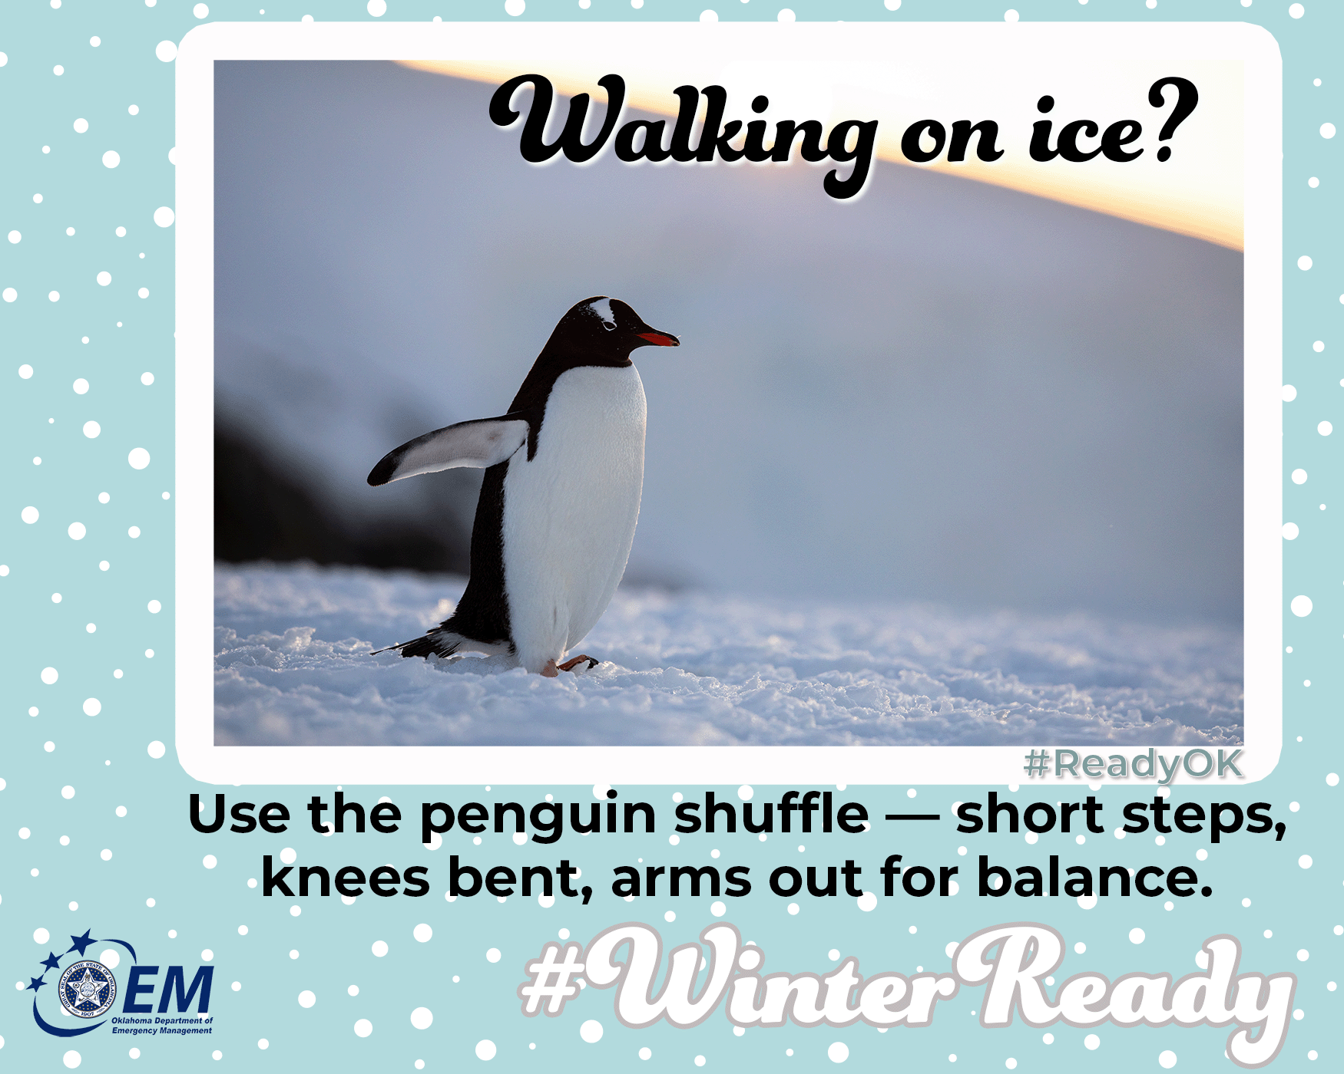
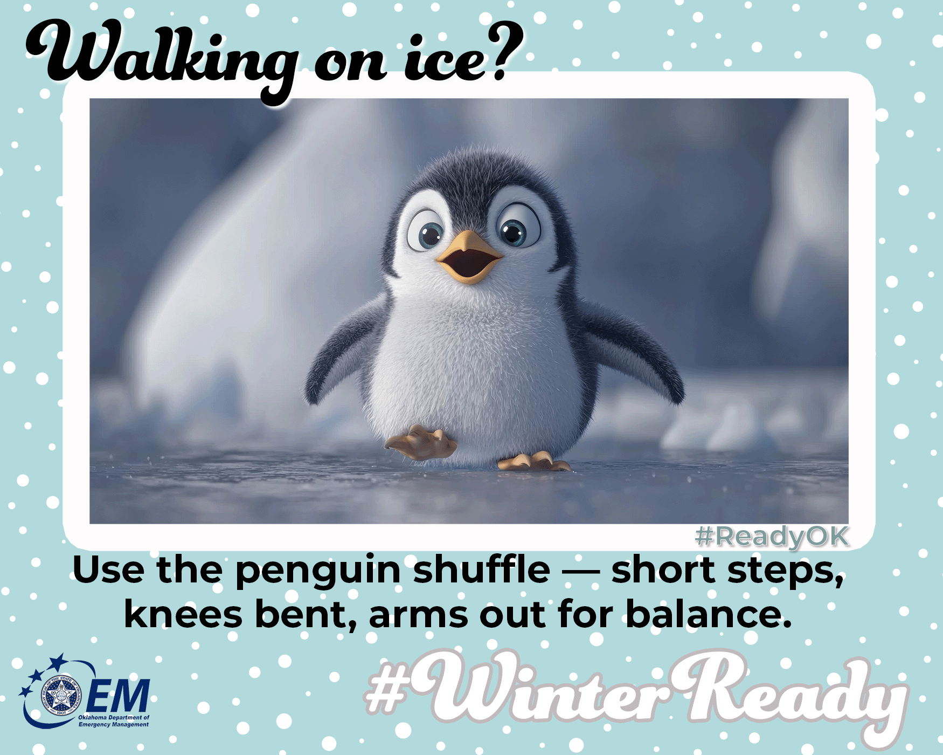

Walking on ice? Take it easy!
🧊 Use the penguin shuffle—short steps, knees bent, arms out for balance. And wear shoes with good traction. Stay upright and enjoy the winter wonderland!
How to walk safely:
- Wear ice cleats or waffle boots.
- Walk on snow/grass if possible—better traction.
- Keep hands out of pockets for balance.
- Use railings on stairs; go slow.
- If you fall, try to relax and protect your head.
Hypothermia symptoms and treatment:
- Signs: Shivering, pale skin, confusion, slow reactions.
- Act fast: Get indoors immediately, remove wet clothes, warm core first (torso), sip warm drinks, avoid alcohol—call for help if needed.
For more information on preparing for winter, go to https://oklahoma.gov/oem/readyok/be-aware/winter-weather.html.
#WinterReady #ReadyOK #IceSafety #WinterTips
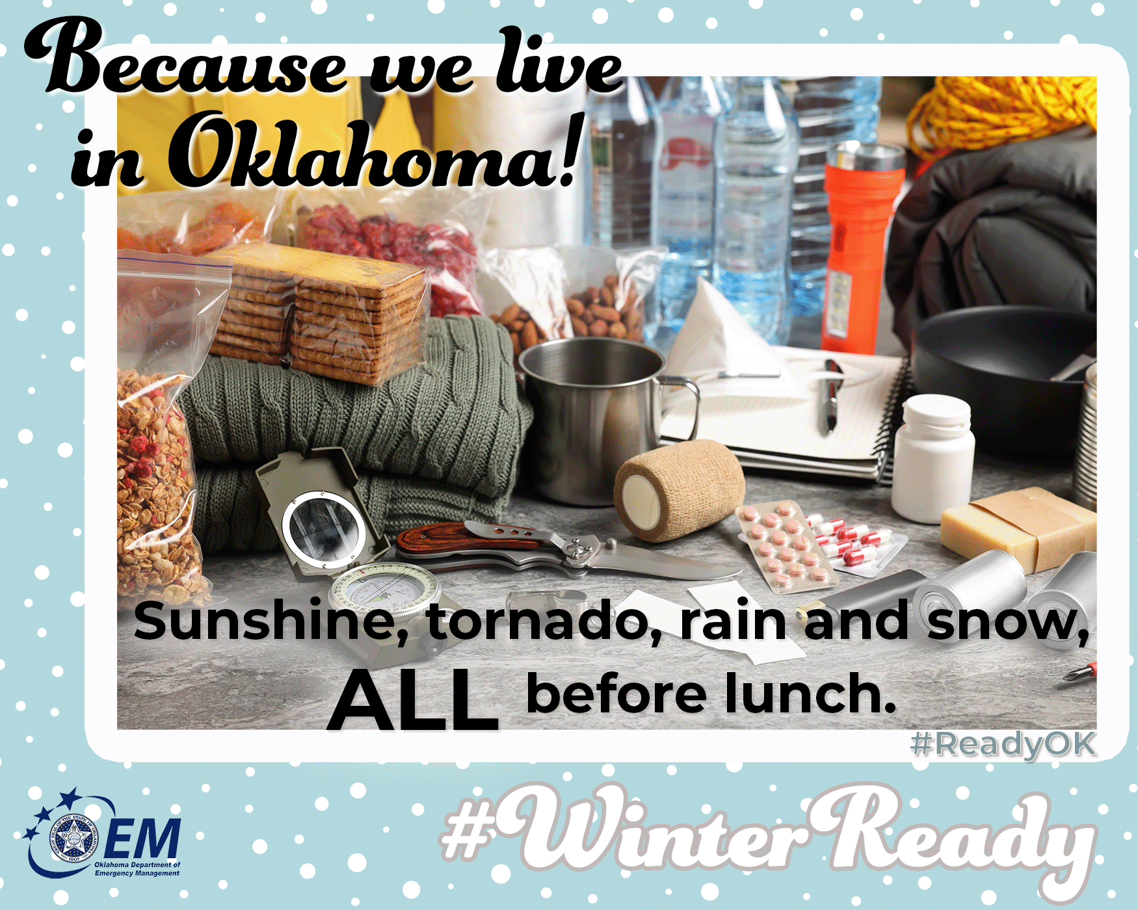
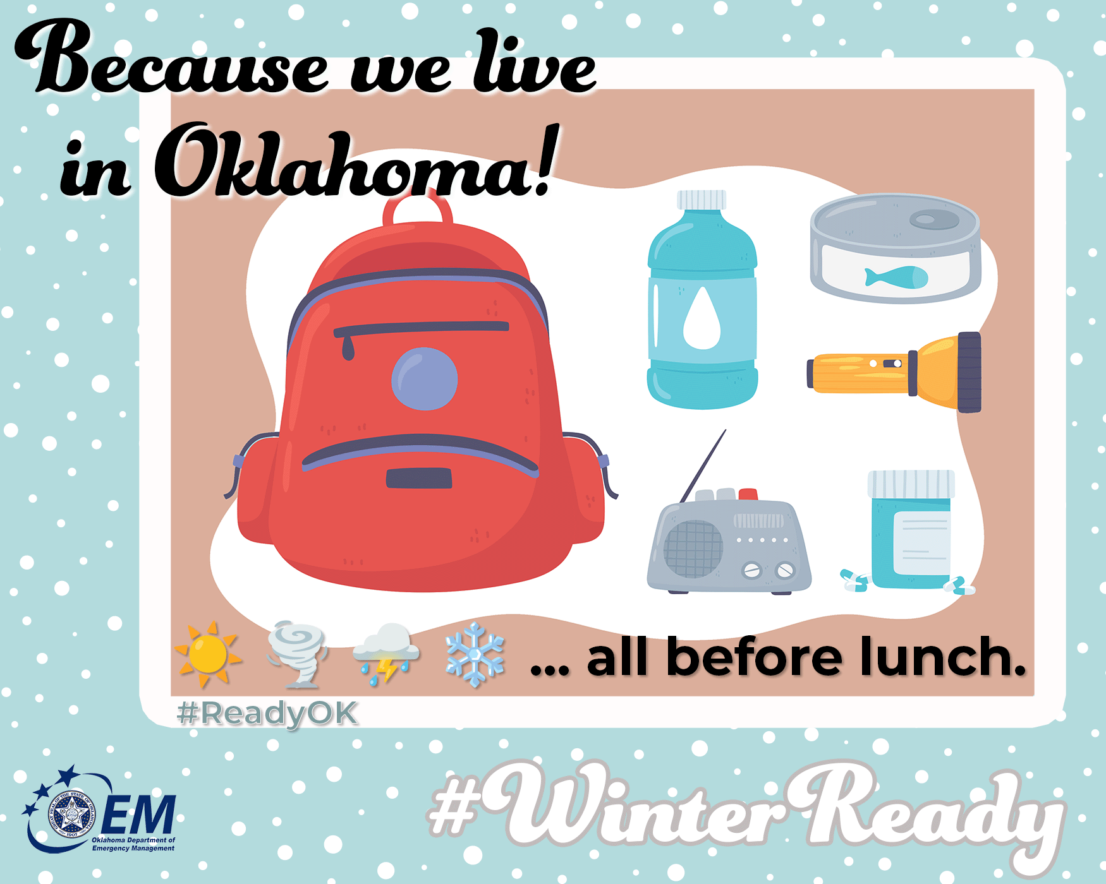

🌪️❄️ Oklahoma Weather Plot Twist Kit
Here in Oklahoma, we know the weather can do:
☀️→🌪️→⛈️→❄️ … all before lunch.
So let’s be ready for whatever surprise the sky brings us!
Build your OK Home Emergency Kit with:
💧 Water (1 gallon per person/day — because iced tea doesn’t count 😜)
🥫 Shelf stable food in case it’s a long winter.
🔦 Flashlights + batteries (storms love stealing electricity)
📻 NOAA Weather Radio for when we have thunder snow!
🧥 Blankets and warm layers for those “freeze warnings… in April?!” moments
🔌 Backup power bank for phones (how else will we check radar?)
🩹 First-aid kit for every “well that wasn’t smart” incident
Extra OK-ready add-ons:
🐾 Pet supplies for your furry storm buddy
👓 Spare glasses (wind + glasses = oof)
🗂️ Important papers in a grab-and-go folder
🎧 Headphones for when the tornado sirens test your nerves 😅
Let’s give unpredictable weather the side-eye 😎
Prepared Oklahomans = Resilient Oklahomans!
For more information on preparing for winter, go to https://oklahoma.gov/oem/readyok/be-aware/winter-weather.html.
#WinterReady #ReadyOK #EmergencyKit #PrepLikeAPro

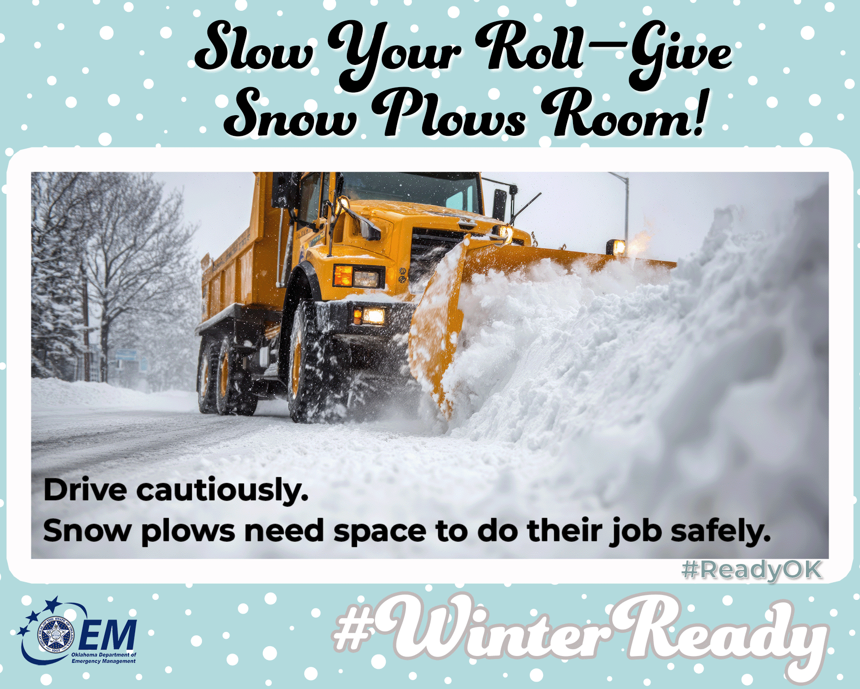
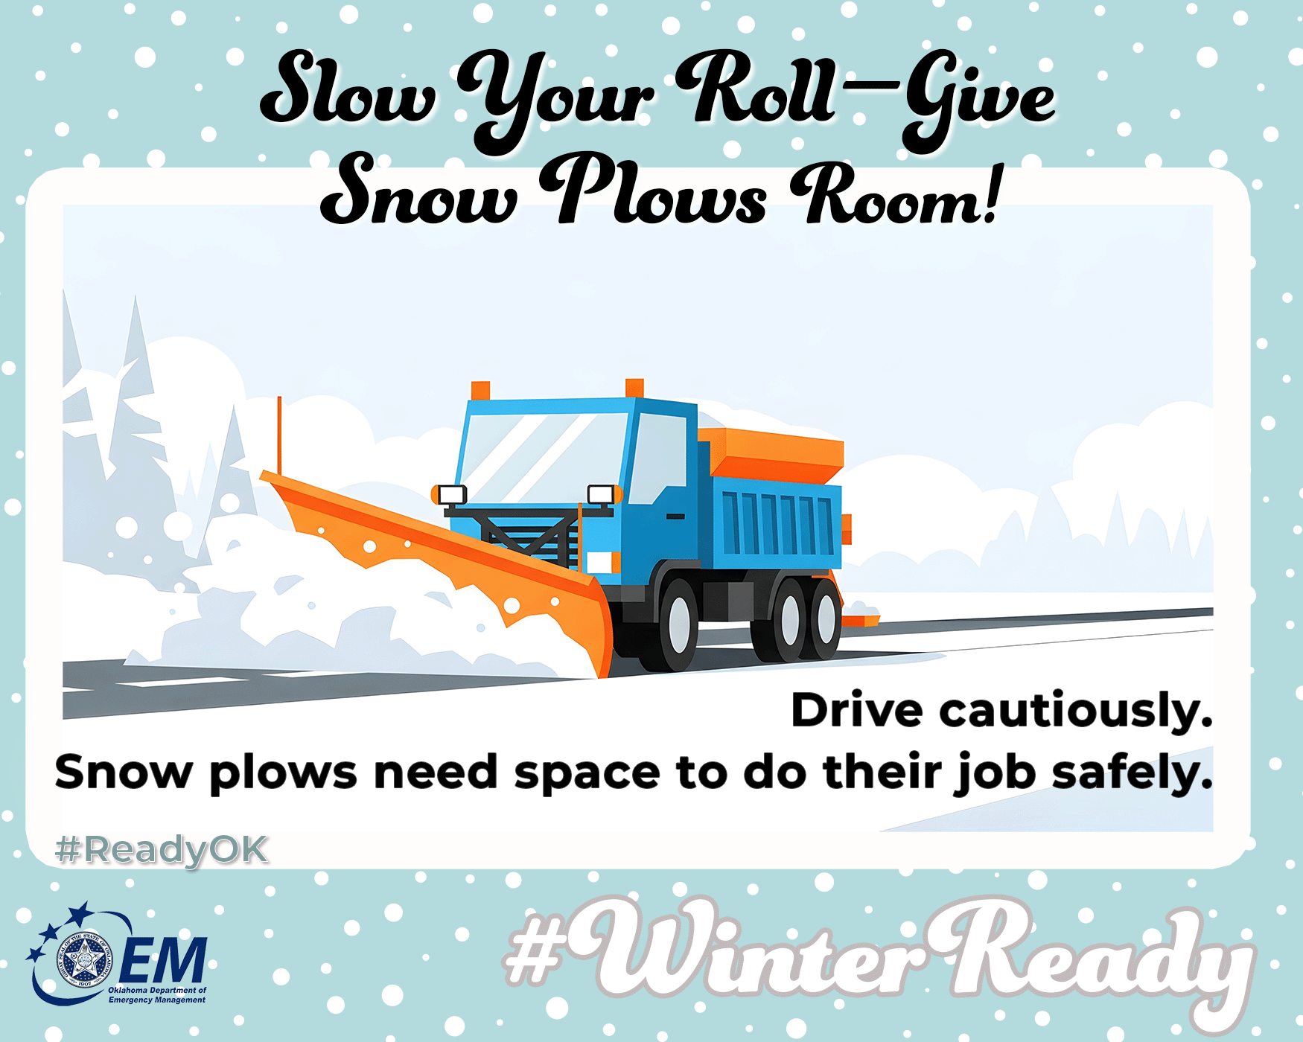

🚘❄️ Winter Driving Safety: Give Snow Plows Room to Work
When winter weather hits, road crews work long hours to keep Oklahoma’s highways and streets safe. Please do your part by driving with extra caution and giving snow plows the space they need to do their job safely.
Safety reminders:
- 👀Stay back at least 200 feet from snow plows and sanding trucks.
- 🚫Never pass a snow plow on the right. Plows push snow and ice in that direction.
- 🚘Slow down — even treated roads can still be slick and hazardous.
- 🐢Keep headlights on and avoid sudden stops or lane changes.
- 🚗Be patient. Plows often travel at slower speeds for a reason — safety.
Your patience and awareness help protect both you and our road crews.
Together, we can make sure everyone arrives safely this winter.
Cold Snap: A Snapshot of Winter Safety. For more information on preparing for winter, go to https://oklahoma.gov/oem/readyok/be-aware/winter-weather.html.
#WinterReady #ReadyOK #DontCrowdThePlow

