Oklahoma School for the Blind
Oklahoma School for the Blind
3300 Gibson Street
Muskogee, Oklahoma 74403
Phone: (918) 781-8200
Toll-free in OK: (877) 229-7136
Website: http://osb.k12.ok.us

Information for Parents

Oklahoma School for the Blind (OSB) is a vital part of educational opportunities available for blind and visually impaired students in Oklahoma. The following information on OSB programs is provided to help parents make informed decisions about the education of their children with visual impairments.

OSB was established by the state Legislature to provide specialized and intensive services that focus on the unique learning needs of students with visual disabilities.

The school is located in Muskogee, Oklahoma. It serves both residential and day students in pre-K through high school grades. Residential students live on campus in dormitory suites with house parents on site 24 hours a day.

Students attend classes Monday-Thursday. OSB transports residential students to and from their home communities for weekends and holidays.

OSB recognizes and addresses the educational needs and interests of each student. Every student receives instruction and guidance from staff who are specially trained to work with children and young people who have visual impairments.

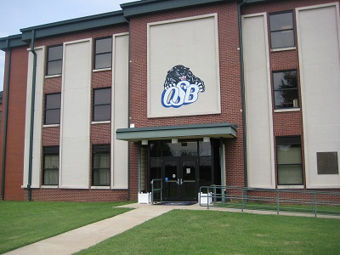

The school also partners with public schools, providing consultation for the development of effective educational programs for visually impaired students in their home districts.

OSB offers:
- Instructional methods, materials and technology specialized for visually impaired students of all ages.

- Intensive instruction in both academics and blindness skills.

- Teachers trained and certified in education of the visually impaired.

- Small class size – individual attention to each child.

- A wide range of extracurricular opportunities.

- Social and cultural activities, competitions, chances to interact with students at other schools.

- Sports, recreation and physical education options.

- Instruction in independent living skills for home, school and future life.

- Training in assistive technology skills for school and work.

- Vocational training options.

- Work experience for older students.

- A safe, supervised environment.

- On-campus health services and social services to assist students.

PROGRAMS and SERVICES

OSB provides specialized and intensive educational programming that is individualized and designed to teach students the many skills they will need to succeed in school and post-secondary life.
- OSB offers a comprehensive curriculum of reading, language arts, mathematics, social studies, science, physical education, music and computer science for residential and day students.
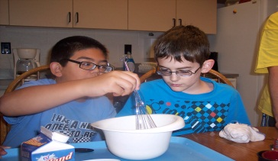
- Specialized instruction includes braille, orientation and mobility, optimum use of low vision, adaptive equipment and technology, and tactile graphic skills.

- In addition, students may receive assessment, counseling, physical therapy, speech and language therapy, hearing tests and health care services.

- The secondary school program includes college preparation, vocational training and a work-study program.

- Social and recreational activities include student organizations, interscholastic athletics, field trips, cultural events and community projects.

- Teaching materials and instructional styles are adapted to meet the needs of each student. Independent living skills are taught to enable each student to attain maximum independence and strengthen social skills and self-esteem.

Academic programs.
- OSB is fully accredited and teaches state-mandated education requirements.
- North Central Accreditation.

Instruction in special skills for learning and living with visual disabilities.
- Instruction in adaptive communication skills, including, when needed, Braille reading and writing, use of large print and magnified instructional materials, use of tactile learning tools such as tactile maps and science diagrams, use of audio media, computer technologies and many other assistive technology devices and methods for access to information.
- Orientation and mobility instruction, including white cane travel if needed. O & M training helps students navigate safely around their school and home environments, and is essential for safe travel in the larger community.
- Independent living skills. Students learn special skills, techniques and technologies that improve their ability to function independently at home, school and in the community. Students with vision loss learn adaptive skills for personal hygiene and grooming, selecting and caring for clothes, keeping bedrooms and play areas in order, eating and table etiquette, sewing, cooking, managing money, using special technologies to do household and study tasks, shopping for necessities, and many other functions of daily life that others depend on sight to accomplish.
Specially trained teachers and other staff who understand vision loss and its effects on development.
- Teachers who are certified in visual impairment.
- Instructors certified to teach orientation & mobility, communication skills including Braille, math and science learning techniques for visually impaired students, assistive technology skills, daily living skills, adaptive physical education and sports, vocational skills and other adaptive techniques to help students succeed in school and beyond despite their vision loss.
- Social workers, therapists, house parents and other staff who specialize in working with students who have visual impairments and additional disabilities.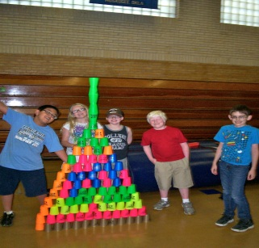
Opportunities to participate in extracurricular activities.
- OSB’s accomplished Academic Team travels across the state to compete against public schools. Students have a chance to demonstrate their academic prowess while making new friends and building self-confidence.
- Opportunity to participate in student organizations:
- Competitions and statewide organizations:
- Braille Challenge: OSB hosts the Regional Braille Challenge, a program of the Braille Institute. It is an academic competition unlike any other. This two-stage contest is designed to motivate blind students to emphasize their study of braille, while rewarding their success with a fun-filled, but challenging, day of events.
- Supervised field trips include participation in the American Quarter Horse Association’s Western Heritage Day, where students experience our state’s western culture.
- The on-campus Panthers’ Den is a snack bar and recreation center where students can participate with fellow students in a variety of supervised recreational activities including games, pool, air hockey, crafts, foosball, large screen TV and movies.
- Recreation staff provide organized activities such as trips to the local skating rink, movies, swimming, Girl Scouts, picnics and community events.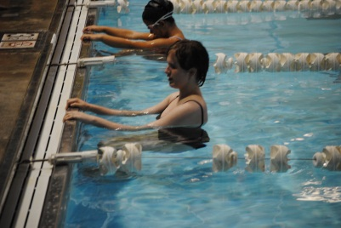
Sports and physical education.
- Adaptive physical education. All students participate in physical education adapted to meet their individual needs. Adaptive PE is addressed in development of each child’s education plan, and no child is left out.
- Swim team.
- Outdoor facilities include playgrounds, a track and a ball field.
- Planned 1K, 3 K and 5K marked courses on campus for running.
- As part of the South Central Association of Schools for the Blind (SCASB) OSB participates in yearly competitions in Wrestling and Cheerleading. This conference includes Texas, Louisiana, Mississippi, Alabama, Georgia, and Oklahoma.
- Special Olympics, including Bocce, Music and Dance.
- Bowling.
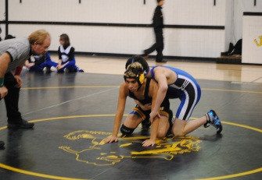
Assistive technology – providing training and tools to access the world.
- Assessment to determine the student’s assistive and mainstream technology needs.
- A range of AT classes teaching fundamental to sophisticated skills.
- The school’s AT Lab helps students apply AT skills to classroom learning.
- Instruction on building block skill sets for accessing information on the computer.
- Advanced AT classes.
- Classes in keyboarding, access software such as JAWS and ZoomText, website navigation using assistive technology, word processing, use of notebooks and hand-held computer devices, reading and researching using assistive technology and much more.
- Instruction in AT skills for college studies and the workplace.
- Development of AT skills for transitioning to post-secondary life.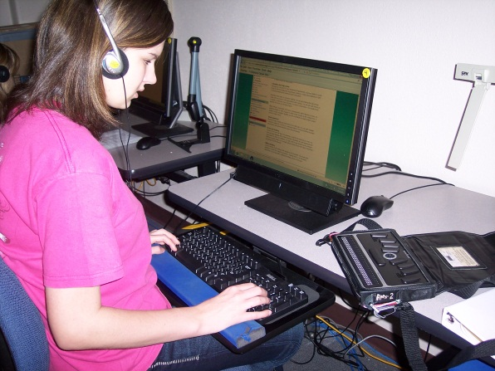 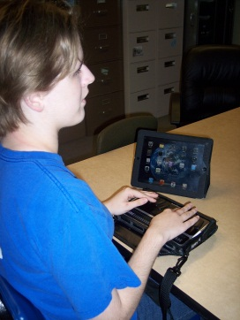
- Students can try out and learn to use a wide variety of assistive technology devices and software, to find what works best for them.
- According to Jim Fruchterman, CEO and Founder of Benetech, students attending schools for the blind are twice as likely as public school students to learn to use assistive technologies.
Summer programs,
- OSB’s summer program is open to blind and visually impaired students who attend public, private or home schools, as well as to OSB students. The month-long summer session focuses on building and reinforcing the special skills these children may need to give them full access to education and to participate in social and recreational activities with their peers. The summer program also provides assistive technology assessments, the chance to try out a variety of assistive devices, and training in the use of different technologies. 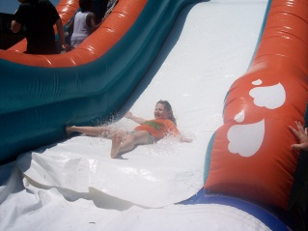
Outreach Services.
- OSB serves as a statewide resource for students with visual impairments who do not attend OSB.
- Outreach staff provides consultation, curriculum assistance, classroom modifications and assistance with technical equipment. Students receive free evaluations on academic achievement, orientation and mobility, low vision, psychological profiles and living skills. Early intervention services are provided to young students to help them prepare for school.
Student services.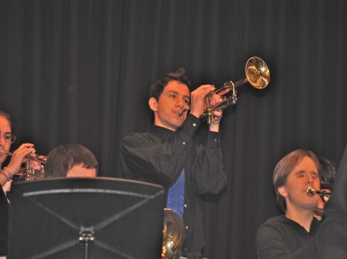
- The school health clinic.
- A licensed social worker is available to counsel with students and parents.
- Residential students are transported between home communities and OSB for weekends and holidays.
- Campus facilities include classroom buildings and dormitories with interior connecting hallways, play areas and equipment, cafeteria, snack bar and student recreation center, a library.
- The OSB Library houses books and reading material in large print, Braille, and other accessible formats.
- Administration and staff: OSB is a division of the Oklahoma Department of Rehabilitation Services (DRS), which also provides services for adult blind and visually impaired Oklahomans and administers the state’s Library for the Blind. A qualified school superintendent is responsible for OSB programs, staffing, facilities and day to day operations. School faculty includes certified teachers of the visually impaired, teachers with subject certifications, and teachers specialized in assistive technology, adaptive physical education, Braille instruction, and other subjects that address the educational needs of students with visual disabilities.
- Assuring the safety and security of all students is a top priority. The OSB campus is secured against uninvited entry. Security and fire alarm systems are in place, in addition to a comprehensive security plan.
Eligibility and admission.
- To be eligible to attend OSB a student must have a visual impairment. The impairment can be a corrected visual acuity of 20/70 or less, or a visual field no greater than 20 degrees in the better eye. Even if a student does not meet either of these criteria, he/she may also be eligible to attend OSB if there is a visual impairment which, even with the best correction, adversely affects the student's performance in the regular classroom.
- The student’s visual impairment should be a major contributor to his/her inability to succeed in the public school.
- The school accepts referrals from Local Education Agencies (LEAs), educational cooperatives, parents residing within the State of Oklahoma, and/or third party agencies or individuals.
- Admission to the school is accomplished through application directly from parents or guardians.
A statewide resource for the education of children and youth with visual impairments.
- OSB Outreach Coordinators are available to consult with public schools regarding educational services for students who have visual disabilities.
- OSB is a center of expertise for the training of teachers of the visually impaired who serve blind and visually impaired students statewide. School faculty provide instruction to teachers enrolled in Northeastern State University’s certification program for teachers of the visually impaired.
- Summer Program for visually impaired students attending public and private schools in their home communities.
- Future Shock.
- OSB’s full time focus is on the special skills, methods and materials necessary to give blind and visually impaired children an equal opportunity for a quality education, OSB is a center of expertise
SPECIAL SKILLS for LEARNING and SUCCESS:
Unique Educational Needs of Students with Visual Impairments

Maximizing lifelong success is the goal of education. Students with visual impairments have unique learning needs that must be addressed if they are going to access the regular core school curriculum and become independent, productive citizens to the greatest degree possible. In addition to the general education that all students receive, students with visual impairments, starting at birth, also need an expanded curriculum to meet needs directly related to their vision disability. These expanded curriculum areas include instruction in:
- Compensatory skills that permit access to the general curriculum (such as braille, communication skills, study skills, and concept development)
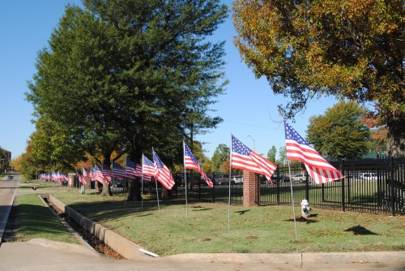
- Independent living skills
- Orientation and mobility skills
- Recreation and leisure skills
- Assistive technology
- Social interaction skills
- Career education
- Sensory efficiency (including visual, tactual and auditory skills), and
- Self-determination

DRS Pub. #13-13 Date: October 2013
This publication is authorized by the Oklahoma Commission for Rehabilitation Services in accordance with state and federal regulations and produced by the Oklahoma Department of Rehabilitation Services. This publication is available on the DRS website.

