Oklahoma School for the Deaf
Oklahoma School for the Deaf
1100 East Oklahoma Ave.
Sulphur, Oklahoma 73086-3108
Toll-free: 1-888-685-3323
Phone: 580-622-4900
http://www.osd.k12.ok.us

Information for Parents

Oklahoma School for the Deaf (OSD) is the premier educational program for deaf and hard of hearing students in the state of Oklahoma. The following information on OSD programs is provided to help parents make informed decisions about the education of their children who are deaf or hard of hearing.

OSD is a special state supported school established by Article 13, Section 2 of the Oklahoma State Constitution to provide specialized and intensive services that focus on the unique learning needs of students who are deaf and hard of hearing.

The school is located in Sulphur, Oklahoma. OSD serves both residential and day students in pre-K through high school grades. Residential students live on campus in dormitories with house parents on site 24 hours a day.

Students attend classes Monday-Thursday. OSD transports residential students to and from various areas of the state for weekends and holidays.

OSD recognizes and addresses the educational needs and interests of each student. Every student receives instruction from staff who are specially trained to work with children and young people who are deaf and hard of hearing.

The school also partners with public schools, providing consultation and outreach for the development of effective educational programs for deaf and hard of hearing students in their home districts.
OSD’s mission is to ensure that every student is equipped for life-long learning, responsible citizenship, and productive employment in an ever-changing society.

Students at OSD receive:
- Instructional methods, materials and technology specialized for deaf and hard of hearing students of all ages.

- Intensive instruction in academic, communication and independent living skills.

- Teachers trained in education of the deaf.

- An opportunity to gain knowledge about both deaf and hearing cultures and gain equal respect for the two languages, American Sign Language and English.

- Small class size – tailored to the unique needs of deaf and hard of hearing students.

- Social and cultural activities and chances to interact with students at other schools.

- Sports, recreation and physical education options.

- Training in technology skills for school and work.

- Vocational training and work experience for older students.

- A safe, supervised environment.

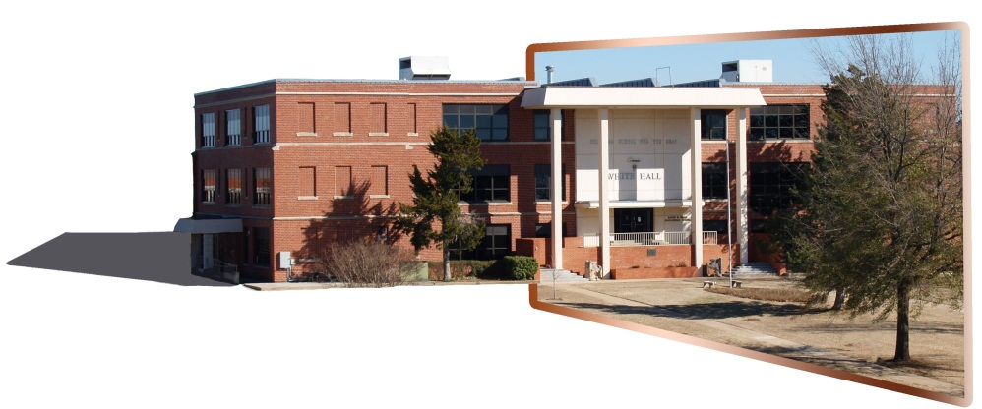
- OSD tuition, and room and board are free to Oklahoma families.

Oklahoma School for the Deaf
Oklahoma School for the Deaf
1100 East Oklahoma Ave.
Sulphur, Oklahoma 73086-3108
Toll-free: 1-888-685-3323
Phone: 580-622-4900
http://www.osd.k12.ok.us

Programs and Services

OSD provides specialized educational programming that is individualized and designed to teach students the many skills they will need to succeed in school and post-secondary life.

Academic Programs
- OSD is fully accredited and teaches state-mandated education requirements. The school is accredited by the Conference of Educational Administrators of Schools and Programs for the Deaf, Inc. and North Central Association.
- OSD places strong emphasis on literacy through programs such as the Accelerated Reader and Fairview Reading Program and programs such as tutoring and remediation.
Specially Trained Teachers and Staff
- Teachers are trained and certified in deaf education.
- Teachers and other school staff are fluent in the use of sign language who can communicate directly with deaf and hard of hearing students.
- Social workers, school counselors, house parents and other staff specialize in working with students who are deaf and hard of hearing.


Opportunities to Participate in Extracurricular Activities
- Opportunity to participate in student organizations.
- Competitions in sports and academics.
- Supervised field trips include trips to sports and cultural events.
- Art, theater, dance and other cultural activities.
- OSD participates in the area Special Olympics.
Sports, Physical Education and Recreation
- All students are offered opportunities to participate in physical education.
- OSD is a hosting member of Great Plains Schools for the Deaf (GPSD) in all sports. Teams compete with both deaf and public schools and with schools in other states in the region.
- Team sports include football, basketball, volleyball, track and more.

- Athletic facilities include gymnasium, a swimming pool, weight room, dance room and tennis court.
- Games, movie theatre, TV and other recreation facilities are provided in the Student Union.


Assistive Technology – Providing Training and Tools to Access the World
- Classes teach fundamental to sophisticated computer and telecommunications technology skills.
- Classes in keyboarding, website navigation, word processing, use of notebooks and hand-held computer devices, researching, and ever-evolving telecommunications technologies.
- Computer labs help students do research and work on classroom projects.
- Students learn to use communication devices such as videophones, TTY, and relay services for greater independence at home and work.
Vocational Training and Transition to Higher Education or Work
- Occupational Training Opportunities for the Deaf (OTOD) students spend a 3-hour block every week day working on a trainee basis in the community. At the start, job coaches accompany students to work and assist in developing job skills, training and work ethics. At the employer's discretion, the students may work without assistance at any time. The program allows students to experience several employment opportunities each school year.
- A special course in Independent Living Skills offers practical experiences in banking, budgeting of income, apartment hunting, reading and understanding bills, and other consumer skills.
Summer Programs
- OSD offers summer camps that focus on academic progress as well as social and recreational experiences for both elementary and high school age students.
- Summer camps are free of charge to students. OSD provides transportation between camp and designated sites throughout the state of Oklahoma.
OSD Student services
- An on-campus health clinic provides routine health services.
- On campus school support counseling services are available to students.
- Residential students are transported between designated sites throughout the state for weekends and holidays.
- A fully equipped school library houses books, magazines and videos for classroom, research and recreational use.

- Assuring the safety and security of all students is a top priority. The OSD campus is secured against uninvited entry. Security and fire alarm systems are in place, in addition to a comprehensive security plan.
Eligibility and Admission
- To be eligible to attend OSD a student must be deaf or hard of hearing.
- The student’s hearing disability must be the student’s primary disability.
- The school accepts referrals from Local Education Agencies (LEAs), educational cooperatives, parents residing within the State of Oklahoma, and/or third party agencies or individuals.
- Admission to the school is accomplished through application directly from parents or guardians.
- The OSD Admissions Committee reviews the application and all pertinent documentation and determines if OSD is an appropriate placement.
A Statewide Resource Center
- OSD Outreach Coordinators are available to consult with public schools regarding educational services for students who are deaf and hard of hearing.
- OSD offers Sign Language Proficiency Interview testing (SLPI) for any school or community wishing to send people for the SLPI to help determine their sign language proficiency level.
- The school is a source of information on the qualifications required of educational interpreters for the deaf.
- OSD satellite pre-schools provide expertise in working with young deaf children to families living in other cities around the state.
- OSD’s full time focus is on the special skills, methods and materials necessary to give deaf and hard of hearing children an equal opportunity for a quality education. OSD is the state’s center of expertise in education of the deaf.

“OSD Information for Parents”
October 1, 2012

DRS Pub. #13-02 Date: October 2013 This publication is authorized by the Oklahoma Commission for Rehabilitation Services in accordance with state and federal regulations and produced by the Oklahoma Department of Rehabilitation Services. This publication is available on the DRS website.
OSD is a proud member of the Oklahoma
Department of Rehabilitation Services

