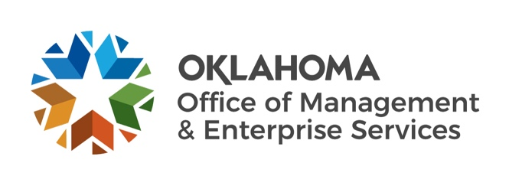
December 2022 BOE Budget Highlights
Purpose of December BOE meeting: Certify revenues accrued in FY-2022 and certify amounts available for appropriation for FY-2024.

FY 2022 highlights:
- Actual General Revenue Collections: $8,493,673,252, an increase of $1,851,651,924 or 27.9% from the June 2021 estimate. This surplus was deposited to the Constitutional Reserve Fund (Rainy Day) in July.
- Actual Total Certified Funds Collections: $8,779,140,550, an increase of $1,863,685,496 or 26.9% from the June 2021 estimate.
FY 2023 highlights (no board actions):
- General Revenue Collections June 2022 Estimate = $7,436,351,615; Appropriations Authority (95%) = $7,064,534,034.
- General Revenue Collections December 2022 Projection = $8,996,563,662, an outlook improvement of $1,560,212,047, or 21.0%.
- Key drivers for improved general revenue fund outlook are expected increases in gross production taxes, personal and corporate income taxes, sales tax, and use tax collections.
- All State Certified Funds Collections June 2022 Estimate = $ 7,709,184,497; Appropriations Authority (95%) = $7,323,725,272.
- All State Certified Funds Collections December 2022 Projection = $9,259,092,548, an outlook improvement of $1,549,908,051, or 20.1%.
- Total Authorized Expenditures (Legislative appropriations and spending authorizations from all certified funds, authorized funds, cash, and all other sources): $10,200,270,240.
FY 2024 highlights:
- General Revenue Collections Estimate: $9,129,713,268; Appropriations Authority (95%): $8,673,227,604.
- All State Certified Funds Collections Estimate: $9,401,537; Appropriations Authority (95%): $8,931,460,777.
- Total expenditure authority (all state certified and authorized funds, federal funds, unspent General Revenue from FY-21 and FY-22, and available cash): $13,020,658,771.

The Official December 2022 BOE packet can be found online at the following link: https://oklahoma.gov/omes/services/budget/boe-packets.html.

