COR104 Base Benefits Manual

Authorized by: [_CORE_] Original Issue: [07/01/2004]
Maintained by: [____Base Benefits Lead___] Current Version: [09/24/2015]
Review Date: [12/30/2016]

Table of Contents

Document History 4
Benefit Enrollment 5
Overview 5
Terminology 5
Objective 6
Benefits Program Participation 7
Benefit Program Participation Tab 7
Leave Benefits 8
Leave Plans Elections Page 9
Savings Plan Benefits 11
Savings Plan Elections Tab 11
Savings Plan Elections Tab (Used for OPERS DC Pathfinder) 15
OPERS Defined Benefit (DB) Retirement Plan 20
Savings Plan Elections Tab (Used for OPERS Defined Benefit plan) 20
Retirement Benefits 22
Retirement Plans Tab 22
Additional Pay Data 24
Additional Pay Tab 24
General Deduction Data 25
General Deduction Data Tab 25
Adjusting Benefit Deductions on Payline 29
Payline Security Page 29
Adjusting Benefit Deductions in General Deductions and Additional Pay 31
General Deduction Data Tab 31
Additional Pay Tab 32
Review Employee Benefit Deductions 33
Review Paycheck Data Page 33
Leave Accrual Processing 36
Leave Accrual Process Tab 36
Leave Accrual Statement 40
Inquiring on Employee Leave Balances 45
Leave Accrual Balances Tab 45

Document History

Document Revision | Date | Description
1.0 | 07/01/2004 | Initial Document
1.1 | 11/08/2008 | 9.0 Upgrade
1.2 | 05/01/2010 | Commitment Accounting Changes
1.3 | 07/20/2010 | Standardize Manuals
1.4  1.5  1.6  1.7  1.8 | 01/28/2011  01/31/2012  01/31/2013  02/07/2014  09/24/2015 | Deleted Savings Bonds pages, updated screen shots, added new codes and deleted obsolete codes.  Added new codes and deleted obsolete codes  Deleted obsolete codes, new procedure change regarding terminating leave balances.  Added new codes, new procedure change regarding leave accrual process.  Added new codes and new retirement plan

Benefit Enrollment

Overview
Sick and Annual Leave, SoonerSave Plans, OPERS and other retirement plans will be managed at the agency level using PeopleSoft. PeopleSoft will be the system of record for the sick and annual leave plans. SoonerSave, OPERS and other retirement plan enrollments must be made in PeopleSoft so the correct payroll deductions can be taken. Enrollment, changes and termination of these plans will be administered in the Base Benefits module of the PeopleSoft HRMS application.

The Employee Benefits Department (EBD) of Human Capital Management will continue to be the source for the benefits not listed above. Data from EBD will be passed to PeopleSoft via an interface. Enrollment, changes and termination of the following benefits will continue to be managed by EBD:

Health Supplemental Life
Dental Dependent Life
Vision Medical Flexible Spending Account
Disability Dependent Care Flexible Spending Account
Life Benefit Allowance

PeopleSoft Payroll calculates the employee’s deductions and taxation based on the information in the various Base Benefit and Payroll pages of the PeopleSoft database.

Terminology
You will encounter some new terms as you work with PeopleSoft Base Benefits and the PeopleSoft system. Below are the terms and their definitions:

Benefit Program – The Benefit Program contains all the benefit plans that an employee may be eligible to participate in. All full-time employees and regular part-time employees with benefits will be associated with the Regular Program (REG). The above mentioned insurance from EBD will only load on employees enrolled in the REG program. A retired employee returning to the state as a temporary employee and employees not eligible for benefits will have the No Benefits Program (NBP). The returning retired employees will also be required to pay retirement which is part of this NBP program.

Plan Type – The different categories of benefit plans. Each category of benefits has a unique plan type. The plan type is a two digit character field but is commonly displayed as a number. For example, plan type 49 is the SoonerSave annuity and 4Z is the SoonerSave administrative fee.

Benefit Plan – The code used to identify each benefit plan within a given plan type.

Objective
The Base Benefits business processes to enroll participants consist of three parts. The first part is assigning an employee to a Benefit Program, which will be completed by the local HR office in each Agency.

The second part is the enrollment into one or many benefit plans for sick leave, annual leave, SoonerSave and retirement benefits.

The third part is the maintenance of the payroll general deductions for health, dental, vision, disability, life, supplemental life, dependent life, FSA’s and the payroll earnings for the Benefit Allowance and Remaining Benefit Allowance. You should understand these parts so you can administer manual changes as needed.

- Enroll a participant in a benefit program

The employee must be enrolled in the correct benefit program, because you can only enroll participants in specific benefit plans that are associated with their assigned benefit program. Each Agency HR office will enroll an employee into the correct Benefit Program by using the Benefit Program Participation component.

- Use individual benefit pages to enroll the participant in the appropriate sick leave, annual leave, annuity and retirement plans.

- Use the payroll Additional Pay pages to make adjustments to payroll earnings for Benefit Allowance and Remaining Benefit Allowance. Use the payroll general deduction pages to make adjustments to health, dental, vision, disability, life, supplemental life, dependent life and FSA payroll deductions.

If you must enroll an employee in Health, Dental, Vision, Life, Disability, Flexible Spending accounts or Supplemental Life you will not need to enroll dependents in the PeopleSoft system, as that information will be stored in BAS.

Benefits Program Participation
You can use this component to enroll an employee in a Benefit Program. Once the employee is enrolled, they will be eligible for the benefit plans that are defined for the specified program only. The Benefit Program will be assigned at the time the employee is hired into the database. The following navigation would be used to make changes to the existing benefit program.

Navigation: Benefits > Enroll in Benefits > Assign to Benefit Program

Benefit Program Participation Tab

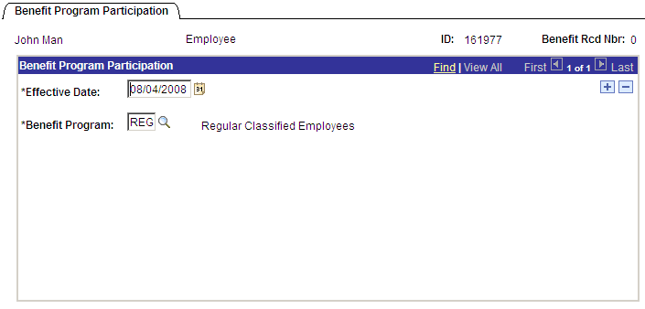

Effective Date - Specify the date the employee was originally enrolled in this Benefit Program. This effective date would be the same date the employee was hired or the effective date of a job change. For example, if an employee moved from a temporary position to a full-time position on August 4, 2008 then the effective date of the REG Benefit Program would be 08/04/2008.

Benefit Program - Select a Benefit Program from the list or type in the code. All employees eligible for benefits will be enrolled in the REG program. Insurance will only load for employees in the REG program.

Employees that don’t qualify for benefits (temporary employees, hourly employees) will be enrolled in the NBP (No Benefits Program) program. NBP also includes the retirement benefits for retirees that have returned to work as temporary employees.

For employees with more than one job, the primary job will have the benefit program as REG. If the employee will be earning leave only at the secondary job, then the benefit program will be the agency number of the secondary job. For example, if the secondary job is at agency 007 the benefit program would then be 007.

Leave Benefits
The State of Oklahoma extends Sick and Annual Leave benefits to eligible employees. Some agencies use PeopleSoft to administer these plans while others continue to track sick and annual leave outside of PeopleSoft.

Each agency will be responsible for enrolling, maintaining, and terminating employee leave information.

Leave accrual rates are based on years of service along with limits and rollover rules. The following tables reflect the accrual rates for each plan type.

Vacation:

Service | Accrual Rate | Accumulation Limit
Less than 5 years | 15 days per year | 30 days (240 Hours)
5-10 years | 18 days per year | 60 days (480 Hours)
10-20 years | 20 days per year | 60 days (480 Hours)
Over 20 years | 25 days per year | 60 days (480 Hours)

Sick:

Service | Accrual Rate | Accumulation Limit
Any Service | 15 days per year | No limit

Leave Plans Elections Page
Navigation: Benefits > Enroll in Benefits > Leave Plans

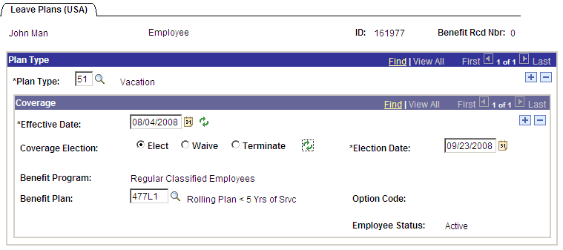

Plan Type - Indicates the leave benefit plan type of 50 (Sick) or 51 (Annual).

Effective Date - This date should be the same as the effective date of the hire row or the date the employee becomes eligible to accrue sick and annual leave. When an employee qualifies for the annual leave level plan change set the effective date to the first day of the pay period. For example, if a monthly employee’s five year anniversary is September 25, 2008 add the new leave plan with a September 1, 2008 effective date. Enter the first day of the next pay period following the termination date for terminating the coverage if the employee is not transferring to another state agency that uses the PeopleSoft leave system.

NOTE: If you know the employee is transferring to another agency that uses PeopleSoft to administer sick and annual leave; do not terminate the current leave plan elections.

Coverage Election - Use this selection to define whether the employee is electing, waiving, or terminating participation. Select from the following valid values: Elect: If the employee is electing coverage. Terminate: if the employee is terminating coverage.

NOTE: The Waive election is not used by the State of Oklahoma and should never be selected.

Refresh Icon - Indicates this field operates in deferred mode. Deferred mode means the system does not automatically validate the field. You can validate the field by clicking th icon or it will be validated when you click

Election Date - This date defaults to the current date. Leave this date as the current date so you know when the election was entered into the database.
Benefit Program - This is a display only description of the employee’s Benefit Program. Most of the time, the field will say Regular Employees.

Benefit Plan - Select the appropriate benefit plan. Only the benefit plans that are associated with the employee's chosen Benefit Program as of the Deduction Begin Date appear in the selection list. For the employees in the Regular Benefit Program, the list will include leave plans from all agencies. Always be sure to select the leave plan that begins with your agency number.

For example: 090L1 is the first annual leave plan for Agency 090.

NOTE: The level of the annual leave plan will be based on the years of service and the limit enforced at the agency level. See the table below (Replace the xxx with your agency number).

Service | Accumulation Limit | Annual Leave Benefit Plan
Less Than 5 years | 30 days (240 Hours) | xxxL1 (xxxB1 for Biweekly)
5-10 years | 60 days (480) | xxxL2 (xxxB2 for Biweekly)
10-20 years | 60 days (480) | xxxL3* (xxxB3 for Biweekly)
Over 20 years | 60 days (480) | xxxL4* (xxxB4 for Biweekly)

* If there is no L3 or L4, select the L2 plan for your agency or if there is no B3 or B4, select the B2 for biweekly.

Option Code - This field will remain blank.

Employee Status - Displays the employee’s effective status as of the coverage begin date

Plus Button - Add a row at the Plan Type level. Once you have entered all the information, click below the blue Plan Type bar to add another Plan Type row.

Save Button - Use to save the information to the database.

Processing Terminations – After all payrolls and accrual processes have been done for the period, then the Leave Plans can be terminated if the employee did not transfer to another state agency on the PeopleSoft leave system. To terminate a benefit plan, insert a new row by clicking the below the blue Coverage bar. Enter the Coverage Begin Date as the first day of the next pay period following the termination date and change the Coverage Election to Terminate. Click

NOTE: It is recommended that any leave balances remaining for terminations be adjusted to .00 (or as close to .00 as possible without going negative) by using adjustments on the Timesheet.

Savings Plan Benefits
Note: Employees enrolled in the Defined Contribution (DC) Pathfinder plan will not be permitted to participate in the SoonerSave Plan and will not qualify for the $25 match in SoonerSave.

The State of Oklahoma offers employees the SoonerSave savings plans to aid in the employee’s long-term investment goals under the Defined Benefit (DB) plan. There are two plans, one each for Monthly and Biweekly employees. Unlike some of the other benefits, the BAS system will NOT be enrolling and maintaining Savings plan data. Therefore you will need to manually enroll, update and terminate an employee’s savings plan data within PeopleSoft. This section will cover the Savings Plan Elections functionality.

Navigation: Benefits > Enroll in Benefits > Savings Plans

Savings Plan Elections Tab
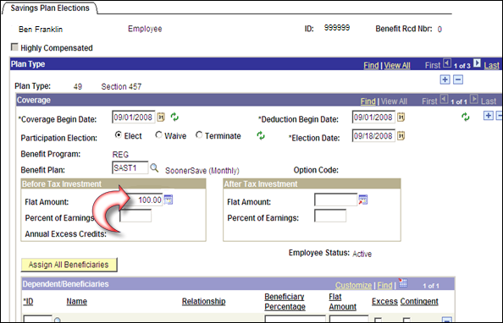

Plan Type | Indicates the benefit plan type. The State of Oklahoma uses Plan Type 49 (section 457) and 4Z Administrative Fee for the SoonerSave Annuity plan.
Coverage Begin Date | Change to the date the coverage for the savings plan should be effective.
Deduction Begin Date | This will default to the Coverage Begin Date. Both dates should be the same.

Participation Election | Use to define whether the employee is electing, waiving, or terminating participation. Select from the following valid values:  Elect: If the employee is electing coverage.  Terminate: If the employee is terminating coverage.  NOTE: The Waive election is not used by the State of Oklahoma and should never be selected.
Refresh Icon 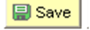 | Indicates this field operates in deferred mode. Deferred mode means the system does not automatically validate the field. You can validate the field by clicking icon or when you click
Election Date | Allow the system to default this field to the current date. Please do not change election date; it assists with trouble shooting in the event of an issue.
Benefit Program | This is a display only description of the employee’s Benefit Program at the time of the Deduction Begin Date.
Benefit Plan | Select the appropriate benefit plan – either SAST1 (Monthly) or SAST2 (Biweekly). Only the benefit plans that are associated with the employee’s chosen Benefit Program as of the Deduction Begin Date appear in the selection list.
Option Code | This field will remain blank.

Before Tax Investment

Flat Amount | Enter the amount the employee has chosen to invest on a pay period basis. This must be done in the Before Tax Investment side.  NOTE: When entering the Plan Type 4Z Administrative Fee; do not enter any amounts in Before Tax or After Tax Investment.
Percent of Earnings | The State is not using this field for SoonerSave.
Annual Excess Credit | The State is not using this field.

After Tax Investment

Flat Amount | The State will NOT be using the fields in this group box.
Percent of earnings | The State will NOT be using the fields in this group box.
 | Click to save the information to the database.

NOTE: Add the Administrative Fee.

The Savings Plan Administrative Fee must also be established. The Plan Type is 4Z. The election is made the same way as the SoonerSave Plan Type 49 elections. However no amounts need to be entered. The admin fee will be correctly processed through Payroll if the election is made here.
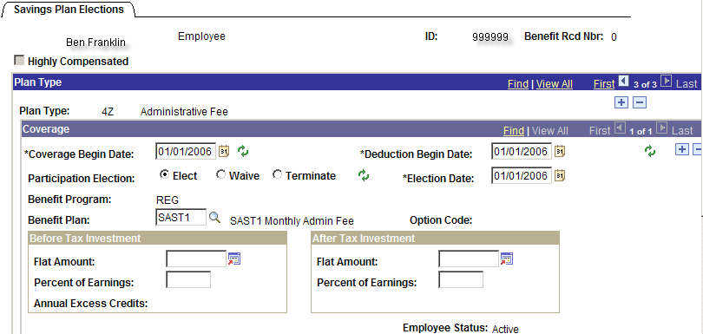

 | The Administrative Fee, Add a row at the Plan Type level. Click the button at the blue Plan Type bar.
Plan Type | Indicates the benefit plan type. The State of Oklahoma uses Plan Type 4Z for the SoonerSave Annuity administrative fee.
Coverage Begin Date | This will be the same date the SoonerSave election begins.
Deduction Begin Date | This will default to the Coverage Begin Date.
Participation Election | Select Elect to start the Administrative Fee deductions.
Refresh Icon | Indicates this field operates in deferred mode. Deferred mode means the system does not automatically validate the field. You can validate the field by clicking icon or when you click
Election Date | Allow the system to default this field to the current date. Please do not change this date; it assists with trouble shooting in the event of an issue.
Benefit Plan | Select the appropriate benefit plan – either SAST1 (Monthly) or SAST2 (Biweekly).
 | Click to save the information to the database.
Processing Terminations | To terminate a benefit plan, insert a new row by clicking the below the blue Coverage bar. Enter the Coverage Begin Date as the first of the next pay period following the termination date and change the Participation Election to Terminate. Click . This should be done after all payrolls are done for the employee.

NOTE: Anytime the SoonerSave election is ended, both the Plan Type 49 and 4Z rows must be terminated.

Defined Contribution (DC) Pathfinder Retirement Plan

The Defined Contribution (DC) Pathfinder plan is a retirement plan where an employee contributes a predetermined portion of their earnings to an individual account, part of which is matched by the employer. This plan is for employees that are hired on or after November 1, 2015 and exempts hazardous duty, district attorneys, assistant district attorneys and other employees of the district attorneys office. The minimum percent of earnings employees can contribute is 4.5%. This plan is managed in the Savings Plan Elections using the 4X plan type. After entries have been made and this page is saved the system will automatically generate additional rows that cannot be altered.

Navigation: Benefits > Enroll in Benefits > Savings Plans

Savings Plan Elections Tab (Used for DC Pathfinder)

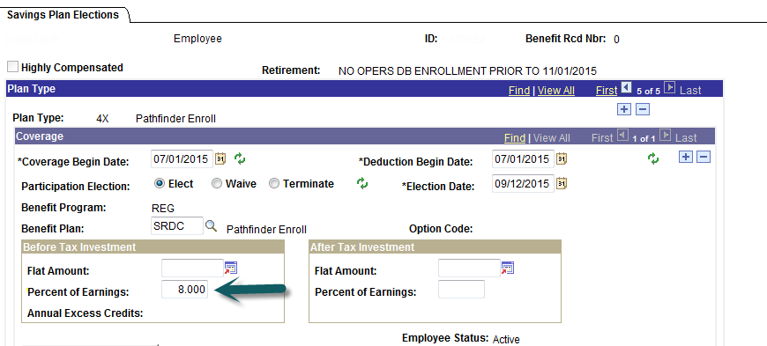

Retirement: | NO OPERS DB ENROLLMENT PRIOR TO 11/01/2015 – Verifies employee eligibility in the Pathfinder (DC) retirement plan.  OPERS DB ENROLLMENT PRIOR TO 11/01/2015 - Indicates employee is previously enrolled in OPERS DB and would need to be enrolled in that plan.

Plan Type | Indicates the benefit plan type. The State of Oklahoma uses Plan Type 4X for Defined Contribution (DC) Pathfinder retirement plan.
Coverage Begin Date | Change to the date the coverage for the DC Pathfinder plan should be effective.
Deduction Begin Date | This will default to the Coverage Begin Date so that both dates are the same.

Participation Election | Use to define whether the employee is electing, waiving, or terminating participation. Select from the following valid values: Elect: If the employee is electing coverage. Terminate: If the employee is terminating coverage.

NOTE: The Waive election is not used by the State of Oklahoma and should never be selected.

Refresh Icon | Indicates this field operates in deferred mode. Deferred mode means the system does not automatically validate the field. You can validate the field by clicking the icon or when you click .
Election Date | Allow the system to default this field to the current date.
Benefit Program | This is a display only description of the employee’s Benefit Program at the time of the Deduction Begin Date.
Benefit Plan | Select the SRDC benefit plan. Only the benefit plans that are associated with the employee’s chosen Benefit Program as of the Deduction Begin Date appear in the selection list.
Option Code | This field will remain blank.

Before Tax Investment
Flat Amount | This field will remain blank.
Percent of Earnings | Enter the total percentage the employee has elected to contribute to the plan. Field will only allow 1 decimal. Minimum contribution is 4.5%.
Annual Excess Credit | The State is not using this field.
After Tax Investment

Flat Amount | The State will NOT be using the fields in this group box.
Percent of earnings | The State will NOT be using the fields in this group box.

Employee Status | Displays the employee’s effective status as of the coverage begin date.
 | Use to save the information to the database.
Processing
Terminations If the employee is transferring to another state agency the Pathfinder DC plan
will not be terminated.

Once this record is saved the system will create all the other plan type enrollment rows, as shown below:

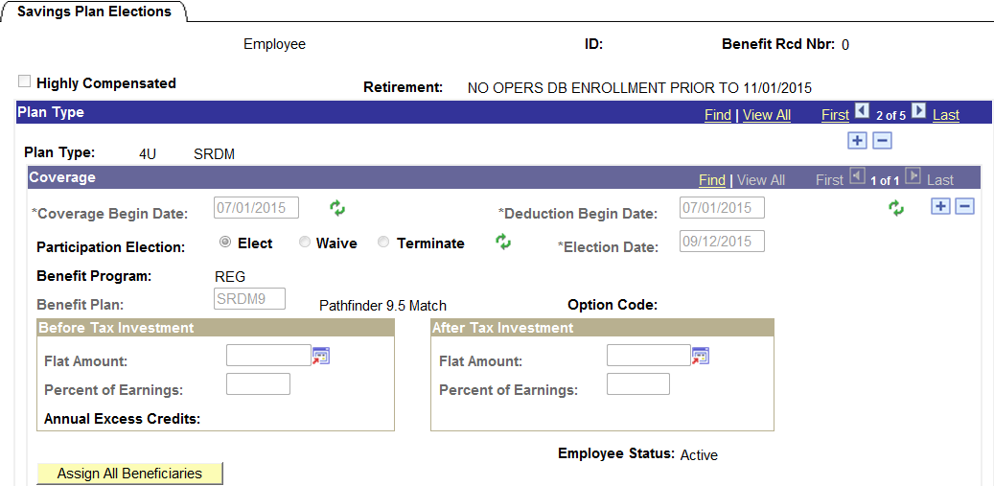

The 4U SRDM Plan is for the additional monies to fund OPERS to equal statutory limitations set at 16.5%. The Benefit Plans will be SRDM9 or SRDM10.

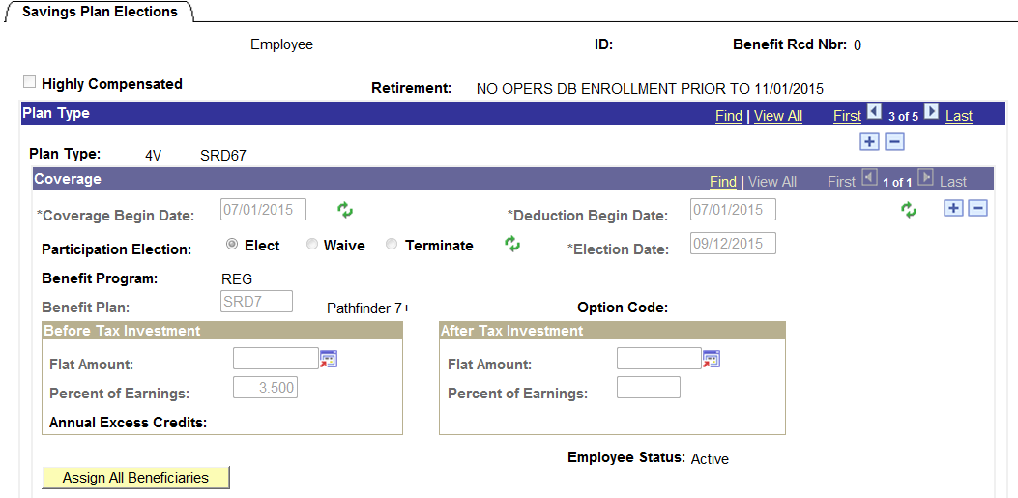

The 4V SRD67 Plan Type is the employee’s share of the Pathfinder plan for the difference above the minimum. The Benefit Plan of SRD6 will be for employee elections between 4.6% to 6.9%. The SRD7 Benefit Plan will be for employee elections of 7.0% and above. Employee minimum contribution of 4.5% along with the employer match of 6% or 7% will go into the 401(a) plan. Employee contributions of 4.6% and above will go into the 457(b) plan.

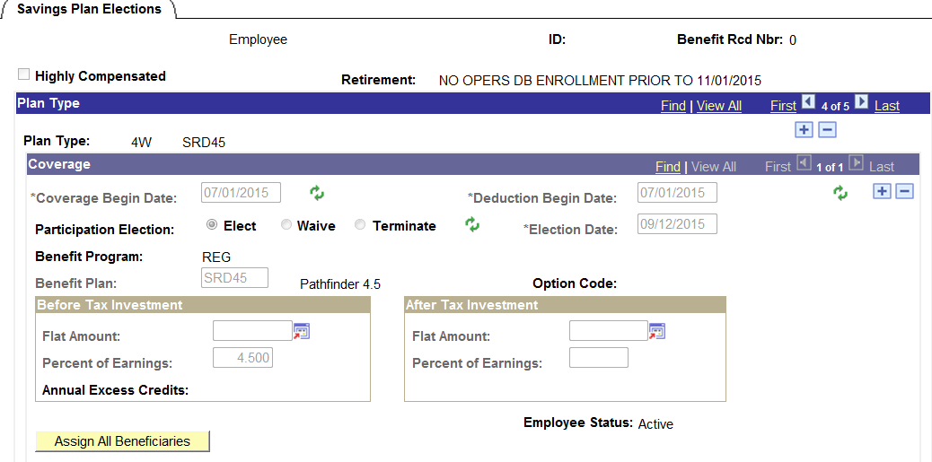

The 4W SRD45 Plan Type is for the employee’s minimum share of the Pathfinder plan. These monies will go into the employee’s 401(a) Plan.

OPERS Defined Benefit (DB) Retirement Plan
The Defined Benefit (DB) retirement plan is an employer-sponsored retirement plan where benefits are guaranteed based on a formula using salary history and duration of employment. This plan is for employees hired prior to November 1, 2015 and employees exempt from the Pathfinder (DC) plan. This plan is managed in the Savings Plan Elections using the 4Y plan type.

Navigation: Benefits > Enroll in Benefits > Savings Plans

Savings Plan Elections Tab (Used for OPERS Defined Benefit plan)

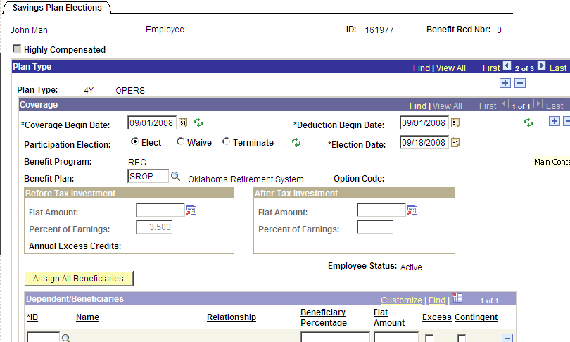

Plan Type |  | Indicates the benefit plan type. The State of Oklahoma uses Plan Type 4Y for OPERS Defined Benefit (DB) retirement benefits. If data for SoonerSave already exists you will need to add a row click button below the blue Plan Type bar to add another Plan Type row.
Coverage Begin Date |  | Change to the date the coverage for the OPERS DB plan should be effective.
Deduction Begin Date |  | This will default to the Coverage Begin Date so that both dates are the same.
Participation Election | Use to define whether the employee is electing, waiving, or terminating participation. Select from the following valid values: Elect: If the employee is electing coverage. Terminate: If the employee is terminating coverage.

NOTE: The Waive election is not used by the State of Oklahoma and should never be selected.

Refresh Icon | Indicates this field operates in deferred mode. Deferred mode means the system does not automatically validate the field. You can validate the field by clicking the icon or when you click .
Election Date | Allow the system to default this field to the current date.
Benefit Program | This is a display only description of the employee’s Benefit Program at the time of the Deduction Begin Date.
Benefit Plan | Select the SROP benefit plan. Only the benefit plans that are associated with the employee’s chosen Benefit Program as of the Deduction Begin Date appear in the selection list.
Option Code | This field will remain blank.

Before Tax Investment

Flat Amount | This field will remain blank.
Percent of Earnings | The system will default in 3.5%.
Annual Excess Credit | The State is not using this field.
After Tax Investment

Flat Amount | The State will NOT be using the fields in this group box.
Percent of earnings | The State will NOT be using the fields in this group box.

Employee Status | Displays the employee’s effective status as of the coverage begin date.
 | Use to save the information to the database.
Processing Terminations | If the employee is transferring to a state agency, do not terminate OPERS DB plan election.  To terminate a benefit plan, insert a new row by clicking the below the blue Coverage bar. Enter the Coverage Begin Date as the first day of the next pay period following the termination date and change the Participation Election to Terminate. Click This should not be done until all payrolls are completed for the employee.

NOTE: The Step Up plan is administered in the Retirement Plan component (next section).

Retirement Benefits
Each Agency will have to manually enroll, update and terminate an employee’s retirement plan data within PeopleSoft.

To enroll an employee in a retirement plan, use the following navigation:

Navigation: Benefits > Enroll in Benefits > Retirement Plans

Retirement Plans Tab
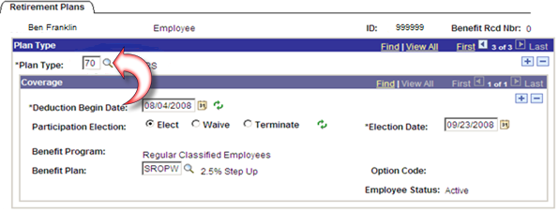

Plan Type | Indicates the Retirement benefit plan type of 70 (PERS), 7Z (PERS2), or 7Y (PERS3).
Deduction Begin Date | Change to the date the coverage for the retirement plan should be effective. The system verifies that the Benefit Program is in effect as of the Deduction Begin Date. If an error is encountered, the Deduction Begin Date needs to be changed or the Hire Date for the employee needs to be corrected.

Participation Election |  | Use to define whether the employee is electing, waiving, or terminating participation. Select from the following valid values:  Elect: If the employee is electing coverage.  Terminate: If the employee is terminating coverage.  NOTE: The Waive election is not used by the State of Oklahoma and should never be selected.
 |  | Indicates this field operates in deferred mode. Deferred mode means the system does not automatically validate the field. You can validate the field by clicking icon or when you click
Election date |  | This date defaults to the current date, leave as current date.
Benefit Program |  | This is a display only description of the employee’s Benefit Program.
Benefit Plan |  | Select the benefit plan. Only the benefit plans that you've associated with the employee's chosen Benefit Program as of the Deduction Begin Date appear in the selection list.  Currently the valid benefit plans for the 70 PERS Plan include:  292OK – DEQ – Oklahoma County Retirement  292TU – DEQ – Tulsa County Retirement  OSBI – Police Pension  SRJD2 – Judges & Justices  SROL1 – OLERS  SROL2 – OLERS  SROPA – Elected Official, Option A  SROPB – Elected Officials Plan B  SROPC – Correctional Officers Ret  SROPD – Elected Officials - Plan D  SROPE – Elected Officials - Plan E  SROPQ – Elected Officials - Plan Q  SROPS – Elected Officials Plan “S”  SROPW – 2.5% Step Up  SROPY – Elected Officials - Plan Y  SRTA – Teachers Ret Ardmore HE Ctr  SRTD1 – SRTD1 Teachers Ret EE pd by ER  SRTE – Teachers Retirement  SRTS – Teachers Retirement State Paid  SRTX – Teacher Retirement-Exempt  SRWL – Wildlife Retirement
Option Code |  | This field should remain blank.
Employee Status |  | Displays the employee’s effective status as of the coverage begin date.
 |  | Use to save your information to the database.
 | Processing Terminations | To terminate a benefit plan, insert a new row, click below the blue Coverage bar. Enter the Coverage Begin Date as the first day of the next pay period following the termination date and change the Participation Election to Terminate. Click This should not be done until all payrolls are completed for the employee.

Additional Pay Data
The PeopleSoft Additional Pay pages store information about recurring payments made to an employee by the State. These are earnings paid to the employee on a regular basis in addition to their regular pay. The amount of the payment is specified, the frequency with which it will be paid, and the date or goal amount at which it should stop.

You can view the Benefit Allowance earnings code on this page. The State may also use the additional pay pages for the following types of payments:

- Bonuses
- Car allowances
- Uniform allowances

Navigation: Payroll for North America > Employee Pay Data USA > Create Additional Pay

Additional Pay Tab
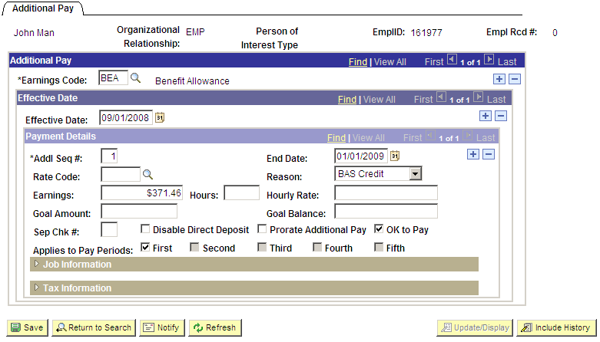

Earnings Code | BEA is for Benefit Allowance and RBA is excess Remaining Benefit Allowance.
Effective Date | Set to the date the benefit begins to be paid to the employee.
End Date | The future date the payment will stop.
Earnings | The amount of the per pay period earnings.
OK to Pay | This checkbox must be checked in order for the earnings to be paid.

NOTE: Refer to the payroll training manuals for guidance on how to change additional pay data.

General Deduction Data
The PeopleSoft General Deduction pages store information about recurring deductions made to an employee by the State on a regular basis. These are deductions paid to the employee on a regular basis. The effective date and end date of the deduction is specified, the type of deduction and the amount of the deduction for each pay period is saved here. Deductions for union dues, parking and garnishments will be found here but only the employee benefit deductions are addressed in this manual.

The benefit deductions are calculated by EBD then loaded into the PeopleSoft system on a nightly basis. Use the General Deduction Table to view the benefit deductions.

Navigation: Payroll for North America > Employee Pay Data USA > Deductions > Create General Deductions

General Deduction Data Tab
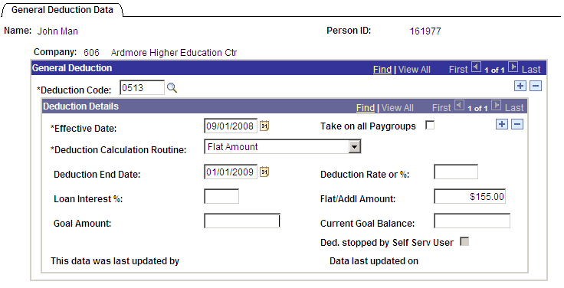

Deduction Code | All of the deduction codes that were loaded via the EBD interface start with a zero. If an override code is to be used it ends with the letter O (for Override) and is used when the employee needs to have additional deductions due to a retroactive change to benefits.
Effective Date | The date the deductions begin.
Take on all Pay groups | Should always be checked.
Deduction Calc Routine | This must always be set to Flat Amount.
Deduction End Date | The future date the deduction will stop.
Flat/Addl Amount | The amount of the per pay period benefit deduction.

NOTE: Refer to the payroll training manuals for guidance on how to change general deduction data. The EBD benefit deductions should feed into PeopleSoft via a nightly interface. If a change was made in BAS on Monday, it should be in PeopleSoft Tuesday.

The current general deductions for EBD deductions are listed below. The deduction codes ending with “O” are for “overrides” and are to be used to set up an additional deduction for an employee needing to catch up for missed deductions.

The 05xx and 02xx series codes designate pre-tax deductions. The 06xx and 04xx series designate post-tax deductions. Any deductions that are covered by the employee’s benefit allowance are loaded with the 05xx or 02xx codes. If the employee did not elect premium conversion then any deductions not covered by the benefit allowance would be loaded with a 06xx or 04xx code.

Before Tax Deduction Code |  | Description |  | After Tax Deduction Code
0218 |  | HEA998 OptOut2 |  | only before tax
0219 |  | HEA999 OptOut |  | only before tax
 |  | Flexible Spending Account
0221 |  | URM010 Medical Reimbursement |  | only before tax
0221O |  | URM010 Medical Reimbrsmnt Override |  | only before tax
0222 |  | DDC010 Dependent Care Spending Acct |  | only before tax
0222O |  | DDC010 Dep Care Spd Acct Override |  | only before tax
0299 |  | HSA010 Health Savings Account |  | only before tax
0299O |  | HSA010 Health Savings Account Override |  | only before tax
 |  | Vision
0289 |  | VSP080 Vision Care Direct |  | 0489
0289O |  | VSP080 Vision Care Direct Override |  | 0489O
0290 |  | VSP030 Vision Service Plan |  | 0490
0290O |  | VSP030 Vision Service Plan Override |  | 0490O
0292 |  | VSP050 Primary Vision Care Services |  | 0492
0292O |  | VSP050 Primary Vision Care Services Override |  | 0492O
0293 |  | VSP060 United Healthcare Vision |  | 0493
0293O |  | VSP060 United Healthcare Vision Override |  | 0493O
0294 |  | VSP070 Humana |  | 0494
0294O |  | VSP070 Humana Override |  | 0494O
0296 |  | VSP090 Superior Vision Services |  | 0496
0296O |  | VSP090 Superior Vision Services Override |  | 0496O

Before Tax Deduction Code |  | Description |  | After Tax Deduction Code
 |  | Employee Health
0500 |  | HEA230 EE BCBS of OK BlueLincs HMO(01/16) |  | 0600
0500O |  | HEA230 EE BCBS of OK BlueLincs Override |  | 0600O
0513 |  | HEA010 EE HealthChoice High |  | 0613
0513O |  | HEA010 EE HealthChoice High Override |  | 0613O
0521 |  | HEA120 EE Aetna Integris HMO (01/2016) |  | 0621
0521O |  | HEA120 EE Aetna Integris HMO Override |  | 0621O
0525 |  | HEA220 EE HealthChoice S-Acct |  | 0625
0525O |  | HEA220 EE HealthChoice S-Acct Override |  | 0625O
0526 |  | HEA011 EE HealthChoice High Alternative |  | 0626
0526O |  | HEA011 EE HealthChoice High Altern Override |  | 0626O
0528 |  | HEA012 EE HealthChoice Basic |  | 0628
0528O |  | HEA012 EE HealthChoice Basic Override |  | 0628O
0530 |  | HEA094 EE CommunityCare HMO |  | 0630
0530O |  | HEA094 EE CommunityCare HMO Override |  | 0630O
0531 |  | HEA014 EE HealthChoice USA |  | 0631
0531O |  | HEA014 EE HealthChoice USA Override |  | 0631O
0532 |  | HEA114 EE GlobalHealth HMO |  | 0632
0532O |  | HEA114 EE GlobalHealth HMO Override |  | 0632O
0533 |  | HEA013 EE HealthChoice Basic Alternative |  | 0633
0533O |  | HEA013 EE HealthChoice Basic Altern Override |  | 0633O
0534 |  | HEA211 EE TRICARE OptOut/Supplement |  | 0634
0534O |  | HEA211 EE TRICARE OptOut/Supp Override |  | 0634O
 |  | Dependent Health
0501 |  | HEA230 DP BCBS of OK BlueLincs HMO(01/16) |  | 0601
0501O |  | HEA230 DP BCBS of OK BlueLIncs Override |  | 0601O
0537 |  | HEA094 DP CommunityCare Alternative |  | 0637
0537O |  | HEA094 DP CommunityCare Altern Override |  | 0637O
0541 |  | HEA114 DP GlobalHealth HMO |  | 0641
0541O |  | HEA114 DP GlobalHealth HMO Override |  | 0641O
0545 |  | HEA120 DP Aetna Integris HMO (01/2016) |  | 0645
0545O |  | HEA120 DP Aetna Integris HMO Override |  | 0645O
0548 |  | HEA211 DP TRICARE OptOut/Supplement |  | 0648
0548O |  | HEA211 DP TRICARE OptOut/Supp Override |  | 0648O
0549 |  | HEA014 DP HealthChoice USA |  | 0649
0549O |  | HEA014 DP HealthChoice USA Override |  | 0649O
0550 |  | HEA010 DP HealthChoice High |  | 0650
0550O |  | HEA010 DP HealthChoice High Override |  | 0650O
0551 |  | HEA012 DP HealthChoice Basic |  | 0651
0551O |  | HEA012 DP HealthChoice Basic Override |  | 0651O
0552 |  | HEA013 DP HealthChoice Basic Alternative |  | 0652
0552O |  | HEA013 DP HealthChoice Basic Altern Override |  | 0652O
0555 |  | HEA011 DP HealthChoice High Alternative |  | 0655
 |  | Dependent Health Continued
0555O |  | HEA011 DP HealthChoice High Altern Override |  | 0655O
0559 |  | HEA220 DP HealthChoice S-Acct |  | 0659
0559O |  | HEA220 DP HealthChoice S-Acct Override |  | 0659O

Before Tax Deduction Code |  | Description |  | After Tax Deduction Code
 |  | Dental
0266 |  | DEN998 Dental Default Opt-Out |  | only before tax
0560 |  | DEN010 Health Choice Dental |  | 0660
0560O |  | DEN010 Health Choice Dental Override |  | 0660O
0561 |  | DEN030 Assurant Heritage Plus Prepaid |  | 0661
0561O |  | DEN030 Assurant Heritg Plus Prepaid Override |  | 0661O
0562 |  | DEN032 Assurant Freedom Preferred |  | 0662
0562O |  | DEN032 Assurant Freedom Preferred Override |  | 0662O
0563 |  | DEN040 Cigna Dental Prepaid |  | 0663
0563O |  | DEN040 Cigna Dental Prepaid Override |  | 0663O
0566 |  | DEN064 Delta Choice PPO |  | 0666
0566O |  | DEN064 Delta Choice PPO Override |  | 0666O
0567 |  | DEN066 Delta Dental PPO-POS |  | 0667
0567O |  | DEN066 Delta Dental PPO-POS Override |  | 0667O
0568 |  | DEN034 Assurant Heritage Secure |  | 0668
0568O |  | DEN034 Assurant Heritage Secure Override |  | 0668O
0569 |  | DEN068 Delta Dental Premier |  | 0669
0569O |  | DEN068 Delta Dental Premier Override |  | 0669O
 |  | Disability
0570 |  | DIS010 EE Disability |  | 0670
0570O |  | DIS010 EE Disability Override |  | 0670O
 |  | Life
0575 |  | LIF010 EE Basic Life |  | 0675
0575O |  | LIF010 EE Basic Life Override |  | 0675O
0585 |  | SUP010 EE Supplemental Life |  | 0685
0585O |  | SUP010 EE Supplemental Life Override |  | 0685O
 |  | Dependent Life
only after tax |  | DEP010 Dependent Life Low |  | 0690
only after tax |  | DEP010 Dependent Life Low Override |  | 0690O
only after tax |  | DEP012 Dependent Life Standard |  | 0691
only after tax |  | DEP012 Dependent Life Standard Override |  | 0691O
only after tax |  | DEP014 Dependent Life Premier |  | 0692
only after tax |  | DEP014 Dependent Life Premier Override |  | 0692O

Adjusting Benefit Deductions on Payline
You will use the One Time Override – Deduction Data Tab on the payline to enter amounts for SoonerSave, SoonerSave Admin Fee and other retirement deduction adjustments and for EBD benefit adjustments for one pay period only. This can only be done during the payroll processing after Paysheets have been created. (Refer to the Payroll training manuals.)

Navigation: Payroll for North America > Payroll Processing USA > Update Paysheets > By Payline Security

Payline Security Page
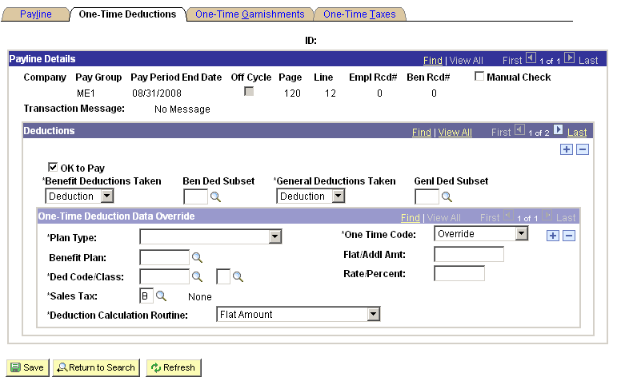

If the deduction override only pertains to benefit deductions overall (not for a specific one), or to only use a special benefits subset for this payroll (ignoring benefit deductions not in subset) you will click on the down arrow under ‘Benefit Deductions Taken’ and make the appropriate selection. If you selected ‘Subset’ then you must fill in the Prompt Box under ‘Ben Ded Subset’.

The One-Time Deduction Data Override scroll area is where you enter specific information pertaining to a specific deduction and amount. You will need to select the proper Plan Type by clicking on the down arrow and selecting the appropriate plan. The One Time Code selection area tells the system to:

- Override - Override employee setup data for this tax class and use the amount given.
- Arrears - The amount given is for an arrears payback. The state does not use this feature.
- Addition - The amount given is in Addition to what should be taken out for this employee.
- Refund - The amount given is a Refund to the employee.

When the deduction override pertains to a benefit deduction you must enter the Benefit Plan or click on the prompt icon and select the correct plan. The Benefit Plan area should be left blank for General Deduction overrides. The Flat/Addl Amt area is for the amount of the override or refund. Deduction Code/Class prompt boxes are to be filled in as follows:

- The first box is the Deduction Code you need to use for this override.
- The second box pertains to whether this deduction is a Before or After tax deduction. (B = Before, A = After, P = Employer fee or share and should always be used for SoonerSave Admin. Fee).

The last area on this page that the State of Oklahoma will use is the Deduction Calculation Routine selection area. Click on the down arrow and select the correct calculation routine. For the most part, the State of Oklahoma will be selecting ‘Flat Amount” which is the system default. When all the data is properly completed, click

Adjusting Benefit Deductions in General Deductions and Additional Pay
For EBD benefit deduction adjustments that would last for more than one pay period, the deduction would be added to the General Deduction Data using the corresponding deduction code that ends with the letter O (for Override). If it affects the Benefit Allowance, too, then the corresponding earnings code that ends with the letter O (for Override) would be used on Additional Pay. This would be done when an employee missed deductions and/or the amount is too large for one pay check.

Navigation: Payroll for North America > Employee Pay Data USA > Deductions > Create General Deductions

General Deduction Data Tab
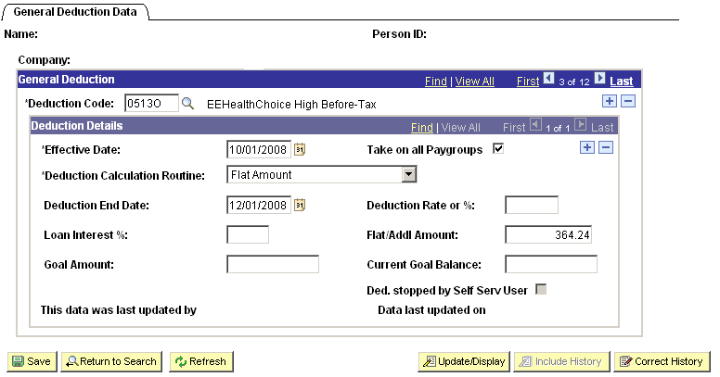

Add a row at the Deduction Code level. Enter the Deduction Code with the letter O at the end for the Override. Complete the page with Effective Date when the override should begin on payroll and the Deduction End Date when it should end on payroll. The Deduction Calculation Routine should be ‘Flat Amount’. Enter the pay period amount in Flat/Addl Amount and click

If it is determined that the Benefit Allowance needs to be adjusted too, then the override can be put in Additional Pay.

Additional Pay Tab
Navigation: Payroll for North America > Employee Pay Data USA > Create Additional Pay

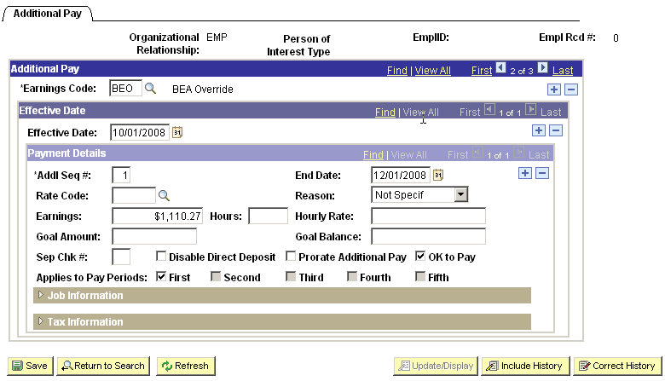

Add a row at the Earnings Code level. Enter the Earnings Code as BEO as the override for BEA and/or RBO as the override for RBA. Enter the Effective Date that the earnings should start on payroll and the End Date when the amount should stop on payroll. Enter the Addl Seq# as 1, the amount in the Earnings and check the OK to Pay and click

Entering overrides on Additional Pay and General Deductions as shown above will result in these amounts being added to the usual earnings and deductions for the pay period.

Review Employee Benefit Deductions
Once payroll has calculated employee paychecks you will be able to see the benefit allowance and all benefit deductions and amounts that were calculated for that paycheck. Refer to the payroll training manuals to learn how to view the Paycheck Data.

Navigation: Payroll for North America > Payroll Processing USA > Produce Payroll > Review Paycheck

Review Paycheck Data Page

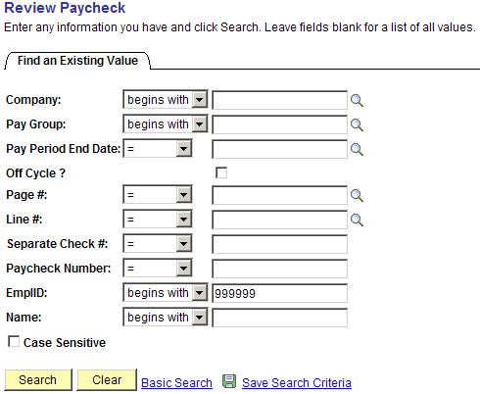

Enter Employee ID.

Click .

Click the Paycheck link that you wish to view.

The system takes you to the following page:

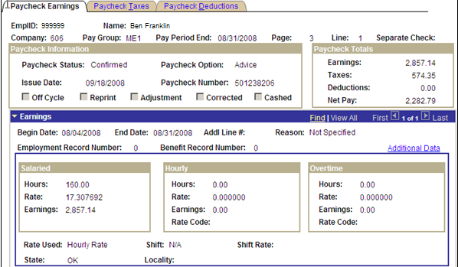

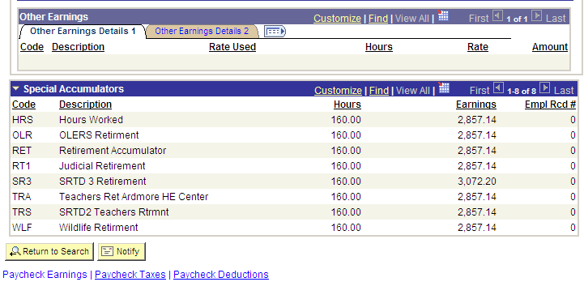

Click the Paycheck Deductions Tab to go to the following page. This is a customized view to allow the pertinent information to be viewed on one page. Customize views are created by clicking the Customize link.

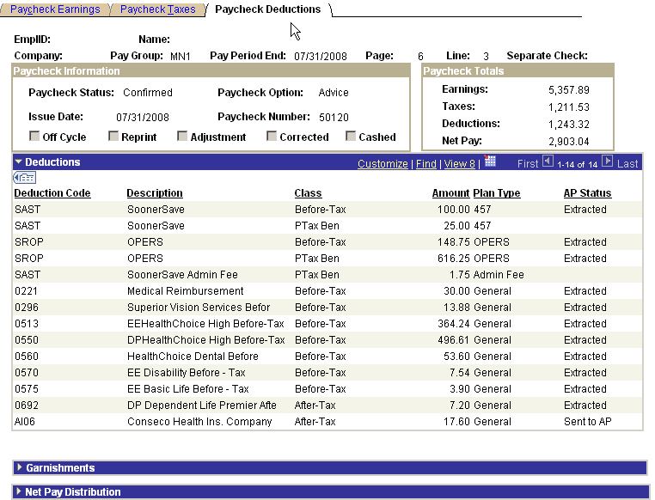

Deduction codes for OPERS Pathfinder retirement plan are as follows:
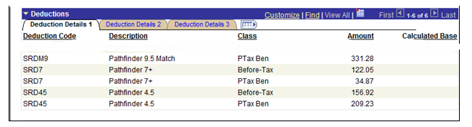

Leave Accrual Processing
Each Agency using the PeopleSoft Leave Accrual System will be responsible for running the Leave Accrual Process for each of their Leave Plans. The leave accrual process will add any accrued hours to the employee’s leave balances and also deduct any used hours from the balances. You will run the Accrual Process for your Agency (Company) by Plan Type and Benefit Plan. Because there is more than one Leave Benefit Plan within each agency, you will need to run the process more than once.

Navigation: Benefits > Manage Leave Accruals > Calculate Periodic Accrual (0446)

Leave Accrual Process Tab
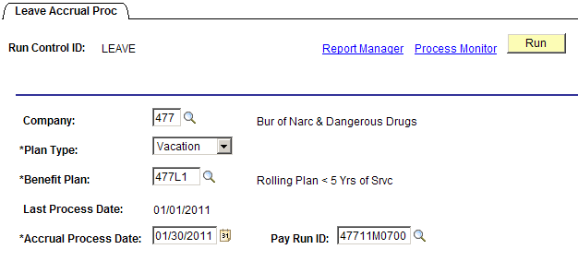

The Run Control page is where you specify the parameters or details of what you want the leave process to do. You may find it helpful to create and save a run control for each leave plan you will be processing. Run Controls are re-usable pages, so once you create and save one, you can use the same one again to run the leave accrual process for the same leave plan but for another process date. The actual Run Control ID is up to you, but some people use the leave plan of interest.

The system will show you benefit plans within the Plan Type you choose. Choose your agency-specific plan from the list:

- If you need to use the magnifying glass lookup for the benefit plan, enter the agency number to narrow the search results.

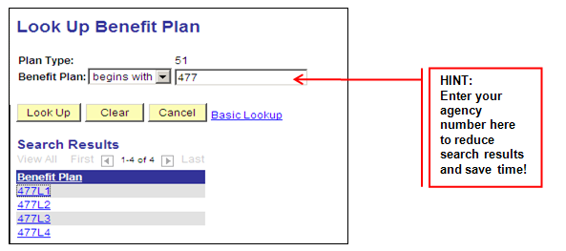

NOTE: Make sure to select one of your Agency’s Plans from the list, run the process to success, and then run the process again for the next plan. This process must be repeated for Sick and every Annual Leave Plan.

Run Control ID | This is the run control ID that you used to begin processing the Leave accruals. It is display only.
Company | Enter your Agency number (company) that you want to process.
Plan Type and Benefit Plan | Enter the plan type and benefit plan that you are processing.
Last Process Date | This field displays the date that you last ran the Leave Accrual process for this plan type and benefit plan.
Accrual Process Date | The system will automatically set the accrual process date to the current date. You must change this date to the next to the last day of the pay period that payrolls were run for. Based on the pay Period End Date of the On-Cycle Pay Calendar that the Run ID is associated with, the Accrual Process Date can only be one (1) day earlier than the Pay Period End Date or equal to the Pay Period End Date. You will receive warning messages if any other dates are used and the system will not process.  NOTE: You can only run this process twice, once using the day before the pay period end date and, if necessary, it can be run again using the last day of the pay period.
Pay Run ID | Enter the Pay Run ID of the On-Cycle Pay Calendar associated with the pay period that the accrual is being processed.

Click to take you to the Process scheduler where you can submit the process.

Once you enter all the parameters. click . The system will transfer you to the Process Scheduler Request Page.

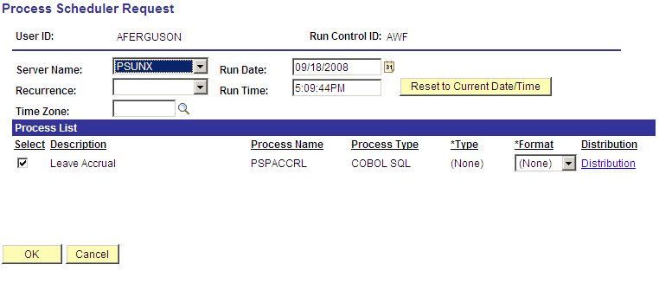

Make sure the Server Name is PSUNX and that there is a check in the box to the left of the Leave Accrual process – this check should default in.
Click to submit the process.

Below is a summary of where the leave accrual process and printing of the leave statement fall into the mix of the entire payroll process.

Process Flow:

- Enter time taken and adjustments on Timesheet page.
- Run Time Administration Process.
- Validate hours in the Estimated – Ready for Payroll status using the Payable Status Report.
- If any corrections are needed for the hours entered, the data on Timesheet can be changed and Time Admin can be run again. Once the payrolls are confirmed, the hours posted cannot be changed.
- Process payroll through the GL Process. If the sick and/or annual leave time is received after the regular payroll process is under way, you will need to process these hours through an off-cycle payroll to have them posted before the next regular payroll.
- Due to procedural changes in 2013, the leave accrual process may need to be done twice if the agency has any terminal leave payouts. Process all payrolls for the pay period, run the leave accrual process (using the day prior to the last day of the pay period), then run another off-cycle for any terminal/annual leave payouts. Once the annual leave payouts have been completed, run the leave accrual process again using the last day of the pay period to pull everything through the system to keep leave balances on the timesheet in sync with benefit balances.
- Print and distribute the Leave Statements according to agency procedures.

Leave Accrual Checklist that can be printed for each month and used as a guide. This will help ensure there are no issues caused by running these steps out of order.
 | If running the leave statement for March, check to see that all the March payrolls (regular, supplemental and off-cycle) have been processed through GL before running leave accruals.
Run the accrual process for sick leave. | Benefits > Manage Leave Accruals > Calculate Periodic Accrual | Company:  (Enter agency #)  Plan Type:  (Choose Sick)  Benefit Plan:  (Enter company number + SK, i.e. 400SK) (Use xxxBK for Biweekly)  Accrual Process Date:  NOTE: Always change this date!  (Enter the next to last day of the pay period the payrolls were run for…for example if March Payrolls are all confirmed enter 03/30/2008 as accrual process date.)
Run the accrual process for annual leave. | Benefits > Manage Leave Accruals > Calculate Periodic Accrual | Company:  (Enter agency #)  Plan Type:  (Choose Vacation…the PeopleSoft plan type value for annual leave plans)  Benefit Plan:  (Enter company number + annual leave level…L1, L2, L3 or L4), (B1, B2, B3, and B4 for Biweekly)  Accrual Process Date:  NOTE: Always change this date!  (Enter the next to last day of the pay period the payrolls were run for…i.e., if March Payrolls are all confirmed enter 03/30/2008 as accrual process date.)
Print the leave statement. | OK Custom Reports/Processes > OK Reports > Benefits > Emp Leave Accrual Rpt (0053) | Pay End Date:  (Enter the last day of the pay period.)  Sort Order:  (Choose your preference for distribution…Name, PeopleSoft Employee ID or Mail Drop.)  Company:  (Enter your agency number.)
Open the PDF file and print the leave statements. Validate and distribute to employees.

Leave Accrual Statement
Each Agency using the PeopleSoft Leave Accrual System will be responsible for running the Leave Statement. This process is run after the Leave Accrual Process has been run for every one of your agency specific sick and annual leave plans. You can only run the leave statement for the agency you have security to. Choose the last day of the pay period, sort order and enter the agency number. This report will need to be run on the PSUNX server with the Web/PDF output format.

Navigation: OK Custom Reports/Processes > OK Reports > Benefits > Emp Leave Accrual Rpt (0053)

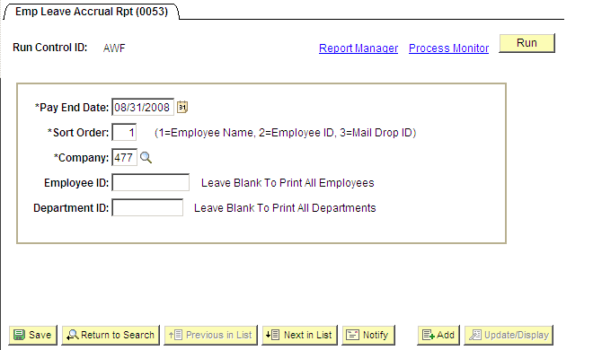

Pay End Date | To ensure accuracy, all leave statements must be run the last day of the pay period.
Sort Order | You have the flexibility to sort by Employee Name or PeopleSoft Employee ID or Mil Drop ID.
Company | Enter the agency number.
Employee ID | Enter the PeopleSoft employee ID to run the statement for one employee.
Department ID | Enter a department ID to run the statement for one department within your agency.

Enter the required data, click .

Set the following fields:

- Server Name: PSUNX
- Check mark is in the box next to OCBB0053
- Type: Web
- Format: PDF

Click to create the report.

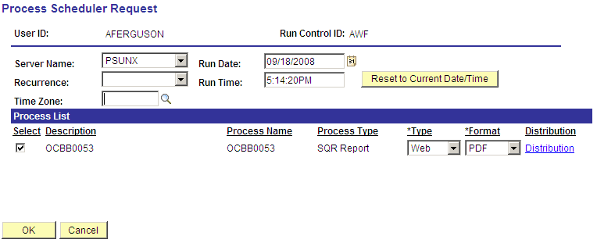

Click the Process Monitor link to view the status and to get to the statement.

Once in the Process Monitor page, find the OCBB0053 SQR Report and click the Details link.

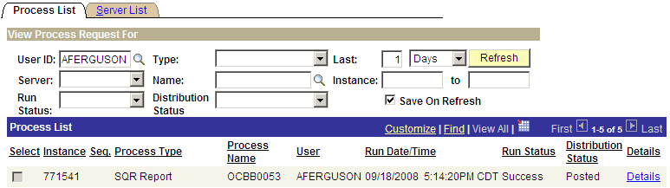

This will take you to the Process Detail page that shows a View Log/Trace link. Click View Log/Trace link to open the window where you will find a link to the PDF report that was created.

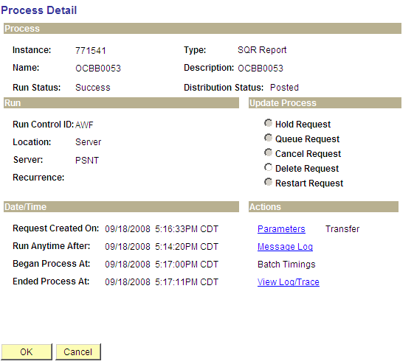

Click the OCBB0053xxxxxxx.PDF link to open the PDF file. You can then print the report according to agency procedures.

If you have a pop-up blocker application running on your internet explorer, you may need to disable it before the new window will open.
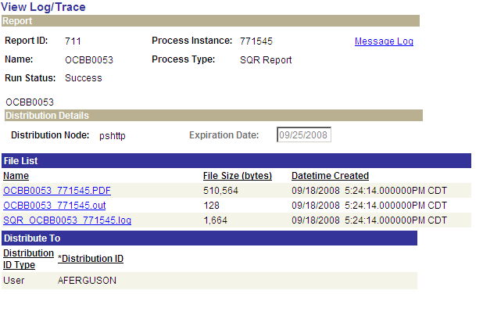

Report will be in a PDF file.

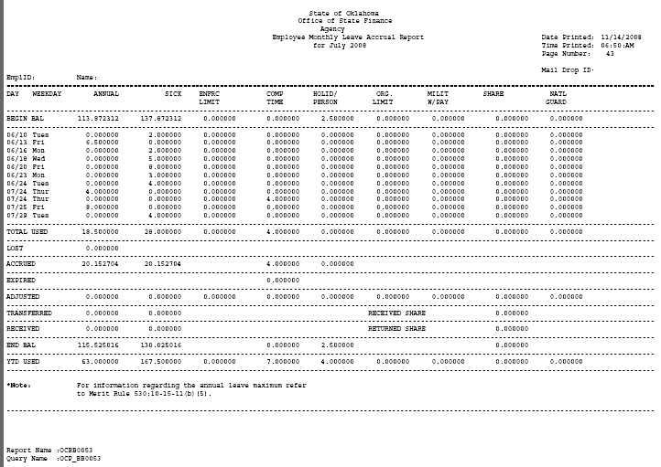

For biweekly agencies, the Leave Accrual Statement can be run biweekly.

Navigation: OK Custom Reports/Processes > OK Reports > Benefits > Bi-Wkly Emp Leave Accrual Rpt (0053)

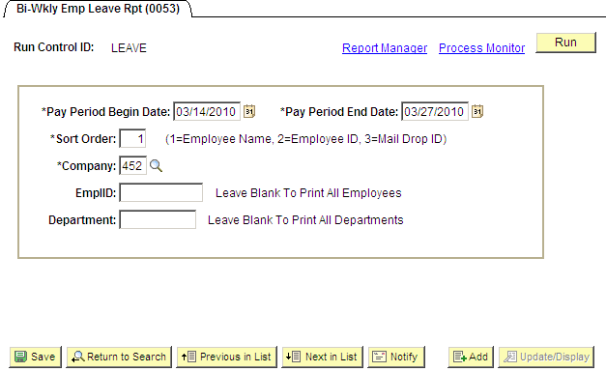

Pay Period Begin Date | Enter the first day of the pay period.
Pay Period End Date | To ensure accuracy, all leave statements must be run using the last day of the pay period.
Sort Order | You have the flexibility to sort by Employee Name or PeopleSoft Employee ID or Mail Drop ID.
Company | Enter the agency number.
Employee ID | Enter the PeopleSoft employee ID to run the statement for one employee.
Department ID | Enter a department ID to run the statement for one department within your agency.  Enter the required fields and click 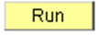 and continue the steps outlined for the Monthly Leave Accrual Statement for the Process Scheduler Request.

Inquiring on Employee Leave Balances
If your agency is maintaining leave balances in PeopleSoft, you will be able to see the employee’s balances throughout history via an online page. Each time the Leave Accrual Process runs, it inserts a row into this table so a history of the employee’s available balances and earned and taken hours are captured.

Navigation: Benefits > Manage Leave Accruals > Review Accrual Balances

Leave Accrual Balances Tab
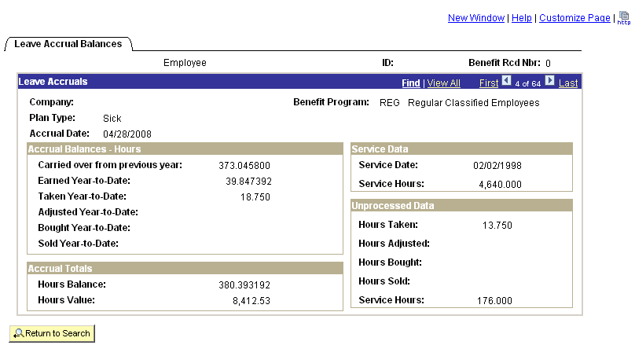

The employee’s Company, Benefit Program, Plan Type and Accrual Date display at the top of the page. Sick is Plan Type 50 and always displays first in the list. Annual leave is under the delivered Vacation Plan Type 51. The transactional fields are discussed below. The most recent Accrual Date will be the first row.

Carried over from previous year | If the employee can carryover unused hours from previous years, they will be displayed here. This field is only updated for the first Leave Accrual process of the year.
Earned YTD | This field shows the hours that the employee has earned so far this year.
Taken YTD | Likewise, this field shows hours taken.
Adjusted YTD | Lost Leave and other adjustments made to the leave will be combined.
Service Date | This date is the date the system used to determine the number of service months for the employee. The service months are used to calculate the employee’s accruals for the specific Benefit Plan they are enrolled in.

Service Hours | The number of service hours that have been processed (confirmed and paid) through payroll will be displayed.
Hours Balance | The amount of leave the employee has available.
Hours Value | The hours available multiplied by the employee’s current hourly rate.
Unprocessed Data | After you run the Payroll Confirm process but before you have run the Leave accrual process, hours may display here. As soon as you run the leave accrual process, the unprocessed hours will be moved to the Service Hours field in the Service Data box, the leave values will be reflected in the appropriate fields in the Accrual Balances section.  Unprocessed Hours Taken and Unprocessed Hours Adjusted update the Hours Balance in real-time. Any Unprocessed Hours Taken has reduced the Hours Balance for that same accrual date. Unprocessed Hours Adjusted has been added to the Hours Balance.

The following print screen shows what happens when the leave accrual process for 07/31/2005 is run. Any information from payrolls confirmed after the 06/30/2005 accrual process was run is stored in the Unprocessed Data box of that row. As this Unprocessed Data is populated with Hours Taken and Hours Adjusted, the Hours Balance displayed on the 06/30/2005 row changes. With the next accrual process run, the Unprocessed Data from the 06/30/2005 row is used to determine the Year-to-Date amounts for the 07/31/2005 Accrual Balances – Hours box.

The Hours Taken in the 06/30/2005 Unprocessed Data box is 36.23. This 36.23 comes from all time confirmed on payrolls after the 06/30/2005 accrual row was created. When the 07/31/2005 accrual process is run notice that the 36.23 hours taken is added to the Taken Year-to-Date of the 07/31/2005 row.

168.30 Taken Year-to-Date hours on the 06/30/2005 row.
+ 36.23 Hours Taken in the 06/30/2005 unprocessed data box.
= 204.53 Hours Taken Year-to-Date on the 07/31/2005 row.

Unprocessed hours also update the Hours Balance. The true balance on the 06/30/2005 row is determined by adding the 36.23 hours taken in the unprocessed box to the hours balance on the 06/30/2005 row.

0.006256 Hours Balance on the 06/30/2005 row.
+ 36.230000 Hours Taken in the 06/30/2005 unprocessed data box.
= 36.236256.

Positive Adjusted Hours add to the accrual. In order to calculate the true balance, reduce the Hours Balance by the unprocessed Adjusted Hours amount.

On the 06/30/2005 row of data the 168 service hours in the Unprocessed Data box is used to calculate the accrual amount for July. 168 X 0.057692 = 9.692256. This is then added to the Earned Year-to-Date amount from the 06/30/2005 row and displayed on the 07/31/2005 row as 69.230400. The only way to know the monthly accrual is to subtract the Earned Year-to-Date of the 06/30/2005 row from the 07/31/2005 row.

If you start at the true Hours Balance for July and add the accrual for August and subtract the hours taken and add the hours adjusted you will come up with the end balance for August.

36.236256 Hours Balance for July (after adding back in the unprocessed Hours Taken).
+ 9.692256 Accrual based on 168 service hours.
- 36.23 hours taken that posted and confirmed through payroll after the 06/30/2005 accrual process run.
= 9.698512 Hours Balance after the 07/31/2005 accrual process run.
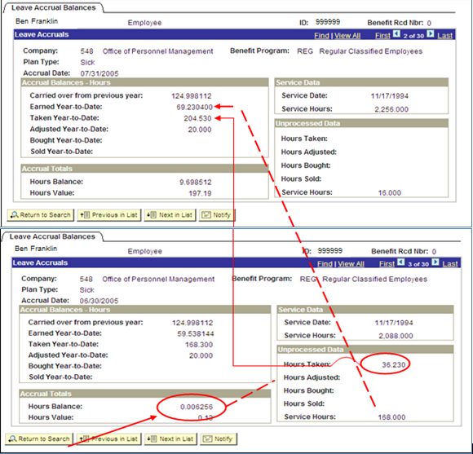

Remember, there will eventually be many rows of data in this display page, one for each time the leave accrual process updates the employee’s balances. You should learn to pay close attention to the Company, Plan type, and Accrual Date fields while using the button to move through the employee’s leave history. Together these fields should help you understand the rows of data available in this page.

