COR105 Maintaining Payroll

Records Manual

Authorized by: [_CORE_] Original Issue: [09/15/2009]
Maintained by: [____Accounts Payable Lead___] Current Version: [05/02/2016]
Review Date: [12/31/2016]

Table of Contents

Table of Contents 3
Document History 5
Maintaining Payroll Data Overview 6
Additional Pay 7
Overview 7
Job Information 10
Tax Information 11
Scroll Areas 11
Direct Deposit Processing 12
Overview 12
Direct Deposit Page 13
To Change or Update 15
Error Messages 15
Employee Tax Distribution 17
Maintaining Employee Tax Data 18
Overview 18
Federal Tax Data 18
State Tax Data 21
Local Tax Data (Not Used by the State) 22
Non-Resident Alien Tax Processing 23
Overview 23
Earnings as 1042 Eligible 24
PeopleSoft Delivered 1042-S Income Codes 25
Treaty NR Alien Table 26
Employee Set Up for 1042 Processing 28
Personal Data 28
Address History Page 29
Personal History Page 30
Identification Data 31
Employee Tax Data – 1042-S 34
Employee Federal Tax Data Page 34
Edits and Warnings 37
Inquiring on Employee 1042 Balances 38
Employee Garnishment 40
Overview 40
Garnishment Spec Data 1 41
Garnishment Spec Data 2 43
Garnishment Spec Data 3 44
Garnishment Spec Data 4 46
Disposable Earnings Calculations 48
Garnishment Spec Data 5 50
Garnishment Spec Data 6 51
Garnishment Spec Data 7 52
Adding the Garnishment Deduction 54
Payroll General Deductions 56
Overview 56
General Deduction Data 56
Payroll Options Pages 61
Overview 61
Payroll Options 1 62
Payroll Options 2 64
Payroll Data Inquiry Pages 66
Overview 66
Paycheck Earnings 67
Paycheck Taxes 69
1042 Tax Data 71
Paycheck Deductions 72
Garnishments 75
Net Pay Distribution 75
Paycheck Summary 76
Paycheck Summary 77
Earnings 77
Deductions 78
Taxes 78
Employee Payroll Balances 79
Check Year-To-Date Balances 79
Earnings Balances 81
Deduction Balances 84
Tax Balances 86
1042 Taxes 88
Garnishment Balances Page 90
Special Accumulator Balances Page 92
Review/Update Year End Data 93
Year End Data 94
Commitment Accounting 95
Overview 95
Funding Overview 95
Review Department Budget Table 96
Department Budget Table – Department Budget Date 97
Department Budget Table – Department Budget Defaults 98
Department Budget Table – Department Budget Earnings 100
Department Budget Table – Department Budget Deductions 102
Department Budget Table – Department Budget Taxes 103
Department Budget Table – Department Budget Actuals 104
Update Employee Funding 105
Add Position or Appointment Funding 111
Add Position Level Funding 112
Add Appointment Level Funding 117
Mid Pay Period Funding Changes 122
Funding Change on Payline 122
Actuals Distribution 127
Review / Correct Employee’s Actuals Distribution 127
Pre-Commitment Accounting Time 135
Process Time Prior to Commitment Accounting 135

Document History

Document Revision | Date | Description
1.0 | 09/15/2009 | Initial Document
1.2 | 12/22/2009 | Commitment Accounting Revisions
1.3 | 05/01/2010 | Updated for Direct Deposit and removed Job Data pages. Also, added to COR 301 Human Resources Manual.
1.4 | 07/20/2010 | CORE manual standardization
1.5 | 01/28/2011 | Eliminated US Savings Bonds section
1.6 | 05/02/2016 | Eliminated Earned Income Credit section

Maintaining Payroll Data Overview

PeopleSoft Payroll for North America gives you complete control over all aspects of payroll operation —from time reporting, payroll calculation, and tax computation to check preparation, payroll reporting, and tax reporting. You define and establish earnings, deductions, taxes, and processes that fit your business needs.

PeopleSoft Payroll processing is efficient and allows you to calculate a payroll on employees only where needed, such as when you've made a change to an employee's pay or when an error occurred previously and an employee's pay has not yet been calculated. Rather than processing all employees during each calculation the system can process only the ones flagged as needing to be calculated. Depending on the number of changes you make, it may only take a few minutes. You can run the calculate process multiple times before confirming a payroll.

You also have the option to recalculate the entire payroll on those rare occasions when you make a change to table information after you have calculated a payroll. For example, if you need to make an adjustment on a health insurance premium after you've calculated the payroll for a period, you must update the appropriate Benefits Tables. Then recalculate the entire payroll to ensure that the health deductions for all employees enrolled in that plan are calculated with the new rate.

This training manual will cover establishing and maintaining Payroll Data for PeopleSoft Release 9.0. The Employee Pay Data USA menu contains the pages that you will use to maintain employee payroll-specific data, such as tax information, additional pay, general deductions, savings bonds, direct deposit, and garnishments information.

These pages work in conjunction with the information entered on the employees’ Job and Base Benefit pages.

Additional Pay

Overview

The PeopleSoft Additional Pay pages store information about recurring payments made to an employee by the State. These are earnings paid to the employee on a regular basis in addition to their regular pay. The amount of the payment is specified, the frequency with which it will be paid, and if necessary, the date or goal amount at which it should stop.

When the State creates Paysheets, additional pay records that are marked as ‘OK to Pay’, and have not reached the end date or goal balance, will be added to the employee’s paysheet for payment on the employee’s check. These earnings will be located in the Other Earnings area of the payline. The State is using additional pay pages for the following types of payments:

- Benefit Allowances
- Remaining Benefit Allowances
- Housing Allowances
- Car Allowances
- Uniform Allowances

NAVIGATION: Payroll for North America > Employee Pay Data USA > Create Additional Pay

Enter the search criteria for the employee and click . If you know the employee’s ID, enter the number in the EmplID field. If you do not know the ID, you can do a search using the employee’s first or last name.

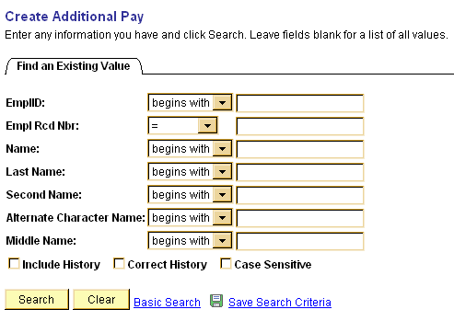
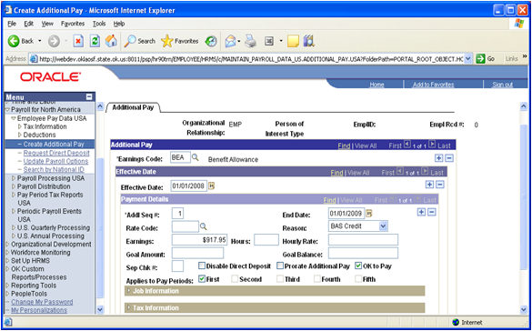

Select an Earnings Code using the lookup button. The Effective Date defaults to the current date and usually is changed because this is the start date of the additional pay that you are adding.

Enter the Addl Seq # 1 unless there are multiple additional pay records for an earnings type. If multiple additional pay records exist, this sequential number is increased by one.

When necessary enter an End Date if there is a specific date that this additional pay is to stop, (Ex: ‘BEA’ or ‘RBA’) otherwise leave this field blank.

Fill in the Goal Amount if this additional pay is to be paid out until a specific amount is reached. The application will keep track of the accruing total amount paid in the Goal Balance field. Once the amount in the Goal Balance field is equal to the Goal Amount field the additional pay process will stop.

NOTE: The Goal Balance field is updated only when a payroll confirmation process is completed successfully.

Enter the Earnings amount and check the box. The OK to Pay selection allows this payment to be added to the employee’s payline for disbursement on the employees check. If you leave the OK to Pay box blank, the system will ignore this setup.

The Applies to Pay Periods check boxes designates when the earnings are to be added to the employee’s payline. All the check boxes will default as selected. Update the check boxes appropriately, checking only the First for employees being paid monthly or, where appropriate, bi-weekly. Sometimes an employee on a bi-weekly pay cycle will have both the First and Second pay periods checked.

Click to save the page.

Other fields on this page that the State of Oklahoma currently doesn’t use are:

Rate Code | If you select a rate code for the additional earnings, the system uses the rate or percent defined for the rate code on the Compensation Rate Code table, Job Code table, or Employee Compensation table.
Hours, Hourly Rate | Enter as necessary, depending on the type of earnings being paid. Used in place of entering data in the Earnings field.
Sep Chk# | Enter a number (starting with “1”) if the earnings should be paid on a separate check.
Disable Direct Deposit | Click the box if the earnings should not be included in the direct deposit advice but should be paid on a separate check.
Prorate Additional Pay | Click the box if you want the system to pay a prorated amount when the effective date falls in the middle of the pay period.

Job Information

To view this information, click the in front of Job Information

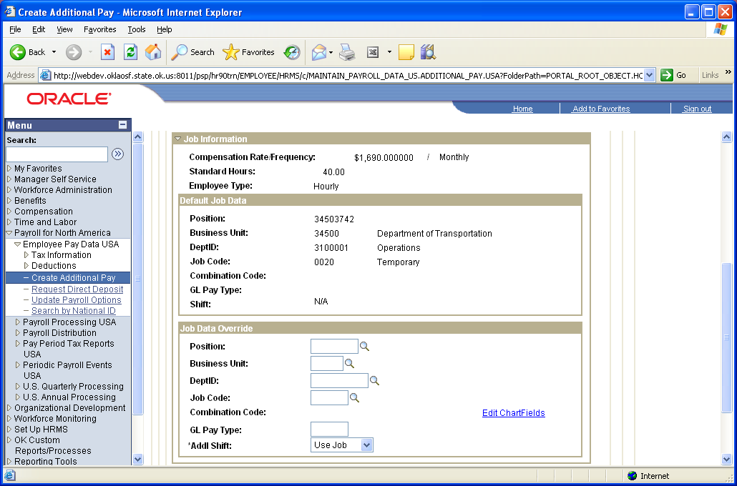

This group box displays the job data information as entered on the employee's Job record. The Combination Code is “blank” due to the fact that Additional Pay will be charged to the GL account(s) defined on the Department Budget Table.

Tax Information

Use the Tax Information group box to change any of the employee’s default tax information.

To view this information, click the in front of Tax Information

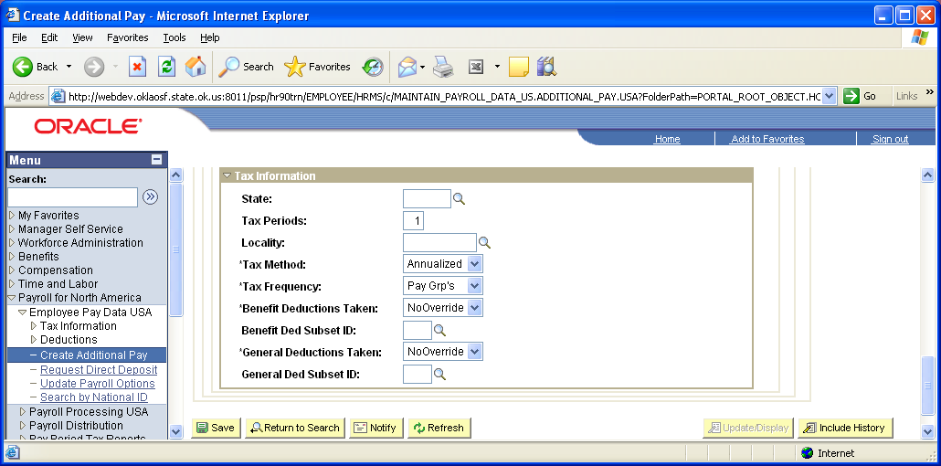

Scroll Areas

The Additional Pay page is made up of three scroll areas. The Additional Pay scroll area contains the Earnings Code to be paid. To insert a row, click the sign at the top right corner of the page.

Inserting rows at this level will pay multiple earnings to the employee.

The Effective Date scroll area will control when the earnings begin. To insert a row, click the sign across from the effective date.
The Payment Details scroll area controls how the earnings should pay on the specified effective date. To insert a row, click the sign.

Direct Deposit Processing

Overview

Direct deposit information for the State of Oklahoma will be entered at the Agency level for the primary job only. The State will give each employee the option of one direct deposit account. When an employee submits paperwork for direct deposit and the data is entered into the system, the next pay cycle that is processed for the employee, his/her net pay will be electronically transferred to the employees account. The State of Oklahoma will no longer process prenotes with the banks.

Establishing Employee Direct Deposit
Use this page to enter the information to enable the direct deposit of employee pay to checking and/or savings bank accounts

Navigation: Payroll for North America > Employee Pay Data USA > Request Direct Deposit > Direct Deposit

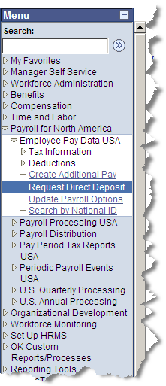

Direct Deposit Page

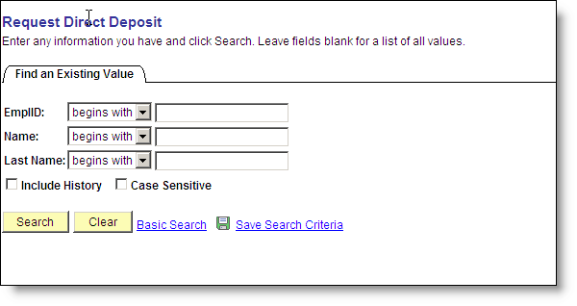

To select an employee, enter the EmplID in the search criteria field and click . If you don’t know the EmplID you enter the Last Name in the appropriate search field.
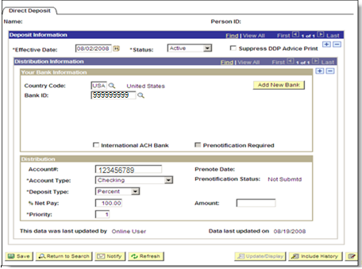

Once you receive direct deposit paperwork from an employee, begin defining the direct deposit details. The employee should have included a cancelled check with the routing/transit and account numbers along the bottom. You will need to enter the correct digits for the Bank ID (bank routing number) and the Account (Bank Account Number) into the Direct Deposit page. Numbers are usually listed across the bottom of the check, as described below.

Routing Number Check Number Account Number (Note: order may vary according to banks).
(Bank ID)

Example: 999999999 5646 123456789

Enter the Effective Date and set the Status to “Active”.

Enter the Bank ID and Account#.

Click and select the Account Type (as specified on Direct Deposit form) from the drop down list.

Click and select the Deposit Type from the drop down list, this will always be Percent.

Enter “100%” in the % Net Pay field.
Set the Priority to “1”

Information in the Data last updated fields is entered by the application. It displays information about the user and last time the data was updated.

Click .

To Change or Update
If you need to change/update a direct deposit you will need to add a new row, enter new effective date and enter the new information.

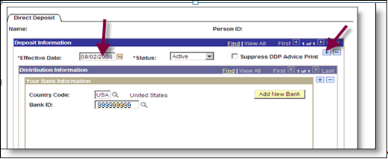

Click .

Error Messages

If an Account Type of Savings or Checking is selected, PeopleSoft runs a validation to ensure that the Bank ID and Account Number fields are filled in. The system issues the following error message if either of these fields is blank:
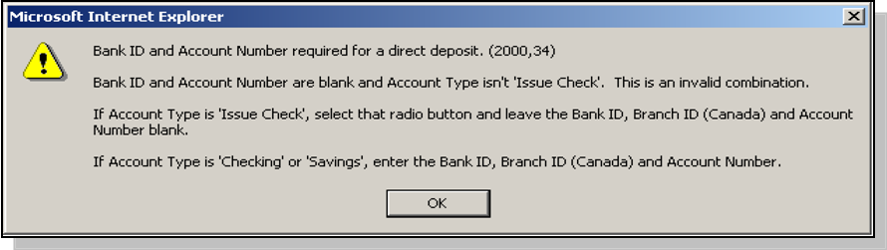

NOTE: This is an error message and not a warning. The data must be entered to save this page.

Other fields on this page that the State of Oklahoma currently doesn’t use are:

Add New Bank | Do Not Use You will get an error message – You are not authorized to access this component.
International ACH Bank | If checked, you will receive error message when you save. At this time, the International Direct Deposit is not available.
Amount | Oklahoma does not use this field
Suppress DDP Advice Print | Do Not check this box  - The State has not yet implemented the self-service portion of PeopleSoft that would allow this functionality.
Priority | The State of Oklahoma only allows an employee one direct deposit definition. There will always be a 1 in this field.
Prenotification Status and Prenote Date | The State of Oklahoma no longer prenotes. The defaulted in data is ignored.
Prenotification Reqd) | The State of Oklahoma no longer prenotes. This box is grayed out not allowing access to the check box.

Employee Tax Distribution

NAVIGATION: Payroll for North America > Employee Pay Data USA > Tax Information > Update Tax Distribution

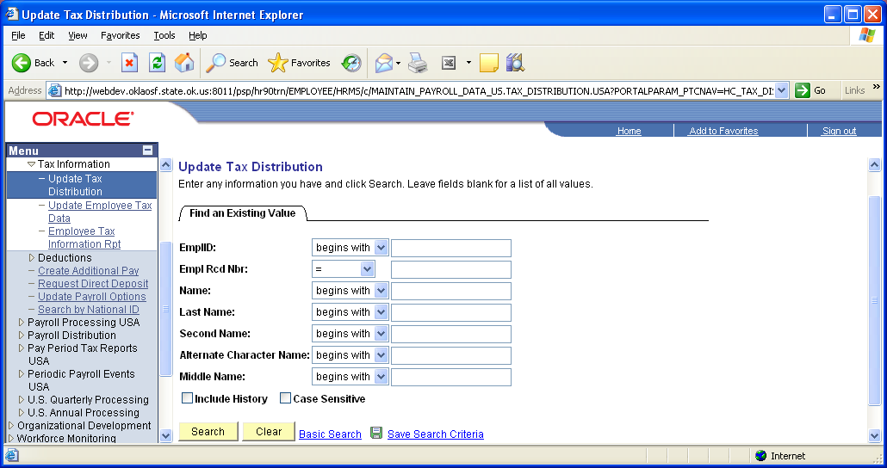

Select an employee, enter the criteria, click .

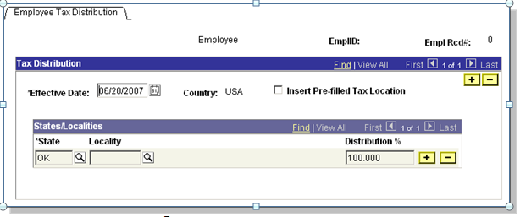

Maintaining Employee Tax Data

Overview
One of the core data elements that PeopleSoft Payroll needs to correctly compensate an employee is tax information. The Employee Tax Data pages must be completed to identify the type of State and Federal Tax information that needs to be maintained, along with the exemptions, additional withholding amounts, etc.

When a new employee is hired in PeopleSoft, the employee’s tax records should be updated to reflect their correct W-4 information.

NOTE: The information on this page defaults in a Single with one (1) exemption.

Federal Tax Data
The Federal Tax Data page is used to enter and maintain the federal tax information that the system uses to calculate federal taxes for employees.

NAVIGATION: Payroll for North America > Employee Pay Data USA > Tax Information > Update Employee Tax Data > Federal Tax Data

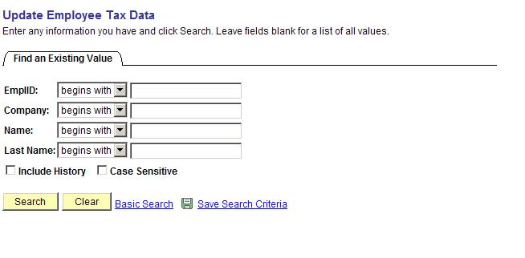

Select an employee, enter the criteria, click .
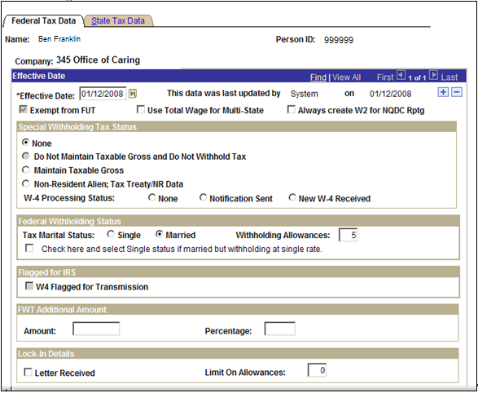

Enter the Effective Date of the employee’s hire and choose the correct Tax Marital Status.

NOTE: If adding tax data information for the first time on an employee the Effective Date should always be the same as the Hire Date on his/her Job Data record. The Federal, State, and Local Tax Data pages are a set of “chained” pages. The effective date field is only enterable on the Federal Tax page and is display only on the State and Local pages.

Critical CAUTION: The Special Tax Withholding Status ”Do Not Maintain Taxable Gross and Do Not Withhold Tax” should NEVER be selected and is grayed out for that reason.

Enter the number of allowances in the Withholding Allowances field.

For an employee who elects to have additional withholdings deducted, you will use the FWT Additional Amount group box. You can specify both an amount and/or a percentage in this group box.
Other fields on the Federal Tax Data page where data is defaulted in, and/or could be used, are as follows:

Federal Tax data last updated by | This field displays the last entity to update the record, along with the date of the update.
Exempt from FUT | Depending on the Agency (Company), the system has been configured to default employee to FUT and SUT exempt or eligible. This default controls the values in these checkboxes, and is grayed out at the employee level for the State of Oklahoma.
Use Total Wages for Multi-State Employee | PeopleSoft will include wages from multiple states to calculate state tax if this box is checked.
Special Tax Withholding Status | None - This tax status indicates that the system should refer to the delivered Federal tax table in its calculation of the employee’s taxes.  Maintain Gross - This option overrides the normal tax calculation.  If you do not indicate any amount or percentage in the Additional Withholding Amount or Percentage fields, the system will maintain a gross earnings balance but will not withhold any FWT. You can fill in an amount or percentage in the Additional Withholding Amount or Percentage fields and the system will withhold only what you specify.  Do Not Maintain Taxable Gross and Do Not Withhold Tax – This option should NEVER be selected.  It will result in FWT not being withheld from the employee's pay and no Federal Taxable gross balance being maintained.
W-4 Processing Status | PeopleSoft offers functionality that can alert you to employees who have claimed tax-exempt status on their W-4.  None - If the employee has no special exempt status.  Notification Sent - If you have notified the employee to submit a new Form W-4  New W-4 Received - If the employee has submitted a new W-4 indicating tax-exempt status
Tax Marital Status | Use these fields to reflect the employee’s marital status for federal withholding taxes, as indicated on the submitted form W-4.
Withholding Allowances | Enter the number of allowances that the employee claims for federal withholding tax purposes. This number should match the number on the employee's W-4 form.
Letter Received | Use this checkbox to indicate that the IRS has sent the State a letter mandating that an employee’s withholding allowances cannot exceed a limit.
Limit on Allowances | If the above is true, you will enter the maximum number of allowances possible.

State Tax Data
This page is used to enter and maintain state tax information that the system uses to calculate state taxes for employees

Click the State Tax Data Tab.

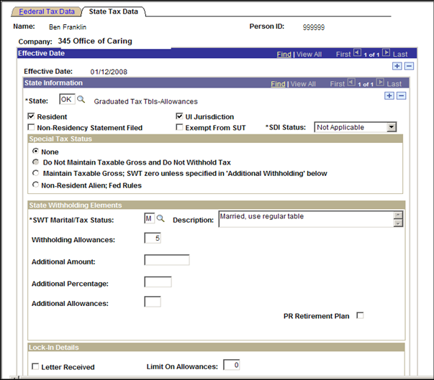

NOTE: The State only taxes and collects Unemployment Insurance (UI) for the state of Oklahoma even if the employee resides in another state.

Select the State ‘OK’ using the lookup button. Click the Resident checkbox to indicate that Oklahoma is the employee’s state of residence. Click to save these pages.
Other fields that can be filled in are as follows:

UI Jurisdiction | Select the UI Jurisdiction check box if the state selected in the State field is the state of jurisdiction for unemployment insurance tax. This field will always be selected for Oklahoma.
Special Tax Status | Select None to indicate that no special tax status exists for the employee The system will calculate state withholding tax based on the employee's gross, marital status, and withholding allowances.
Maintain Gross Taxable | Select this option to override the normal tax calculation. If you do not use the amount or percentage fields in the Additional Amount Adjustment group box, no State withholding will be calculated for the employee. If you do use the amount or percentage fields, the system will withhold either the flat amount or a percentage of the taxable wages.
Do Not Maintain Taxable Gross and Do Not Withhold Tax | Selecting this option will indicate that state withholding taxes should NOT be withheld from the employee's pay and that not balances for taxable gross will be maintained.
Non-Resident Alien | The State will use this check box to calculate state taxes using the same treaty rule as used for federal tax calculations. Please see 1042 processing for details, beginning on page 14.
SWT Marital/Tax Status  (State Withholding Tax Marital/  Tax Status) | Select the appropriate marital/tax status for state withholding taxes, as indicated on the employee’s W-4.
Withholding Allowances | Enter the number of allowances that the employee claimed for state withholding on the W-4 form.
Additional Amount | If the employee elects to have additional withholding deducted, you will use these fields to indicate that additional taxes are to be taken. You can specify both an amount and a percentage.
SDI Status | The default should be correct, It reflects the value of the SDI Deduction on the State Tax Table and is derived from the Employee's SDI Status entered on his or her Company Table.

Local Tax Data (Not Used by the State)

The State of Oklahoma does not collect Local Taxes. This page is not available.

Non-Resident Alien Tax Processing

Overview
The State University system extends scholarships and fellowship funding to students from outside the US which there are special US tax laws for these funds. To accommodate these situations, the U.S. government has entered into tax treaties with nearly 40 foreign jurisdictions. (PeopleSoft delivers treaty definitions for these countries). Income tax treaties serve to coordinate the tax systems of the United States and other countries that are parties to these treaties. Treaty provisions affect the taxation of non-resident aliens working in the U.S. While tax treaties are generally based on a standard model, each treaty might have slightly different provisions, depending on the country’s specific negotiated rules.

To claim the benefits of a treaty, an employee must have a visa and be a resident of one of the treaty countries. An employee can claim benefits of only one treaty at any given time. Employees who want to claim benefits under a tax treaty must submit a written statement and applicable forms (W-4, Form 8233, and Form 1001) to the State of Oklahoma.

As an employer, the State must apply the specific treaty rules when calculating federal withholding tax. These rules often include time limits and earnings caps. Different types of earnings, such as scholarships, grants, and fellowships, might be subject to different taxation rates. The State must produce Form
1042-S and a 1042 Summary Form for each non-resident alien employee affected by the special withholding rates. (If the State files 250 or more 1042-S forms, reporting must be done on magnetic media.) Earnings reported on a 1042-S are not reported on a W2. Employees may need both a W2 and a 1042-S if some earnings are covered by the special tax treaty rates and some are not. In addition to employees covered by tax treaties, some non-resident alien employees, such as those with specific types of earnings (i.e. scholarships, fellowships, and grants) must also have those earnings reported on a 1042-S.

Countries participating in tax treaties with the United States should have an entry in the Treaty/NR Alien Table. This manual will cover setting up and maintaining 1042-employee tax information. Complete the following steps to properly tax a Non-Resident Employee.

- Select the appropriate earnings code that is linked to 1042 income codes.

- Establish/Maintain Treaties in the Treaty/NR Alien table.

- Specify the employee’s 1042 status on the Employee Tax data page.

- Track 1042 balances

- Produce 1042 forms for Non-Resident Employees

Earnings as 1042 Eligible
PeopleSoft delivers specific earnings codes that are setup and recognized by the application as an earnings code that is eligible for 1042 tax processing. These earnings codes are as follows:

Earnings Code | Description
12R | Royalties
15S | Scholarship/Fellowship Grants
16I | Independent Personal Services
17D | Dependent Personal Services
18T | Teaching
19S | Study and Training

To view the setup of one of these earnings codes you would navigate to the Earnings Table.

NAVIGATION: Set Up HRMS > Product Related > Payroll for North America > Compensation and Earnings > Earnings Table

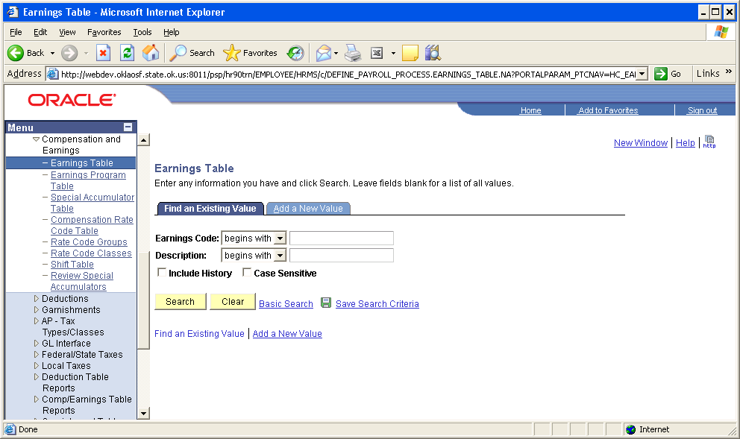

To review a specific earnings code, enter the earnings code and click .
On the Taxes Tab, in our example, the Income Code (for 1042-S) field has been specified as Schol/Fell. This configuration links the earnings to a special income code and tax treaty, insuring proper taxation of the specific Earnings Code. Income codes are delivered values that designate categories of earnings typically received by Non-Resident Alien employees.

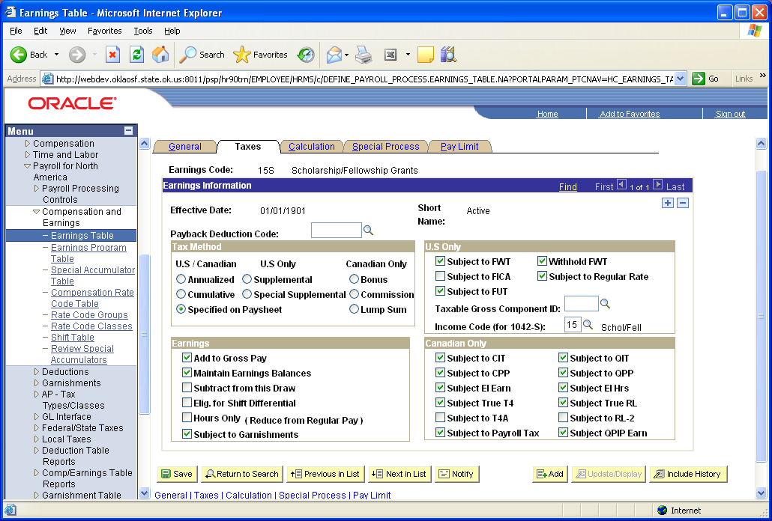

PeopleSoft Delivered 1042-S Income Codes
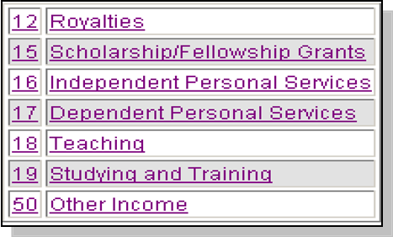

NOTE: If a 1042-S employee is not paid by one of these earnings code, the system will NOT apply the special taxation indicated for the treaty and will tax the earnings as W-2 instead.

Treaty NR Alien Table

The State will use this page to capture the tax rates specified in tax treaties (including exempt earnings, which are recorded with a 0% tax rate). This table identifies those earnings, indicated by Income codes, subject to a flat withholding tax. The percentage of tax calculated depends on whether the employee has provided the correct forms indicating an alien and special taxation status. To view the PeopleSoft delivered tax treaties you will need to navigate to the Treaty/NR Alien Table.

Navigation: Set Up HRMS > Product Related > Payroll for North America > Federal/State Taxes > Treaty/NR Alien Table

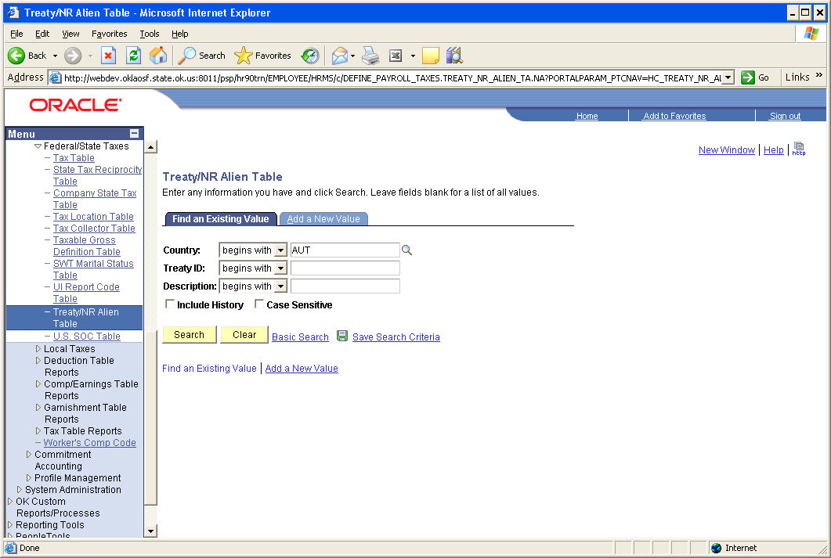

To select an existing value, enter the Country and click .
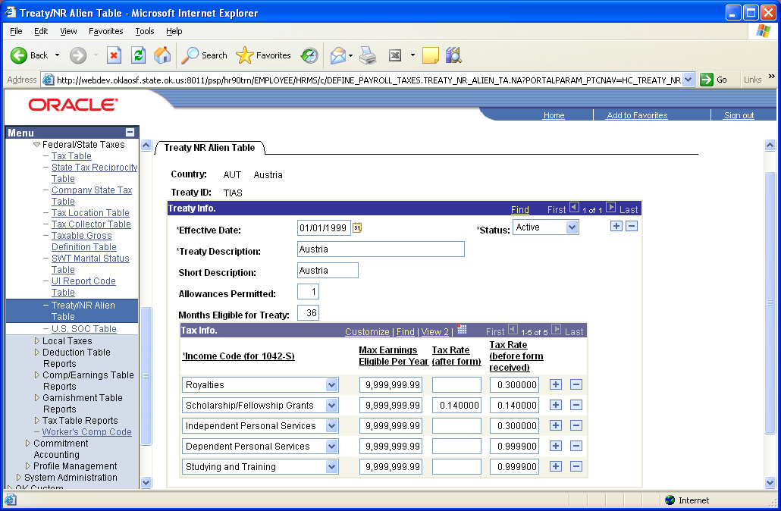

Country | To establish entries on the Tax Treaty NR Alien Table that are applicable to more than one country (for example, to use for all scholarship income that is to be taxed at 30%), you can use any value prefixed by a $ in the country code (for example, Country = $S).
Allowances Permitted | For each tax treaty record you establish, specify the number of allowances permitted by the treaty.
Income Code (for 1042-S) | Select each type of earnings subject to special tax treatment under the treaty.
Max Earnings Eligible per Year | Specify the earnings caps that apply for each earnings type.
Tax Rate (after form) | Specify the taxation rates that apply for each earnings type once the employee has submitted an 8233, W-8, W-8 BEN, or W-9 form.
Tax Rate (before form received) | Specify the taxation rates that apply for each earnings type if the employee neglects to turn in one of the forms listed above before the end of the pay period.

Employee Set Up for 1042 Processing
There are several components to be completed for 1042 Processing. The Personal Data and Identification Data pages have to be set up in Human Resources and additional tax data entered in Payroll.

Personal Data
The Personal Data page is used to show the employee’s address in their home country, as well as show proof of eligibility to work in the U.S.

Navigation: Workforce Administration > Personal Information > Modify a Person

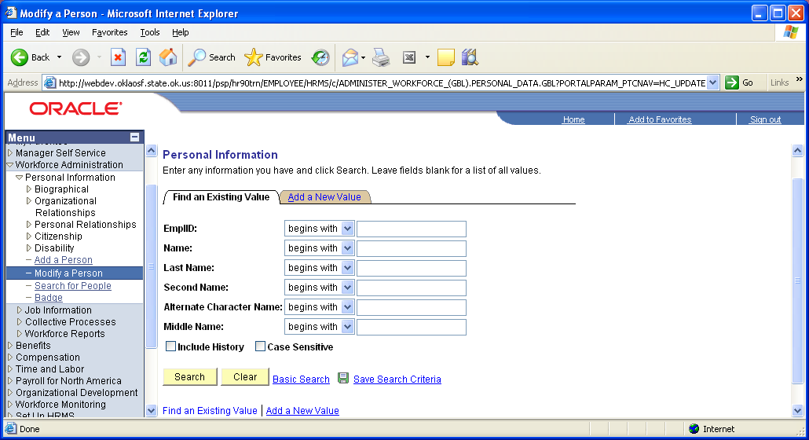

To select an employee, enter the criteria and click .

Address History Page

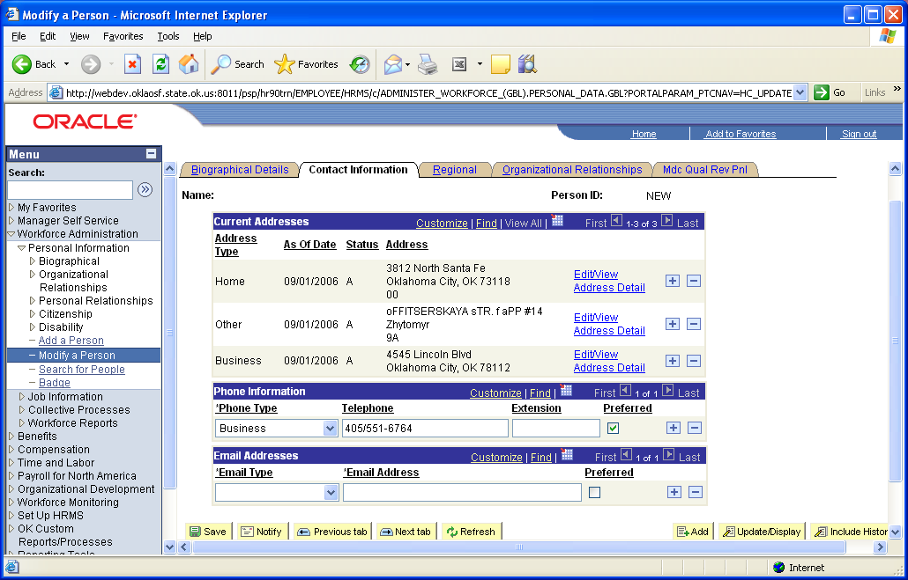

The employee should have three (3) addresses listed:

Address Type Home – Lists the employee’s address in the United States
Address Type Other – Lists the employee’s actual home address in their respective country.
Address Type Business – Lists the employees work address.

Personal History Page

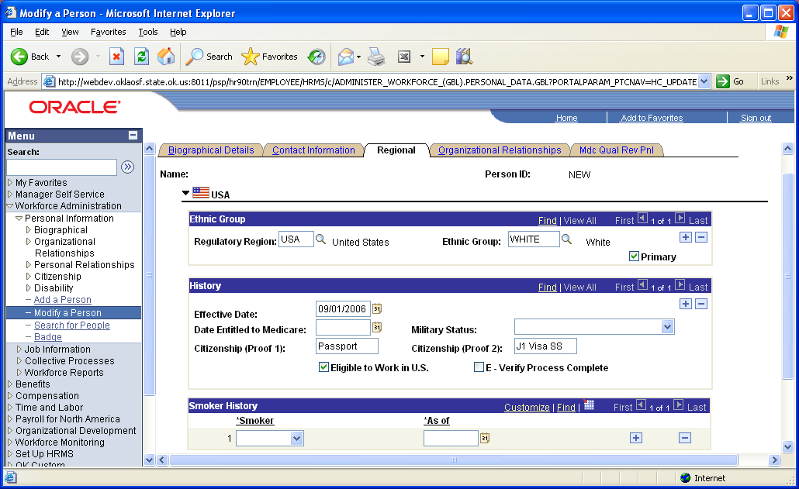

Select the checkbox next to Eligible to Work in U.S. Enter two forms of identification in the History group box (Citizenship (Proof 1): and Citizenship (Proof 2): fields) to show which documents were used to verify that the employee is legally eligible to work in the United States.

Identification Data

The Identification Data pages list information on the employee’s Passport and Visa/Permit.

Navigation: Workforce Administration > Personal Information > Citizenship > Identification Data

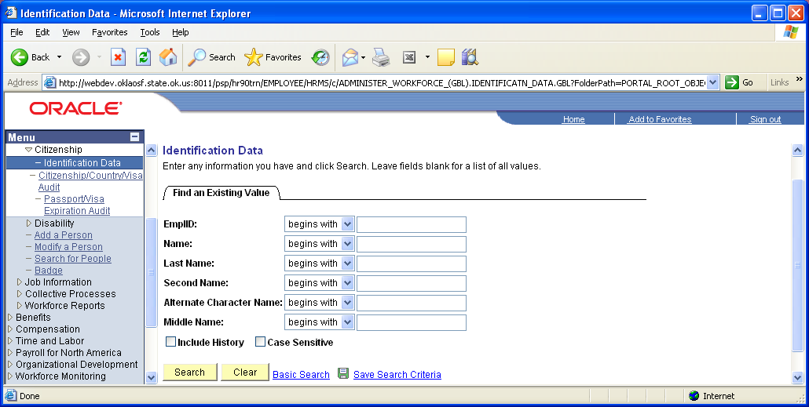

To select an employee, enter the criteria and click . Then click the Visa/Permit Data Tab.
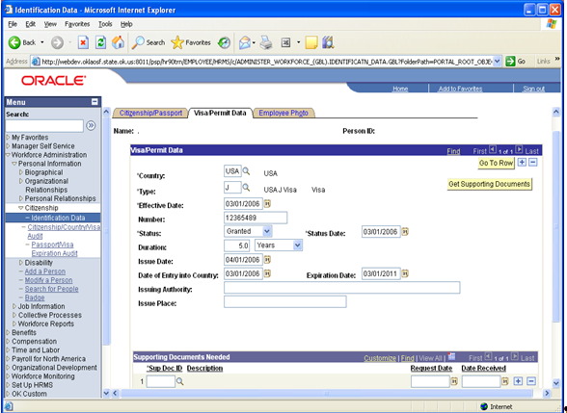

NOTE: You can also be transferred to this page when you click Visa/Permit Data on the Biographical Details page.

Country – Enter or click and select the country to specify the issuing country for the individual’s visa or permit.
Type – Click and select the type of visa or permit from the Visa/Permit Table page. The available types are based on the country specified.

Effective Date – Enter the date on which the visa or permit is effective or the date which the information should become effective in your database.

Number – Enter the issuance number from the official visa or permit.

Status – Select the status of the visa or permit. Values for this field are delivered. Do not try to modify these values in any way.

Duration – Specify the length of time during which if visa or permit is valid.

Issue Date – Enter the date of issuance from the visa or permit.

Date of Entry into the Country – Enter the official date on which the individual entered the country.

Expiration Date – Enter the date on which the visa or permit expires. The system calculates the expiration date based on the specified duration and the date of entry into the country. You can override the system-calculated date.

Issuing Authority – This is the name of the agency or authority that issued the visa or permit.

Issue Place – The data entered here is the location where the official visa or permit was issued.

Supporting Document ID – Select the supporting documents required for this type of visa or permit.

Get Supporting Documents – Click to retrieve the supporting document IDs and descriptions from the Visa/Permit Table page for this type of visa or permit.

NOTE: The button is used to have the system enter a list of appropriate supporting documents needed to obtain the visa/permit type you entered in the Supporting Documents Needed group box. This is NOT used by the State of Oklahoma.

Request Date – Enter the date on which your agency requests the supporting document(s). (NOT used by the State of Oklahoma).

Date Received – Enter the date that your agency received the supporting document(s) (NOT used by the State of Oklahoma).

Employee Tax Data – 1042-S

The State of Oklahoma must indicate that the employee is eligible for 1042-S tax processing on the Federal tax data page. To claim benefits of a treaty, an employee must have a visa and be a resident of one of the treaty countries. An employee can claim benefits for only one treaty at any particular time. Employees who want to claim benefits under a tax treaty must submit a written statement to their employer, along with applicable forms.

Indicate that the employee is a non-resident Alien in the Special Tax Withholding group box on the Federal tax data page. The information in this group box assigns the employee to a tax treaty table and enables the eligible employee to be subject to a reduced tax treaty rate.

Employee Federal Tax Data Page

Navigation: Payroll for North America > Employee Pay Data USA > Tax Information > Update Employee Tax Data

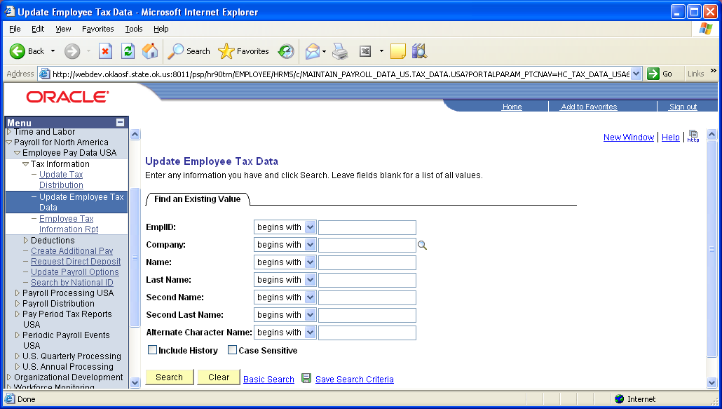

To select an employee, enter the criteria and click .

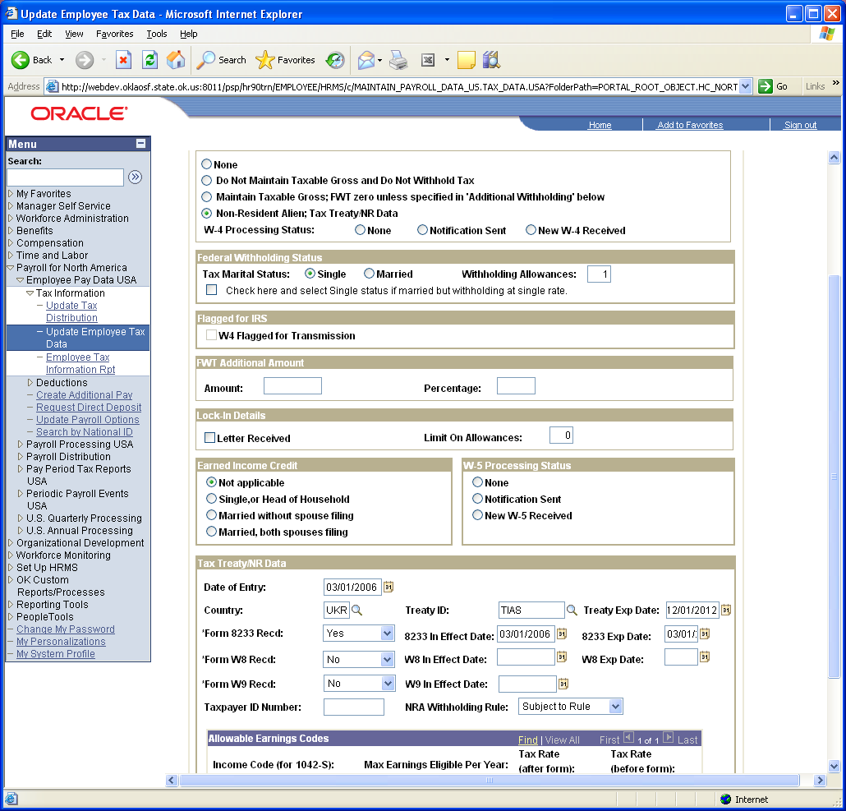

In the Special Tax Withholding Status group box select the radio button next to Non-Resident Alien; Tax Treaty/NR Data. This will instruct the system to tax the employee as a Non-Resident Alien. When this option is selected provide the appropriate taxation information for the Non-Resident Alien on the Tax Treaty NR Data group box.

In the Tax Treaty/NR Data group box enter the Date of Entry and select the Country using the lookup button. Enter the Treaty ID of TIAS and the system will default the Expiration Date. Then select Yes for Form 8233 Recd and the effective date and expiration date of the 8233 Form.

Further explanation of the fields on this page follows:

Country | Select a country from the delivered list, or select one of the generic or State entries that are prefixed with $ that you may have established on the Tax Treaty NR Alien Table.
Treaty Exp Date  (Treaty Expiration Date) | The treaty expiration date defaults in. The system calculates the date based on the Date of Entry and rules established on the Tax Treaty/NR Data Table.
Form 8233 Recd? | Form 8223 is required for all income codes except 15 (scholarships and fellowships). Select Yes or No from the drop down list, and enter the appropriate date in the 8233 In Effect Date field.
Form W8-BEN Recd? | Form W8-BEN, formerly Form 1001, is required for scholarship and fellowship income. (The W-8 is a certification of Foreign status). Select Yes or No from the drop down list, and enter the appropriate date in the W8-BEN In Effect Date field.
Form W9 Recd? | If applicable to the employee, select Yes or No from the drop down list, and enter the appropriate date in the W9 In Effect Date field. Form W9 was formerly known as Form 1078. (The IRS prefers the W-8 form, but the W-9 is the State’s way to certify and identify a taxpayer’s identification number (TIN)).
Taxpayer ID Number | Enter the taxpayer ID number (TIN) of the employee. If you enter a value here, the system uses this value instead of the SSN when producing the 1042 forms/magnetic media.

PeopleSoft populates the Allowable Earnings Codes group box with information entered on the Treaty/NR Alien Table page according to the Country and Treaty ID you specify.

Max Earnings Eligible Per Year | This is the earnings cap that applies to each earnings type per the tax treaties for nonresident aliens.
Tax Rate (after form) | For nonresident aliens, whose forms (8223 or W8-BEN) have been completed and are in effect, this is the tax rate that is applied to their income until the income exceeds the maximum earnings specified.
Tax Rate (before form) | For nonresident aliens this is the tax rate that is applied to the employee's income if their forms (8223 or W8-BEN) have not been completed.

Edits and Warnings

The system will check to see if the Country you specify is the same as that on the employee’s Personal Information data. If not, it will issue the following warning:

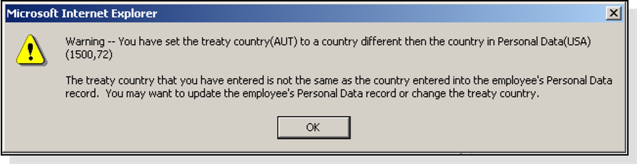

The system also runs a validation to ensure that the employee that are eligible for 1042 tax processing have a Visa on record.

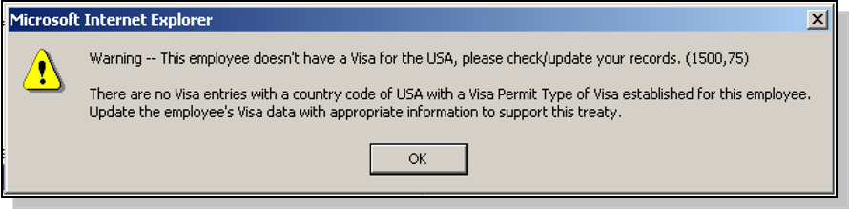

NOTE: These warnings indicate that the employee may have set-up issues and require changes on other records. Please contact the OSF or your local HR administrator office with any questions before saving.

The system will re-set the treaty date (even if you had not yet entered a date in that field). The date will reflect the value on the Treaty table for the country specified. This is a message only and does not indicate any problem or error.

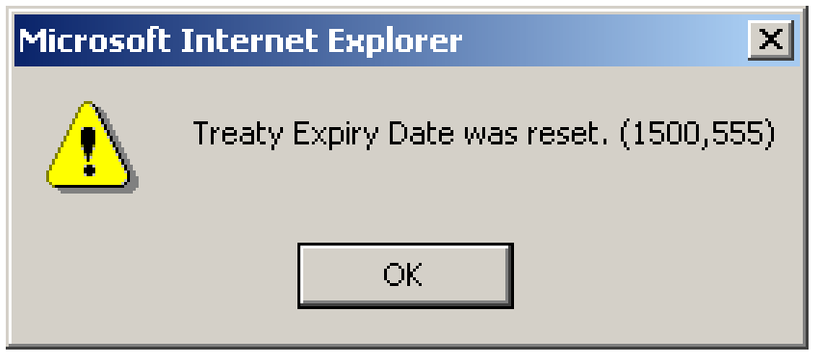

Inquiring on Employee 1042 Balances

Once you have confirmed payroll(s) for employees with 1042 tax statuses, review the Taxable Gross and Tax Balances. PeopleSoft provides inquiry pages for viewing 1042 tax balances.

Navigation: Payroll for North America > Periodic Payroll Events USA > Balance Reviews > 1042 Taxes

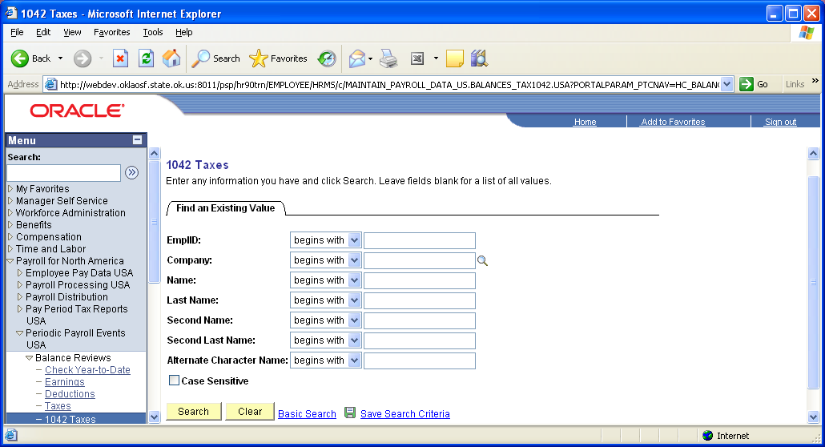

To select an employee, enter the criteria and click .
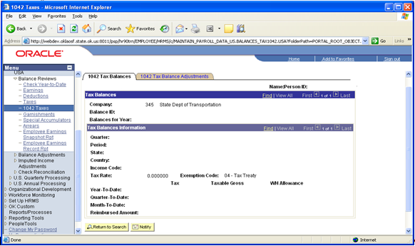

The Tax Balances scroll area displays the employee’s balances by Company, Balance ID and balance year.

The Tax Balances Information scroll area displays the specific tax treaty entity and details about how the tax was calculated. Organized by Quarter, balance period and treaty, it also displays the Year, Quarter, and Month-to-date totals for the tax and taxable gross.

Click the YTD 1042 Adjustment Tab to see any 1042 tax balance adjustments that have been made for the employee.

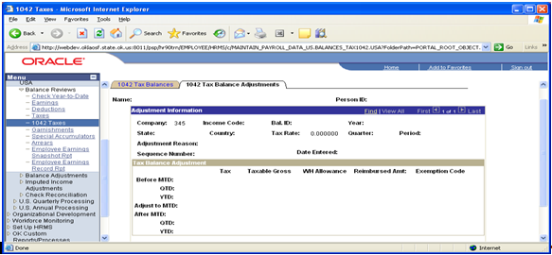

Employee Garnishment

Overview
PeopleSoft delivers extensive garnishment functionality to accommodate most court orders. Some of the functionality is listed below:

- Integrated payroll deduction of Garnishments based on individual employee Garnish Specifications
- Disposable earnings definition that is configurable by the State
- Record of the Vendor or Payee that should receive the garnishment once deducted
- The ability to do a one-time suspension of a garnishment deduction on the paysheet

PeopleSoft maintains the Garnishment rule information and calculation rules, but the state can add additional rules when needed. The State can also select the composition of an employee’s Disposable Earnings. All employee garnishments will be entered and maintained within PeopleSoft at the Agency level. Each Agency will enter, maintain, and stop an employee’s garnishment using the Garn Spec pages.

Navigation: Payroll for North America > Employee Pay Data USA > Deductions > Create Garnishments

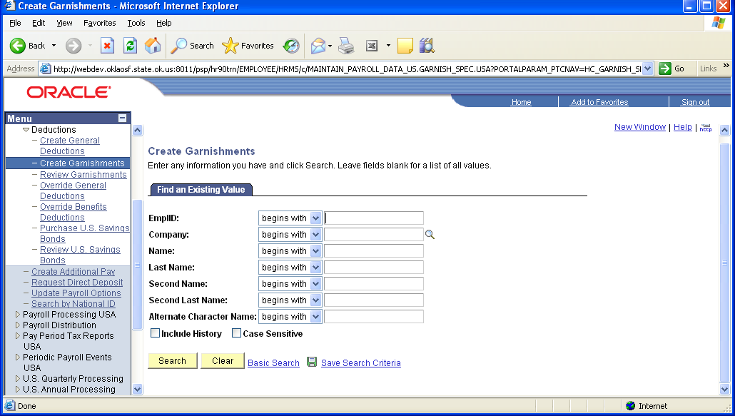

To select an employee, enter the criteria and click .

Garnishment Spec Data 1

Use the Garnishment Spec Data 1 page to enter garnishment order information.
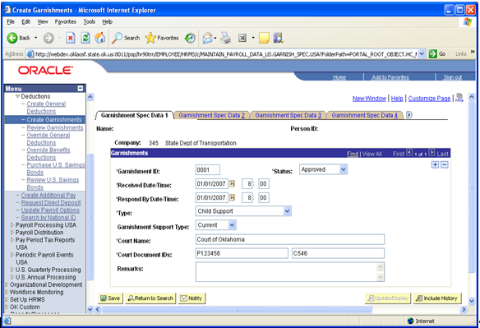

NOTE: You can define only one garnishment specification for each garnishment order that you receive for an employee. The system requires that each garnishment specification have a unique garnish ID.

Enter the Garnish ID and select the Status of “Approved” from the dropdown list. Enter the Received Date/Time and the Respond By Date/Time.

Click to select the Type from the dropdown list (Current or Arrears).

Enter the Court Name and Court Document IDs - these fields must be entered.

Remarks Field – Optional

NOTE: These garnishment spec pages are subject to court subpoenas so be careful what you put in the remarks fields.

Status | You will use this field to update the status of the garnishment as it changes over time.  Received: Select this value when you establish a new garnishment record. You can also use it to test the garnishment deduction before you put it into production via an online check scenario.  Approved: Use this value to indicate that you will be complying with the issuing authority.  Completed: Select this value when the garnishment is paid in full.  Rejected: Select this value if you cannot comply with the garnishment or levy. For example, if you have terminated the employee and there are no wages to garnish, you can reject the garnishment.  Suspended: Use this value to stop the garnishment deduction while preserving the garnishment specification data.  If you choose Received or Approved, the system will process the garnishment when you run Pay Calculation. If you select Completed, Rejected, or Suspended, the system will ignore the garnishment during the Calculation process.
Received Date/Time | Enter the date and time the state received the garnishment from the court, authorized agency, or government agency.
Respond  By Date/Time | Enter the date and time by which the State must tell the court, authorized agency, or government agency whether you can comply with the garnishment order. (If the employee is no longer employed, you cannot garnish wages)
Type | Select the type of garnishment or levy from the following list:  Writ of Garnishment: Typical garnishment type for failure to pay.  Tax Levy: Failure to pay taxes. (Federal or State)  Chapter 13 Bankruptcy: Bankruptcy in Canada, or Chapter 13 bankruptcy in the U.S.  Wage Assignment: Similar to a writ, signifying a failure to pay.  Child Support, Spousal Support, and Dependent Support: Typically ordered by a family court. If you select this value, also select Current or Arrears in the Garnishment Support Type field - Student Loans (Federal or State).
Garnishment Support Type | Applies only for garnishment types of Child, Dependent, and Spousal Supports.
Court Name | Use this field to indicate the name of the court, authorized agency, or government agency that has legal jurisdiction over the garnishment. This would generally be the Court that forwarded the garnishment to the State.
Court Document IDs | Enter any codes with which the State can identify the garnishment documents from the court or reports that might be sent back to the court or government agency. For example, garnishment documents might carry a file or case number that would be helpful when referring to the garnishment, but a tax levy usually uses a date and the employee's social security number (SSN)

Garnishment Spec Data 2

Use this page to indicate payee information. PeopleSoft uses the Vendor ID to correctly create the Garnishment payment voucher through Accounts Payable.

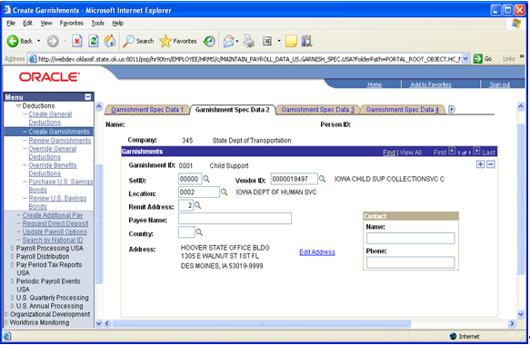

Enter the SetID (will always be 00000), and select the Vendor ID, Location, and Remit Address using . When you tab out of the fields, the address information will default in from the Vendor Table.

NOTE: Ensure that an address is entered; otherwise AP will not produce a check even though the deduction is taken out of the employee’s paycheck.

Garnishment Spec Data 3

Use this page to define garnishment deduction parameters and limitations.

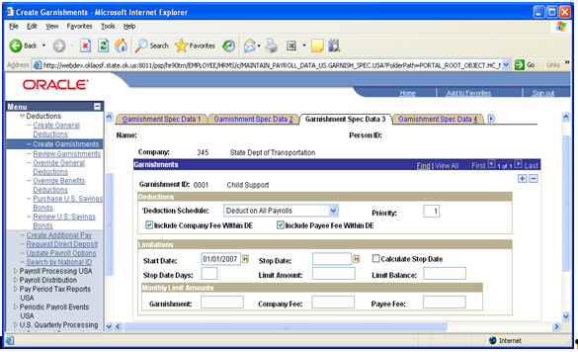

Deduction Schedule | This is where you tell the system how to deduct each garnishment:  - Deduct on All Payrolls: By choosing this option, you indicate that the system should process the garnishment deduction on all payrolls processed for the employee up to the Monthly Limit Amount entered in the Monthly Limit Amounts Grid area. If nothing is enter, the garnishment amount will be deducted from all of the employees’ pay. You will have to do some additional data entry on Garnishment Spec Data 4 page to complete the deduction information. (Monthly).  - Deduct by Schedule: This option indicates to the system that you will define a schedule for the garnishment deduction. You will need to complete data on the Garnishment Spec Data 5 page to create the deduction schedule and complete the deduction information, used for Bi-Weekly pay cycles.
Priority | Select the processing priority of the garnishment in case the employee has multiple garnishments. For example, Child support garnishments take priority over Tax Levies. You should understand that this priority is not the same as the deduction priority in the General Deduction Table. Also remember that a lower priority number means a higher order of processing and therefore a higher priority. The system uses this value to process garnishments to which proration rules do not apply.
Include Company Fee Within DE | - The State of Oklahoma does not include a company fee in the employee’s deduction but some agencies do.
Include Payee Fee Within DE | - This should be left as checked (the default) unless the court order specifies differently.

Limits
The fields in this box allow you to place restrictions on the time a garnishment is in effect or on the amount the garnishment can reach. Some states will not allow more than one writ type garnishment to be collected at a time, such as Oklahoma. Oklahoma also limits the deduction not to be taken for more than 180 days per writ.

Start Date | Leave this field blank if the garnishment is to start immediately (the garnishment will be taken on the first payroll that is processed after the garnishment has been entered). Otherwise, start the garnishment on the first day of the month following the receipt of the garnishment.
Stop Date | The State will be leaving this field blank as well to insure the entire garnishment is collected. If you use this field you must enter a date that is GREATER than the check date for a pay period to have the system take the garnishment for that period. If the date is less than the check date, the garnishment will NOT be deducted.  NOTE: Rule of thumb is to enter the begin date of the employees’ next pay cycle.
Calculate Stop Date  Stop Date Days | These fields allow you to accommodate state laws (i.e. Tennessee, Oklahoma) where a certain type of garnishment (Writ) cannot extend beyond a certain number of days. The system includes logic that can figure out when the employee has earnings available for garnishing and extends the end date to the limit you define.
Limit Amount | This field allows you to enter a limit amount to establish a maximum total amount for the garnishment deduction (sometimes a garnishment will come with a pre-defined limit amount as set by the issuing authority). When this field has an amount, the limit balance field will be updated each time the State runs Pay Confirmation reflecting how much of the garnishment has been paid to date. When the limit balance equals the limit amount, the system automatically stops taking the deduction. If you do not want to define a limit, leave this field blank.  Once an amount has been entered and saved, this field can NOT be changed without assistance from CORE.
Limit Balance | This field is only maintained when a Limit Amount has been entered. Each time the State runs Pay Confirmation, the system will update the amount in this field, displaying how much of the garnishment has been paid to date. When the limit balance equals the limit amount, the system automatically stops taking the deduction.  This field can NOT be changed without assistance from CORE.

Garnishment Spec Data 4

Use this page to define deduction information when deducting from all payrolls. Before using this page, select the Deduct on All Payrolls option on the Garnishment Spec Data 3 page.

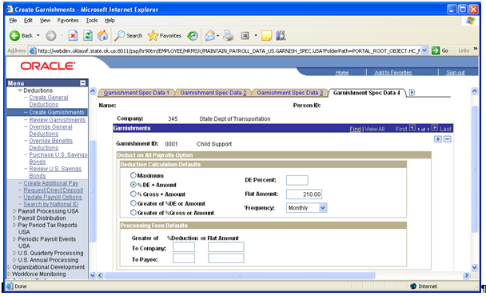

Select the appropriate Deduction Calculation Defaults radio button. If you select "Maximum” no other selection is necessary. If you select “% DE + Amount”, enter the DE Percent and/or Flat Amount. Now select the Frequency from the drop down list by clicking .

The data below explains the relationship of the radio buttons and fields in the Deduction Calculation Defaults group box.

Maximum | If you select this option, the system will calculate: Disposable Earnings (DE) – Exemptions = Garnishment Deduction  In other words, the system will take all it can get. This option is most commonly used for Tax Levy or Bankruptcy garnishments (unless an amount is specified on the court order).
DE Percent | Enter the percentage specified in the court order.
Flat Amount | Usually used for Child Support. Enter amount specified in the court order.
Frequency | If you enter a flat amount or percentage, you need to also select a deduction frequency. The system will use this frequency to adjust the flat amount to the employee’s pay frequency and to calculate the deduction amount accordingly per pay period.

Processing Fees Defaults

Depending on the Court Order, you may have to indicate a fee for the Payee. On the Garnishment Spec Data 2 page, you specified whether to include the payee fee in the employee's disposable earnings.

Some garnishment orders may require comparing a flat amount to a percentage of the deduction and then take the greater of the two. If that is the case, enter both, and the system will take the greater amount. Is this is the situation remember to also check the correct radio button.

Disposable Earnings Calculations

Disposable earnings (DE) are the earnings subject to garnishment. What constitutes disposable earnings varies according to the governing jurisdiction (that is, federal, state, provincial, or local authority). For example, a disposable earnings definition might specify the calculation of an employee's gross earnings minus all federal and state taxes along with any health insurance premiums in effect prior to the date of the court order.

PeopleSoft maintains and delivers the standard federal and state disposable earnings definitions with PeopleSoft Payroll for North America. Where appropriate, the rules have been updated to include deductions to be included specific to the State of Oklahoma.

If the Court order specifies that the employee’s disposable earnings should exclude specific deductions other than already specified in the rule, like health care for dependents, those deductions can be added at the employee level on Garnishment Spec Data 6, but for standard DE rules the CORE Team updates the delivered DE Rules as shown below.

Navigation: Set Up HRMS > Product Related > Payroll for North America > Garnishments > Disposable Earnings Defn

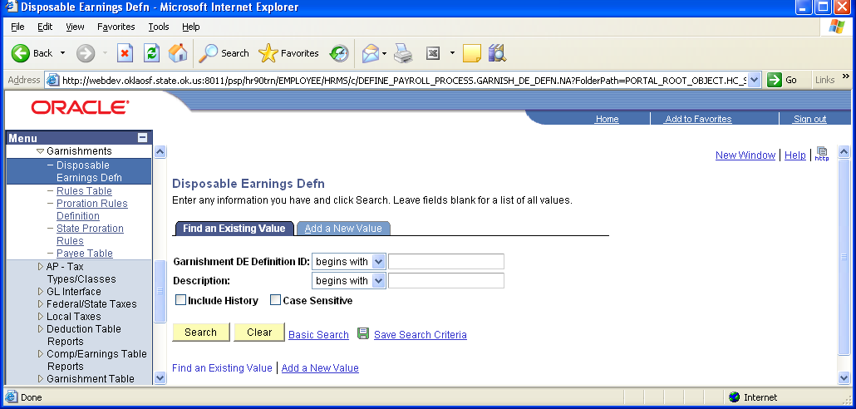

Select the correct Disposable Earnings Defn you want to review and click .

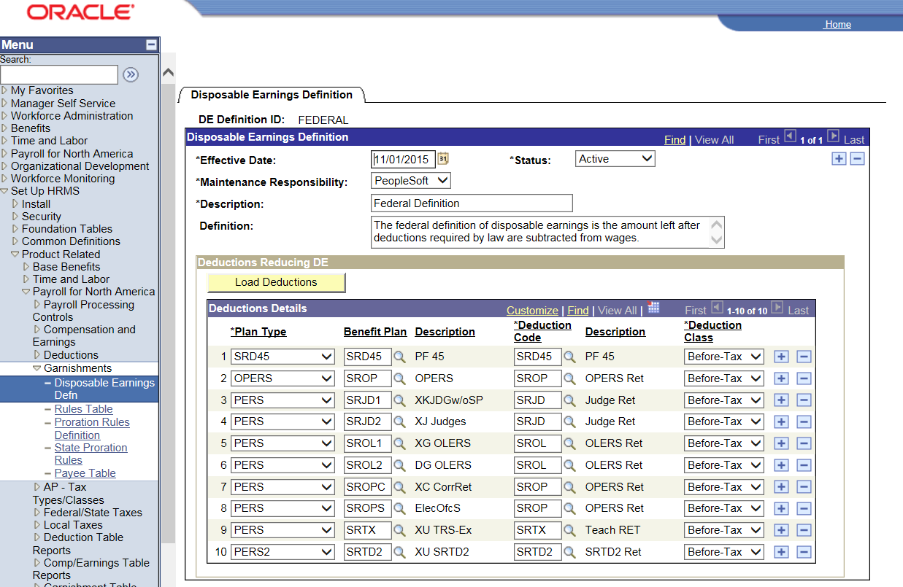

The Deductions Details criteria box is where the State modifies the DE Definition by adding the deductions that will be subtracted from wages when calculating the disposable earnings. Contact CORE to update Garnishment Rule Disposable Earnings Definitions.

Garnishment Spec Data 5

Use this page to define the payment schedule for the garnishment, used for Bi-Weekly pay cycles. Before using this page you must select the Deduct by Schedule option on the Garnishment Spec Data 3 page.

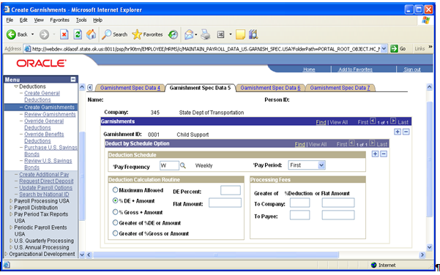

NOTE: Bi-weekly employees will require a schedule to properly calculate and deduct garnishments. Specify a pay frequency of B and enter the details in the deduction calculation group box. For bi-weekly employees you will have to have at least two rows of data filled in (one for the first pay period and one for the second pay period). Monthly employees will NOT use this page; they will only use the Garnishment Spec Data 4 page.

Garnishment Spec Data 6

Use this page to indicate which garnishment rule governs each garnishment. PeopleSoft allows you to enter multiple garnish law sources and rule IDs for each employee to accommodate orders from different states and courts. If an employee has both federal and state ordered garnishments, enter the federal code ($U), and then insert a row for each additional state.

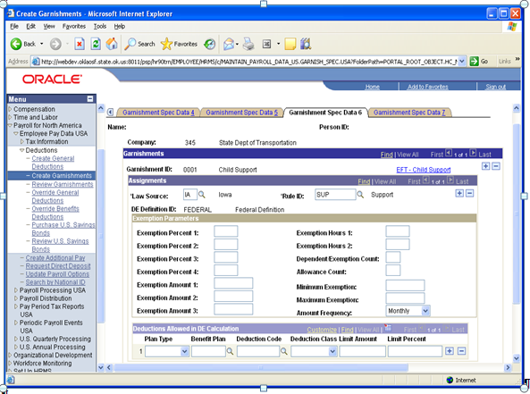

Select the Garnish Law Source (Jurisdictional Entity) and Rule ID using the lookup buttons.

NOTE: In the U.S., when an employee has more than one garnishment in a single state, the system determines proration rules based on the garnish law source. If the garnishments are for more than one state, the system uses the proration rule of the employee's work state.

Exemption Parameters

The system uses this group box to calculate the most favorable garnishment deduction amount for the employee. Depending on the exemption calculation routine (in Garnishment Rules Table 2) that applies to this rule, the system uses one or more of these exemption parameters to calculate the amount of disposable earnings that are exempt from garnishment. You must enter only the exemption parameters that are appropriate to the rule.

Dep/Exempt Count  (Dependent or Exemption Count) | Enter the number of dependents or exemptions claimed by the employee.
Allowance Count | Enter the number of allowances claimed by the employee.
Exempt Amount | If the court determines an exemption amount, enter it here.
Amount Frequency | If the court determines an exemption amount frequency (daily, weekly, or monthly), select it here.

Deductions Allowed in DE Calc

Depending on the Disposable Earnings definition established for the Garnishment rule by the State, the system will populate the fields in this group box with all the deductions that are allowed once you have run the first pay calc. This page will display the amount being subtracted from the employee’s gross before calculating the garnishment deduction.

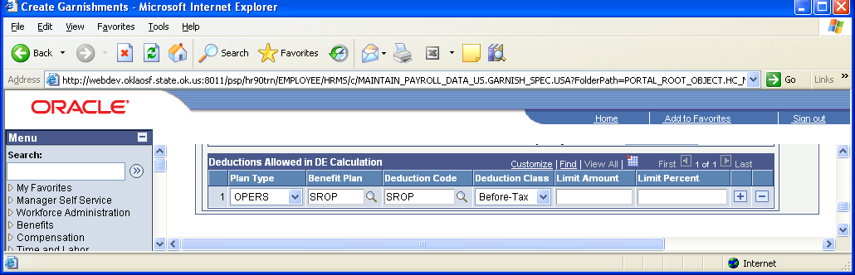

Critical CAUTION: For all Federal Tax Levy garnishments ONLY the deductions and amounts NOT covered by the employee’s BEA should be listed here.

The system will automatically add ALL deductions that the employee has at the time the garnishment is entered. Therefore, once the fields are updated after the first payroll calculation, they need to be reviewed. ALL deductions covered by the employee’s BEA have to be deleted. If a partial amount needs to be subtracted, enter that amount in the Exempt Amount field.

Garnishment Spec Data 7

Use this page to prorate garnishments for employees who have more than one. Garnishments cannot go into arrears. The system will allow you to use pre-defined proration rules (maintained by PeopleSoft) to collect from each of the employee’s garnishments each pay period, if the employee’s wages are not enough to cover his or her garnishment.
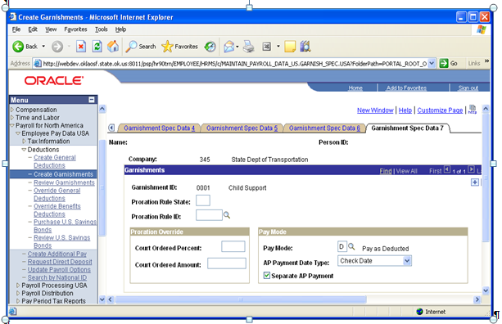

The Garnishment ID that you entered on Garn Spec 1 displays at the top of the page. Enter the Proration Rule State "OK”; this is the state where the employee works and select the Proration Rule ID.

If there is a Court Ordered Proration Override enter the Court-Ordered Amount or Percent by which to prorate the employee's garnishments. When the Proration Override criteria box is left blank, the system uses the proration rules set by Federal and State laws. Only use this criteria box if the court order specifically states something other than what is specified by Federal or State guidelines.

NOTE: Only Writs and Support garnishments use proration rules because there can be more than one.
For Writs, the proration rule for Oklahoma is FIRST1. This rule states that it will handle multiple writs on a “first come first serve” basis. In other words the system will calculate and pay the writ that was received first (based on the Start Date entered on Garnishment Spec Data 3). Once that writ has been paid the system will go to the next one in line and so on.
The Pay Mode group box is for functionality with the PeopleSoft Payables (AP) module and should be set as follows:

Pay Mode = D Pay as Directed
AP Payment Date Type = Check Date

The check box should be checked next to Separate AP Payment.

Adding the Garnishment Deduction
In addition to entering the Garnishment Specification data, you need to add the General deduction of GARNSH to the employee.

Navigation: Payroll for North America > Employee Pay Data USA > Deductions > Create General Deductions

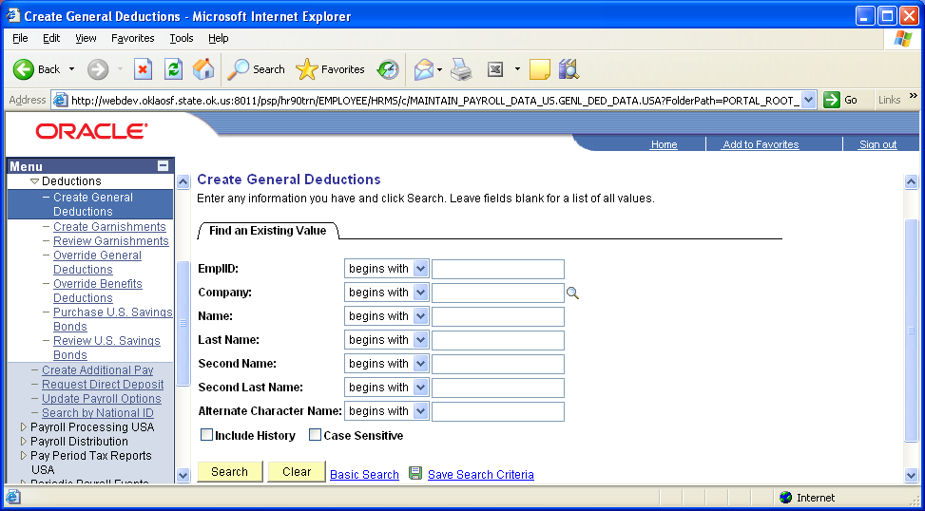

To select an employee, enter the search criteria and click .

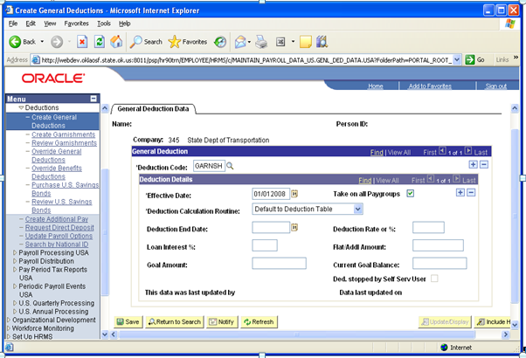

Enter the Deduction Code using the lookup button. Select the Take on all Paygroups checkbox to insure employees with multiple jobs in different paygroups will have the garnishment taken from all pay.

The Effective Date should be the Begin Date of the employee’s next pay cycle.

The system will default in "Default to Deduction Table” as the Deduction Calculation Routine because the deduction has been defined as a garnishment.

During payroll calculation and confirmation processes the system will use the Garnishment Spec Data pages to calculate the garnishment amount. Click

Payroll General Deductions

Overview
In PeopleSoft Human Resources, a general deduction is any deduction that is not a benefit deduction. Charitable deductions, union dues, parking, garnishments, bonds, and so on all fit into this category. Use the General Deduction Table to define how these non-benefit deductions are calculated.

In this section, we discuss how to setup General Deduction for employees.

NOTE: All Benefit Deductions, excluding Savings Plans, are setup as General Deductions but the data for these Benefit Deductions is programmatically entered for each employee by the EBC Inbound Interface.

General Deduction Data

Navigation: Payroll for North America > Employee Pay Data USA > Deductions > Create General Deductions

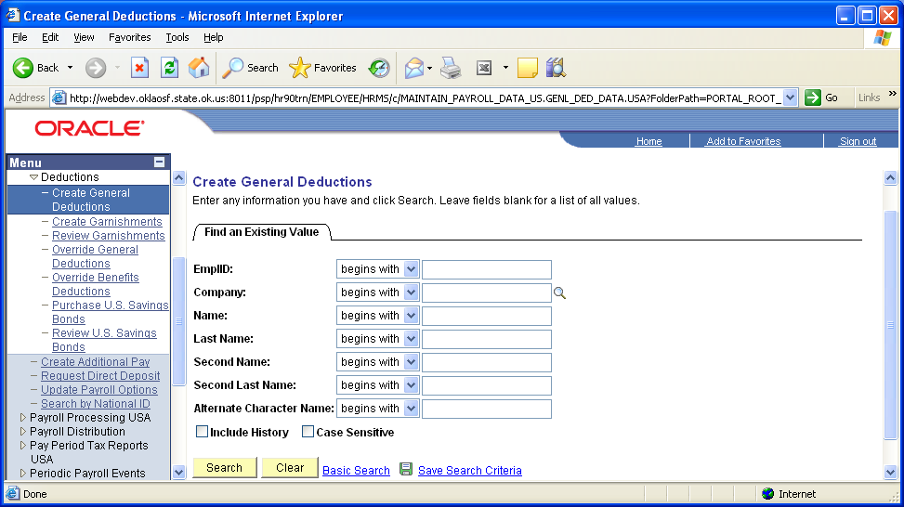
All deduction codes that begin with a 0 are benefit deductions.

All deduction codes that begin with an alpha character are for deductions other than those that come from EBC.

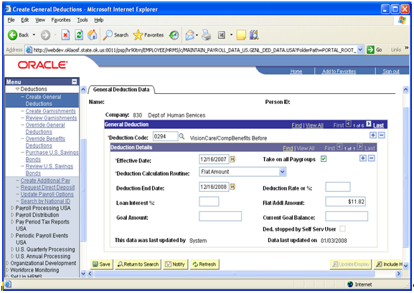

Select the Deduction Code using the lookup button.

Enter the Effective Date (beginning of employees’ next pay cycle) and select the Deduction Calculation Routine. In our example, we will use Flat Amount.

Enter the Flat/Addl Amount and click

To add another General Deduction, insert a new row click across from the Deduction Code.

To add a new effective date and change the deduction amount, insert a new row, click across from the Effective Date.
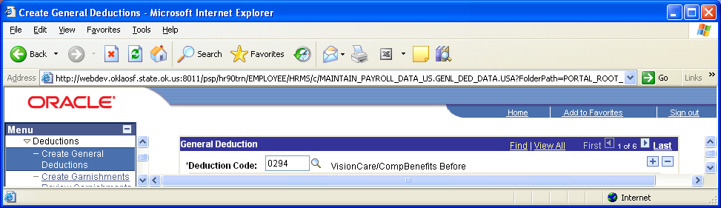

To add a new effective date and change the deduction amount, insert a new row, click across from the Effective Date.

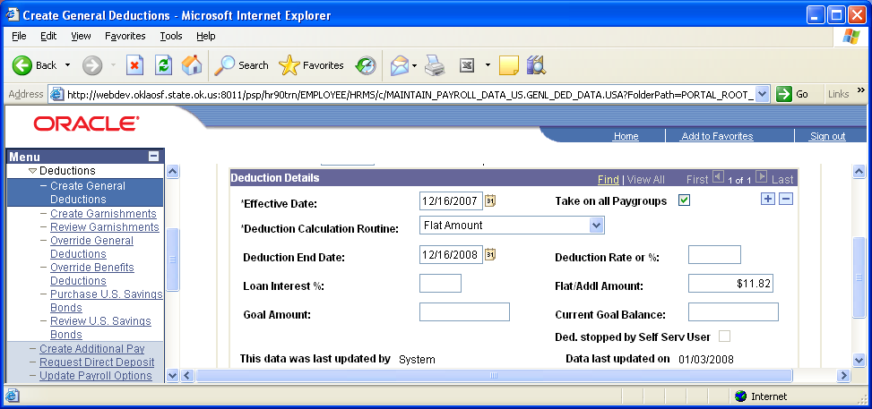

Update the Flat/Addl Amount and click

Deduction Code | Select the code for the general deduction the system should take for this employee.
Take on all Paygroups | This option applies only to employees who have jobs in more than one pay group. The State will not be combining earnings from multiple jobs that are paid on the same pay run, but instead the employee will receive two checks.  The system will take the deduction only when the employee’s primary paygroup is paid if this flag is checked off. If it is checked on, the system will take the deduction from all jobs where the deduction is active.
Deduction Calculation Routine | The Deduction Calculation Routine determines how a deduction is calculated for an employee. The state will not be using Special Deduction Calculation.  Select Default to Deduction Table to use the deduction calculation routine specified on the Deduction Table. If you select this option, the system takes the amount or percent from the Deduction Table; thus, the Flat/Addl Amount (flat/additional amount) field and the Deduction Rate or % field on this page is not available for entry.  Select Flat Amount to establish the deduction as a flat amount.  Select Percent of Federal Gross to calculate the deduction as a percent of Federal gross income. N/A.  Select Percent of Net Pay to calculate the deduction as a percent of net pay. N/A.  Select Percent of Special Earnings to calculate the deduction as a percent of a special accumulator, such as 401K. Enter the percent in the Deduction Rate or % field. N/A.  Select Percent of Total Gross to calculate the deduction as a percent of total gross income. N/A.  Select Rate x Hours Worked to calculate the deduction as rate multiplied by hours worked (hours with the FLSA flag selected). N/A.  Select Rate x Special Hours to calculate the deduction as a rate multiplied by hours that have a special accumulator associated with them. N/A.  Select Rate x Total Hours to calculate the deduction as a rate multiplied by total hours. Enter the rate in the Deduction Rate or % field. N/A.
Deduction Rate or % | Depending on the value you select for the Deduction Calculation Routine field, you may need to enter a rate or percent in this field. This will determine how much to take out for the deduction.
Flat/Addl Amount | Depending on the value you select for the Deduction Calculation Routine field, you may need to enter a flat or additional amount in this field.
Goal Amount | Enter the limit for the total amount of the deduction. After this goal is met, the deduction ends. However, if there is a maximum yearly deduction, and the maximum has been reached, the system does not take the deduction, regardless of whether the goal amount has been reached. For example, if the maximum yearly deduction amount allowed for United Way is $80, and an employee's goal amount for United Way is $100, the system stops taking the deduction when $80 is reached.
Current Goal Balance | Displays the total amount taken to date from the employee's pay for this deduction. The system updates this amount after every payroll run, during the Pay Confirmation process. When the Current Goal Balance equals the Goal Amount for this deduction, the system automatically stops taking the deduction. If you want the deduction to start again, you must add another effective dated row and corresponding data.
Ded. stopped by Self Serv User | If the employee stops a voluntary deduction using the Voluntary Deduction Update self-service Web application, the system will automatically select this check box. Note: The State is not yet using employee Payroll self Service
This data was last updated by, On | Each time the general deduction is updated, the system indicates whether an Online operator or a self-service Web user made the update, and it displays the date of the most recent update. Online operators can update online using the General Deduction Data page. The employee, also known as the Web user, can update using the Voluntary Deduction self-service application.

Payroll Options Pages

Overview
PeopleSoft delivers two pages that allow you to update or manipulate optional payroll data such as check address, Paycheck location, and Check name. The settings will be defaulted for all State employees and can be changed for exceptions only.

Navigation: Payroll for North America > Employee Pay Data USA > Update Payroll Options

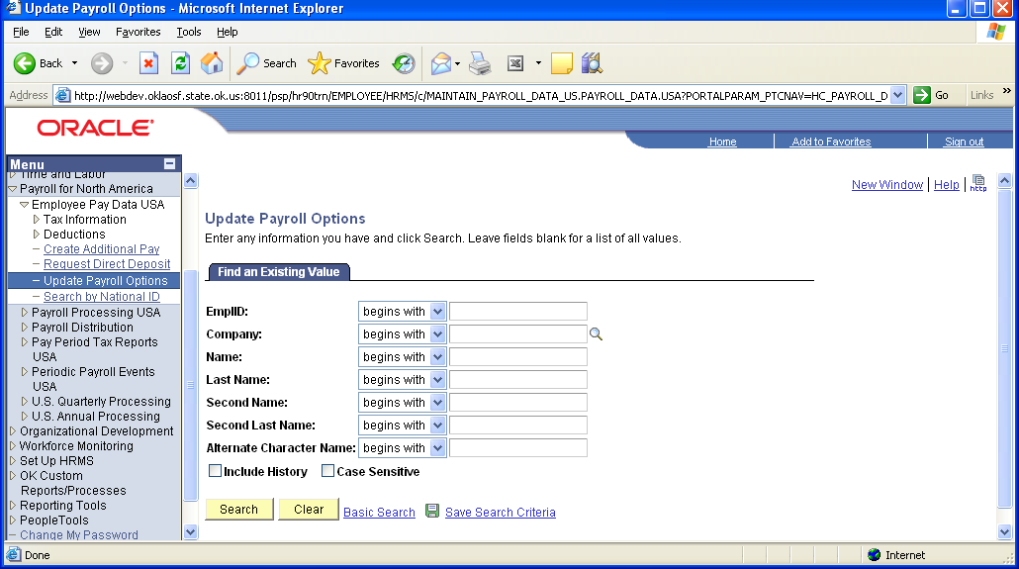

To select an employee, enter your criteria and click .

Payroll Options 1

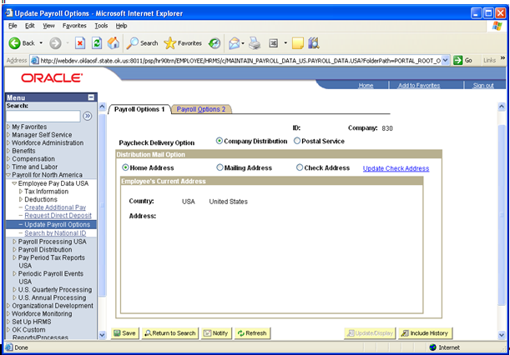

Home Address | This radio button indicates that the system should use the employee’s Home address from Personal data. The home address data will display automatically when this button is selected. Check to make sure it is correct.
Mailing Address | This radio button indicates that the system should use the employee’s Mailing address from Personal data. Make sure there is a mailing address for the system to use if you choose this radio button. (Note: Only Home Address is being converted into Personal Data.)The mailing address data will display automatically when this button is selected.
Check Address | This radio button indicates that the system should use the employee’s Check address from Personal data. The check address data will display automatically when this button is selected. (Note: This data is NOT being converted in).
The State of Oklahoma only allows the use of the radio button next to Company Distribution. The Postal Service radio button is NOT an option for the State of Oklahoma at this time.

Update  Check Address | If none of the above options are sufficient, you can actually change the Check address right on this page and the system will cross update the same address in the employee’s Personal data record. When you click this hyperlink, the address fields change to allow data entry. The system will show “Current and Future Addresses” as shown below. Use the effective date carefully, as it will be saved to the Personal data

To update the address, click Update Check Address link.

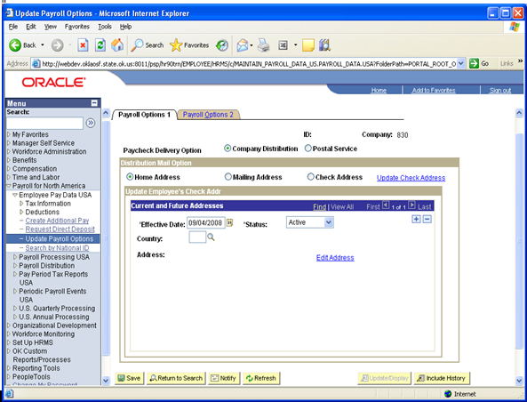

Enter the Effective Date and Country. Once the country has been selected, click Edit Address link.
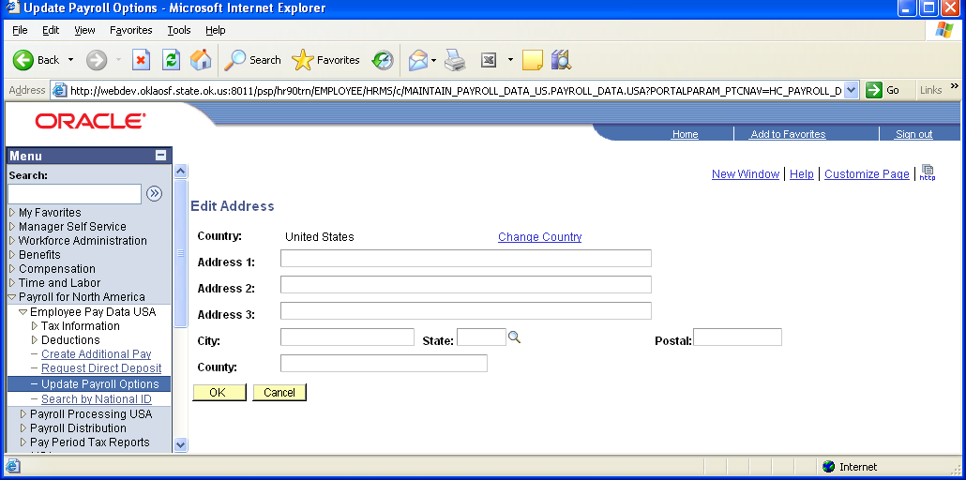

Fill in the address change and click .

Payroll Options 2

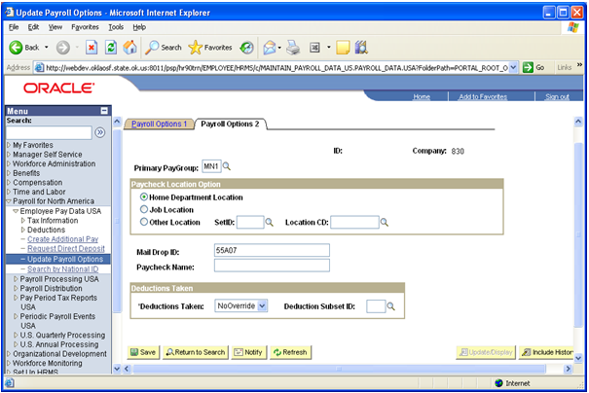

NOTE: The Primary PayGroup displayed on this page should always match the Pay Group of the primary job on Job Data. If they do not match, they should be brought in sync. However, do NOT change the Primary Pay Group if paysheets have already been created.

Payroll Options 2 includes location details that control the paycheck distribution process depending on the configuration of the Paycheck sequencing configurations on the paygroup table. Three things must be true for the location Options to function. On the employee’s Paygroup:

- ‘Paycheck Sequence’ is set to ’Company Distribution Order’ on the Check Distribution page. This is true for all State pay groups.

- ‘Paycheck Location Option’ is set to ‘Select on Payroll Data Panel’ on the Check Distribution page. This is not true for any State Paygroups. The State has chosen ‘Home Department Location’ on each pay group.

- Location is entered as a Check Print Sequence on the Check Sequencing page. This is true for all State pay groups.

NOTE: The resulting effect will be that the paycheck will always be sorted to go to the employee’s Home Department Location, regardless of the choice made on this page.

The Mail Drop ID is where the Warrant Sequence information is entered. Warrant sequence is used to sort the checks.

The information has to be manually entered so that checks and advices sort properly based on your agency’s needs.

Deductions Taken

Deduction | This will be the State’s configuration for this field. It tells the system to process the standard general deductions for this employee as set up on the Deduction Table.
Subset | This option would tell the system take only those general deductions included in the Deduction Subset you specify in the Deduction Subset ID field to the right.
No Override | This will preclude any deduction overrides from taking effect.
None | Select this option if no general deductions should be taken out of the paycheck.

Payroll Data Inquiry Pages

Overview

PeopleSoft provides inquiry pages that are designed to organize and communicate employee payroll data details while avoiding the need for excessive report printing. Use these pages to effectively verify calculation results.

Navigation: Payroll for North America > Payroll Processing USA > Produce Payroll > Review Paycheck

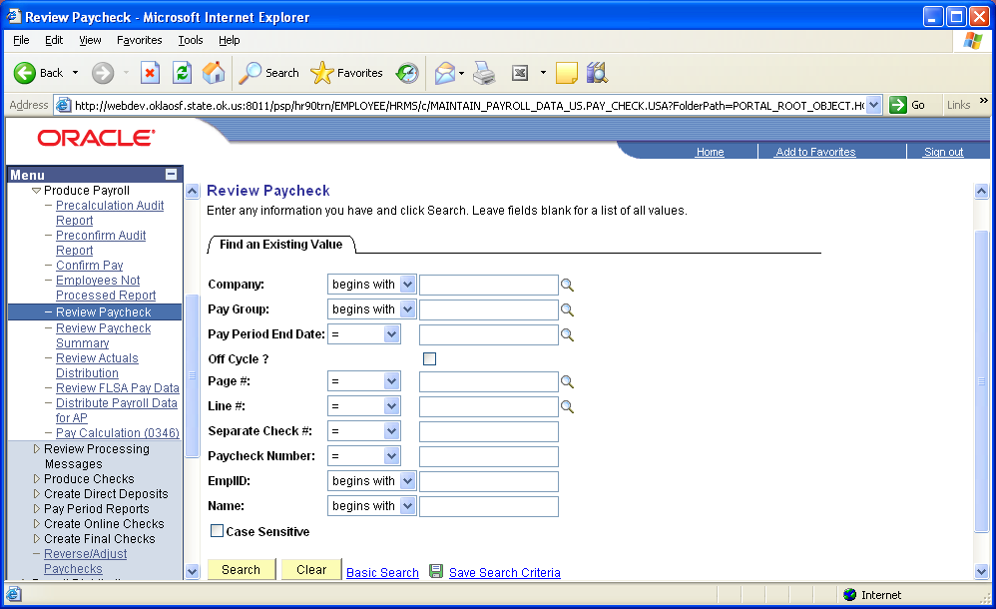

Enter your selection criteria and click .

- To see all warrants/advices for a specific employee, enter EmplID.

- To see all warrants/advices for a specific payroll, enter the Pay Period End Date.

Paycheck Earnings

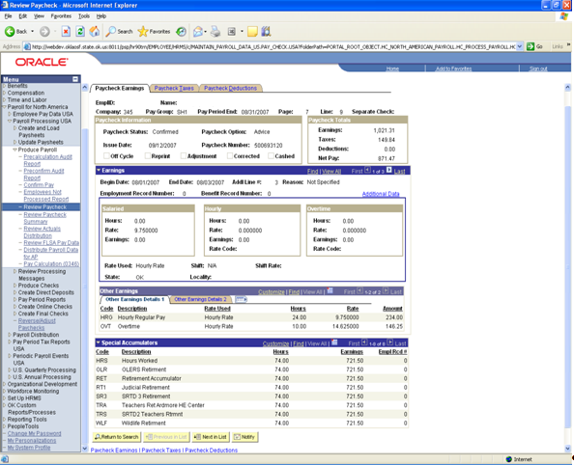

Use this page to review the detail of how an employee was paid. This page can be viewed immediately after running the first calculation, assuming there were no errors generated during the process. If you are trying to access the Paycheck Inquiry page and the system tells you there are no matching entries found, go back and verify your search criteria. If you are still unable to see data, there has probably been a change to the employee’s payline data since the calculation was run. PeopleSoft will not display an employee’s paycheck if the data is not consistent with that on the payline pages. This indicates a need to recalculate the payroll to capture the manual changes performed for the employee.
The top portion of the paycheck inquiry page displays the paycheck status in the section labeled Paycheck Information.

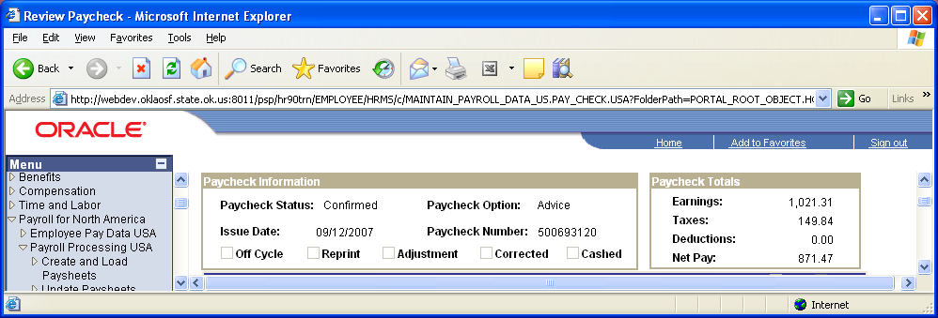

Calculated | The data has been calculated only. No balances have been updated and there will be no paycheck number displaying.
Confirmed | The data represents what was finally paid to the employee. Balances will reflect this information and the check or advice number will display.
Reversed | The Check was reversed.
Reversing check | Reversal in process
Adjusted | The data reflects an adjusted paycheck has been done for the employee. The original check was reversed automatically.

The Other Earnings Details 2 group box indicates if the earnings were added to gross, would show a change in tax method that was used during calculation processes and if a Rate Code was used to bring in the earnings.

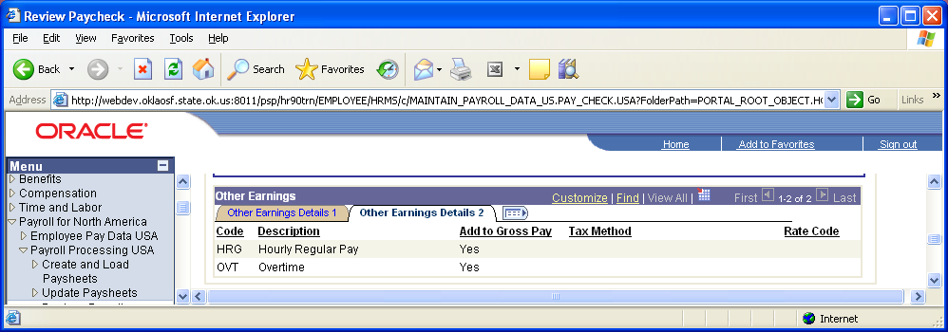

If you click , you can view all the information (Other Earnings Details 1 data and Other Earnings Details 2 data) on one line.

Paycheck Taxes

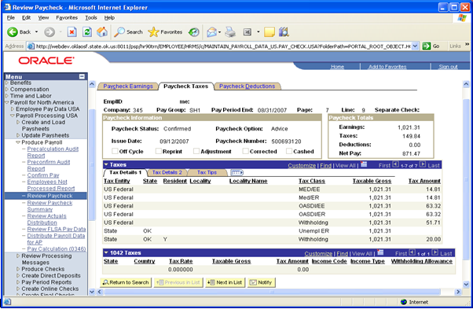

The Paycheck Taxes pages display all data pertaining to employee’s calculated payroll tax data. Tax Details 1 Tab displays tax types, tax classes, taxable gross and calculated tax amounts. On the Taxes scroll bar, use the button to move through the rows of tax data or click View All to see all the tax rows on the page.

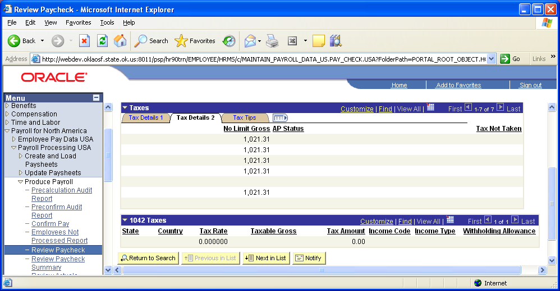

The Tax Details 2 Tab displays the ‘No Limit Gross’ amounts, AP Status, and any amounts pertaining to taxes not taken.

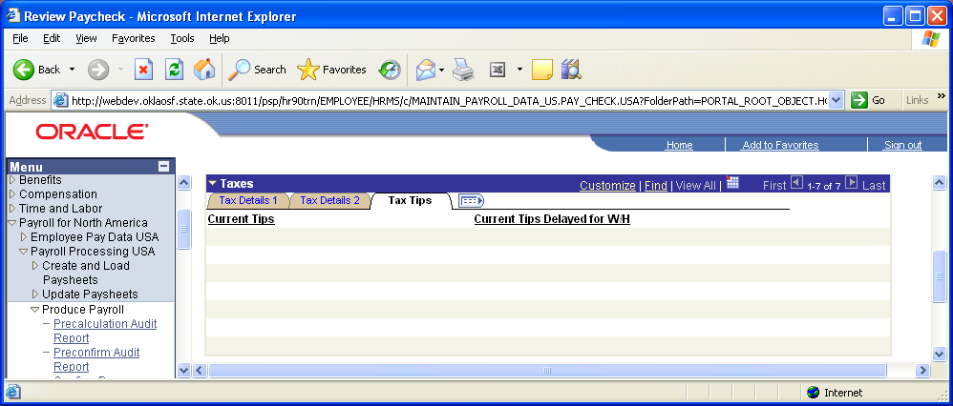
Tax Details 3 Tab will display tip information pertaining to tax calculations. If you click , you can view all the tax data on one line.

1042 Tax Data

The 1042 Tax Data group box can be found at the bottom of the Paycheck Taxes page, shown below:

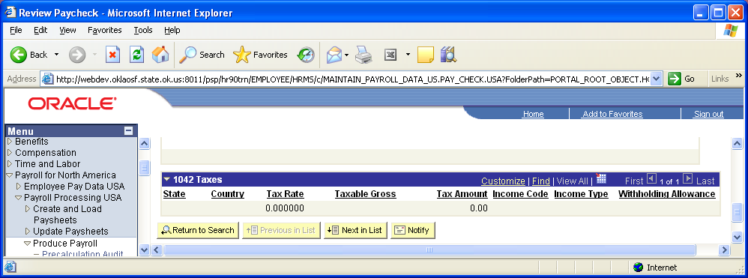

If the employee has 1042 earnings paid this period, you would view the associated taxes here.

Paycheck Deductions

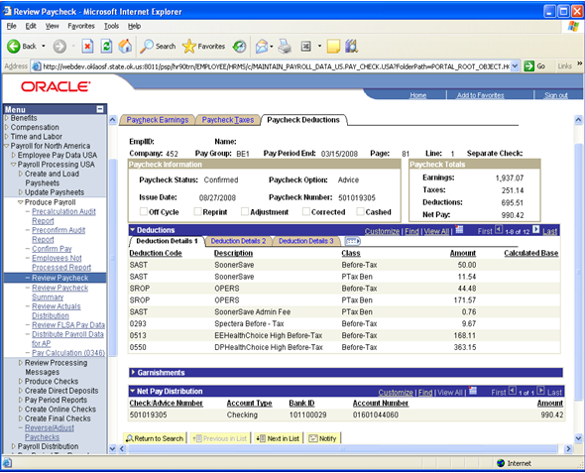

The Paycheck Deduction pages display information pertaining to each deduction calculated for the employee. The Deduction Details 1 Tab in the deductions group box displays deduction code, deduction description, deduction class, calculated deduction amount, and calculated base.

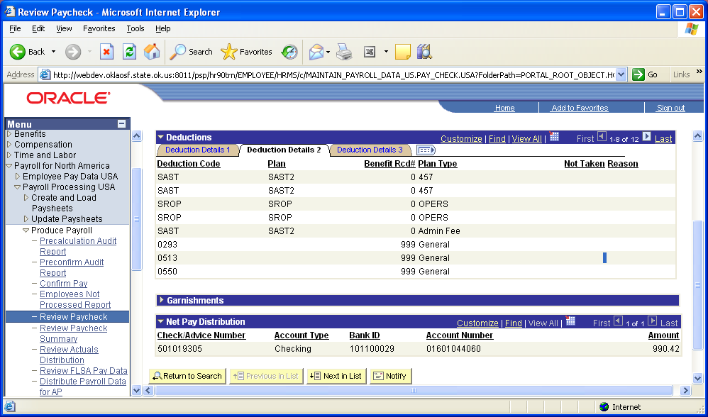

Deduction Details 2 Tab in the deductions group box displays deduction code, benefit plan, benefit record, plan type, any deduction amounts not taken and the reason for deductions not being taken.
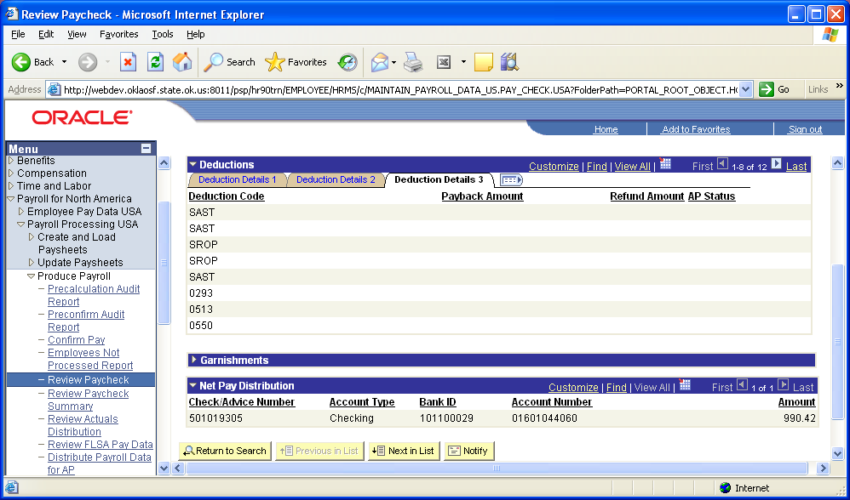

Deduction Details 3 Tab in the deduction group box re-displays the deduction code along with any payback and/or refund amounts along with the AP status. If you click , you can view all the deduction detail data on one line.

Garnishments

Click to open the Garnishments group box.

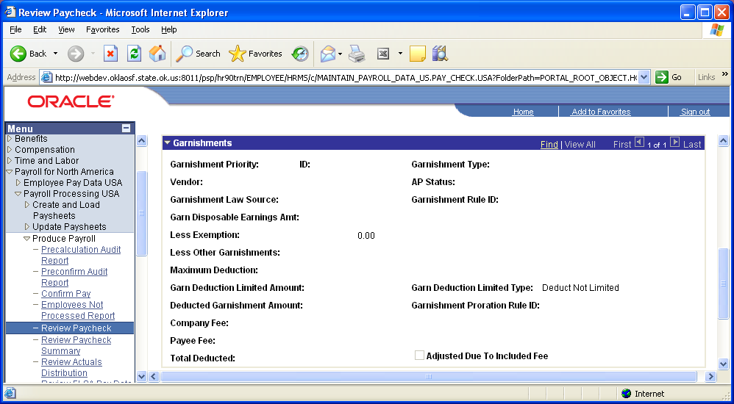

This group box within the Deduction page displays all data regarding the employee’s garnishment(s) that the system used to calculate the garnishment deduction.

Net Pay Distribution

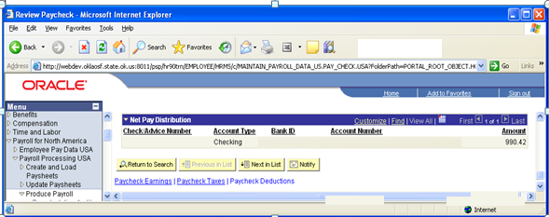

The Net Pay Distribution group box displays the Check/Advice Number, Account Type, Bank ID, Account Number and Amount deposited only after confirmation has run successfully. This information is based on Direct Deposit setup.

Paycheck Summary

Use this page to view paycheck summary information. The button will allow you to expand and minimize the areas to view earnings, deductions and/or tax information.

Navigation: Payroll for North America > Payroll Processing USA > Produce Payroll > Review Paycheck Summary

To view paycheck summary data, enter your criteria and click .

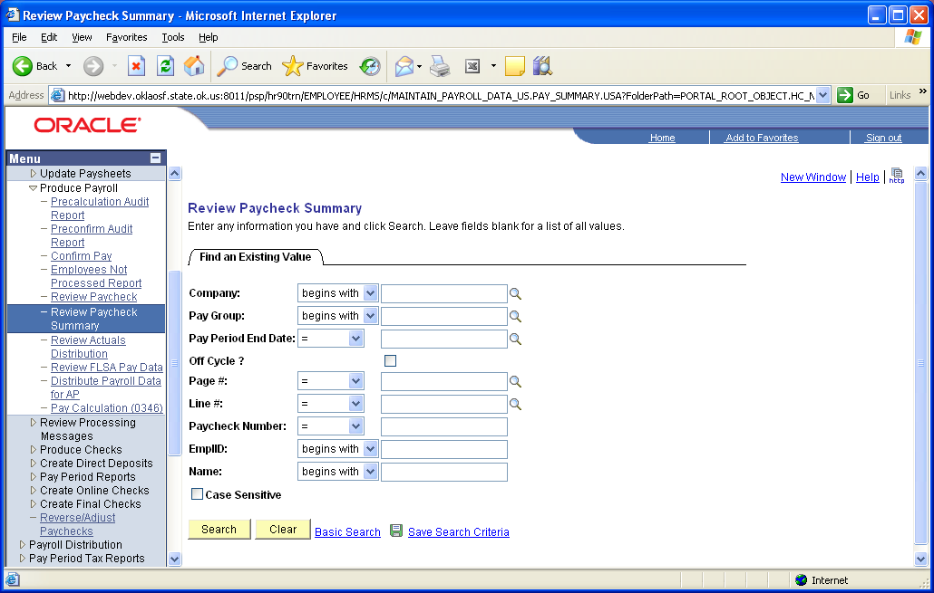

Paycheck Summary

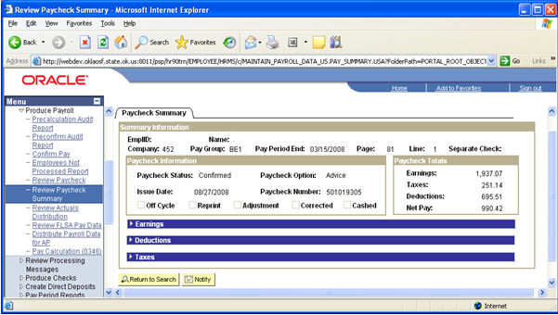

This page displays the basic information pertaining to the check data that you selected.

Earnings

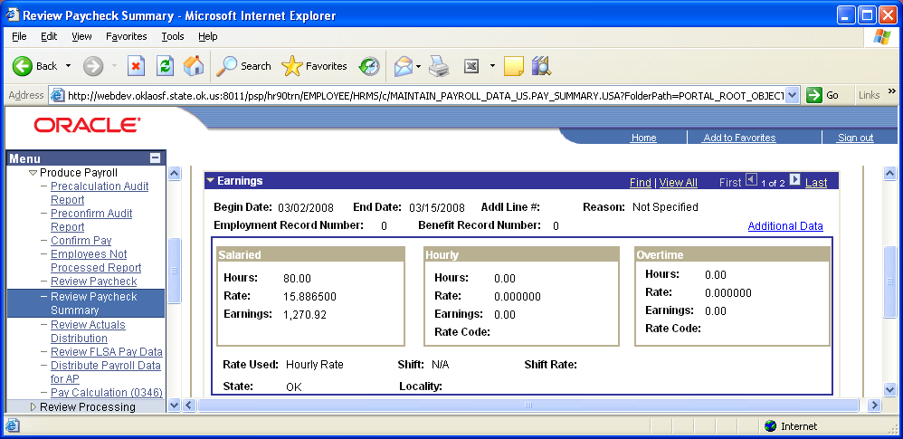

Deductions

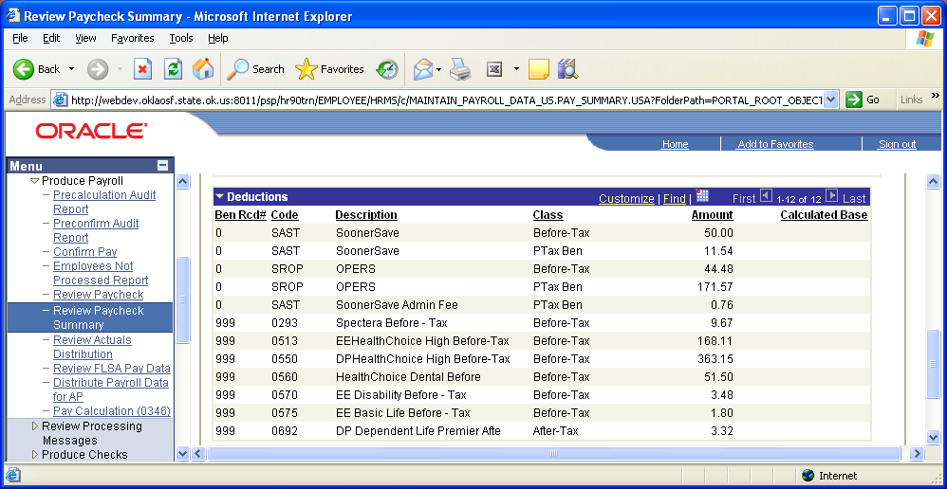

Taxes

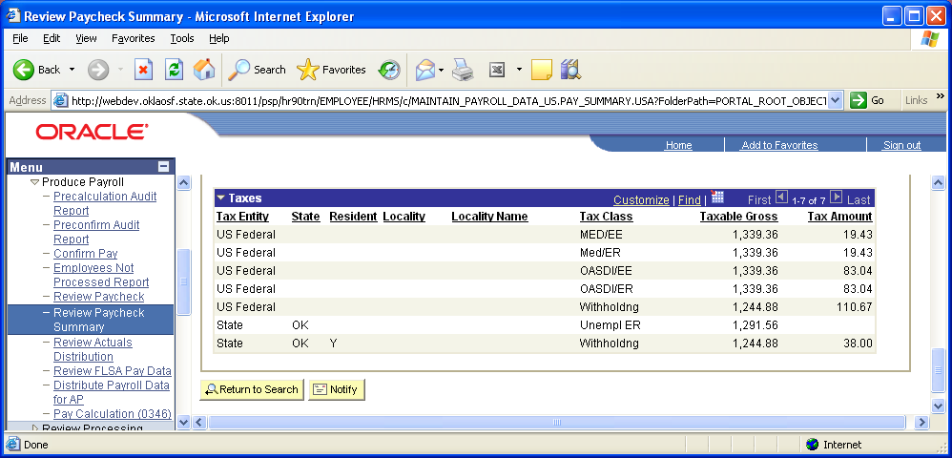

Employee Payroll Balances

PeopleSoft maintains accumulating balances (calendar Year and Fiscal Year) for each employee and payroll element; check year-to-date, earnings, taxes, deductions, etc., as shown below.

Check Year-To-Date Balances

Navigation:Payroll for North America > Periodic Payroll Events USA > Balance Reviews > Check Year-to-Date

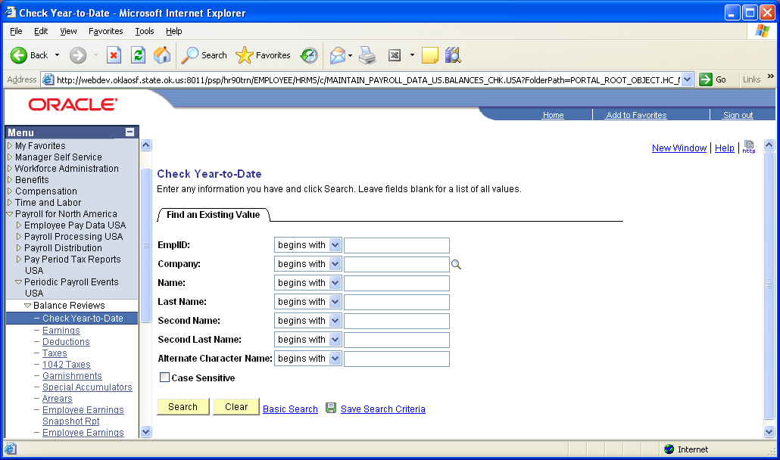

To view an employee’s check year-to-date balances, enter your criteria and click .
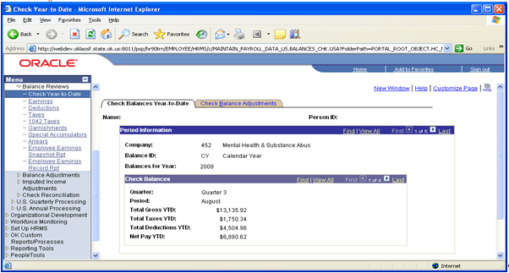

The system stores payroll year-to-date balances displaying gross earnings, YTD total taxes, YTD total deductions and YTD net pay. Use the Check Balances group box button to move through balances by Quarter, and Period (month). To change to Fiscal Year and/or prior Calendar/Fiscal years, use the Period Information group box button. To view any adjustments made during the period click on the Check Balance Adjustments Tab.

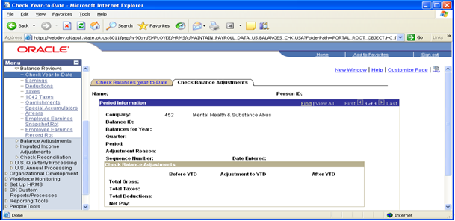

This page will show all information pertaining to adjustments made throughout Calendar/Fiscal year being displayed.

Earnings Balances

Navigation: Payroll for North America > Periodic Payroll Events USA > Balance Reviews > Earnings

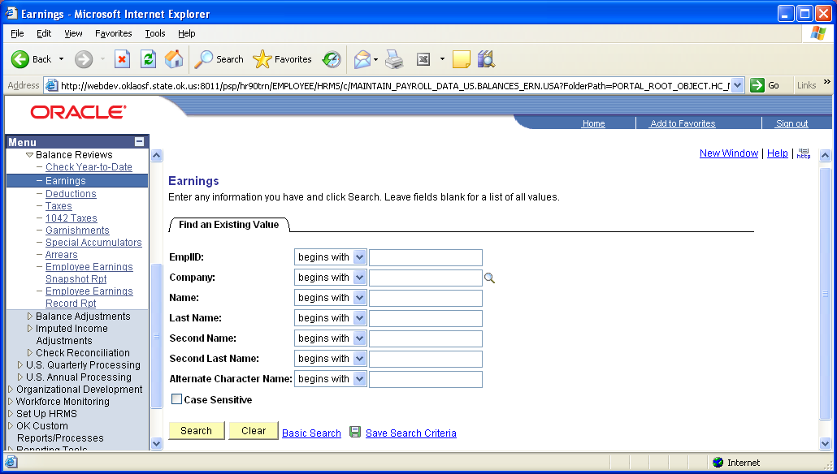

To view an employee’s earnings balance, enter your criteria and click .
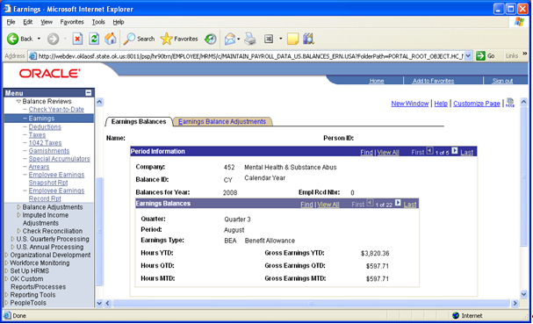

Use the button on the Earnings Balances group box to move through balances by Quarter, Period (month) and earnings type. To change Calendar/Fiscal Years, use the button on the Period Information group box. The page will display the hours and gross totals for the Year, Quarter, and Month to date for each earnings type.

To view any adjustments made during the period click the Earnings Balance Adjustments Tab.
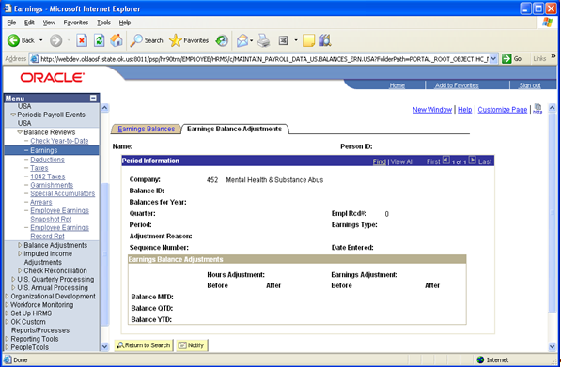

This page will show all information pertaining to adjustments made to specific earnings types throughout Calendar/Fiscal year being displayed.

Deduction Balances

Navigation: Payroll for North America > Periodic Payroll Events USA > Balance Reviews > Deductions

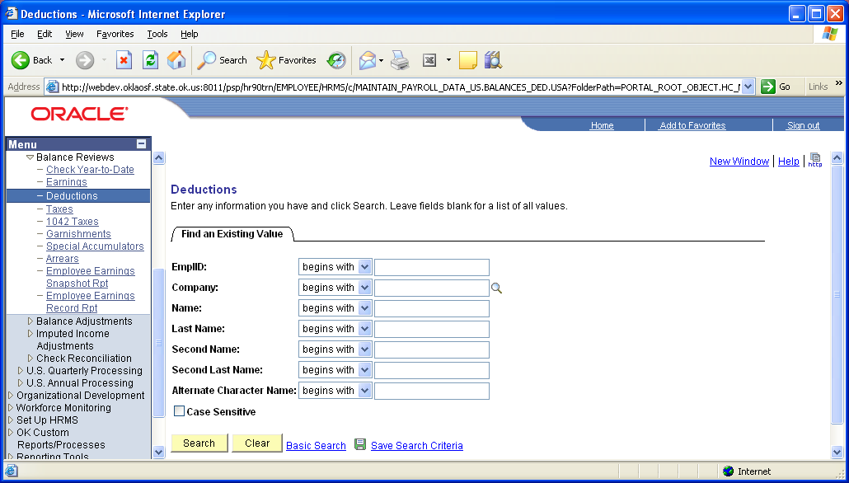

To view deduction balances, enter your criteria and click .
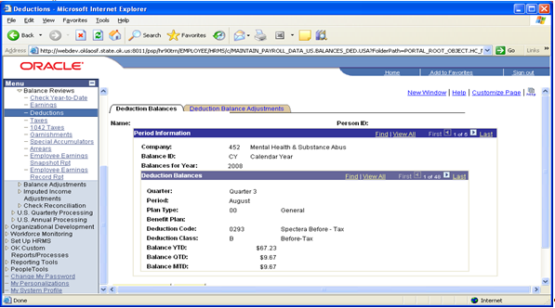

The Deduction Balance page organizes data by Calendar/Fiscal year and then by the quarter, period and deduction detail. Use the button in the Deduction Balance group box to view the deductions. Use the button in the Period Information group box to view current Fiscal Year totals and/or prior Calendar/Fiscal periods.

To view any adjustments made during the period click the Deduction Balance Adjustments Tab.

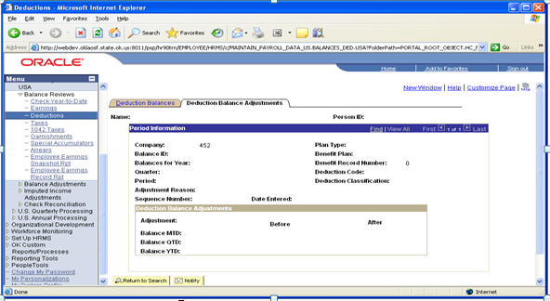

Tax Balances

Navigation: Payroll for North America > Periodic Payroll Events USA > Balance Reviews > Taxes

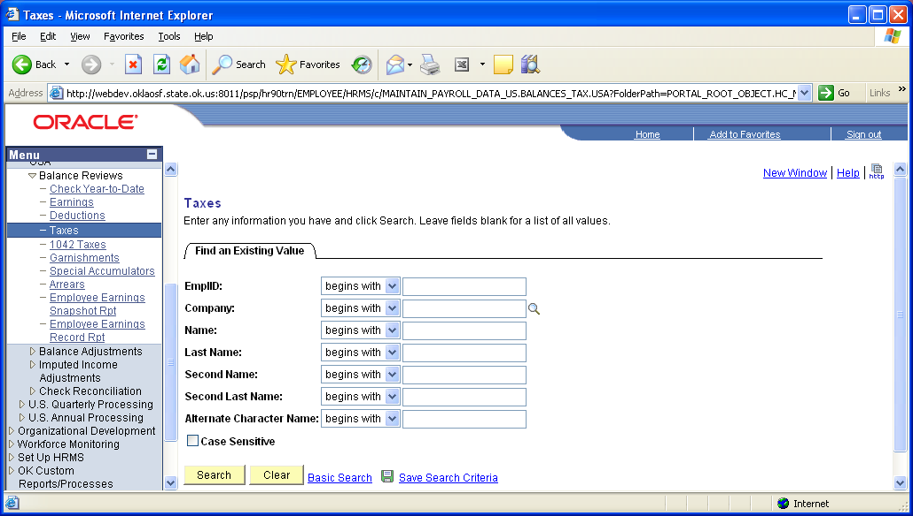

To view an employee’s tax balances, enter your criteria and click .
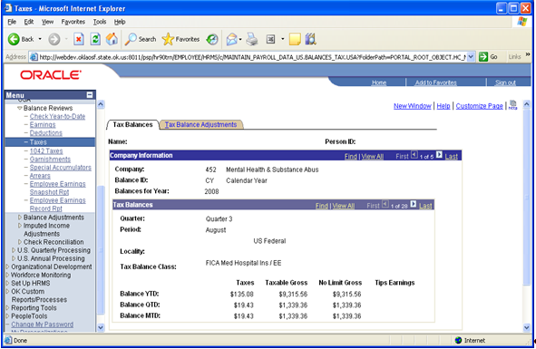

The Tax Balance page organizes data by Calendar/Fiscal year and then by the quarter, period and tax detail. Use the button in the Tax Balance group box to view the taxes. Use the button in the Company Information group box to view current Fiscal Year totals and/or prior Calendar/Fiscal periods.

This page displays, by tax class, taxes paid, calculated taxable gross, calculated no limit gross and tips earnings for year-to-date (YTD), quarter-to-date (QTD) and month-to-date (MTD) totals.

The Tax Balance Class indicates whether the tax was employee or employer paid.

NOTE: EE designates Employee paid and ER designates Employer paid taxes.

To view any adjustments made during the period click the Tax Balance Adjustments Tab.

1042 Taxes

Navigation: Payroll for North America > Periodic Payroll Events USA > Balance Reviews > 1042 Taxes

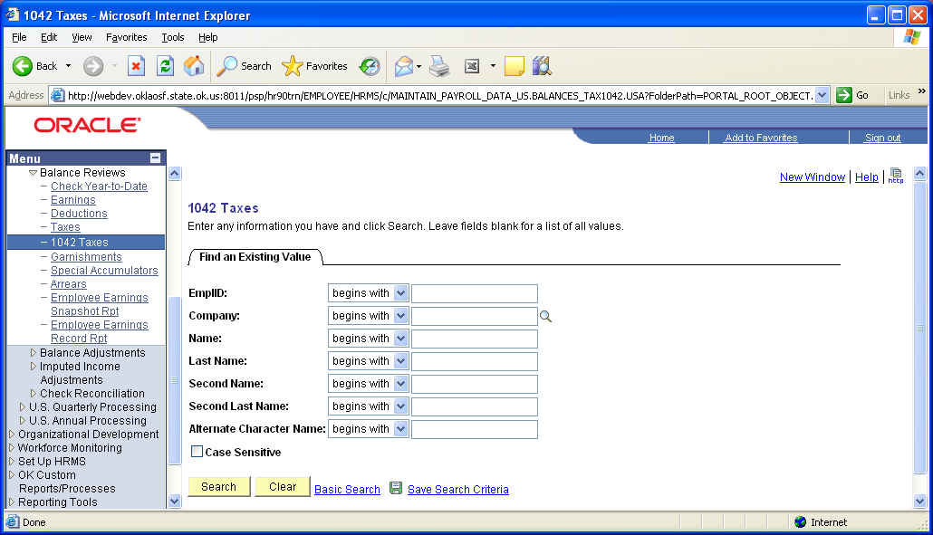

To view an employee’s 1042 tax balances, enter your criteria and click .

The 1042 Tax Balance page organizes data by Calendar/Fiscal year and then by the quarter, period and tax detail. Use the button in the Tax Balances Information group box to view the taxes. Use the button in the Tax Balances group box to view current Fiscal Year totals and/or prior Calendar/Fiscal periods.

Along with the tax balances this page also displays additional information relating to the tax treaty, etc., used during the calculation of the tax.

Click the 1042 Tax Balance Adjustments Tab to view any adjustments made during the period(s).

Garnishment Balances Page

The Garnishment balance page displays Company Information by Balance ID, and Fiscal Year.

Navigation: Payroll for North America > Periodic Payroll Events USA > Balance Reviews > Garnishments

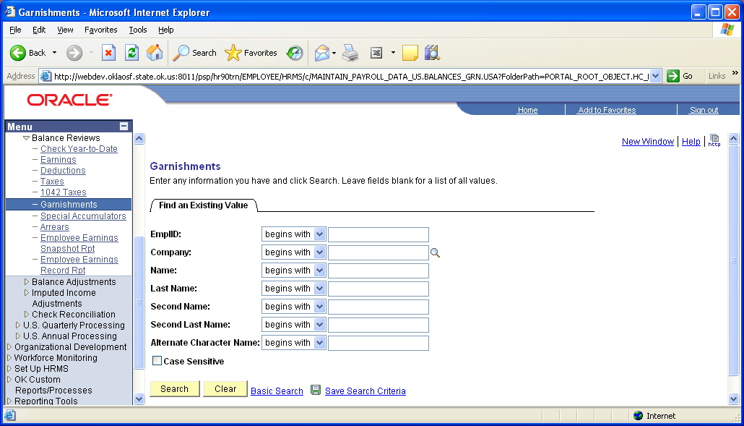

To select an employee, enter your criteria and click .
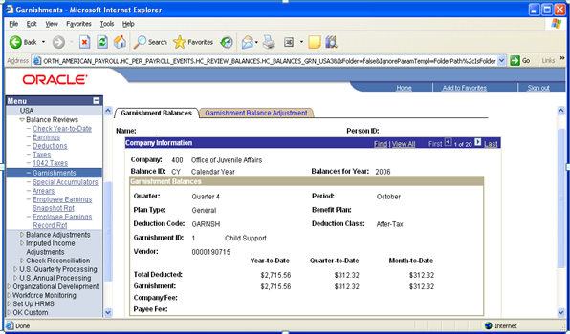

Click the button to scroll through the data or use the View All hyperlink. The Garnishment Balances section displays information by Quarter, Period and month, Plan Type (always general), Garnishment deduction, Garnishment ID and type of garnishment for which funds were deducted. The fees will display if they are deducted in addition to the garnishment.

Click the Garnishment Balance Adjustment Tab to view any adjustments that were made.

Special Accumulator Balances Page

Navigation: Payroll for North America > Periodic Payroll Events USA > Balance Reviews > Special Accumulators

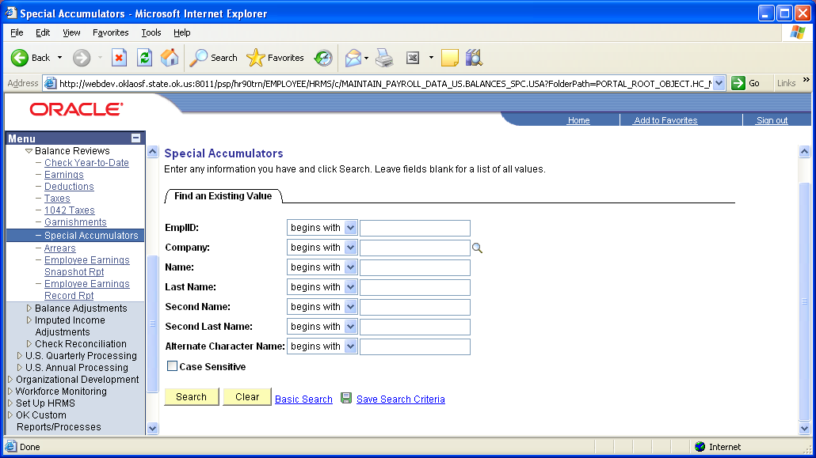

To select an employee, enter your criteria and click .

The Special Accumulator Balances page lets you see the hours and earnings that have added to a specific accumulator over time. The Company, Balance ID, and Balance Year organize the page. Employee Record Number will pertain to employees with multiple jobs.

Use the Company Information group box scroll area to move through time and the Special Accumulator Balances scroll area to move through the various special accumulators for the given Balance Year. The button will move you to the next row.

Special Accumulators are PeopleSoft holding fields used in calculations that allow the State to total sub-sets of earnings or deductions for use in other calculations. These balances can used by various retirement processes to know when to move from one percentage to another – as in Teacher’s Retirement when the State has met its max and employee is to start paying.

Review/Update Year End Data
Use this page to view employee’s summarized W-2 information. This information will not display until the State has completes year-end processing and issues W-2 forms from PeopleSoft.

Navigation: Payroll for North America > U.S. Annual Processing > Create W-2 Data > Review/Update Year End Data

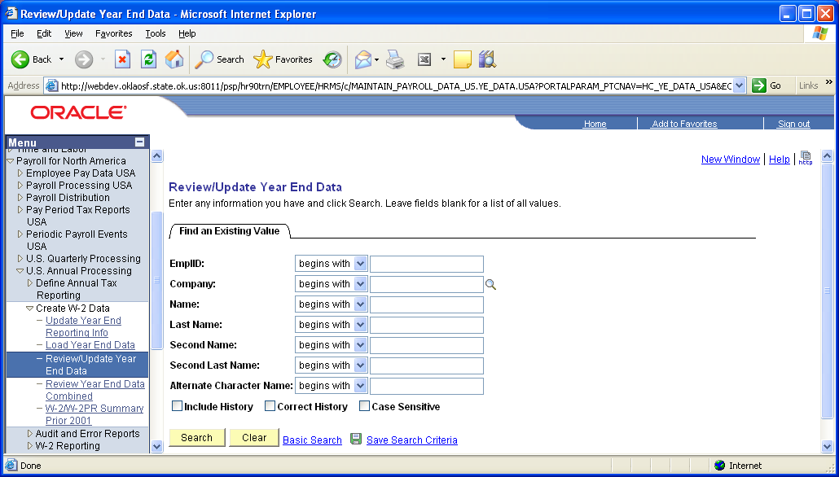

To select an employee, enter your criteria and click .

Year End Data

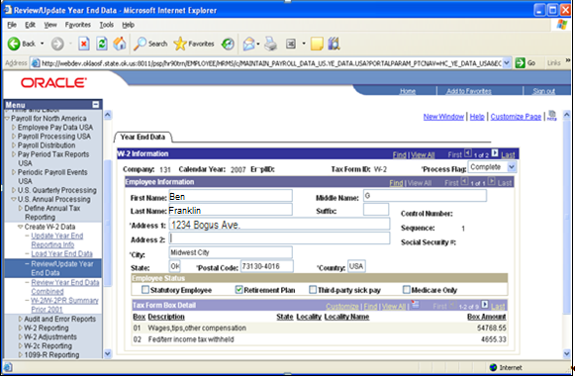

This page displays the employee’s address, social security number, and Employer SWT ID by Company and Year and employee. Although it will not pertain to the State, the system can issue multiple State W-2 forms if the employee worked in more than one state during the year.

Commitment Accounting

Overview

Commitment Accounting is a feature in PeopleSoft that establishes payroll funding for an employee. Based on the established funding, Commitment Accounting will distribute earnings, deductions, and taxes. This distribution is sent to the General Ledger.

Funding Overview

Job Earnings Distribution (JED) will no longer be used to establish funding for an employee who is in a Commitment Accounting Department. Funding will now be established using the Department Budget Tables (DBT). A conversion program will update all employees in the agency converting to Commitment Accounting, changing the JED page setting of the Job Earnings Distribution Type to NONE. During the conversion process the DBT’s will be generated for the agency. The DBT’s contain the funding for the agencies department, if the positions or employees in the department require different funding that which was established for the Department, Position Level or Appointment Level funding will be created.

Moving forward, the DBT’s will require maintenance for new hires, transfers in/out of the agency and general changes in funding. CORE will provide automated yearly maintenance to generate DBT entries for the next fiscal year.

Review Department Budget Table

The New Hire process will automatically set the Earnings Distribution Type on the Earnings Distribution Page to NONE. No data entry will be required on this page. The default funding for an employee will be established on the Department Budget Tables.

Navigation: Setup HRMS > Product Related > Commitment Accounting > Budget Information > Department Budget Table USA

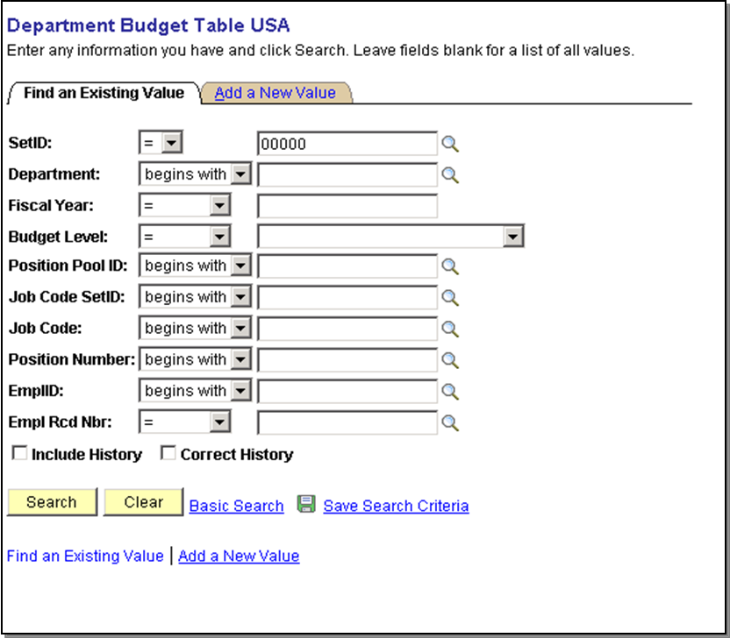

Enter the SetID – this is the five digit Agency/Company number.

Enter Department, Fiscal Year and Budget Level - for Budget level select Department from the drop down list. Select .

Department Budget Table – Department Budget Date

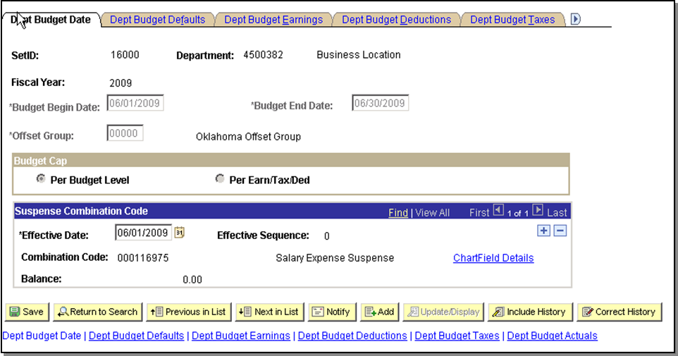

Budget Begin and Budget End Date is the Fiscal Year begin and end dates, unless the department was created after the fiscal year began, then the Begin Date is set to the first day the department was active for the agency.

Offset Group: Stores the liability accounts for the offsetting entries sent to the General Ledger.

Budget Cap: The Budget Cap determines if budgeting will have a cap. This feature is not currently being used and therefore “Per Budget Level” is selected.

Suspense Combination Code: The suspense combination code for all departments will be supplied by OSF. The Actuals process charge all unfunded amounts to the suspense account enabling the Actuals process to continue posting to the other specified Chartfield Strings even when the funding source is exhausted or inactive. At least one Suspense Combo Code and effective date must be entered for each Department Budget. The Combo Code used here cannot be used anywhere else in the Department Budget. Any changes to the Suspense Combo Code should be made by inserting a new effective-dated row. The system forces transactions into the Suspense Combo Code when a funding source is no longer usable. Examples of when this code will get used are:

- Funding at a lower level (i.e., Appointment) and a DBT entry is not setup for an employee; the system does not know how to fund that person. As long as the employee is in a Department that has at least one entry on the DBT, the system uses the Suspense Account Code on that record for distribution.
- If a flat dollar amount is assigned to a funding source and that dollar amount is reached and there is no other funding source defined to take over, the system uses the Suspense Account Code for distribution.
- If the funding end date is reached and there is no new funding source to take over, the Suspense Account Code is used for distribution.

Department Budget Table – Department Budget Defaults

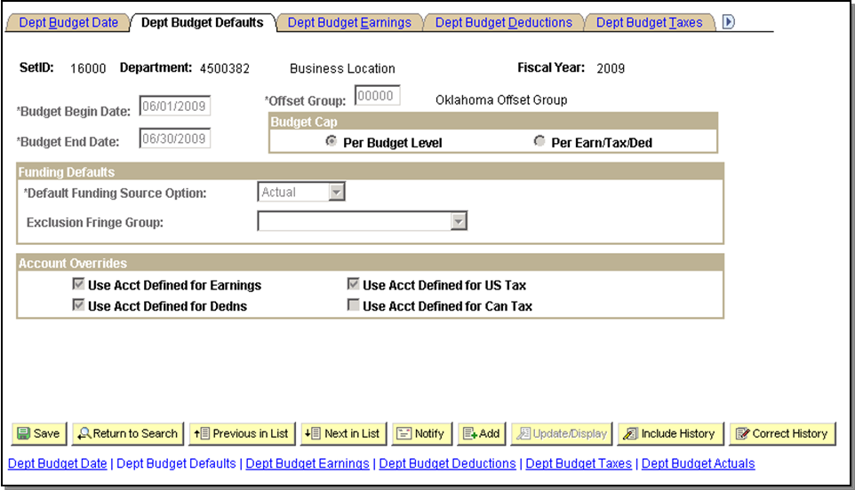

This page is used to identify default funding sources for deductions and taxes as well as how overrides to Combo Codes should be handled as they relate to the earnings set up. The page is also used to identify at each DBT entry if account mapping needs to take place or not. Information at the top portion of the page is display only and is present by virtue of the options chosen on the Department Budget Date page.

NOTE: The first two pages, Department Budget Date and Department Budget Defaults, are driven at the Department level even if budgeting at Position or Appointment levels. This means that the options chosen on these pages are really at the Department level and if changes are made for a single DBT entry on one of these pages, that change is reflected on all the DBT entries for that Department. Additionally, once a DBT entry has been created for a Department, the data entry on these two pages will be complete for subsequent new entries in that Department and only the Earnings, Deductions, and Taxes pages may need to be adjusted.

Default Funding Source Option
Default Funding Source Option is used to tell the system how to process and populate Deductions and Taxes entries as they relate to the Earnings entries or any overrides that might have been put into the system. The option selected for this field is ‘Actuals’. This option populates the Deductions and Taxes pages with the same Chart String combinations and percentage splits defined on the Earnings page when the entry is saved. When Actuals are distributed, the system distributes Deductions and Taxes the same way that Earnings are distributed either based on DBT, on the Paysheet or TL if there have been overrides.

EXAMPLE: Earnings are distributed on DBT as follows - Combo Code A 50% and Combo Code B 50%. DBT is saved with the same distribution split and all Earnings, Deductions and Taxes entries are split 50/50 over these two codes. If, however, in Time & Labor all earnings were reported to Combo Code C then that would override the DBT and Deductions and Taxes entries would also be distributed to Combo Code C.

Exclusion Fringe Group
This field identifies the group of fringe that is excluded from distribution when dollars come over on any of the fringe values associated with the group. For example, if Medical is part of the Group then any dollars associated with Medical will not be distributed anywhere.

Account Overrides
These boxes are used to identify which mappings are to be used.

Department Budget Table – Department Budget Earnings

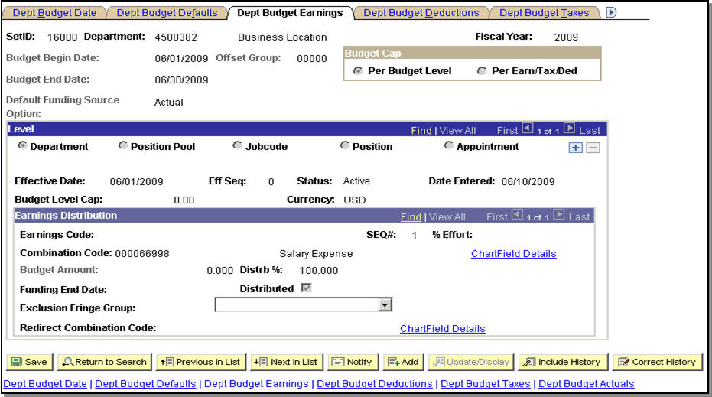

This page defines the distributions for all costs associated with earnings from payroll. This page also serves to create encumbrance entries for costs related to earnings. These values can be entered as a percentage of distribution, a funding dollar amount, or a combination of both.

Level
Indicates the level of funding for this row; defaults from initial setup when entering data on the Add page of the component. Department, Position and Appointment will be used.

Budget Level Cap
The Budget Level Cap defines the budget level for a department, a position or an appointment. The Cap is used to ensure that the sum of all lower-level budgets do not exceed this higher-level Budget Cap. It is not used for checking funds during the processing of Encumbrances and Actuals. The Department, Position, and Appointment levels will be utilized.

Earnings Distribution Section
Establish multiple funding sources and (optionally) specify a Funding End Date for each source. Funding sources are defined using a valid set of Chartfields chosen by clicking the Chartfield Details link and searching for the Chartfields that make up a valid combination. It is mandatory to establish at least one entry for each budget level in which the Earnings Code is blank. This entry is the default funding source and will be used as the funding for all earnings where a specific entry for an Earnings Code has not been established. To create multiple funding sources, insert multiple rows in the earnings distribution box to specify other funding sources. There is no limit to the number of budget rows.
Earnings Code
To specify a budget for a particular type of earning, the Earnings Code is selected from the list of valid values and associated to a combo code. A default value of BLANK also needs to be selected and associated to a combo code. The default row of a BLANK earnings code will be setup for all agencies. If necessary, on an agency by agency basis, earnings codes can be assigned individual funding.

SEQ#
This field is used to identify which funding distribution takes priority. This value will be set to ‘1’ when only a single a combo code is associated to the record. If the funding is split among more than one combo code, the SEQ# is incremented.

Combination Code
Enter the valid Combo Code associated with the funding using the ChartField Details link to the right of this text. For each row representing a funding distribution, assign a valid Combo Code for the system to use when distributing earnings.

Budget Amount
If there is a specific dollar amount associated with the funding for this level, use the Budget Amount field. When specifying multiple Combo Codes with a budget amount for a single budget SEQ#, percentage distribution is implied by the ratio between the amounts.

Distrb %
Enter a Distribution percent for each row with a SEQ#. The distribution percentages must total 100%.

Funding End Date
This field indicated a Funding End Date for a funding source. The system ignores the funding source if processing occurs at a date later than the Funding End Date specified. The pay end date is used for comparison when processing Actuals. This field is will NOT be used.

%Effort (Percentage of Effort)
This is an Informational Only field. The percentage represents an estimate of activity attributable to and associated with a specific funding source for the defined begin and end dates. The percentages entered in this field do not have to equal 100%. This field is informational only and is not used in processing.

Exclusion Fringe Group
The Exclusion Fringe Group is used to exclude costs associated with the values in the group from distribution of actuals. This field will have a value defined by CORE.

Redirect Combination Code
The Redirect Combination Code is used to override the Fringe Group funding. This field will NOT be used by CORE.

Distributed
This field is not editable but is set by the system during processing. This box gets set “ON” when the entry is used to create encumbrance or distribution details. Once it is set “ON” the values on this page are no longer editable, even in Correct History Mode. The reason for this is that the system recognizes that details will have most likely been sent to GL or are awaiting posting to GL and correcting the history on this page would cause a discrepancy between the two systems.

Department Budget Table – Department Budget Deductions

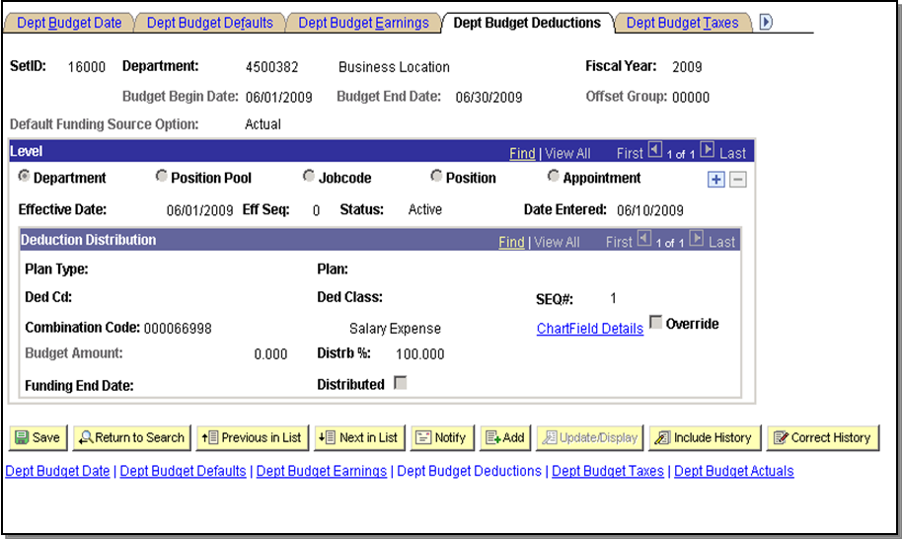

This page is used to define distributions for employer-paid deduction expenses. The data on this page will be populated with the data from the Earnings Page. No data entry is necessary on this page.

Department Budget Table – Department Budget Taxes

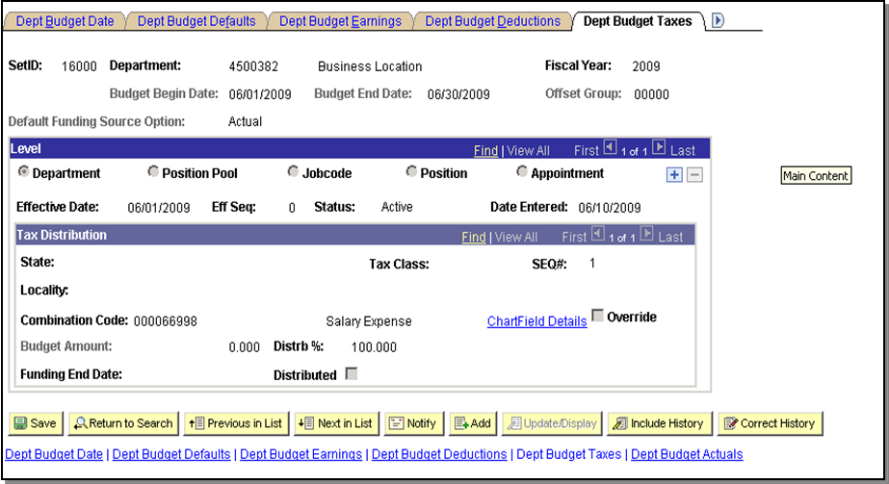

This page is used to define distributions for employer-paid taxes. The data on this page will be populated with the data from the Earnings Page. No data entry is necessary on this page.

Department Budget Table – Department Budget Actuals

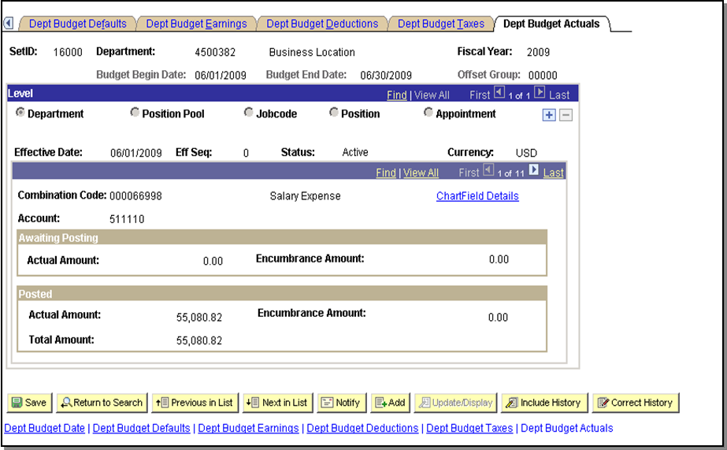

The data on this page is updated by the Actuals Distribution process, PSPPFUND. This page displays actuals for departments by combination code within each budget level, along with the total posted amount.

Update Employee Funding

In order to change an employee’s funding, one first needs to determine if the employee is funded at the department level, position level or an appointment level.

- Determine the employee’s department by looking at the Job record
- Determine the employee’s current position by looking at the Job record
- Navigate to the Department Budget Table
- Search for the Appointment Level Funding first.
- If the Appointment is not found, search for the Position level funding.
- If the Position Level funding is not found, the employee is funded at the department level. If you change the funding at the Department Level, you are changing everyone in that department.

Navigation: Setup HRMS > Product Related > Commitment Accounting > Budget Information > Department Budget Table USA

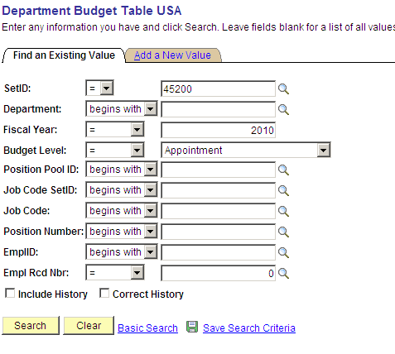

Click . Review the list returned for the Appointments that requires updating.
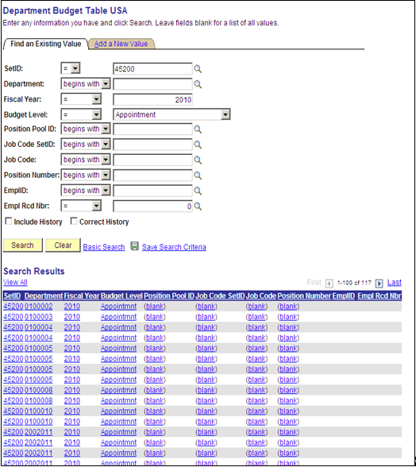

If the Emplid that requires a funding change is listed, click the EmplID to select it from the Search Results listing.

Searching for a Position is similar to that of the Appointment, just change the search dialog box to Position.
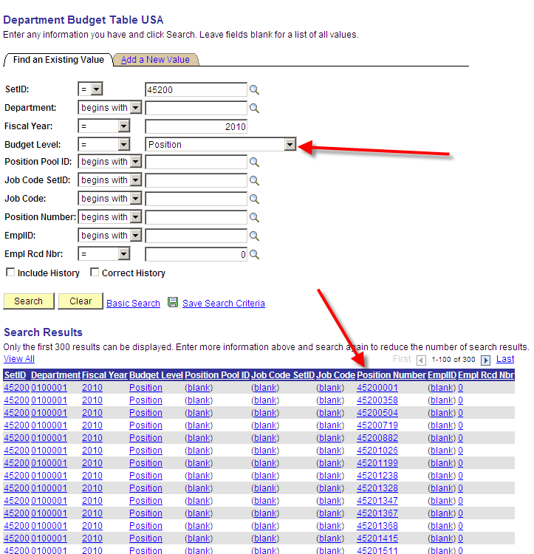

Review the listing looking for the position number that requires modification and select the record.

The first two (2) tabs will be grayed out, so you can only view the data here. The Dept. Budget Earnings Tab is the only page that requires updating.

The following screen shots can be used to change the funding at the Department, Position and Appointment Levels. This example is for Position.
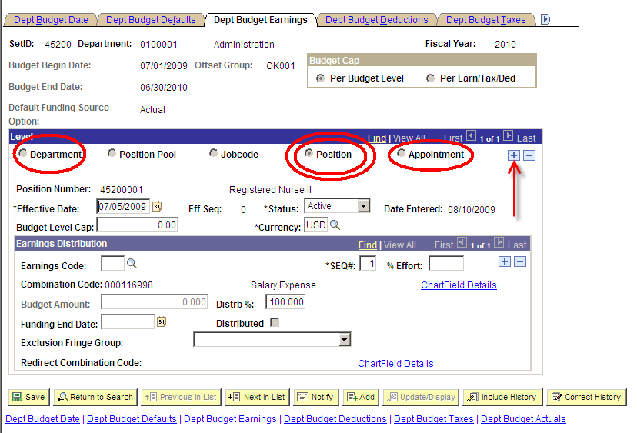

Click to insert a new Position row.

Enter the effective date of funding change. This date should be when the funding is effective, if changing this for a particular payroll it is best to set the date the Pay Period Begin Date.

Select the Chartfield Details link to assign the new effective dated row the necessary combo code.

If you know the new Combination Code, enter it in the appropriate field and click .

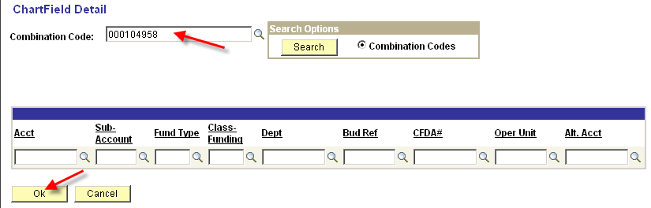

Otherwise follow these steps:

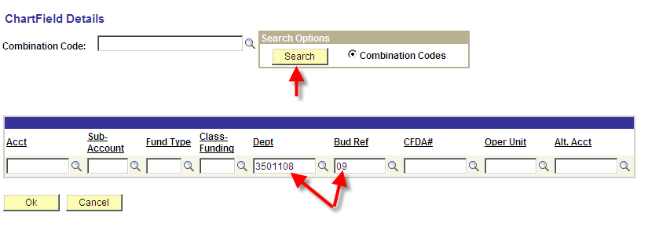

Enter the Dept and BudRef

Click , pulls up all valid GL Combo Codes for the Department and Fiscal Year specified.

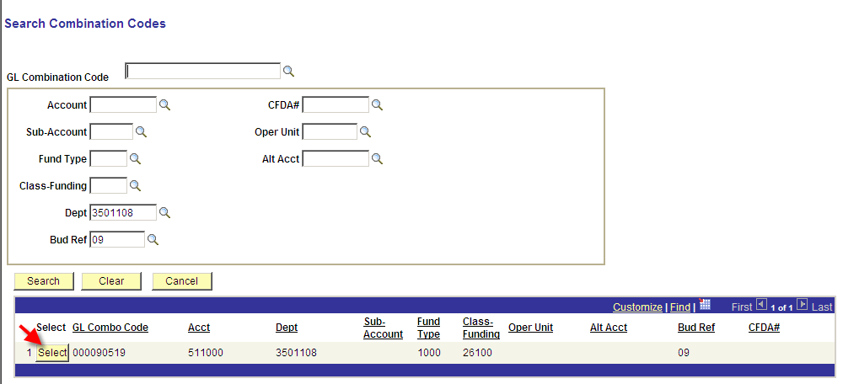

Locate the valid Combo Code and click to the left of the GL Combo Code.

This will take you back to the ChartField Detail page. The Acct, Fund Type, and Class-Funding fields are now also populated.

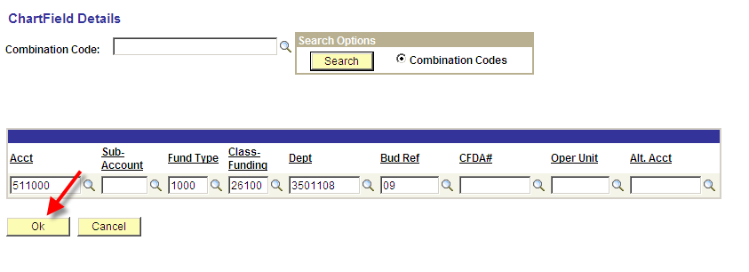

Click to go back to the Dept Budget Earnings page.

Click 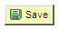.

Critical NOTE: DO NOT CHANGE the Dept. Budget Deductions and Dept. Budget Taxes, unless the funding is different than that of the Earnings. The State of Oklahoma generally has the funding of the deduction and taxes follow the earnings.

Add Position or Appointment Funding

In order to add funding for an employee or position, one first needs to determine at what level the funding should be established – Department, Position, or Appointment. Funding is added if:
- A new position is created and the position funding is different than the Department Default.
- An employee is hired, rehired, or transferred from another company or department and that employee’s funding is different than the Department Default funding.

When preparing to add funding, the following steps are followed:

- Determine the employee’s department by looking at the Job record.
- Determine the employee’s current position by looking at the Job record.
- Navigate to the Department Budget Table.
- Compare the employee’s funding to the Default Department funding record. If the funding is the same, then the employee receives default funding and nothing else is to be done.
- If the employee’s funding is different than the Default Department funding record, then determine if position funding exists for this employee’s position. If a position funding record exists for this position, compare the employee’s funding with the position funding record. If the funding is the same, then the employee receives position funding and nothing else is to be done.
- If there is no position funding record, then add a Position Level funding record for this position by following the steps below.
- If a position funding record does exist, but the funding is different from the funding that should be established for the employee, then add Appointment Level funding for this employee by following the steps below.

Critical NOTE: Before creating an Appointment Level funding record, first determine if Position Level funding for this position needs to be changed. If the funding is to be changed, follow the steps in this section: Update Employee Funding.

Add Position Level Funding

Navigation: Set Up HRMS > Product Related > Commitment Accounting > Budget Information > Department Budget Table USA

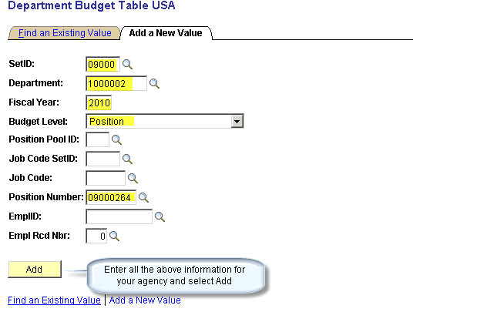

Click .

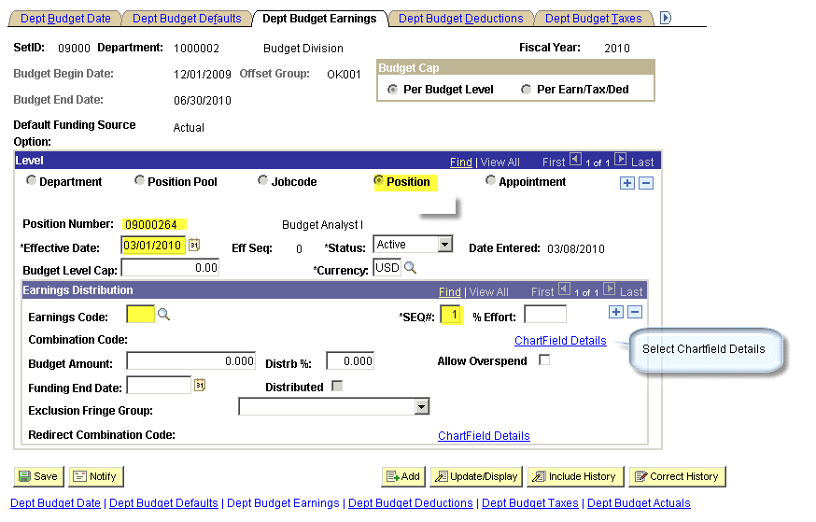

Effective Date: - Reflects the date of the funding source.

Eff Seq: - Defaults to “0”. Use this number to track multiple transactions that occur on the same date.

States: - Active or Inactive

Earnings Code: - Must be blank

SEQ#: - 1
Select the Chartfield Details link to assign the new effective dated row the necessary combo code.

If you know the new Combination Code, enter it in the appropriate field and click .

Otherwise follow these steps:

Enter the Dept and BudRef fields.

Click , pulls up all valid GL Combo Codes for the Department and Fiscal Year specified.

Locate the valid Combo Code and click to the left of the GL Combo Code.

This will take you back to the ChartField Detail page. The Acct, Fund Type, and Class-Funding fields are now also populated.

Click to go back to the Dept Budget Earnings page.

Distrb%: - Enter the percentage allocated to the selected Account Code.
Click .

Critical NOTE: DO NOT CHANGE the Dept. Budget Deductions and Dept. Budget Taxes, unless the funding is different than that of the Earnings. The State of Oklahoma generally has the funding of the deduction and taxes follow the earnings.

Add Appointment Level Funding

Navigation: Set Up HRMS > Product Related > Commitment Accounting > Budget Information > Department Budget Table USA

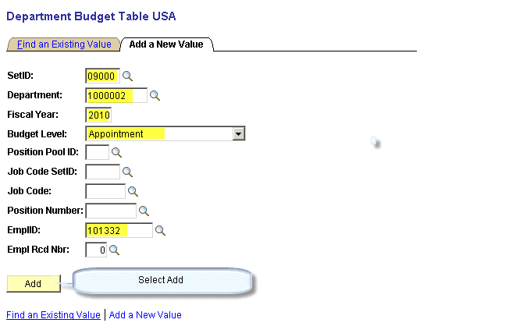

Click .
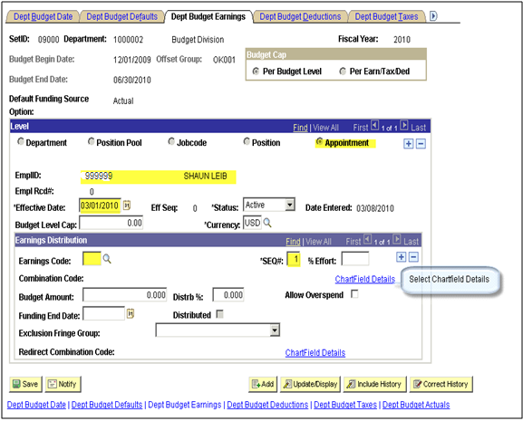

Effective Date: - Reflects the date of the funding source.

Eff Seq: - Defaults to “0”. Use this number to track multiple transactions that occur on the same date.

States: - Active or Inactive

Earnings Code: - Must be blank

SEQ#: - 1
Select the Chartfield Details link to assign the new effective dated row the necessary combo code.

If you know the new Combination Code, enter it in the appropriate field and click .

Otherwise follow these steps:

Enter the Dept and BudRef

Click , pulls up all valid GL Combo Codes for the Department and Fiscal Year specified.

Locate the valid Combo Code and click to the left of the GL Combo Code.

This will take you back to the ChartField Detail page. The Acct, Fund Type, and Class-Funding fields are now also populated.

Click to go back to the Dept Budget Earnings page.

Distrb%: - Enter the percentage allocated to the selected Account Code.

Click .

Critical NOTE: DO NOT CHANGE the Dept. Budget Deductions and Dept. Budget Taxes, unless the funding is different than that of the Earnings. The State of Oklahoma generally has the funding of the deduction and taxes follow the earnings.

Mid Pay Period Funding Changes
When funding is changed in the middle of a pay period, ALL Earnings, Deductions and Taxes will be split funded accordingly. Therefore, if time is entered for any earnings that reduce from REG in Time & Labor after the funding changes, the earnings will be split funded even though the hours for that specific TRC/Earn Code are entered during the period the “new” combo code is in effect.

If the funding needs to be changed for a particular Earnings Code to charge to just one Combo Code, the change has to be made on the payline. This becomes important in particular for Federal Funding.

Funding Change on Payline
Navigation: Payroll for North America > Payroll Processing USA > Update Paysheets >
By Payline Security

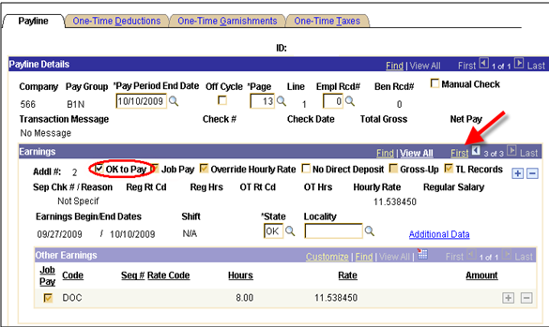

Uncheck OK to Pay. Click First to go to the first row.

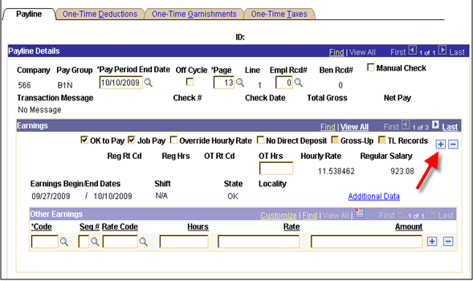

Press the button to insert a new row.

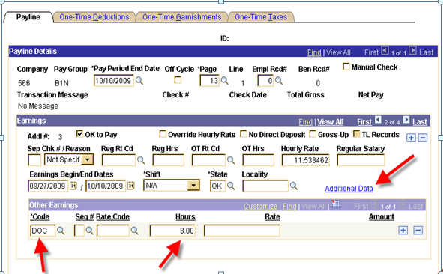

Re-enter 8 hours of DOC pay and click the Additional Data link.
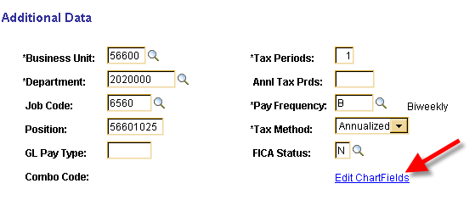

Click the Edit ChartFields link.

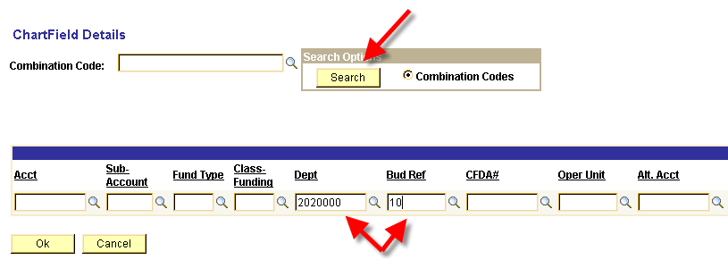

Enter the Dept and Bud Ref (or the Combination Code if known). Click .
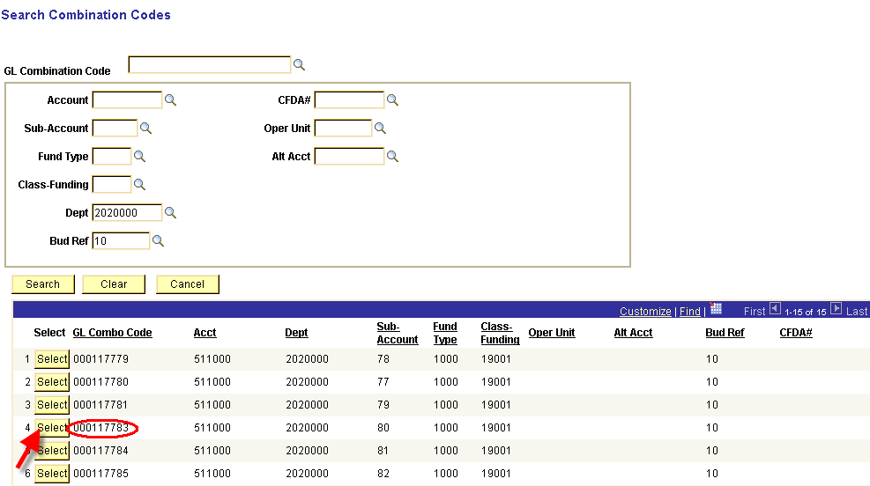

Locate the valid Combo Code and click to the left of the GL Combo Code, which takes you back to the ChartField Details page.

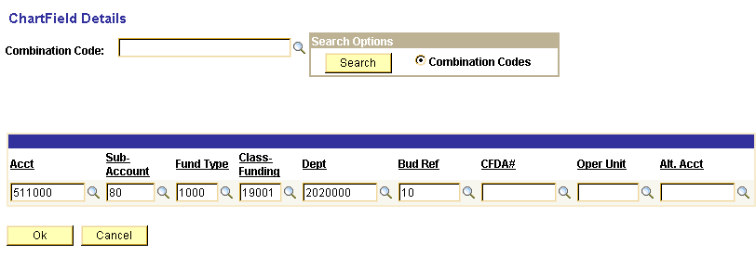

Click , which takes you back to the Additional Data page.
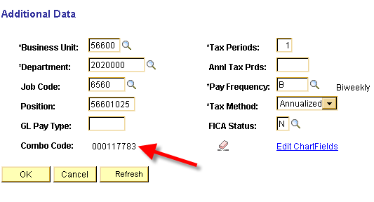

Notice the Combo Code has been filled in. Click .

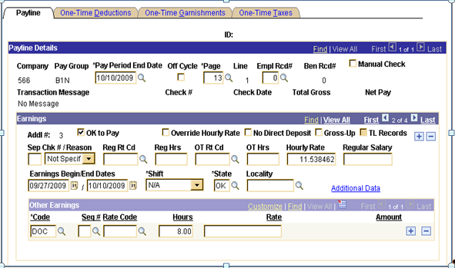

Click .

Once Actuals Distribution has been run, the changes will be reflected.

Actuals Distribution

Review / Correct Employee’s Actuals Distribution
The State of Oklahoma will NOT allow payrolls to process beyond the Funding Reports step until ALL deficits are cleared up.

In order to clear up deficits Use the Review Actuals Distribution page to modify funding distribution after the Actuals Distribution process and before posting to the General Ledger. The funding source can be changed but the total dollar amount must stay the same.

Navigation: Payroll for North America > Payroll Distribution > Commitment Accounting USA > Review Actuals Distribution

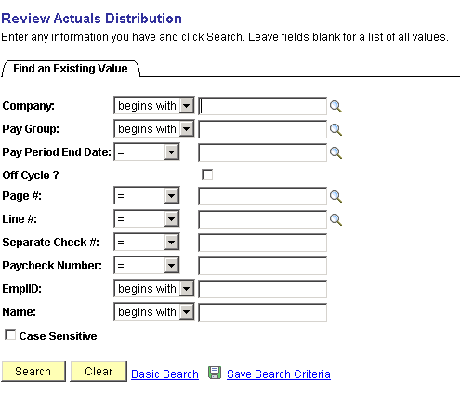

On the above search criteria page, enter the Company, Pay Group, Pay Period End Date and the employee’s EmplID which requires a funding adjustment. You may use any of the other criteria for searching the Actuals Distribution, the more fields you provide the faster the data is returned.

Click .
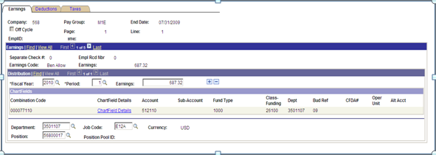

The Earnings page displays the Actuals Distribution that was distributed during the Actuals Distribution process (PSPPFUND). 1 of 5 rows of data is available to change funding.

Funding can be changed by selecting the ChartField Details link.

Example Changing the Chartfield Details:

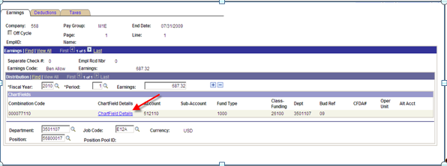

Select the Chartfield Details link:

If you know the new Combination Code, enter it in the appropriate field and click .

Otherwise follow these steps:

Enter the Dept and BudRef
Click , pulls up all valid GL Combo Codes for the Department and Fiscal specified.

Locate the valid Combo Code and click to the left of the GL Combo Code. This will take you back to the ChartField Detail page. The Acct, Fund Type, and Class-Funding fields are now also populated.

Click to go back to the Review Actuals page.
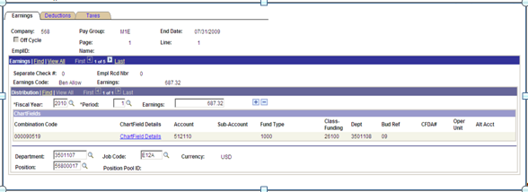

The Review Actuals page for Earnings is returned with the new Combo Code displayed.
Change the Combo Code for each Earnings row.

Since the Earnings records were changed to a new combo code, the Deductions and Taxes also need to change to the new Combo Code.

Select the Deductions Tab:

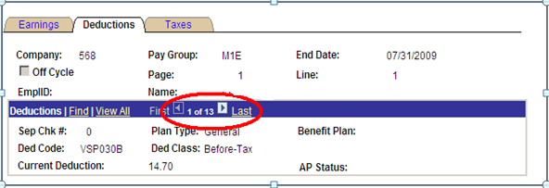

Notice that the number of records total 13. The first deduction displayed above is VSP030B. This is an EMPLOYEE deduction. Only EMPLOYER deductions are distributed.

Select the View All link and change the Combo Code on ALL of the EMPLOYER deductions.
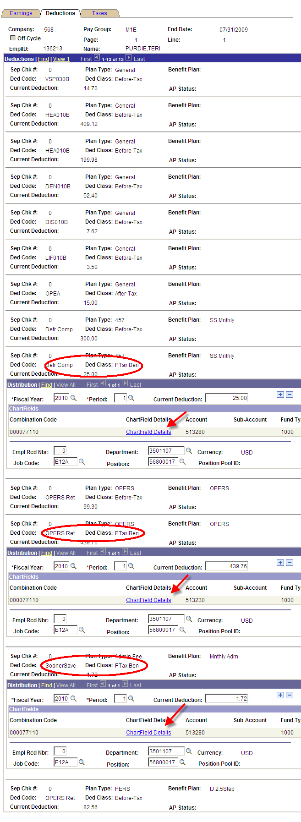
For each EMPLOYER deduction follow the directions above for changing the ChartFields.

Select the Taxes Tab:

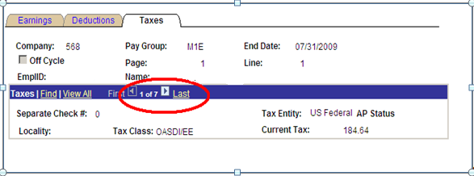

Select the View All link to display all of the Taxes.
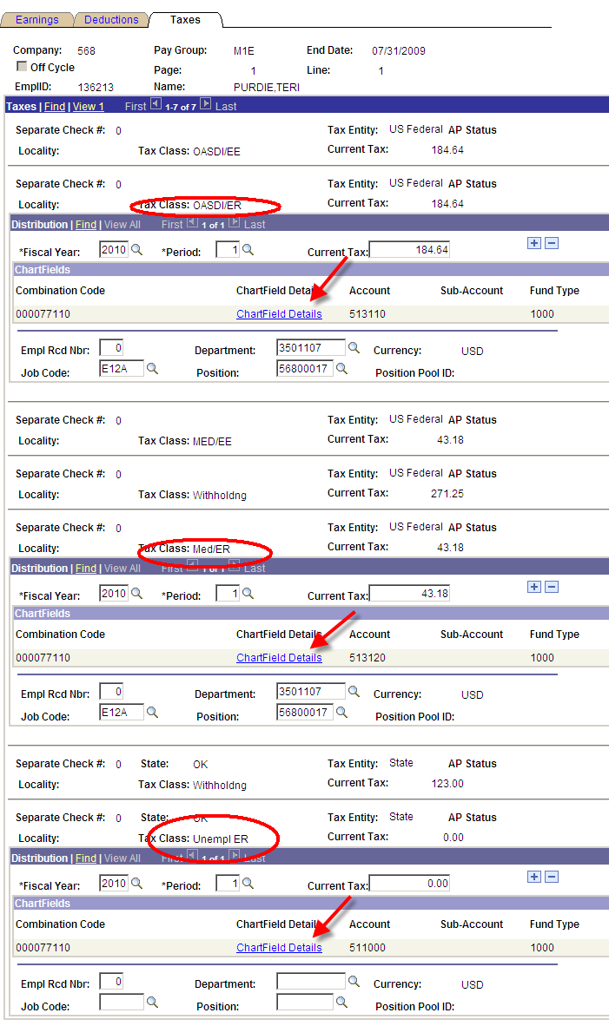

For each EMPLOYER paid tax, change the combo codes using the same steps above for changing the ChartField Details.

Pre-Commitment Accounting Time

Process Time Prior to Commitment Accounting
Any time entered in Time and Labor prior to the Commitment Accounting Go-Live date has to be processed separately. All Pre-Commitment Accounting time must be processed using the ‘old’ Pay Groups and the ‘old’ MDC Allocations processes as an Off-Cycle payroll.

Create Off-Cycle paysheets prior to creating paysheets for the on-cycle payroll:

- Identify your agency’s Commitment Accounting Go-Live date. This date will be different for monthly and bi-weekly if your agency pays both types of employees.

Navigate to Job Data and select an employee who is in the appropriate Pay Group (monthly or bi-weekly if applicable to your agency). Look for the row in Job that has a Reason of “Conversion – Commitment Acctg”. The Effective Date of that row is the Go-Live date for that Pay Group.

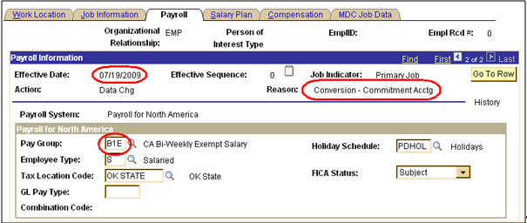

- Run the Pre Commitment Accounting Payline Audit. This report will identify time in payable time that has a DUR prior to the agency Commitment Accounting live date, and has a payable status of AP (Approved), RP (Rejected by Payroll), or ES (Estimated).

Navigation: OK Custom Reports/Processes > OK Reports > Payroll > Pre-CA Payline Aud(0432)

Enter the Run Control ID which will take you to the Pre-CA Payline Audit parameters page.
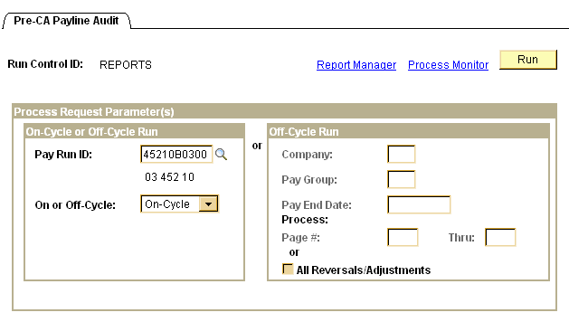

In the On-Cycle or Off-Cycle Run group box, enter the correct Pay Run ID and select On-Cycle, then click .

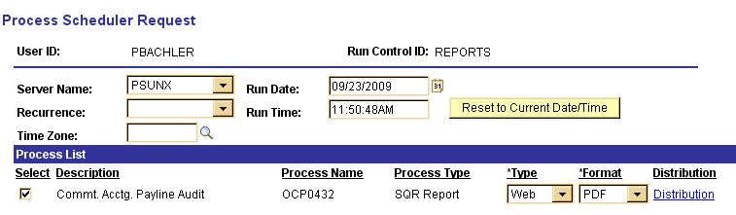

On the Process Scheduler Request page, make sure Server Name is set to PSUNX.

In the ‘Process List’ group box:
- Check box should be checked next to Commt. Acctg. Payline Audit
- Type should be set to Web
- Format should be set to PDF

Click .
When the screen goes back to the Pre-CA Payline Audit parameter page, take note of the Process Instance number and click Process Monitor link.

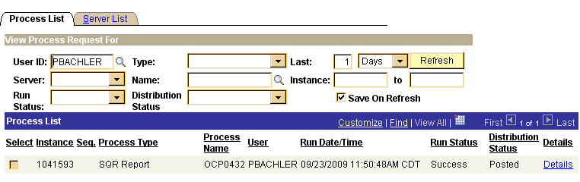

When the job has run to Success and Distribution Status says Posted, click the Details link. On the Process Detail page click View Log/Trace link.

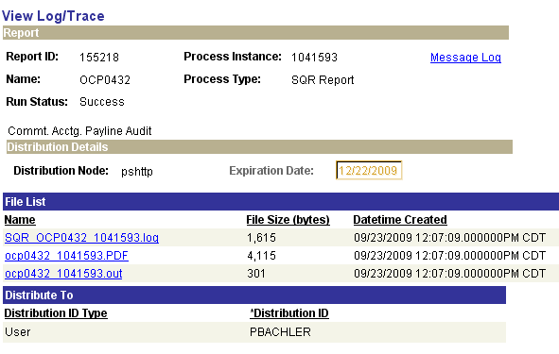

Click the .PDF file to open and print the audit report. If the report returns any rows, then this time must be processed as an off-cycle payroll run before paysheets are created for the On-Cycle payroll.
- Request an Off-Cycle Pay Calendar from CORE for the prior pay group(s):

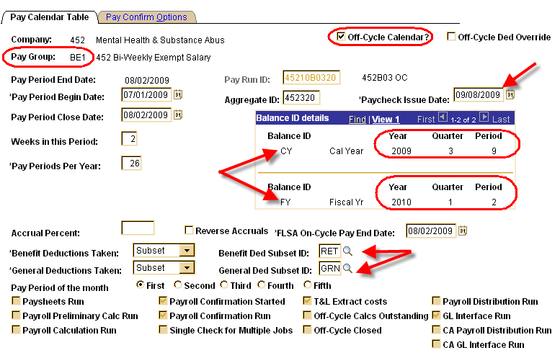

Pay Group(s): Pay group(s) the employees were in prior to Commitment Accounting Go-Live.

Pay Begin Date: MUST be prior to the Commitment Accounting Go-Live date.

Pay End Date: MUST be within the current balance period (the balance period of the open on-cycle calendar for CY and FY).

Check Date: MUST be within the current balance period (the balance period of the open on-cycle calendar for CY and FY).

Benefit and General Deduction Subset: Select as appropriate.

Pay Run ID: Per CORE standard.
- Run the Load Time and Labor process loading only prior period time into off-cycle paysheets.

Navigation: Payroll for North America > Payroll Processing USA > Create and Load Paysheets >Load Time and Labor

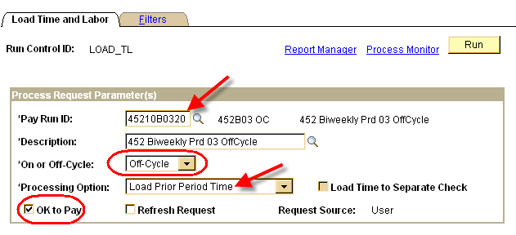

Enter the Off-Cycle Run Control ID for the Off-Cycle Pay Calendar(s) for the prior to Commitment Accounting Pay Group(s).

Select Off-Cycle

Select Load Prior Period Time for the Process Option.

OK to Pay is Y (checked on).

Click the Filters Tab.
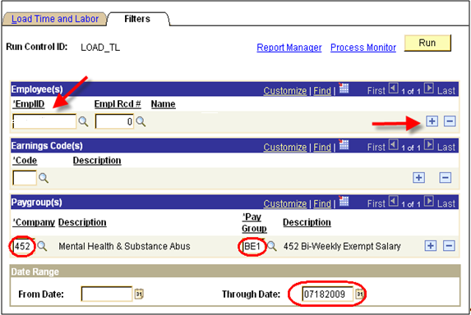

Enter the EmplID(s) listed on the Pre-CA Payline Audit report.

Enter your agency number in the Company field.

Enter the Pay Group(s) being processed. Enter only prior to Commitment Accounting Pay Group(s).

Enter the date range to pull from Time and Labor.

From Date can be blank to pull the earliest date in Payable Time DUR.

Through Date MUST be one day less than the Commitment Accounting Go-Live date.

Click .

Click .
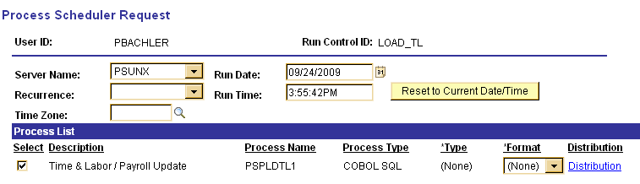

On the Process Scheduler Request page, make sure Server Name is set to PSUNX.

In the ‘Process List’ group box:
- Check box should be checked next to Time & Labor / Payroll Update
- Type should be set to (None)
- Format should be set to (None)

Click .

- Re-run the Pre-CA Payline Audit report to ensure all prior period time is gone from Payable time.

- From this point, the payroll process follows the normal off-cycle payroll processing steps.

- REMEMBER: ALL Off-Cycle paysheets MUST be confirmed before the On-Cycle payroll is confirmed.

