COR106 Time and Labor Manual

Revised: July 20, 2010

Authorized by: [_CORE_] Original Issue: [11/03/2004]
Maintained by: [____HRMS Team___] Current Version: [07/20/2010]
Review Date: [12/30/2010]

Table of Contents
Table of Contents 3
Document History 5
Time and Labor 6
Business Process Flow 6
Time and Labor Concepts 7
Terminology 7
Configuration 9
Defining a Compensatory Time Off Plan 11
Defining a Time Reporting Code (TRC) 12
TRC Definition of Hourly (HREG) 13
Time Reporting Codes for Agency 805 14
Defining Workgroups 18
Defining Static Groups 20
Erolling & Maintaining Time Reporter 21
Business Process Flow 21
Defining Time Reporter Data 22
Updating Static Group 24
Current Group Members 26
Maintain Time Reporter Data Page 27
Enroll Time Reporter in Compensatory Time Plan 28
Entering Time 30
Business Process Flow 30
Timesheet 31
Timesheet Page 32
Processing Time 37
Business Process Flow 37
Processing Time Administration (Time Admin) 38
View Payable Time 43
Business Process Flow 43
Viewing Payable Time 44
Payable Time Statuses 46
Viewing Unprocessed Payable Time 51
Reviewing Exception 53
Business Process Flow 53
Checking For Exceptions 54
Manage Group Exceptions 57
Exceptions Detail Info 58
Payable Time 63
Approve Time by Group or Time Reporter 64
Correcting Business Process Flow 68
Timesheet 69
Time Administration Process 70
Payable Time Detail 71
Processing Comp Time 72
Business Process Flow 72
Overview 73
Comp Time Plans and their TRCs 74
Timesheet 77
Running Time Administration 79
Message Log 82
Check for Payable Time 83
Viewing Compensatory Time Balances 85
Process Shared Leave/Giving & Receiving 88
Overview 88
Giving Shared Leave 90
Receiving Shared Leave 91
Running Time Administration for Both Employees 93
Employee ID 999999 – Receiving Leave 94
Employee ID 999998 – Giving Leave 94
Review Compensatory Time Balance for Employee 999999 95
Using Shared Leave – Employee 999999 96
Check Payable Time for Employee 999999 98
Check Shared Comp Time Balance – Employee 999999 99
Processing Sick and Annual Leave 101
Overview 101
Time Reporting Codes (TRCs), Sick & Annual Leave 102
TRCs for Annual Leave – Agency 805 102
TRCs for Sick Leave – Agency 805 102
Entering the Annual Leave Taken 103
Entering the Sick Leave Taken 104
Run Time Administration Process for Employee ID 999999 105
Processing Longevity 106
Partial Longevity 106
Longevity Payout – Longevity Process 107
Processing Terminal Leave Payout 108
Step 1 – Entering Time into Timesheet 108
Step 2 - Run Time Administration by Employee ID 109
Step 3 - Check Payable Time Detail 111
Adjust Paid Time 112
Closing Rejected Rows 112
Processing Adjustments thru T&L 114
TRCs for Adjustments 114
FMLA Accumulator 115
Check Reversal 118
Queries 119

Document History

Document Revision | Date | Description
1.0 | 11/03/2004 | Initial Document
1.1 | 11/28/2008 | Revised for Upgrade from Release 8.3 to 9.0
1.2 | 04/20/2009 | FMLA Accumulator Chapter added
1.3 | 05/01/2010 | Changes made due to Commitment Accounting implementation
1.4 | 07/20/2010 | CORE manual standardization

Time and Labor

Business Process Flow
Payable Time
is ready to go to Payroll
to be paid
Exceptions
Must be corrected in Timesheet
and processed thru Time Admin again to produce Payable Time
Process time through
Time Administration
to produce Payable Time or Exceptions

All Employees are Time Reporters.

Time Admin takes in Timesheet, validates it and produces either Payable Time or Exceptions.

.

Only Payable Time can be sent to Payroll.

Exceptions must be cleared.

Key or Load time into
Timesheet
for each Time Reporter

Manager Self Service > Time Management > Report time > Timesheet

Time and Labor > Process Time > Request Time Administration

Manager Self Service > Time Management > Approve Time and Exceptions > Exceptions

Manager Self Service > Time Management > Approve Time and Exceptions > Payable Time

Time and Labor Concepts

PeopleSoft Time and Labor is a software application with many features and functions that are integrated with the other PeopleSoft application (Human Resources, Base Benefits and North American Payroll) being implemented at the State of Oklahoma. This training documentation will cover only those functions currently implemented.

This training manual does not cover all possible scenarios you may encounter while using PeopleSoft Time & Labor. However, it does cover the most frequently encountered scenarios.

Terminology

The following section provides the various terms utilized in the PeopleSoft Time & Labor system. Below are the terms and definitions:

Timesheet – is an input screen into which you key or load time worked and/or time taken off for each employee.

For salaried employees, enter exceptional time, the system automatically generates their regular pay for each pay period.

An example of exception time would be employee John Doe took off 8 hours sick on February 3. Enter the correct TRC for sick time (SCKTK) and the number of hours taken on the Timesheet. The PeopleSoft application will move the 8 hours from the Regular Earnings category to the Sick Time category and reduce the employee’s sick time balance available.

For hourly and temporary employees, you must key or load in the hours worked into their Timesheet in order for them to get a paycheck. The system does not automatically generate their regular hours worked onto paysheets.

NOTE: The Timesheets are always LIVE and can be changed at any time in the future. The entries are always there and the system knows which ones have already been processed and which ones are new entries that need to be processed.

Time Administration – The batch program takes time entered into Timesheet and validates it against pre-established rules producing Payable Time, if the time does not violate any rules. If the time entered violates a rule, the system will not produce payable time for that time entry. The time in violation of the rules are set to an Exception Status and will not be processed until the exception has been cleared up.

Payable Time – Time that has been processed through the Time Administration batch program. Payable Time can be pulled into Payroll for processing. Only payable time can be sent over to payroll.
Exceptions – Time entered in error that must be reviewed. The time with the exception will not be processed until the exception is cleared. The employee cannot be paid for time that is flagged as an exception.

Time Reporter – Any employee that has time processed through Time and Labor. Every employee must be a time reporter to have time processed by Time Administration.

Time Reporting Code (TRC) – A code that designates the type of work performed, leave time or other type of time that needs to be processed through Time and Labor. Each agency has access to the TRCs as assigned to their agency through the Time Reporting Code Program. Examples are: LWOPS (Leave Without Pay Scheduled), OTSTR (Overtime Straight), JURY (Jury Duty), SCKTK (Sick Time Taken), and ANNLV (Annual Leave Taken).

Time Reporting Code Program (TRC Program) – Time Reporting Codes are grouped together into Time Reporting Code Programs so agencies will only see TRCs relevant to their agency when entering time for an employee. The naming convention for TRC Programs has been defined as: 3 character agency + 01. Therefore, the TRC Program for Department of Mental Health is 45201. All agencies that have hourly/temp employees will use the TRC Program of HRLY.

Unprocessed Payable Time – Payable Time with status Estimated, Approved, Rejected. These statuses indicate that time has not been taken by payroll.

Workgroup – This is a group of employees that use similar data within the Time and Labor application. Most agencies will have two or more Workgroups – one for salaried employees and one for hourly/temporary employees.

Time Period – Covers a range of dates for time reporting purpose. Time periods are normally aligned with pay periods.

Configuration

To understand how transactions are processed through Time and Labor, it’s important to understand how the system was configured. Each of the following sections indicates a part of the configuration.

Time Reporting Codes are:
- Mapped to a Payroll Earnings Code, if it affects the employee’s pay, benefit accruals or other accumulators.
- Designated as having an impact on Compensatory Time Plans, if appropriate.
- Used for reporting purposes to determine trends or summary in type of work performed.

The naming convention for Time Reporting Codes is to use up to five characters that describe the code as best as possible (i.e. LWOPS = Leave Without Pay – Scheduled).

Time Reporting Code Programs – Time Reporting Codes are grouped together in Time Reporting Code Programs by agency.

A Time Reporting Code is assigned at the Workgroup level (covered later). This is helpful during time entry. Rather than seeing all the Time Reporting Codes defined for all agencies, only Time Reporting Codes relevant to your agency will be available for entry. An example of a Time Reporting Code Program is 54801 which is set up for agency 548.

Each agency will have at least one Time Reporting Code Program for their full-time, salaried employees. If they have part-time, temporary employees they will have a second Time Reporting Code Program (hourly employees).

The naming convention for Time Reporting Code Programs is:
- First three characters are the agency number
- The last two characters are either “01” for full-time, salaried employees (80501) or “02” for special processing.
- HRLY for part-time, temporary employees.

Therefore, Rehabilitation services will have two Time Reporting Code Programs (80501 and HRLY).

Annual Leave and Sick Leave Plans are accrual-type plans. They are tracked in Base Benefits. The accrual process for these plans is run after all the payrolls for a given pay period (monthly or biweekly) are finished. Annual and Sick leave taken or adjustments must be processed through payroll before leave accruals can be processed.
In Time and Labor, the following Compensation plans have been established:

- COMPCORE – Comp Core Project
- COMPPUB – Compensatory Time Plan for Public Safety
- COMPREG – Compensatory Time Plan for All others
- COOLOFF – Administrative Leave, Cool Off – (32 hours)
- ENFORCED – Enforced Leave – (80 hours)
- HOLIDAY – Holiday Leave
- MILITARY – Military Leave – (240 hours)
- ORG – Organizational Leave – (24 hours)
- SHARED – Shared Leave
- SHLFTERM – Shared Lifetime Leave for Terminally Ill – (2920 hours which is 365 days)
- SHLFNOTERM – Shared Lifetime Leave for Non-Terminally Ill – (2088 hours which is 261 days)

Compensatory Time Off Plans – There are several Compensatory Time Plans that have been setup in Time and Labor. These plans have balances updated based on Time Reporting Codes entered for an employees time. For example, an employee currently has a Compensatory Time Balance of 20 hours. This week enter eight (8) hours using a Time Reporting Code that adds to the Compensatory Time Balance. The next time we process that time, the balance will get updated to 28 hours.

Comp Time Data is all handled in Time & Labor – including the comp time balances.

Defining a Compensatory Time Off Plan

Compensatory Time Plans have been established with limits and expirations as defined in the merit rules.

Navigation: Set Up HRMS > Product Related > Time and Labor > Time Reporting > Compensation Time Off Plan

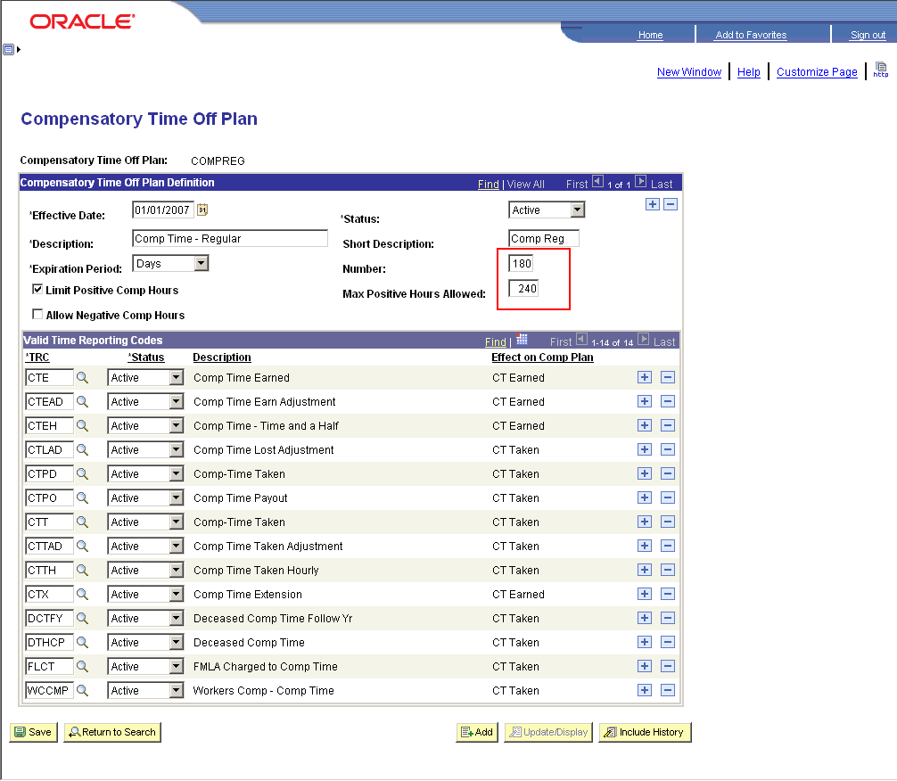

In the screen print above, notice that a Compensatory Time Plan has been established called – COMPREG. It says that Comp Time will expire in 180 days if not taken. It also indicates that a person can only accumulate a maximum of 240 hours. The Time reporting Codes (TRCs) that update the Comp Plan Balance Record are shown in the “Valid Time Reporting Codes” section.

NOTE: Time is accumulated and taken on a first in, first out basis.

Defining a Time Reporting Code (TRC)

The time reporting code for Comp Time Earned is CTE in this example. The definition pages are shown below.

Navigation: Set Up HRMS > Product Related > Time and Labor > Time Reporting > Time Reporting Codes- TRC

CTE Definition - TRC1 Tab

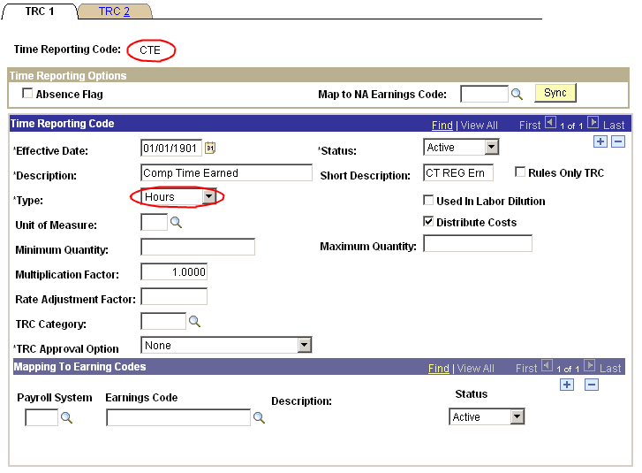

The CTE Time Reporting Code - TRC2 Tab is shown below. As it is defined, it adds to the Comp Time Balance.

CTE Definition - TRC2 Tab

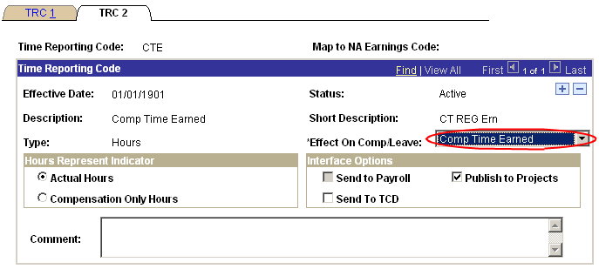

Therefore, by including this Time Reporting Code in this plan it will add hours to an employees balance when time is entered against this Time Reporting Code.

TRC Definition of Hourly (HREG)

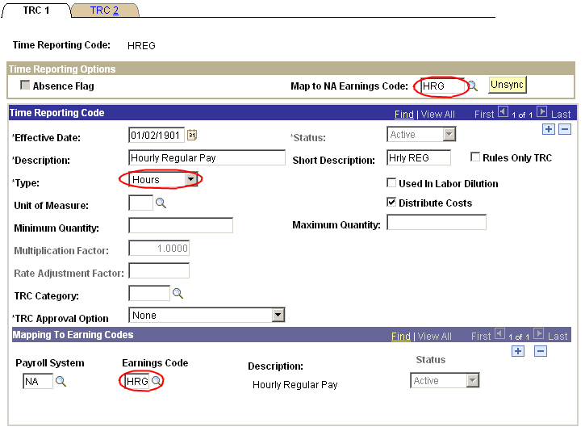

HREG Definition – Tab TRC2

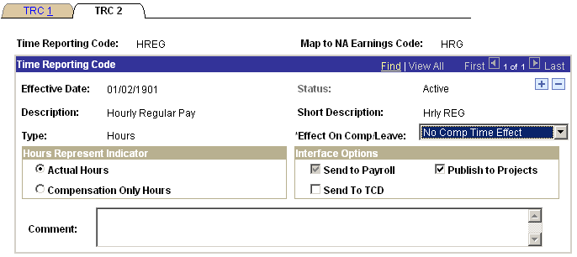

Time Reporting Codes for Agency 805

TRC |  | Descr |  | TRC Type |  | Earn Code |  | Comp Leave Ind |  | Add to Gross
ADJ |  | Earnings Adjustments |  | H |  | ADJ |  | NO |  | Y
ADLAD |  | Admin Lv Cool Off Adjustment |  | H |  |  |  | CERN |  | Y
ADLCO |  | Salary Admin Cool Off |  | H |  | ADL |  | CERN |  | Y
ADMLV |  | Salary Administrative Leave |  | H |  | ADM |  | NO |  | Y
ANNAD |  | Annual Leave Adjustment |  | H |  | ANA |  | NO |  | N
ANNLV |  | Annual Leave Salaried |  | H |  | ANL |  | LTKN |  | N
ANREC |  | Annual Leave Received |  | H |  | ANR |  | NO |  | N
BOARD |  | Board Members and Commissioner |  | H |  | BRD |  | NO |  | Y
BONE |  | Salary Regular Pay |  | H |  | SRG |  | NO |  | Y
CADJ |  | Comp Rate Adj (Mid Week) |  | H |  | CAJ |  | NO |  | Y
CAR |  | Vehicle Usage |  | A |  | CAR |  | NO |  | N
CAREE |  | Career Progression |  | A |  | CRP |  | NO |  | Y
CHARG |  | Charge Tips |  | A |  | CRT |  | NO |  | Y
COMM |  | Commissions |  | A |  | COM |  | NO |  | Y
CSI |  | Continuous Service Incentive |  | A |  | CSI |  | NO |  | Y
CTE |  | Comp Time Earned |  | H |  |  |  | CERN |  | Y
CTEAD |  | Comp Time Earn Adjustment |  | H |  |  |  | CERN |  | Y
CTEH |  | Comp Time - Time and a Half |  | H |  |  |  | CERN |  | Y
CTPO |  | Comp Time Payout |  | H |  | CTO |  | CTKN |  | Y
CTT |  | Comp-Time Taken |  | H |  | CTP |  | CTKN |  | Y
DALFY |  | Deceased Ann LV Follow Year |  | A |  | TVC |  | NO |  | N
DBD |  | Refund From Unpurchased Bonds |  | A |  | DBD |  | NO |  | Y
DBRFY |  | Deceased Bond Refund Follow Yr |  | A |  | TBD |  | NO |  | N
DCTFY |  | Deceased Comp Time Follow Yr |  | H |  | TCP |  | CTKN |  | N
DDCO |  | Dependent Care/other Cafe Plan |  | A |  | DCO |  | NO |  | N
DDCR |  | Dependant Day Care Adj |  | A |  | DDA |  | NO |  | N
DDPFY |  | Deceased Diff Pay Following Yr |  | A |  | TSH |  | NO |  | N
DHLFY |  | Deceased Holiday Pay Follow Yr |  | H |  | THL |  | CTKN |  | N
DISLV |  | Salary Regular Pay |  | H |  | SRG |  | NO |  | Y
DLGFY |  | Deceased Longevity Follow Yr |  | A |  | TLG |  | NO |  | N
DOTFY |  | Deceased O/T Follow Year |  | A |  | TOV |  | NO |  | N
DPINC |  | Data Processing Signing Incent |  | A |  | DPI |  | NO |  | Y
DRGFY |  | Deceased Reg Pay Following Yr |  | A |  | TEA |  | NO |  | N
DTHCP |  | Deceased Comp Time |  | H |  | DCP |  | CTKN |  | Y
DTHEA |  | Deceased Regular Pay |  | H |  | DEA |  | NO |  | Y
DTHHL |  | Deceased Holiday Pay |  | H |  | DHL |  | CTKN |  | Y
DTHLG |  | Deceased Longevity Payout |  | A |  | DLG |  | NO |  | Y
DTHOV |  | Deceased Overtime |  | H |  | DOV |  | NO |  | Y
DTHSH |  | Deceased Shift Differential |  | A |  | DSH |  | NO |  | Y
DTHVC |  | Deceased Annual Leave |  | H |  | DVC |  | NO |  | Y
EDUC |  | Educational Leave |  | H |  | LED |  | NO |  | Y
EEXPA |  | Employee Expense Allowance |  | A |  | EEA |  | NO |  | Y
ENFAD |  | Enforced Leave Adjustment |  | H |  |  |  | CERN |  | Y
ENFLV |  | Enforced Leave |  | H |  | ENF |  | CERN |  | N
EQUIT |  | Equity Based Pay Adjustment |  | A |  | EBP |  | NO |  | Y
EVA |  | EVE .12 HR (20.00 MO) |  | H |  | EVA |  | NO |  | Y
FEEWV |  | Fee Waiver Tickets Misc |  | A |  | FTM |  | NO |  | N
FLCT |  | FMLA Charged to Comp Time |  | H |  | FMC |  | CTKN |  | Y
FMAL |  | FMLA Charged to AL |  | H |  | FMA |  | NO |  | Y
FMDOC |  | FMLA Leave |  | H |  | FML |  | NO |  | N
FMHL |  | FMLA Charged Holiday Pay |  | H |  | FMH |  | CTKN |  | Y
FMSH |  | FMLA Charged Shared Leave |  | H |  | FMR |  | CTKN |  | Y
FMSL |  | FMLA Charged Sick Leave |  | H |  | FMS |  | NO |  | Y
FURLO |  | Furlough |  | H |  | FLW |  | NO |  | N
GIVAN |  | Annual Leave Given |  | H |  | ANG |  | LTKN |  | N
GIVSK |  | Sick Hours Given |  | H |  | SKG |  | LTKN |  | N
GRAT |  | Gratuity Pay |  | A |  | GRT |  | NO |  | Y
GTL |  | Group Term Life |  | A |  | GTL |  | NO |  | N
HECR |  | Higher Ed Cafe Refund |  | A |  | HCF |  | NO |  | N
HOLAD |  | Holiday Leave Adjustment |  | H |  |  |  | CERN |  | Y
HOLDY |  | Holiday - Salary |  | H |  | HOL |  | NO |  | Y
HOLPO |  | Holiday Payout |  | H |  | HPD |  | CTKN |  | Y
HOLT |  | Holiday - Salary |  | H |  | HOL |  | CTKN |  | Y
HOLWK |  | Holiday Worked |  | H |  |  |  | CERN |  | N
HOUS |  | Housing Allowance |  | A |  | HOU |  | NO |  | Y
HREG |  | Hourly Regular Pay |  | H |  | HRG |  | NO |  | Y
INDIN |  | Individual Incentive |  | A |  | IDC |  | NO |  | Y
JURY |  | Salary Regular Pay |  | H |  | SRG |  | NO |  | Y
LATXF |  | Lateral Transfer Adjustment |  | A |  | LAT |  | NO |  | Y
LONGO |  | Longevity Other-Dec, RIF, Ret |  | A |  | RLO |  | NO |  | Y
LONGV |  | Longevity |  | A |  | LON |  | NO |  | Y
LWOPE |  | Leave W/O Pay - Educational |  | H |  | DOC |  | NO |  | Y
LWOPP |  | Leave Without Pay - Suspended |  | H |  | DOC |  | NO |  | Y
LWOPS |  | Leave Without Pay - Scheduled |  | H |  | DOC |  | NO |  | Y
LWOPU |  | Leave Without Pay - Unschedule |  | H |  | DOC |  | NO |  | Y
LWPFW |  | Leave Without Pay W/C FMLA |  | H |  | DOC |  | NO |  | Y
LWPMI |  | Leave Without Pay - Military |  | H |  | DOC |  | NO |  | Y
MDA |  | MID .12 HR (20.00 MO) |  | H |  | MDA |  | NO |  | Y
MEDR |  | Medical Reimbursement |  | A |  | MED |  | NO |  | N
MILAD |  | Military Leave Adjustment |  | H |  |  |  | CERN |  | Y
MILLV |  | Military Leave Salary |  | H |  | MLS |  | CERN |  | Y
MISC |  | Miscellaneous (Contact OSF) |  | A |  | MIS |  | NO |  | N
MOVE |  | Moving Expenses |  | A |  | MOV |  | NO |  | N
MRKT |  | Market Adjustment Pay |  | A |  | MRK |  | NO |  | Y
NATL |  | Salary Regular Pay |  | H |  | SRG |  | NO |  | Y
NONDP |  | Non-DP Incentive |  | A |  | SIC |  | NO |  | Y
ORGAD |  | Organizational Leave Adjustment |  | H |  |  |  | CERN |  | Y
ORGD |  | Salary Regular Pay |  | H |  | SRG |  | NO |  | Y
ORGLV |  | Organizational Leave Salary |  | H |  | OLS |  | CERN |  | Y
OTHPD |  | Other Paid Leave |  | H |  | OTH |  | NO |  | Y
OTPAY |  | Overtime @ 1.5x |  | H |  | OVT |  | NO |  | Y
OTSTR |  | Overtime @ 1.0x (Straight) |  | H |  | OTS |  | NO |  | Y
PERF |  | Perform Award NonDiscretionary |  | A |  | PRF |  | NO |  | Y
PERFD |  | Perform Award Discretionary |  | A |  | PRD |  | NO |  | Y
PROBA |  | Probationary Per Complete |  | A |  | PRB |  | NO |  | Y
RADJ |  | Retro Pay Adjustment |  | A |  | RAJ |  | NO |  | Y
RETPY |  | Retirement Pay |  | A |  | RTP |  | NO |  | Y
SCKTK |  | Sick Leave Salaried |  | H |  | SKL |  | LTKN |  | N
SEVRN |  | Severance Pay |  | A |  | SEV |  | NO |  | Y
SHA |  | SHIFT .12 HR (20.00 MO) |  | H |  | SHA |  | NO |  | Y
SHLAD |  | Shared Leave Adjustment |  | H |  |  |  | CERN |  | Y
SHLGV |  | Shared Leave Given Back |  | H |  |  |  | CTKN |  | Y
SHLNA |  | Shared Leave Non-Term Adjust |  | H |  |  |  | CERN |  | Y
SHLNT |  | Shared Leave Non-Terminal |  | H |  |  |  | CERN |  | Y
SHLTA |  | Shared Leave - Term ILL Adjust |  | H |  |  |  | CERN |  | Y
SHLTR |  | Shared Leave - Terminally Ill |  | H |  |  |  | CERN |  | Y
SHLVT |  | Shared Leave Taken |  | H |  | LVS |  | CTKN |  | Y
SHP |  | SHIFT 2.00 HR (350.00 MO) |  | H |  | SHP |  | NO |  | Y
SHREC |  | Shared Leave Rec |  | H |  |  |  | CERN |  | N
SICAD |  | Sick Hours Adjustment |  | H |  | SCA |  | NO |  | N
SICRC |  | Sick Leave Received |  | H |  | SKR |  | NO |  | N
SLVER |  | OK Health Program - Silver |  | A |  | SLV |  | NO |  | Y
STINS |  | State Insurance Cafe Refund |  | A |  | SCF |  | NO |  | N
STUFD |  | Student Fund |  | A |  | STF |  | NO |  | N
SUSPD |  | Suspended With Pay |  | H |  | SUS |  | NO |  | Y
TERM |  | Annual Leave Payout |  | H |  | ALP |  | NO |  | Y
TIPAD |  | Tip Adjustments to Minimum |  | A |  | TAD |  | NO |  | Y
TIPCA |  | Cash Tips |  | A |  | CAT |  | NO |  | Y
TIPCR |  | Tip Credit |  | A |  | TRC |  | NO |  | N
UNTIN |  | Unit Incentive |  | A |  | GRI |  | NO |  | Y
VIS |  | Visual Care Reimbursement |  | A |  | VIS |  | NO |  | N
VOLFF |  | Salary Regular Pay |  | H |  | SRG |  | NO |  | Y
WCANN |  | Workers Comp - Annual Leave |  | H |  | WCA |  | NO |  | Y
WCCMP |  | Workers Comp - Comp Time |  | H |  | WCC |  | NO |  | Y
WCSCK |  | Workers Comp - Sick Leave |  | H |  | WCS |  | NO |  | Y
WCSH |  | Sick Leave Hourly |  | H |  |  |  | NO |  | Y
WCSHR |  | Workers Comp - Shared Leave |  | H |  | WCH |  | CTKN |  | Y
WCSS |  | Sick Leave Salaried |  | H |  | SKL |  | NO |  | N
WCWOP |  | Worker's Comp - Without Pay |  | H |  | WCO |  | NO |  | N

Defining Workgroups

In PeopleSoft Time and Labor, employees that share similar characteristics can be grouped together in Workgroups. For the State of Oklahoma it was determined to group full-time, salaried employees from the same agency into their own workgroup. If an agency has hourly/temporary employees they have also been grouped together in their own Workgroup.

The naming convention for Workgroups is an eight character value as follows:
- The first three characters are the agency number.
- The next three characters are “00-“
- The last two characters are either “01” for full-time salaried employees, or “02” for part-time/temporary employees.

Therefore, Rehabilitation Services will have two (2) Workgroups:

80500-01 for their Full-time Salaried Employees and
80500-02 for their part-time/temporary employees.

Navigation: Set Up HRMS > Product Related > Time and Labor > Rules and Workgroups >Workgroup

Let’s take a look at how a Workgroup is defined and see how it relates to the State of Oklahoma.

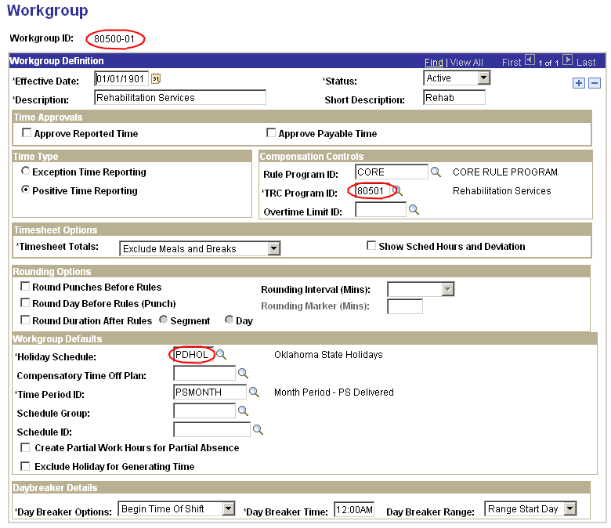
At the top there is the usual Effective Date, Status, and Description fields. There is also a check mark for “Approve Reported Time” and “Approve Payable Time”. It has been determined that all time entered into Time and Labor will have already gone through an approval process. Therefore, this feature will not be used and no Workgroups should have these checkboxes selected.

Time Type – All Workgroups will have the Time Type designated as Positive Time Reporting.

Compensation Controls – One rule has been established regarding Compensatory Time being calculated at time and a half. The Rule Program ID field will have a value of CORE for each Salary related Workgroup. Each Workgroup will have a TRC Program associated with it (see previous section on TRC Program) and should be entered in the TRC Program ID field.

Workgroup Defaults – The Holiday Schedule is maintained in Payroll, but Time and Labor will use it. A Holiday Schedule of PDHOL has been established for Workgroups that include full-time salaried employees. A Holiday Schedule of NONE has been established for Workgroups with part-time, temporary employees. Also, a separate Holiday Schedule of AHEHOL has been established for Ardmore Higher Ed. The Time Period ID is not necessary because schedules are not being used at this point and we have Positive Time Reporters. The other default in Workgroup is the Time Period ID. Most Workgroups have Time Reporter ID of PSMONTH or BIWEEKLY except for agency 830 which uses Time Period ID DHSMONTH.

For the sections shown in this screen print, Rounding Options and Day Break Options are not relevant to the State of Oklahoma. These are for Punch-Time Reporters and the State of Oklahoma does not use Punch-Time Reporting.

Defining Static Groups

PeopleSoft Time & Labor allows you to set up groups of employees to be used in a variety of on-line and batch functions which are called Static Groups. This is different from Workgroups.

Static Groups are used predominately for batch processing of time and to determine which employees can be viewed when entering time. For example, the Time Administrator for OPM will not be able to enter time for employees of Rehab Services. We will see this in the section regarding processing time.

All the Static Groups for the State of Oklahoma have been established and set up. You must maintain the Static Groups as employees come and go from your agency.

Navigation: Set Up HRMS >Security > Time and Labor Security > Static Group

In the screen print below, you can see how a Static Group for Office of Personnel Management was established.

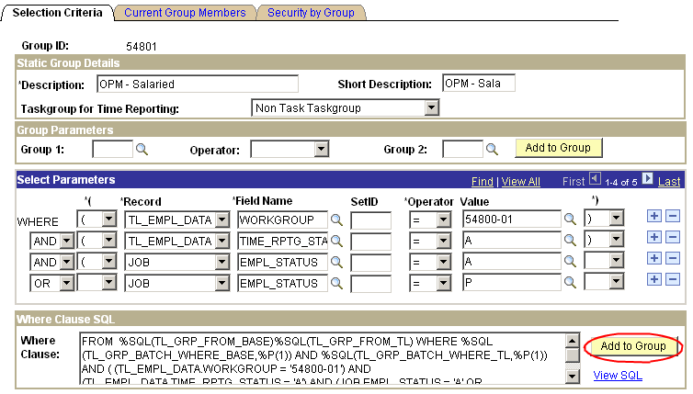

In common terms, what the Select Parameters section is saying is: “look at the record TL_EMPL_DATA (which is where the Time Reporter Page Data is stored) and the field within that record called WORKGROUP. If the WORKGROUP value in the employee’s time reporter page is 54800-01, then add that employee to this Static Group”. The second line says to only include the Time Reporters that are Active in this Static Group. So – these two lines are saying if the time reporter has a workgroup = 54800-01 and the status is Active, add that time reporter to the Static Group.

The Current Group Members Tab lists the time reporters that are currently in the Static group. Here you can use the Find function to search for specific employee ID.

Enrolling & Maintaining Time Reporter

Business Process Flow

An employee must be hired in HCM before they can be enrolled in Time & Labor. The Enrollment process may be done through a link in HR or directly in Time & Labor.

All Time Reporters are Elapsed Time Reporters.

All Time Reporters will use the Time Reporting Template called REGULAR.

All Time Reporters will have a default Time Period of PSMONTH, BIWEEKLY, or DHSMONTH.

No Time Reporters will track tasks. Therefore, all Time Reporters will use the delivered Taskgroup of PSNONTASK.

New employee gets enrolled in a Static Group when group is refreshed.

Employee may be enrolled in multiple Comp Plans.

Time and Labor > Enroll Time Reporters > Create Time Reporter Data

Set Up HRMS > Security > Time and Labor Security > Static Group

Time and Labor > Enroll Time Reporters > Comp Plan Enrollment

Enroll
Time Reporter
Complete
Enroll Time Reporter in Comp Plans
Determine Comp Plans to Enroll in
Refresh Static Group to include Time Reporter
Determine Static Group to Enroll in
Time Reporter
Enrolled
Determine Agency (workgroup)

Defining Time Reporter Data
Enrolling an employee in Time and Labor can be done through the Employment Information page in the Job Data component. Use this approach if you want to enroll them during data entry for hiring or if they are changing information on Job Data that will change their Time & Labor enrollment information. For example, if they change agencies they will be changing Workgroups.

Navigation: Workforce Administration > Job Information > Job Data > Employment Information Tab

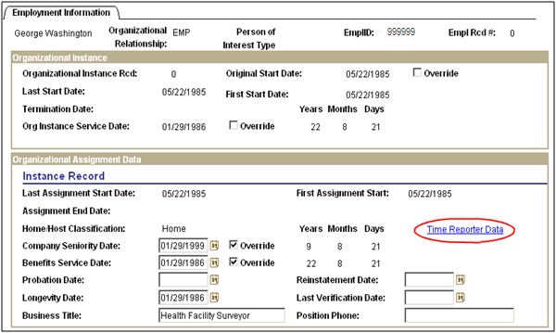

Click Time Reporter Data link to access the page.
Use this page to enroll an employee in Time & Labor when Hiring, Rehiring or moving an employee from one agency to another or one workgroup to another.

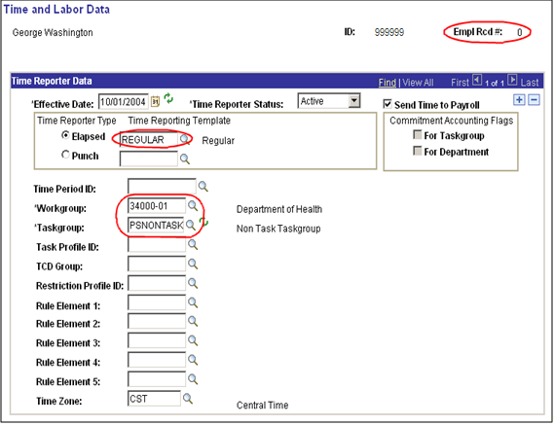

Populate the relevant fields in the following manner:

Effective Date – WATCH THIS DATE. On a new HIRE or REHIRE, this date must match the HIRE date or the REHIRE date on the Job record. On other changes, it should be the date that the change becomes effective. It is the date you want to start entering time for.
Time Reporter Status – Active
Send Time to Payroll – Checked – updated by the system when you get out of the record.
Time Reporter Type – Elapsed
Time Reporting Template – REGULAR
Workgroup – Agency Number + 00 + -01 for Salary or -02 for Hourly. Example: 54800-01
Taskgroup – PSNONTASK or PSNONCATSK (Commitment Accounting)
Time Zone – CST

Click .

Updating Static Group

Updating the Static Group is the last step in this business process. This will add or remove Time Reporters from the group as necessary. Static Groups will already be established.

Navigation: Set Up HRMS > Security > Time and Labor Security > Static Group

The Selection Criteria page provided below.

To add time reporter(s) to a Static group:

Click .

A message box will appear indicating how many people were added to the group. To see the members of this group, click the Current Group Members Tab.

Always click after adding the employees to the static group.

To remove time reporter(s) from a Static Group:

Select the Current Group Members Tab:
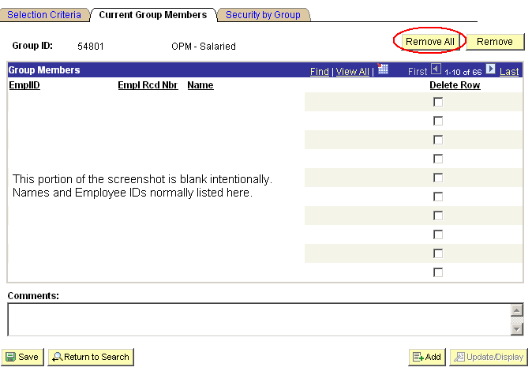

Click , then select the Selection Criteria Tab and click and click .

Below is the alternative method to remove only one or a few time reporters:

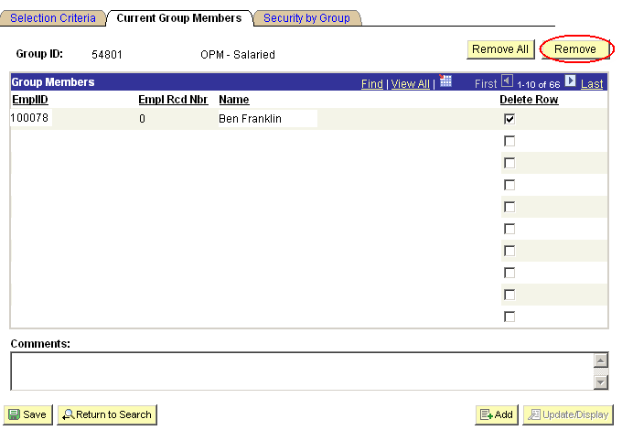

Select the Current Group Members Tab.

Check the box next the delete row box on the time reporter to be removed.

Click and click .

Current Group Members
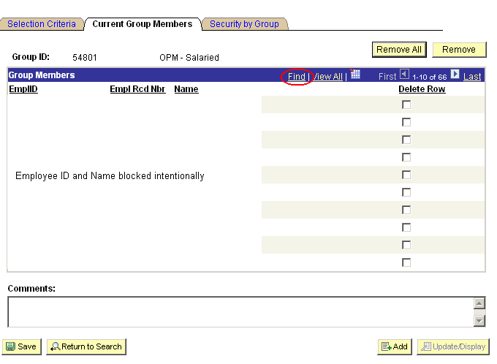

Use FIND to search for the new employees added to the group.

Maintain Time Reporter Data Page

Navigation: Time and Labor > Enroll Time Reporters > Maintain Time Reporter Data

Notice that the Maintain Time Reporter Data page looks exactly like the Create Time Reporter page.

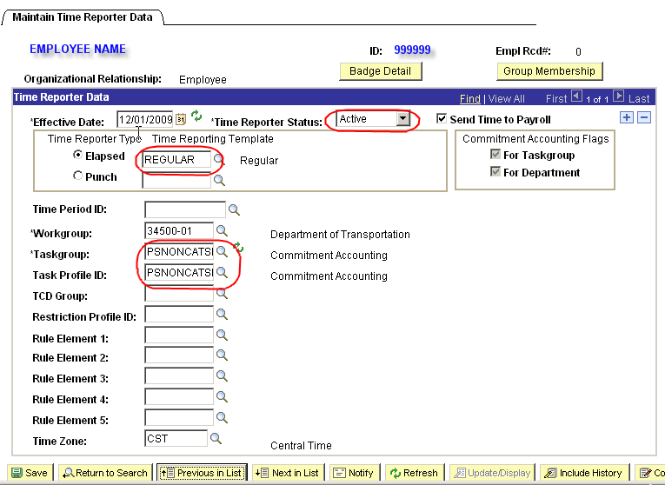

Make changes as necessary by inserting a new effective dated row. For example, if a person switches Workgroups, insert a new row with the date it becomes effective and enter the other appropriate values.

Always click before you leave the page.

NOTE: The HIRE and Adding a Concurrent Job selection will automatically insert this page for you. Any other type of action requires you to manually insert a row to make your changes.

NOTE: Remember to update the Static Groups if someone switches Workgroups or Agencies.

Enroll Time Reporter in Compensatory Time Plan

The next step is to enroll the employee in the eligible Time Reporter in the Compensatory Time Plans.

NOTE: Add all Comp Plans before saving.

If you wanted to enroll 999999, employee in additional plans, you retrieve his enrollment record as in the previous screen then click on the Effective Date level. This will provide a new field for entering a Compensatory Time Plan.

NOTE: The other plans are not brought forward and displayed here but the employee is still enrolled in them.

Navigation: Time and Labor >Enroll Time Reporters > Comp Plan Enrollment

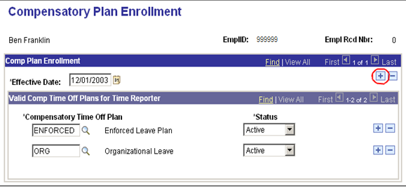
Enter the three (3) new Compensatory Time Plans in the fields provided and click .

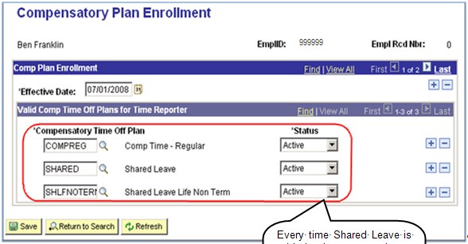
Every time Shared Leave is added, there must be a Shared Leave Non Term or Shared Leave Terminal enrollment to track lifetime usage.

Every time Shared Leave is added, there must be a Shared Leave Non Term or Shared Leave Terminal enrollment to track lifetime usage.

Critical NOTE: Always SAVE before you exit the page.

Entering Time

Business Process Flow

Manager Self Service > Time Management > Report Time > Timesheet
Collect
Time Info
Identify Time Reporters to enter daily time for.
Enter hours and TRC by Time Reporter.
Time info collected

A Time Reporter is any employee having time entered in Time & Labor.

Enter all time and Time Reporting Codes for Hourly/Temps and only exceptions for Salaried employees.

All time that is entered or loaded at the State of Oklahoma will be entered
through the Timesheet Page.

Timesheet

Navigation: Manager Self Service > Time Management > Report Time > Timesheet

To enter time for an employee, navigate to the Timesheet page. At the Search Dialog Box:
Enter the Employee ID, click .

NOTE: You can also search by Group ID, Employee ID, Last Name, First Name, Department and Workgroup. If using the Name search, it is case sensitive.

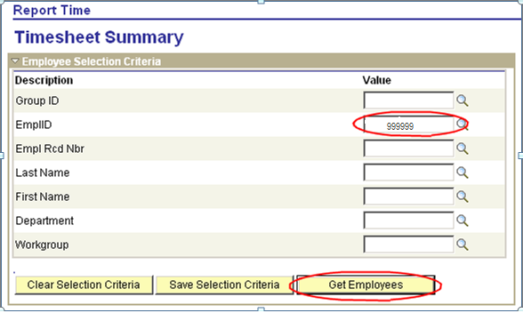

The employee will be listed below this same search box. Click Employee Name link to access timesheet.

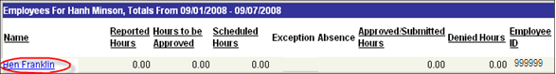

Timesheet Page

On the timesheet page:
In the View By field, select “Week”, “Day”, or “Time Period” from the dropdown box. In this example, we will select “Week”.

Enter the date 07/01/08 and click . This action will pull up the timesheet with start date of 07/01/08.

The default is three (3) blank lines before time is entered for the period selected.
Each type of TRC must have its own row.
Use to add or to delete a row.

Enter 8 hours Leave without Pay, Scheduled (LWOPS) on July 1st.
Enter 4 hours Comp Time Earned on July 2nd.
Enter in the Sick Leave of eight (8) hours on July 3rd.

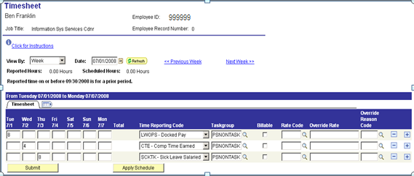

Click .

If the message below appears:

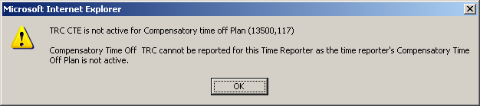

It is an indication that the Comp Time Plan has not been set up for the employee and timesheet cannot be saved.

NOTE: If you can not see a comp plan TRC, it means that either the employee is not enrolled in the comp plan or the TRCs are not in the TRC program for the agency.

There are two (2) choices: Delete the CTE time and then click or enroll the employee in the Comp Time Plan and then click .

To enroll the employee in the comp time plan, go to:

Navigation: Time and Labor > Enroll Time Reporters > Comp Plan Enrollment

Select the plan and .

Go back to Timesheet and add the additional row for CTE.

Navigation: Manager Self Service > Time Management > Report Time > Timesheet

You must click SUBMIT on this page before you go to another week. The system will let you change pages without the data being saved. After you save, the page may resemble the timesheet below. It sorts the rows based on Time Reporting Code values.

Notice the bottom of the screen reflects the status of time submitted.

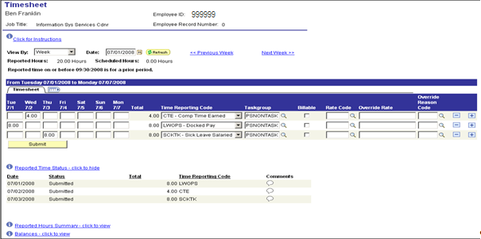

Click Next Week >> link and enter eight (8) hours of Annual Leave on July 8th and click to save the record.

NOTE: Time must be submitted to save before going to the next page (next week)

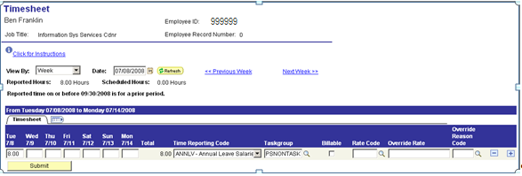

Any blue link can be opened to view additional information as shown in the example below.

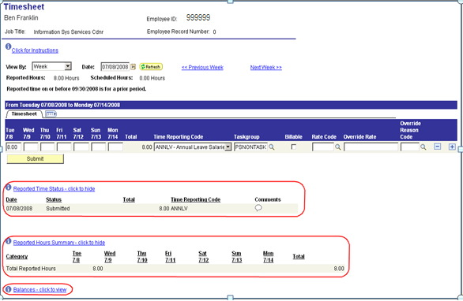

A new feature in this version is the ability to view balances in the Timesheet page. After a timesheet is opened, if the employee participates in leave plan or comp plan in PeopleSoft, then a Balances-click to view link will appear toward the bottom of the page.

Clicking the Balances-click to view link will show the sick, vacation (annual), and comp time balances for the employee.

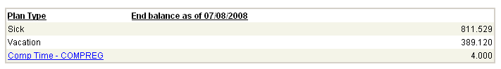

NOTE:
Sick and vacation balances are as of the last day leave accruals were processed minus any time submitted on the timesheet. Sick and vacation adjustments are not included in the balances until after the adjustments are processed in a confirmed payroll and leave accrual has been processed.

Comp time balance (Enforced, CompReg, Admin Leave, etc…) is as of the first date on the timesheet. Comp time balances are updated after time administration has been run. Clicking the Comp Time hyperlink will open the Compensation Time page:

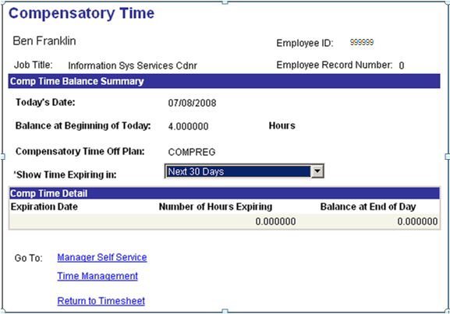

Processing Time

Business Process Flow

Time and Labor > Process Time > Request Time Administration
Process
Time Info
Identify Time Reporters or Static Groups to process
Determine the correct processing date
Time Processed

Employee must be hired in HRMS enrolled in a workgroup and enrolled in a static group before time can be entered

Time Reporter is any employee who has their time processed through the Time & Labor system.

Static Groups (not workgroups) are a group of Time Reporters that can be brought together under one group usually for processing.

The processing date will usually be the last day of the pay cycle.

See also: Review Payable Time and Review Exceptions

Process Time

Processing Time Administration (Time Admin)

Now that time has been entered, it needs to be processed. This is done by running a batch job called Time Administration.

Navigation: Time and Labor > Process Time > Request Time Administration

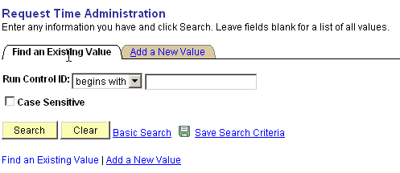

Click and select an existing run control value. If there is not one set up, go to Add a New Value Tab to add a run control value.

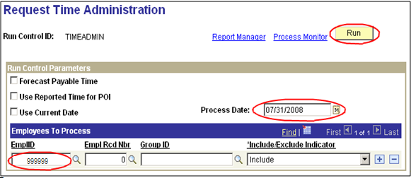

Under the “Run Control Parameters” section, the checkboxes should all be blank. The Process Date will process all time up to and including the date entered. This is generally the last day of the pay period.

Notice the and buttons. These work the same way as all other pages in PeopleSoft. This allows you to enter one or more employees and/or groups. If a value is entered in the EmplID field and after tabbing out, the Group ID field disappears. Likewise, if you enter a value in the Group ID field and after tabbing out, the EmplID and Empl Rcd Nbr fields disappear.
After filling in the run control parameter fields, click It is not necessary to save this page because when you click the Run button, the record will be saved.

Another page is displayed. Select Server PSUNX.

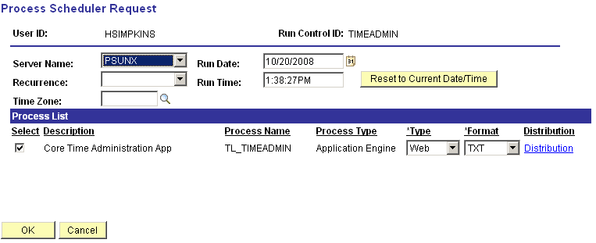

To begin the batch process, click . This will return you back to the run control page.

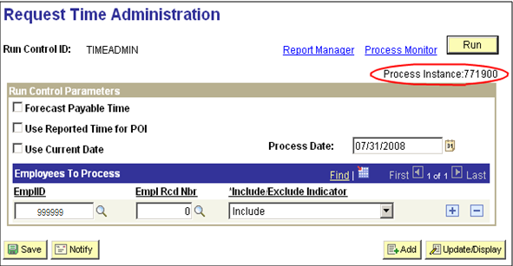

The process instance number assigned is very important. If you experience a problem with the process ending with a “No Success” status on Process Monitor, contact the helpdesk. Do not submit another Time Administration process. The Help Desk will request the Process Instance Number to aid in research.
At this point, click Process Monitor link to monitor the process or you can also get to the Process Monitor page through the following navigation:

Navigation: PeopleTools > Process Scheduler > Process Monitor

The Process Monitor will show all jobs based on the criteria you have entered at the top of the page (your User Id, Last number of Days, etc…).

The job will have a different status as it progresses. When completed, it will indicate a status of ‘Success’. Click repeatedly to receive an update on the status.

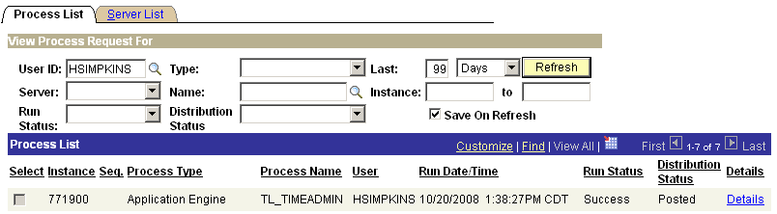
Click the Refresh Button to watch the progress of the process.

Run Status must say ‘Success’ before you can see the output of the process.

When the Run Status goes to ‘Success’ and the Distribution Status goes to ‘Posted’, click the Details link to go to the next page.
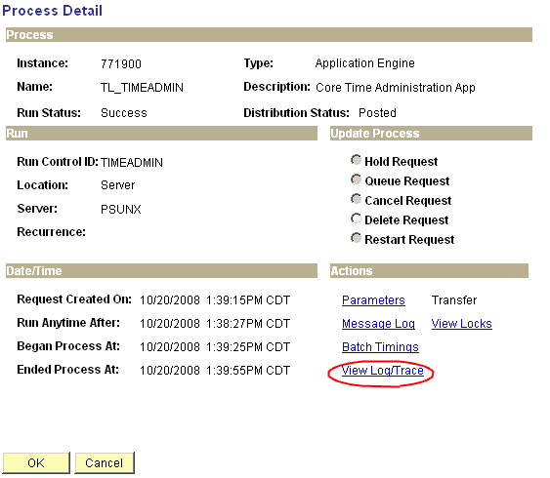

Select View Log/Trace link.

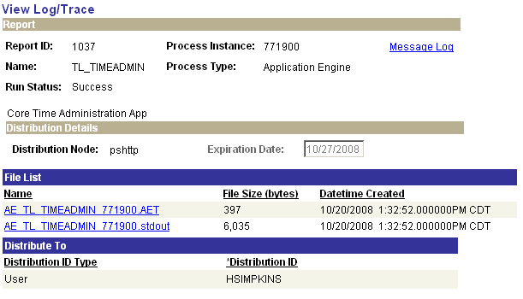

Click the blue link with *.stdout extension to view log file:
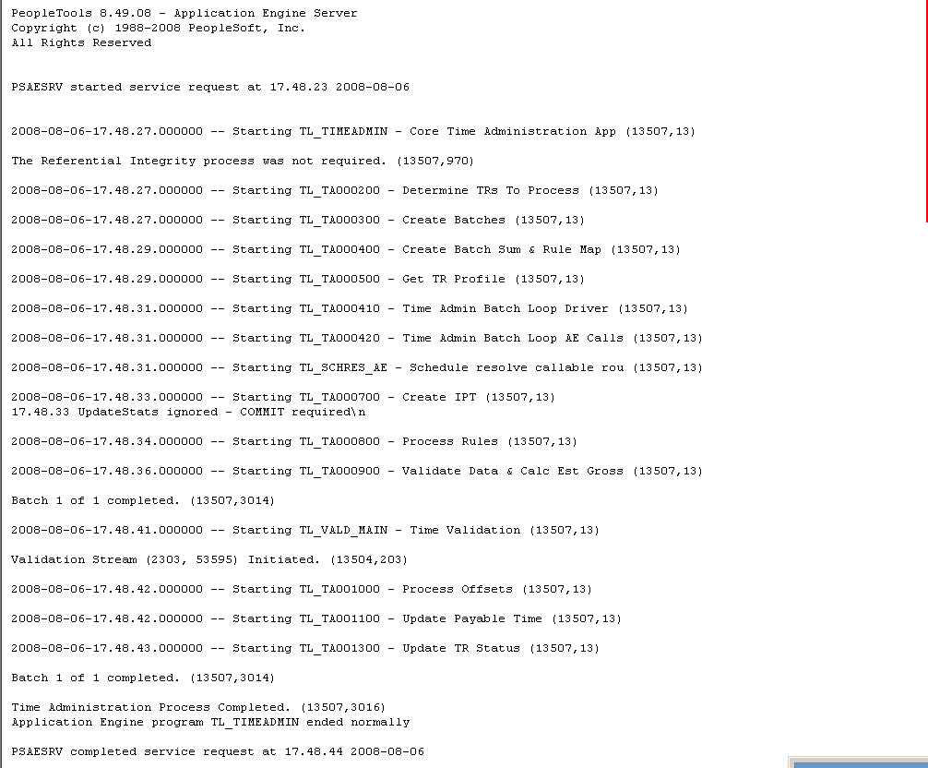

Look at the bottom of the page to make sure that the Time Administration Process completed. Example: Batch 1 of 1 completed.

After checking the Message Log, we have to check ‘payable time’ for the time that was entered in Timesheet.

View Payable Time

Business Process Flow

Inquire Payable Time

Manager Self Service > Time Management > View Time > Payable Time Summary

Manager Self Service > Time Management > View Time > Payable Time Detail

Payable Time Reviewed
Summary or Detail info by TR
Summary
Detail

Payable Time is updated during Time Admin run. If time passes all edits, it becomes Payable Time and can be loaded to Payroll.

Time Reporter (TR) is any employee who has their time processed through the Time & Labor system.

There is also a Payable Time Report that can be run:
Time and Labor > Reports > Payable Status

Viewing Payable Time

Once the job is complete, Payable Time can be viewed.

To see the Payable Time we navigate to the Payable Time Detail page. Enter the Employee and click to search for the employee. Click the Employee Name link, enter the Start and End Date and click to see payable time generated after running time administration process.

Navigation: Manager Self Service > Time Management > View Time > Payable Time Detail

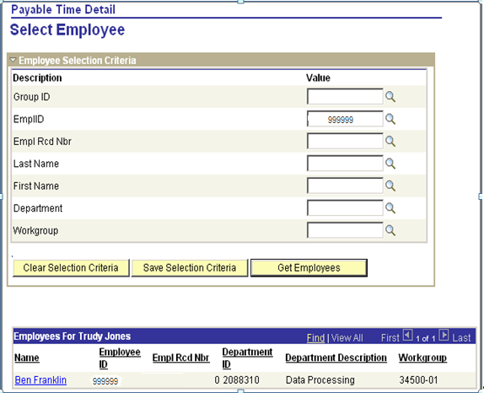

Click and click Employee Name link.
Enter the Start and End Date up to 31 days and click .

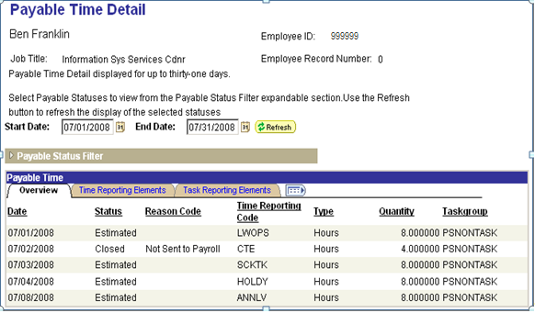

This page shows the data that was entered on the Timesheet page and processed through Time Administration. When Time Administration has processed the data, the Status should be (in most cases) Estimated – Ready for Payroll. Once Payroll takes the data and starts processing it the status will change. Some of the statuses are also accompanied with Reason Code.

The results for the Comp Time entered is reflected. Notice that the Payable Status indicates Closed. The reason this does not show a Payable Status of Estimated – Ready for Payroll is because employees do not get paid when they earn Comp Time. They get paid when they take Comp Time. While this row will remain in this status indefinitely, the employee’s Comp Time balance will be updated to reflect the eight (8) hours earned.

Payable Time Statuses

The following table, from PeopleBooks, lists the Status Codes that will be encountered at the State of Oklahoma.

Status Codes | Description | Reason Codes
Estimated (ES) | This is the first stage of payable time created by the Time Administration process, unless you’ve activated the Needs Approval option on the Workgroup page. It includes cost estimates calculated by Time Administration if you’ve selected the Calculate Estimated Gross option on Time and Labor Installation Page.  Time Administration updates the original payable time whenever you change reported time that relates to payable time with a payable status of Estimated-Ready for Payroll. | No reason code is associated with this status.
Needs Approval (NA) | If the workgroup or TRC is set up to require approval of payable time, the Time Administration process sets this status. It is similar to Estimated except that the time must be approved before it can be sent to a payroll system. You approve time using the Approve Payable Time page.  Time Administration updates the original payable time whenever you change reported time that relates to payable time with a payable status of Needs Approval. | No reason code is associated with this status.
Approved − Goes to Payroll (AP) | Approved payable time can be sent to your payroll system. When payable time reaches the approved stage, the system sets the frozen indicator on.  Time Administration creates offsetting entries whenever you change reported time that relates to payable time with a payable status of Approved-Goes to Payroll. | No reason code is associated with this status.
Closed (CL) | When payable time reaches the closed stage, the system turns on the frozen indicator. Payable status is set to this status when any of the following conditions are met:  The Send Time to Payroll check box is selected on the Maintain Time Reporter Data page.  The status of the TRC is not Active.  The workgroup or TRC does not need approval and the Publish unmapped TRC as No Pay check box on the TL Installation page is not selected.  The payable time has been taken by payroll, but it will not be labor distributed or diluted because you did not select the Labor Distribution and Dilution options on the Pay System page. (In this case, you’ll see the Pay System code and Pay Request Number on the View Payable Time Details page.)  When the workgroup or TRC is set up to require approval of payable time, then the approval process sets this status.  Time Administration creates offsetting entries whenever you change reported time that relates to payable time with a payable status of Closed. | These reason codes can be associated with the Closed status:  Not Sent to Payroll (NSP) – Time and Labor sets this reason code when payable status changes to Closed.  Not Distributed (NDS) – When the payroll system (GP or PNA) successfully processes time, and the pay system is not configured for the Time and Labor Distribution process, payroll sets the payable status code to Closed and the reason code to Not Distributed.  Record Adjustment (RAJ) – Time and Labor sets the payable status to Closed and the reason code to record adjustment (RAJ) when paid time is adjusted in Time and Labor.
Sent to Payroll (SP) | When payable time is selected, the payroll system sets this status code (either GP or PNA).  Payable time has this status when it is sent to payroll and payroll either takes or rejects the entry. When payable time reaches this stage, the system turns on the frozen indicator.  Time Administration creates offsetting entries whenever you change reported time that relates to payable time with this status. | No reason code is associated with this status.
Rejected by Payroll (RP) | Time that payroll has refused.  Time Administration creates offsetting entries whenever you change reported time that relates to payable time with a payable status of Rejected by Payroll.  The Set Ignore Status for Not Ok to Pay check box on the TL Installation page defines which payable code and reason codes Time and Labor sets during the Distribution Dilution process for PNA integration when a no pay other earning or pay earning are processed:  If the Set Ignore Status for Not Ok to Pay check box is selected, then Time and Labor sets the payable time status code to Ignore (IG) and the reason code to Manual Reject  If the Set Ignore Status for Not Ok to Pay check box is not selected, then Time and Labor sets the payable status code to Rejected by Payroll (RP) and the reason code to Payroll Not Processed (PNP).  NOTE: The default setting for this check box is selected. | These reason codes can be associated with this status:  Manual Reject (MRJ) –  Payroll Not Processed (PNP) – The payroll system sets the payable time status to Rejected by Payroll and the reason code to Payroll Not Processed for any payable time that is not processed by the payroll system (either GP or PNA)  Cancelled (CAN) – If a Global Payroll user cancels an entire Calendar Group run (pay run), Global Payroll sets the payable status code to Rejected by Payroll and the reason code to Cancelled. .PNA sets related rows of payable time to Rejected by Payroll and the reason code to Cancelled when a payrun is unsheeted.
Taken - Used by Payroll (TP) | Time has been accepted by Payroll. Time Administration creates offsetting entries whenever you change reported time that relates to payable time with a payable status of Taken − Used by Payroll. | No reason code is associated with this status.  When payable time is taken by the payroll system (GP or PNA) the payroll system sets this status code and removes any associated reason code (sets to blank).
Distributed (PD) | Time that has actual costs from payroll applied by the Labor Distribution process. Time Administration creates offsetting entries whenever you change reported time that relates to payable time with a payable status of Paid-Labor Distributed. | A reason code may be set or removed, depending on the payroll system:  Prior Period Salary Adjustment (PPS) – When PNA selects prior period time for a salaried employee, it sets this status and reason code.  Global Payroll sets this status and removes any associated reason code (sets to blank) on a new row for a prior period adjustment.
No Pay (NP) | Used by the Project Costing application only. The No Pay status is a status used to reflect transaction rows that are not going to payroll but are in a closed state.  When payable time reaches the closed stage, the system turns on the frozen indicator. Payable status is set to this status when any of the following conditions are met:  The Send Time to Payroll check box is cleared on the Maintain Time Reporter Data page.  The status of the TRC is not Active.  Time is approved and the Publish unmapped TRC as No Pay check box on the TL Installation page is selected. | Not Sent to Payroll (NSP) – Time and Labor sets this status and reason code when the TRC is not mapped to an earnings code. This reason code differentiates payable time that is closed without being sent to payroll (suspended) and payable time that is closed because it is sent to payroll.
Ignore (IG) | When a Time and Labor user indicates on the Adjust Paid Time page that rows that have been rejected by the payroll system should not be paid, Time and Labor sets this payable status.  The Set Ignore Status for Not Ok to Pay check box on the TL Installation page defines the payable time status code and reason codes that Time and Labor sets during the Distribution Dilution process when a no pay other earning or pay earning are processed: If the check box is selected, then Time and Labor sets this payable status.  Payable time rows with this status are never pulled by Global Payroll. | Manual Reject (MJR) – Time and Labor associates this reason code to rows when it changes the status to Ignore.  Not Used (NUS) – Global Payroll adds this reason code to payable time with this status.
Reversed Check (RV) | This status code exists to handle check reversals in PNA. The PNA Reversal process generates payable time rows with this status. Time and Labor generates the reversed payable time row and any new payable time to be loaded in a subsequent Load process. This process occurs after PNA has successfully completed the Confirm Pay process.  NOTE: If the process ends abnormally, you must restart the process from the Process Monitor. | The reason code that is associated with the Reversed Check status is always Reversed (CRV).

Viewing Unprocessed Payable Time

The View Unprocessed Payable Time page displays all rows in payable time that have not been processed by payroll. The data is sorted by Date and then by Time Reporting Code. Payable time with these status codes is displayed on this page: Estimated, Approved, Needs Approval, Rejected by Payroll, Sent to Payroll, and Taken by Payroll.

Navigation: Time and Labor > View Unprocessed Time > Unprocessed Payable Time

Enter Employee ID and click .

Enter Start Date and End Date for a specific period to be viewed or leave blank to pull up all unprocessed payable time. When start date and end date are blank, they default to start date: 01/01/1990 and end date: 01/01/2500.

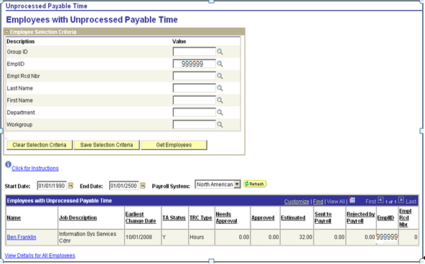

The bottom of the page shows the total hours or amounts of unprocessed payable time by status. This employee has 8 hours of ‘Estimated’ time. To view the details, click the Employee Name link.
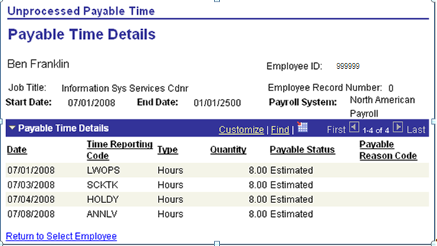

NOTE: This page shows the detail of the hours ‘Estimated’ including the date and the Time Reporting Code.

Reviewing Exception

Business Process Flow

Manager Self Service > Time Management > Approve Time and Exception > Exceptions

Time and Labor > Process Time > Request Time Administration

TR = Time Reporter, a person who has their time processed through the Time & Labor system.

If exceptions were resolved, Time Admin will need to be run again.

Review Exceptions

Decide if reviewing by group or TR.

Resolve Exceptions by group
Resolve Exceptions for TR

No

Were exceptions corrected?

Run Time Admin

Time info collected

Checking For Exceptions

Time Administration process will generate exceptions when time does not comply with a rule or pass validation such as leave or compensation time balance. Exceptions must be resolved each pay period.

Once Time Administration process is complete, check the Payable Time page to ensure all time was processed.

Navigation: Manager Self Service > Time Management > View Time > Payable Time Detail

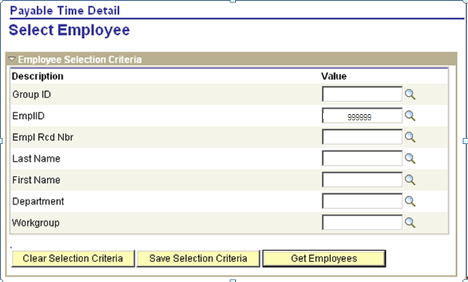

Click and click Employee Name link.
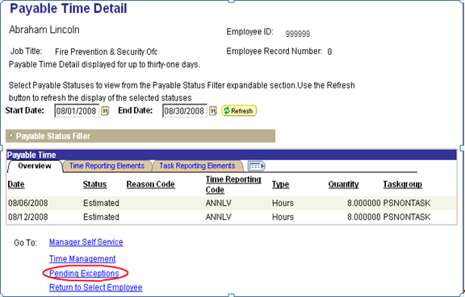

To view the exceptions, click Pending Exceptions link at the bottom of the page.

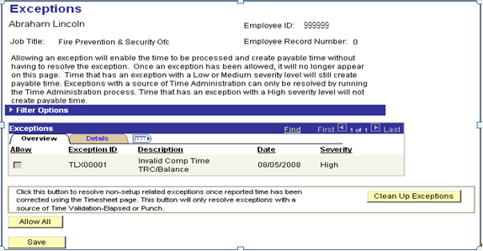

NOTE: Do not click on ‘Clean Up Exceptions’; Clicking on ‘Clean Up Exceptions’ will do nothing.
The Details Tab will give additional information on the exception:

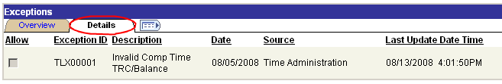

To see the detail description, scroll further to the right and click the Exception Description link.

The Exception Description link provides a more detailed description to help resolve the exception(s):

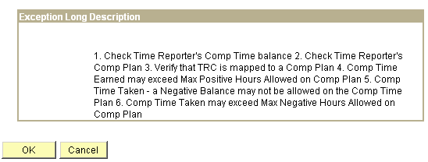

Also check for exceptions by group instead of by individual employee. The next section will show how to check exceptions by group.

Manage Group Exceptions

Navigation: Manager Self Service > Time Management > Approve Time and Exceptions > Exceptions

Enter Group ID and click .

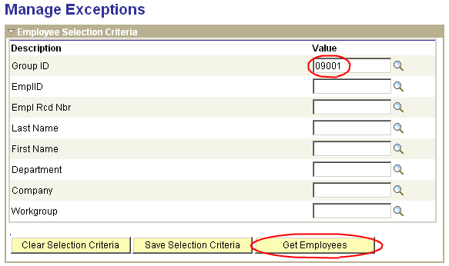

If there are exceptions for this group, a list of exceptions will appear:

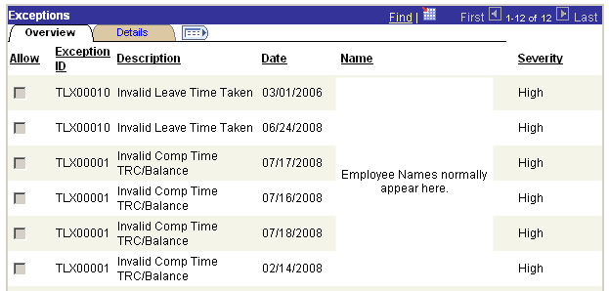

Exceptions Detail Info

To view detail on the exceptions, click the Detail Page, scroll to the right, and click the Exception Description link.

Detail Exception Description:

Below are a few common exceptions that we may encounter:

- Invalid Comp Time TRC/Balance
- Invalid Time Reporter Status
- Invalid Leave Time Taken
- TRC is not in TRC Program
- Invalid Payroll Status

The detail Exception Description gives us an idea on where to look for the issues that caused the exceptions and resolve them.

Look at the exception below:

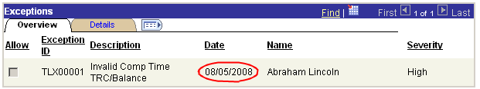
This employee has an exception on reported date 08/05/08. The long description for these exceptions is below:

The system is telling us to check the following items:
- Check time reporter’s comp time balance
- Check time reporter’s comp plan
- Verify that TRC is mapped to a comp plan
- Comp time earned may exceed max positive hours allowed on comp plan
- Comp time taken – a negative balance may not be allowed on the comp time plan
- Comp time taken may exceed max negative hours allowed

We need to first check the employee’s comp time balance. In order to know which comp time balance to check, we need to look at the timesheet for the date involved:

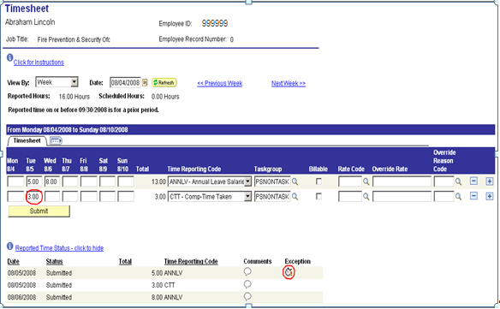
Notice that the employee had 3 hours CTT on 08/05/08 which is a comp time taken code for comp time plan COMPREG. Note also that there is an icon in the Reported Time Status line to denote that there is an exception for the reported date on the timesheet page. If there are multiple entries for the same day, one exception will stop all other entries from going to payable time until the exception is resolved.

NOTE: The Exception icon is not specific to the Time Reporting Code that it appears next to. It may be for multiple items on that date.

Look at the employee’s comp time balance for this comp plan by running query GO_TL_COMP_DAY_BAL.

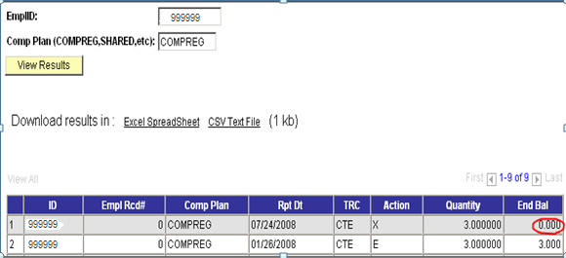

The employee only has zero (0) hours of comp time balance on 07/24/08. Therefore, the entry on 08/05/08 created an exception. We must resolve the balance issue by either using another leave type for 08/05/08 or delete the comp time taken.

In this example, let’s change the comp time taken from three (3) hours of CTT to three (3) hours of ANNLV.

Click .

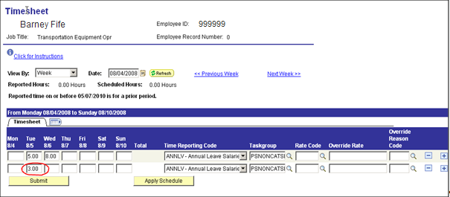

After the changes have been made on the timesheet, Request Time Administration process must be run again on this employee to process the changes.

Once time administration has completed, check the exception again to make sure that the issue has been resolved.

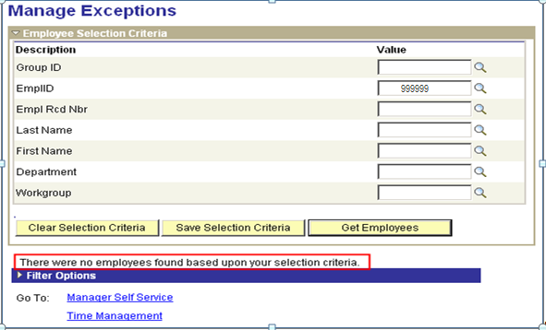
Notice that the exception is now gone. This is a simple example of the exceptions that may occur. There are situations where finding out the cause of the exceptions may be more complicated. In those cases, more research will be needed. Please follow the suggestions on the long description of the exception to resolve issues.

The exceptions are varied and caused by multiple reasons. It is not feasible to list them all here.

Payable Time

When Time Reporting Codes (TRCs) for sick or annual leave has been changed or deleted after being processed through a payroll, the Time Administration process creates an offset with payable status “Need Approval”. These offset will not be processed through payroll until they are approved. These TRCs must be approved in a timely manner for the sick and annual leave balances to be accurate.

Below is a high-level flow to show where this approval process fits into the payroll process:

- Enter time taken and/or adjustments into Timesheet page.
- Run Time Admin Process.
- Approve TRC(s) that in a Needs Approval status.
- Validate hours in Payable Time status using the Payable Status Report. There should be “Approved” payable status for time deleted and “Estimated” status for new time entered.
- If any corrections are needed for the hours entered, the data on Timesheet can be changed and Time Administration can be run again.
- Process payroll.

Approve Time by Group or Time Reporter

Navigation: Manager Self Service > Time Management > Approve Time and Exceptions > Payable Time

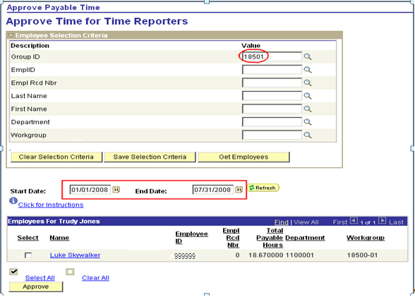

Enter the Group ID, Employee ID, or Workgroup.

Start Date: Enter the beginning of the month in which the correction occurred.

End Date: Enter the last day of the current month.

Using the Approve Time by Group Page you can enter your agency number and a date range to find all the employees that have TRCs needing to be approved.

Enter a large date range (go back at least two or three months) to capture any TRCs that may have an old date.

Click and select the group or employee that needs TRCs approved.
After the bottom of the page is populated with a list of employees with time to be approved, click the Employee Name for a detailed page for the particular employee. In this example, this group only has one employee with time to be approved.

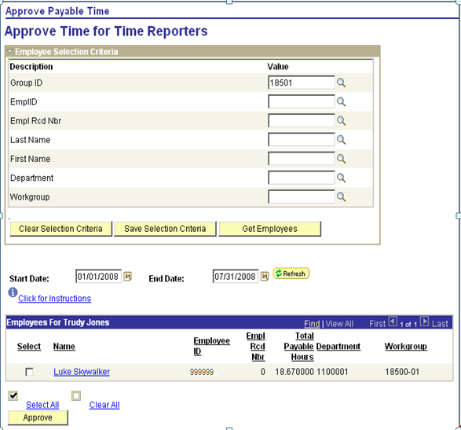

Clicking the employee name link will open the detailed Approve Payable Time page.
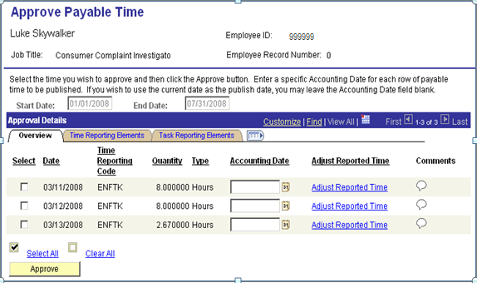

The detail shows the quantity for each individual TRC that needs approved.

Click the individual Select Boxes or Select All to approve all time listed.
Click .

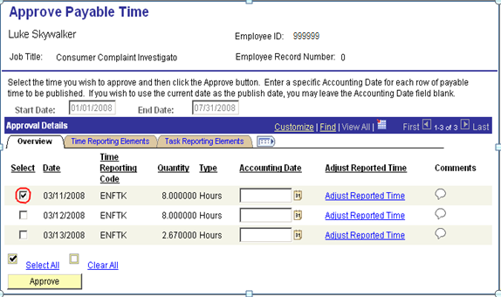

To confirm the Approval, click .
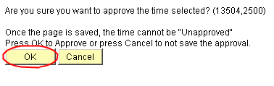

Another Dialogue box will appear :

Click .

The payable status immediately changes to Closed (for comp-time TRCs) or to Approved – Ready for Payroll (if the TRC feeds to payroll like ANNLV or SCKTK).

The next run of payroll will pick up and process any Approved – Ready for Payroll TRCs.

Click the Return to Approval Summary link at the bottom of the page. Process the next employee in the list. Repeat this process until all time has been approved.

As you become more comfortable with this process or do not need to look at the detail for each employee, you have the option to save time by approving all employees at one time from the Approve Time by Group page. Be sure to look at the list carefully before Approving all employees.

Correcting Business Process Flow

Manager Self Service > Time Management > View Time > Payable Time Detail

Time and Labor > Reports > Payable Status Report

Manager Self Service > Time Management > Report Time > Timesheet

Time and Labor > Process Time > Request Time Administration

Correct
Time

This may be from View Payable Time page, Payable Status Report or notice from Payroll that change needs to be made.

Use Timesheet page to retrieve original information to be added to or modified and make changes as needed.

Changes will be reflected in the next Payroll Calculation. If the current Payroll run has not been confirmed yet, these changes can still be included in that run.

Identify Time Reporters to correct time for.

Change/Add hours and TRC by Time Reporter.

Run Time Admin

Time info corrected

Earlier reported time can be corrected before Payroll processing. Timesheet data can be changed up until Payroll runs the Final Calculation process. In this example, the Comp Time Earned for Employee 999999 should have been 8 hours of Comp Time Earned instead of 4 hours on 07/02.

Access Timesheet page and make correction by over keying the Original 4 hours with the correct value of 8 hours.

Timesheet

Navigation: Manager Self Service > Time Management > Report Time > Timesheet

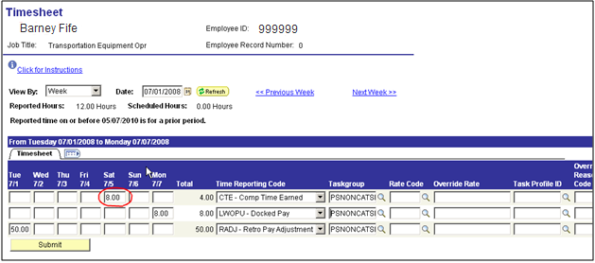

Click .

Time Administration Process

Navigation: Time and Labor > Process Time > Request Time Administration

Time Administration process must be run anytime a change/add is made to the timesheet. Ensure that the process date is the last day of your pay period and all Run Control Parameters are unchecked.

Click .

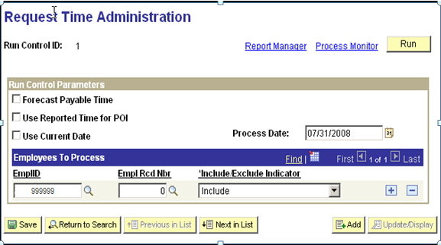

Payable Time Detail

Navigation: Manager Self Service > Time Management > View Time > Payable Time Detail

After Time Administration process has completed with a “Success” status, access Payable Time Detail to review the change.

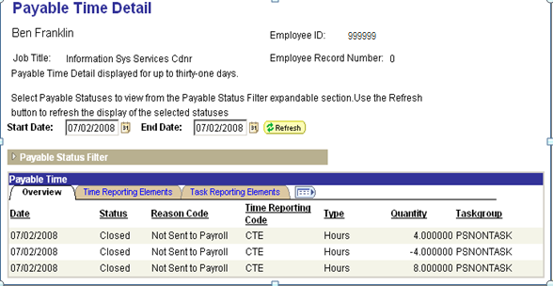

There are now three (3) rows for the same TRC code on the date that we made the change. The net result is eight (8) hours CTE on 07/02/08.

Processing Comp Time

Business Process Flow

Time and Labor > Enroll Time Reporter > Comp Plan Enrollment

Manager Self Service > Time Management > Report Time > Timesheet

Time and Labor > Process Time > Request Time Administration

Time and Labor > View Time > Compensation Time

Process Comp Time

Comp Time TRCs are not available to select in Timesheet if Time Reporter is not enrolled in Comp Plan.

Comp Time is updated when Time Admin is run.

Select to view balance from a list of Compensatory Time Plans if Time Reporter is enrolled in more than one plan.

Enroll Time Reporter in Comp Time Plan

Key Comp Time Earned or Taken into
Timesheet

Run Time Admin

View Comp time Balance

Overview

All the comp time entries – comp time earned, comp time taken, comp time shared, comp time given and comp time received are entered into the Timesheet Page in Time and Labor through Manager Self Service. These entries are processed by Time Administration and update the comp time balances.

The State of Oklahoma has designed and uses a Leave Statement. This Leave Statement pulls the comp time information from Time and Labor and prints it along with the other kinds of leave that employee has available.

The following is a list of the predefined Comp Time Off Plans for the State of Oklahoma.

Comp Time Off Plans

ADMIN LEAVE Administrative Leave Plan
COMPCORE Comp Core Project
COMPPUB Comp Time Plan – Public Safety
COMPREG Comp Time – Regular
COMPSEC Comp Time – Security
COOLOFF Admin Leave – Cool Off (32 hours)
ENFORCED Enforced Leave Plan – (80 hours)
HOLIDAY Holiday Leave Plan
MILITARY Military Leave – (240 hours)
ORG Organizational Leave – (24 hours)
SHARED Shared Leave
SHLFNOTERM (Accumulator), Shared Life Non Term – (2088 hours which is 261 days)
SHLFTERM (Accumulator), Shared Life Term – (2920 hours which is 365 days)

NOTE: When using Shared Leave, you must also post the time taken to either SHLFNOTERM or SHLFTERM along with TRC SHARED. These two are used to accumulate the total hours that have been taken.

The employee must be hired, added to a Static Group, and enroll in comp time plans for which they are eligible before any type of comp time (earned or taken) can be entered into Timesheet for that employee.

The employee must also have available Comp Time Balance for the specific plan prior to the date Comp Time Taken being entered into Timesheet.

Comp Time Plans and their TRCs

In the section entitled “Enrolling Time Reporters”, we enrolled employee 999999 into Static Group 54801.

We also enrolled this employee into Comp Time Off Plans of Enforced, Org, CompReg, Shared, and Shlfnoterm. The following is a list of the Comp Time Off Plans and the TRCS that affect them.

Time Reporting Codes for the COMPREG Comp Time Plan
TRC |  | Descr |  | TRC Type |  | Earn Code |  | Comp Leave Ind |  | Add to Gross
CTE |  | Comp Time Earned |  | H |  |  |  | CERN
CTEAD |  | Comp Time Earn Adjustment |  | H |  |  |  | CERN
CTEH |  | Comp Time - Time and a Half |  | H |  |  |  | CERN
CTPO |  | Comp Time Payout |  | H |  | CTO |  | CTKN |  | Y
CTT |  | Comp-Time Taken |  | H |  | CTP |  | CTKN |  | Y
DCTFY |  | Deceased Comp Time Follow Yr |  | H |  | TCP |  | CTKN |  | Y
DTHCP |  | Deceased Comp Time |  | H |  | DCP |  | CTKN |  | Y
FLCT |  | FMLA Charged to Comp Time |  | H |  | FMC |  | CTKN |  | Y

Time Reporting Codes for the COMCORE Comp Time Plan
The TRCs are the same as the COMPREG plan but end with a 1.

Time Reporting Codes for the COMPPUB Comp Time Plan
The TRCs are the same as the COMPREG plan but end with a 2.

Time Reporting Codes for the COOLOFF Comp Time Plan
TRC |  | Descr |  | TRC Type |  | Earn Code |  | Comp Leave Ind |  | Add to Gross
ADLAD |  | Admin Lv Cool Off Adjustment |  | H |  |  |  | CERN
ADLCO |  | Salary Admin Cool Off |  | H |  | ADL |  | CERN |  | Y
COCNV |  | Cooloff for Conversion |  | H |  |  |  | CERN

Time Reporting Codes for the ENFORCED Comp Time Plan
TRC |  | Descr |  | TRC Type |  | Earn Code |  | Comp Leave Ind |  | Add to Gross
ENCNV |  | Enforced for Conversion |  | H |  |  |  | CERN
ENFAD |  | Enforced Leave Adjustment |  | H |  |  |  | CERN
ENFLV |  | Enforced Leave |  | H |  | ENF |  | CERN |  | N

Time Reporting Codes for the HOLIDAY Comp Time Plan
TRC |  | Descr |  | TRC Type |  | Earn Code |  | Comp Leave Ind |  | Add to Gross
DHLFY |  | Deceased Holiday Pay Follow Yr |  | H |  | THL |  | CTKN |  | Y
DTHHL |  | Deceased Holiday Pay |  | H |  | DHL |  | CTKN |  | Y
FMHL |  | FMLA Charged Holiday Pay |  | H |  | FMH |  | CTKN |  | Y
HLCNV |  | Holiday for Conversion |  | H |  |  |  | CERN
HOLAD |  | Holiday Leave Adjustment |  | H |  |  |  | CERN
HOLPO |  | Holiday Payout |  | H |  | HPD |  | CTKN |  | Y
HOLT |  | Holiday - Salary |  | H |  | HOL |  | CTKN |  | Y
HOLWK |  | Holiday Worked |  | H |  |  |  | CERN

Time Reporting Codes for the MILITARY Comp Time Plan
TRC |  | Descr |  | TRC Type |  | Earn Code |  | Comp Leave Ind |  | Add to Gross
MILAD |  | Military Leave Adjustment |  | H |  |  |  | CERN
MILLV |  | Military Leave Salary |  | H |  | MLS |  | CERN |  | Y
MLCNV |  | Military for Conversion |  | H |  |  |  | CERN

Time Reporting Codes for the ORG Comp Time Plan
TRC |  | Descr |  | TRC Type |  | Earn Code |  | Comp Leave Ind |  | Add to Gross
OGCNV |  | Org Leave for Conversion |  | H |  |  |  | CERN
ORGAD |  | Organizational Leave Adjustment |  | H |  |  |  | CERN
ORGLV |  | Organizational Leave Salary |  | H |  | OLS |  | CERN |  | Y

Time Reporting Codes for the SHARED Comp Time Plan
TRC |  | Descr |  | TRC Type |  | Earn Code |  | Comp Leave Ind |  | Add to Gross
FMSH |  | FMLA Charged Shared Leave |  | H |  | FMR |  | CTKN |  | Y
S1CNV |  | Shared Lv for Conversion |  | H |  |  |  | CERN
SHLAD |  | Shared Leave Adjustment |  | H |  |  |  | CERN
SHLGV |  | Shared Leave Given Back |  | H |  |  |  | CTKN
SHLVT |  | Shared Leave Taken |  | H |  | LVS |  | CTKN |  | Y
SHREC |  | Shared Leave Rec |  | H |  |  |  | CERN
WCSHR |  | Workers Comp - Shared Leave |  | H |  | WCH |  | CTKN |  | Y

Time Reporting Codes for the SHLFNOTRERM Comp Time Plan
TRC |  | Descr |  | TRC Type |  | Earn Code |  | Comp Leave Ind |  | Add to Gross
S2CNV |  | Shared Non Term for Conversion |  | H |  |  |  | CERN
SHLNA |  | Shared Leave Non-Term Adjust |  | H |  |  |  | CERN
SHLNT |  | Shared Leave Non-Terminal |  | H |  |  |  | CERN

Time Reporting Codes for the SHLFTERM Comp Time Plan
TRC |  | Descr |  | TRC Type |  | Earn Code |  | Comp Leave Ind |  | Add to Gross
S3CNV |  | Shared Lv Term for Conversion |  | H |  |  |  | CERN
SHLTA |  | Shared Leave - Term ILL Adjust |  | H |  |  |  | CERN
SHLTR |  | Shared Leave - Terminally Ill |  | H |  |  |  | CERN

Timesheet

Navigation: Manager Self Service > Time Management > Report Time > Timesheet

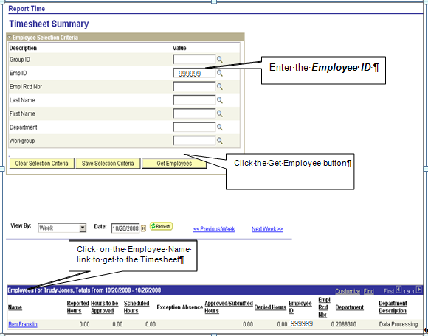

Enter the Employee ID

Click

Click Employee Name link.

PeopleSoft requires a comp time balance before any comp time can be taken.

Comp Time balance will not be updated on comp time earned or taken until Time Administration has been processed.
In the Timesheet page, select View By “Week” and enter 08/01/08 in the date field. Click Enter 4 hours for 08/01/08 and select TRC code CTT.

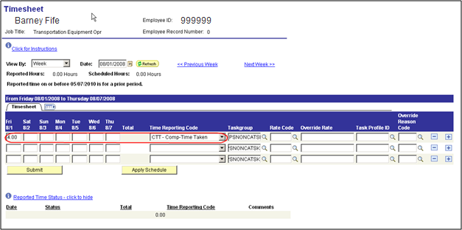

Click .

Click Next Week >> to continue entering time for the next week.

Enter eight (8) hours of CTE for 08/08/08

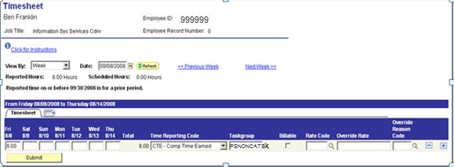

Click .

Running Time Administration

Navigation: Time and Labor > Process Time > Request Time Administration

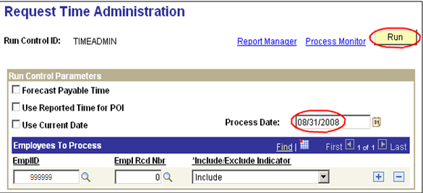

Click .

It will take you to the next screen – Process Scheduler Request

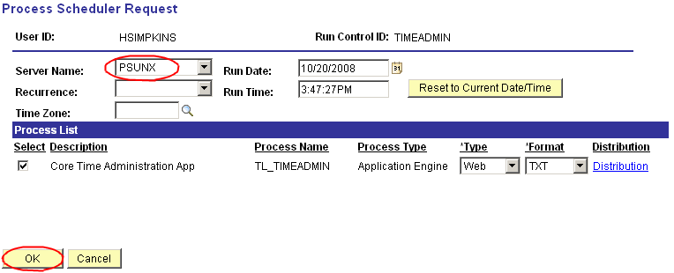

A Process Instance Number is assigned when the process is submitted.
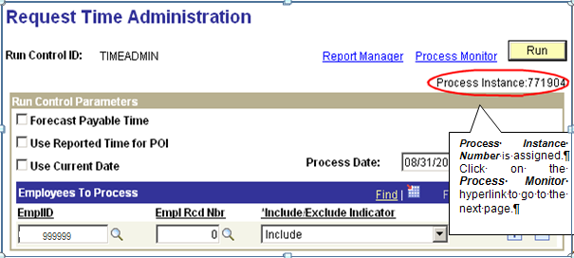

Process Instance Number is assigned.
Click Process Monitor link to go to the next page.

Click repeatedly until the Run Status shows “Success”

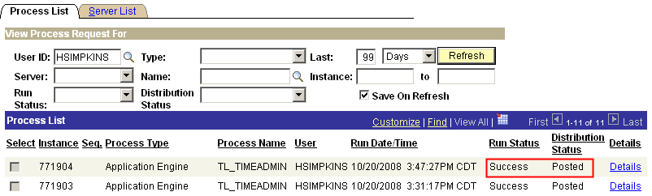

When the process goes to Success and distribution status shows Posted,
click Details link to see the output of the process.
When the process goes to Success and distribution status shows Posted, click Details link to see the output of the process.

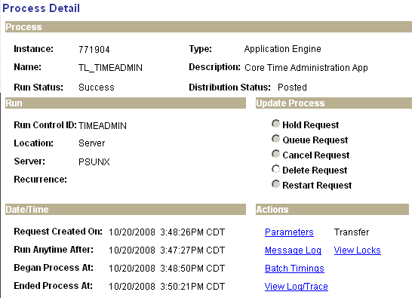

Click View Log/Trace link.

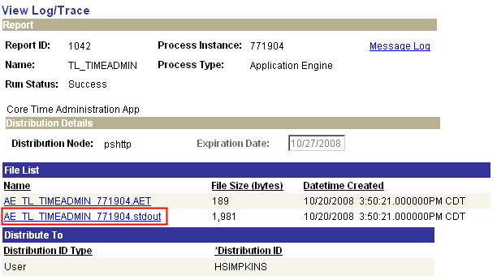
Click this link to open the file log.

Click the .stdout link

Message Log

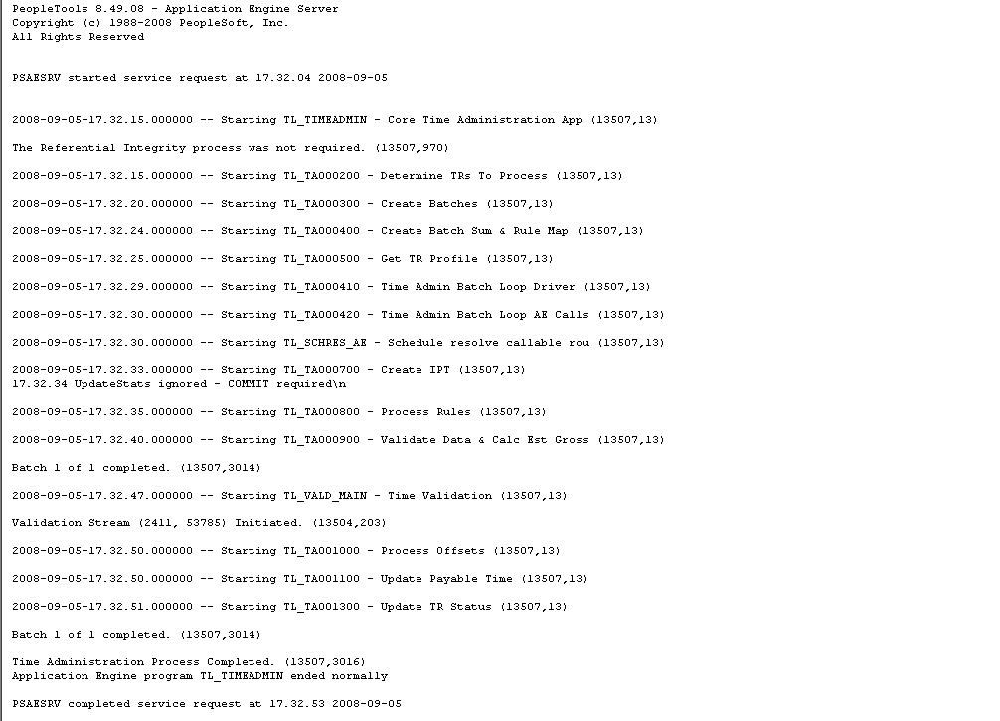

After Time Administration has been completed with ‘Success’ status, review the Payable Time Detail page to make sure that comp time processed successfully. If comp time entered in timesheet does not appear in Payable Time Detail, check exceptions. If Time Administration has a “No Success” status, do not re-run. Contact Help Desk immediately.

Check for Payable Time

Navigation: Manager Self Service > Time Management > View Time > Payable Time Detail

Enter employee ID, click Get Employee, and click the employee name link.

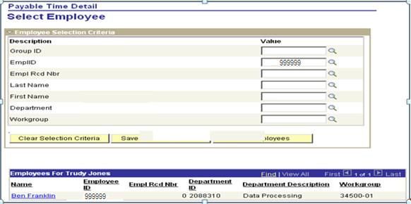

Enter Start Date: 08/01/08

Enter End Date: 08/31/08

Click .
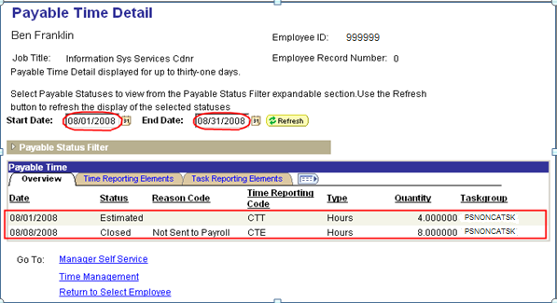

The payable times are listed by Date, Status, Reason Code if applicable, Time Reporting Code (TRC), Type, and Quantity.

The payable status on 08/01/08 is flagged as “Estimated” and ready to be taken and paid through payroll.

Viewing Compensatory Time Balances

Navigation: Manager Self Service > Time Management > View Time > Compensation Time

Enter the employee ID, click , and click the Employee Name link on the Comp Plan row you wish to view. In this case, the comp plan to view is COMPREG.

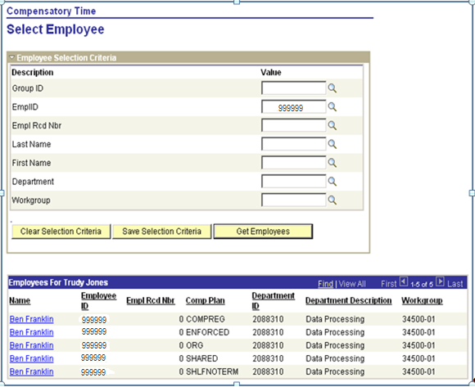

At the Compensatory Time page, select “Show All” in the “Show Time Expiring In” field. You can also select 30 days, 90 days, or One Year depending on how much information you would like to review.
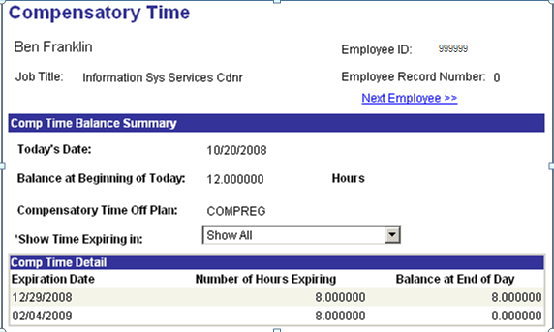

The comp time balance as of 10/20/08 is 12 hours. Another location to view Comp Time balances is through Timesheet page. If the employee participates in a comp plan, then a Balances-Click to view link will appear toward the bottom of the page.

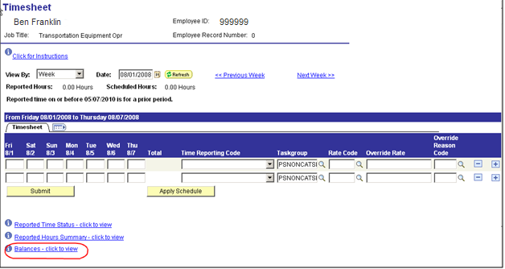
The balance is shown here as of the first day of the period on the timesheet. Time does not update until time administration has been run. Also does not show the comp time expired, so it will generate an exception when time administration is run.

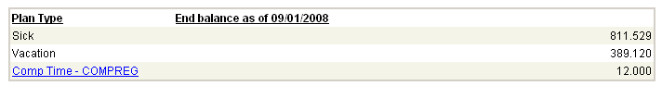

To access the detail page, click blue link associated with the comp plan.

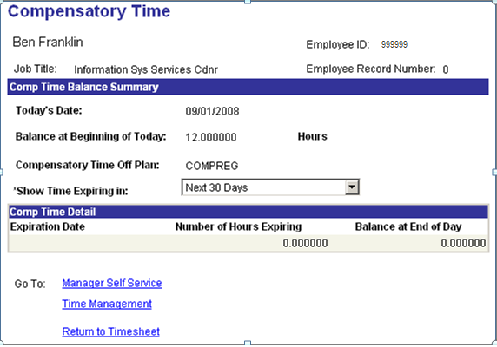

Process Shared Leave/Giving & Receiving

Overview

The State of Oklahoma allows the giving of accumulated annual leave and accumulated sick leave from one employee to another employee that has a long-term medical emergency that has used all of their own accumulated leave. This giving and receiving is referred to as Shared Leave.

The amount of hours given from one employee to another has to be subtracted from the giving employee’s leave balance to reduce it. It also has to be added to the receiving employee’s leave balance before that employee has the time available to be taken.
Two special accumulators have been established that will be updated each time that shared leave time is taken. The special accumulators are SHLFNOTERM – Shared Life Non Term with a maximum limit of 261 days or 2088 hours and SHLFTERM – Shared Life Term with a maximum limit of 365 days or 2920 hours.

The receiving employee must be enrolled in comp plan SHARED and SHLFNOTERM or SHLFTERM. Posting shared leave is always a two-line process in timesheet.

Below are Time Reporting Codes (TRCs) set up to record Share Leave transactions.

Use these first three (3) codes to transfer from one employee’s annual or sick balance to another employees shared leave balance.

TRC | Short Description | Purpose
GIVAN | Give AnnLv | Annual Leave Given is used to reduce the annual leave balance of an employee giving leave to somebody else.
GIVSK | Give SicLv | Sick Leave Given is used to reduce the sick leave balance of an employee giving leave to somebody else.
SHREC | ShrLv Recd | Shared Leave Received is used to add hours to an employee’s shared leave balance.
Use the following two (2) codes together to post time taken for an employee on a non-terminal shared leave. These two (2) codes must always be used together
.
SHLVT | ShrLv Takn | Shared Leave Taken is used to post time taken. Enter a positive number to reduce the employees shared leave balance.
SHLNT | ShrLvNonTr | Shared Leave Non-Terminal is used to track the use of the non-terminal leave. The limit is 2088 hours. Enter a positive number to add to the amount of leave used.
Use the following two (2) codes together to post time taken for an employee on a terminally ill shared leave. These two (2) codes must always be used together.

SHLVT | ShrLv Takn | Shared Leave Taken is used to post time taken. Enter a positive number to reduce the employees shared leave balance.
SHLTR | ShrLvTerm | Shared Leave Terminally Ill is used to track the use of the terminal leave. The limit is 2920 hours. Enter a positive number to add to the amount of leave used.
Use the following codes to make adjustments to the shared leave balances. If Shared is adjusted, then the non-terminal or terminally ill values must also be adjusted.

SHLAD | ShrLv Adj | Shared Leave Adjustment is used to add hours or reduce hours from the shared leave balance. Positive numbers add to the balance, negative numbers reduce the balance.
SHLNA | ShrLvNTAdj | Shared Leave Non-Term Adjust is used to add hours or reduce hours from the amount of leave used for employees on non-terminal leave.
SHLTA | ShrLvTrAdj | Shared Leave –Term Ill Adjust is used to add hours or reduce hours from the amount of leave used for employees on terminally ill leave.
When the employee returns to work use the following codes to give back any available shared leave balance to the employee that gave the sick or annual leave.

SHLGV | Give ShrLv | Shared Leave Given Back is used to reduce the shared leave balance. Enter a positive number to reduce the shared leave balance for the employee that was on the shared leave.
ANREC | AnnLv Recd | Annual Leave Received is used to post annual leave time to the employee that originally donated it. Enter a positive number to add hours back to the employees annual leave balance.
SICRC | SicLv Recd | Sick Leave Received is used to post sick leave time to the employee that originally donated it. Enter a positive number to add hours back to the employees sick leave balance.

Giving Shared Leave

Navigation: Manager Self Service > Time Management > Report Time > Timesheet

The first step is deducting leave from donating employee. In our example, Employee 999998 is giving 80 hours of sick leave and 40 hours of annual leave to employee 999999.

Enter Employee ID click . Choose the Employee Name link.

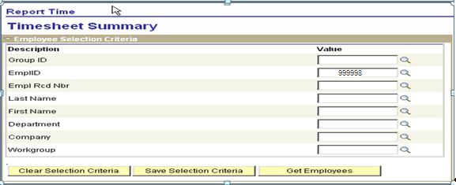

Select View by “Week” and enter date 07/01/08, and click . Enter 80 hours of GIVAN and 40 hours GIVSK. These are the entries to take the annual and sick leave out of the giving employee’s balances.

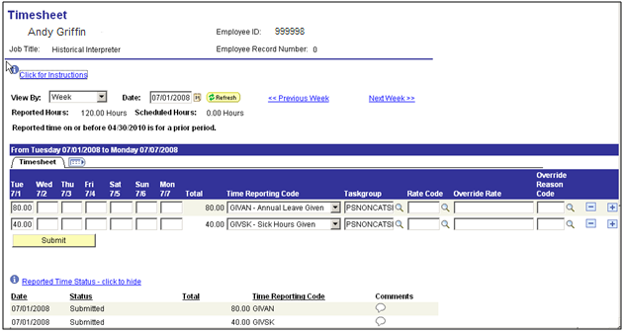

The second step is to post the given time to the RECEIVING employee balances. We will do this on the following page.

Receiving Shared Leave

Navigation: Manager Self Service > Time Management > Report Time > Timesheet

Enter Employee ID and click . Choose the Employee Name link.

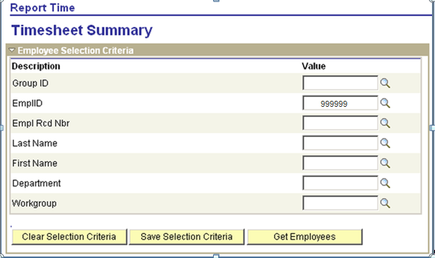

The Employee must have available Shared Leave balance on a date prior to the date Share leave is taken.
Navigation: Manager Self Service > Time Management > Report Time > Timesheet

Select View By “Week”
Enter date 07/01/08 and click .
Enter 120 hours into the Tuesday 07//01 field.
Select SHREC from the TRC drop down list.

NOTE: The SHREC hours posted are the converted hours derived from the Share Leave form.

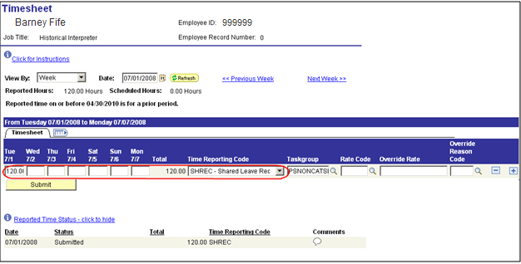

Click .

NOTE: Remember that the employee must be enrolled in SHARED LEAVE comp plans before the shared leave TRCs are available to use.

The next step is running Time Admin.

Running Time Administration for Both Employees

Navigation: Time and Labor > Process Time > Request Time Administration

Enter Process Date 07/31/08
Employee ID 999998 (donor) and employee ID 999999 (recipient) and click .

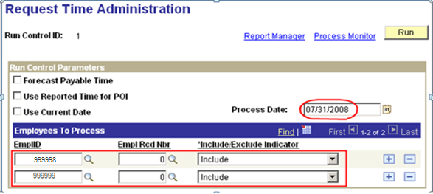

When the process is submitted, the system assigns a process instance.

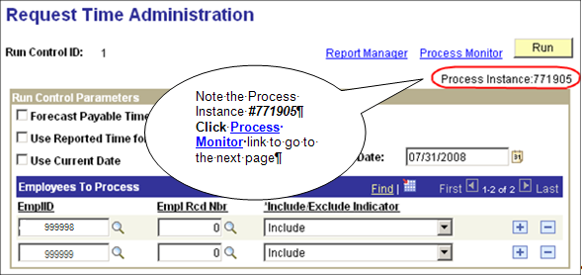

Note the Process Instance #771905 and click Process Monitor link to go to the next page.

Run the process to Success and go through the usual checking of Details and the Message Log.

Employee ID 999999 – Receiving Leave

Navigation: Manager Self Service > Time Management > View Time > Payable Time Detail

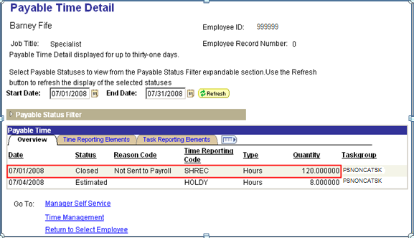

Employee ID 999998 – Giving Leave

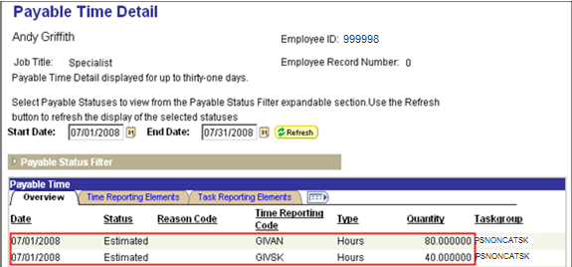

These two (2) entries will reduce the giving employee’s (114017) Annual leave balance and Sick leave balance respectively when it posts through Payroll and the Leave Accrual Process is run.
We must verify that the 120 hours is available in employee 100213 SHARED Leave Balance.

Review Compensatory Time Balance for Employee 999999

Navigation: Manager Self Service > Time Management > View Time > Compensation Time

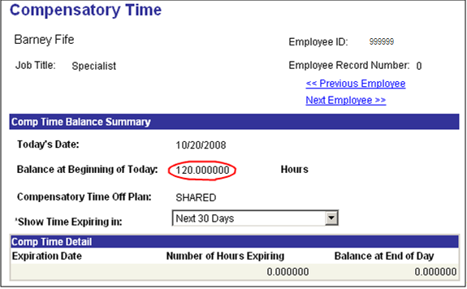

Now that the balance is loaded, we are ready to use the shared leave.

The balance can also be viewed in the timesheet. Refer to Viewing Compensation Balance section. You can also run the query GO_TL_COMP_DAY_BAL.

Using Shared Leave – Employee 999999

Navigation: Manager Self Service > Time Management > Report Time > Timesheet

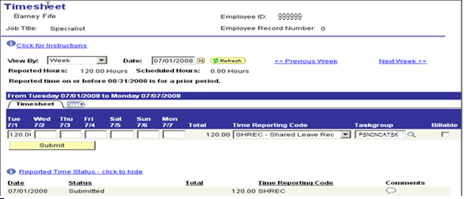

In the Timesheet Page starting with July 1, do not delete the entry to post Shared leave received. Scroll over to the far right of the page, click twice to add two (2) rows.

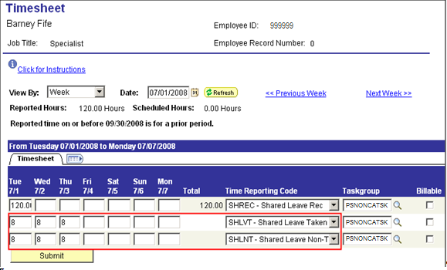

Post eight (8) hours per day into Tues-Thurs boxes – starting with 07/01 using TRC code SHLVT.
Post eight (8) hours per day into Tues-Thurs boxes – starting with 07/01 using TRC code SHLNT.
TRC code SHLVT reduces the recipient’s Shared leave balance and will process payment through payroll.

TRC code SHLNT or SHLTR accumulates and tracks the lifetime Share leave usage allowed by the state.

The next step is to run the Time Administration process again for the recipient through 07/31/08.

Navigation: Time and Labor > Process Time > Request Time Administration

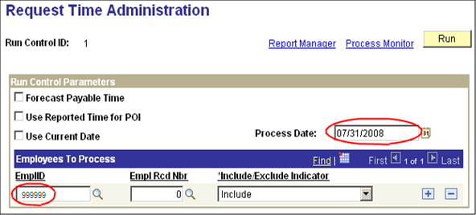

After Time Administration runs to success, check the DETAILS link and the View Log/Trace Message Log when finished.

Check Payable Time for Employee 999999

Navigation: Manager Self Service > Time Management > View Time > Payable Time Detail

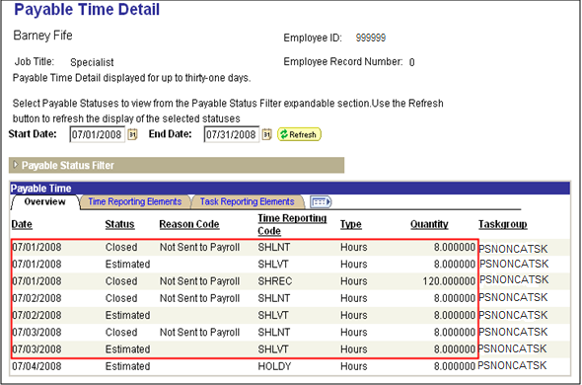

The SHLVT rows are marked – Estimated – Ready for Payroll. These lines will process through payroll and generate payment.

The SHLNT rows are marked – Closed and updated the SHARED LEAVE Comp Time Balance and the SHARED Leave NonTerm Accumulator (SHLFNOTERM Comp Time Balance).

Check Shared Comp Time Balance – Employee 999999

Navigation: Manager Self Service > Time Management > View Time > Compensation Time

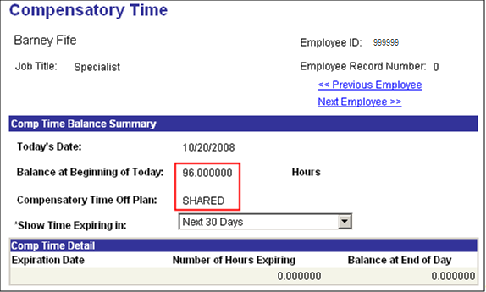

SHARED Leave now shows a balance of 96 hours since it just subtracted the 24 hours from the 120 hours that we posted.

Check the accumulator balance SHLFNOTERM.

Click Return to Select Employee link the following list of this employee’s Comp Time Plans appears:

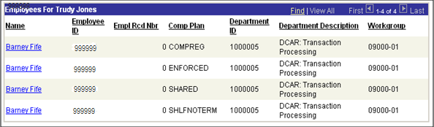

Click SHLFNOTERM.
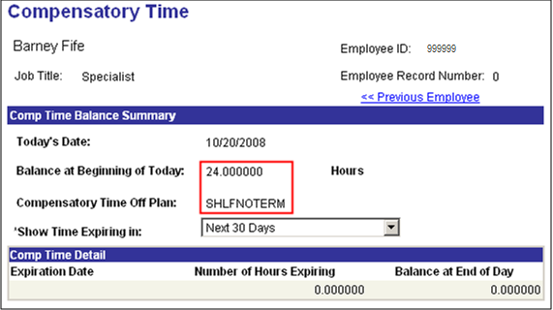

This accumulator shows a balance of 24 hours now since we posted the 24 hours through Time Administration.

Processing Sick and Annual Leave

Overview

The State of Oklahoma has designed the leave process to use the Time and Labor function in PeopleSoft. Sick Leave and Annual Leave are considered part of the Base Benefits part of PeopleSoft. However, all annual leave and sick leave used has to be posted into the Timesheet Page and processed through Time and Labor. Employee must be enrolled in the appropriate leave plans in order for leave to be posted in timesheet.

All the sick and annual leave entries must be processed through Time Administration to generate payable time. Payable time has to be taken by payroll so that the leave balances will be updated after payroll has been confirmed and leave accrual processed.

The leave accrual process for sick leave and annual leave is run once-a-month on the next to last day of the month, after all the payrolls for that month have been confirmed.

The Leave Statement Report generated in Base Benefits looks at Payable Time and selects the leave time with a status of TP (Taken by Payroll) or PD (Distributed). This is the reason that sick and annual leave time taken must go through Time and Labor in order for the Leave Statements to be correct.

Any reversal or correction that adds back to the employee Annual or Sick Leave balance must be approved and processed through a confirmed paycheck. After the accrual process has been completed, the Annual and Sick Leave balances will be updated in the benefits accrual page.

On Timesheet you have access by blue hyper link to view balances of annual, sick and any comp plans that the employee is enrolled in with a balance. The Annual and Sick leave is updated in timesheet as soon as you click submit. The annual and sick are real time balances.

Time Reporting Codes (TRCs), Sick & Annual Leave

There is special group of TRCs for Sick and Annual Leave. Each agency has a list of their specific codes. We will use the TRC List for Agency 805 as our example.

TRCs for Annual Leave – Agency 805
TRC |  | Descr |  | TRC Type |  | Earn Code |  | Comp Leave Ind |  | Add to Gross
ANNAD |  | Annual Leave Adjustment |  | Hours |  | ANA |  | NO |  | N
GIVAN |  | Annual Leave Given |  | Hours |  | ANG |  | LTKN |  | N
TERM |  | Annual Leave Payout |  | Hours |  | ALP |  | NO |  | Y
ANREC |  | Annual Leave Received |  | Hours |  | ANR |  | NO |  | N
ANNLV |  | Annual Leave Salaried |  | Hours |  | ANL |  | LTKN |  | N
ANNHR |  | Annual Leave Hourly |  | Hours |  | ANH |  | LTKN |  | N

TRCs for Sick Leave – Agency 805
TRC |  | Descr |  | TRC Type |  | Earn Code |  | Comp Leave Ind |  | Add to Gross
SICAD |  | Sick Hours Adjustment |  | Hours |  | SCA |  | NO |  | N
SICGV |  | Sick Hours Given |  | Hours |  | SCA |  | NO |  | N
GIVSK |  | Sick Hours Given |  | Hours |  | SKG |  | LTKN |  | N
WCSH |  | Sick Leave Hourly |  | Hours |  |  |  | NO |  | Y
SICRC |  | Sick Leave Received |  | Hours |  | SKR |  | NO |  | N
SCKTK |  | Sick Leave Salaried |  | Hours |  | SKL |  | LTKN |  | N
WCSS |  | Sick Leave Salaried |  | Hours |  | SKL |  | NO |  | N
SCKHR |  | Sick Leave Hourly |  | Hours |  | SKH |  | LTKN |  | N

Entering the Annual Leave Taken

Navigation: Manager Self Service > Time Management > Report Time > Timesheet

Employee 999999 took eight (8) hours of annual leave on 07/07 and 6 hours of sick leave on 07/14/2008.

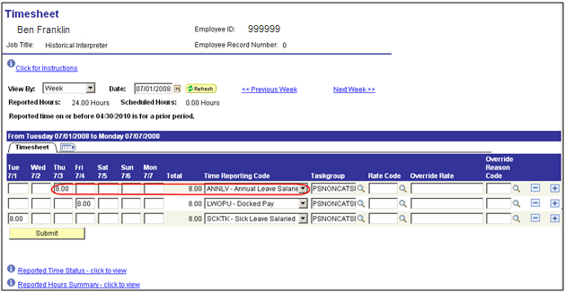

Click on the far right of the page to add a line. Post 8 hours under the Monday 7/7 field on the new line. Select ANNLV from the time reporting code (TRC) drop down list. Click . At this point, the balance in Timesheet is updated. To view balances, click the Balances – click to view link:

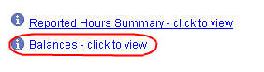

NOTE: Since the Sick and Annual leave are updated as time are submitted, the balance may not match the Leave Accrual page or Leave statement.

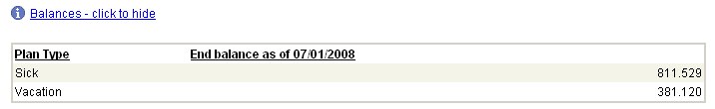

Click Next Week >> link.

Entering the Sick Leave Taken
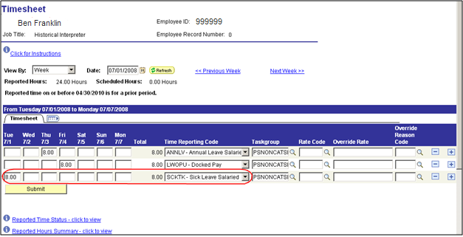

Click to add a new line.
Enter six (6) into the field under Monday 7/7 field
Select SCKTK from the Time Reporting Code drop down list (TRC)
Click .

Notice the balance is updated at this point in timesheet page.

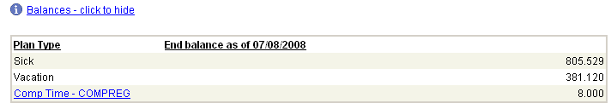

We have finished entering leave time for this employee.

Run Time Administration Process for Employee ID 999999

We will run the time administration process using the process date of 07/31/08.

Follow the same steps to process this leave through time administration as we did when we processed the comp time through time administration.

When time administration finishes, check for payable time, as was done for the Comp Time.

Processing Longevity

Partial Longevity

One of first steps on the Main and Supplemental Payroll Processing Steps is running the Longevity Part-time Process. This step produces a listing of all employees for the agency that would be eligible for a partial longevity. The payroll user must take this report and manually calculate the amount of Longevity the employee should be paid.

Navigation: OK Custom Reports/Processes > OK Reports > Payroll > Mdc Lgvty Cmp (0024)

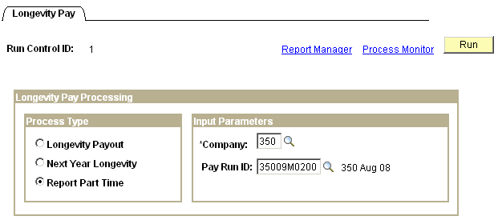

The payroll user takes the amount of money that the employee is due for his partial longevity and keys it into the Timesheet page on the anniversary date

Navigation: Manager Self Service > Time Management > Report Time > Timesheet

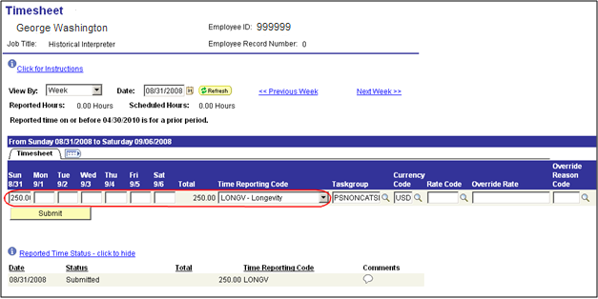

Longevity Payout – Longevity Process

Another step on the Main and Supplemental Payroll Processing Steps is to run the Longevity Payout Process. This process produces a report and it updates Timesheet on the longevity date with the LONGV Time Reporting Code and the amount of money that is owed the employee.

Navigation: OK Custom Reports/Processes > OK Reports > Payroll > Mdc Lgvty Cmp (0024)

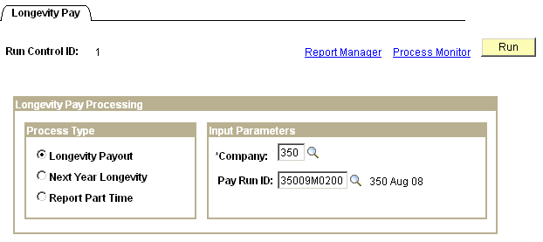

When Time Administration is processed, the longevity payment will be inserted into Payable Time to be taken by payroll for processing.

Processing Terminal Leave Payout

Step 1 – Entering Time into Timesheet

Navigation: Manager Self Service > Time Management > Report Time > Timesheet

Post the number of hours the terminated employee is to be paid in Timesheet

Select TRC ‘TERM’. Enter the hours on a date when the employee was ACTIVE. If the employee’s JOB Data record shows termination date of 08/01/08, the last day this employee worked was 07/31/08.

Enter 20.00 hours of TERM on 07/31/08 and submit time.

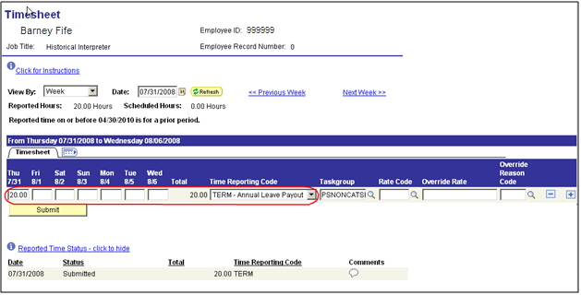

Step 2 - Run Time Administration by Employee ID

The Process Date on the run control for Time Administration should be the Last Date that the employee was ACTIVE.

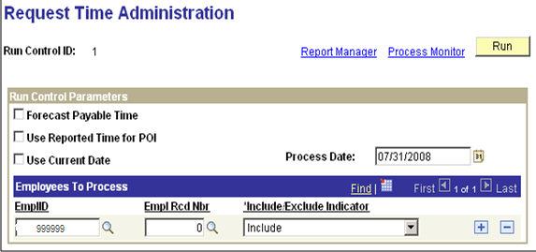

Example – If employee A’s last day to work was 07/31/08, HR should terminate the employee as of 08/01/08

The process date on the Time Administration Run Control would be 07/31/08.
Click .

- Check the Message Log and be sure the bottom of the report does not say “No employees to process”. This message means that the employee was not selected to process.
- Check for Time and Labor Exceptions.

Navigation: Manager Self Service > Time Management > Approve Time and Exceptions > Exceptions

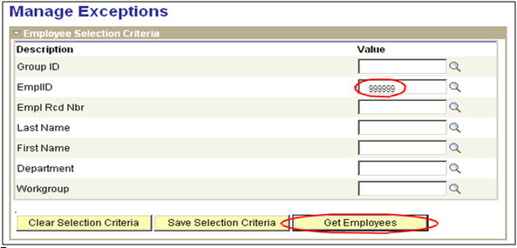

Enter Employee ID and click .

You are looking for the ‘There were no employees found based upon your selection criteria.’ message which means you do not have any errors

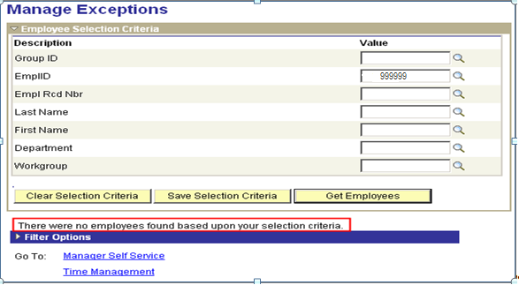

Step 3 - Check Payable Time Detail

Navigation: Manager Self Service > Time Management > View Time > Payable Time Detail

Be sure that the time says – Estimated – Ready for Payroll

Enter the Employee ID and the date range that includes the time entered (up to 31 days) and click .

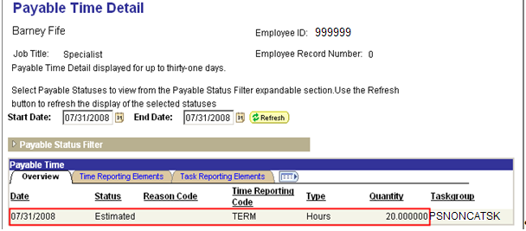

Adjust Paid Time

Closing Rejected Rows

Payable Time with status Rejected by Payroll can be closed to keep them from being processed through payroll.

To close Rejected rows, navigate to the Adjust Paid Time Page.

Critical NOTE: Be cautious when you close annual or sick leave that has been rejected, and not pulled through payroll, can put you out of balance with your accrual balances, and this action cannot be reversed. Closing a transaction is used for specific errors and clean up.

Navigation: Time and Labor > Report Time > Adjust Paid Time

Enter the Employee ID, start date and end date (up to 31 days), click .

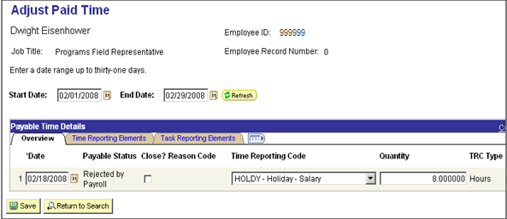
Click the ‘Close?’ Checkbox for the row(s) you want to close and click .

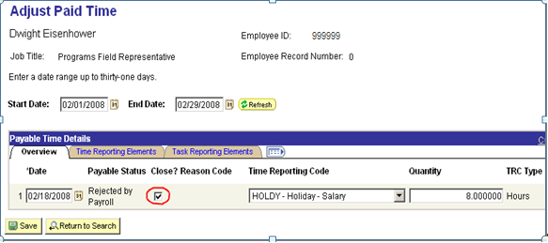

The entry will disappear from this screen after you click However, it will continue to show on the Payable Time Detail Screen. The Payable Time Detail Screen now shows the status of the closed time as “Ignore” and Reason Code “Manual Reject”.

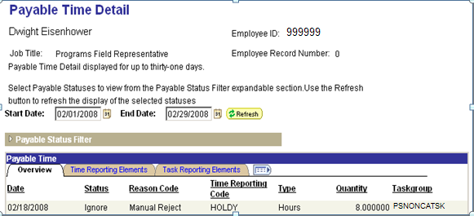

Closing the time will stop the system from attempting to send it to Payroll every time that Payroll pulls transactions or Time and Labor loads transactions.

Processing Adjustments thru T&L

All adjustments must be made through the Timesheet page. Be sure to use the appropriate adjustment code. When entering the value (hours or amounts) for the TRC, a positive amount will pay or add to leave balances. Leave adjustment can only be posted using adjustment TRCs. Regular leave TRC such as ANNLV or SCKTK should never be posted as a negative value to process adjustments.

TRCs for Adjustments
TRC |  | Descr |  | TRC Type |  | Earn Code |  | Comp Leave Ind |  | Add to Gross
ANNAD |  | Annual Leave Adjustment |  | Hours |  | ANA |  | NO |  | N
ADLAD |  | Admin Lv Cool Off Adjustment |  | H |  |  |  | CERN |  | Y
ADJ |  | Earnings Adjustments |  | H |  | ADJ |  | NO |  | Y
CADJ |  | Comp Rate Adj (Mid Week) |  | H |  | CAJ |  | NO |  | Y
CTEAD |  | Comp Time Earn Adjustment |  | H |  |  |  | CERN |  | Y
ENFAD |  | Enforced Leave Adjustment |  | H |  |  |  | CERN |  | Y
EQUIT |  | Equity Based Pay Adjustment |  | A |  | EBP |  | NO |  | Y
HOLAD |  | Holiday Leave Adjustment |  | H |  |  |  | CERN |  | Y
LATXF |  | Lateral Transfer Adjustment |  | A |  | LAT |  | NO |  | Y
MILAD |  | Military Leave Adjustment |  | H |  |  |  | CERN |  | Y
ORGAD |  | Organizational Leave Adjustment |  | H |  |  |  | CERN |  | Y
RADJ |  | Retro Pay Adjustment |  | A |  | RAJ |  | NO |  | Y
SHLAD |  | Shared Leave Adjustment |  | H |  |  |  | CERN |  | Y
SHLNA |  | Shared Leave Non-Term Adjust |  | H |  |  |  | CERN |  | Y
SHLTA |  | Shared Leave - Term ILL Adjust |  | H |  |  |  | CERN |  | Y
SICAD |  | Sick Hours Adjustment |  | H |  | SCA |  | NO |  | N

FMLA Accumulator

Navigation: Manager Self Service > Time Management > View Time > Accumulators

A new feature that has been added to this version is the Accumulators page. This page is currently used to track total FMLA usage by employee between a range of dates.

Enter Employee ID and click , and click Employee Name link.

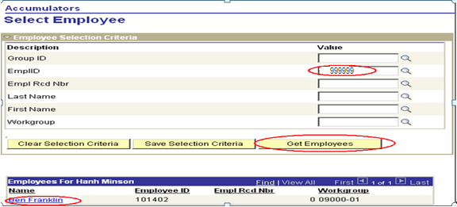

On the next screen, enter Start Date and End Date, and click .

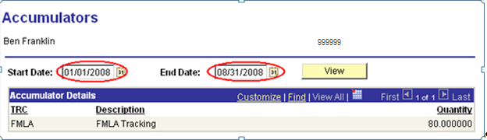

The bottom of the page shows the total number of FMLA hours taken between 01/01/08 and 08/31/08.
A query is also provided to track FMLA usage by date and time reporting code for individual employee: GO_TL_FMLA_TRC. The query is sorted by name and time reporting code and includes the employee ID, name, date of report (DUR), quantity, time reporting code (TRC), and payable status.

Navigation: Reporting Tools > Query Manager > Query Viewer

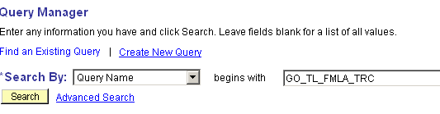

In the Query Name field, type in the query name GO_TL_FMLA_TRC and click .

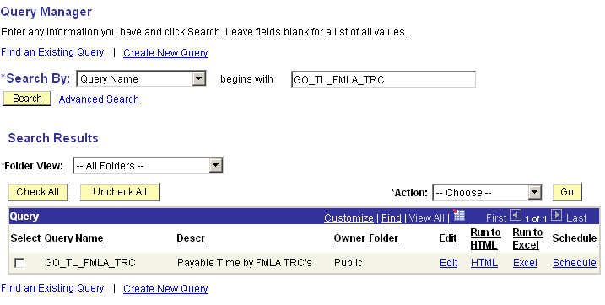

To run the query, click the HTML or Excel link and fill out the prompts:

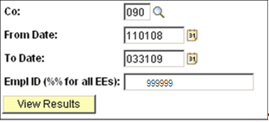

Co: Enter the agency number.
From Date/To Date: Enter the start date and date to be tracked
Empl ID: Enter the employee ID or %% to select all employees for the agency.
Click .
Below is an example of a query result for FMLA tracking:

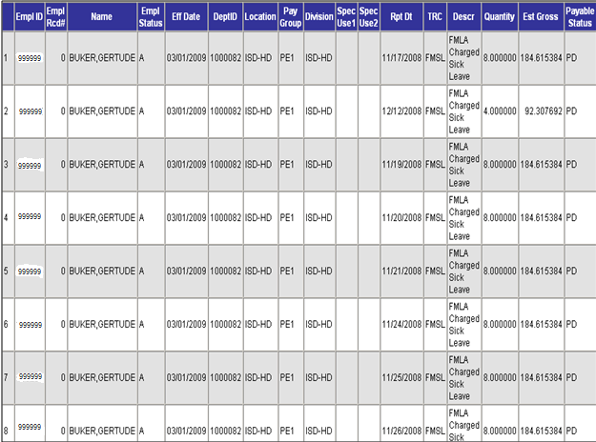

Check Reversal
Typically, when time is taken and processed through payroll, payable status for that time is set to “TP” – Taken by Payroll. When a check that had time pulled in from Time and Labor is being reversed, two options are available during the reversal process:

- Reverse only: This option creates offset payable time with status “Reversed” as shown below when the check reversal is confirmed. The time will not be pulled into payroll again. Normally, this option will not be selected.

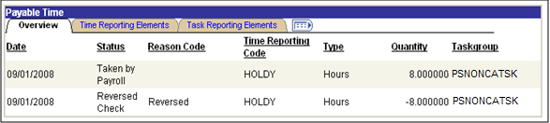

- Reverse and Generate New Row: This option creates offset payable time with status “Reversed” and an additional row in payable time with “Estimated” status when the check reversal is confirmed. The “Estimated” payable time will be pulled into payroll again when payroll is processed.

The Reverse and Generate option normally will be used when a check is being reversed. If time entered was invalid or incorrect and should not be pulled into payroll again, it should be corrected on the Timesheet and processed through Time Administration. It is recommended that the replacement check should not be issued until the reversal has been processed. This allows reversed time to either be processed through payroll again, or if needed, time can be corrected and then processed again. If a check is replaced before a reversal is processed, time being pulled into payroll again may cause overpayment.

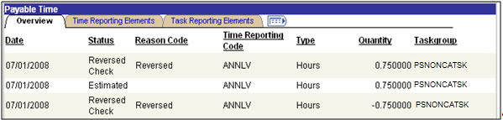

Queries

There are several queries available, depending on user security, to extract Time and Labor information.

Navigation: Reporting Tools > Query Viewer

Type in “GO_TL” in the Query Name field and click to pull up a list of Time and Labor queries available.

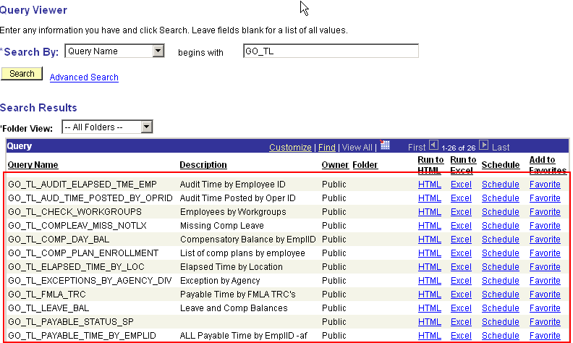

To run a query, click the HTML or Excel link.

In this example, we are running query: GO_TL_COMP_DAY_BAL by clicking on the HTML link.
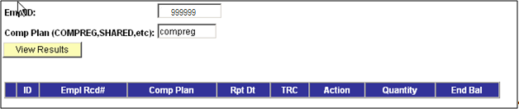

Some queries will prompt for values. In this case, enter the employee ID, and the Com Plan.
Click .

The query returned the results below:

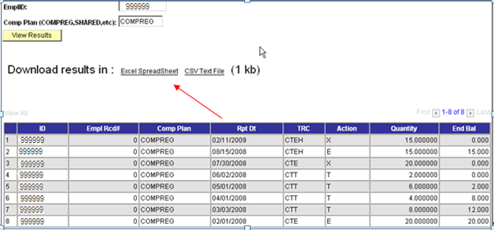

At this point, you can print the page, or download query to Excel by clicking the Excel Spreadsheet link.

Adding Queries to Favorites list:

Queries that are run frequently can be added into Favorite list. To add a query, click the Favorite link next to the query.
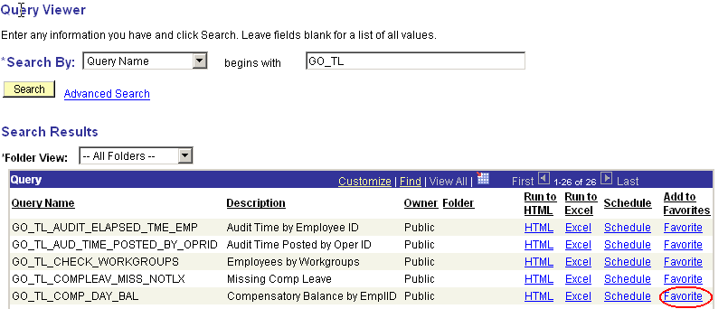

Now, the query is in the favorite list whenever Query Viewer is accessed.

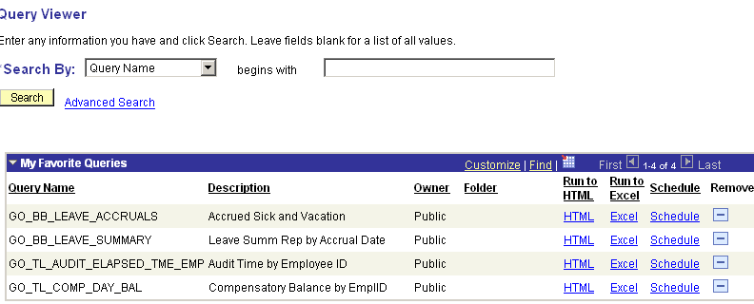

Scheduling a Query to Run

If there are large queries that may take a long time to run, the queries can be scheduled to run to avoid system time-out.

Navigation: Reporting Tools > Query > Schedule Query

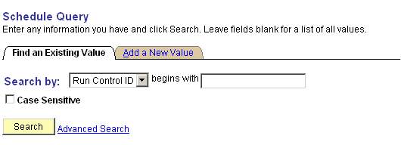
Click to select a Run Control ID or select Add a New Value Tab to add a new Run Control ID.

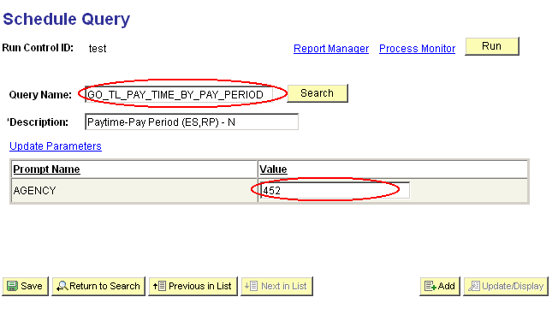

In Query Name field, enter the query name to be scheduled.
In this example, the query prompts for the agency value.

After all fields are filled, click .

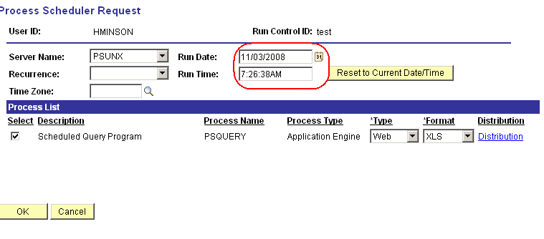

Type in the Run Date and Run Time for the query to process and click .
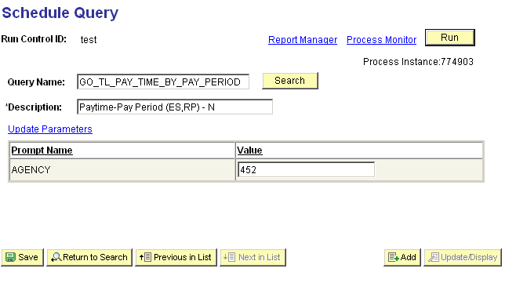

To access a scheduled query that has been run, click the Process Monitor link.

Process Monitor can also be accessed by the following:

Navigation: People Tools > Process Scheduler > Process Monitor

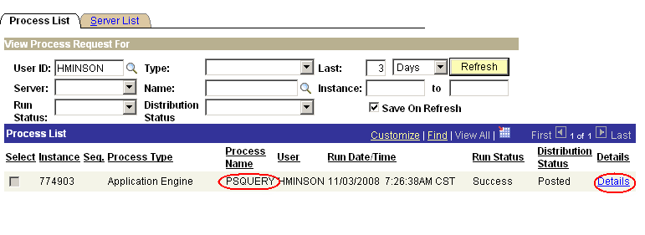

Notice the Process Name is PSQUERY. When the Run Status indicates “Success” and Distribution Status indicates “Posted”, click the Details link.
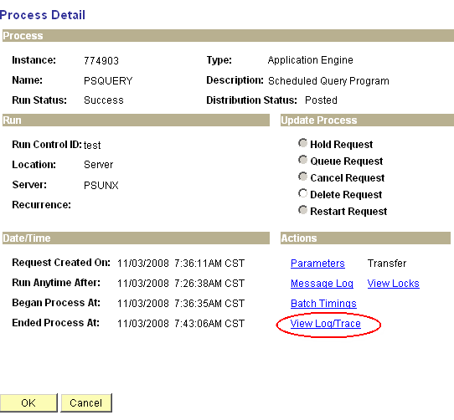

Click View Log/Trace link.

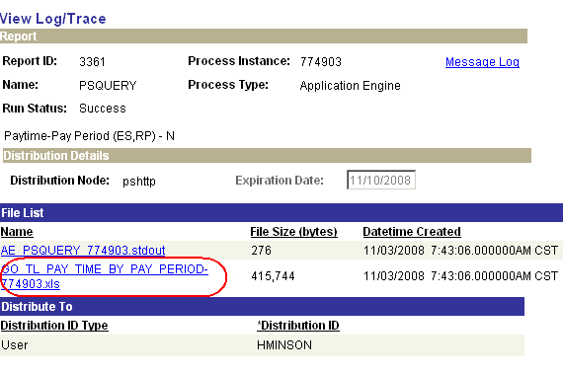

Click the link with *.xls extension to open query results. The query can be opened or saved in Excel format.

