COR310 Disciplinary Actions & Grievances Manual
Table of Contents

Document History 3
Disciplinary Actions & Grievances Overview 5
Role Definitions 5
PeopleSoft HCM Sign In 6
Record Disciplinary Actions 7
Step 1 – Select Employee 7
Step 2 – Record Disciplinary Incident 8
Step 3 – Record Disciplinary Action Taken 11
Step 4 – Disciplinary Resolution Tab 14
Record Grievances 15
Step 1 – Add a Grievance 15
Step 2 – Record Grievance 16
Step 3 – Record Grievance Steps 18
Step 4 – Record Grievance Resolution 19
Step 5 – View a Grievance 21
Run Queries 22
View Queries 22
Disciplinary Action and Grievance Queries 24
Security Access Process 25

Document History
Document Revision | Date | Description
1.0 | 07/06/2011 | Initial Document
1.1  1.2 | 08/22/2011  09/19/2011 | Added new search screen shots that reflect the new disciplinary and grievance actions.  Clarified Grievance Status Date usage

Authorized by: [_CORE_] Original Issue: [07/06/2011]
Maintained by: [____HCM Lead___] Current Version: [09/19/2011]
Review Date: [07/01/2012]

Disciplinary Actions & Grievances Overview
This manual provides the instructions for you to Record, Update and Report on employee disciplinary actions and employee grievances. The Merit Protection Commission can report on summary statistics of Disciplinary Actions and Grievances by agencies, but cannot identify individuals.

Role Definitions
Disciplinary Actions Manager – Each agency has identified Disciplinary Actions Manager(s) within their respective agencies to enter, update and report on Disciplinary Actions. This person(s) will have access to the Record Disciplinary Actions component and be able to manage the disciplinary process for employees in their agency.

Grievance Manager – Each agency has identified Grievance Manager(s) within their respective agencies to enter, update and report on employee grievances. This person(s) will have access to the Record Grievances component and be able to manage the grievance process for employees in their agency.

PeopleSoft HCM Sign In
As with all Oracle - PeopleSoft applications, you will receive a User ID and Password for the Human Capital Management application from CORE Security. The Sign-In Screen example is provided below and is the same as other Oracle - PeopleSoft sign-in applications

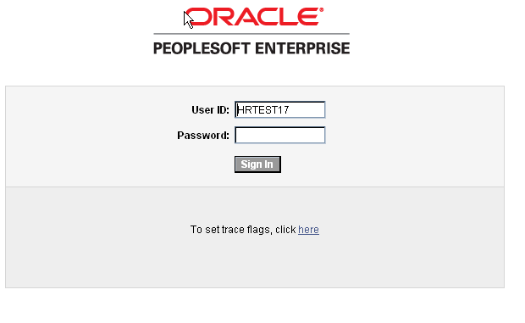

Oracle – PeopleSoft Sign-in Link:
https://corehr.ok.gov/psp/mrhri/?cmd=login&languageCd=ENG&

After your initial log in, the system will prompt you to change your password. The new password must be at least eight (8) characters long and CORE Security recommends the password you choose also incorporates numbers and/or capitol letters.

If you forget your password, please call the Office of State Finance Help Desk: 405 521-2444 or 866 521-2444. The Help Desk can reset your password over the phone. If you have not been active in the Human Capital Management application for more than 60 days, you will lose your security access. To regain security access, resubmit the OSF Form 304.

CORE Security Link:
http://www.ok.gov/OSF/CORE/Security/index.html

Record Disciplinary Actions

Step 1 – Select Employee
Navigation: Workforce Administration > Labor Administration > Record Disciplinary Actions

Select an employee to view or update an existing disciplinary record or to add a new disciplinary incident.

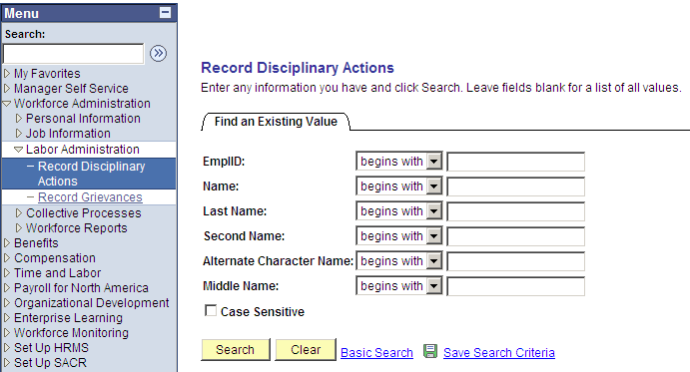

There are several options to look up an employee. The most effective option is to access an employee directly with their Employee ID.

If you know the PeopleSoft Employee ID, enter the number in the EmplId field.

Click .

NOTE: You may also search by Last Name, but be careful as there may be employees with the same name.

Step 2 – Record Disciplinary Incident
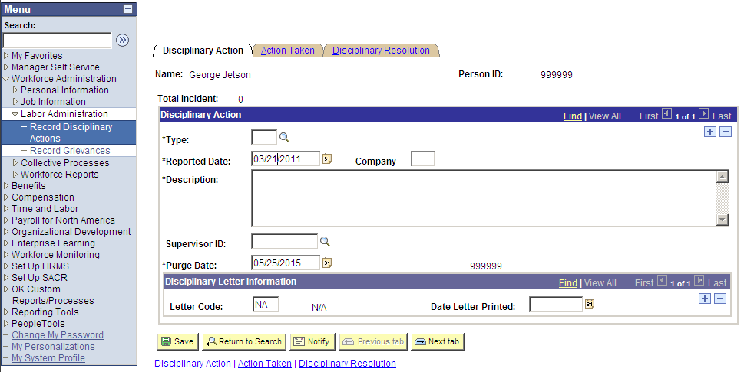

On the Disciplinary Action Tab:

Enter Disciplinary Action Type, (See list on following page)
Enter the Date it was reported.
Enter the Company (Agency#).
Enter a brief Description of the incident (optional)
Enter the employee’s Supervisor ID (optional)

NOTE: The Supervisor ID refers to the Employee ID of the Supervisor. You may click the magnifying glass icon to search by last name if you do not know the employee ID.

NOTE: The Purge Date is informational only and defaults to 4 years after the Reported Date. It is a reminder that disciplinary actions should not be considered beyond that date.

Disciplinary Types

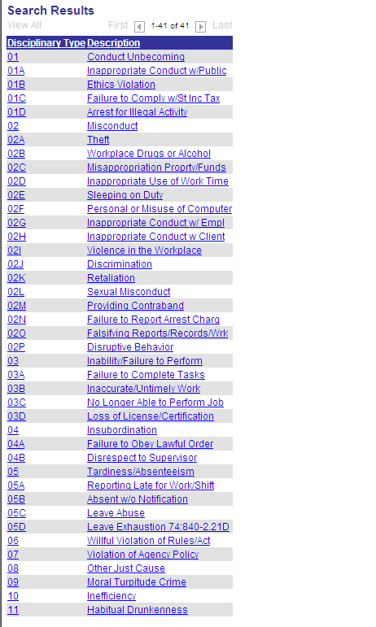

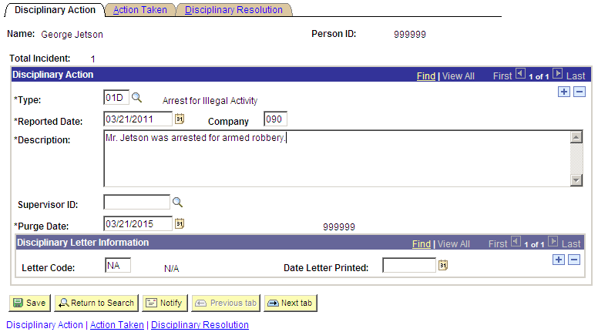

NOTE: You may record additional Disciplinary Action Types for the same employee by clicking the button within the Disciplinary Action block. The button will remove a Disciplinary Action type from this employee.

Click .

Step 3 – Record Disciplinary Action Taken
Click the Action Taken Tab:

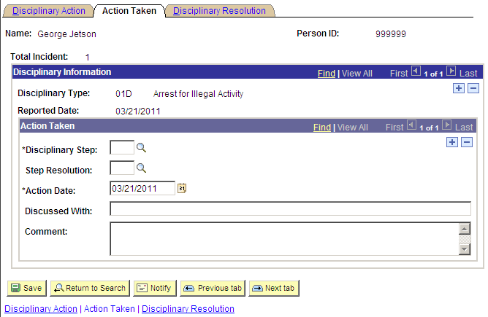

NOTE: If you have more than one disciplinary action, click the View All link so they are all displayed on the page, or you may scroll through the records using the and buttons.

On the Action Taken page:

Enter Disciplinary Step, (see list on following page).
Enter the Step Resolution, (optional, Disciplinary Steps all begin with ‘D’, see list on following page).
Enter the Action Date when the step was taken with the employee.
Enter r participants in a discussion, (optional).
Enter a brief Comment, (optional).

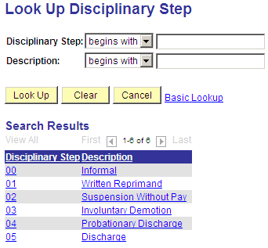

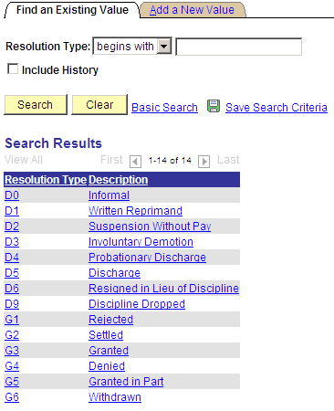

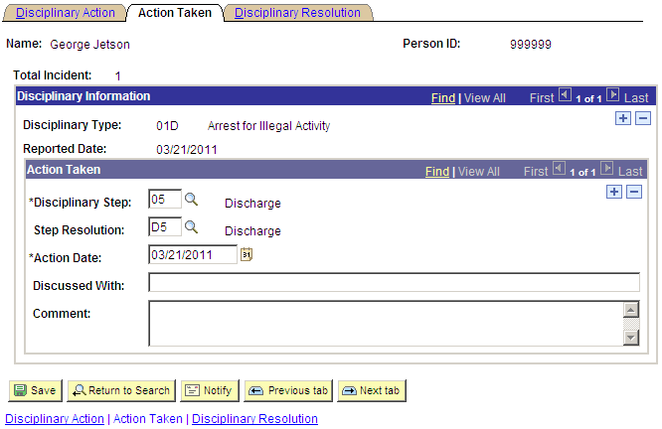

Click .

Step 4 – Disciplinary Resolution Tab
Click the Action Taken Tab:

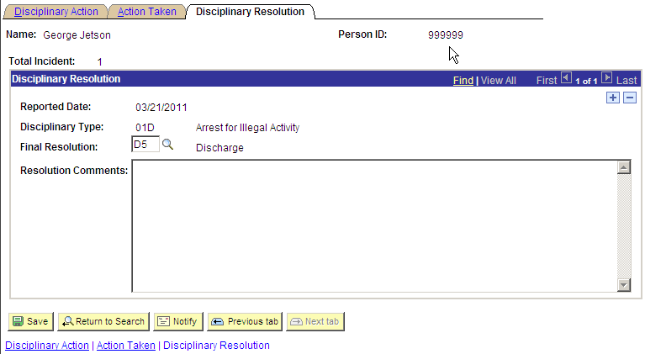

On the Disciplinary Resolution Tab:

Enter the Final Resolution for the incident.
Enter Resolution Comments (optional).

Click .

NOTE: Only Disciplinary Records that show a resolution are reported to MPC. Some agencies may break out a single event into separate Disciplinary Types, then only record a resolution on the main type for reporting to MPC.

Record Grievances

Step 1 – Add a Grievance
Navigation: Workforce Administration > Labor Administration > Record Grievances

Click the Add a New Value Tab to add a new grievance.

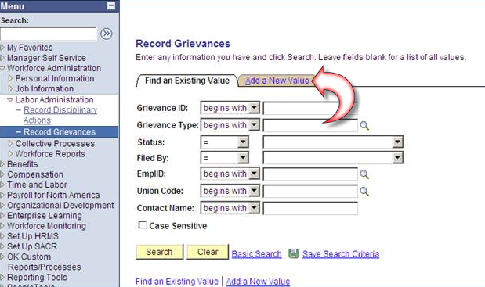

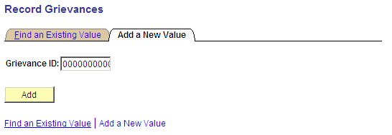

Click the button. Do not enter a Grievance ID. The system will assign the next Grievance ID when you save.

Step 2 – Record Grievance

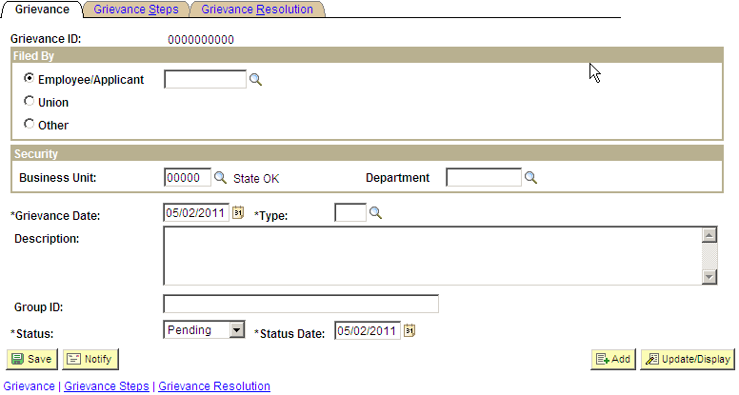

On the Grievance Tab:

Enter the Employee ID,
Enter the Business Unit and Department (otherwise the system will not apply security).
Enter the Grievance Date.
Enter the Grievance Type (see next page for valid values).
Enter the Status (valid values are: Appealed, Dismissed, Pending, Rejected, Settled, Upheld, Withdrawn).
Enter the Status Date for the current status (you will need to update this date when you change the status and resolve the grievance.)

Enter Description of the grievance (optional)
Enter Group ID (optional, use if this grievance belongs to a group grievance)

NOTE: Your agency will determine how to identify group grievances.

Grievance Types:

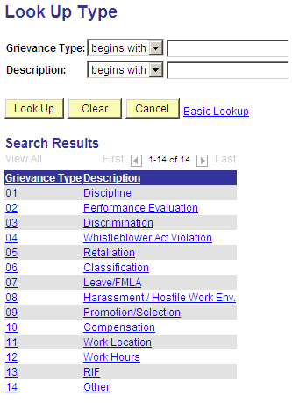

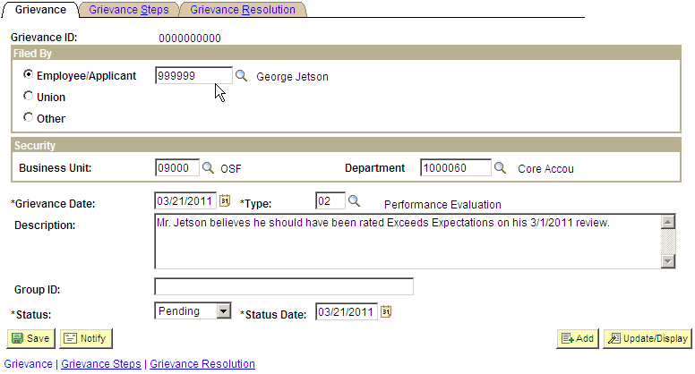

Click the Grievance Steps Tab:

Step 3 – Record Grievance Steps
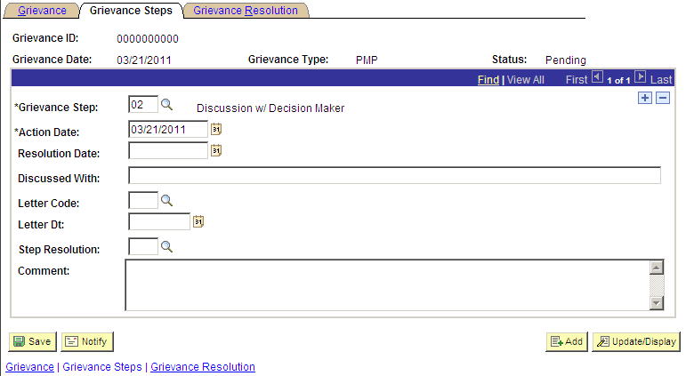

On the Grievance Steps Tab:

Enter Grievance Step,

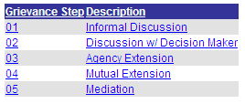

Enter the Date the step was performed.
Enter the Date the step was resolved (optional).
Enter the participants in discussing the step (optional).
Enter a Step Resolution (optional).
Enter a brief Comment (optional).

Click the Grievance Resolution Tab:

Step 4 – Record Grievance Resolution
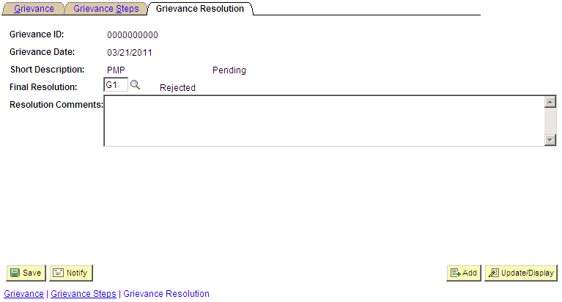

On the Disciplinary Resolution page:

Enter the Final Resolution for the grievance (Grievance Resolution codes begin with “G”).

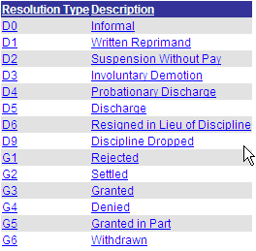

Enter Resolution Comments (optional).

Click the Grievance Tab:

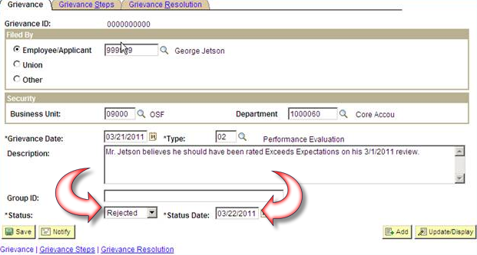

Enter the final Status

Enter the final Status Date

NOTE: MPC will use the Grievance Date and final Status Date to determine the Resolution Time per Merit Rule 455:10-19-5.

Click .

Step 5 – View a Grievance

Navigation: Workforce Administration > Labor Administration > Record Grievances

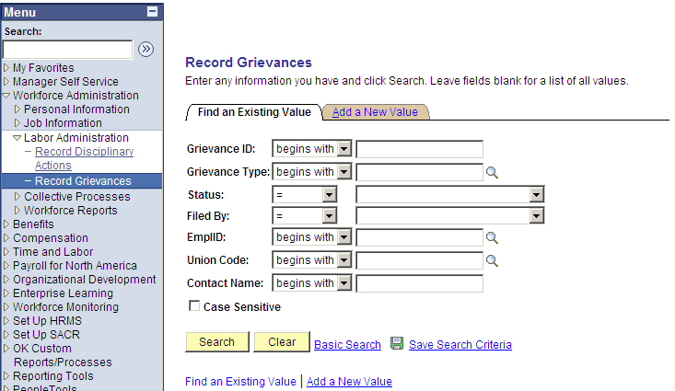

There are several options to look up an existing grievance. The most effective option is to access a grievance with the Grievance ID, or you can enter an Employee ID to search for a grievance.

Click .

Run Queries

View Queries
Navigation: Reporting Tools> Query > Query Viewer

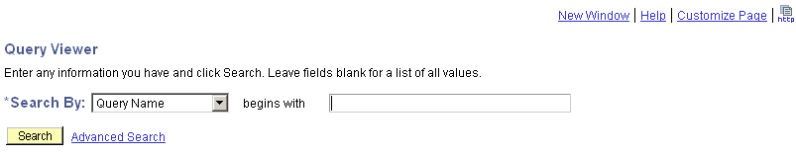

Click for a list of available queries. To narrow your search, enter the first few letters of a report. Hint: most valid queries begin with ‘GO_’.

The query name will appear in the ‘Search Results’ as shown below:

NOTE: You can also enter the entire name of the Query in the search box.

Key the partial name of the query in the empty box and click .

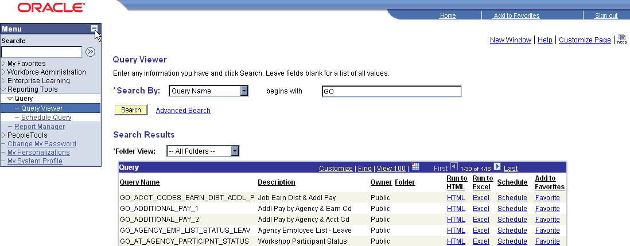

Click the HTML link for the query you are going to view. For the example we used GO_AT_AGENCY and a new window will open to run the query. You also can run the results directly to an Excel spreadsheet and sort the data. Click Excel link.

Examples of parameters for a query are provided below. Enter the required values and click .

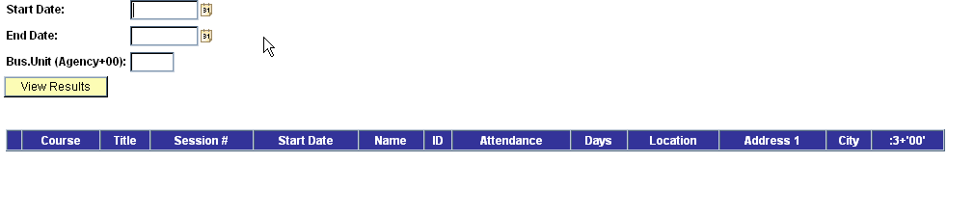

Review Results of Query

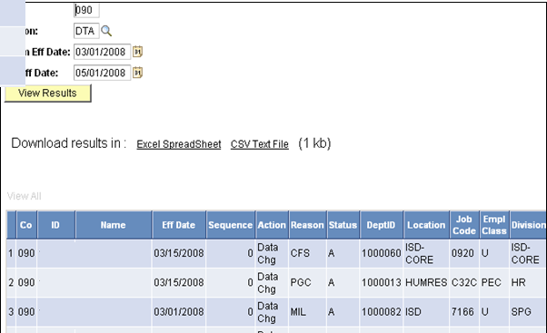

NOTE: To download the results of a query to Excel, click the Excel Spreadsheet link.

Disciplinary Action and Grievance Queries

The following queries are currently available to report on Disciplinary Actions and Grievances:

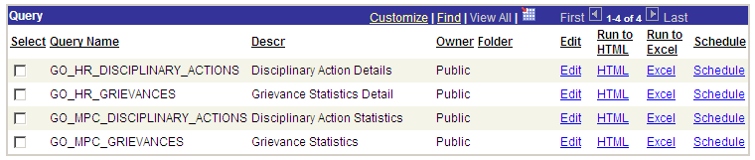

Security Access Process
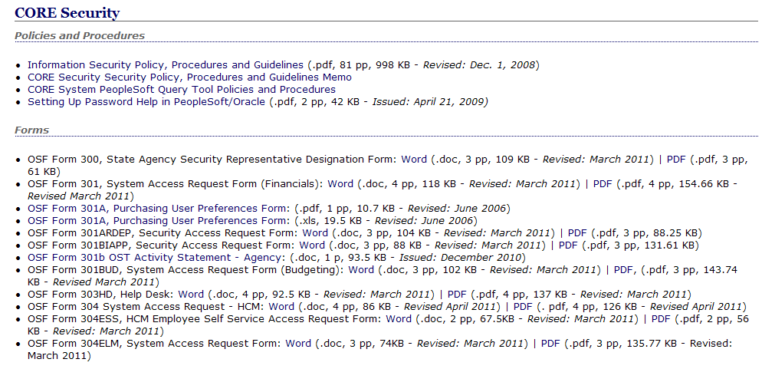

Disciplinary Manager(s) and Grievance Manager(s) for each agency will be required to submit an OSF Form 304 security form to gain access to maintain Disciplinary Actions and/or Grievances.

The CORE Website has the Security OSF Form 304 (HCM) (link provided below). Complete the form and return the Security Lead at the CORE Office, (address information located on the last page of the form).

NOTE: Check the Disciplinary Manager and/or the Grievance Manager along with the Run Query Box(s). The only exception would be for current HCM users who already have access to run queries and therefore would not need to check the Run Query box on the form.

CORE Website Link OSF Form 304 (HCM): http://www.ok.gov/OSF/CORE/Security/index.html

