COR402 Accounts Receivable –

Receivable Creation Manual

The content of this training manual is based largely on a generic system configuration and illustrates the base-line functionality required to execute transactions in the module. Your agency may be utilizing more or less of the functionality illustrated in this manual. This manual is intended to be a framework upon which agencies can add agency-specific training content that speaks specifically to the system functionality that they have deployed and related configuration that they use for transaction processing. Agencies should not depend on these manuals for end-user training or problem resolution until they have been reviewed by the agency for appropriateness.

Table of Contents

Document History 4
Receivables Creation 5
Key Terms 6
Account Receivable Business Unit 6
Billing Business Unit 6
Customer 6
Customer ID 6
Bill (Invoice) 6
Distribution Code 6
Item 6
Pending Item 6
Pending Item Group 6
Process Flows 7
Guidelines, Concepts and Alternatives 8
External Pending Items 9
Manage External Pending Items 9
Group Control Page 11
Pending Item 1 Page 12
Pending Item 2 Page 14
Accounting Entries Page 15
Group Action Page 16
Online Pending Items 18
Enter Online Pending Items 18
Group Control Page 19
Pending Item 1 Page 20
Pending Item 2 Page 22
Accounting Entries Page 23
Group Action Page 25
Correcting Pending Items 27
Review and Correct Pending Items Using Entry Pages 27
Pending Item 1 Page 29
Correcting Pending Items Using Posting Error Pages 31
Pending Item 1 Page 32
Item Inquiry and Review 34
Review All Items by Group 34
Group Control Page 36
Pending Item 1 Page 37
Pending Item 2 Page 39
Review Item Groups Not Set To Post 40
Groups Not Set To Post Page 40
Review Billings by Unit 42
Pending Item Reports 44
Item Detail Report 44
Item Detail Page 45
Item Accounting Entries Report 47
Accounting Entries Page 48

Authorized by: [_EBS_] Original Issue: [11/01/2004]
Maintained by: [____AR Lead___] Current Version: [10/1/2014]
Review Date: [10/1/2014]

Document History
Document Revision | Date | Description
1.0  2.0 | 04/30/2010  05/01/2014 | Initial Document  Upgrade Update

Receivables Creation

Creating a Receivables Item in the system can be done manually within the Accounts Receivable module or can be done thru integration with external sources like the Billing Module. Receivables Items are posted to customer accounts, while Pending Items exist in the system but have not been posted to a customer account.

After Pending Items are entered in the system, use the Receivable Update Application Engine process (ARUPDATE) to post them. The process creates the items, generates accounting entries, updates item activity, and updates the customer balance.

The Receivables module follows the standard of bundling Pending Items into Groups rather than handling them individually. To each group of pending items, the system assigns a group ID that remains with the group even after it is posted. The system executed batch processes of pending items in groups also.

The majority of Items will be created thru the Billing to Accounts Receivable interface. When Pending Items are entered through a billing interface, the system edits External Groups and identifies
errors when the Receivable Update process is executed.

Key Terms
Account Receivable Business Unit: Each agency has one, and only one Billing Business Unit. The Business Unit is the 3 digit agency code, plus 00. For example, Office of State Finance is 09000.

Billing Business Unit: Each agency has one, and only one Billing Business Unit. The Business Unit is the 3 digit agency code, plus 00. For example, Office of State Finance is 09000.

Customer: A customer is an external entity that is defined in a Contract to receive invoices and from which revenue is recognized. Customers can be individuals, businesses or federal grantors.

Customer ID: Customer ID is a unique identifier for Customers within the system. Customer ID’s can be assigned by the system or keyed manually by a user. Each agency will have unique list of Customer ID’s with which they do business (generate revenue).

Bill (Invoice): The transaction containing invoice information for a Customer (bill header, bill lines, amounts, due dates, etc.). Bills are created then ‘Finalized’ in Billing to become a completed Invoice to which customer cash can be applied. The term Bill and Invoice can be used interchangeably.

Distribution Code: Distribution codes simplify the process of generating accounting entries by defining a valid combination of Chartfield values that are used as defaults on other pages. Distribution Codes can be defined for Revenue or Accounts Receivable.

Item: An Item is a receivable transaction in the system. Generally, Items are invoices that are interfaced from the Billing Module.

Pending Item: Pending Items are Customer Receivables that have been created in the system but are not yet posted to the Customer Account. Pending Items can come from outside of Accounts Receivable, like invoices from Billing, or they can be created in Accounts Receivable.

Pending Item Group: A Group of Pending Items that are collectively entered on-line or interfaced from an external source (Billing). Groups have totals, counts, accounting entries and are posted to Customer Accounts thru Receivables Update process.

Process Flows
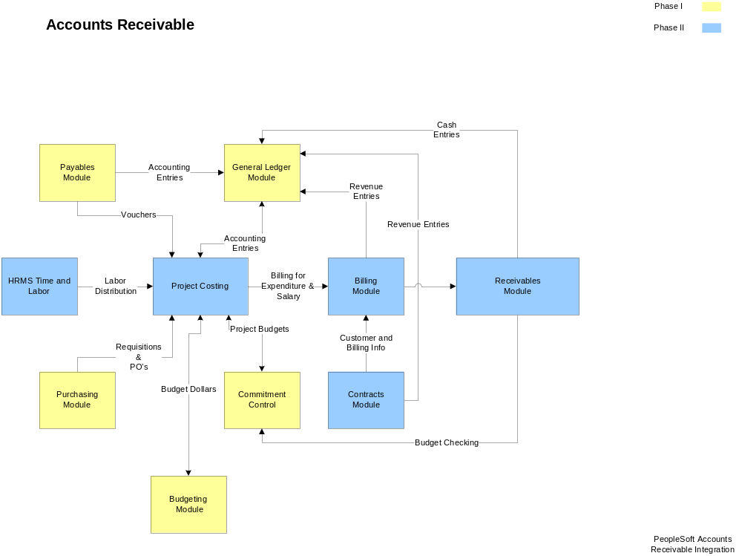
Diagram 1: Accounts Receivable Module Integration

Guidelines, Concepts and Alternatives

PeopleSoft Billing uses extensive defaults to automatically populate bill information. Since Accounts Receivable uses finalized bills extensively in processing, this hierarchy also impacts the Receivables module.

During online Bill entry, as certain fields are populated, the system automatically populates other fields on the Bill Header based on the defaults that are configured by the agency. Automatic field population also occurs during the Billing Interface process (BIIF0001) when a field that has possible default information is left blank.

For example, an agency may extend different ‘Payment Terms’ to customers based on the ‘Type’ of invoice that is being generated. If Payment Terms are defined by Bill Type, then each time a Bill Type is selected onto an invoice the corresponding Payment Terms are defaulted to the Bill Header.

Since Accounts Receivable uses Customers extensively, the Billing default hierarchy impacts processing in Receivables as well. Within the default hierarchy values defined at the Lower-level of the diagram below “Override” values at a Higher-level in the hierarchy. For example, Payment Terms defined for the Customer would override Payment Terms defined for the Bill Type. When creating invoice on-line the system will search for the lowest level value in the hierarchy to populate a particular default field.

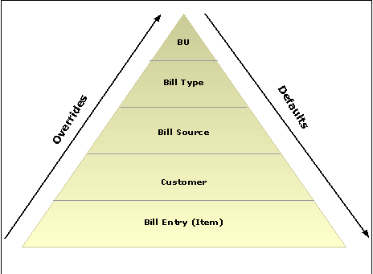

Diagram 3: Billing Default Hierarchy

External Pending Items

Receivables Items (invoices) can originate from within the Accounts Receivable system or from outside the module, as is the case with invoices from the Billing Module. Items originating from outside of Accounts Receivable are called External Items. External Pending Items are added to the system in Groups. A Pending Item Group consists of one or more invoices.

Since External Pending Items are interfaced from external sources, they are searched for and retrieved with many required values already populated. External Pending Items are generally eligible to be posted to Customer Accounts when received in the Accounts Receivable module.

Manage External Pending Items

Navigation: Accounts Receivable > Pending Items>External Items > Group Entry > Find an Existing Value

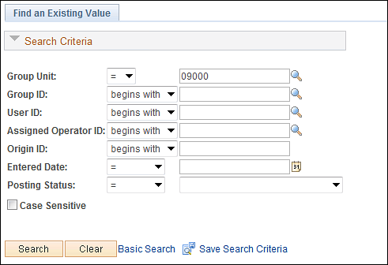

Use the Search criteria to find the desired External Pending Item Group.

Group Unit – populate with the agency business unit number.

Group ID – if the External Pending Item Group ID is known, search by that value.

User ID – populate with the User ID that created the Group.

Origin ID – for External Pending Item Groups this value will be ‘EXT’ or External.

Entered Date – date entered

Posting Status – initially the interfaced Pending Item Group will be set to ‘Not Posted’.

Click to find the External Pending Item Group.

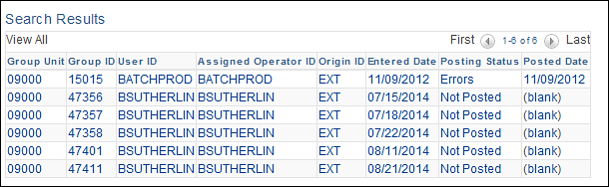

Select the desired External Pending Item Group.

Group Control Page
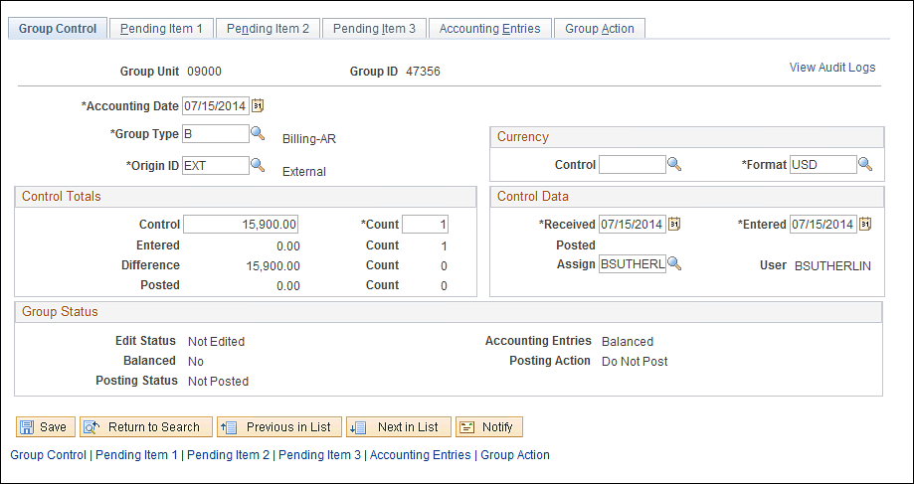

Use the Group Control page to review the External Pending Item Group information.

Accounting Date – this value is the date that the accounting entries for the Group will be posted to the General Ledger.

Group Type – this value represents the source of the Group. For External Groups, this value will generally be ‘B’ for Billing.

Control – this amount represents the total amount of all Items in the Group.

Count – represents the total count of Items (invoices) in the Group.

The Group Status section of the page displays various status values for the Group:
Balanced – indicates whether or not the Group is balanced. The External Group will initially come in as ‘No’.
Posting Status – indicates whether or not the Group has been posted to customer account thru the Receivables Update process. Once processed by Receivable Update the status will be ‘Complete’ or ‘Errors’.
Accounting Entries – indicates whether the Group Accounting Entries are in balance.
Posting Action – indicates what Posting Action the group is currently set to. The Group can be set to ‘Post Now’, ‘Do Not Post’, Batch Standard’ and ‘Batch Priority’.

Click the Pending Tab.

Alternatively, use the Pending Item 1 link at the bottom of the page.

Pending Item 1 Page
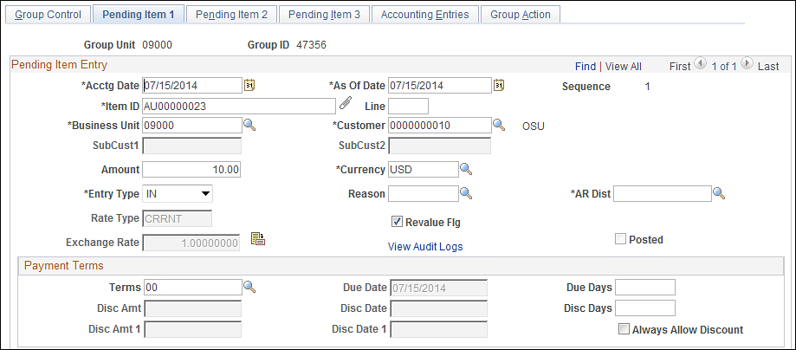
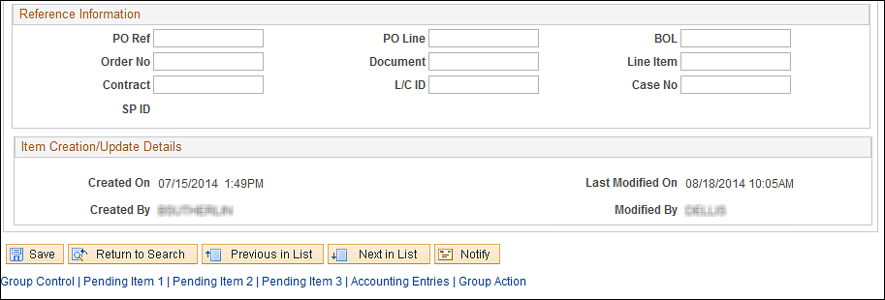

The Pending Item 1 page displays a row for each Item in the Group. Each row contains invoice details.

NOTE: Use the scroll arrows to view each Item row in the Group. The number of Item rows in the Group is also displayed in the Count field on the Group Control Tab.

Sequence – each Item row in the Group will be assigned a Sequence number.

Item ID – this field holds the Invoice number.

Posted – this checkbox indicates whether the Item has been posted to customer account.

Customer – the customer ID from the invoice.

Amount – this field displays the individual Item amount.

Entry Type/Reason – these values determine how Item accounting entries are created, how they are carried with the pending item through posting, and how they are considered when history is generated.

AR Dist - the distribution code defaults the ChartFields that are used when the system generates accounting entries. For External groups this value should be populated from the invoice in Billing.

Terms – displays the payment terms for the Item. These are derived through the default hierarchy for External Items.

Use Reference Information to add additional data elements to the Item that can be used as historical reference.

Click the Tab.

Alternatively, use the Pending Item 2 link at the bottom of the page.

Pending Item 2 Page

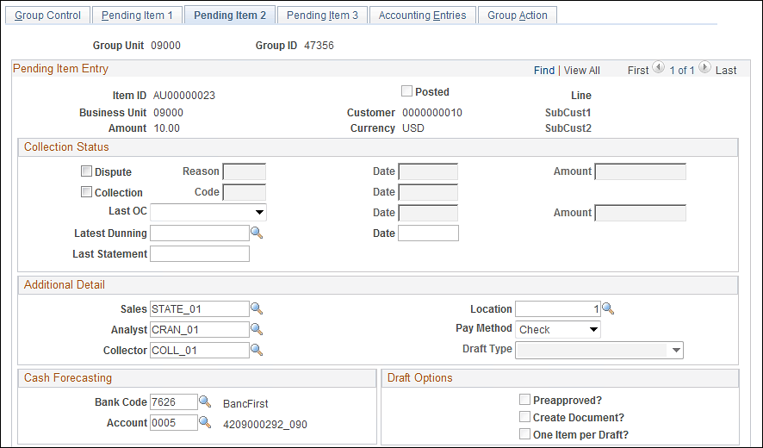
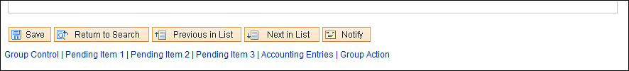

The Pending Item 2 page also displays a row for each Item in the Group with additional information.

Posted – indicates whether the Item has been posted to the customer account.

Use the Collection Status section of the page to record Item collection attributes.

The Cash Forecasting section of the page displays Bank information for the Item. This information will come from the default hierarchy for Billing Items.

The Additional Detail fields display defaults from the default hierarchy. Generally these values will come from the Customer Bill To Options for External Items.

Click the Tab.

Alternatively, use the Accounting Entries link at the bottom of the page.

Accounting Entries Page
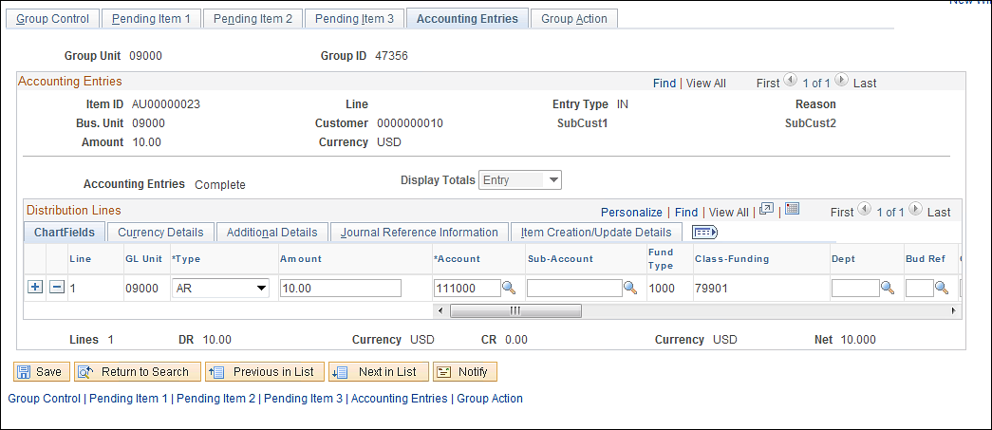

The Accounting Entries page displays an accounting entry row for each Item in the Group.

NOTE: Use the scroll arrows to view each Item accounting entry row in the Group.

Type – indicates the type of accounting entry (revenue, accounts receivable, etc.)

Amount – displays the amount of the accounting entry line.

Chartfields – the chartfield values displayed for the Item were populated on the Invoice for External Pending Items.

Click the Tab.

Alternatively, use the Group Action link at the bottom of the page.

Group Action Page

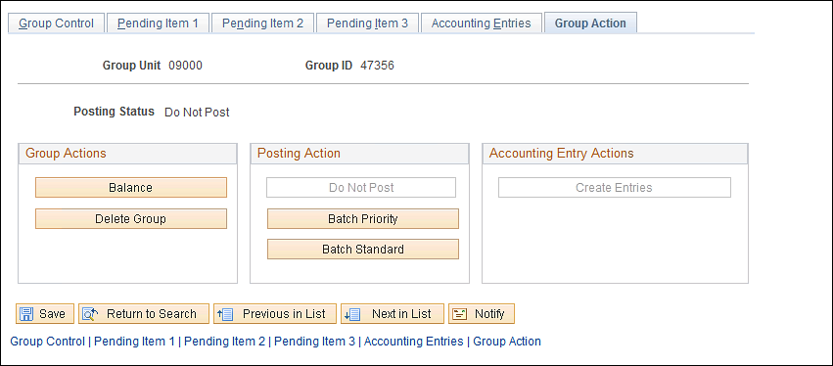

The Group Action page displays different actions that can be taken on the Group of Items. Some of these actions are set when the Group is External.

The Group Actions allow the user to balance the items and accounting entries in the Group:

Use to balance the Group. The system reviews the completed fields on the Group Control page to confirm that the control amount and count are equal to the entered amount and count. If the entered Pending Items match the group controls and you entered them online, the system checks that the accounting entries are balanced

The Posting Actions allow the user to set the Group to Post:

Use to save the Group but set it in a Non-Postable status.

Click to ensure the Group will be processed next time the Receivables Update process is executed.

Click to make the Group eligible to be picked up the next time Receivables Update is executed.

Use the Accounting Entries section of the page to create Accounting Entries for each Item in the group.

Click to ensure the Group is in Balance.

Click to set the Group to Post.

Click the Tab.

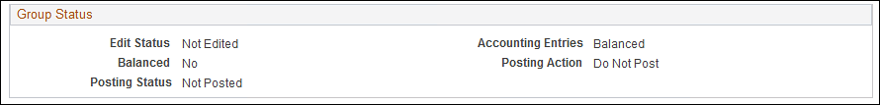

The Group should be Edited, Balanced, Not Posted (until Receivables Update has been run), Balanced and set to Post.

NOTE: Once the External Pending Item Group has been balanced, accounting entries complete and set to Post, the Group will be ready to be selected by the Receivables Update process and posted to the customers’ accounts(s).

Click to save any changes made to the Pending Item Group.

Online Pending Items

Receivables Items (invoices) can originate from within the Accounts Receivable system or from outside the module, as is the case with invoices from the Billing Module. Items created ad hoc within the Receivables module are called Online Pending Items. These Items will remain as Pending Items until they are processed by the Receivables Update process.

Online Pending Items are created by the User and therefore are populated manually. Online Pending Items could be useful when creating receivables items (invoices) on an ad hoc basis for walk-up customers or for cash that needs to be applied to an invoice without using the Billing module.

Enter Online Pending Items

Navigation: Accounts Receivable > Pending Items > Online Items > Group Entry > Add a New Value

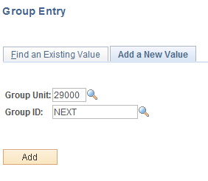

Group Unit – enter the agency business unit value.

Group ID – leave this value as ‘NEXT’ to have the system assign the next available Group ID number, or key the desired Group ID.

Click to enter the Group Entry pages.

Group Control Page

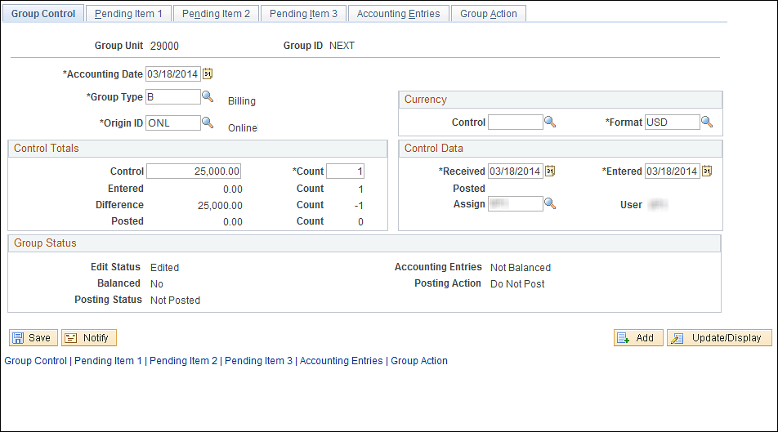

Use the Group Control page to enter the Online Pending Item Group information.

Accounting Date – this value is the date that the accounting entries for the Group will be posted to the General Ledger.

Group Type – this value represents the source of the Group.

Control – this amount represents the total amount of all Items in the Group.

Count – represents the total count of Items (invoices) in the Group.

The Group Status section of the page displays various status values for the Group:
Balanced – indicates whether or not the Group is balanced. The Online Group will initially be created as ‘No’.
Posting Status – indicates whether or not the Group has been posted to customer accounts thru the Receivables Update process. Once processed by Receivable Update the status will be ‘Complete’ or ‘Errors’.
Accounting Entries – indicates whether the Group Accounting Entries are in balance.
Posting Action – indicates what Posting Action the group is currently set to. The Group can be set to ‘Post Now’, ‘Do Not Post’, Batch Standard’ and ‘Batch Priority’.

Click the Tab.

Pending Item 1 Page

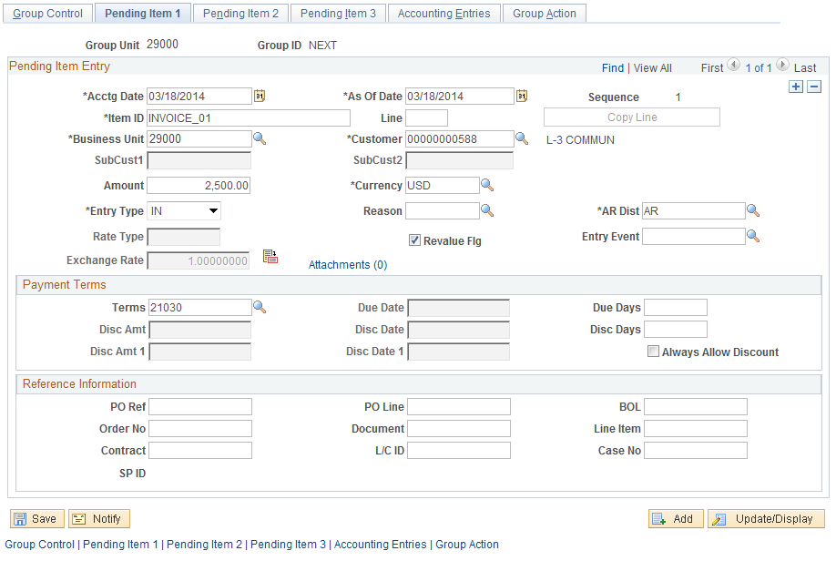

The Pending Item 1 page displays allows for Items to be entered into the Group individually. Each Item (invoice) will house its own separate properties within the Group.

NOTE: Use the button to add additional rows in the Group to accommodate multiple Items.

Sequence – each Item row in the Group will be assigned a Sequence number.

Item ID – enter the Invoice number for the item.

Customer – enter the customer ID for the invoice.

Amount – this field holds the individual Item amount.

Entry Type/Reason – these values determine how Item accounting entries are created, how they are carried with the pending item through posting, and how they are considered when history is generated.

AR Dist - enter the distribution code that governs the ChartFields that are used when the system generates accounting entries

Terms – displays the payment terms for the Item. These are derived through the default hierarchy for External Items.

Use Reference Information to add additional data elements to the Item that can be used as historical reference.

Click the Tab.

Pending Item 2 Page

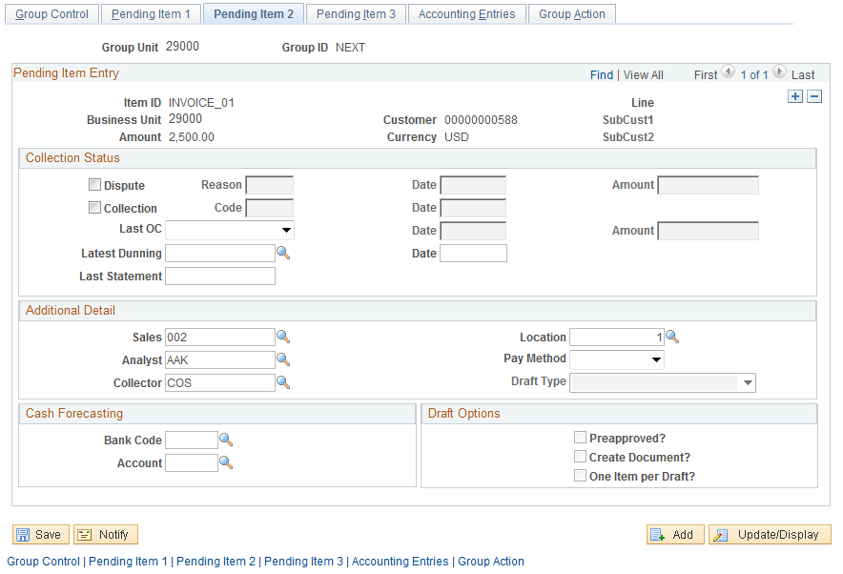

The page also displays a row for each Item in the Group allowing additional information to be captured.

Use the Collection Status section of the page to record Item collection attributes.

The Additional Detail fields display defaults from the receivables default hierarchy. Generally these values will come from the Customer Bill To Options for Online Items.

Click the Tab.

Accounting Entries Page

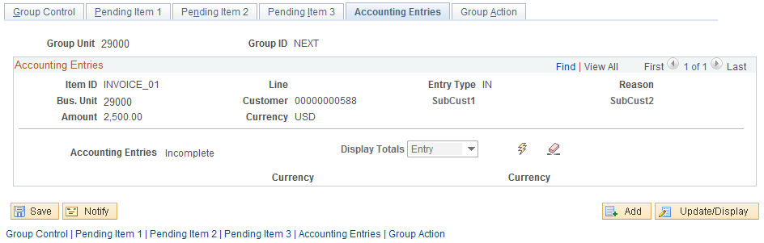

Use the Accounting Entries page to create accounting entries for the Items. The page initially is displayed without entry lines.

The accounting entry status will display Incomplete initially.

Click the button to have the system create accounting entries for each Item in the Group.

Accounting Entries page continued

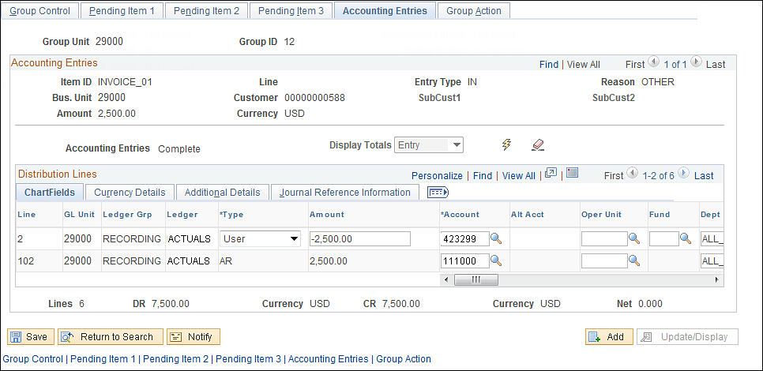

Once the Create accounting entries icon has been selected, both sides of the entry should be visible.

Amount – the amount values for the entry should default from the Item amount defined by the user.

Chartfields – populate both sides of the entry with the desired chartfield values.

NOTE: Use the Delete icon to Delete Item accounting entry and start over.

NOTE: The accounting entry status should be set to ‘Complete’.

Group Action Page

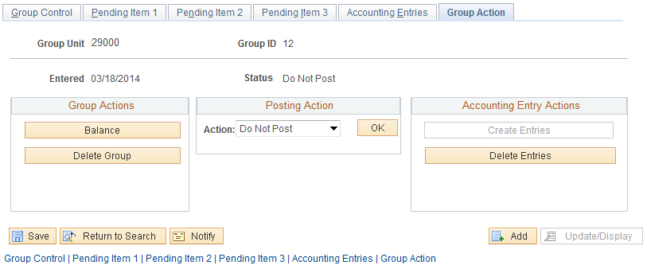

The Group Action page displays different actions that can be taken on the Group of Items.

The Group Actions section allows the user to balance the items and accounting entries in the Group:

Use to balance the Group. The system reviews the completed fields on the Group Control page to confirm that the control amount and count are equal to the entered amount and count. If the entered Pending Items match the group controls and you entered them online, the system checks that the accounting entries are balanced.

The Posting Actions allow the user to set the Group to Post:

Use the Do Not Post designation to save the Group but set it in a Non-Postable status.

Click 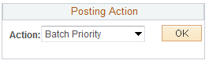 to ensure the Group will be processed next time the Receivables Update process is executed.

Use the Accounting Entries section of the page to create Accounting Entries for each Item in the group.

Click to ensure the Group is in Balance.

Click to set the Group to Post.

Click the Group Control Tab.

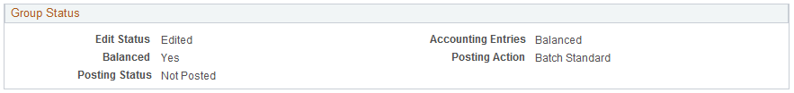

The Group should be Edited, Balanced, Not Posted (until Receivables Update has been run), Balanced and set to Post.

NOTE: Once the Online Pending Item Group has been balanced, accounting entries complete and set to Post, the Group will be ready to be selected by the Receivables Update process and posted to the customer’s accounts(s).

Click to save the Pending Item Group.

Correcting Pending Items

When Pending Items are entered online, the system validates the data and displays an Error message if the data fails one or more system edits. These types of edits ensure that all required fields are populated and values provided by the user are valid.

The Receivables Update process also edits Pending Item data and flags the Item errors when found. This is common for External Pending Items that are interfaced into Accounts Receivable and often edited initially in the Receivables Update process.

Pending Items Groups can be searched for by Error status and updated to correct errors. Once the errors have been corrected, run the Receivables Update process to validate that the error corrections were valid.

Review and Correct Pending Items Using Entry Pages

Navigation: Accounts Receivable > Pending Items > External Items > Group Entry > Find an Existing Value

OR

Navigation: Accounts Receivable > Pending Items > Online Items > Group Entry > Find an Existing Value

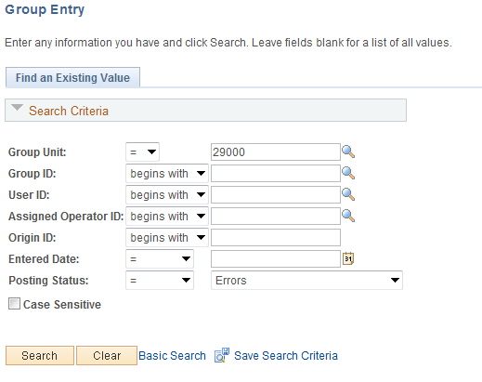

Use the Search criteria to find the desired Pending Item Group that is in Error Status.

Group Unit – populate with the agency business unit number.

Group ID – if the Pending Item Group ID in error known, search by that value.

User ID – populate with the User ID that created the Group.

Posting Status – to correct Pending Item Groups in error, set this field to ‘Errors’.

Click to find the Pending Item Group to correct.

NOTE: Pending Item Errors can be different in nature. The User will need to search for the Pending Item Group in error, review Pending Item 1 page for the error message, then take appropriate action.

NOTE: The Item Error illustrated in this example is a “Combination Edit’ error for incorrect chartfield values on the Item accounting entry.

Pending Item 1 Page

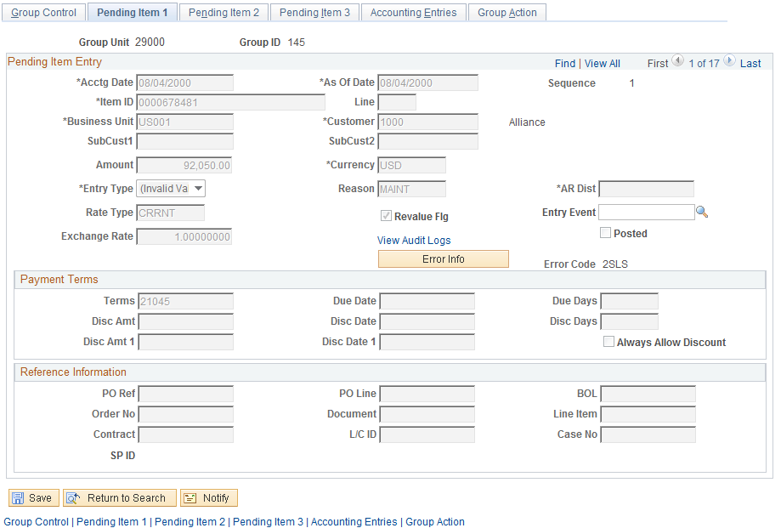

The Pending Item 1 page will display an ‘Error Info’ button and an ‘Error Code’. Use this information to review the error and take corrective action.

Error Code – displays a code associated with the Item Error.

Click to view the Item error detailed message.

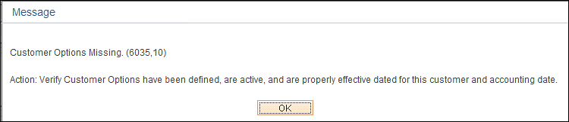

Review the Error Message provided for the Item error. This message will provide details needed to take action on the Item error.

NOTE: For an Item Error related to Combination Edits, as in this example, navigate to the Accounting Entries page to take corrective action.

Click to close the error message and take corrective action.

Click the Tab.

Accounting Entries page

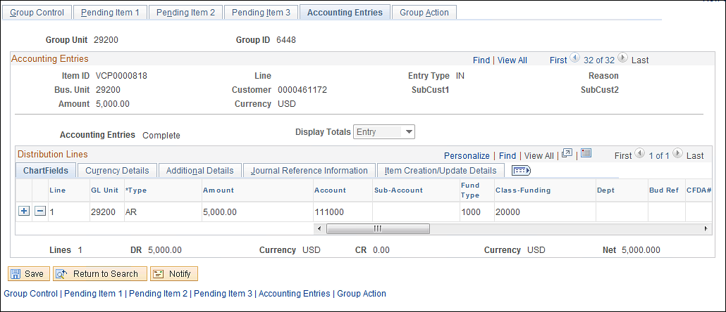

Take corrective action on the Item Error.

Click to save any changes made to the Pending Item Group.

Correcting Pending Items Using Posting Error Pages

Navigation: Accounts Receivable > Receivables Update > Correct Posting Errors > External Items > Find an Existing Value

OR

Navigation: Accounts Receivable > Receivables Updatg > Correct Posting Errors > Online Items > Find an Existing Value

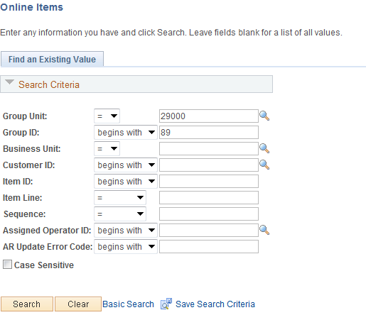

Use the Search criteria to find the desired Pending Item Group that has Posting Errors.

Group Unit – populate with the agency business unit number.

Group ID – if the Pending Item Group ID in error known, search by that value.

Business Unit – populate with the agency business unit number (this value is required).

Click to find the Pending Item Group with Posting Errors.

NOTE: Only Pending Items with Posting Errors will be displayed in this search.

Pending Item 1 Page

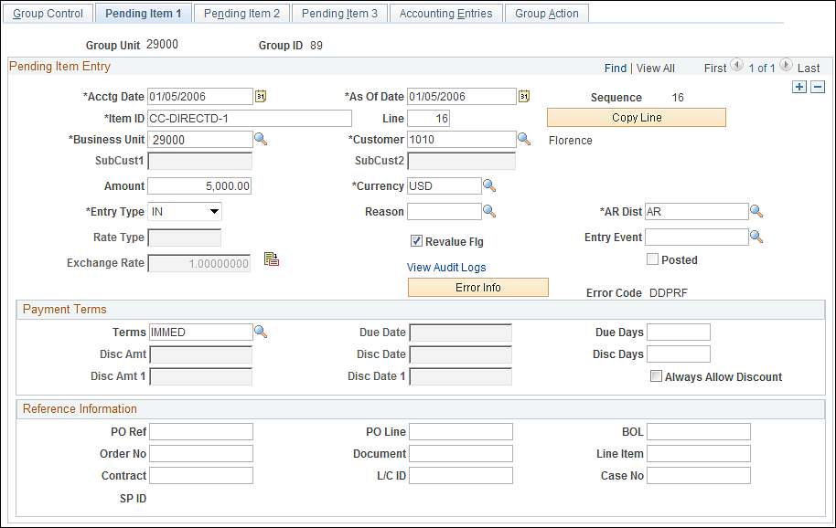

The Pending Item 1 page will display an ‘Error Info’ button and an ‘Error Code’. Use this information to review the error and take corrective action.

NOTE: Although the Pending Item Group may have multiple Items, only those Items with Posting Errors will be displayed in this component.

Error Code – displays a code associated with the Item Error.

Click to view the Item error detailed message.

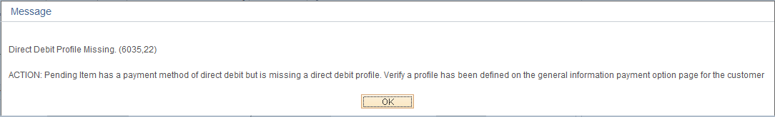

Review the Error Message provided for the Item error. This message will provide details needed to take action on the Item error.

NOTE: For an Item Error related to Combination Edits, as in this example, navigate to the Accounting Entries page to take corrective action.

Click to close the error message and take corrective action.

Click the Tab.

Pending Item 2 page

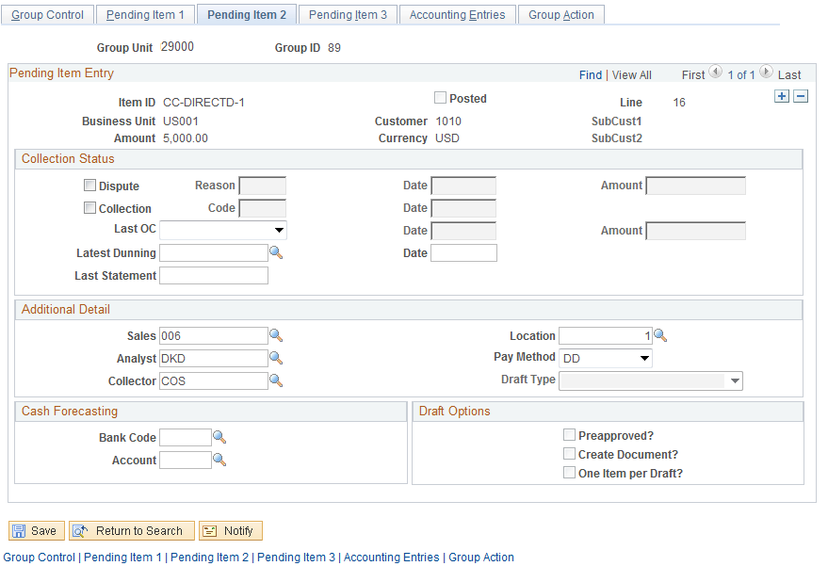

Take corrective action on the Item Error.

Click to save any corrective changes made to the Pending Item.

Item Inquiry and Review

Once Pending Items have been created (or interfaced), balanced, set to post and posted to customer accounts, they can only be seen thru the Item Review pages. Use these pages to review or research historical Item information.

Review All Items by Group

Navigation: Accounts Receivable>Pending Items>Review Items>All Items>Find an Existing Value

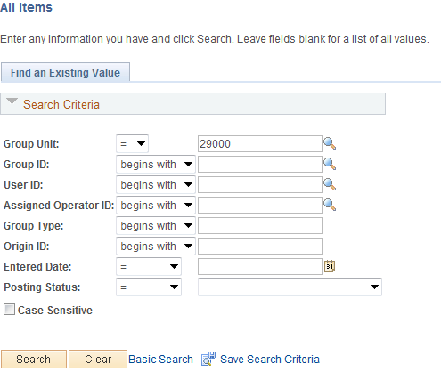

Use the Search criteria to find the desired External Pending Item Group.

Group Unit – populate with the agency business unit number.

Group ID –search by that Group ID if known.

User ID – populate with the User ID that created the Group.

Posting Status – search for Items by the Group status.

Click to find Pending Items matching the search criteria.

Select the desired Pending Item Group to review.

Group Control Page

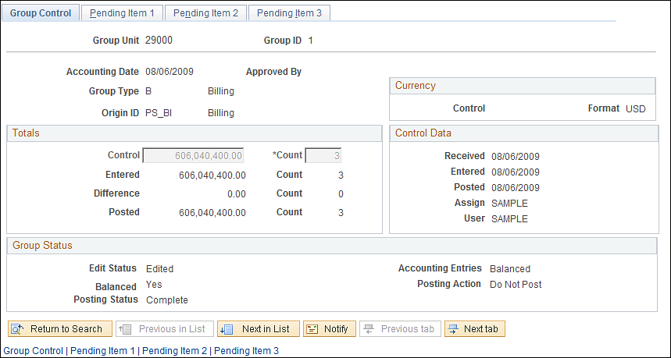

Use the Group Control page to review the Item Group information.

Accounting Date – this value is the date that the accounting entries for the Group were, or will be posted, to the General Ledger.

Group Type – this value represents the source of the Group.

Control – this amount represents the total amount of all Items in the Group.

Count – represents the total count of Items (invoices) in the Group.

The Group Status section of the page displays various status values for the Group:
Balanced – indicates whether or not the Group is balanced.
Posting Status – indicates whether or not the Group has been posted to customer account through the Receivables Update process. Once processed by Receivable Update the status will be ‘Complete’ or ‘Errors’.
Accounting Entries – indicates whether the Group Accounting Entries are in balance.
Posting Action – indicates what Posting Action the group is currently set to. The Group can be set to ‘Post Now’, ‘Do Not Post’, Batch Standard’ and ‘Batch Priority’.

Click the Tab.

Alternatively, use the Pending Item 1 link at the bottom of the page.

Pending Item 1 Page

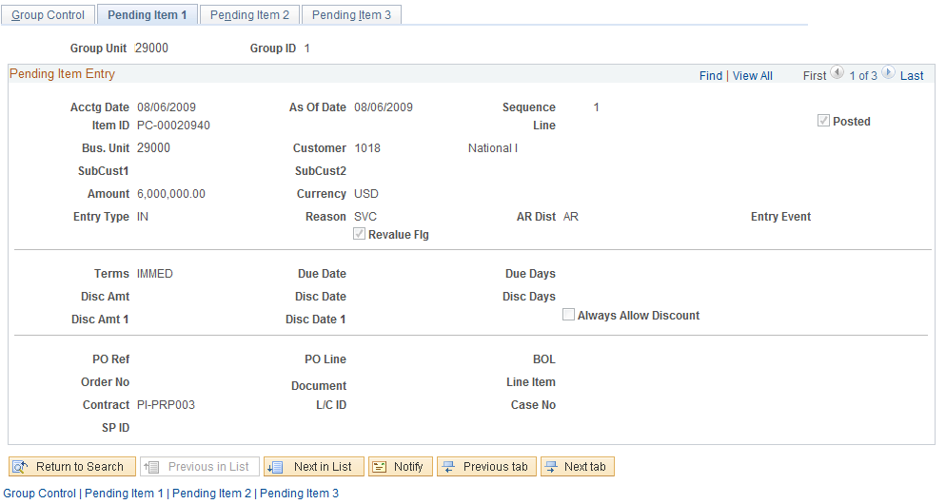

The Pending Item 1 page displays a row for each Item in the Group. Each row contains invoice details for review.

NOTE: Use the scroll arrows to view each Item row in the Group. The number of Item rows in the Group is also displayed in the Count field on the Group Control Tab.

Sequence – each Item row in the Group will be assigned a Sequence number.

Item ID – this field holds the Invoice number for the item.

Posted – this checkbox indicates whether the Item has been posted to customer account.

Customer – the customer ID from the invoice.

Amount – this field displays the individual Item amount.

Entry Type/Reason – these values determine how Item accounting entries are created, how they are carried with the pending item through posting, and how they are considered when history is generated.

AR Dist - the distribution code defaults the ChartFields that are used when the system generates accounting entries. For External groups this value should be populated from the invoice in Billing.

Terms – displays the payment terms for the Item. These are derived through the default hierarchy for External Items.

Use Reference Information to add additional data elements to the Item that can be used as historical reference.

Click the Tab.

Alternatively use the Pending Item 2 link at the bottom of the page.

Pending Item 2 Page
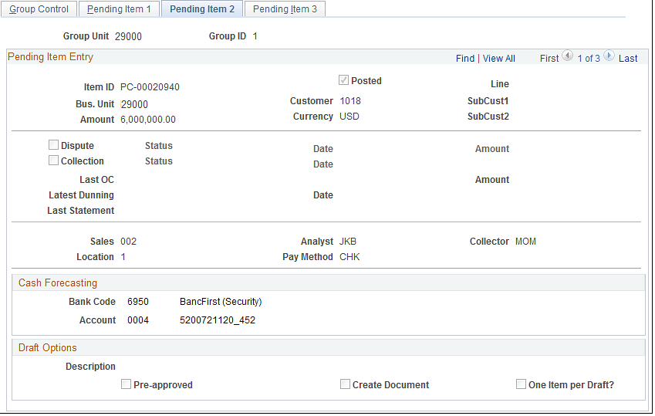

Use the Pending Item 2 page to review dispute, collection, bank and customer default values for each Item.

NOTE: Use the scroll arrows to view each Item row in the Group if necessary.

Review Item Groups Not Set To Post

Navigation: Accounts Receivable > Pending Items > Review Items > Groups Not Set To Post

Groups Not Set To Post Page

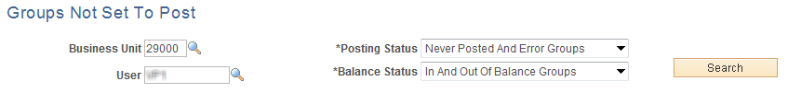

Use the Groups Not Set To Post page to find Pending Item Groups that are not yet set to ‘Post’. These Groups could be in Error status, not Balanced or simply not yet flagged to Post. Use this feature to find Pending Item Groups and take action allowing the group to be posted to a Customer Account.

Business Unit – populate with the agency business unit value.

User – search for Groups by User ID who created the Group.

Posting Status – select from the valid options of “Error Only” or “Error and Never Posted”

Balance Status – select from Groups that are “In Balance”, “Not in Balance” or both.

Click to retrieve Item Groups matching the search criteria.

Groups Not Set To Post page continued

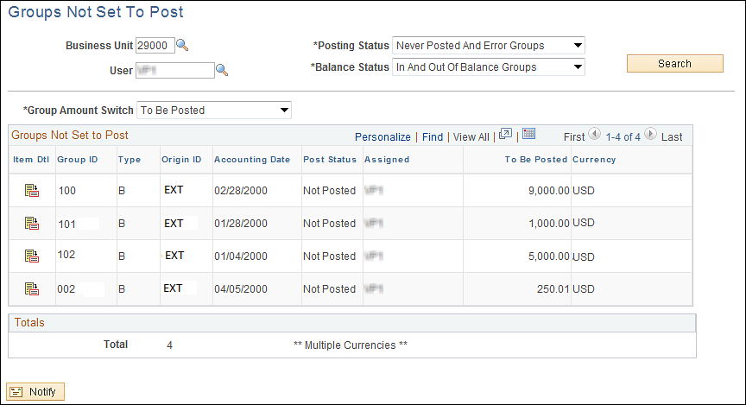

The search results show all Groups not set to Post that match the search fields.

Group ID – displays the group(s).

Post Status – indicates the Posting status of the Group indicating whether the Group is in Error, Not Set to Post, etc.

Use the icon to drill to the Item Group to take action.

Review Billings by Unit

Navigation: Accounts Receivable > Pending Items > Review Items > Billings by Unit

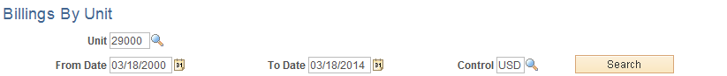

Use the Billings By Unit page to find Pending Item Groups by Billing Business Unit. These Groups could be in Error status, Posted status or Not Posted status.

Business Unit – populate with the agency business unit value.

From/To Date – populate a period of time from which Pending Items will be selected.

Control – populate with ‘USD’

Click to retrieve Item Groups matching the search criteria.
Billings By Unit page continued

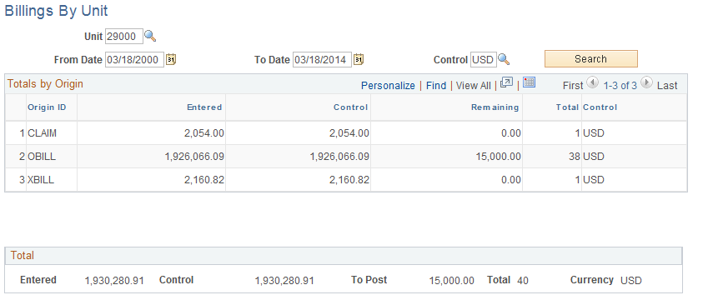

The search results show all Pending Item Groups matching the search criteria.

Origin ID – displays the bill origin value.

Entered – the amount of the Pending Item Group.

Use the Total section of the page to view totals for all Pending Item Groups in the search.

Pending Item Reports

A series of delivered reports for Pending Items are available. These reports can be used to produce a listing of Pending Items for agency research or historical purposes.

Item Detail Report

Navigation: Accounts Receivable > Pending Items > Reports > Item Detail > Find an Existing Value

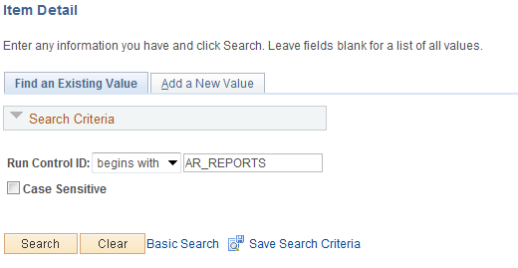

Use an Existing Run Control value or create a New Value.

Click to use an existing Run Control value.

Item Detail Page

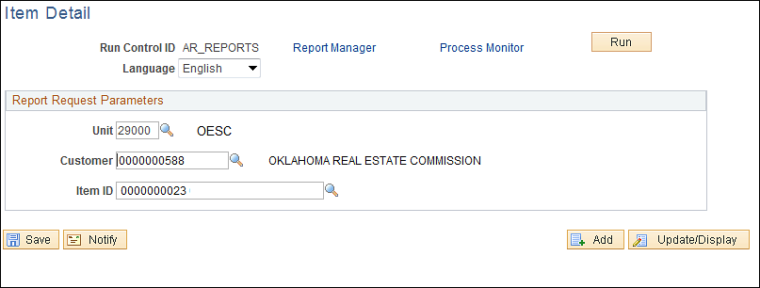

Use the Item Detail report to show information about a particular Item in the system.

Unit – select the business unit in which the Item exists.

Item ID – select the Item ID.

Click to execute the Item Detail report.

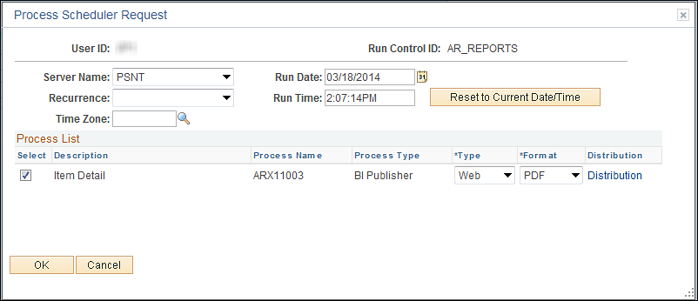

Select the checkbox next to the desired report (ARX110003).

Click to execute the report. Navigate to the Process Monitor to view the Process instance and retrieve the Report.

Item Accounting Entries Report

Navigation: Accounts Receivable > Pending Items > Reports > Accounting Entries > Find an Existing Value

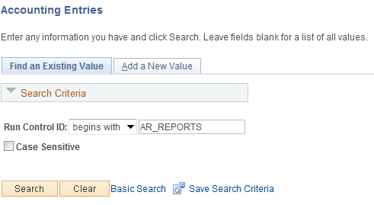

Use an Existing Run Control value or create a New Value.

Click to use an existing Run Control value.

Accounting Entries Page
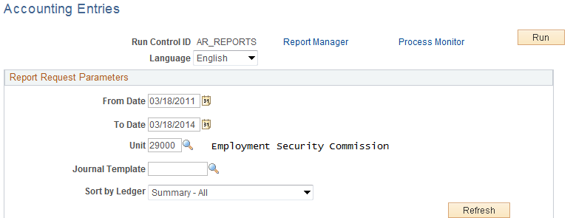

Use the Accounting Entry report to display accounting entries for Items within a give business unit and date range.

From/To Dates – select a period of time from which to retrieve accounting entries.

Unit – populate with the agency business unit value.

Journal Template – optionally, provide the Journal Template used by the accounting entries.

Sort by Ledger – determine if the report will be summarized or contain detail.

Click to list the chartfield values that can be listed on the report.

Accounting Entries page continued

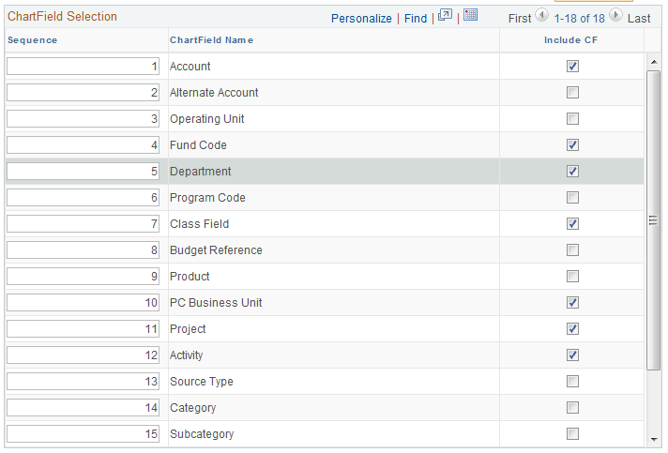

Sequence – determine in what column sequence the chartfields selected will appear on the report.

Include CF – select this checkbox next to the chartfield to display that value on the report.

NOTE: For example, to view accounting entries by account, class fund and budget ref, select only those chartfield values.

Click to execute the Item Accounting Entries report.

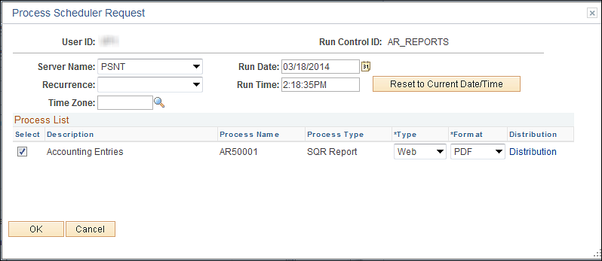

Select the checkbox next to the desired report (AR5001).

Click to execute the report. Navigate to the Process Monitor to view the Process instance and retrieve the Report.

