COR403 Accounts Receivable -
Receivables Deposits Manual

The content of this training manual is based largely on a generic system configuration and illustrates the base-line functionality required to execute transactions in the module. Your agency may be utilizing more or less of the functionality illustrated in this manual. This manual is intended to be a framework upon which agencies can add agency-specific training content that speaks specifically to the system functionality that they have deployed and related configuration that they use for transaction processing. Agencies should not depend on these manuals for end-user training or problem resolution until they have been reviewed by the agency for appropriateness.

Authorized by: [EBS_] Original Issue: [05/01/2014]
Maintained by: [Accounts Receivable Lead___]
Review Date: [05/01/2014]

Table of Contents
Document History 4
Receivables Deposits 5
Key Terms 6
Account Receivable Business Unit 6
Billing Business Unit 6
Customer 6
Customer ID 6
Bill (Invoice) 6
Distribution Code 6
Pending Item 6
Maintenance Worksheet 6
Payment 6
Deposit 7
Payment Worksheet 7
Process Flows 8
Guidelines, Concepts and Alternatives 9
Regular Receivables Deposits 10
Enter a Regular Deposit 10
Totals Page 11
Payments Page 13
Express Receivables Deposits 15
Enter an Express Deposit 15
Totals Page 16
Payments Page 18
Action Page 20
Create a Payment Worksheet 22
Create a Payment Worksheet 22
Worksheet Action Page 24
Worksheet Application Page 26
Worksheet Application Detail View Page 27
Worksheet Action Page 29
Managing Payment Posting 30
Unpost a Payment 30
Payment Control Page 31
Options Page 32
Action Page 33
Item Activity From a Payment 34
Item Activity From A Payment Page 35

Document History

Document Revision | Date | Description
1.0  2.0 | 04/15/2010  05/01/2014 | Initial Document  Upgrade Update

Receivables Deposits

Receivable Deposits are customer payments that will be applied to open receivables (invoices) in the system. These Deposits differ from Cash Deposits (Direct Journal Deposits) in that cash deposits are not applied to open receivables.

Receivables Deposits are entered into the system similarly to Cash Deposits but can contain additional data elements used to apply the payment to the invoice.

Receivables Deposits are entered as Regular or Express Deposits. These deposit payments will be approved and cash applied to open Items through a Payment Worksheet. Payment Worksheets allow the user to view all open Items and apply payments to Items as necessary.

Key Terms
Account Receivable Business Unit: Each agency has one, and only one Billing Business Unit. The Business Unit is the 3 digit agency code, plus 00. For example, Office of State Finance is 09000.

Billing Business Unit: Each agency has one, and only one, Billing Business Unit. The Business Unit is the 3 digit agency code, plus 00. For example, Office of State Finance is 09000.

Customer: A customer is an external entity that is defined in a Contract to receive invoices and from which revenue is recognized. Customers can be individuals, businesses or federal grantors.

Customer ID: Customer ID is a unique identifier for Customers within the system. Customer ID’s can be assigned by the system or keyed manually by a user. Each agency will have unique list of Customer ID’s with which they do business (generate revenue).

Bill (Invoice): The transaction containing invoice information for a Customer (bill header, bill lines, amounts, due dates, etc.). Bills are created then ‘Finalized’ in the Billing Module to become a completed Invoice to which customer cash can be applied. The term Bill and Invoice can be used interchangeably.

Distribution Code: Distribution codes simplify the process of generating accounting entries by defining a valid combination of Chartfield values that are used as defaults on other pages. Distribution Codes can be defined for Revenue or Accounts Receivable.

Pending Item: Pending Items are Customer Receivables that have been created in the system but are not yet Posted to the Customer Account. Pending Items can come from outside of Accounts Receivable, like invoices from Billing or they can be created in Accounts Receivable.

Maintenance Worksheet: A worksheet that allows receivables items to be written-off, adjusted or offset. In a worksheet Items are retrieve and desired action taken to reflect item activity

Payment: Payments received from customers are recorded in the system with related data elements including Payment ID, Amount and Payment Type.

Deposit: A Deposit represents a customer Payment or group of Payments that are batched together for posting. Deposits contain banking information, control totals, processing dates and all related Payment information

Payment Worksheet: Functions to apply Payments entered into the system thru Deposits, to open Items in the system. This is the cash application tool used to match payments with invoices.

Process Flows

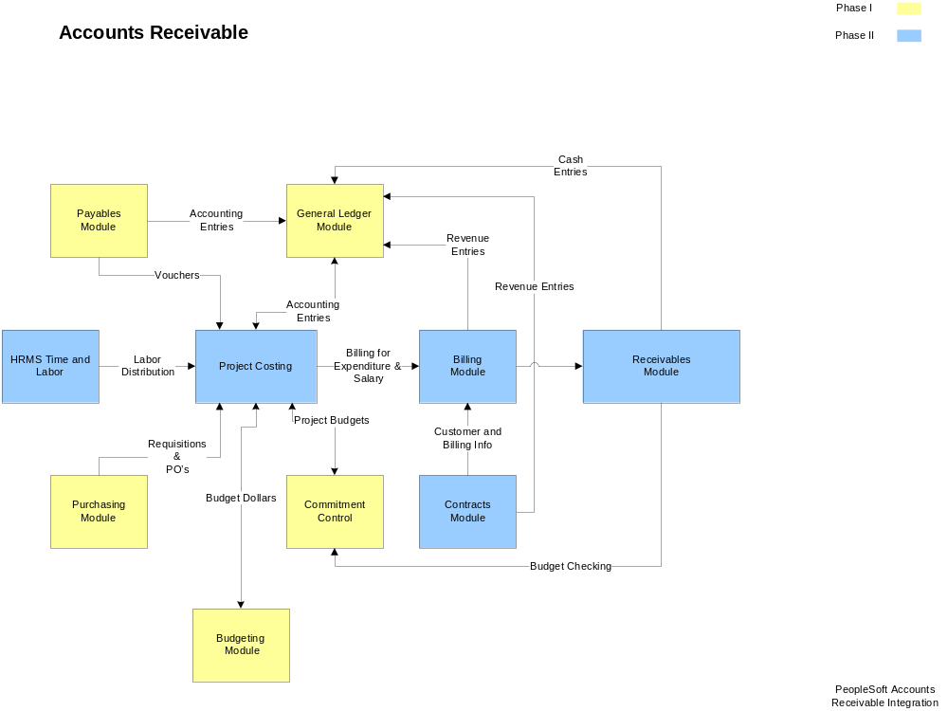

Diagram 1: Accounts Receivable Module Integration

Guidelines, Concepts and Alternatives
PeopleSoft Billing uses extensive defaults to automatically populate bill information. Since Accounts Receivable uses finalized bills extensively in processing, this hierarchy also impacts the Receivables module.

During online Bill entry, as certain fields are populated, the system automatically populates other fields on the Bill Header based on the defaults that are configured by the agency. Automatic field population also occurs during the Billing Interface process (BIIF0001) when a field that has possible default information is left blank.

For example, an agency may extend different ‘Payment Terms’ to customers based on the ‘Type’ of invoice that is being generated. If Payment Terms are defined by Bill Type, then each time a Bill Type is selected onto an invoice the corresponding Payment Terms are defaulted to the Bill Header.

Since Accounts Receivable uses Customers extensively, the Billing default hierarchy impacts processing in Receivables as well. Within the default hierarchy values defined at the Lower-level of the diagram below “Override” values at a Higher-level in the hierarchy. For example, Payment Terms defined for the Customer would override Payment Terms defined for the Bill Type. When creating invoice on-line the system will search for the lowest level value in the hierarchy to populate a particular default field.

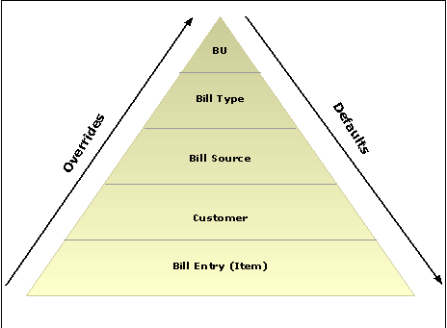

Diagram 3: Billing Default Hierarchy

Regular Receivables Deposits
The Regular Deposit feature allows users to create Deposits with multiple payments and provide payment information used to apply the payments to open items in the system. Alternatively, Regular Deposits allow use of the Direct Journal feature to handle payments as miscelaneous receipts that will not be applied to items.

Deposits are entered into the system by Deposit Unit and Deposit ID. Deposit unit will default to the Agency Business Unit value. Deposit ID will be defaulted by the system using an auto-numbering format with an agency business unit mask

Enter a Regular Deposit

Navigation: Accounts Receivable > Payments > Online Payments > Regular Deposit > Add a
New Value

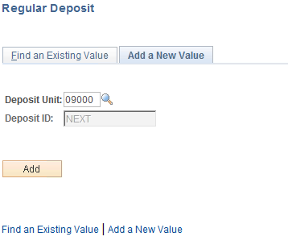

Deposit Unit – is the Agency Business Unit depositing the funds. The Business Unit will default based on User Preferences.

Deposit ID – defaults to NEXT. The sytem will use autonumbering to assign the next available Depost ID number. The number will start with the 3-digit agency number.

Click to enter the Regular Deposit pages.

Totals Page

NOTE: The Deposit ID will change from “NEXT” to a number when the Deposit is saved. Each Deposit ID will begin with the Agency number.

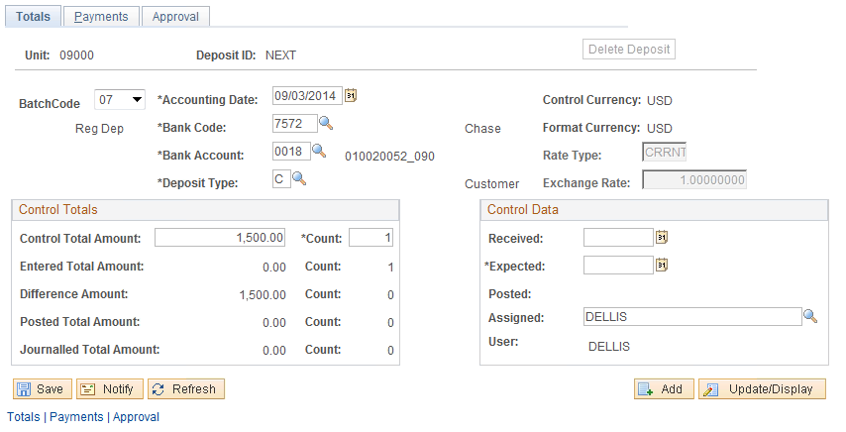

The Deposit Totals page contains Batch, Bank, Accounting, User and Control Total information. The Deposit Totals page functions as the control mechanism for all deposits entered on the Payments page. The Bank information populated on the Deposit Totals page will apply to all payments recorded on the subsequent Payment page and Control Totals must match the sum of all payments entered for the Deposit.

Batch Code – this field is the OST Deposit Batch Code. The value will default to 99, but can be changed by the user. Available values will be controlled by user security based on the type of deposit the user is authorized to create.
Agency Users can select the following Batch Codes:
07 – Fed Wires and ACH Transactions deposited to Clearing and ASA Accounts
61 – Fed Wires and ACH Transactions deposited to Agency Funds
99 – Deposits to Financial Institutions

Accounting Date – defaults to today’s date. The value should not be changed.

Bank Code – Bank Code indicates which bank facility will be used for the deposit. For Batch Code ’07 and ‘61’the value will default based on the Deposit Unit (agency) when the Batch Code is selected by the user. For Batch Code ‘99’the user must select the Bank Code. The available values for Bank Code selection will be limited by Deposit Unit.

Bank Account – The Bank Account identifies the account within the banking facility that the deposit will be directed to. The value will default based on the Deposit Unit (agency) and Bank Code. The available values for Bank Account selection will be limited by the Deposit Unit and Bank Code and should not be changed.

Deposit Type –this field defaults from the Bank configuration. Deposit Types are used to categorize different types of deposits within the system.

Control Currency –defaults to USD and should not be changed.

Format Currency - defaults to USD and should not be changed.

Rate Type – defaults to CRRNT

Exchange Rate – defaults to 1.0000000

Control Total Amount – this field should reflect the total for all payments received in the Deposit. The value in this field will be edited against the sum of all payments to ensure the control total is correct.

Count – this field should hold the total number of payments in this Deposit.

Entered Total Amount/Count – these fields reflect the total amount of payments and payment counts entered by the user.

Difference Amount/Count – these fields reflect any discrepancy between the Total Amount/Count defined by the user and the sum of payments and payments count entered on the Payments page.

Posted Total Amount/Count – this field reflects Deposits posted to accounts.

Journal Total Amount/Count – this field reflects any Direct Journal activity.

Received Date – for Batch Code 99 the field will default in as current.

Expected Date – for Batch Code 99 the field will default in as current date and should not be changed.

Funds Available Date – must be populated for Batch Codes ‘07’ and ‘61’.

Assigned – by default this field holds the User ID of the person creating the deposit.

Payments Page

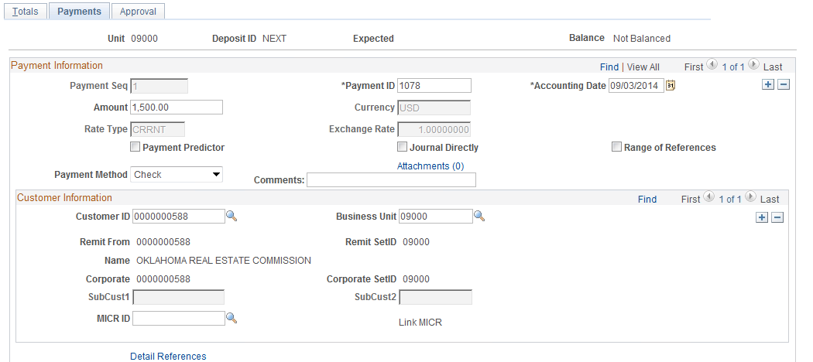
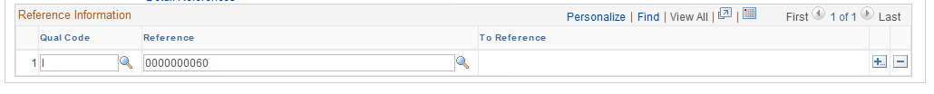

The Deposit Payments page contains details for each payment in the deposit. This includes payment type or method, payment ID, amount, etc. The Reference Information identifies the Item that the payment will be applied to. This functionality is related to Accounts Receivable balances and should not be used by agencies which have not implemented that module

Payment ID – populate this field with the Payment ID for the payment received. For example, if the payment method was check, this field would hold the check number.

Accounting Date – defaults to today’s date. This value should not be changed.

Amount – enter the amount of this payment.

Journal Directly – select this checkbox if the payment will be journalled directly. This feature will be used to make miscellaneous deposits that are not applied to an open item or invoice.

NOTE: For Receivables Deposits (this example) this checkbox will NOT be selected.

Payment Method – select the method of payment from the available values.

Comments – use the Comments field to record any applicable comments for this payment. The Comment field can hold up to 30 characters in length.

Customer – if the payment will be applied to a customer item, populate this field with the Customer ID.

Business Unit – for payments applied to a Customer, populate the Business Unit (agency) value.

Reference Information – use additional Reference Information to tie this payment to an item.
Qual Code – for payments to be applied to open items, the user can optionally define the type of document – Reference Qualifier Code – that can be used for cash application.
Reference – for the Reference Qualifier Code defined above, provide the reference identification number. For example, if the Reference Qualifier Code is Item, provide the Item ID.

NOTE: Use the icon to insert additional rows for multiple payments in the Deposit.

When all payments have been entered for this Deposit, click the icon to save the Deposit.

NOTE: The Balance message in the top right hand corner of the Deposit entry pages indicates whether the Deposit is in “Balance” or “Not Balanced”. Once the Deposit is saved, corrections to balance the deposit should be made in the Regular Deposit Balancing pages.

Express Receivables Deposits
Express Deposit features can be used to record a payment and apply the payment to an Item simultanously. You must know the Item ID to apply the payment using Express Deposit functionality.

If you know the Customer ID, Amount, Reference Criteria or Business Unit only, the Worksheet features must be used to apply the payment to an item.

Express Deposits are entered into the system by Deposit Unit and Deposit ID. Deposit unit will default to the Agency Business Unit value. Deposit ID will be defaulted by the system using an autonumbering format with an agency business unit mask.

Enter an Express Deposit

Navigation: Accounts Receivable > Payments > Online Payments > Express Deposit > Add a
New Value

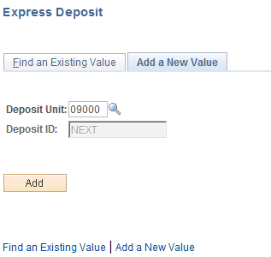

Deposit Unit – is the Agency Business Unit depositing the funds. The Business Unit will default based on User Preferences.

Deposit ID – defaults to NEXT. The sytem will use autonumbering to assign the next available Depost ID number. The number will start with the 3-digit agency number.

Click to enter the Express Deposit pages.

Totals Page

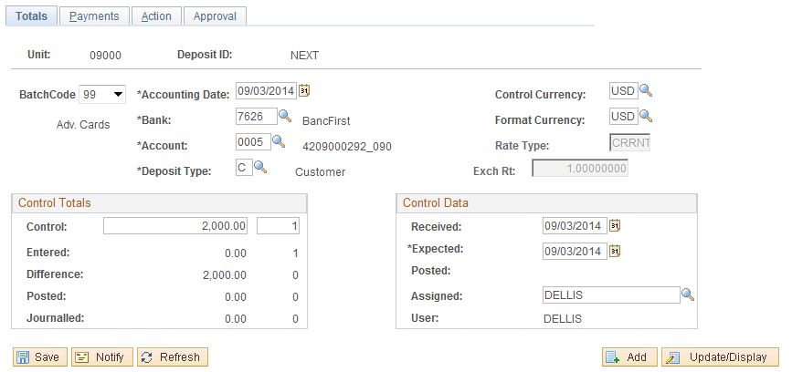

The Express Deposit Totals page is the same as the Regular Deposit Totals page. It contains Batch, Bank, Accounting, User and Control Total information. The Express Deposit Totals page functions as the control mechanism for all deposits entered on the Payments page. The Bank information populated on the Deposit Totals page will apply to all payments recorded on the subsequent Payment page and Control Totals must match the sum of all payments entered for the Deposit

Batch Code – this field is the OST Deposit Batch Code. The value will default to 99, but can be changed by the user. Available values will be controlled by user security based on the type of deposit the user is authorized to create.
Agency Users can select the following Batch Codes:
07 – Fed Wires and ACH Transactions deposited to Clearing and ASA Accounts
61 – Fed Wires and ACH Transactions deposited to Agency Funds
99 – Deposits to Financial Institutions

Accounting Date – defaults to today’s date. The value should not be changed.

Bank Code – Bank Code indicates which bank facility will be used for the deposit. For Batch Code ’07 and ‘61’the value will default based on the Deposit Unit (agency) when the Batch Code is selected by the user. For Batch Code ‘99’the user must select the Bank Code. The available values for Bank Code selection will be limited by Deposit Unit.

Bank Account – The Bank Account identifies the account within the banking facility that the deposit will be directed to. The value will default based on the Deposit Unit (agency) and Bank Code selected. The available values for Bank Account selection will be limited by the Deposit Unit and Bank Code.

Deposit Type –this field defaults from the Bank configuration. Deposit Types are used to categorize different types of deposits within the system.

Control Currency –defaults to USD and should not be changed.

Format Currency - defaults to USD and should not be changed.

Rate Type – defaults to CRRNT

Exchange Rate – defaults to 1.0000000

Control Total Amount – this field should reflect the total for all payments received in the Deposit. The value in this field will be edited against the sum of all payments to ensure the control total is correct.

Count – this field should hold the total number of payments in this Deposit.

Entered Total Amount/Count – these fields reflect the total amount of payments and payment counts entered by the user.

Difference Amount/Count – these fields reflect any discrepancy between the Total Amount/Count defined by the user and the sum of payments and payments count entered on the Payments page.

Posted Total Amount/Count – this field reflects Deposits posted to accounts.

Journal Total Amount/Count – this field reflects any Direct Journal activity.

Received Date – for Batch Code 99 the field will default in as current.

Expected Date – for Batch Code 99 the field will default in as current date and should not be changed.

Funds Available Date – must be populated for Batch 07 and 61 processing.

Assigned – by default this field holds the User ID of the person creating the deposit.

Payments Page

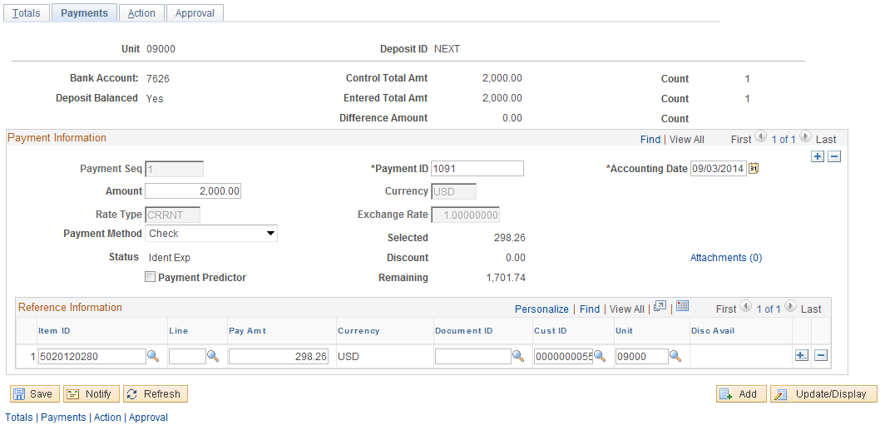

The Deposit Payments page contains details for each payment in the deposit. This includes payment type or method, payment ID, amount, etc. Optionally, customer ID and additional reference information can be included in the payment details.

Bank Account – reflects the value populated on the Totals page.

Deposit Balanced – reflects the Balance indicator for the Deposit. All payment collectively must match the Control Totals defined on the Totals page for the indicator to read ‘Yes’.

Control Total – Amounts and Counts from the Totals page are also displayed.

Payment ID – populate this field with the Payment ID for the payment received. For example, if the payment method was check, this field would hold the check number.

Acctg Date – defaults from the value populated on the Totals page. This value should not be changed.

Amount – enter the amount of this payment.

Payment Method – select the method of payment from the available values.

Selected – displays the total amount of the payment applied to an Item.

Item ID – enter the Item ID of the item you want this payment applied to. When you provide an item
ID, the system displays the item’s Pay Amt (payment amount). You can override this amount to create a partial payment. The system displays a value in the Customer ID or Unit fields unless an item ID references more than one item. If the system finds more than one item for the item and item line that you entered, it populates only the item ID.

NOTE: Item Information is optional on the Express Deposit feature. This information can be used to match Payments received by customers to open Items.

NOTE: When Item Information is populated on the Payment page it is NOT necessary to create a Payment Worksheet to apply the payment to the Open Item. The Receivables Update process will update the customer account automatically.

When all payments have been entered for this Deposit, click the icon to save the Deposit.

Action Page

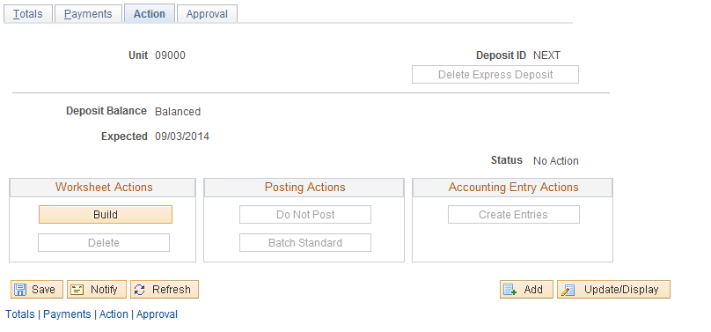

The Express Deposit Actions page allows the user to select a particular processing action for the Deposit. Available actions impact the Payment Worksheet (application), Deposit Posting and Accounting Entries.

Status – this field displays the posting action for the deposit. Values are No Action (deposit not ready to post) or Standard (deposit has been set to post). When the user enters the page initially the Status should be set to No Action.

Worksheet Actions:
Build – click the button to build a payment Worksheet so the payments can be applied to the Item ID’s defined in the Deposit. The system will create one Worksheet for each Item in the Deposit. Once the Worksheets have been built the payments can be posted to customer accounts.

NOTE: The Worksheets can only be built if Item ID information has been populated on the Payments page in the Reference Information section of the page.

Delete – click the button to Click to delete the payment group that was created without deleting the entire deposit. This would be used if you accidentally selected the wrong Worksheet Action and wanted to delete the worksheets, but retain the express deposit information that was entered. This button will only be active if Worksheets have been built.

NOTE: Click the Go to Worksheet hyperlink once the worksheets have been built to view them.

NOTE: The number of worksheets created will be displayed in the top right hand corner of the page in the Worksheets Created field.

NOTE: The Worksheet Build feature is optional on the Express Deposit. Payment Worksheets do not have to be built from this page, but rather can be created thru the Payment Worksheet component and used to apply payments subsequently.

Posting Actions
Do Not Post - Use this option to change the posting option for payments set to Standard if the payments have not been processed yet. This option is not active when first entering the page.
Batch Standard – click the button to make the Deposit eligible for posting next time the Receivables Update process is executed. Once the Worksheets are created, this button should be selected to enable the system to post payments to customer accounts and create corresponding accounting entries. The Status must be Standard.

Accounting Entries:
Create Accounting Entries – click the button to create accounting entries online for all applied payments in the deposit. The deposit must be in balance. Generally, you let the Receivable Update process create accounting entries. You only need to create accounting entries online when you must review them right away. Once the Worksheets have been created for the payments, this button is inactive.

NOTE: Use the button to delete the express deposit anytime before a Worksheet has been created. Afterwards this function is not available.

Create a Payment Worksheet
Payment Worksheets serve as the mechanism to apply Customer Deposits (payments) to Open Items (invoices). Since a worksheet is built upon existing Deposits in the system, the deposit must first be entered and saved before the worksheet can be created.

The worksheet allows the user to search for Open Items by various values (Customer ID, Item ID, etc.). Once Items have been retrieved, they can be selected in the worksheet to match the deposit with the Open Item.

Although Open Items are created or interfaced in the Accounts Receivable module by Group, the Payment Worksheet displays each Open Item individually by Item number. That allows the user to apply customer payments in whole or partially to an Item.

Create a Payment Worksheet

Navigation: Accounts Receivable > Payments > Apply Payments > Create Worksheet > Find an Existing Value

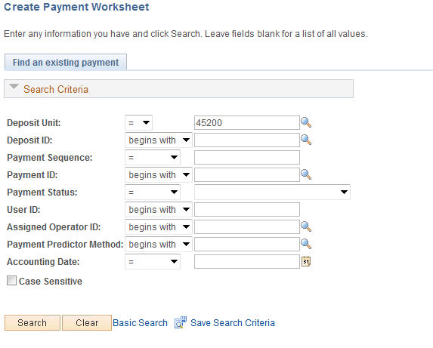
Use the Search criteria to find the Deposit that the payment worksheet will be built upon.

Deposit Unit – enter the agency business unit value.

Deposit ID – if known, search for a particular Deposit ID.

Payment ID – search by Payment ID within a particular Deposit ID. This could be check number, etc.

Payment Status – search for Deposits by the payment status.

NOTE: Deposits that have Reference information identified (Item ID, etc.) have a status of ‘Applied’. Deposits without Reference Information but contain Customer ID will be in a status of ‘Identified’.

Click to retrieve all Deposits that match the Search Criteria.

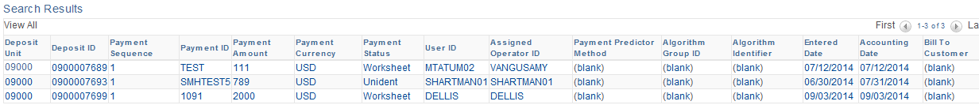

Select from the list the Deposit ID that the worksheet will be built with.

Worksheet Action Page

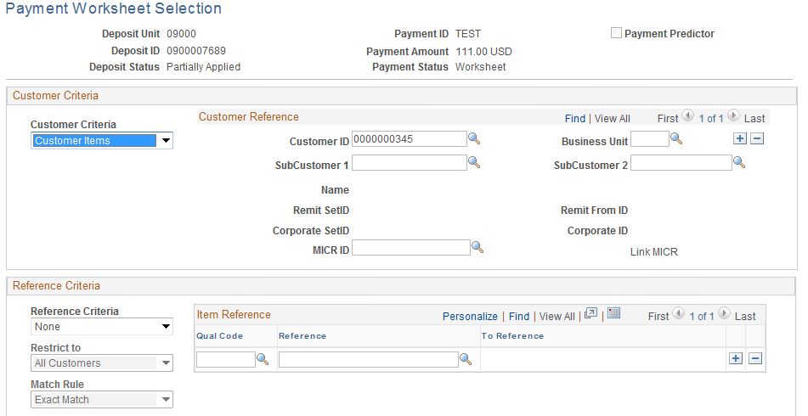
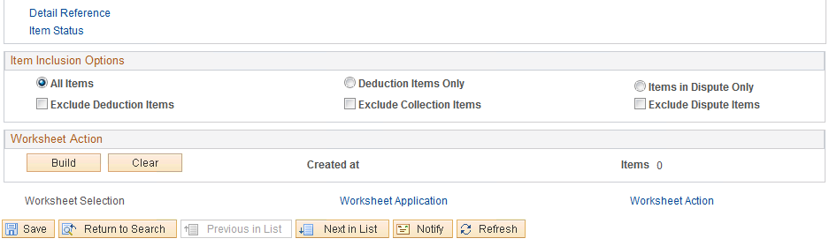

Use the Worksheet Selection page to identify which Open Items will be selected in the Worksheet for payment.

Customer Criteria - select the type of customer that you want to include in the worksheet. Generally, this value will be ‘Customer Items’.

NOTE: If the Customer is identified on the Deposit, Customer Items will be selected automatically when the user enters the page.

Customer ID – select the Customer ID that will be used to search for Items.

NOTE: If the Customer is identified on the Deposit, this field will be populated when the user enters the page.

Business Unit – enter the agency business unit value. Defining this value will restrict the Open Items retrieved to only those for a particular business unit.

Use the Reference Criteria section of the page to provide additional information used to identify Items for the worksheet:

NOTE: The Reference Criteria section of the page is optional and allows the user to provide additional data elements associated with desired Items that allows the system to search for and find Items more specifically.

Reference Criteria – select from the pre-defined values that indicate how Items will be searched for and added to the worksheet:
Reference Criteria – identify a specific value or range of values for the worksheet.
Restrict To – select a value to restrict the selection by customer.
Match Rule – select whether the system will use an ‘Exact Match’ or ‘Like Match’ when selecting Items. Like Match allows the user to use a wildcard (%) to search by partial information.
Reference Qualifier Code (Qual Code) – select from the pre-defined list of documents.
Reference – enter the specific Item reference value.

NOTE: Use the button to add additional reference values if necessary.

Use the Item Inclusion Options section to determine which types of Items will be included in the worksheet.

NOTE: Select ‘All Items’ to retrieve all Open Items meeting other criteria into the worksheet.

Click to create the Payment Worksheet based on the criteria provided.

Worksheet Application Page

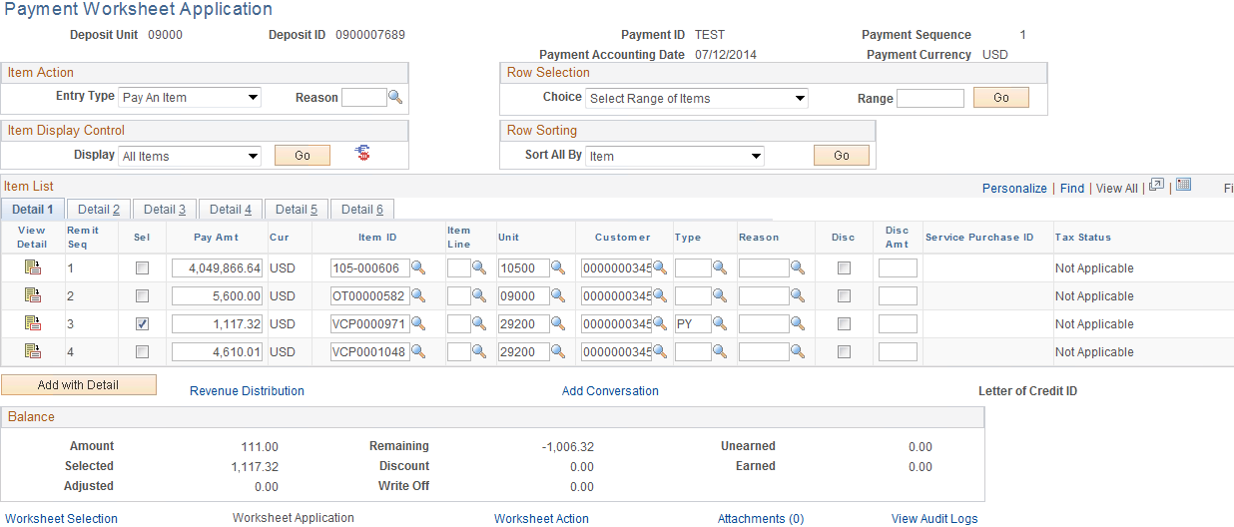

The Worksheet Application page displays all Items that match the Worksheet selection criteria provided by the user.

Entry Type – select the Entry Type from available values. Generally this will be ’Pay An Item’ and will initially be set to this value.

Use the Row Selection feature to select Items in the worksheet.

Use the Display Control feature to filter the Items in the worksheet.
Click to execute the Row Selection or Item Display Control feature.

Click to view Item Details.

Worksheet Application Detail View Page

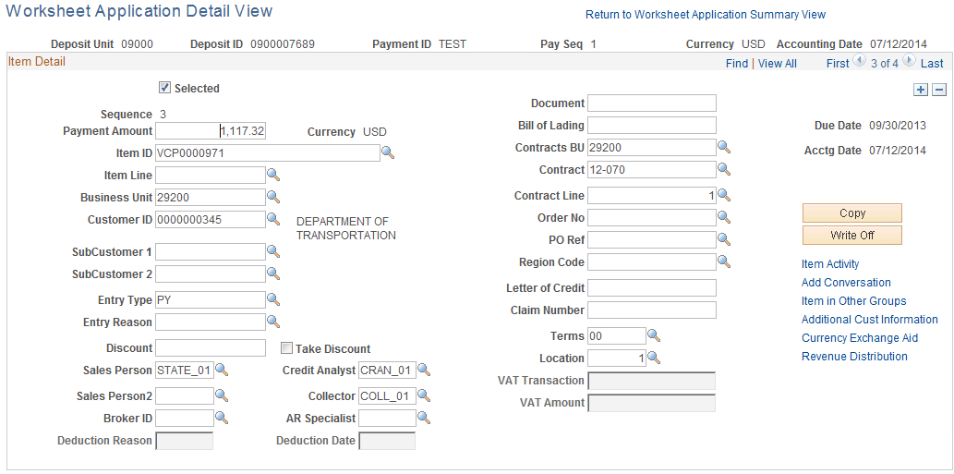
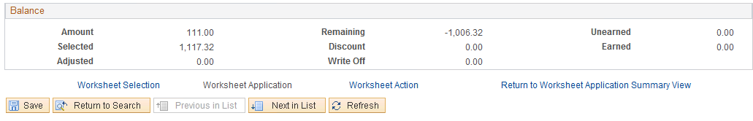

Use the Worksheet Application Detail View page to review additional Item information.
Use the hyperlinks on the right side of the page to navigate to associated Item information.

Click the Return to Worksheet Application Summary View hyperlink.

Worksheet Application page continued

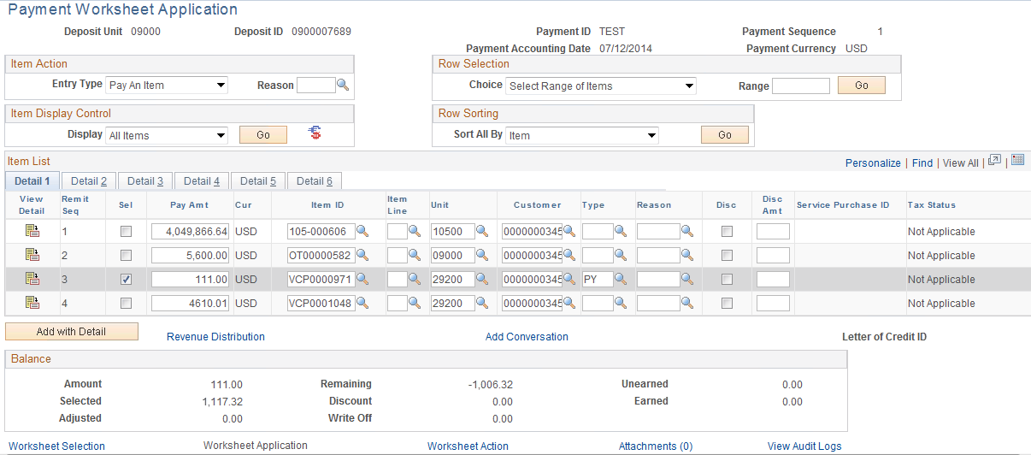

Select – use this checkbox to individually select the Item that will be applied to the deposit in the worksheet.

Pay Amount - displays the amount of the item.

NOTE: To apply an ‘Underpayment’ to an Item, change the Pay Amount value to the amount of the payment.

Item ID –this field displays the Item ID (invoice, etc.).

Type – this value will be set to ‘PY’ by the system, representing payment application to the Item.

Click to save the payment worksheet.

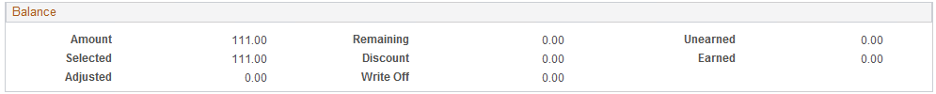

The Selected amount should reflect the total of all Open Items selected in the worksheet

Click the Worksheet Action hyperlink.

Worksheet Action Page

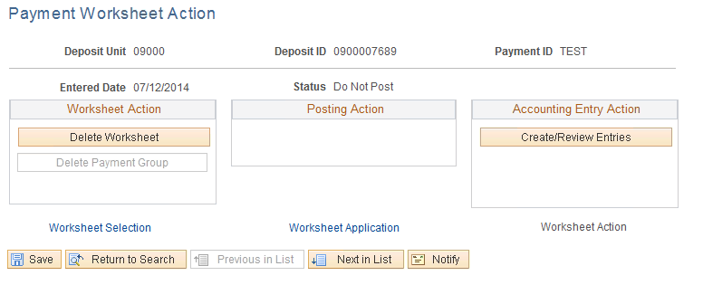

Use the Worksheet Action page to set the payment worksheet to Post, Delete the worksheet or review Accounting Entries.

NOTE: The Receivables Update process will create Accounting Entries associated with the payment worksheet action.

Action – select ‘Batch Standard’ to set the payment worksheet to post the next time Receivables Update is executed.

Click to save the Posting action.

NOTE: The Payment Worksheet should be saved and ready for selection by the Receivables Update process. Once complete, the Receivables Update process will update the customer account to reflect the payment application to the Item(s).

NOTE: To correct Posting Errors navigate to Accounts Receivable > Receivables Update > Correct Posting Errors > Payment.

Managing Payment Posting

Un-post a Payment

Navigation: Accounts Receivable > Receivable Update > Unpost Groups > Payment Group > Find an Existing Value

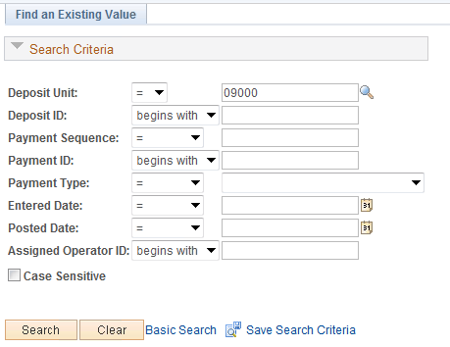

Use the Search criteria to find the Deposit that the payment worksheet will be built upon.

Deposit Unit – enter the agency business unit value.

Deposit ID – if known, search for a particular Deposit ID.

Payment ID – search by Payment ID within a particular Deposit ID. This could be check number, etc.

Click to retrieve all Deposits that match the Search Criteria.

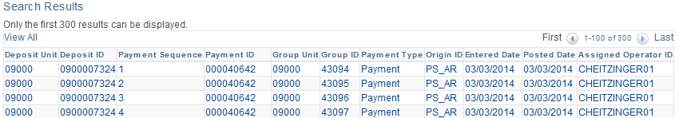

Select from the list the Deposit ID that will be Un-posted.

Payment Control Page

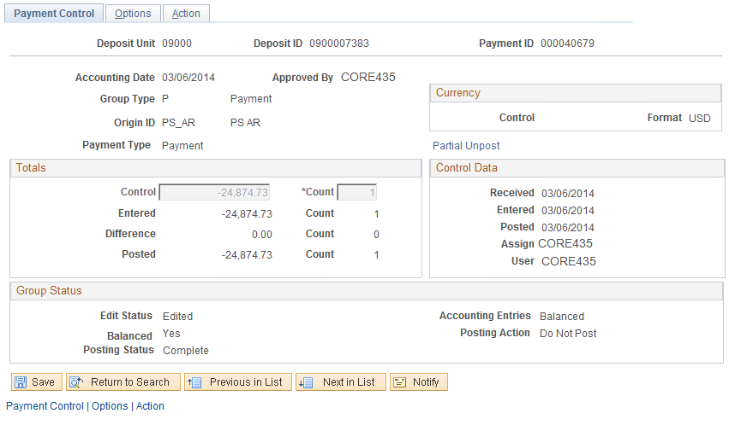

The Payment Control page shows information from the Payment (Deposit) that was posted.

Posted Date – displays the date that the payment was posted to the customer account.

Click the Tab.

Options Page

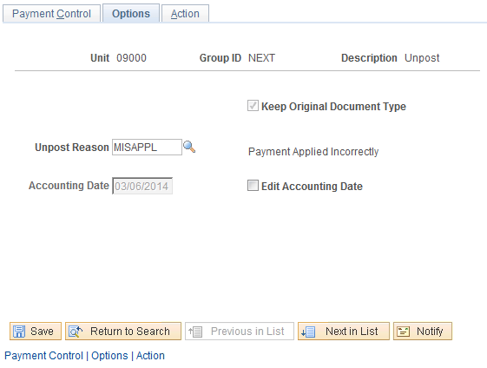

Use the Options page to assign additional information for the Un-posting.

Un-post Reason – Select from the pre-defined list a reason that the payment is being un-posted.

Edit Accounting Date – select to change the Accounting Date for the un-posting. This value is defaulted in as the original posting date.

Accounting Date – when Edit Accounting Date is selected, this field is active allowing the user to change the accounting date value.

Click the Tab.

Action Page

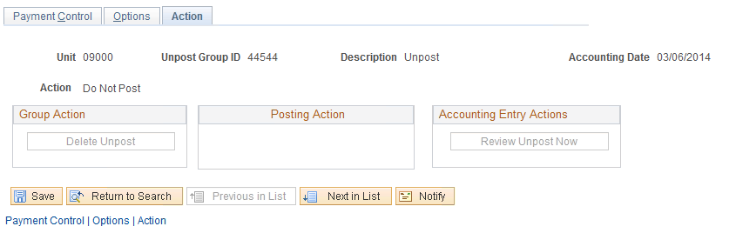

Use the Action page to set the Group to Un-post.

NOTE: The Receivables Update process will create Accounting Entries associated with the
un-post worksheet action.

Posting Action – select ‘Batch Standard’ to set the Group to Unpost the next time Receivables Update is executed.

Click to save the Posting action.

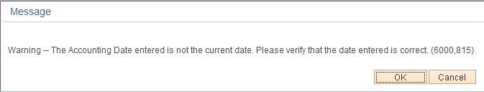

Depending on the Accounting Date used for the Un-posting, the user may receive a Warning.

Click to continue with the Posting action.

NOTE: The Receivables Update process will Unpost the payment the next time it is executed.

NOTE: A new ‘Un-post Group ID’ will be created for the un-posting. This value will be from the same numbering scheme as used for regular Deposits.

Item Activity From a Payment

Navigation: Accounts Receivable > Receivable Update > Posting Results – Payments > Item Activity From Payment > Find an Existing Value

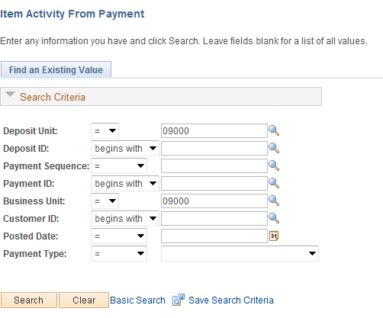

Use the Search criteria to find the Deposit to review.

Deposit Unit – enter the agency business unit value.

Deposit ID – if known, search for a particular Deposit ID.

Payment ID – search by Payment ID within a particular Deposit ID. This could be check number, etc.

Business Unit – required.

NOTE: Deposits that have Reference information identified (Item ID, etc.) have a status of ‘Applied’. Deposits without Reference Information but contain Customer ID will be in a status of ‘Identified’.

Click to retrieve all Deposits that match the Search Criteria.

Item Activity from A Payment Page

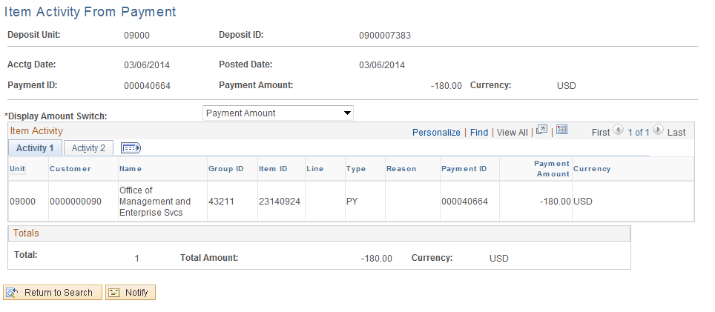

Use the Item Activity from a Payment page to view information about how the Deposit (payment) was applied.

Posted Date – displays the date that the payment was posted to a customer account.

Display Amount Switch – select how the Item Activity section of the page will be displayed.

Item ID – displays the Item(s) that the payment was applied to.

Total – displays the total number of Items that the payment was applied to.

Click to save the Bill.

Click , enter the Standard Billing pages.

Click to execute the Recurring Bill Generation process.

Click to execute the process. Navigate to the Process Monitor to view the Process Instance.

Click to enter the Copy Single Bill pages.

