**State of Oklahoma**

COR461 Time and Labor Manager Self Service Manual

**Revised: August 1, 2019**

Authorized by: [_CORE_] Original Issue: [01/15/2010]

Maintained by: [____Identify Application Lead___] Current Version: [08/01/2019]

Review Date:

Table of Contents

Document History 5

Manager Self Service 6

Objectives 6

Overview 6

Access Employee Timesheets 7

Use Selection Criteria 7

No Selection Criteria 10

Open Employee Timesheet 11

Overview of Timesheet 13

Time Reporting Fields 14

Reported Time Status 15

Reported Hours Summary 16

Balances 17

Manage Employee Timesheet 18

Report Time 18

Report Time 24

Enter a Comment for Reported Time 25

Change Reported Time 29

Delete Reported Time 31

TRC (Time Reporting Code) Access 33

Reported Time Status 33

Reported Hours Summary 34

Balances 36

Approve Reported Time on Timesheet 36

Approve Reported Time 37

Approve/Deny for Employee 40

View Payable Time 41

View Compensatory Time Balance 43

View Accumulators 46

Queries 47

Add Queries to Favorites 50

Schedule a Query to Run 51

Appendix A – Office of State Finance 55

Report Time 55

Enter Time – No Exceptions Reported 56

Enter Time – With Comp Time Earned or Overtime 59

Enter Time – With Leave or Comp Time Taken 62

Enter Time – Holiday Off 65

Enter Time – With Holiday Worked or Administrative Leave Worked 68

Approve Reported Time 72

Appendix B – Reporting Time to a Project 73

Enter Time – No Exceptions Reported 74

Enter Time – Leave or Comp Time Taken 77

Enter Time – With Holiday Worked 78

Approve Reported Time 80

Document History

|  |  |  |
| --- | --- | --- |
| **Document Revision** | **Date** | **Description** |
| 1.0 | 01/15/2010 | Initial Document |
| 1.1 | 02/17/2010 | Revision to Appendix A |
| 2.0 | 09/13/2010 | Added Appendix B |
| 3.0  3.1 | 01/03/2011  08/01/2019 | Added Appendix C  Manual Updates |

Manager Self Service

Objectives

Access Employee Timesheet

Open Timesheet

Approve Reported Time

TRC (Time Reporting Code) Access

Approve Reported Time

Approve/Deny for Employee

Approve/Deny for All Employees

View Payable Time

View Compensatory Time Balances

View Accumulators

Overview

Manager Self-Service is a web-based application that provides managers with access to manage their employees’ time. The release of Manager Self-Service provides managers the ability to report, review, and manage time-related data in the PeopleSoft Time and Labor, timesheet.

Manager Self-Service provides an excellent opportunity for you to ensure your employees’ Timesheet data is accurate and kept up to date. The data entered can affect the accuracy of their pay checks.

One of the advantages of the Manager Self Service system is the data is real-time data.

The following table describes the components used in Manager Self Service.

|  |  |
| --- | --- |
| **Page Name** | **Page Description** |
| Timesheet | Report and/or view your time details for a day, week, or time period. |
| Approve Reported Time | View and approve reported time for an employee or a group of employees |
| Payable Time Summary | View a summary of payable time for an employee |
| Compensatory Time | View comp balances for an employee |
| Accumulators | View an employee’s FMLA accumulator totals |

Access Employee Timesheets

You can access timesheet for one employee or all of your employees. Accessing employee timesheets is a little different than accessing your own timesheet through Employee Self Service. An Employee Selection Criteria grid displays providing you with several fields that you can to select the employee timesheets you would like to access.

**Navigation:** Manager Self Service > Time Management > Report Time > Timesheet

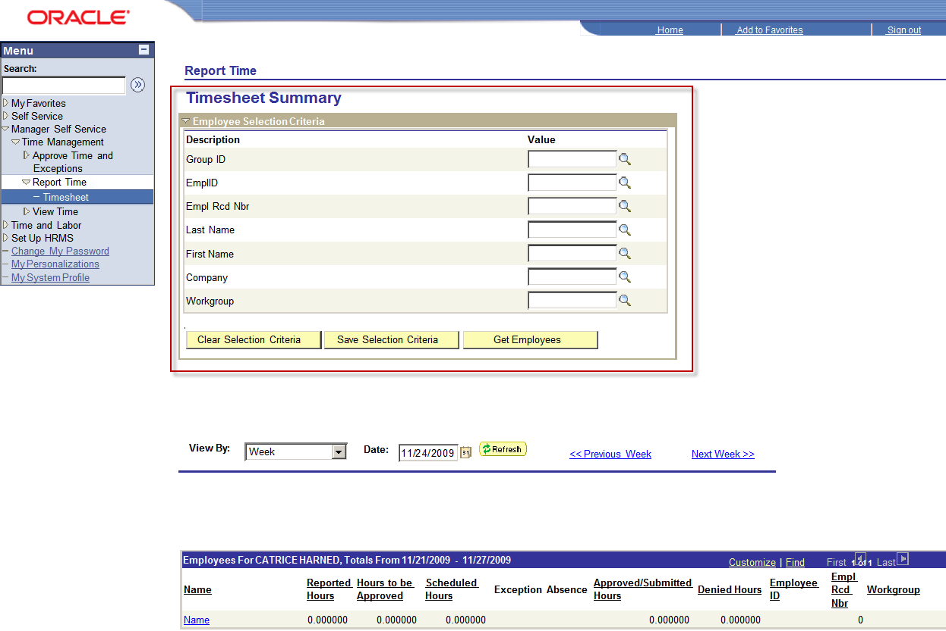

Use Selection Criteria

You can use one or more of the criteria available. For all of the criteria fields you can enter a partial criteria followed by a wild card. You can also click Look up icon. to open and look up the the value.

**Step 1** – Click Look up icon. for Group ID criteria

1. Select Group ID = 090A1

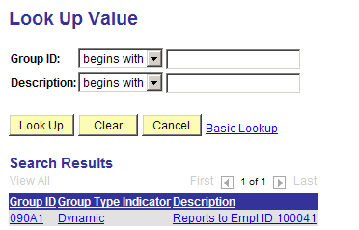

**Step 2** – View By – leave at default of Week.

**Step 3** – Date: Click Calendar icon
 to open a calendar and select the start day of the current Pay Period.

**Step 4** – Click Get Employee button. to display timesheets for all employees in the Dynamic Group.

**NOTE**: All of your employees in Dynamic Group 090A1 display in the ‘Employees for…’ grid. It may be necessary to scroll down to display all of the employees.

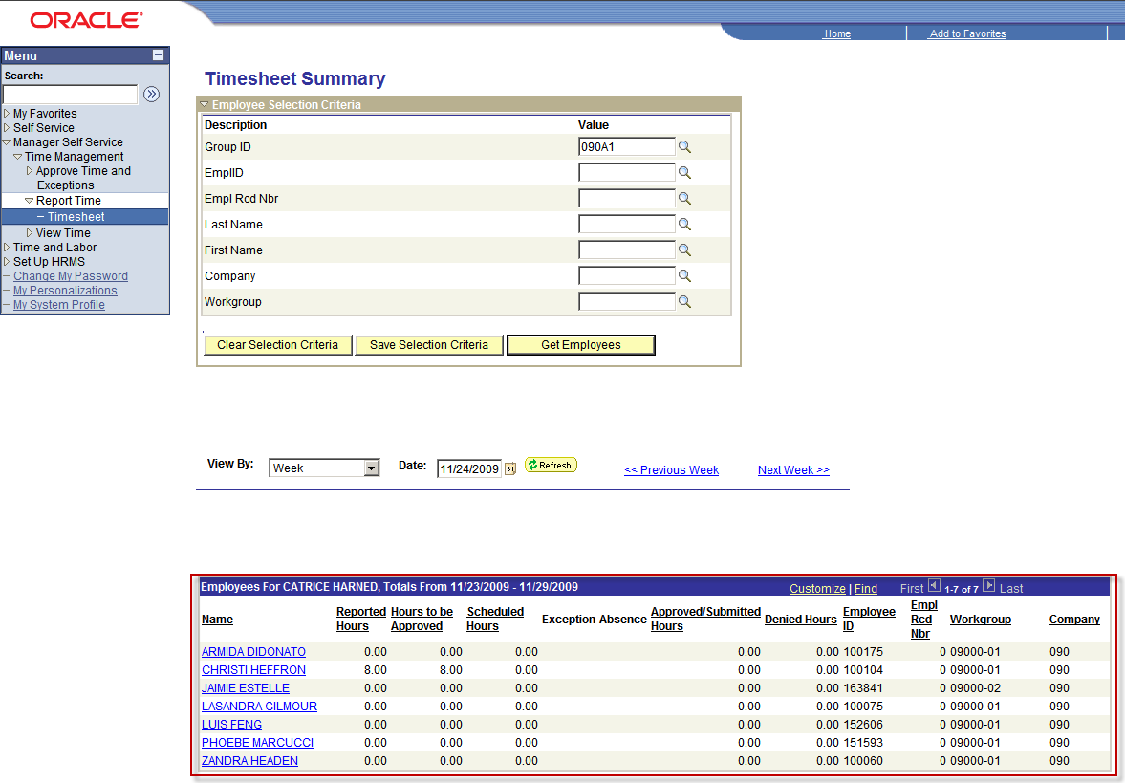

No Selection Criteria

You can display a list of all of your employees without using any criteria.

**Step 1** – View By – leave at default of Week.

**Step 2** – Date: Click Calendar icon to open a calendar and select the start day of the current Pay Period.

**Step 3** – Click Get Employee button. to display timesheets for all of your employees

**NOTE**: All of your employees display in the ‘Employees for…’ grid. It may be necessary to scroll down to display all of the employees.

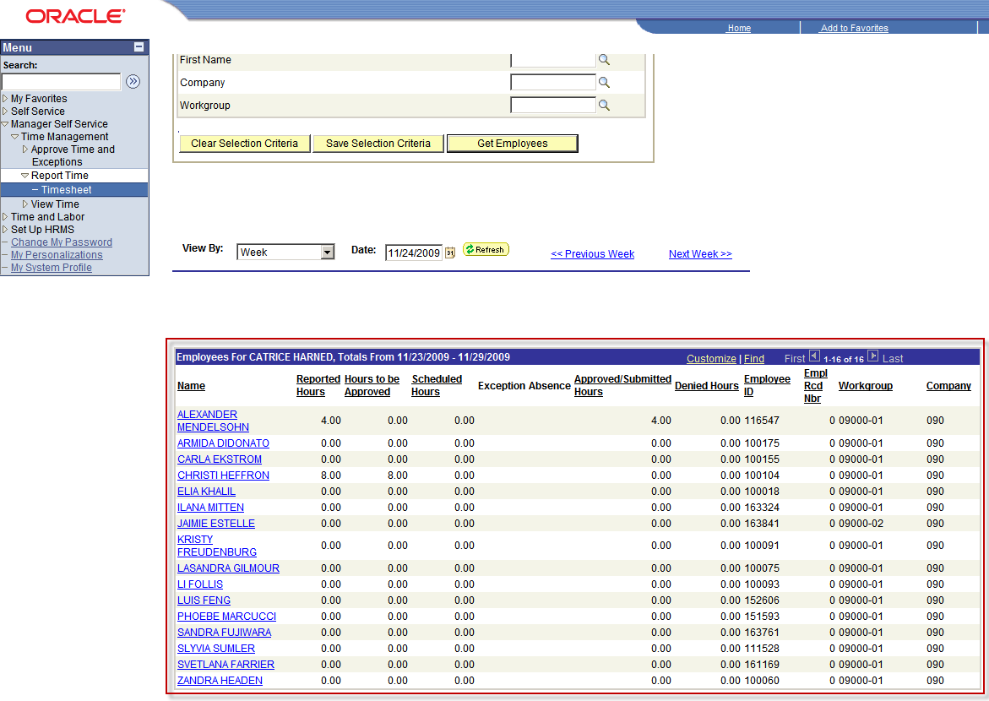

Open Employee Timesheet

To open an employee timesheet click the employee’s hyperlinked name in the ‘Employees for…’ grid.

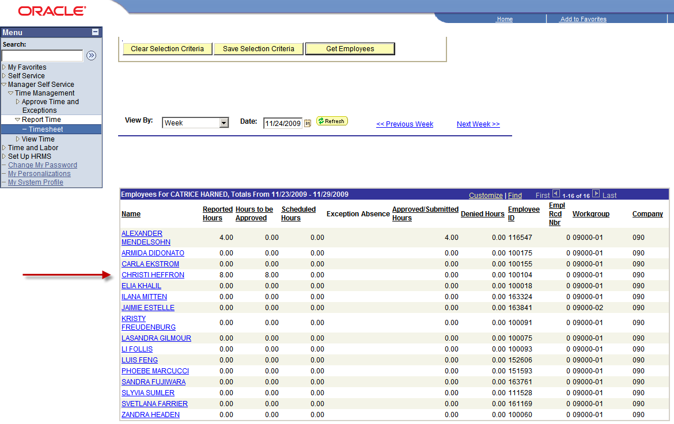

Once you have opened an employee’s timesheet you can:

1. Review the timesheet
2. Report time
3. Change reported time
4. Approve reported time
5. Review Balances
6. Move to the previous/next employee timesheet by clicking on the Previous Employee or Next Employee hyperlinks

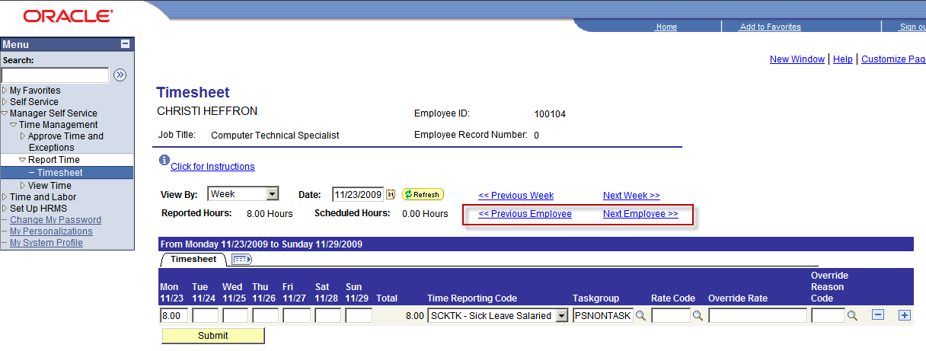

Overview of Timesheet

Timesheet contains the following features:

1. Time reporting fields
2. Reported Time Status
3. Reported Hours Summary
4. Balances

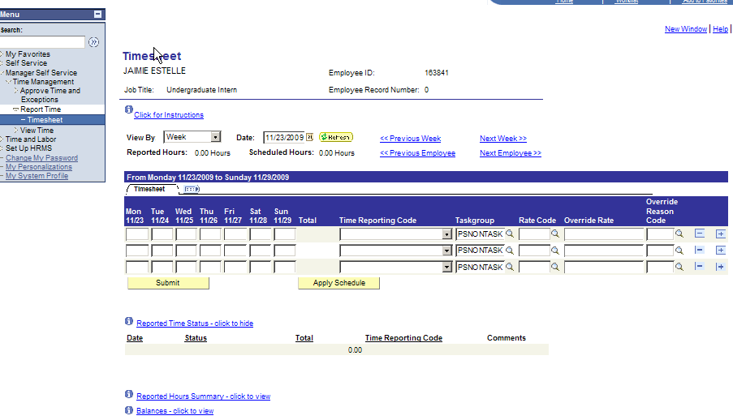

Time Reporting Fields

You can use these fields to report hours and Time Reporting Codes (TRC’s). Each TRC has its own row and can contain several days of data.

**NOTE:** Most of the time the employees report their own time. However, there are TRCs not available to employees; only their managers can use them. When an employee is absent or does not have access to a computer, their manager can report time on their behalf.

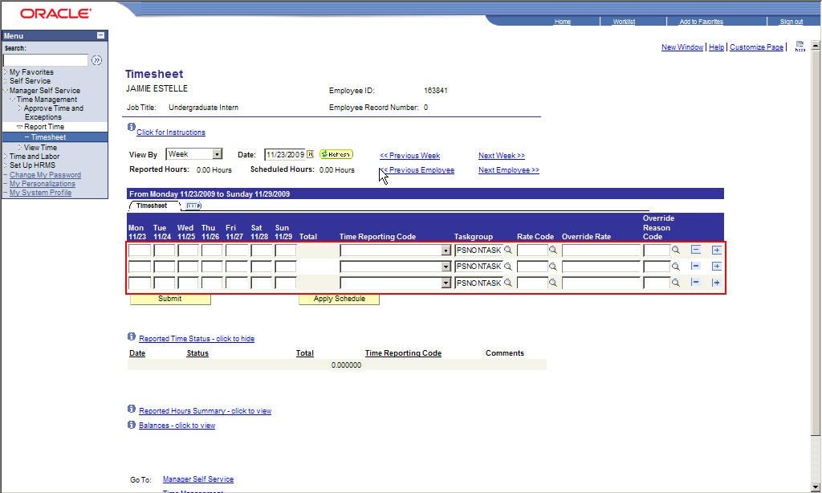

Reported Time Status

This section details the:

1. Status of reported time
2. Date of the reported time
3. Number of hours
4. Time Reporting Code (TRC)
5. Indicates if a comment exists for reported time

The screen shot reflects the Timesheet Reported Time Status section highlighted.


Reported Hours Summary

This section provides a summation of reported hours. The ‘View By’ determines if the summation of reported hours is by day or week.

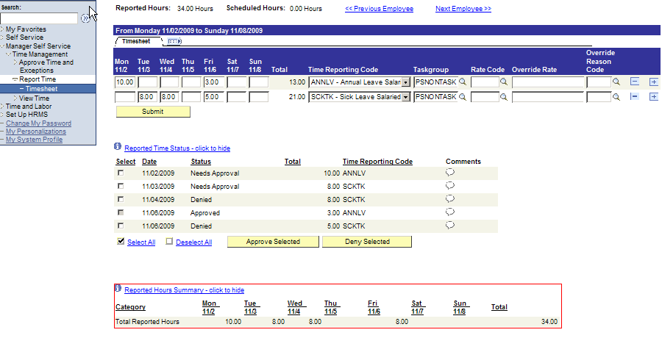

Balances

The Balances section details Leave and Comp Plan balances for each of the leave and comp plans in which the employee is enrolled.

This screen shot reflects the Timesheet Balances Section.


**NOTE:** Sick and Vacation (Annual) balances reflect balances as of the start of the pay period less any Leave time taken during the current pay period. Comp time balances reflect the balance as of the start of the pay period and may not include recent comp time entries and/or prior period adjustments.

Manage Employee Timesheet

Report Time

When you report employee time, you can enter hours for a day, week, or time period for the current pay period or a future pay period.

Salaried Employee: Report exception hours such as annual, sick, or comp time taken only.

Hourly Employee: Report hours worked using the TRC ‘HREG’ and exception hours if applicable.

**NOTE:** Your agency may require additional data entry when you report your time; please refer to any attached Appendices for applicable instructions.

**Step 1** – Select the period for which you would like to report time.

1. Click the View By drop-down list and select Day, Time Period, or Week.

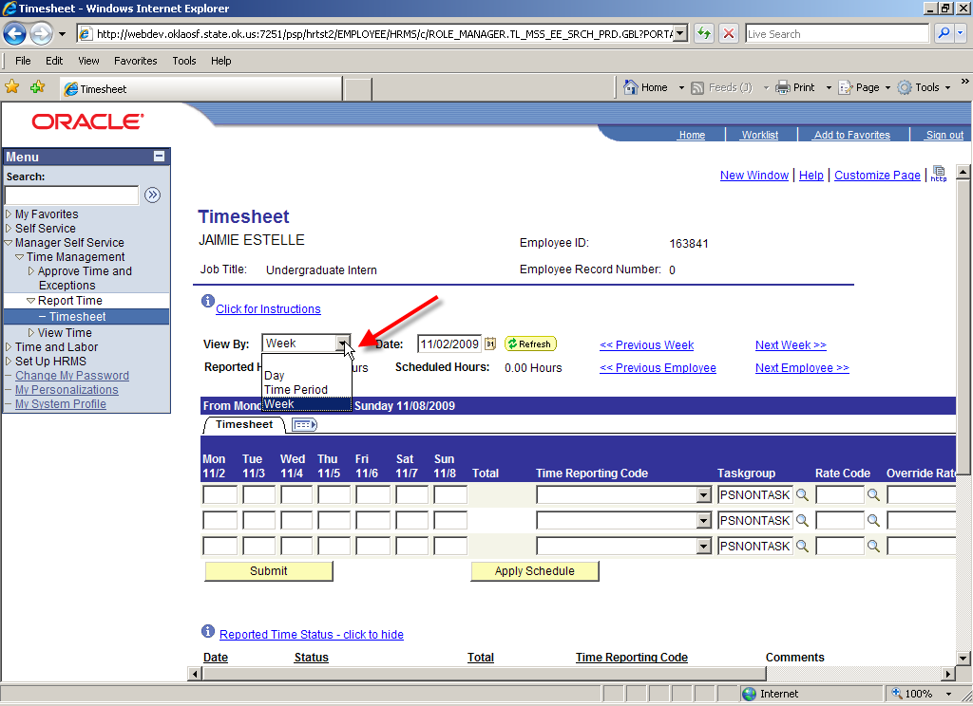

**Step 2** – Select the start date for the current or future pay period.

1. Click the Calendar icon to the right of the Date field.
2. A pop-up Calendar appears.
3. Click the applicable date.

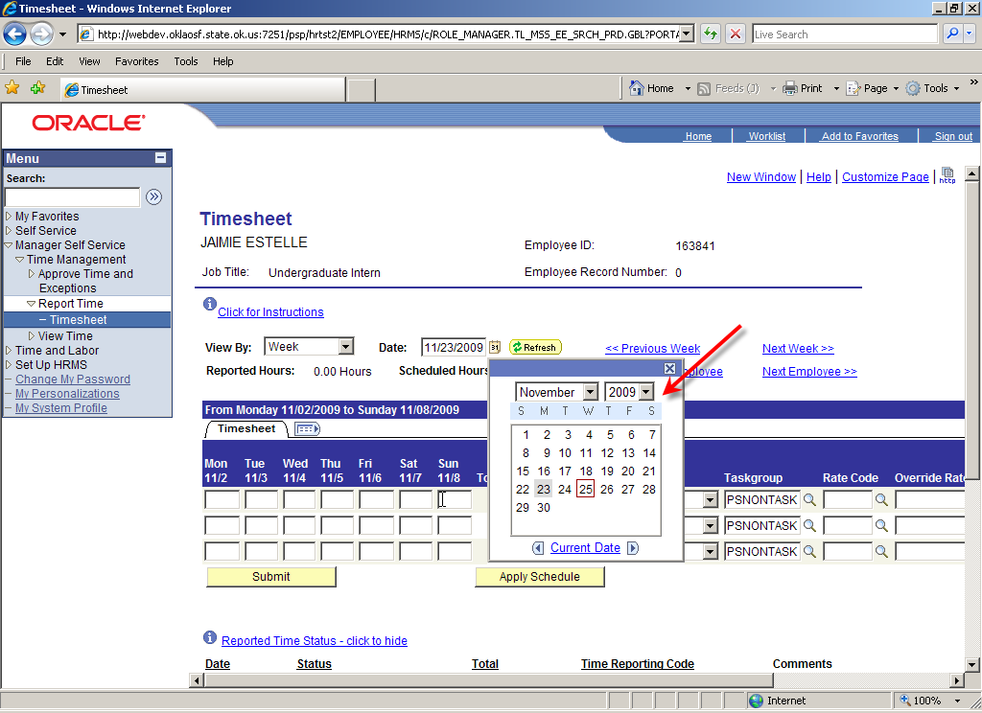

1. Click Refresh button. to refresh the Timesheet to display the selected dates.

**Step 3** – Enter hours on November 23.

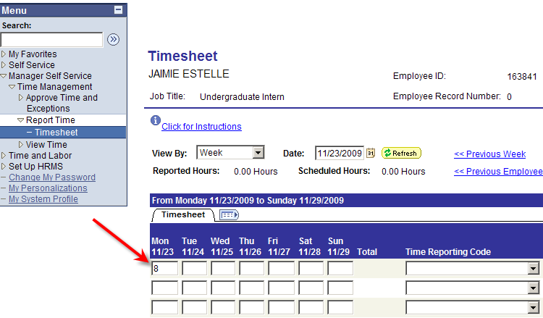

**Step 4** – Select the Time Reporting Code (TRC)

1. Click the Time Reporting Code drop-down arrow and **select** the Time Reporting Code (TRC) from the drop-down list displayed.

This screen shot reflects the Timesheet time reporting fields displaying Time Reporting Codes drop-down list.

1. **Select** ADMLV – Admin leave Salaried

**Step 5** – Click to submit the time you reported.

1. On the Submit Confirmation page, click .

**NOTE:** The submitted time has a Status of ‘Needs Approval’ and the Reported Hours Summary section reflects the submitted hours.

Report Time

You can report time to several different TRC’s. Each TRC requires a separate row.

**Step 1** – To enter another TRC after you have already submitted time, scroll to the right and click to add a new row.

**Step 2** – Enter 4 hours each day on November 24 and November 25 on the newly added row.

**Step 3** – Select TRC ‘LWOP’ – Leave without Pay

**Step 4** – Click to submit the time you reported.

1. On the Submit Confirmation page, click .

**NOTE:** The total number of hours display next to the TRC and Reported Time Status reflects all submitted time.

Enter a Comment for Reported Time

You can enter a comment for any reported time. You can use the Comment field to provide additional information not captured by the time reporting fields such the reason for the change in time reporting code or other notes about the reported time, etc. All comments entered are fully auditable and cannot be changed or deleted. You cannot enter a comment until after you submit reported time. Comment is attached to the day and not the individual time reporting code and hours submitted for the day.

**Step 1** – In the Reported Time Status section, locate the reported time entry requiring a comment.

1. Click to open the Comments field.
2. Enter comments and click .

**Step 2** – A warning page displays providing you with the opportunity to change your mind and cancel the comments. Click to confirm and save your comment.

**NOTE:** The comment symbol changed from to providing a visual cue that comments exist for the date.

**Step 3** – Click to see the comments you entered and saved.

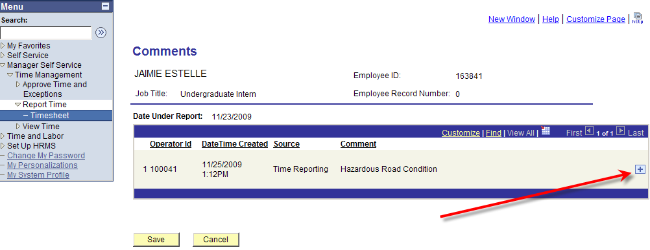

Notice the Comment field is not editable. The following data is detailed:

Sequence number.

Operator ID – indicates the person that entered the comment.

Date Time Created – indicates the date and time the comment was entered and saved.

Source – comment was entered via the employee’s Timesheet

Comment

**NOTE:** Employee, Manager, Timekeeper, and/or Time Administrator can enter comments on a timesheet for the same date by clicking to open a new comment field.

Change Reported Time

You can change reported time for a future, current, or previous time period.

**Step 1** – Select the applicable period and date.

1. View By – select week
2. Date – Select the applicable week

**Step 2** – Change the reported hours:

1. **Delete** the original hours and enter the new amount

-or-

1. Highlight the original hours and enter the new amount.

**NOTE:** The 8 hours on November 23 was changed to 4 hours but the Total ANNLV – Annual Leave Salaried hours still display as 8 hours. The Total hours will not reflect the new total until the time is submitted.

**Step 3** – Click to confirm the change.

1. On the Submit Confirmation page, click

**Step 4** – If applicable, enter a Comment.

**NOTE:** the ADMLV – Admin Leave Salaried hours now reflects a Total of 8 hours and the Reported time Status data reflects 4 hours of ADMLV – Admin Leave Salaried.

Delete Reported Time

You can delete reported time for a future, current, or previous time period.

**Step 1** – Select the applicable period and date.

1. View By – select week
2. Date – select the applicable week

**Step 2** – Delete the LWOP – Leave without Pay row:

1. Scroll to the right and click Minus (-) sign button. to delete the LWOP – Leave without Pay row.

**Step 3** – Click Yes - Delete button. to confirm the deletion of the row. To cancel the deletion of time, click No - Do Not Delete button. to cancel the deletion action.

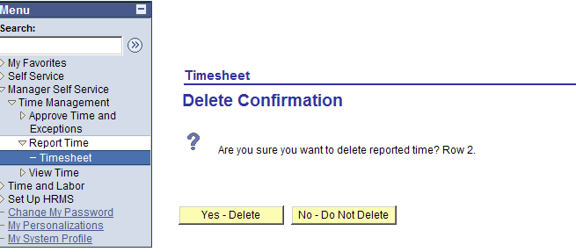

**NOTE:** The deleted LWOP – Leave without Pay row no longer displayed.

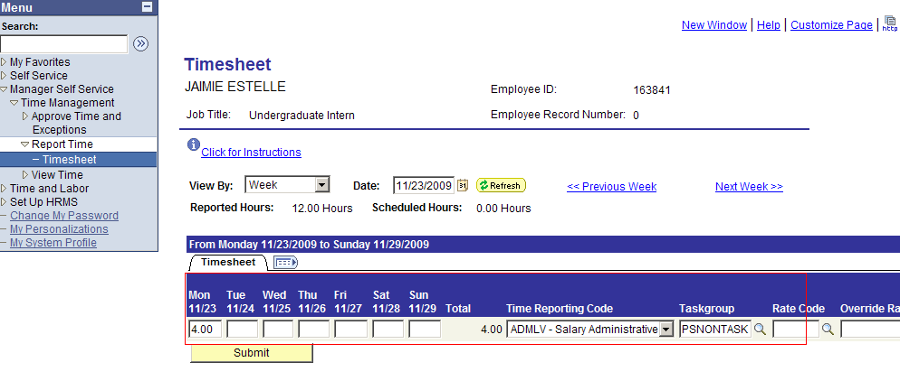

**Step 4** -- Click to confirm LWOP – Leave without Pay row deletion.

1. On the Submit Confirmation page, click

**NOTE:** The Reported Time Status reflects the deletion of the LWOP – Leave without Pay row deletion.

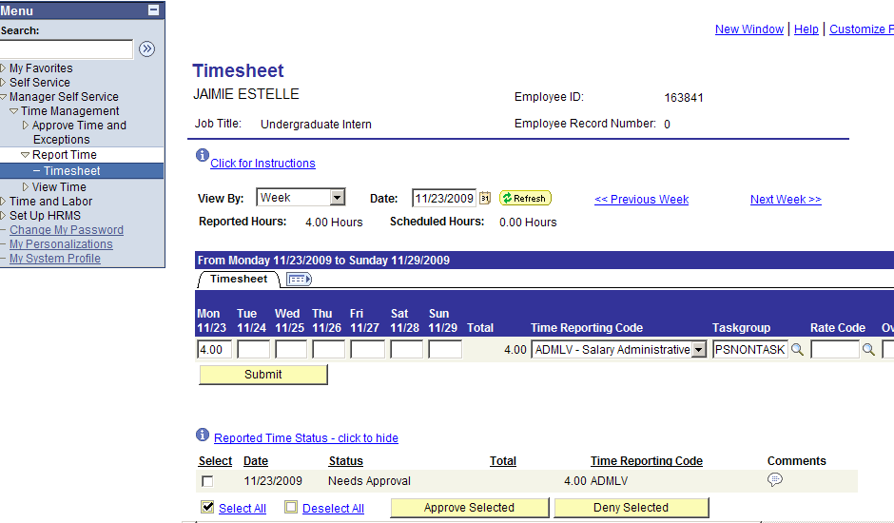

TRC (Time Reporting Code) Access

When you report time, you can only access a select group of TRC’s. Some TRC’s have restricted access; only a Timekeeper and/or Time Administrator can access them. As a manager, you can access Employee and Manager TRC’s.

In the picture below the TRC ‘TERM– Annual Leave Payout’ –is not accessible for editing and the row cannot be deleted.

Timekeepers and/or Time Administrators can access and use TRC’s that you cannot access

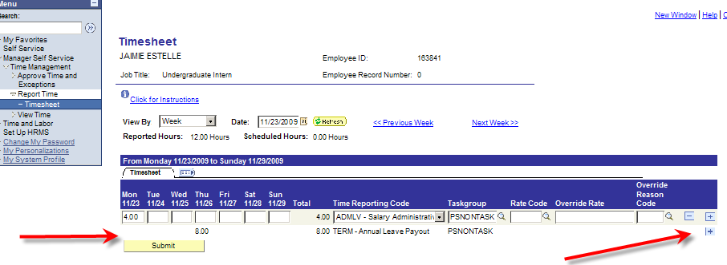

Reported Time Status

Reported Time Status reflects the current status of all submitted timesheet entries. Submitted time can have the following status:

1. Needs Approval – submitted time requiring Approval so that it can be paid
2. Approved – submitted time has been Approved and can be paid
3. Denied – submitted time was Denied and will not be paid.

The screenshot below displays all three statuses of Needs Approval, Approved and Denied reported time.

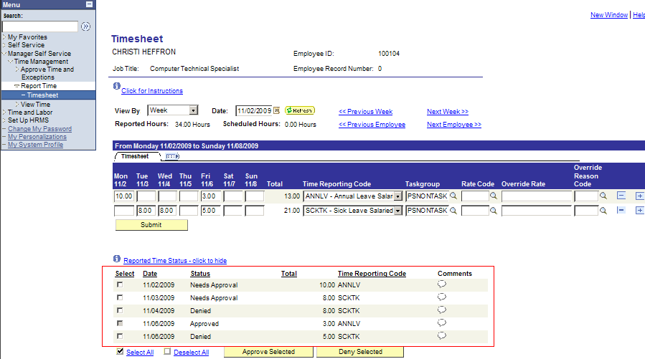

Reported Hours Summary

This section provides a summation of reported hours. Depending on the ‘view’ selected when accessing your timesheet, the summation of reported hours can be by day or week. The ‘View By’ determines the display and summarization of hours in the Reported Hours Summary section.

**View By = Week**

In the picture below the Reported Hours Summary provides a summary of reported hours by day and a total of Reported hours for the week.

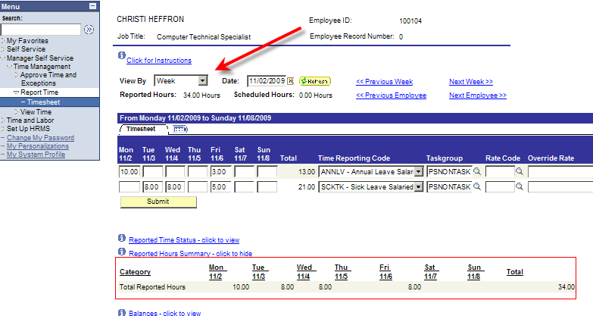

**View By = Time Period**

In the picture below the Reported Hours Summary provides a summary of reported hours by week and a total of hours for the Time Period.

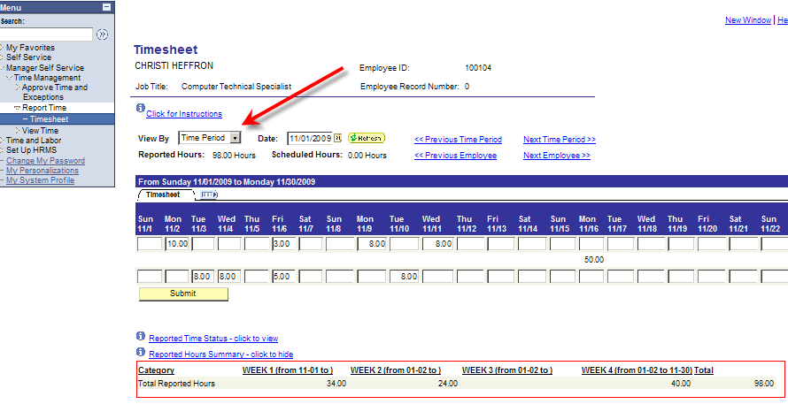

**View By = Day**

In the picture below the Reported Hours Summary provides a summary of reported hours by day.

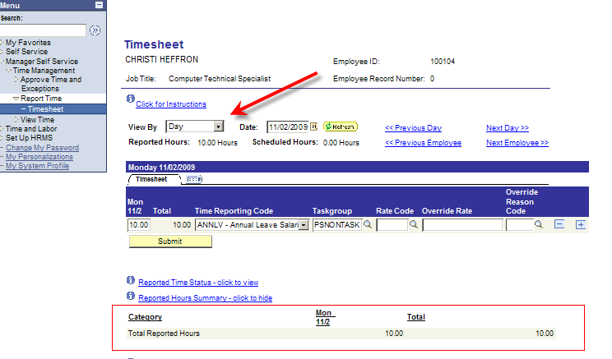

Balances

Leave and Comp Plan balances display on the Timesheet under the Balances hyperlink. Balances displayed, are as of the beginning of the pay period, and do not include any newly reported time. Leave plan balances update dynamically; as soon as you submit Leave time, the balance updates to reflect the Leave hours taken. Comp Plan balances are as of start of the period and may not include recent comp time entries and/or prior period adjustments.

Approve Reported Time on Timesheet

You can approve reported time directly on an employee’s timesheet. You can choose to approve time here or on the Approve Reported Time page.

The picture below displays reported time with a status of Needs Approval.

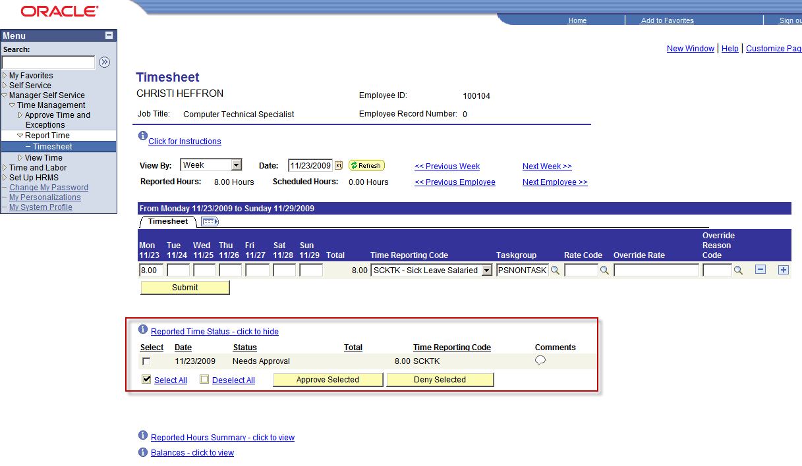

Approve Reported Time

Once an employee’s time has been reported and submitted, it is available for you to approve. You can approve an employee’s reported time directly on their timesheet or using the Approve Reported Time page.

**Navigation**: Manager Self Service > Time Management > Approve Time and Exceptions > Reported Time

Approve Reported Time provides the same employee selection criteria as the timesheet.

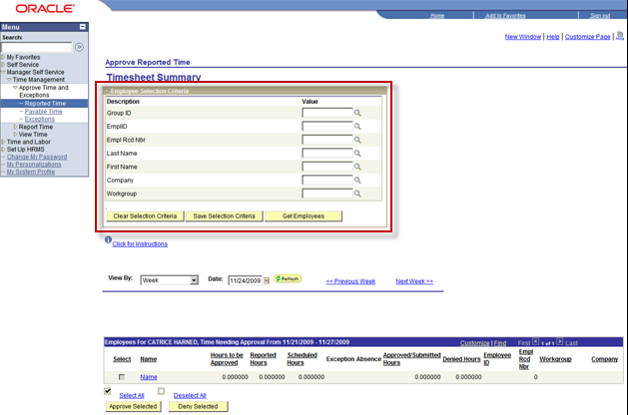

The View By selections includes:

1. All Time After
2. All Time Before
3. Day
4. Week

It is strongly recommended that you use the ‘View By = All Time Before’ to ensure all reported time requiring approval for previous pay periods display.

**Step 1** – View By – select All Time Before

**Step 2** – Date: Click Calandar button. to open a calendar and select the start day of the next Pay Period.

**Step 3** – Click Get Employee button. to display timesheets for all of your employees.

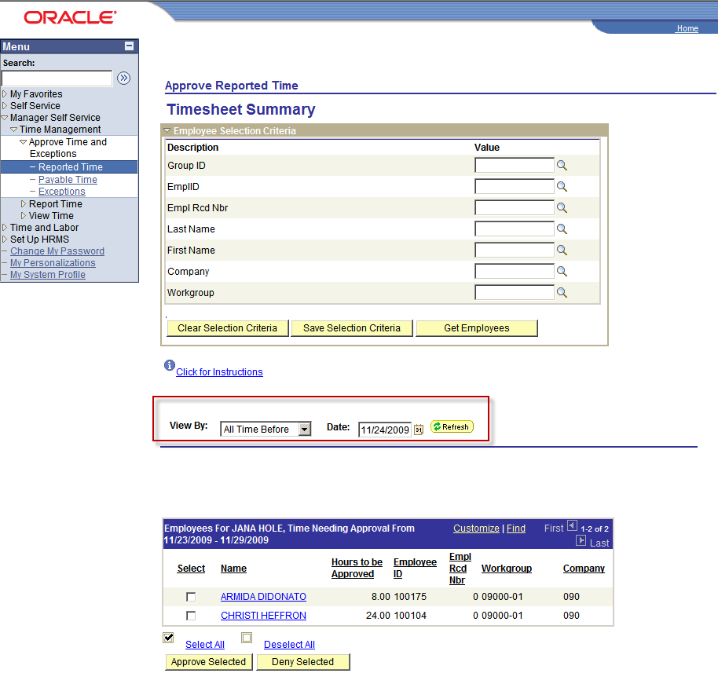

All of your employees with reported time requiring Approval display. You can Approve or Deny reported time. To review the time requiring approval you can click the employee’s hyperlinked name; this will open the employee’s timesheet. Once you have reviewed the time, you can click the ‘Return to Select Employee’ hyperlink to return to the Approve Reported Time page.

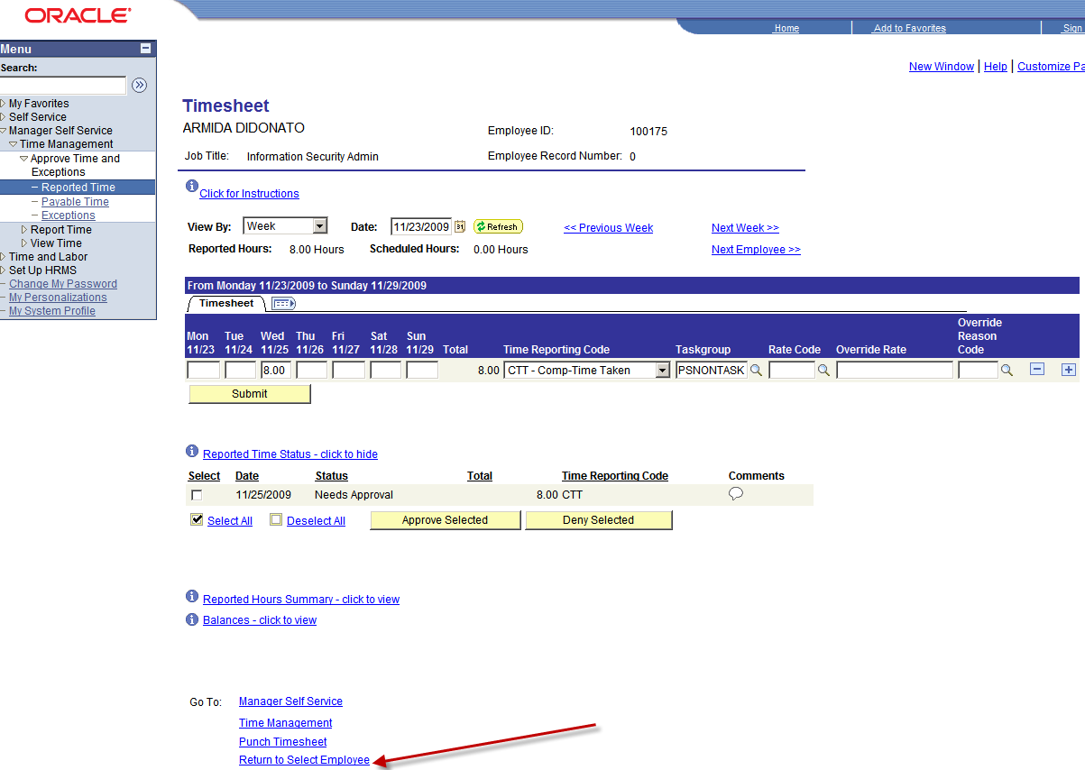

You can approve reported time for one, several, or all employees.

Approve/Deny for Employee

You can use the following steps to approve reported time for one or several employees:

**Step 1** – Check the Select box next to the employee(s) requiring approval

**Step 2** – Click Approve Selected button. to approve reported time for the selected employees

- or -

Click Deny Selected button. to deny reported time for the selected employees.

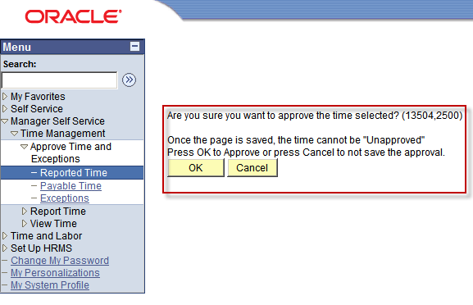

**Step 3** – A warning page displays providing you with the opportunity to change your entry. Click to process your entry.

View Payable Time

You can view an employee’s Payable Time after Time Administration has processed their time. The Time Administration process converts all reported time into payable time, which can then be transferred to Payroll and/or Project Costing.

**NOTE:** Time Administration is processed by agency Time Administrator(s).

**Navigation: Manager Self Service >** Time Management > View Time > Payable Time Summary

**Step 1** – Enter the Employee Selection Criteria

**Step 2** – Click Get Employee button.

**Step 3** – Click employee’s hyperlinked name

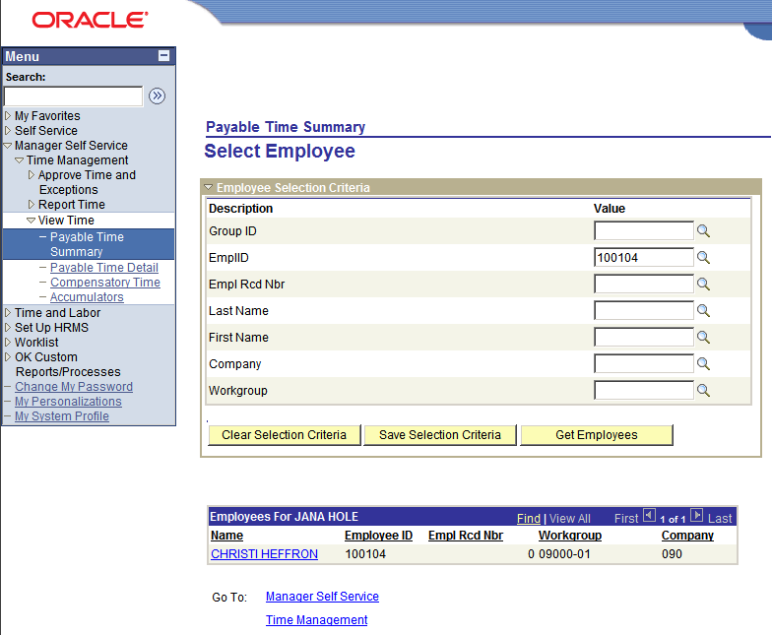

**Step 4** – Start Date – enter the first day of the week you would like to view

**Step 5** – End Date – auto-populates based upon Start Date

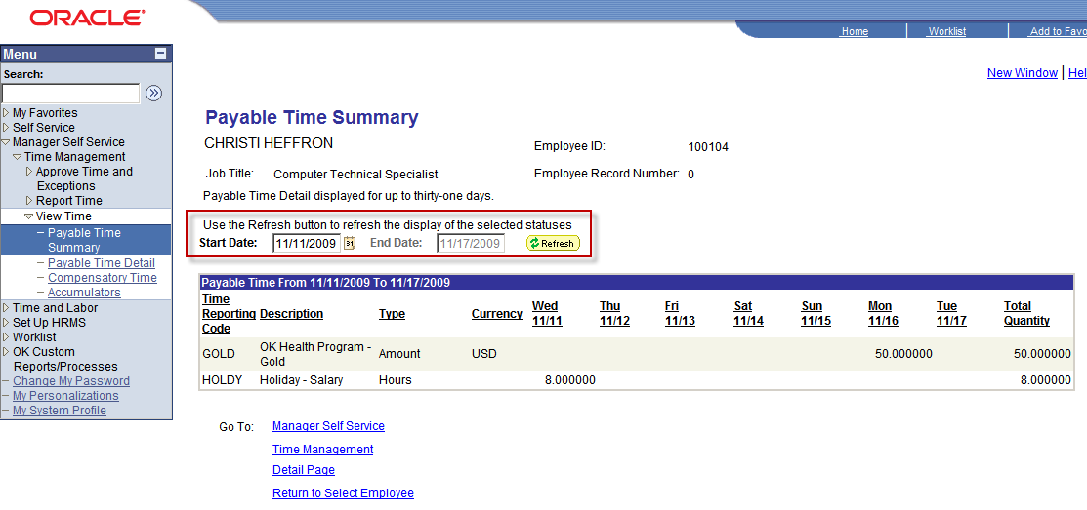

All time is displayed with one row per TRC. The total number of hours is displayed under each applicable day for each TRC. The total number of hours per TRC for the week is displayed under Total Quantity.

View Compensatory Time Balance

You can view Compensatory Time balances for your employees.

**NOTE:** Comp Time balance is as of the last process of Time Administration.

**Navigation**: Manager Self Service > Time Management > View Time > Compensatory Time

**Step 1** – Enter employee selection criteria

**Step 2** – Click Get Employee button.

One row displays for each Comp plan in which the employee is enrolled.

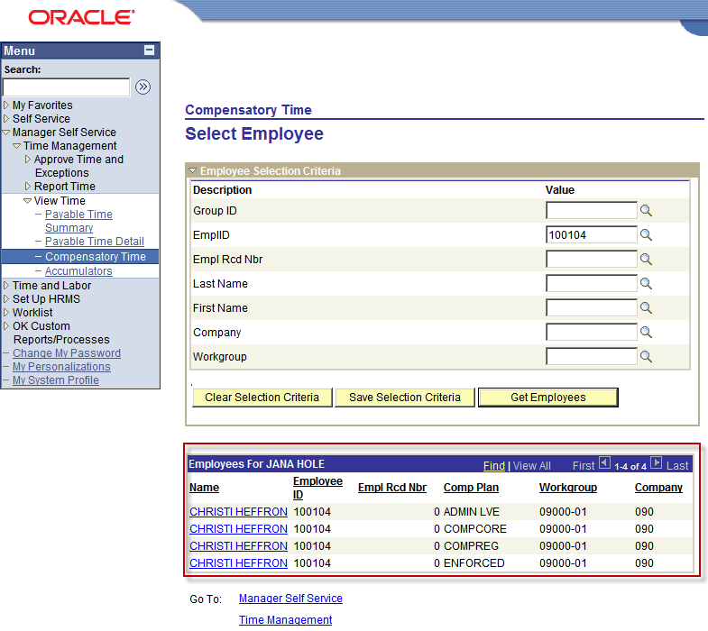

**Step 3** – Click the employee’s hyperlinked name for the Comp Plan you want to review.

This screen shot reflects the Compensatory Time page displaying Show Time Expiring in drop-down list.


**Step 4** – Click the Show Time Expiring in drop-down arrow

**Step 5** – Select the applicable period.

1. In the first picture displayed below the 'Show Time Expiring In' selection is Next 30 Days; three different dates display with the number of hours expiring.
2. In the second picture displayed below the Show Time Expiring In selection is Next 90 Days; five different dates display with the number of hours expiring.

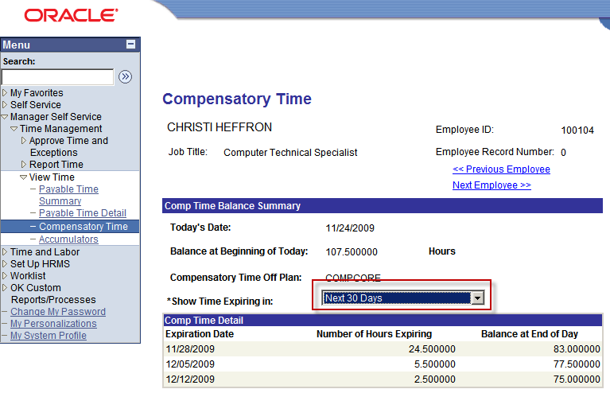

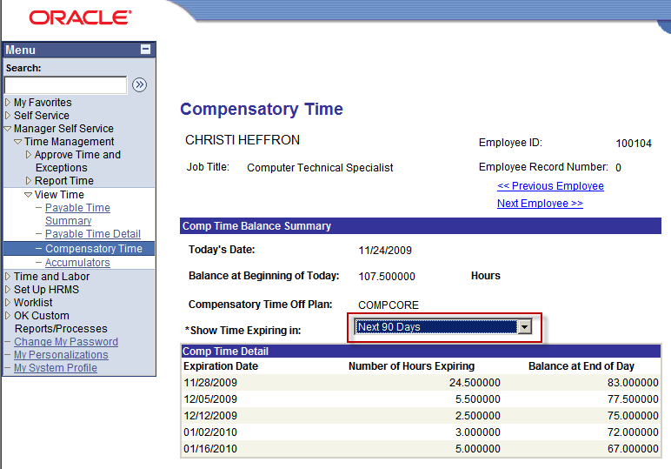

View Accumulators

You can view an employee’s accumulated FMLA hours for a period you define.

**Navigation**: Manager Self Service > Time Management > View Time > Accumulators

**Step 1** – Enter Employee Selection Criteria

**Step 2** – Click Get Employee button.

**Step 3** – Click the employee’s hyperlinked name

**Step 4** – Enter Start Date

**Step 5** – Enter End Date

**Step 6** – Click View button.

The total number of FMLA hours display for the period defined. You can change the Start and End Dates and click View button. to review the total number of FMLA hours for another period.

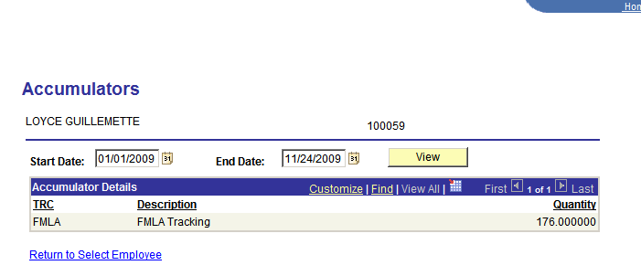

Queries

Several queries exist that you can use to extract Time and Labor data.

Below are the frequently used queries:

GO_MSS_REPORTED_TIME_DETAIL

Detail list of time reported on employees’ timesheets

GO_MSS_REPORTED_TIME_SUMMARY

Summary list of time reported on employees’ timesheets

GO_MSS_REPORTED_TIME_TO_APPROVE

Use this query to check for timesheets need to be approved

GO_MSS_HOURS_OVER_40_WITH_ABSENCE

Use this query to check for hours reported over 40 with absence

**Navigation**: Reporting Tools > Query Viewer

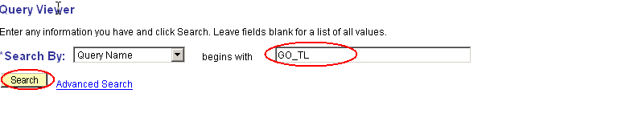

**Step 1 –** Type in “GO_TL” in the Query Name field and clickSearch button. to pull up a list of Time and Labor queries available.

**NOTE:** You can enter the full name of query and click Search button..

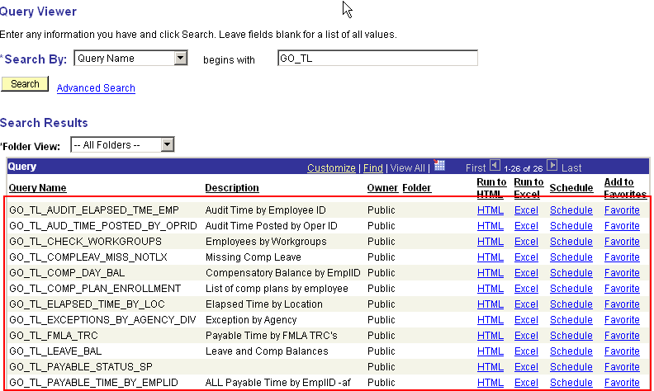

**Step 2 –** Click the HTML or Excel hyperlink to run a query.

In this example, select query: GO_TL_COMP_DAY_BAL by clicking on the HTML hyperlink.

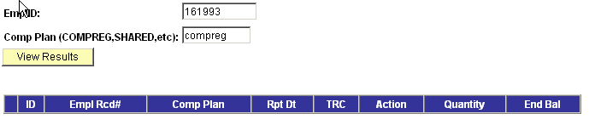

**Step 3 –** Some queries prompt for values. For this example, enter the employee ID, and the Comp Plan and click View Results button.. The query returned the results below:

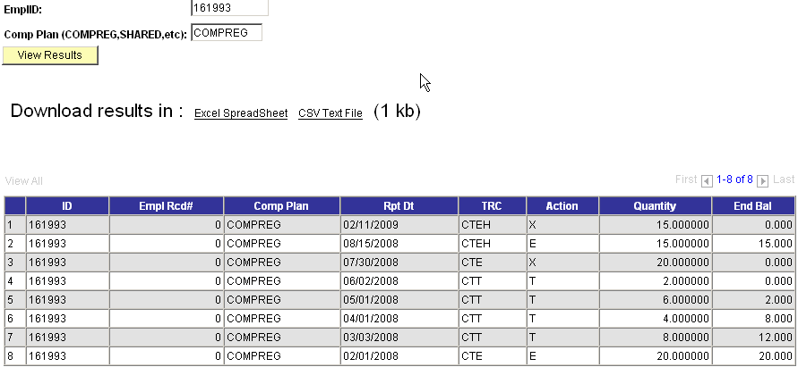

At this point, you can print the page, or download query to Excel by clicking the Excel Spreadsheet link.

Add Queries to Favorites

You can add frequently generated queries to your Favorites list.

**Step 1 –** To add a query, click the Favorite hyperlink next to the query.

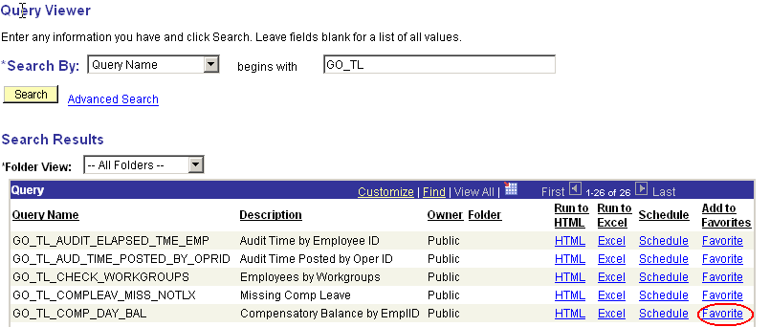

Now, the query is in your Favorites list whenever you access Query Viewer.

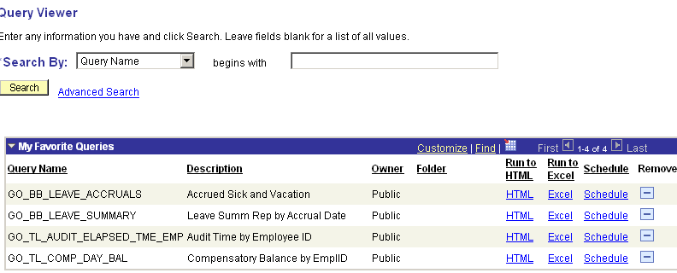

Schedule a Query to Run

Large queries may take a long time to run; you can schedule these queries to run to avoid system time-out.

**Navigation:** Reporting Tools > Query > Schedule Query

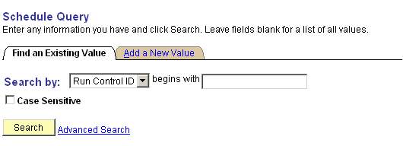

**Step 1 –** Click Search button. to select a Run Control ID or go to “Add a New Value” Tab to add a new Run Control ID.

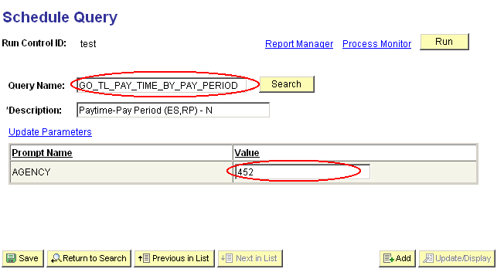

**Step 2 –** In Query Name field, type in the query name to be scheduled to run. In this example, the query prompts for the agency value.

**Step 3 –** After all fields are filled, click Run button. .

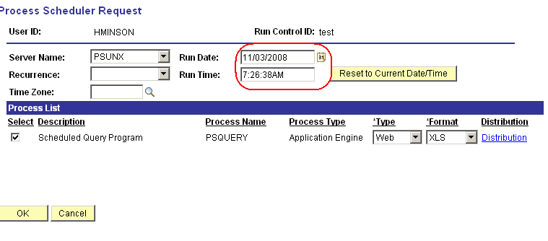

**Step 4 –** Type in the Run Date and Run Time for the query to process, click

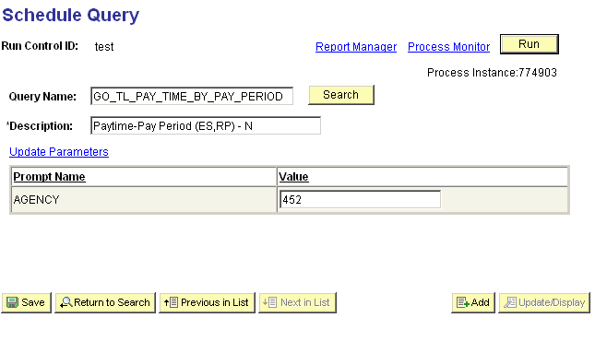

**Step 5 –** To access a scheduled query that has run, click Process Monitor link.

Process Monitor can also be accessed by the following:

**Navigation**: People Tools > Process Scheduler > Process Monitor

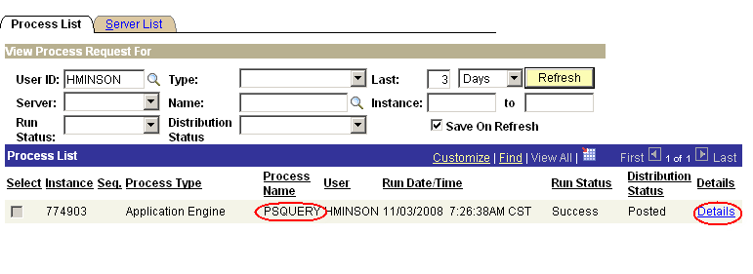

Notice the Process Name is PSQUERY.

**Step 6 –** Click Details link when the Run Status indicates “Success” and Distribution Status indicates “Posted”.

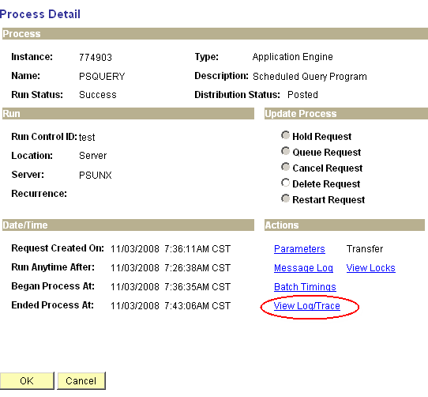

**Step 7 –** Click View Log/Trace link.

**Step 8 –** Click the link with the **\*.xls** extension to open the query results. You can open the query or save it in Excel format.