Enabling Mac OS Updates on a Personal Computer
On your Mac, choose Apple menu > System Preferences, then click Software Update.
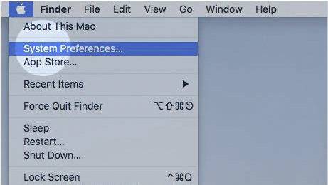
To automatically install MacOS updates, select “Automatically keep my Mac up to date.” Click OK.
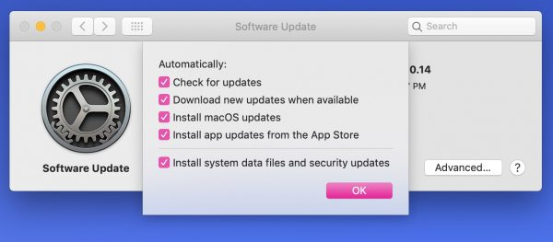
To set advanced update options, click Advanced, then do any of the following: To have your Mac check for updates automatically, select “Check for updates.” To have your Mac download updates without asking, select “Download new updates when available.” To have your Mac install macOS updates automatically, select “Install macOS updates.”

