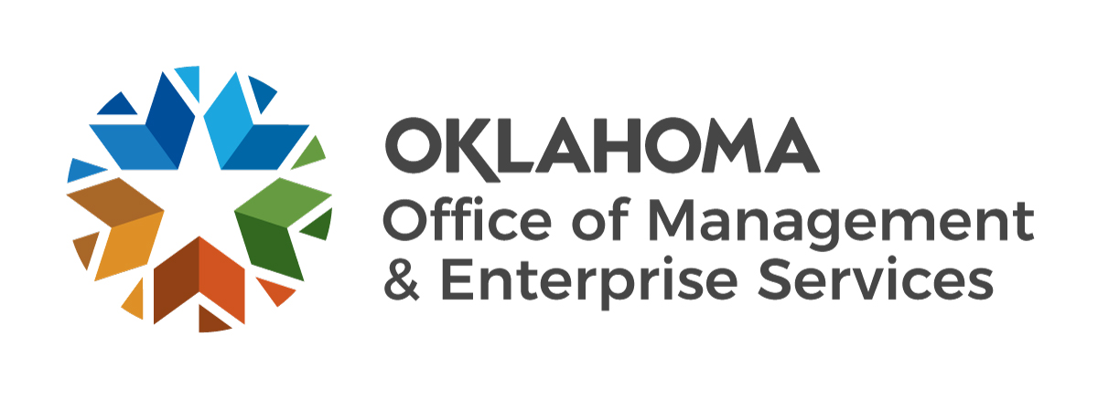 |  | Wish List for Federal Property Donation Program to Receive Federal Surplus Property  (41 CFR 101- 44.207)

Submit to: Property Distribution, OMES Capital Assets Management, 304 S. Miller Place, Oklahoma City, OK 73108;
Telephone: 405-425-2700 or 800-789-6776; Fax: 405-425-2713.

CONTACT INFORMATION
Name of organization |  |  |  |  | Contact name
Street address |  |  |  |  |  |  |  |  | City |  | State |  | ZIP code
P.O. Box number |  |  | County |  |  |  |  | Federal ID number
Phone number |  |  | Fax number |  |  |  |  | Email
DESCRIPTION OF PROPERTY
1.
2.
3.
4.
5.
6.
7.
8.
9.
10.
11.
12.
13.
14.
15.
16.
17.
18.
19.
20.

