# COR132 Purchase Order

# Matching Manual

Table of Contents

Document History 5

Matching a Voucher to PO 6

Creating a Direct Purchase Order 6

Step 1 – Enter Purchase Order Data 6

Step 2 – Update Header Details 8

Step 3 – Enter Item ID 8

Step 4 – Enter the Header Comments 11

Standard Comments 13

Step 5 – Verify Line Item Details 16

Step 6 – Verify Shipping Details and Enter Distribution Information. 18

Schedule 18

Distribution Information 19

Step 7 – Matching 21

Review the Header Match Status 22

Creating Voucher Against a Purchase Order 26

Step 1 – Enter Voucher Data 26

Step 2 – Copy Purchase Order to Voucher 28

1A 29

1B 31

Step 3 – Review Copied Data 32

Matching Process 35

Step 1 – Match Voucher 35

Step 2 – Review Voucher Match Status 39

Step 3 – Review Voucher Match Exception 41

Step 4 – Fix Match Exception 43

Step 5 – Match Voucher Again 46

Step 6 – Review Purchase Order’s Match Status 46

1A 47

1B 47

1A 48

1B 48

Step 7 – Voucher Remaining PO Quantity 48

Purchase Order’s “Distribute By” 49

Step 1 – Enter Purchase Order Data 49

Step 2 – Update Header Details 51

Step 3 – Enter Item ID 52

Step 4 – Enter the Header Comments 55

Standard Comments 56

Step 5 – Verify Line Item Details 60

Step 6 – Verify Shipping Details and Enter Distribution Information 62

Schedule 62

Distribution Information 63

Step 7 – Matching 64

Review the Header Match Status 64

Creating a Voucher Against a Purchase Order 67

Step 1 – Enter Voucher Data 67

Step 2 – Copy Purchase Order to Voucher 69

1A 70

1B 71

Step 3 – Review Copied Data 72

Step 4 – Save Voucher 75

Step 5 – Match the Voucher 75

Step 6 – Review Purchase Order’s Match Status 75

Setting up Match Rules for Unit Price 77

Step 1 – Set Up Price Tolerance 77

Fixing Match Exceptions 80

Step 1 – Run Match Exception Report 80

Step 2 – Identify the Match Exception 85

Match Rule Table 94

Match Rule Clarification and Resolution Tables 95

Matching Rules Delivered with the System 97

Authorized by: [_EBS_] Original Issue: [05/01/2014]

Maintained by: [____Purchasing Lead___]

Review Date: [05/01/2014]

## Document History

|  |  |  |
| --- | --- | --- |
| **Document Revision** | **Date** | **Description** |
| 1.0 | 10/01/2006 | Initial Document |
| 1.1 | 10/01/2007 | Upgrade Revisions |
| 1.2  2.0 | 06/27/2011  05/01/2014 | ADA Compliance  Upgrade Update |
|  |  |  |

## Matching a Voucher to PO

## Creating a Direct Purchase Order

### Step 1 – Enter Purchase Order Data

Navigation: Purchasing > Purchase Orders > Add/Update POs

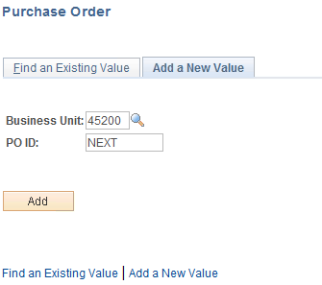

**Business Unit** - Defaults to specific agency for each User.

**Purchase Order Number** - Defaults to NEXT. The system will auto number each Purchase Order.

**NOTE:** Do not change the Purchase Order ID data field. Let the system default NEXT into the data field. The Purchase Order number will be assigned upon saving.

**Click** to take you to the Purchase Order Form page.

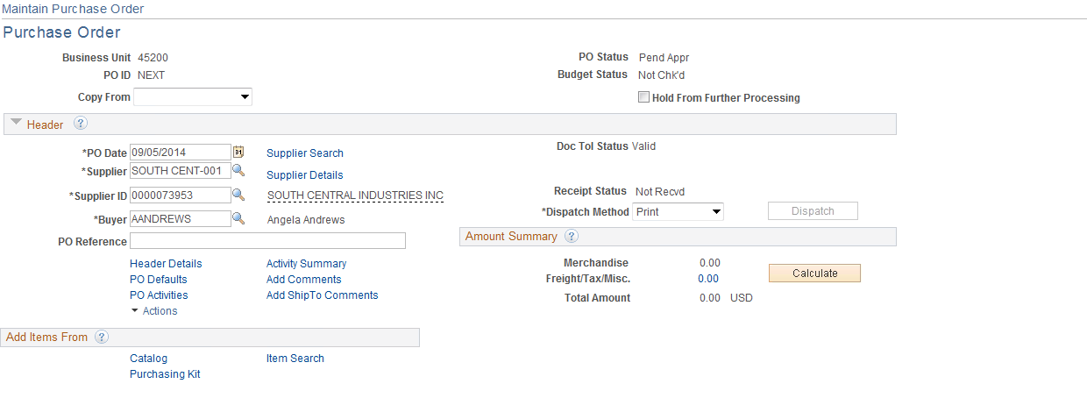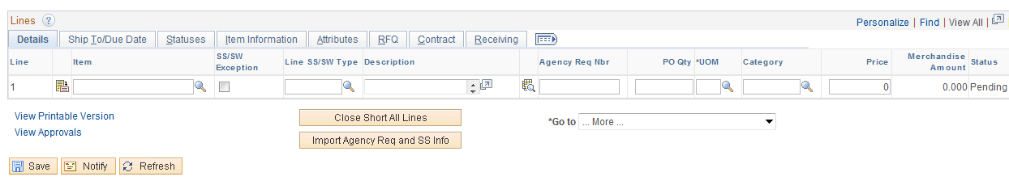

**Enter** the Supplier Number and Buyer’s Name. **Click**  to validate data. (To change the supplier location or address, **click** the Header Details link.)



### Step 2 – Update Header Details

Information entered on this page is associated with the entire Purchase Order.

**Click** the Header Details link.

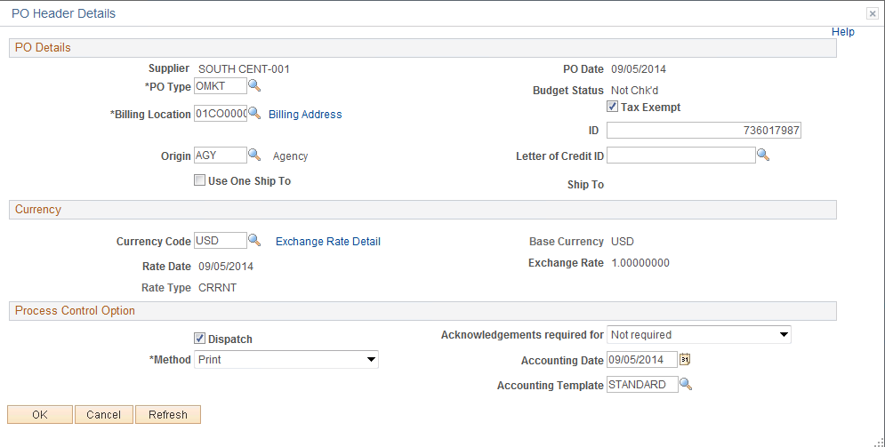

Update information on this page and **click** to return to the Purchase Order Form page.



### Step 3 – Enter Item ID



**Enter** the Item ID and **click** . If the Item ID is not known, **click** the Lookup Icon located to the right of the line.

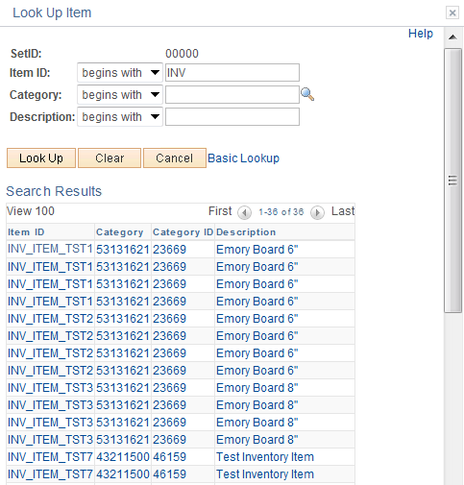

To narrow search results, **enter** an item number, category, or description and **click** .



In this example a description of “EQUIPMENT” was used and received the following results:

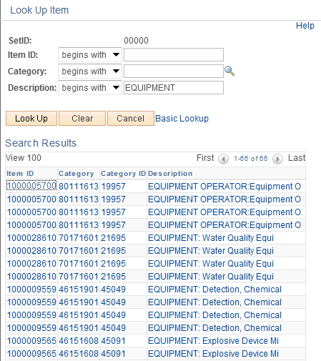

Make selection by clicking the item link.

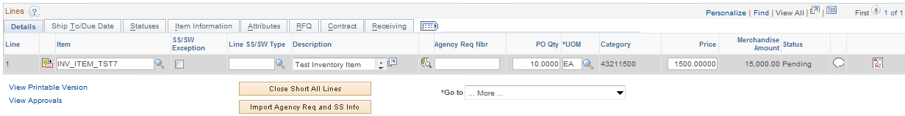

**Enter** the PO QTY and **click** to validate the data.



The Amount defaulted in from the Item ID.

### Step 4 – Enter the Header Comments

Access the Header Comments page by clicking the Header Comments link.

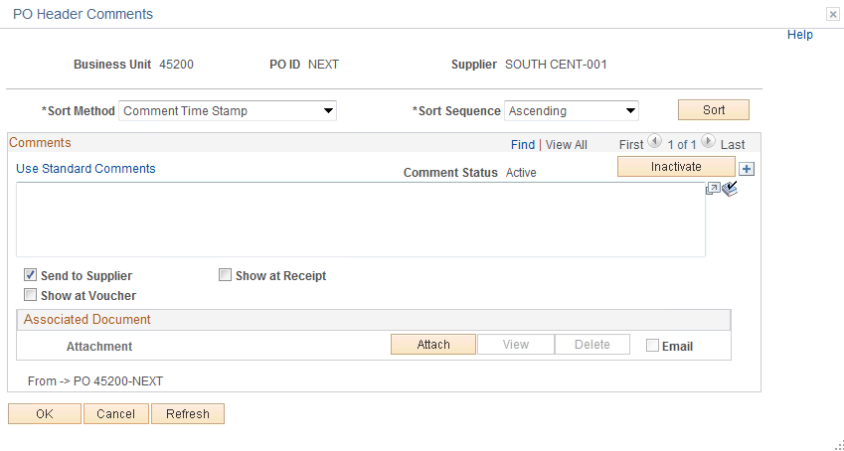

**Enter** any comments that apply to the whole Purchase Order in the Comment Field.

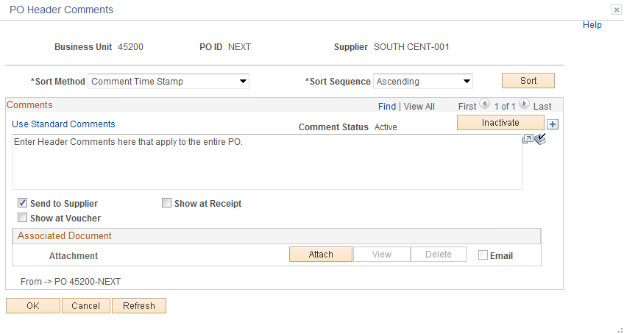

**NOTE:**  The Send to Supplier check box by default will be checked. If you want this comment to appear on the receipt or voucher, check the appropriate box.



PeopleSoft gives you the ability to attach a file to your Purchase Order. Currently this feature is not being utilized.

#### Standard Comments

The Department of Central Services requires certain Purchase Orders to contain certain comments concerning the purchase. Instead of having to type this information into each Purchase Order, DCS has a list of Standard Comments that, when selected, will default in. These comments are called STANDARD COMMENTS and must be added to these Purchase Orders. See DCS rules and regulations: http://www.ok.gov/DCS/Central_Purchasing/index.html.

**Click** the button and the Standard Comments link.

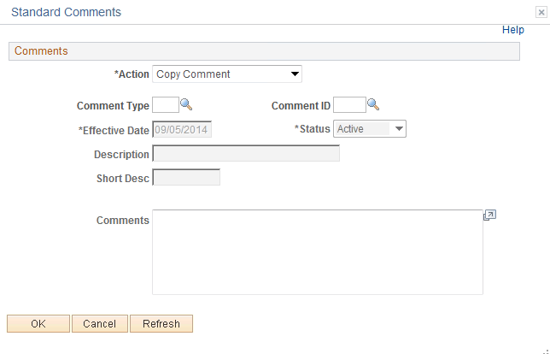

From this page **select** the “Standard Comment” by entering the Comment Type and Comment ID.

If you do not know this information, **click** the Look Up Icon located to the right.



**Click** the Look Up Icon for the Comment Type.

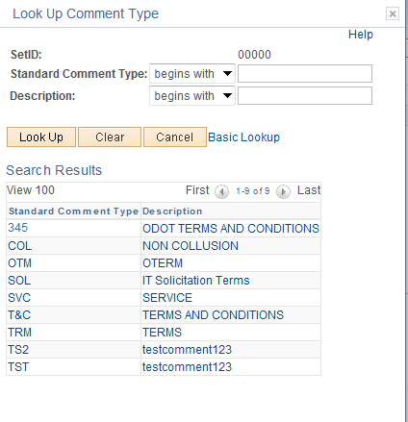

**Select** the comment.

In this example NON COLLUSION will be used.

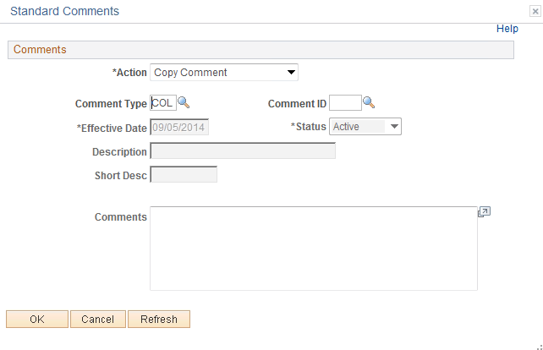

**Click** the Look Up Icon for the Comment ID.

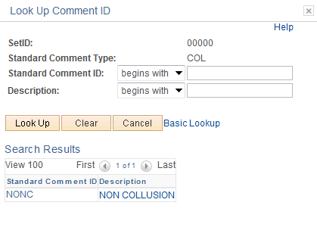

**NOTE:**  The Comment ID is unique to the Comment Type. The Comment ID must have a Comment Type or an error will be received.

**Select** the comment link.

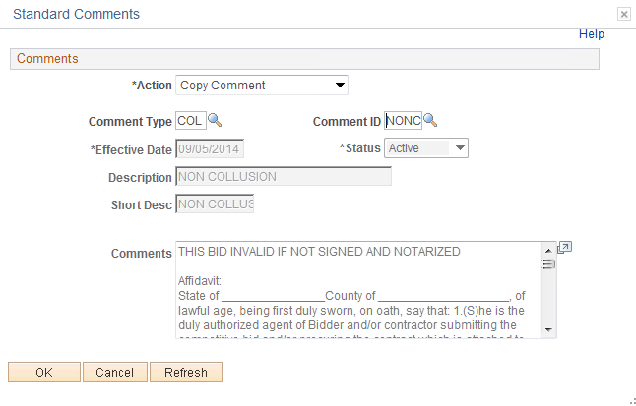

**Click** .

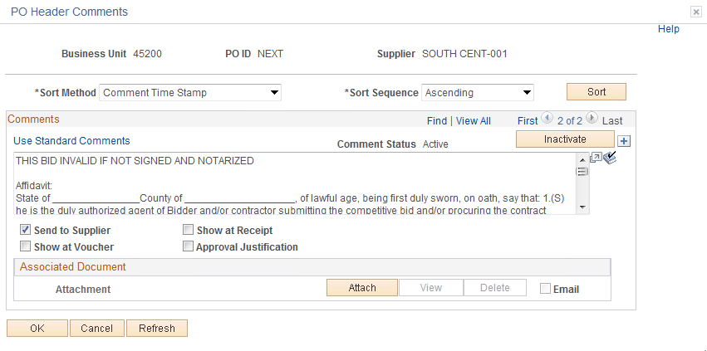

**From (item) link** - If the transaction's comments originated with another transaction, you can click this link to view the originating source transaction. This link is available only if a source is availableFor example, if the PO was copied from another PO containing these comments, you can select this link to view the originating Purchase Order.

**Click** .



### Step 5 – Verify Line Item Details

Under the Lines section of the main PO page, click on the icon on the Line you select to view the Line Details page.



Use the Line Details page to verify or modify additional details on the line.

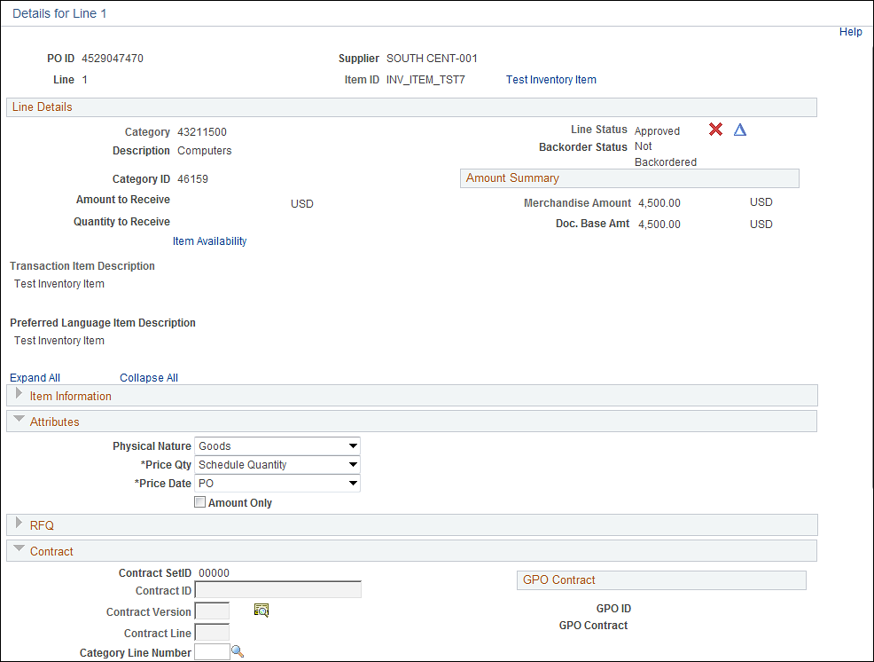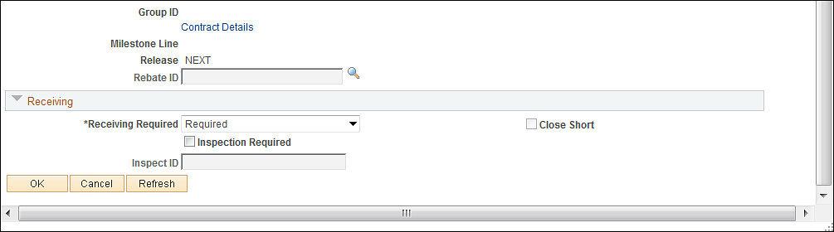

Expand Attributes  to change to Amount Only.



**Amount Only** - This option is used to bypass matching on PO QTY and match only on the Extended Amount.  When this option is selected the PO line must be set up with a PO QTY of “1” and UOM of “SUM”.

Expand Receiving  to alter Receiving as Required or Optional.



**Receiving Required** - This option is used to require the Item Ordered be received and matched to a payment. This option defaults in from the Item ID as being required and must be deselected if not required; otherwise the voucher will fail matching. When Receiving Required is selected this is known as 3-way matching.

**Inspection Required** - This option is used to require the Item Ordered be inspected and matched to a payment. This option does not default in and will need to be selected if used. This option is known as 4-way matching.

Expand Contract  to view and update contract information.



After data has been verified or changed, **click** .

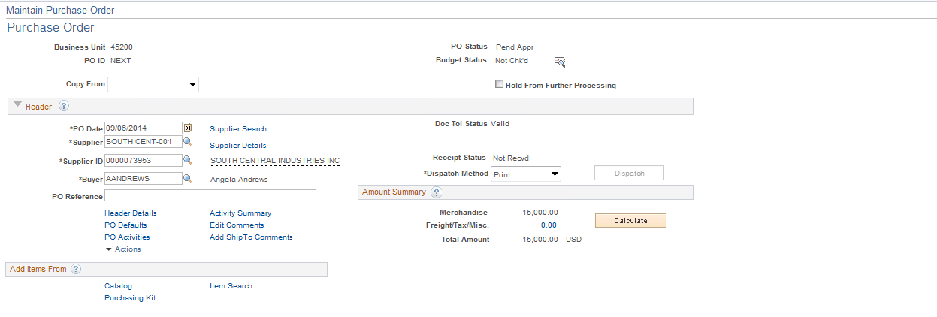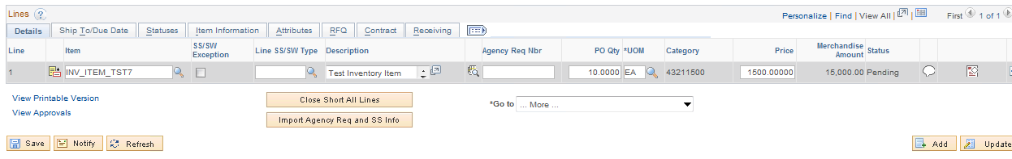

### Step 6 – Verify Shipping Details and Enter Distribution Information.

#### Schedule

Use the Purchase Order Schedule page to specify multiple shipping schedules for each line and to define multiple distributions for each schedule. The Schedule page by default allocates the total by Quantity, but it can also allocate by Dollar amount.

To access the Schedule page, **click** the schedule icon at the far right on the Line Details tab**.**



Schedules page opens.

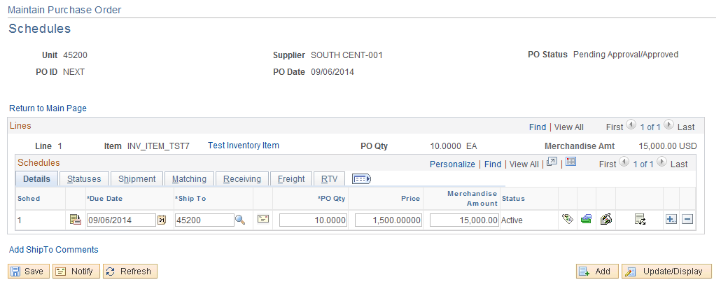

From this Page you can change the Unit Price if needed. (The unit price defaults from the Item ID).

#### Distribution Information

To access the Distributions, **click** the Distributions/Chartfields iconon the far right of the Details tab on the Schedules page.

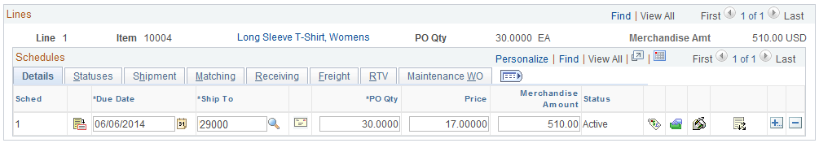

The Distributions page is displayed.

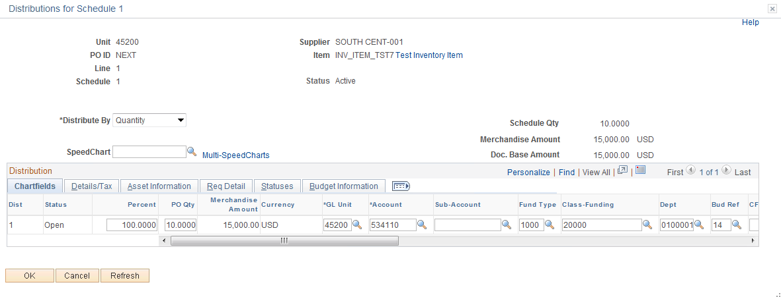

**Distribute by**:

* **Quantity -** Defaults if nothing is selected. Used when ordering quantities.
* **Amount** - Used for 1 sum, mostly contracts.

In this example, the PO line is distributed by Quantity.

**Enter** the Fund, Class Department, Bud Ref and any other information needed. To change the account, **enter** the value or **click** the Look Up Icon .



**Click** to validate the data.



**Click** .



### Step 7 – Matching

Matching is a flexible process that compares vouchers with purchase orders and receiving documents to ensure that you are paying for what you ordered and received. The system automatically performs the required matching based on the document characteristics. The purchase order header sets the match control for all applicable lines. At the purchase order line schedule level, you can also specify if matching is required. The only time matching is not required are for Authority Orders.

* **Two-way matching** compares vouchers and purchase orders if receiving-required is not enabled on the purchase order.
* **Three-way** **matching** compares vouchers, purchase orders, and receipts, if inspection-required is not enabled on the receiver.
* **Four-way matching** compares vouchers, purchase orders, receivers, and inspections if inspection is required.
* **Receipt-only matching** compares vouchers to receipts.

Open the PO.

## Review the Header Match Status

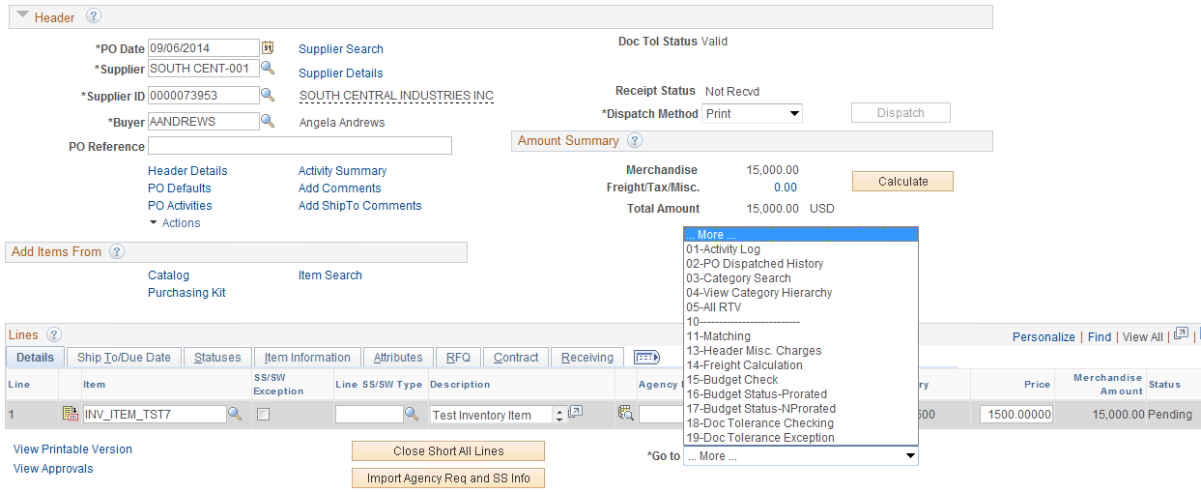

**Click** the dropdown button on .



The choices are displayed.

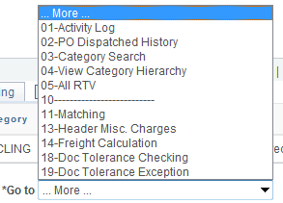

**Select** 11-Matching link. The link will show what kind of matching has been set.

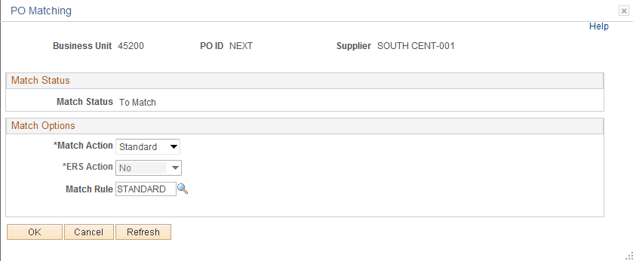

**Click** the dropdown button and **select** No Match. This should never be done unless it is on an Authority Order, (when you select the AO supplier, this will automatically default to “NO MATCH”). The match rules prevent users from creating payments that exceed the Purchase Order and Purchasing Schedule Detail quantities and amounts.



Match action defaults in from the supplier set up.

* All Supplier’s PO(s) Default is set to Match (Except AO)
* Authority Order Supplier Default is set to “No Match”
* The Header matches on Supplier number and Supplier Location.

**Click** .

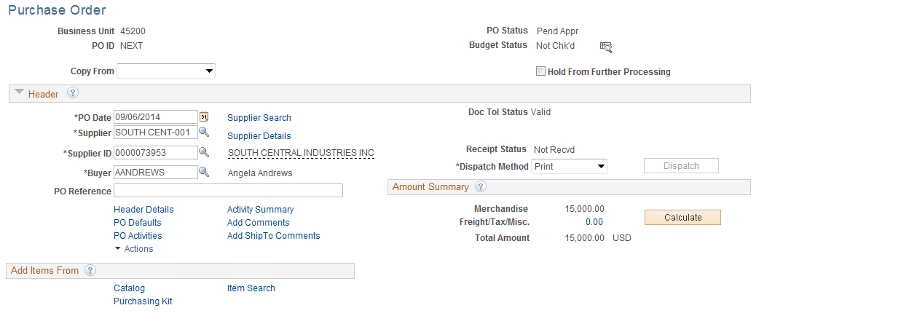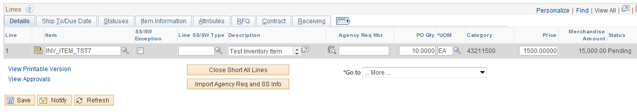

**Click** the Schedule icon on the far right of the Line Details tab**.**

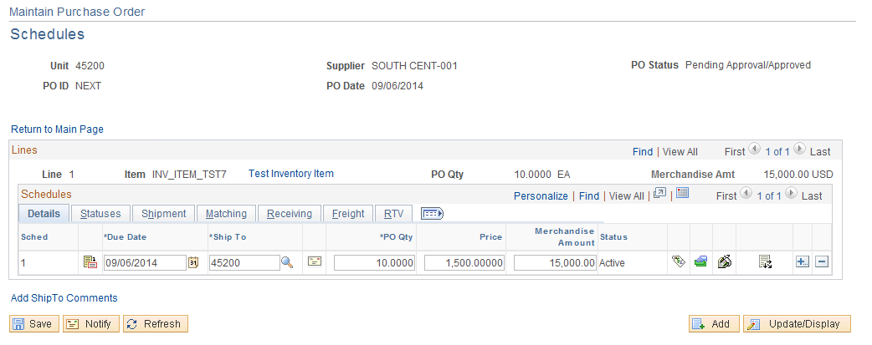

To review the Match Status on a PO Schedule **select** the **Matching Tab**.

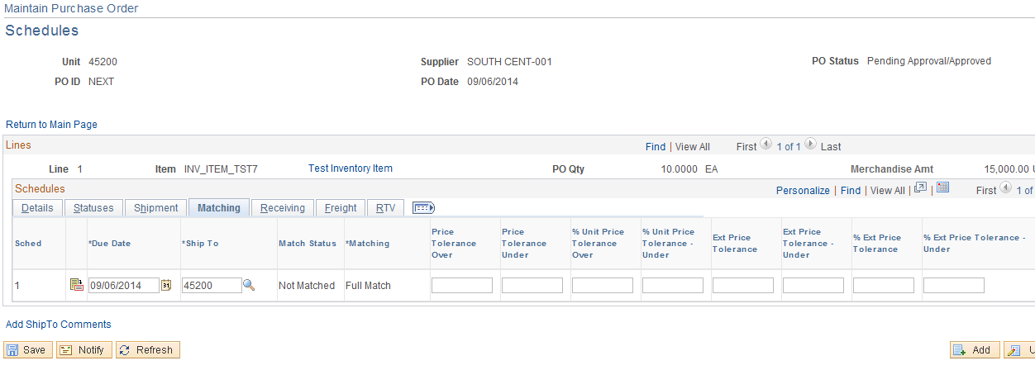

The Matching Field should be set to “Full Match” unless it is an Authority Order.

Schedule matches on:

* Quantity
* Extended amount

**Matching Controls and Receiving Controls** - Defaults in from the Item ID.

The PO is now ready to be saved, pre-approved, budget checked, approved, dispatched, and printed.

## Creating Voucher Against a Purchase Order

### Step 1 – Enter Voucher Data

Navigation: Accounts Payable > Vouchers > Add\Update > Regular Entry

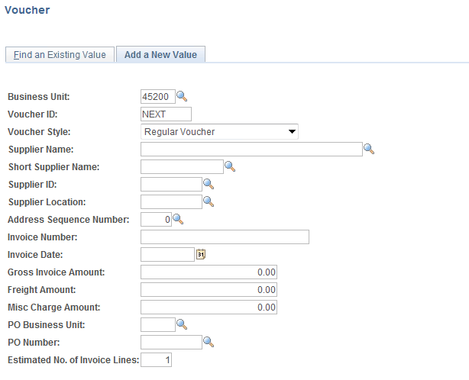

**Business Unit** - Defaults to specific agency for each user.

**Voucher Number** - Defaults to Next. The system will auto number each Voucher.

**Voucher Style -** Defaults to Regular and should not be changed when creating a voucher that requires payment to a supplier.

**NOTE:**  Do not change the Voucher ID field. Let the system default to NEXT into the data field. The Voucher number will be assigned upon saving.

**Enter** only the Invoice number and invoice date fields.

**Enter any other fields for which you have information.**

**If you are copying from a PO, you may enter PO information here or on the Voucher, or you may create the voucher first and then copy from PO.**

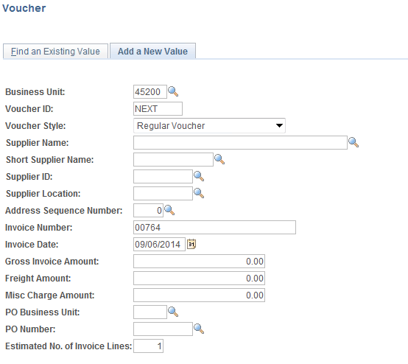

**Click** .

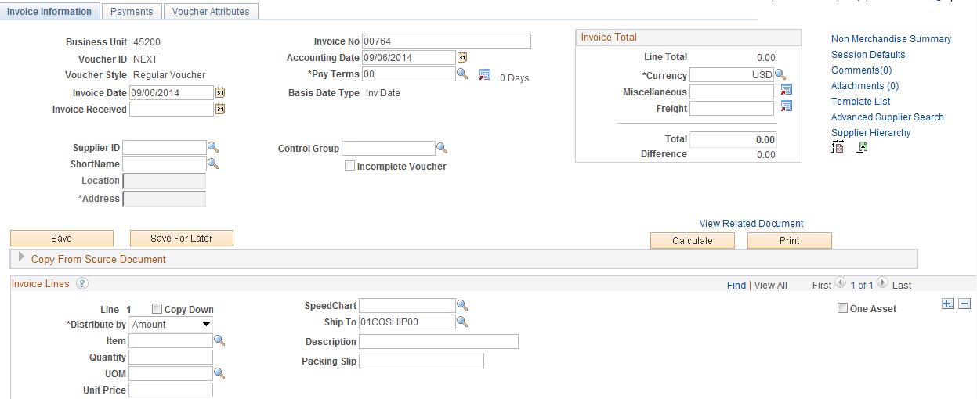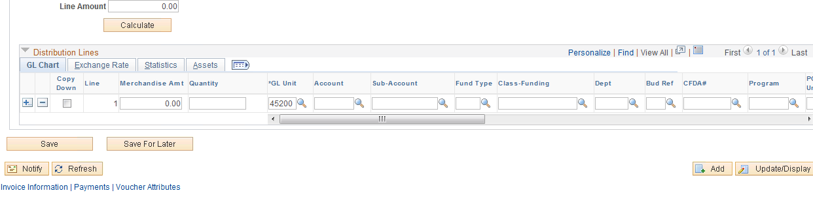

**NOTE:**  Entry Status is “Open”, the Voucher ID is “NEXT”, the Budget Status is “Not Chk’d”, and the Post Status is “Unposted”.

The Accounting Date defaulted to today’s date and should not be changed.

### Step 2 – Copy Purchase Order to Voucher

There are two other methods of copying from a PO, if the option was not chosen on the initial Create Voucher screen.

1. **Click** the Copy from Source Document dropdown arrow button.



**Enter** the PO Unit and PO Number.



**Click** .



In order for the PO to be available for vouchering:

* PO must be dispatched
* PO/Schedule must not be fully matched.
* The PO cannot be closed or canceled.

1. The second method of copying a PO while in the voucher, is to use the Copy From dropdown.

Click on Purchase Order only to select the PO to be copied.

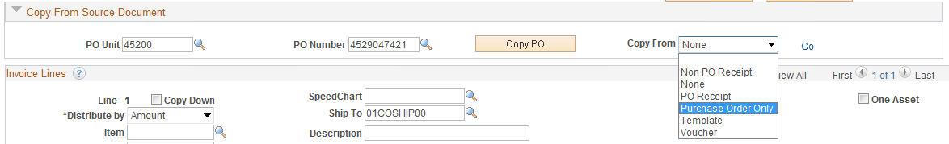

#### 1A

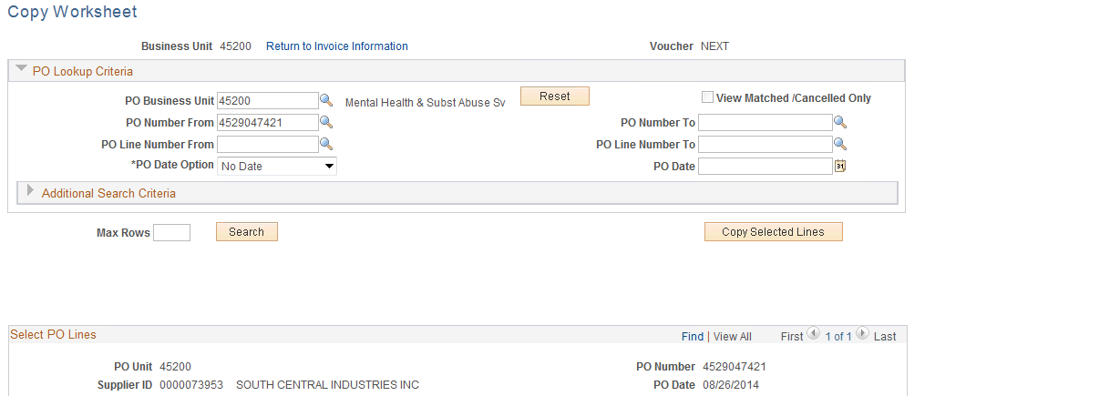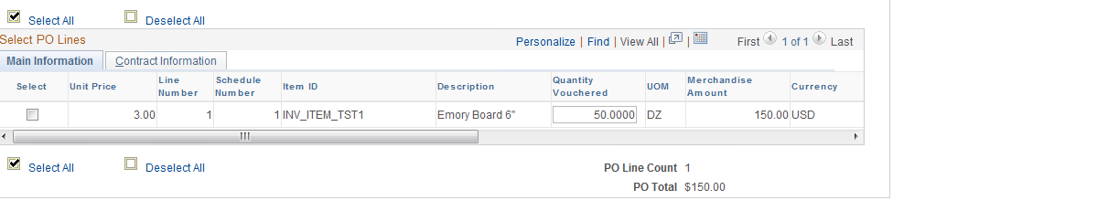

This “Quantity Vouchered” is what is available for vouchering. If the value is zero then there are no available quantities and it will fail matching.

**NOTE:** By selecting the correct “Distribute By” method, if the quantity is zero, it will not be available for vouchering at all.

**Select** the Check Box located to the left of the PO Line/Schedule to copy to the voucher.



The lines are copied to the voucher through the Copy PO function. To add or remove voucher lines use the add/delete buttons on the line level.



If you are vouchering for more/less quantity, you may change it at the line level.

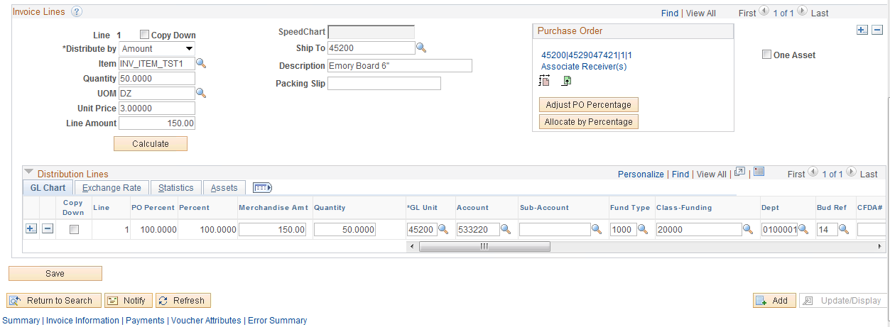

The PO is copied to the voucher by Line Number and Schedule Number. Click on the Purchase Order link to view.

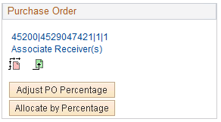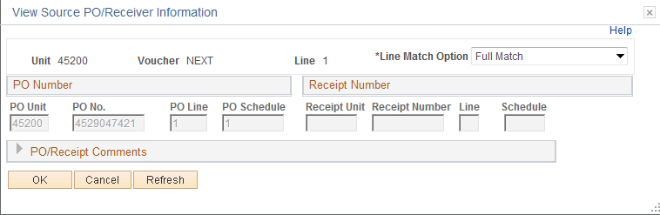

In order for the PO line to be available for vouchering:

• PO line must not be fully matched.

• PO line cannot be closed or inactive.

• At least one PO distribution line on the PO line cannot be finalized.

#### 1B

After the voucher matches successfully against the PO, the Quantity will be updated with the available amount.

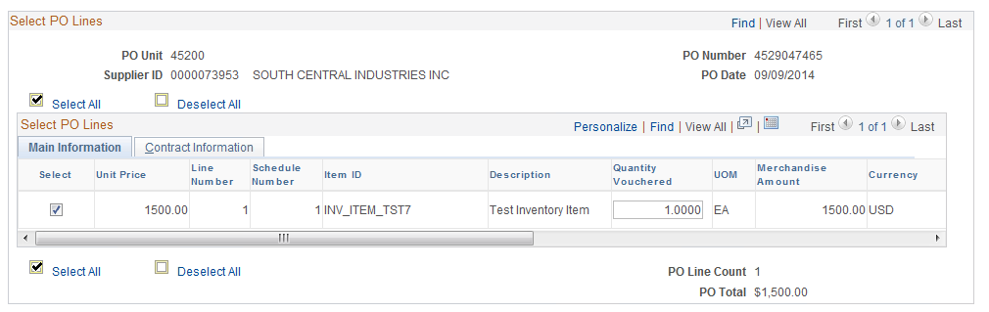

**Click** .



### Step 3 – Review Copied Data

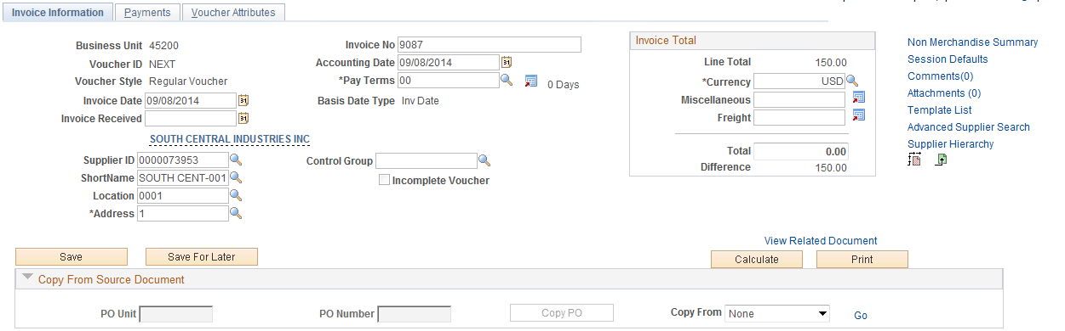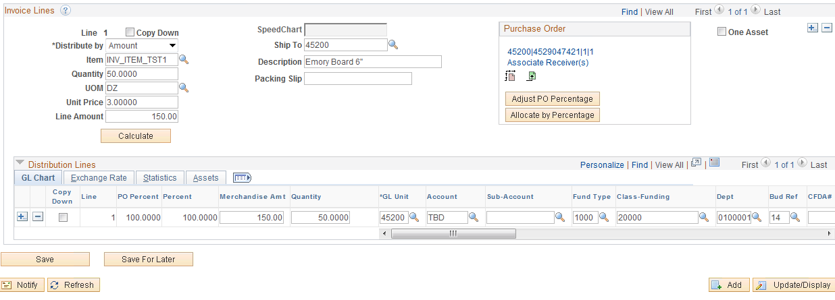

Check the Supplier information, line details and distribution line.

The information that copies to the voucher line when the PO is distributed by quantity is as follows:

* The Quantity is what is available to match against the Purchase Order. The quantity must be changed on the voucher line if the actual quantity on the invoice is less than the available quantity copying into the voucher.
* The unit is price is accessible and can be changed, but payers should notify their supervisors or CPOs if the invoice and PO unit price differs so that it can be addressed timely.
* The Extended Amount field is not accessible. Payers can change the "*Distribute by" field from "Quantity" to "Amount" after copying the PO that is distributed by quantity. This will activate the Extended Amount field; however, the matching tables are updated based on the calculation of quantity x unit price so it is crucial that the extended price mathematically computes based on the information entered in the quantity and unit price fields. If the CPO enters the information correctly on the PO, there would be few reasons to change the "Distribute by" field (rounding sometimes is an issue requiring the payer to activate the Extended Amount field).

The information that copies to the voucher distribution line when the PO is distributed by quantity is as follows:

* The quantity copied to the voucher distribution line is the quantity on the PO distribution line. The sum of the quantities on the voucher distribution lines must be changed to agree to the voucher line quantity. In this example, there is only one distribution line so the voucher distribution line quantity would be changed from 3.0000 to 2.0000.
* The amount copied to the voucher distribution line is the original amount encumbered on the PO distribution line. It is imperative that payers have access to the outstanding encumbrances on the daily Outstanding Orders report so they can ensure a PO distribution line has adequate encumbrance. A PO line with available amount to voucher may have PO distribution lines that have been fully liquidated.
* The chartfield combination also copies from the PO distribution lines. If the account code TBD copies to a voucher distribution line, then the voucher should not be processed (saved) until the account code on the PO has been changed to the correct code. If there are multiple distribution lines, including one or more containing TBD that is (are) not needed to make the payment, the line(s) can be deleted so the voucher can be processed. Once a voucher is saved against a PO distribution line, the PO distribution line will gray out so that funding changes can no longer be made.

To validate the data **click** located in the bottom left hand corner.

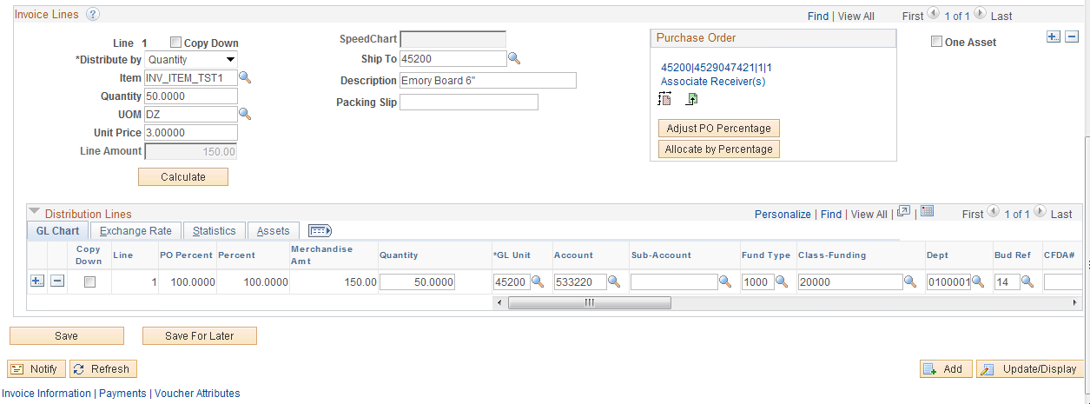

**Click** the Purchase Order and Receiver link in the Purchase Order section at the line level.

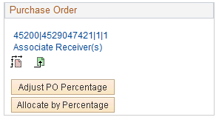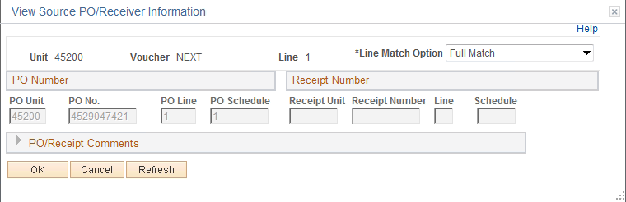

From this page you can see the PO number, PO line, and PO Schedule. The voucher line is attached to the Line Match Option of Full Match copied from the PO schedule and should not be changed.

**Click** .

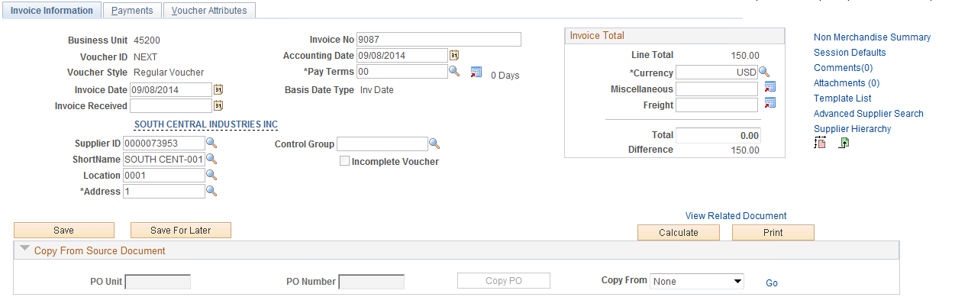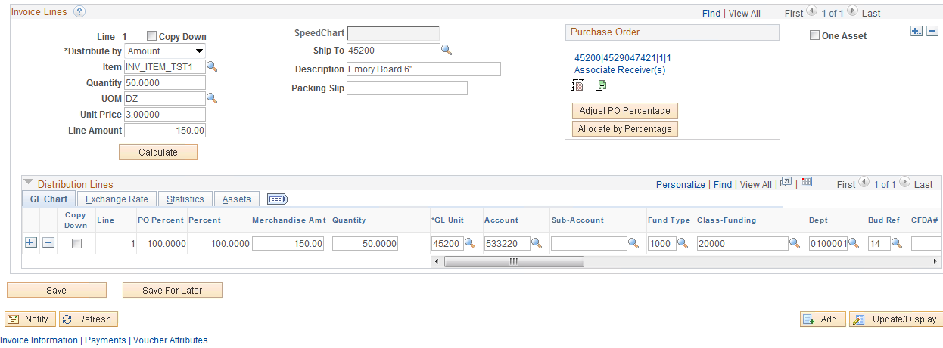

**Enter** the invoice amount in the Total Field and **click** .



## Matching Process

### Step 1 – Match Voucher

The matching process compares the Voucher to the PO and if all criteria are met the voucher will match. If an exception is found, the voucher will fail matching.

Navigation: Accounts Payable > Batch Processes > Vouchers > Matching

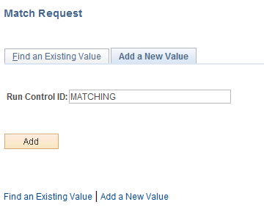

**Click** Tab



**Enter** a “Run Control ID” and **click** .

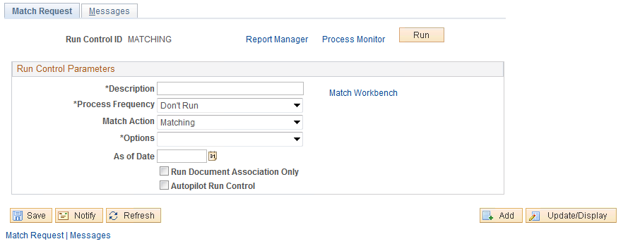

**Enter** a description, change the Process Frequency to “Always Process”, and change the OPTIONS to “VOUCHER”.

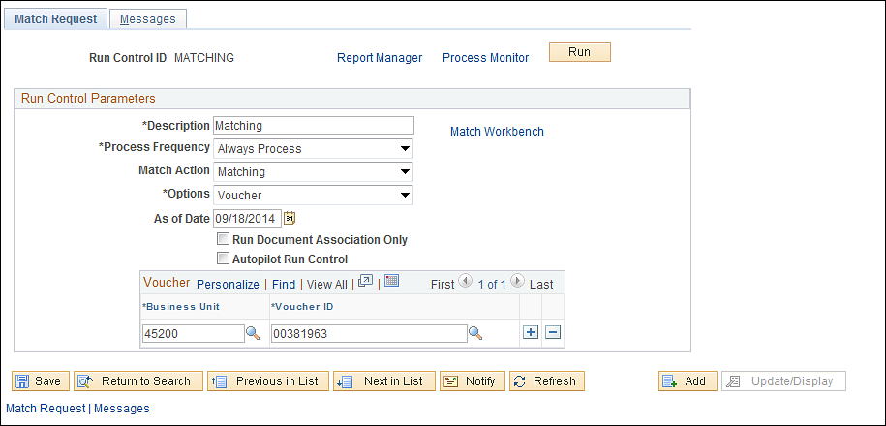

**Enter** Business Unit and Voucher ID.

**Click** .

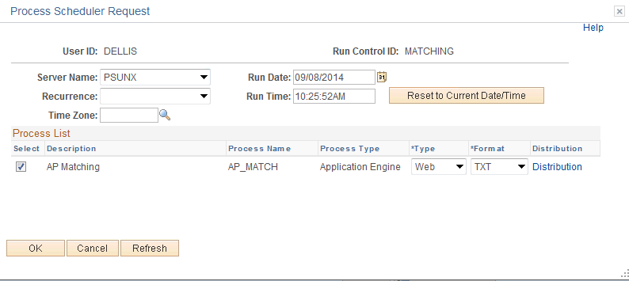

**Enter** **PSUNX** as the Server Name and check the AP/PO Matching box. **Click** .

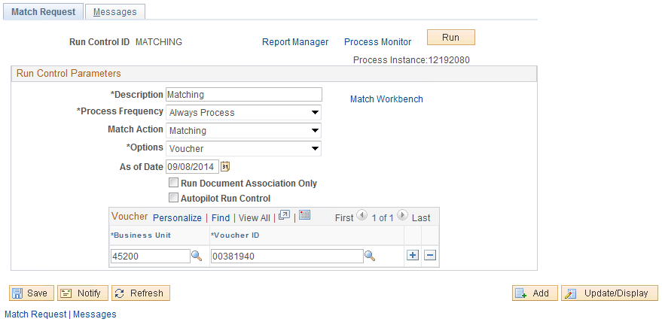

To review your process, **click** the Process Monitor link.

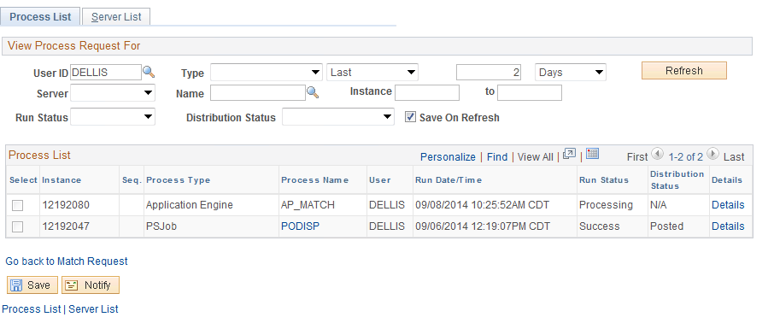

**Click** the button, repeatedly, until the Run Status is Success and the Distribution Status is Posted.



**Click** Details link to review the status of your job.

### Step 2 – Review Voucher Match Status

Navigation: Accounts Payable > Vouchers > Entry > Regular Entry

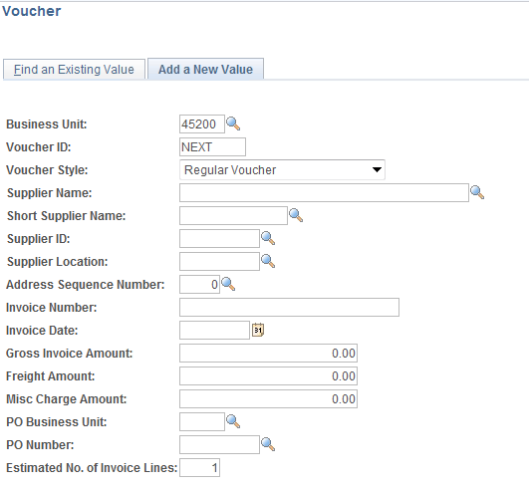

**Click** Find an Existing Value Tab.

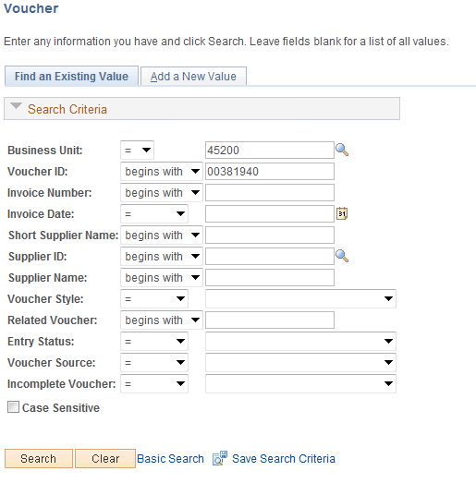

**Enter** the voucher number and **click** .

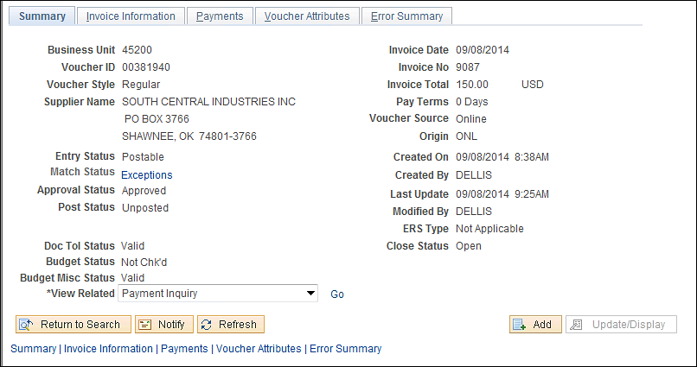

**Click** the Summary Tab.

The voucher match status can be seen on the Summary Tab, if the status is Exceptions, there will be a hyperlink.

Statuses equal:

* Ready
* No Match
* Matched
* Exceptions

### Step 3 – Review Voucher Match Exception

**Click** the Exceptions link. A new window will open.

NOTE: The window will take a couple of minutes to open.

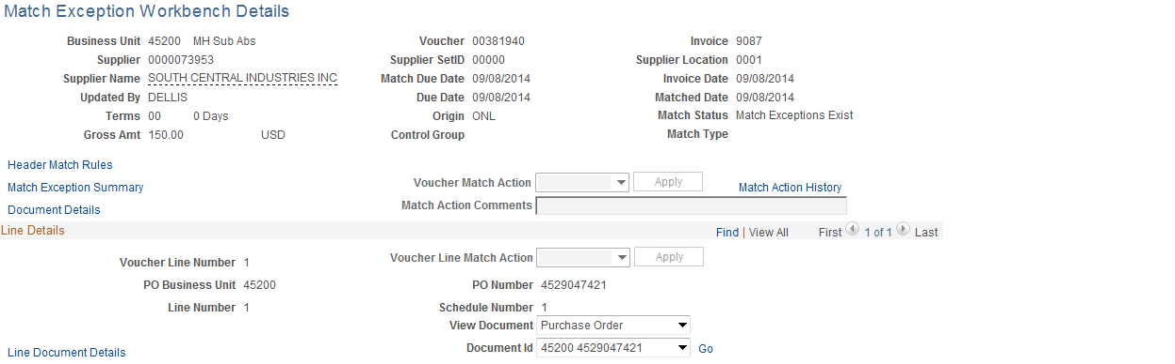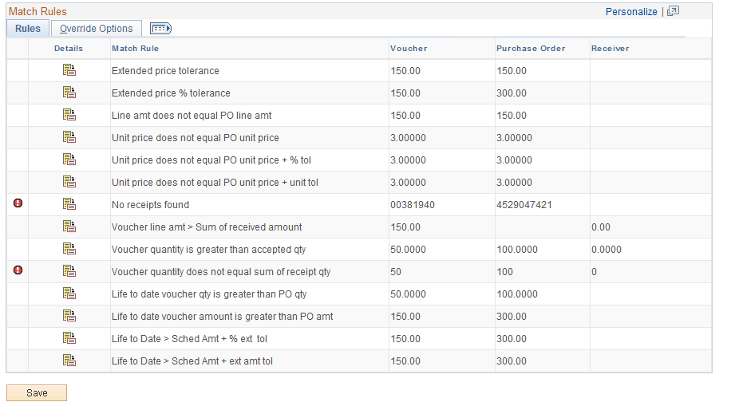

**Click** the icon next to the icon located under Exceptions Log. A new window will open.

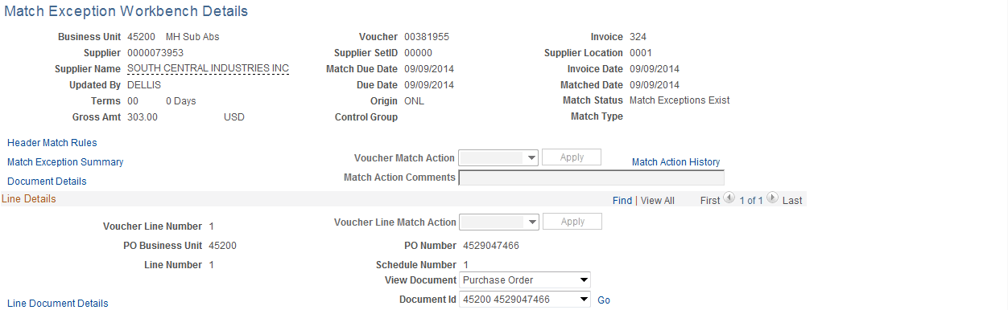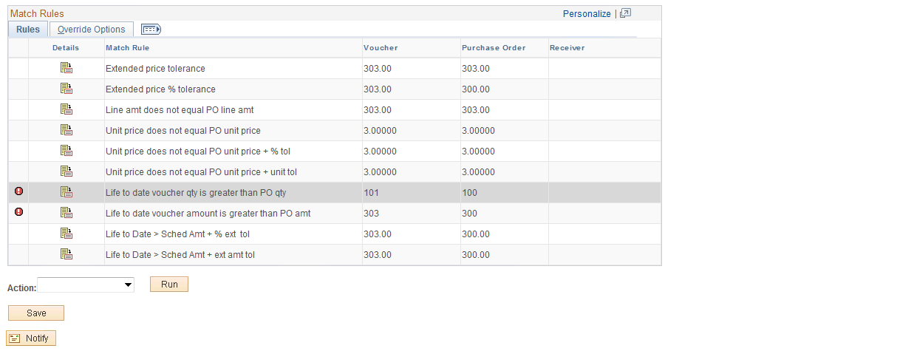

**NOTE:** The override option is not available in production. Match exceptions are not to be overridden and the PO is not to be changed to No Match. The problem must be fixed.

To determine what the match exception is stating or how to fix the problem, review **Matching Rules Delivered with the System** at the end of this manual for details. In this case we are going to assume receiving is not being utilized so we will turn receiving off.

### Step 4 – Fix Match Exception

Navigation: Purchasing > Purchase Orders > Maintain Purchase Orders

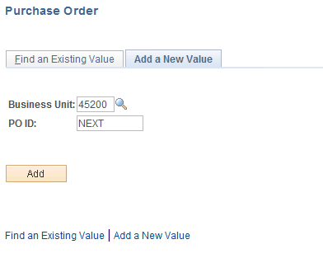

**Click Find an Existing Value** Tab**.**

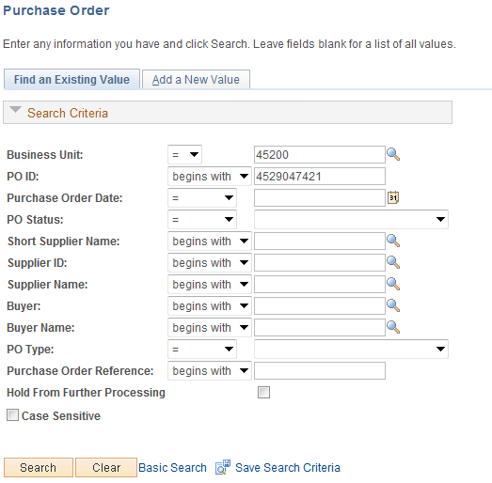

**Enter** PO Number and **click** .

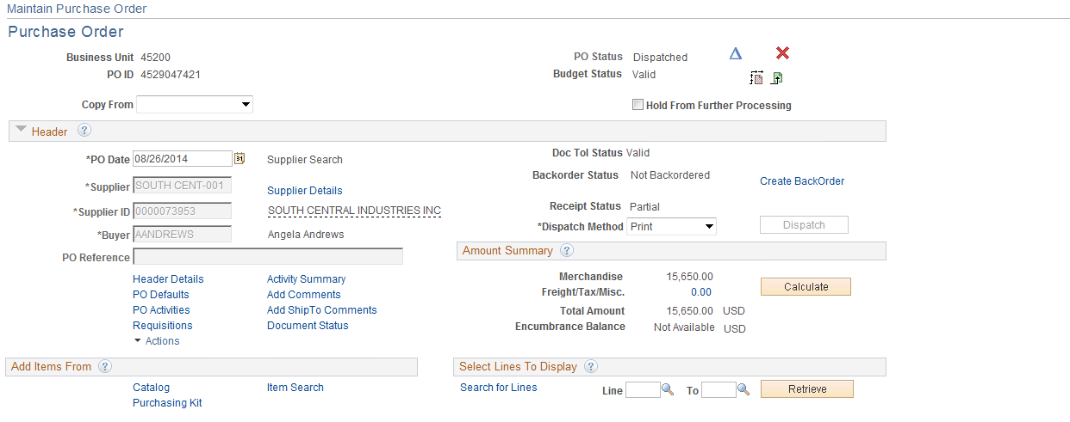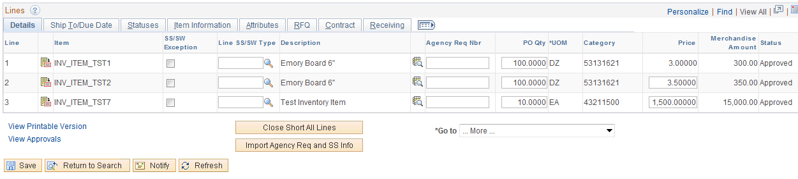

**Click** the icon located on the left side of the line to be changed.

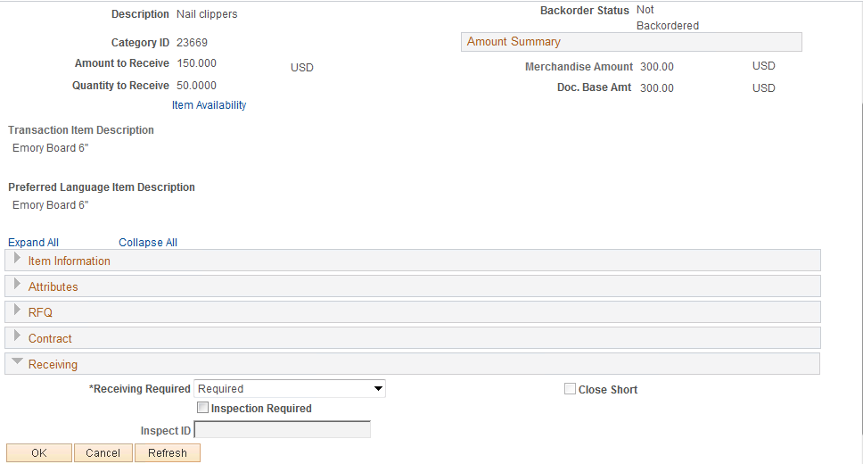

Choose “Optional” from the dropdown and **click** .



**Click** . Notice this was not a change order.



### Step 5 – Match Voucher Again

Match the voucher again by following Step Numbers 1- 4.

### Step 6 – Review Purchase Order’s Match Status

Navigation: Purchasing > Purchase Orders > Review PO Information > Purchase Orders

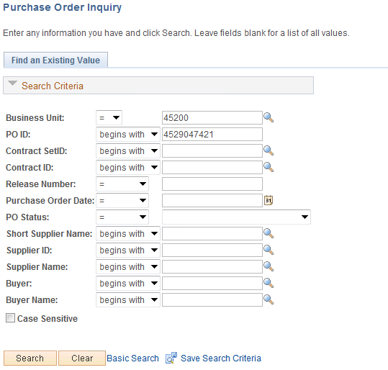

**Enter** the PO number and **click** .

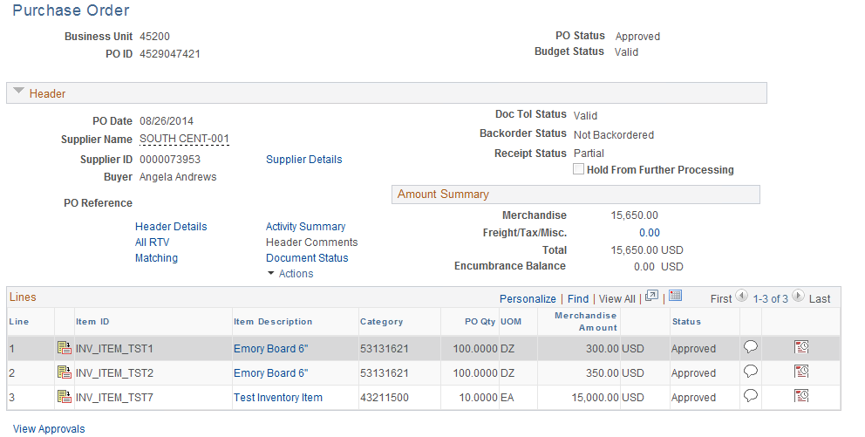

**Click** the[Matching](javascript:submitAction_win2(document.win2,'PO_INQ_WRK_GOTO_MATCHING');) link.

#### 1A

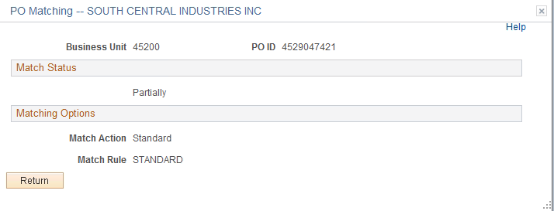

#### 

#### 1B

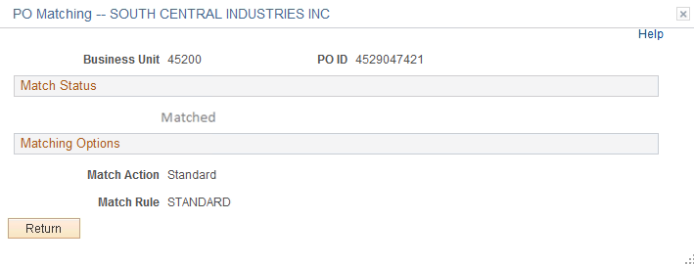

When the PO Quantity fully matches, the status will change.

**Click** .



**Click** Schedule icon on the Line Details tab.

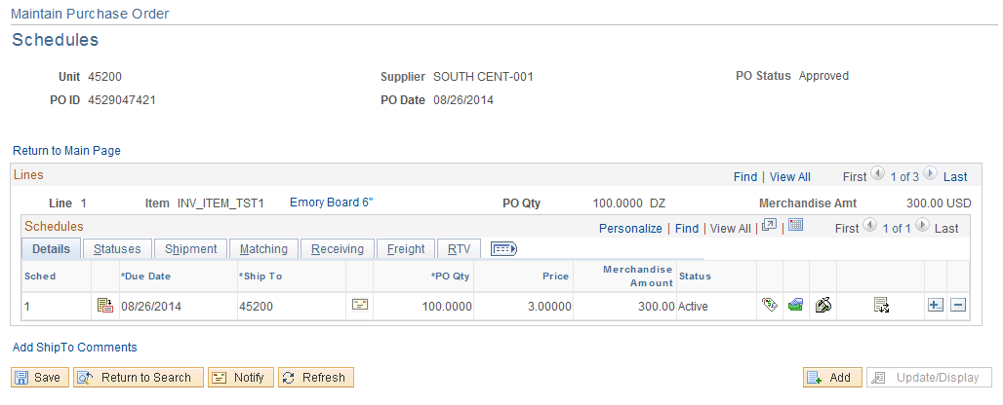

**Click** on the Matching tab and/or Schedule Details icon.



#### 1A

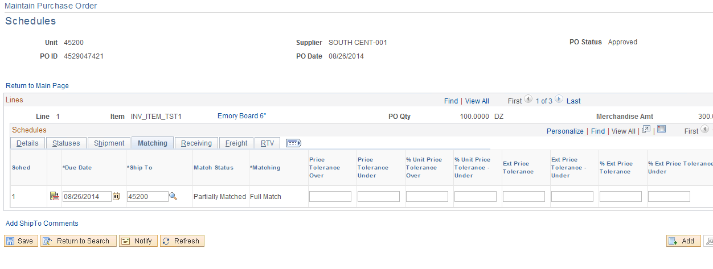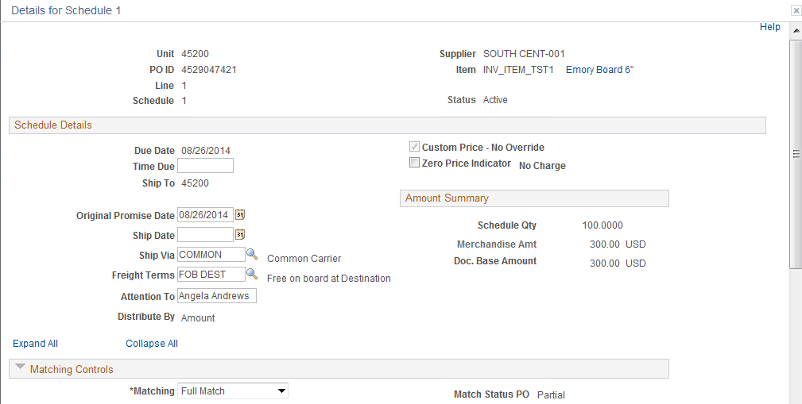

#### 1B

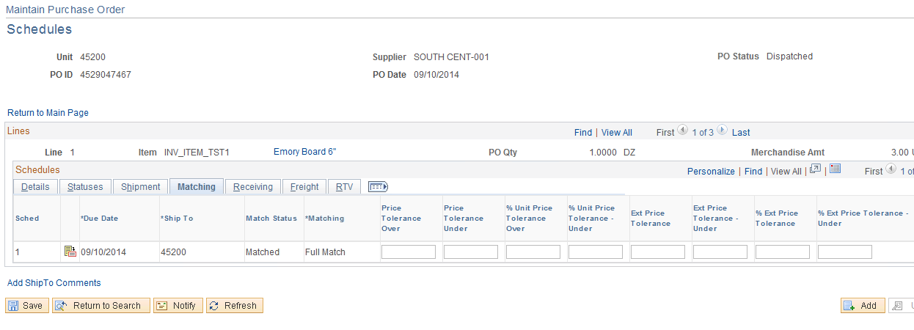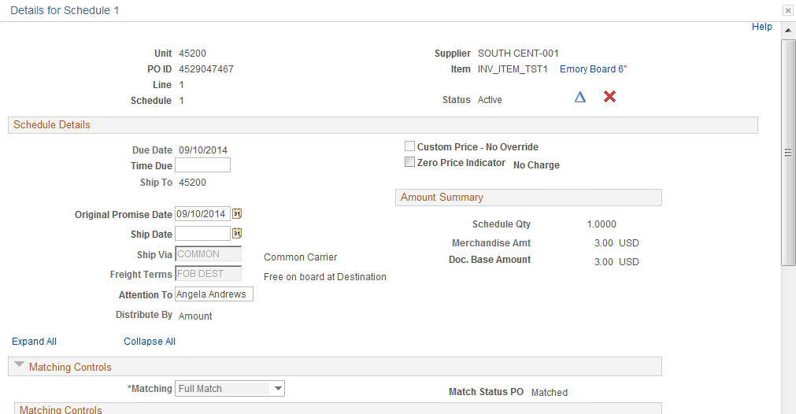

When the PO Schedule fully matches, the Quantity the status will change.

**Click** , then **click** Return to Main Page link.



### Step 7 – Voucher Remaining PO Quantity

Voucher against the remaining quantity go to Creating Voucher Against a Purchase Order on page 26.

## Purchase Order’s “Distribute By”

### Step 1 – Enter Purchase Order Data

Navigation: Purchasing > Purchase Orders > Maintain Purchase Orders

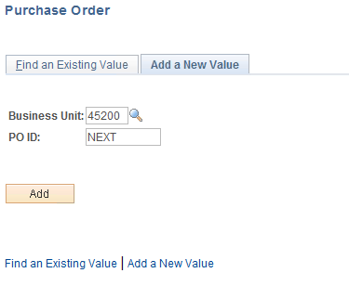

**Business Unit** - Defaults to specific agency for each User.

**Purchase Order Number** - Defaults to NEXT. The system will auto number each Purchase Order.

**NOTE:** Do not change the Purchase Order ID data field. Let the system default NEXT into the data field. The Purchase Order number will be assigned upon saving.

**Click**  to take you to the Maintain Purchase Order page.

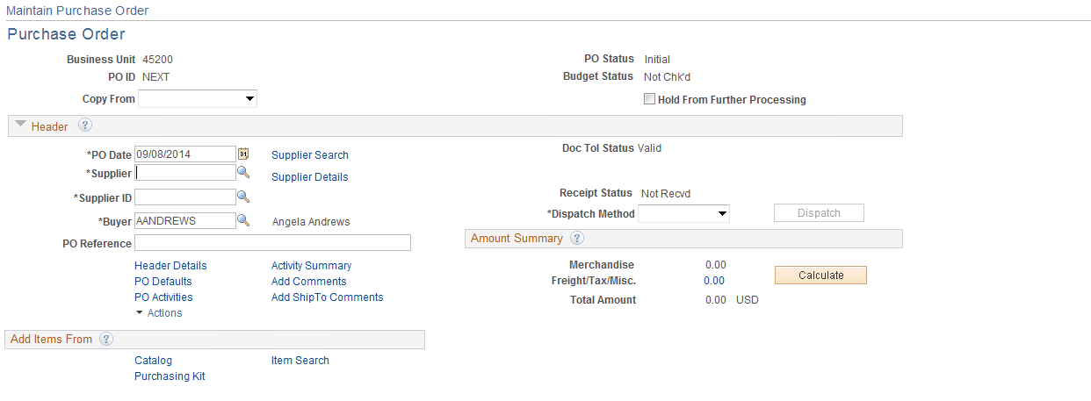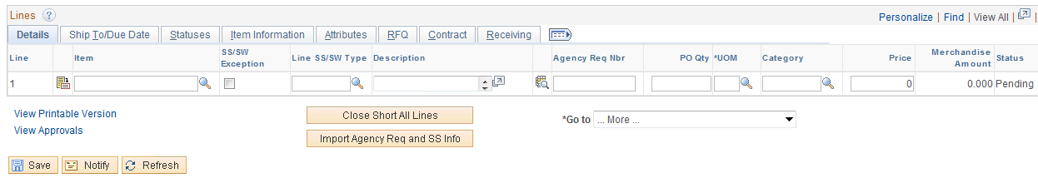

**Enter** the Supplier Id Number and Buyer’s Name. **Click** to validate data.

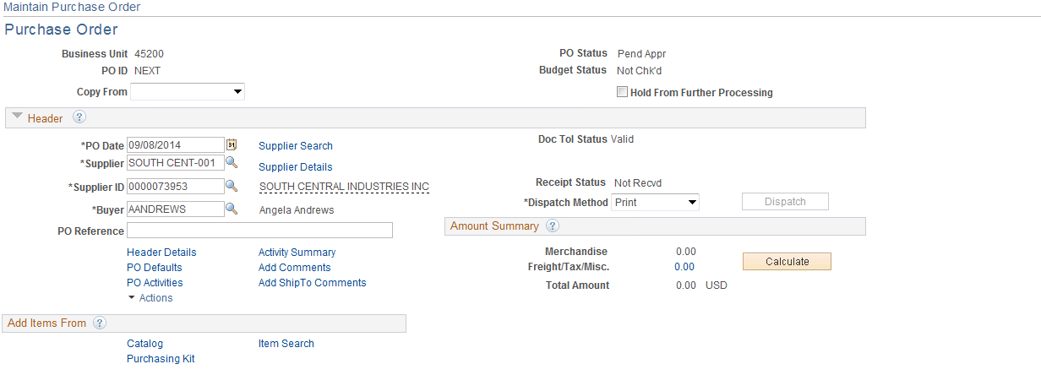

### Step 2 – Update Header Details

Information entered on this page is associated with the entire Purchase Order.

**Click** the Header Details link.

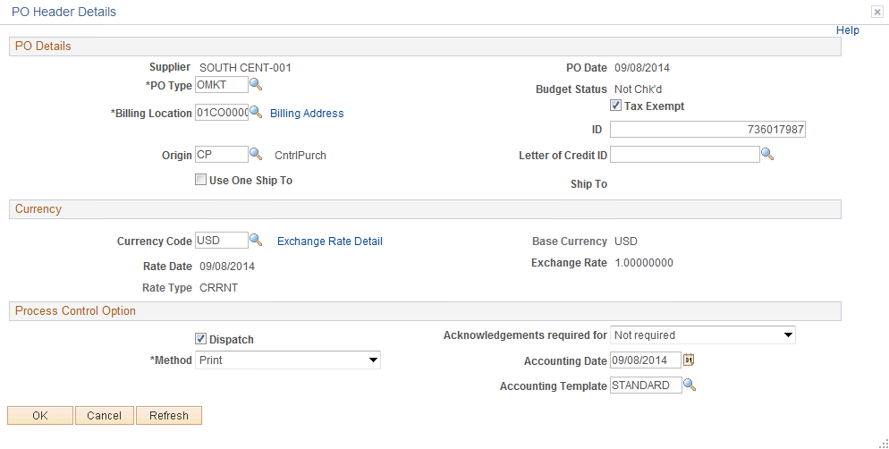

Update information on this page and **click** to return to the Purchase Order Form page.



### Step 3 – Enter Item ID



**Enter** the Item ID and **click** . If the Item ID is not known, **click** the Look Up Icon.

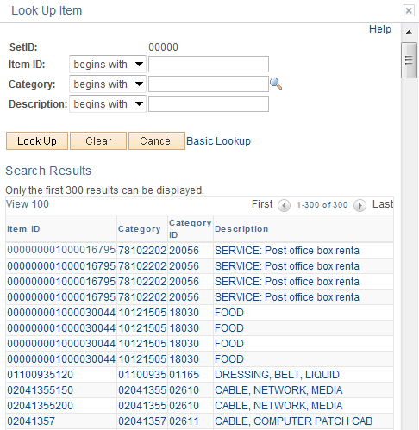

You can narrow your results by entering an item number, category, or description and **click** . In this example a description of “EQUIPMENT” was used and received the following results:

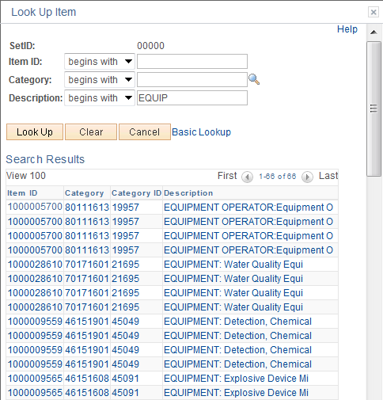

Make your selection by **clicking** on link.

The item information will default into the line.

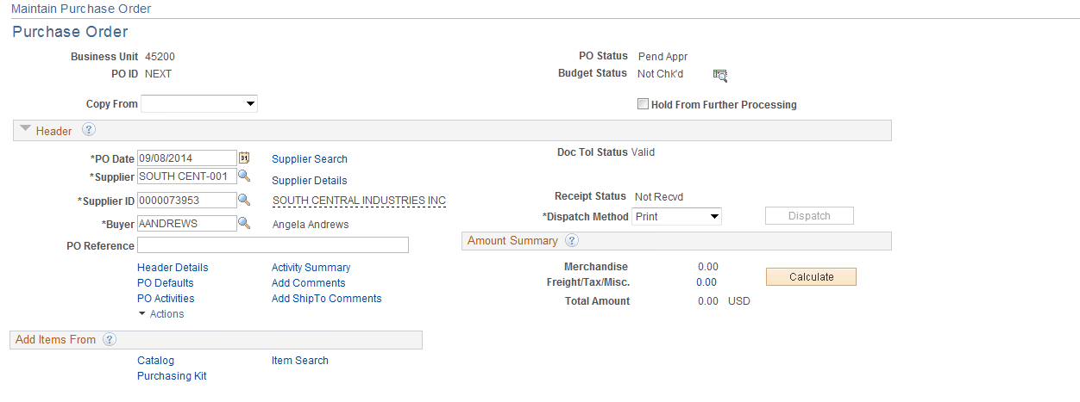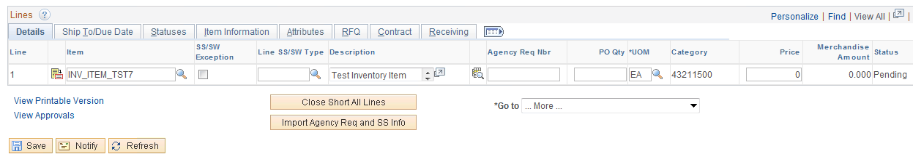

Enter the PO QTY and click to validate the data.

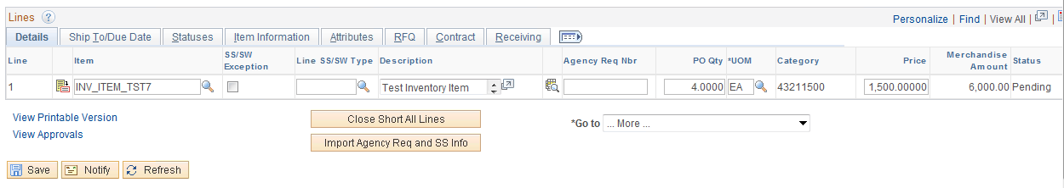

The Amount defaulted in from the Item ID.

### Step 4 – Enter the Header Comments

Access the Header Comments page by **clicking** the Add Comments link.

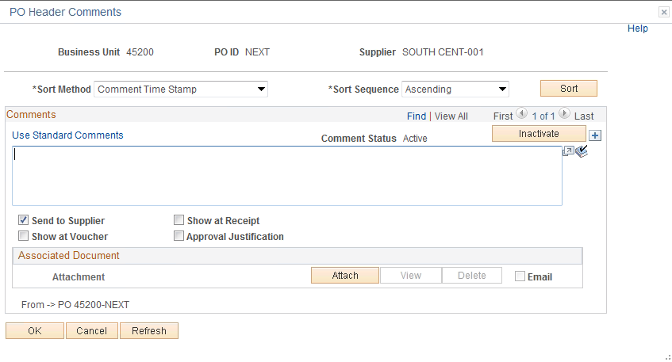

**Enter** comments that apply to the whole Purchase Order in the Comment Field.

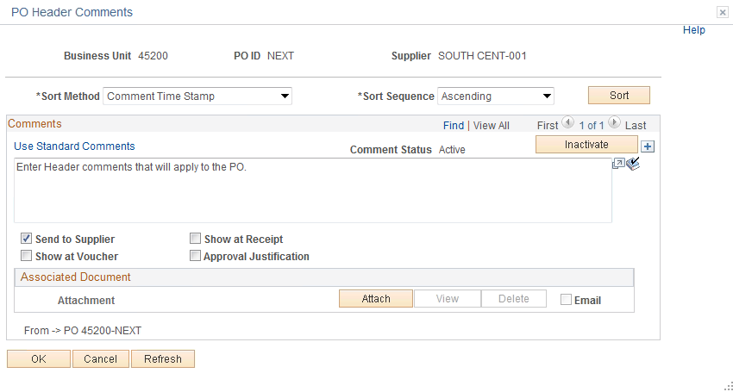

**NOTE:** The Send to Supplier check (box by default will be checked. If you want this comment to appear on the receipt or voucher, check the appropriate box. In this example **click** the Shown at Voucher box.



PeopleSoft gives you the ability to attach a file to your Purchase Order. Currently this feature is not being utilized.

#### Standard Comments

Use the Standard Term Listing Report to obtain the Standard Comments

Navigation: Purchasing > Purchasing Orders > Reports > Standard Term Listing Report

**Enter** Ocppo0090

**Click** in the upper right hand corner and then the Use Standard Comments link.



On the PO Header Comments Page, click the in the upper right corner of the Comments page to add a line to the comments. Then click the [Use Standard Comments](javascript:submitAction_win0(document.win0,'COMM_WRK1_STD_COMMENT_PB$0');) link.

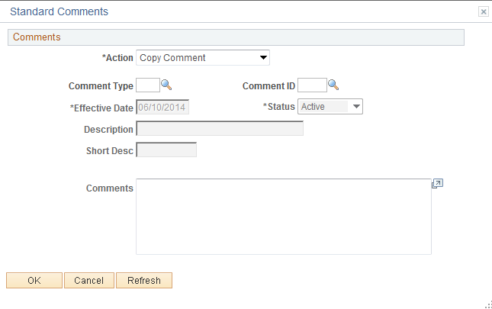

From this page you can select the “Standard Comment” by completing the Comment Type and Comment ID fields. If you do not know this information, **click** the Look Up Icon .



**Click** the Look Up Icon for the Comment Type.

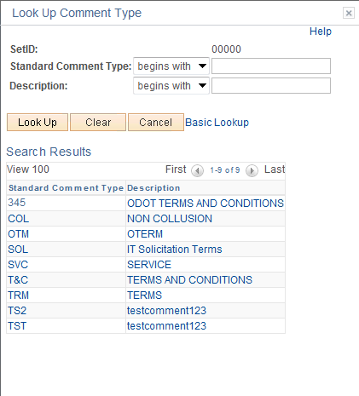

**Select** the comment by **clicking** the comment link. In this example Non Collusion will be used.

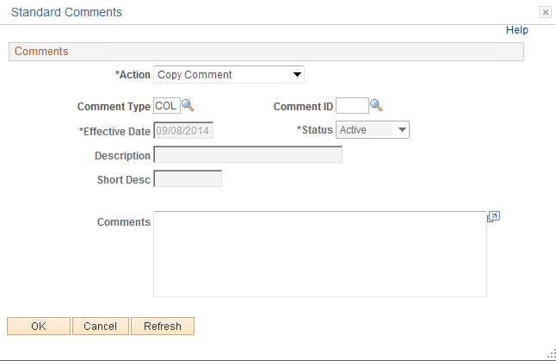

**Click** the Look Up Icon for the Comment ID.

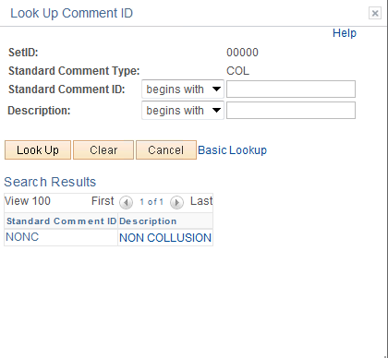

**NOTE:** The Comment ID is unique to the Comment Type. The Comment ID must have a Comment Type or an error will be received.

**Select** the comment by **clicking** on the link.

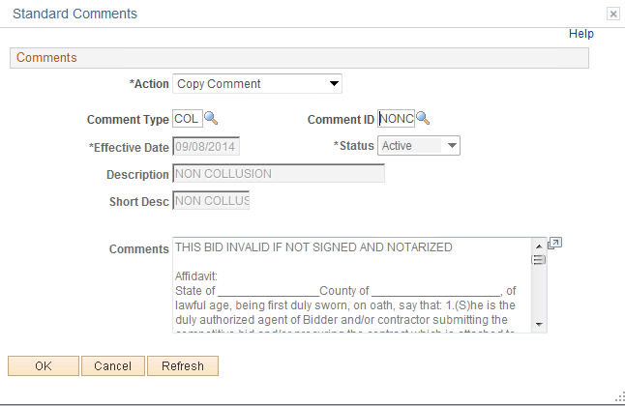

**Click** .

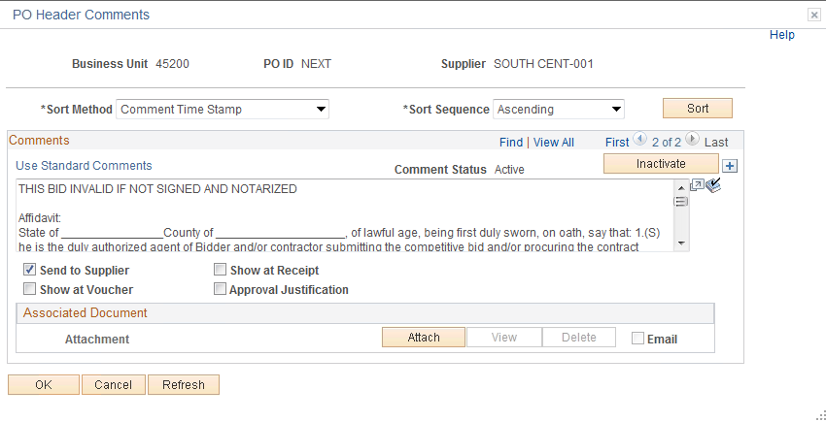

**Click** .



### Step 5 – Verify Line Item Details

Use the Line Details icon to verify or modify additional details on the line. **Select** the Line details icon located to the left of the line on the Maintain Purchase Order page. **Click** the icon.

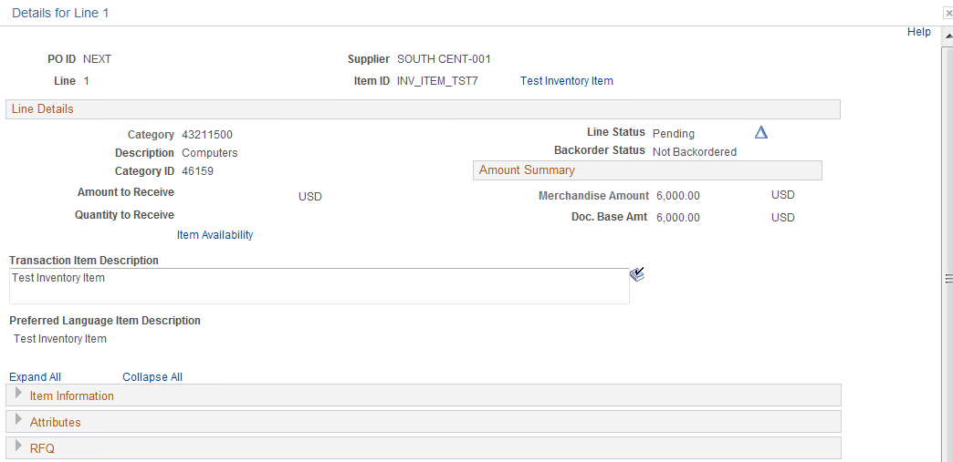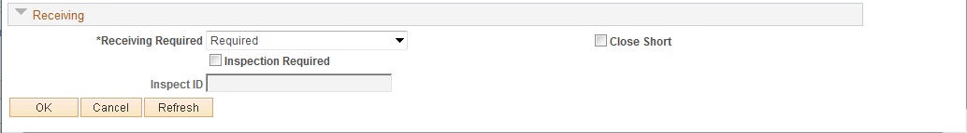

**Receiving Required** - This option is used to require the Item Ordered be received and matched to a payment. This option defaults in from the Item ID as being required and must be deselected if not required; otherwise the voucher will fail matching. When Receiving Required is selected this is known as 3-way matching.

**Inspection Required** - This option is used to require the Item Ordered be inspected and matched to a payment. This option does not default in and will need to be selected if used. This option is known as 4-way matching.

**Select** “Optional”.

**Click**  .



### Step 6 – Verify Shipping Details and Enter Distribution Information

#### Schedule

Use the Purchase Order Schedule page to specify multiple shipping schedules for each line and to define multiple distributions for each schedule. The Schedule page by default allocates the total by Quantity, but it can also allocate by Dollar amount.

**Click** the Schedule icon at the end of the Line Details line which you wish to verify.

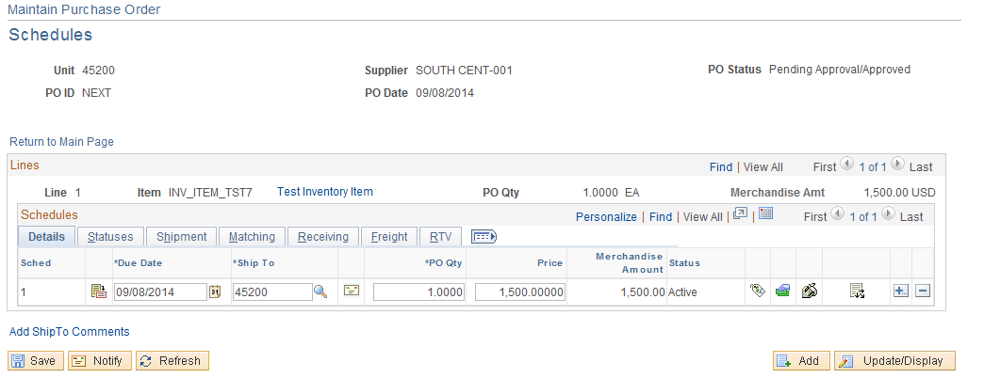

On the Schedule Tab you can change the Unit Price, if needed.

**NOTE:** The unit price defaults from the Item ID.

#### Distribution Information

To access the Distribution page, **click** the Distributions icon.

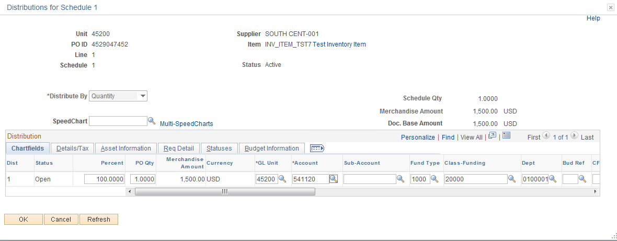

**Distribute by:**

* **Quantity** - Defaults if nothing is selected. Used when ordering quantities.
* **Amount** - Used for 1 sum, mostly contracts.

The selection made will determine when the Purchase Order will be considered fully matched. If “Distribute By” is QTY, it will be considered fully matched when all quantities have been vouchered and matched. If “Distribute BY” is Amount, the Purchase Order will be considered fully matched when total extended amount has been vouchered and matched.

In this example, the PO line is distributed by “Quantity”.

**Enter** the Fund, Class Department, Bud Ref and any other information needed. If needed, you can change the account by entering the value or **click** the Look Up Icon .



**Click** to validate the data and **click** .



### Step 7 – Matching

Matching is a flexible process that compares vouchers with purchase orders and receiving documents to ensure that you are paying for what you ordered and received. The system automatically performs the required matching based on the document characteristics. The purchase order header sets the match control for all applicable lines. At the purchase order line schedule level, you can also specify if matching is required. The only time matching is not required are for Authority Orders.

* Two-way matching compares vouchers and purchase orders if receiving-required is not enabled on the purchase order.
* Three-way matching compares vouchers, purchase orders, and receipts if inspection-required is not enabled on the receiver.
* Four-way matching compares vouchers, purchase orders, receivers, and inspections if inspection is required.
* Receipt-only matching compares vouchers to receipts.

**Return to Maintain Purchase Order page**.

#### Review the Header Match Status

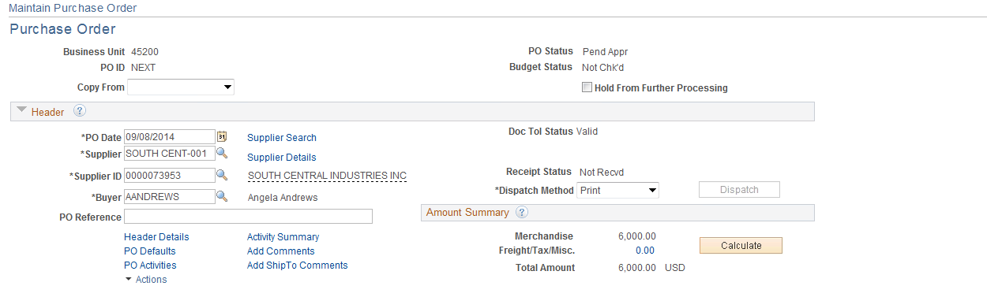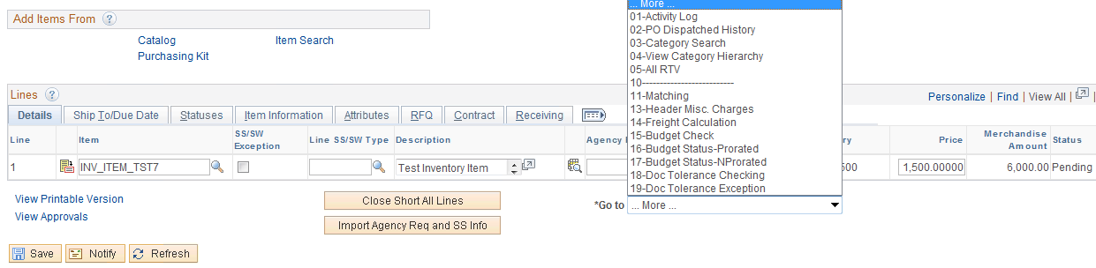

**Click** the button located to the right of the "More" menu**. Select** No. 11-Matching link. The link will show what kind of matching has been set.

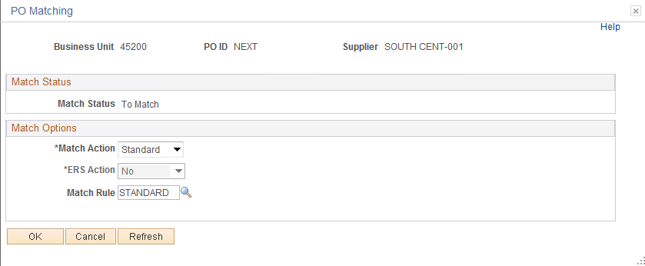

You can change the PO’s Match Action to “No Match” by **clicking** the button and selecting No Match. This should never be done unless it is on an Authority Order. When you select the AO supplier, this will automatically default to “NO MATCH”. The match rules prevent users from creating payments that exceed the Purchase Order and Purchasing Line Schedules quantities and amounts.



Match action defaults in from the supplier set up.

* All Supplier’s PO(s) Default is set to Match (Except AO)
* Authority Order Supplier Default is set to “No Match”
* The Header matches on Supplier number and Supplier Location.

**Click** .

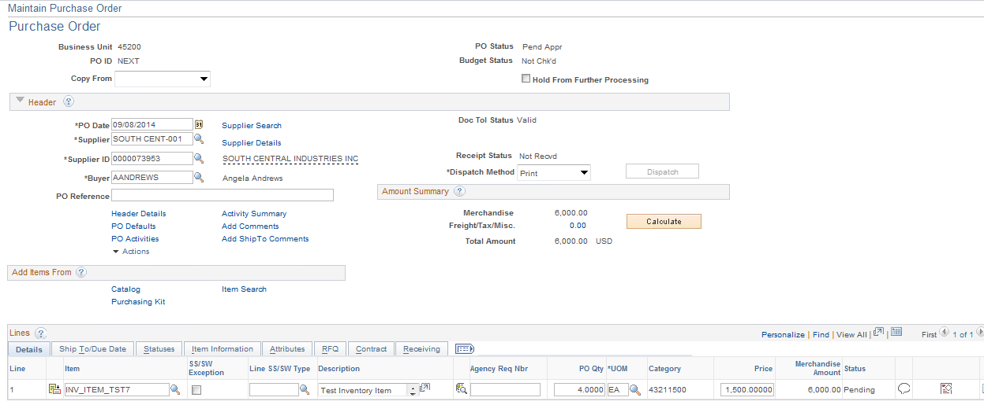

**Click** the Schedule icon.

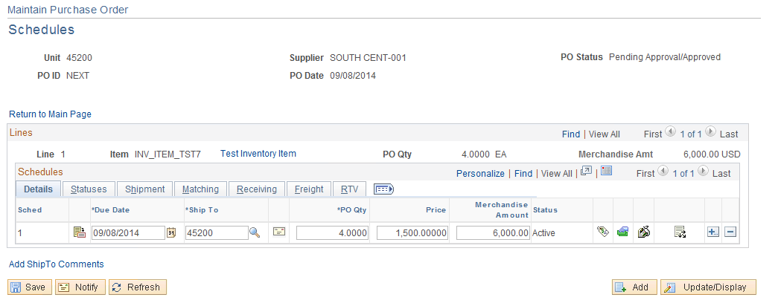

To review the Match Status on a PO Schedule **click** the **Matching** tab.

The matching should be set to “Full Match” unless it is an Authority Order.

**Schedule matches on:**

**Quantity**

* Extended amount
* Matching Controls and Receiving Controls - Default in from the Item ID.

The PO is now ready to be saved, pre-approved, budget checked, approved, dispatched, and printed.

## Creating a Voucher Against a Purchase Order

### Step 1 – Enter Voucher Data

Navigation: Accounts Payable > Vouchers > Add/Update > Regular Entry

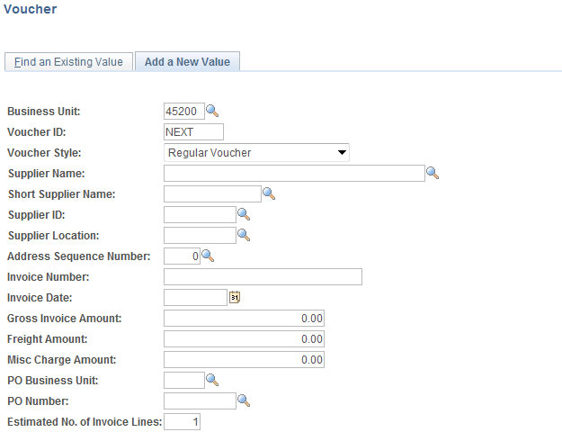

**Business Unit** - Defaults to specific agency for each user.

**Voucher Number** - Defaults to Next. The system will auto number each Voucher.

**Voucher Style** - Defaults to Regular and should not be change when creating basic voucher that requires payment to a supplier.

**NOTE:** Do not change the Voucher ID field. Let the system default to NEXT into the data field. The Voucher number will be assigned upon saving.

**Enter** the Invoice number and invoice date only; the other fields do not need to be populated.

**Note:** Purchase Order Business Unit and Purchase Order number may be entered on this screen to copy the PO to the voucher.

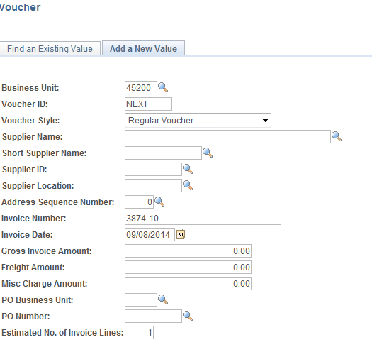

**Click** .



### Step 2 – Copy Purchase Order to Voucher

**Enter** the PO Unit and PO Number and **click** . If PO information is known. If not known, click “Go” to go to the Copy Worksheet to search.



On the Invoice Information **Invoice Information** tab, under Copy From Source Document, **select** the Copy From, **click** the dropdown arrow and select “Purchase Order Only”.

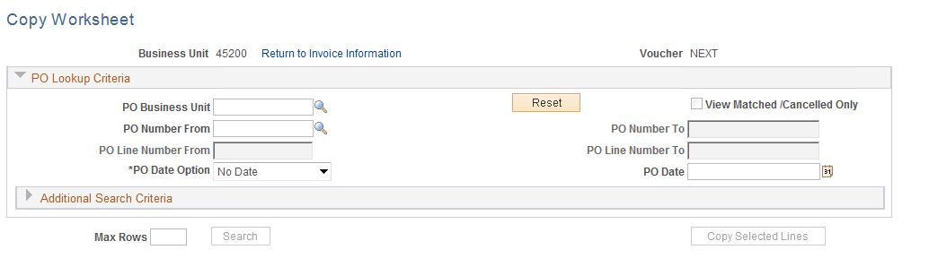

Enter search criteria, and **click** .

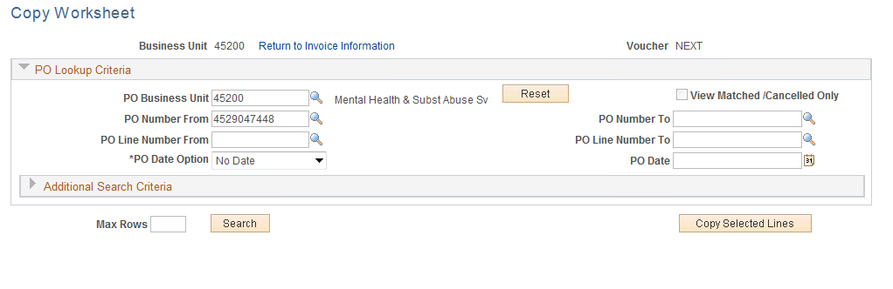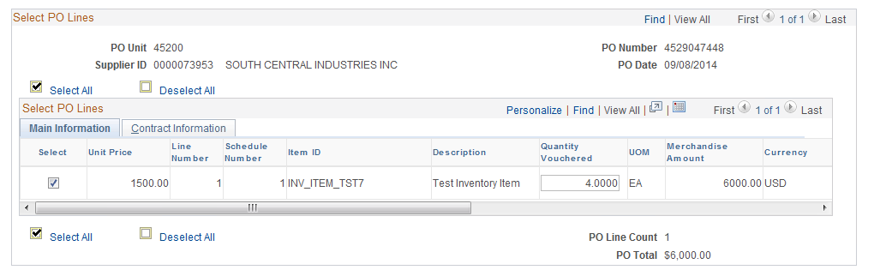

Select the lines to copy by checking the checkbox at the beginning of the lines to be copied. Click on to copy selected line(s) to Voucher.

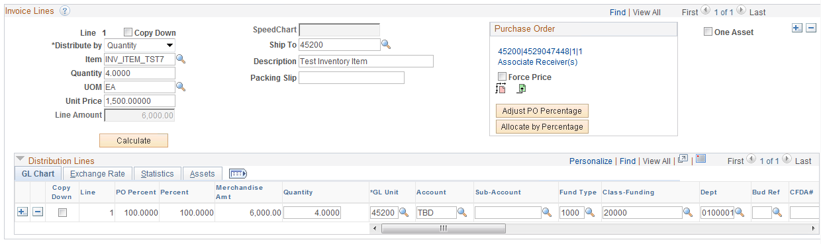

The invoice lines that were checked are copied to the Voucher’s Invoice Information Page.

**NOTE:** If the PO is not available for selection, then either the PO is not in a dispatch status or the PO has been fully matched.

#### 1A



This “Quantity Vouchered” is the quantity available for vouchering. If the value is zero, then there are no available quantities and it will fail matching. (By selecting the correct “Distribute By” method if the quantity is zero, it will not be available for vouchering at all.) The amount in the Merchandise Amt column is the amount left to match on the PO line.

**Click** the check box under the **Select** field to copy to the voucher. **Click** the button.



If you are vouchering for less quantity you may change the quantity. In this example, the quantity is left unchanged.

#### 1B

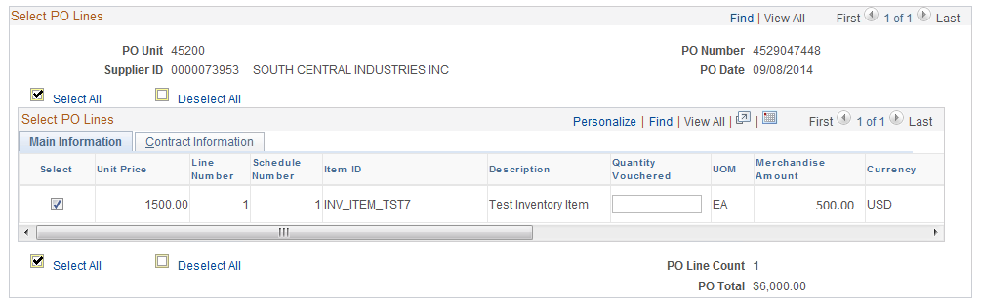

The above example reflects what will be reflected when all quantities have been matched, however, the “Distribute By’ Method was Amount and there is an available balance.



The PO is copied to the voucher by Line Number and Schedule Number. If a PO line and Schedule does not display after searching on the PO, then it is fully matched, inactive or closed, or every PO distribution line associated with the PO line is finalized.

**Click** .



### Step 3 – Review Copied Data

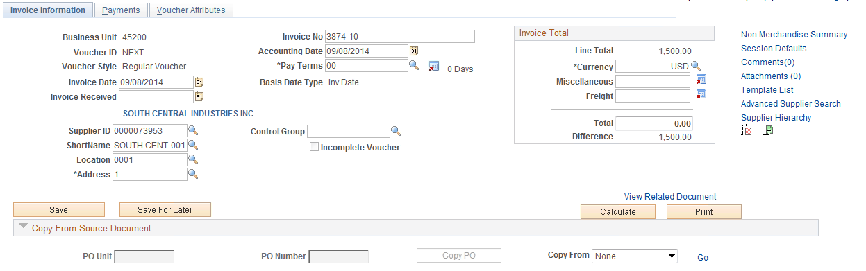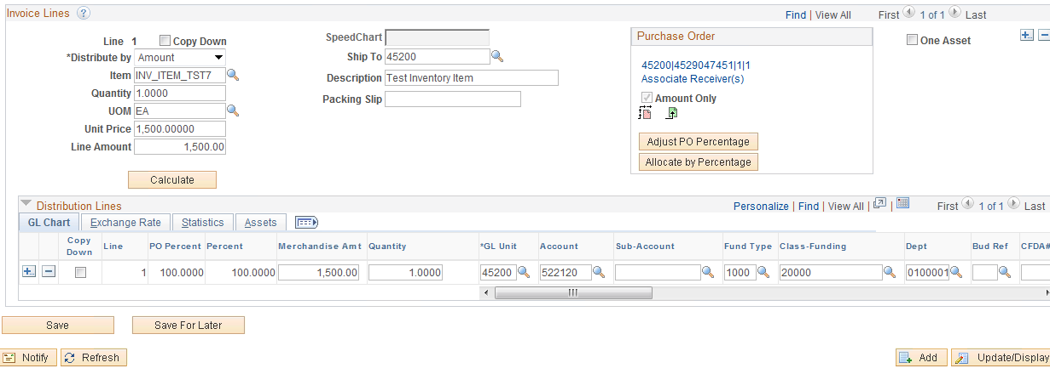

The Supplier Section, Invoice Lines and ChartFields Tab copied in from the Purchase Order.

The information that copies to the voucher line/distribution when the PO is distributed by amount is as follows:

* The Quantity, Unit Price and Extended Amounts are activated on the voucher line when the PO line is distributed by Amount. The payer must enter the Extended Amount for the voucher line, although it cannot exceed the amount copied to the voucher as this is the amount left to match on the PO line. The payer may also enter the Quantity and Unit Price on the voucher line, although the quantity cannot exceed the quantity copied to the voucher as this is the quantity left to match on the PO line. It is a good idea to implement an internal policy that quantity x unit price always equal extended amount to minimize the risk of matching the PO based on incorrect quantities and unit prices on the vouchers.
* The amount copied to the voucher distribution line is the original amount of the encumbrance on the PO distribution line. It is imperative that payers have access to the outstanding encumbrances on the on the daily Outstanding Orders report so they can ensure a PO distribution line has adequate encumbrances. A PO line with available amount to voucher may have PO distribution lines that have been fully liquidated.
* The chartfield combination also copies from the PO distribution lines. If the account code, TBD, copies to the voucher distribution line, then the voucher should not be processed (saved) until the account code on the PO has been changed to the correct code. If there are multiple distribution lines, including one or more containing TBD that is (are) not needed to make the payment, the lines(s) can be deleted so the voucher can be processed. Once a voucher is saved against a PO distribution line, funding changes can no longer be made on the PO distribution line.

In our example, the “Unit Price” is changed to 1495.00. Since the Dist By is Amt, the Extended Amt on the voucher line and the Amount on the voucher distribution line must be changed to 1495.00. (If the Dist by was set to QTY, the Unit Price X QTY would calculate.)

**Enter** 1495.00 in the “Total Field” and **click** to validate the data.

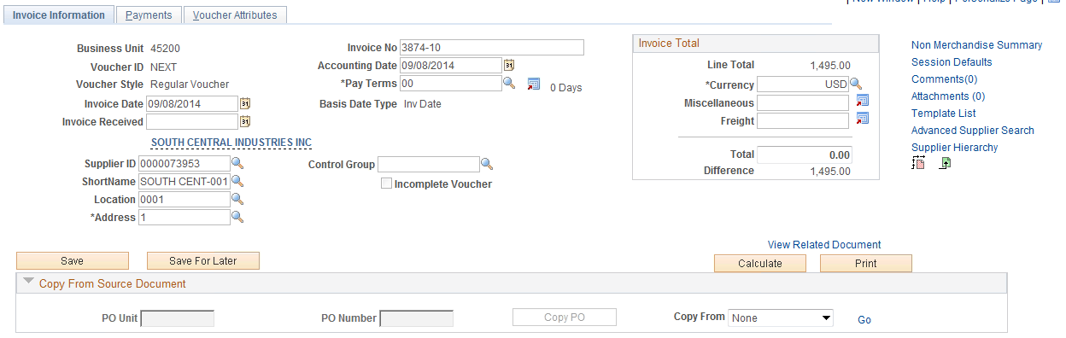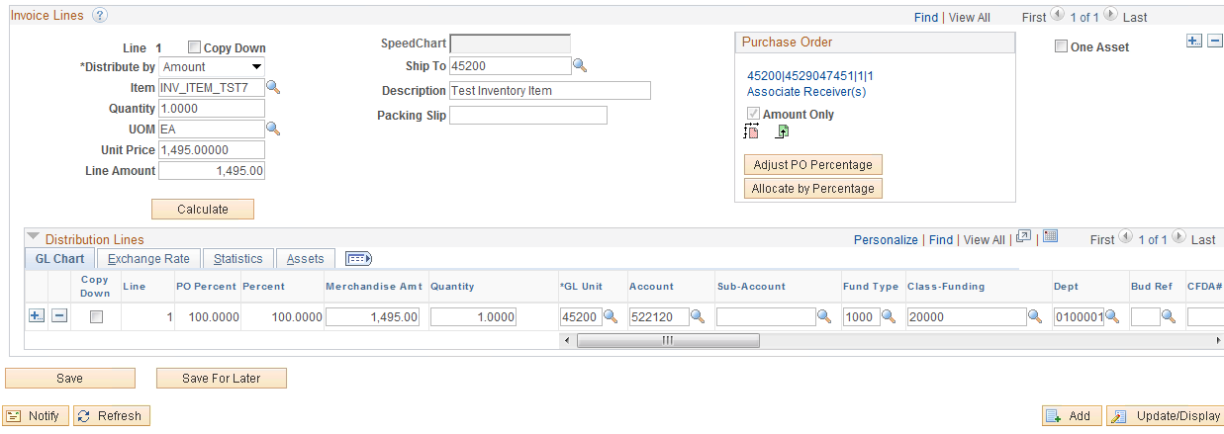

### Step 4 – Save Voucher

**Click** .



### Step 5 – Match the Voucher

Follow Steps 1- 2 beginning on page 35.

### Step 6 – Review Purchase Order’s Match Status

Follow Step 6 beginning on page 47.

**PO’s “Distribute By” set to Amount**

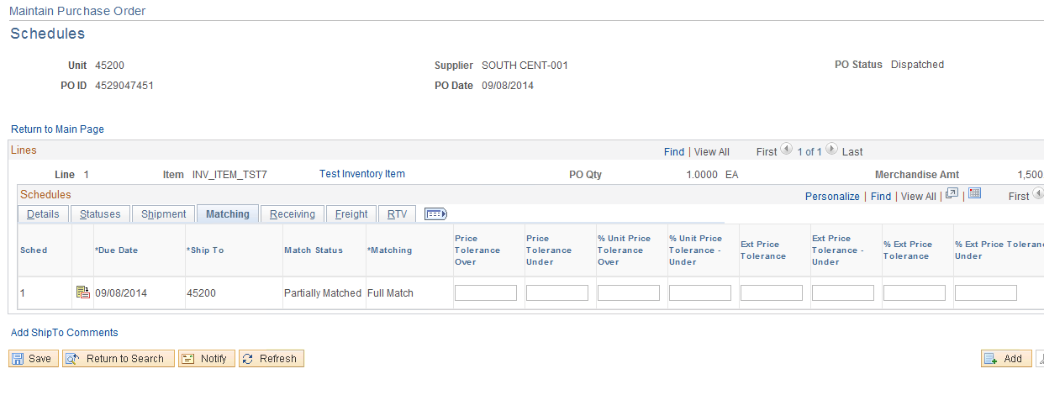

**PO’s “Distribute By” set to QTY.**

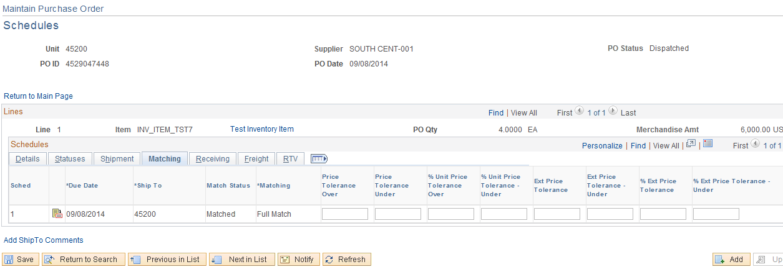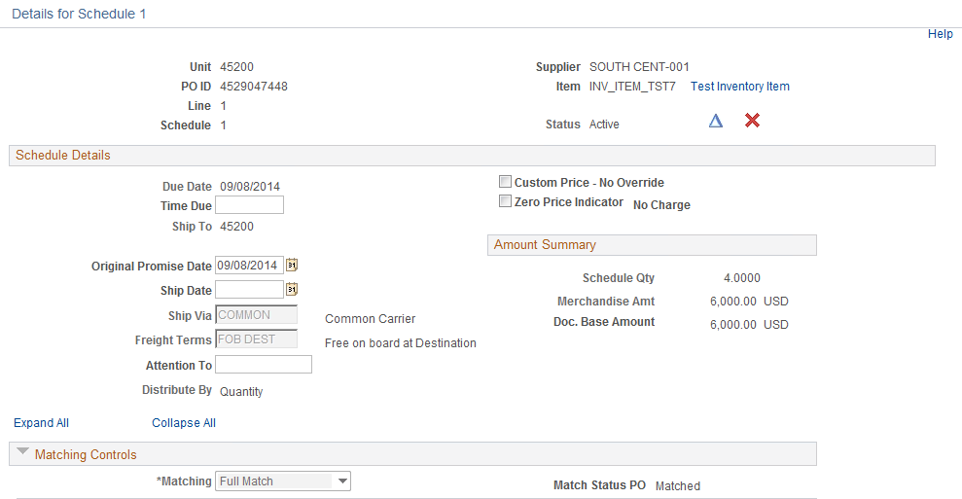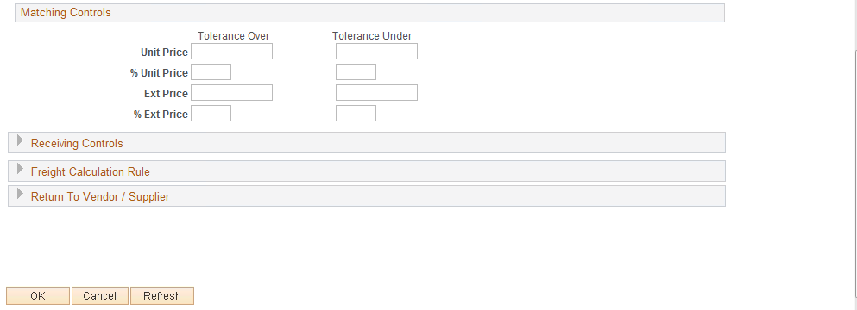

## Setting up Match Rules for Unit Price

PeopleSoft was not configured to match on unit price; however, when creating the Purchasing Order the user can set up a unit price tolerance which will not allow the voucher to match if the tolerance is exceeded.

### Step 1 – Set Up Price Tolerance

Navigation: Purchasing > Purchase Orders > Maintain Purchase Orders

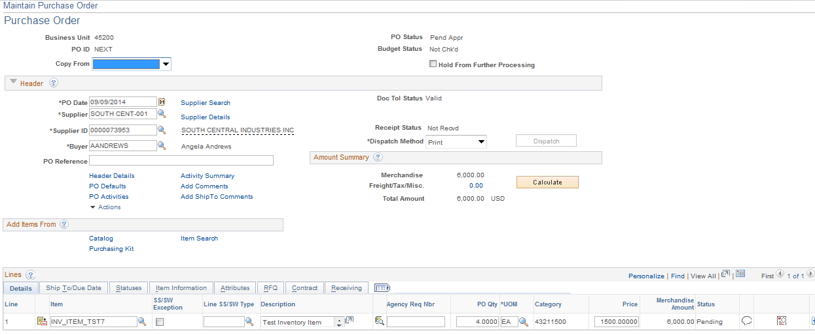

**Click** Scheduleicon.

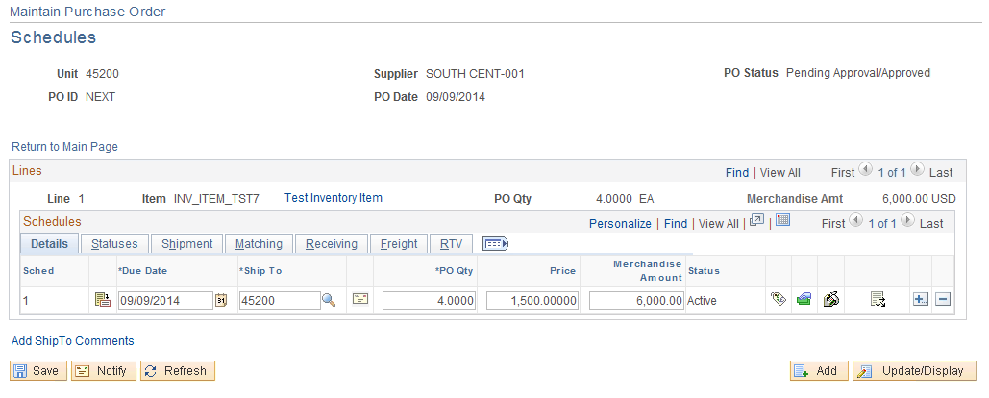

**Click** Schedule Details icon.

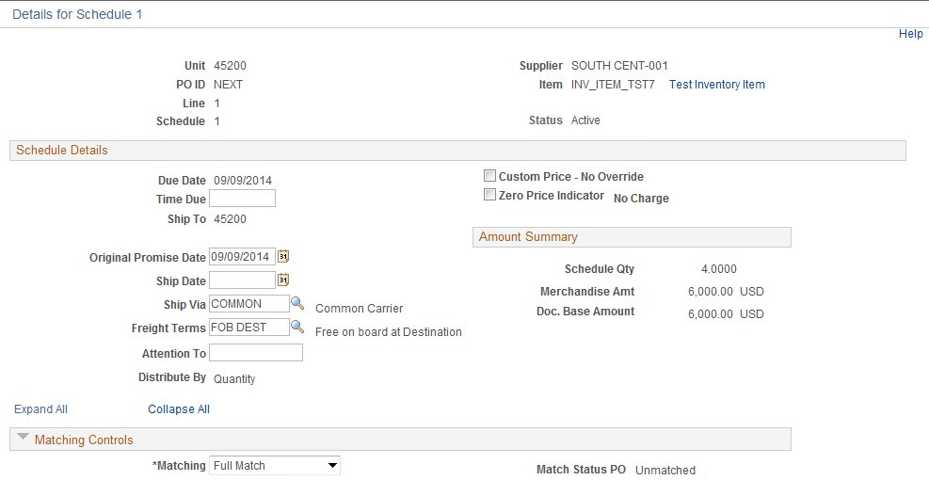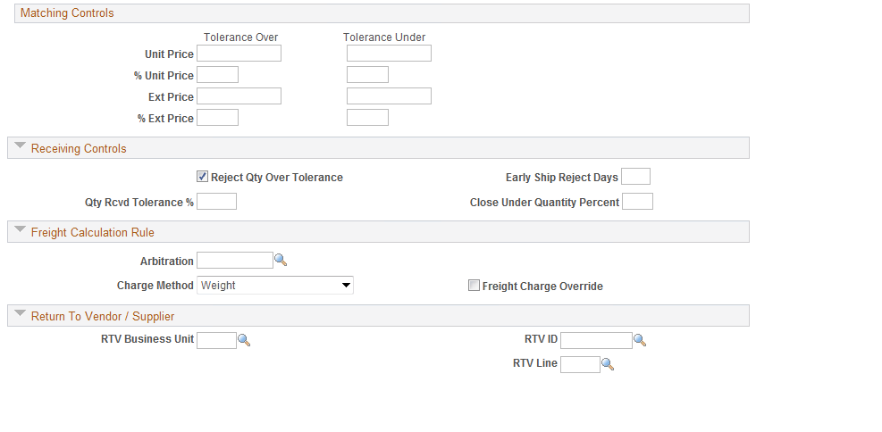

By entering data into the tolerance fields you can determine the allowable until price Accounts Payable will be allowed to use when processing a voucher. If a voucher is created using a unit price outside of the tolerance, a match exception will be received. The tolerance can be set up as an amount or percentage. To set up the Purchase Order not to allow any tolerance, **Enter** a value .0001 in the unit price.

Enter a zero (.0001) in the unit price for both Tolerance Over and Tolerance Under fields. **Click** .



.

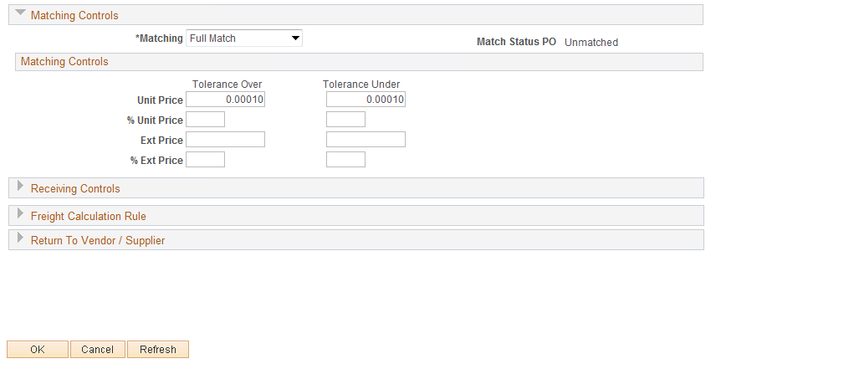

**Click** and continue to process the Purchase Order.



If a voucher is created with a unit price higher or lower than the unit price +/- any tolerance set up on the Purchase Order, a match exception will be received.

P-500 Voucher unit price is not within plus or minus the unit price tolerance amount.

**NOTE:** Do not enter any values for EXT Price Tolerance. This action could put you in violation of the Central Purchasing Act.

## Fixing Match Exceptions

### Step 1 – Run Match Exception Report

Navigation: Accounts Payable > Reports > Vouchers > Match Exceptions

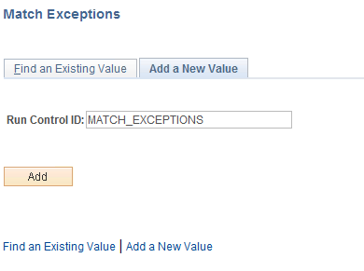

**Enter** a Run Control ID and **click** .

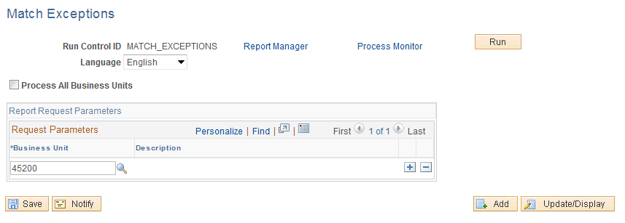

**Click** .

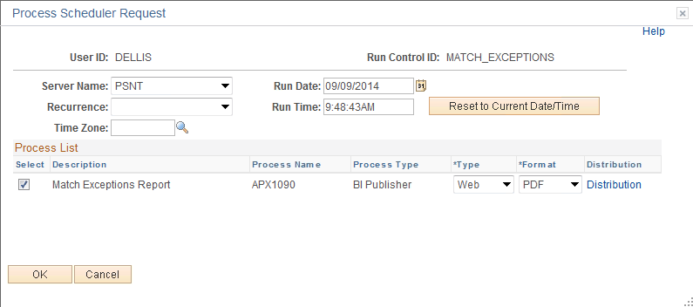

**Server Name:** PSNT

**Format:** PDF

**Click** .

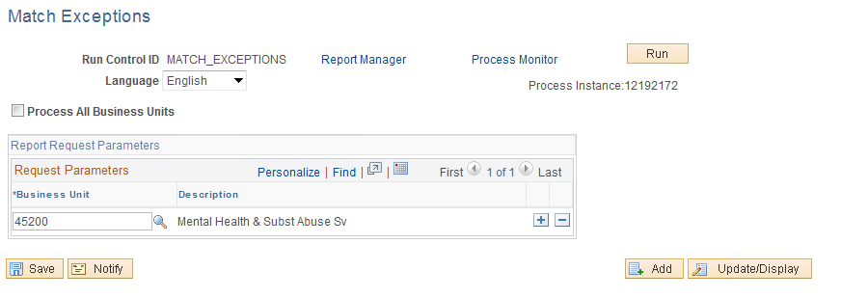

**Click** the Process Monitor link to print the report.

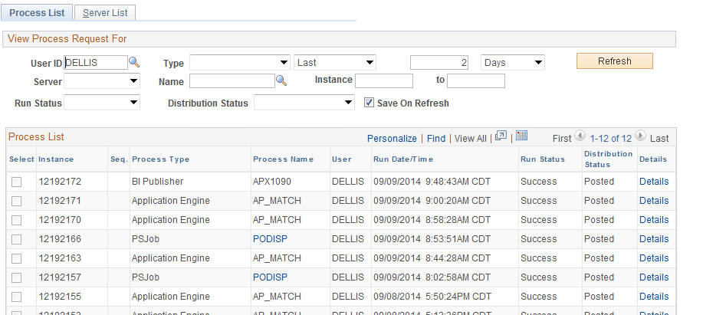

**Click** the Details link.

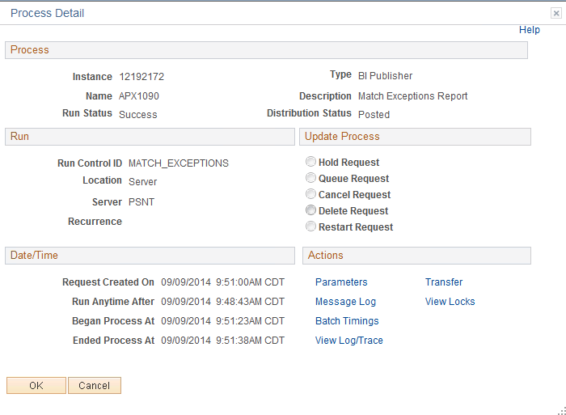

**Click** the View Log/Trace link.

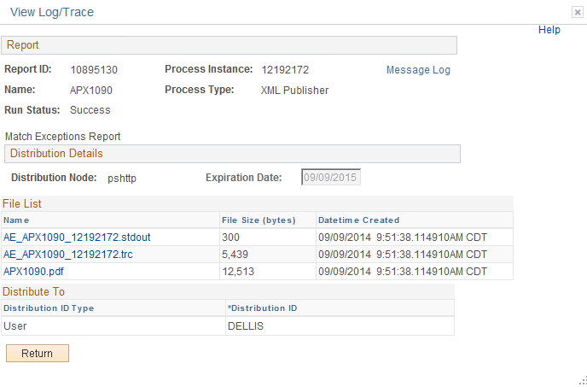

**Click** the PDF link.

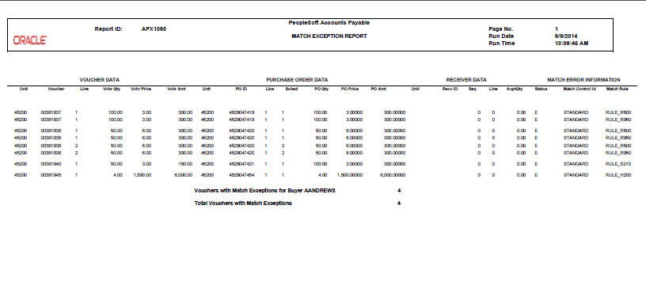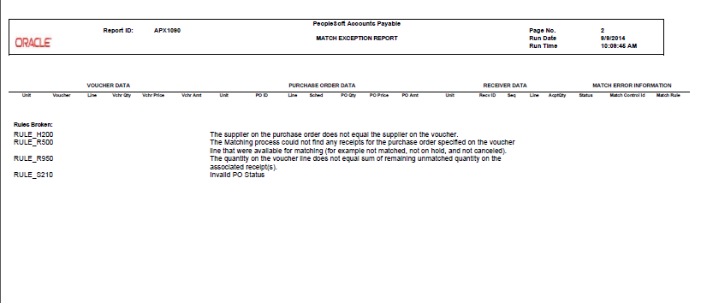

To print: **Click** FILE > Print.

### Step 2 – Identify the Match Exception

Rule H200 - Voucher Supplier <> PO Supplier

* Compare the PO’s Supplier Number and Location to the Voucher’s Header Supplier Number and Location.
* Navigate to the Purchase Order
* Navigate to the Voucher

Navigation: Purchasing > Purchase Orders > Review PO Information > Purchase Orders

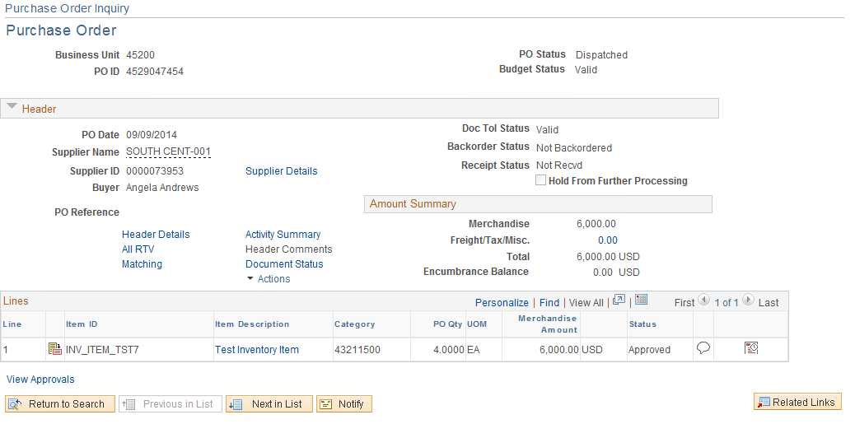

Navigation: Purchasing > Purchase Orders > Review PO Information > Purchase Orders > Supplier Details

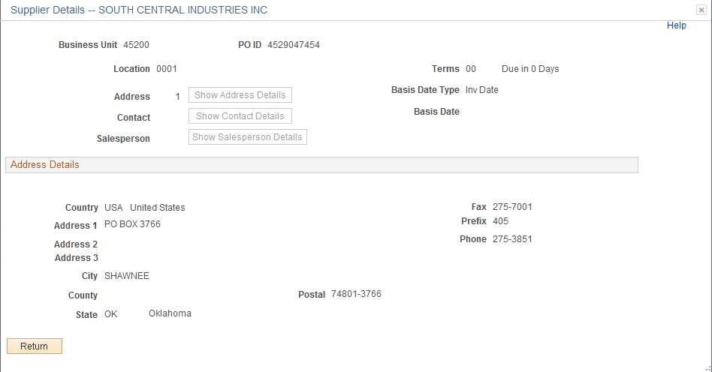

Navigation: Accounts Payable > Vouchers > Entry > Regular Entry

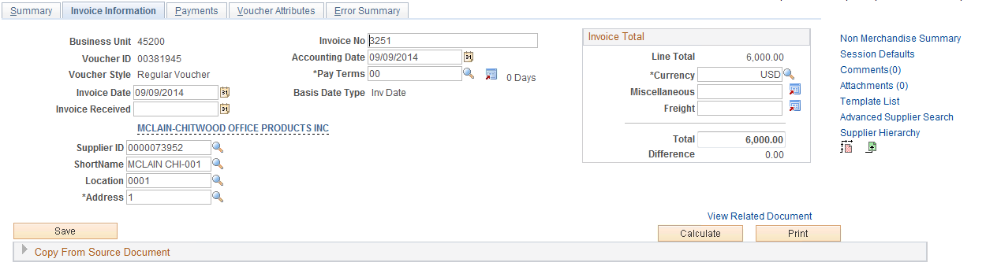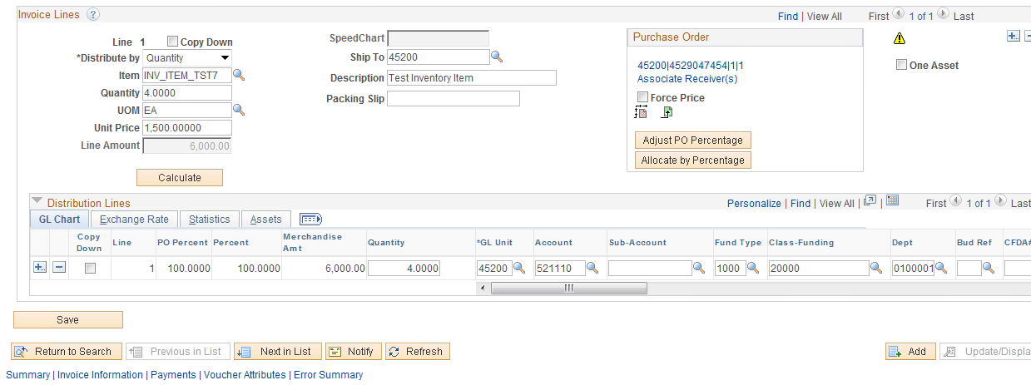

The PO and Voucher have a different Supplier Number. The PO Supplier Number and Location copies into the Voucher, but the H200 exception occurs when the CPO changed the Supplier ID after the voucher was created but before it matched or the AP user changes the location.

**Rule P500** - Voucher unit price is not within plus or minus the unit price tolerance amount.

* Review the Purchase Order unit price and compare it to the Voucher Unit Price.
* Navigate to the Purchase Order
* Navigate to the voucher

Navigation: Purchasing>Purchase Orders > Review PO Information > Purchase Orders > Schedule

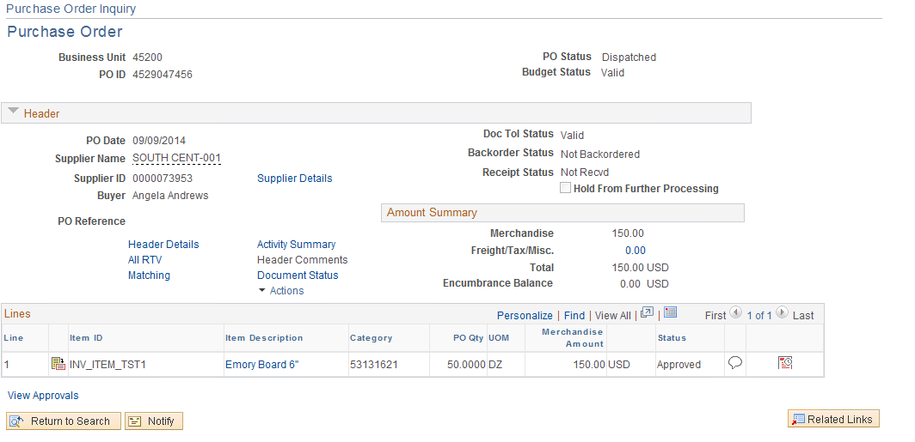

Navigation: Purchasing > Purchase Orders > Review PO Information > Purchase Orders > Schedule > Schedule Details

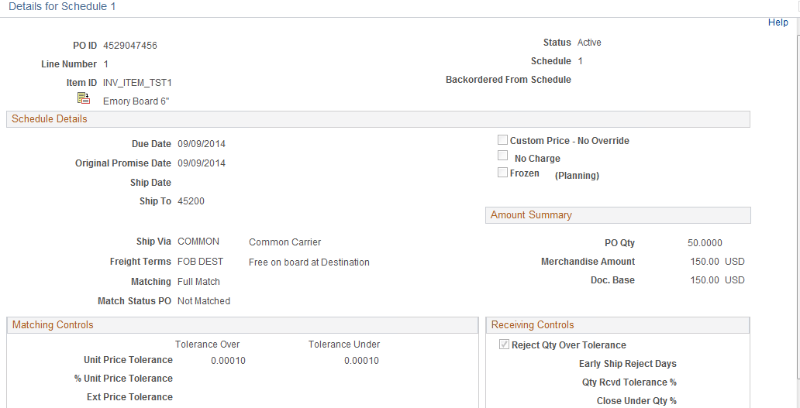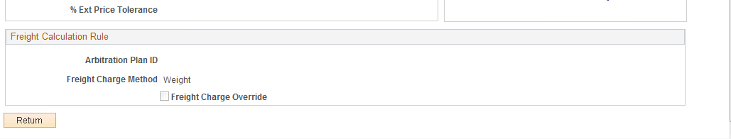

Navigation: Accounts Payable > Vouchers > Entry > Regular Entry

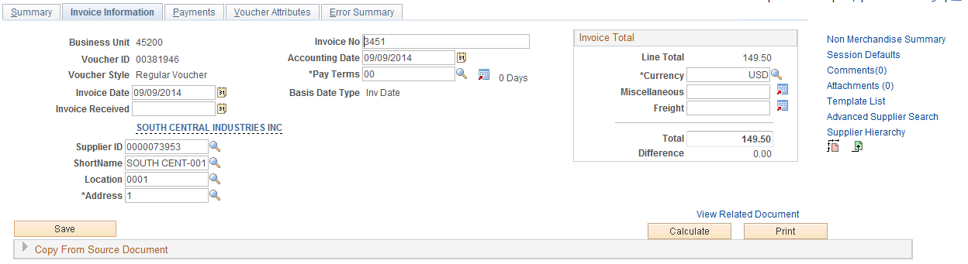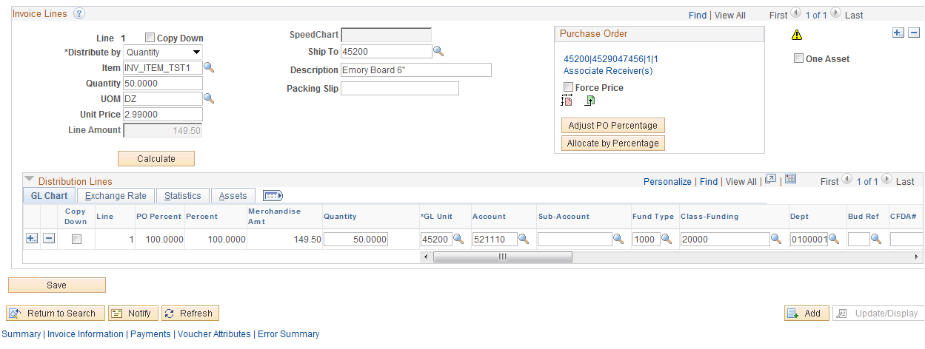

The Purchase Order was set up with a Unit Price Tolerance of .0001. The PO unit price is 3.00 but the voucher unit price is 2.99.

**Rule R500** - No receipts found (Query OCP_PO0316_PO_WITH_RECV_REQ will give you a list of POs with Receiving Required checked).

**Rule S120** - Currently, when this match exception is received it requires the same resolution as the R500 match exception.

* If receiving is not used, removed the receiving required from run the Matching Process again.
* If receiving is used, navigate to the PO Activity Page.
* If a receiver has not been done, contact the receiving department or individual responsible for receiving and have them process a receiver document.
* If a receiver has been done, have Accounts Payable attach it to the voucher.

Navigation: Purchasing > Purchase Orders > Review PO Information > PO Activity Summary

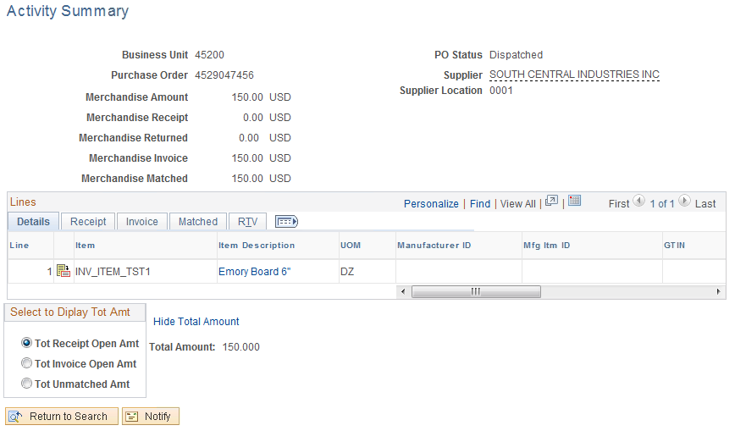

**NOTE: Nothing has been received on PO line 1**. When the receiving required is on, the open quantity and amount calculations are computed by subtracting the Qty Recvd and Qty Accptd from the Order Qty and Amount Ordered on the PO.

**Rule S100** - The match control from the PO/Receiver does not exist in the match control table.

* Navigate to the Purchase Order and review the match status.
* Navigate to the Voucher and review the match status

Navigation: Purchasing > Purchase Orders > Add/Update POs

**Click** Matching link.

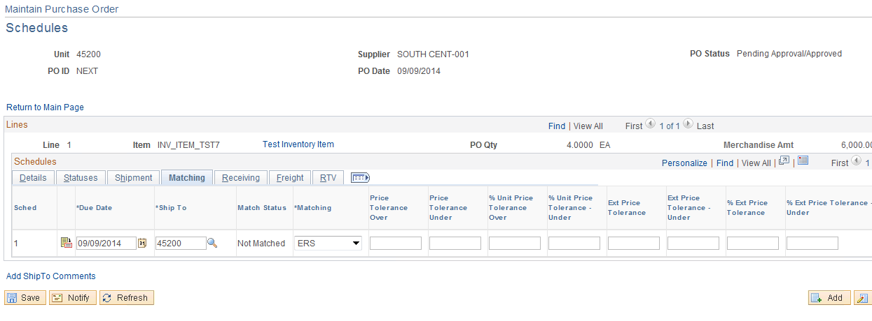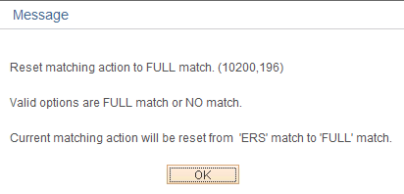

**Rule S210 -** Invalid PO Status. PO must be Approved and Dispatched.

* Navigate to Maintain Purchase Orders. Purchase Order must be in a Dispatch status before the Voucher will match

Navigation: Purchasing > Purchase Orders > Maintain Purchase Order

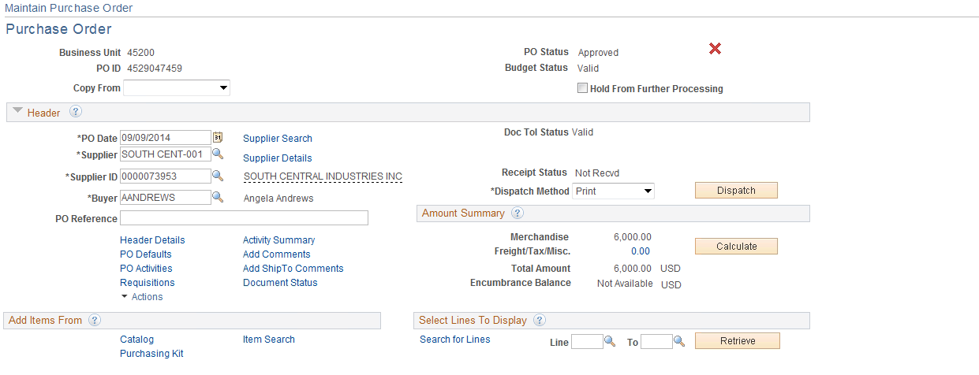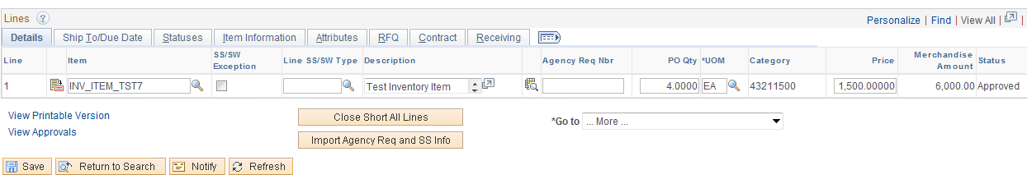

The Purchase Order is in an Approve Status, the voucher will not match until dispatched.

**Rule V200** - Life to Date Voucher Qty > PO Qty + %Tolerance

* Review the PO quantity and Vouchers created against the PO by navigation to the PO Activity Page.
* To review the invoice data **click** the and/or link.

Navigation: Purchasing > Purchase Orders > Review PO Information > Activity Summary

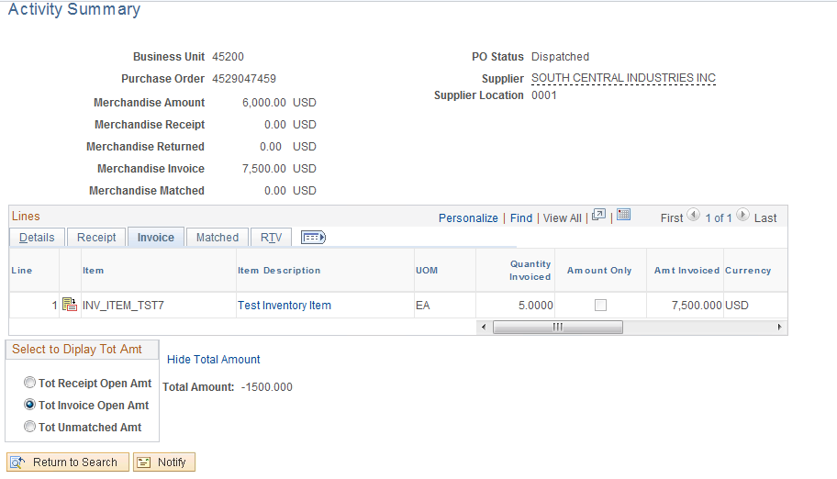

According to the PO Activity Summary PO line 1 has a quantity of 4.00 but there are vouchers created totaling a quantity of 5.00. If you are dealing with more than 2 decimals you may need to review the actual voucher/PO.

**Rule V300** - Life to Date Voucher Amount > PO Amount (No Price Tolerance Specified)

* Review the PO extended amount and Vouchers created against the PO by navigating to the PO Activity Page.
* To review the invoice data click the Invoice and/or Matching link.

Navigation: Purchasing > Purchase Orders > Review PO Information > Activity Summary

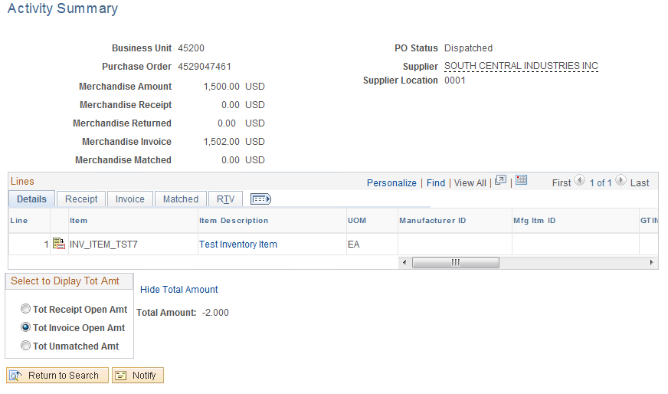

According to the PO Activity Summary page, the extended amount on PO line 1 is 1500.00 but there are vouchers totaling 1502.00.

## Match Rule Table

People Soft delivers one set of Matching Rules These rules can be structured to meet our needs through selecting certain match rule controls. Match rule controls are sets of rules that the system applies against vouchers, purchase orders, and receivers. The system uses these controls during a background process to ensure that voucher header and line amounts are reconciled against purchase order and receiver lines.

| **People Soft Delivered Match Rules** | | |
| --- | --- | --- |
| Rule ID | Description | Apply Rule |
| RULE-E100 | Extended Price Tolerance | Yes |
| RULE-E200 | Extended Price % Tolerance | Yes |
| RULE-E250 | Voucher Ext Amt <> PO Ext Amt (No Tolerances Specified) | No |
| RULE-H100 | Voucher Pay Terms <> PO Pay Terms | No |
| RULE-H200 | Voucher Supplier/Loc <> PO Supplier/Loc | Yes |
| RULE-H400 | Voucher Supplier/Loc <> Receiver Supplier/Loc | Yes |
| RULE-I100 | Inspection Required but not Complete | Yes |
| RULE-L100 | Voucher item <> PO item | No |
| RULE-L200 | Voucher item <> Receiver item | No |
| RULE-P100 | Voucher Price <> PO Price (no tolerances specified) | No |
| RULE-P400 | Voucher Price <> PO Price + % Unit Tolerance | Yes |
| RULE-P500 | Voucher Unit Price <> PO Price + Unit Tolerance | Yes |
| RULE-R500 | No receipts found | Yes |
| RULE-R600 | No receipts found, but unmatched ones exist | Yes |
| RULE-R900 | Total voucher received quantity > Accepted quantity | Yes |
| RULE-R950 | Total Line Invoice Qty <> Sum of Associated Receipts Accepted Qty | Yes |
| RULE-V200 | Life to Date Voucher Qty > PO Qty + %Tolerance | Yes |
| RULE-V300 | Life to Date Voucher Amount > PO Amount (No Price Tolerance Specified) | Yes |
| RULE-V400 | Life to Date Voucher Amt > PO Schedule Amt + % Tolerance | Yes |
| RULE-V500 | Life to Date Voucher Amt > PO Schedule Amt + Tolerance | Yes |

## Match Rule Clarification and Resolution Tables

The system first checks for system errors. The following table lists, defines, and explains the System Matching Rules delivered with the system:

| **Rule ID** | **Short Description** | **Clarification and Resolution** |
| --- | --- | --- |
| **RULE_S100** | The matching on the PO/Receiver does not exist in the match control table. | This error can arise because the voucher requires matching, but the PO is not set up for match. This can happen after the PO was copied into the voucher but before match is run the PO was changed from match to no match or when a PO is copied into the voucher and the voucher is changed from a no match to a match but the PO does not require match. All PO’s should be set up for match with the exception of Authority Orders. |
| **RULE_S110** | RTV/Credit Adjustments are greater than the PO Matched Quantity/Amounts |  |
| **RULE_S120** | Voucher line RTV/Credit Adjustments will bring the Receiver line ship Matched Quantity/Amounts below zero. Modify voucher line credit adjustment and run Matching again | Currently this message is being received in error. Should receive Rule R500. |
| **RULE_S200** | Invalid PO ID | This error can arise after the PO is copied into the voucher, but before match has run a change order **is** processed against the PO requiring the PO to be re-dispatched **but is not**. Review the PO to insure the PO is in a dispatch status. The purchasing user must place the PO in dispatch status. |
| **RULE_S210** | Invalid PO Status. PO must be Approved and Dispatched. | This error can arise after the PO is copied into the voucher, but before match has run a change order **is** processed against the PO requiring the PO to be re-dispatched **but is not**. Review the PO to insure the PO is in a dispatch status. The purchasing user must place the PO in dispatch status. |
| **RULE_S300** | Invalid UOM conversion for PO | This error can arise after the PO is copied into the voucher and the Unit of Measure is changed. The Unit of Measure should never be changed. If it is incorrect then the purchasing user must be notified to correct the PO. |
| **RULE_S400** | Invalid currency exchange rate for PO |  |
| **RULE_S500** | Invalid UOM conversion for receipt |  |
| **RULE_S600** | Invalid currency exchange rate for receipt |  |
| **RULE_S700** | Receipt for voucher line has multiple UOMs |  |
| **RULE_S800** | Receipt for voucher line has multiple transaction currencies |  |

If no system errors exist, which would indicate missing data and would prevent the system from getting the entire voucher, purchase order, and receiver data, the system applies Matching Rules.

## Matching Rules Delivered with the System

This table lists, defines, and explains matching rules.

| **Rule ID** | **Short Description** | **Generates an exception when:** | **Clarification and Resolution** |
| --- | --- | --- | --- |
| RULE-E100 | Extended Price Tolerance | The voucher extended price exceeds the purchase order extended price +/- the extended price tolerance AND the tolerance <> 0. It won't give an exception for non-purchase order receipt. | This error is a result of creating a voucher where you are trying to pay more on a PO line item than is available on the PO. In order to correct, you either reduce the voucher in accordance with the PO or purchasing user must increase the line item in accordance with all applicable state laws. Which user, (Accounts Payable or Purchasing) makes the correction depends on internal agency procedures. |
| RULE-E200 | Extended Price % Tolerance | The voucher extended price exceeds the purchase order extended price +/- the extended price % tolerance AND the tolerance <> 0. It won't give an exception for non-purchase order receipt. | This error is a result of creating a voucher where you are trying to pay more on a PO line item than is available on the PO in addition to having the PO set up with a tolerance level. When paying a voucher that exceeds the PO extended price % tolerance, must see the % for tolerance and either decrease the voucher or decrease PO. Which user, (Accounts Payable or Purchasing) makes the correction depends on internal agency procedures. |
| RULE-H200 | Voucher Line Supplier/Loc<>PO Supplier/Loc | The supplier number and location on the purchase order does not match the supplier number and location on the voucher. It won't give an exception for non-purchase order receipt. | This error is a result of changing the supplier and/or location on the voucher invoice information page after the voucher has been copied. This error causes the supplier number and location on invoice information page not to equal PO supplier number and location. If you require the check to be mailed to another location then change the location address on the payee panel. If this error occurs on the voucher invoice information page, change the supplier number and/or location to match the PO supplier number and/or location, providing the Purchase Order is correct. If Purchase Order is not correct, change the payee on the payee page. |
| RULE-H400 | Voucher Line Supplier/Loc<>Receiver Supplier/Loc | The supplier number and location on the voucher does not match the supplier number and location on the receipt. | This error is a result of a change to the supplier number and/or location on the receiver. To correct, determine the correct supplier and/or location and correct either the voucher, receiver and/or PO. This error could be received in combination error with H200. To correct receiver, change the payee on the payee page. |
| RULE-I100 | Inspection Required but not Complete | The item ordered requires inspection but inspection has not been completed. | A PO can be set up requiring inspection or not. Either the PO or the receiver will need to be corrected. Navigation is shipping, inspect shipment. |
| RULE-P500 | Voucher Unit Price <> PO Price + Unit Tolerance | The unit price on the voucher is either higher or lower than the unit price and tolerance specified on the PO. | To fix this either the voucher’s unit price needs to be changed to match the PO price +/- any tolerance or the PO price or tolerance needs to be changed. Either way the Purchasing Department needs to be notified to resolve the discrepancy. |
| RULE-R500 | No unmatched Receivers exist for this Voucher. There is no record of the merchandise being received as of yet. | The matching process could not find any receipts for the purchase order specified on the voucher line that was available for matching (for example not matched, not on hold, and not cancelled). | The Purchase Order requires a receiving report to be completed, but no report was found. Agencies that utilize receiving must verify receiving has been performed by reviewing the PO on the PO Activity Page. The Activity Page will show if item has been received with the receiver number. If the item has been received, attach item to the voucher by retrieving voucher and “invoice lines” through the hyperlink. Click on the Associate Receiver Lines then Under Receiver Lookup Criteria 1) fill in Recv BU, 2) Click Fetch button, (on the right side of page), 3) Under select Unit – check the box, 4) click the OK button on the bottom. If there are more than one line on the Select Unit Box, make sure you select all appropriate lines. If there are no receipts found then you need to contact your receiving department. If you are not using receiving then the purchasing user needs to turn off receiving on the PO. |
| RULE-R600 | No receipt found, but unmatched ones exist | The matching process found receipts for this purchase order that were available for matching (for example not matched, not on hold, and not cancelled) but could not make an association to the voucher line using any of the receipt aware criteria. | This means that the PO requires a receiving report to be completed. The system sees some receipts out there for this PO but it could not find enough similarities to match them up or they were all used for other vouchers. On the voucher under "invoices lines" is a blue hyperlink "Associate Receiver(s)." Either create a new receipt or locate the correct existing receipt and attach it to this voucher through the hyperlink. Click on the Associate Receiver Lines then Under Receiver Lookup Criteria 1) Fill in Recv BU, 2) Click Fetch button, (on the right side of page), 3) Under Select Unit - check the box, 4) Click the OK button on the bottom. If there are more than one line on the Select Unit Box, make sure you select all appropriate lines. |
| RULE-R900 | Total voucher received quantity > Accepted quantity | The total quantity received (including across all voucher lines and previously matched receivers) exceeds the accepted quantity on the receiver. It won't give an exception for Amt only Receiver. | Quantity on the voucher exceeds quantity on the receiver. Check for receiver that could be missing, if receiver cannot be found, reduce the quantity on the voucher. Hint: You might want to check with internal department to ensure receiver indication is accurate. |
| RULE-R950 | Total Line Invoiced Qty <> Sum of Associated Receipts Accepted Qty | Within the same matching process instance the total receiver quantity associated on the voucher line exceeds the remaining unmatched receipt quantity on the receiver line schedule. | Quantity on the voucher exceeds Associated Receipts Accepted quantity. Check for receiver that could be missing, if receiver cannot be found, reduce the quantity on the voucher. Hint: You might want to check with internal department to ensure receiver indication is accurate. |
| RULE-V200 | Total voucher Qty > PO Qty + % Tolerance | The receiving % tolerance does NOT equal zero, and the total quantity vouchered (including previously matched vouchers) exceeds the quantity on the purchase order plus the allowed over-receiving quantity. It won't give an exception for Amt only purchase order and non-purchase order receipt. | The voucher quantity matching exceeds PO Order quantity. Either reduce voucher quantity or increase PO quantity. Hint: you can receive this error message in combination with E100, E200, and V300. |
| RULE-V300 | Total Voucher extended Amount > PO Schedule extended amount(No Price Tolerance Specified) | The receiving tolerance is zero and the total quantity vouchered (including previously matched vouchers) exceeds the quantity on the purchase order. An exception is not generated for an Amount Only purchase order or non-purchase order receipt. | Either reduce voucher quantity or increase PO quantity. If do not want to match on quantity, mark the PO - Amount Only. Hint: you can receive this error message in combination with E100, and E200.  Hint: One-Sum POs with only one funding line were NOT converted as "amount only" but rather as a quantity of one. Therefore, if a voucher is paid and no changes have been made to the PO, then the PO is no longer available for subsequent payments. Agencies should review these types of POs before processing any payments and change the PO type to amount only or add another item line on the order for the remaining payments. |
| RULE-V400 | Life to Date Voucher Amt > PO Schedule Amt + % Tolerance | The extended price % tolerance is NOT zero, and the total amount vouchered (including amounts on previously matched vouchers) exceeds the purchase order amount (calculated using extended price % tolerance). It won't give an exception for non-purchase order receipt. | Voucher can not be paid against PO or create change order to increase PO. Either decrease the amount on the voucher to match what is on the PO or increase the PO to the amount on the voucher by completing a change order. |
| RULE-V500 | Life to Date Voucher Amt > PO Schedule Amt + Tolerance | The extended price tolerance is NOT zero, and the total amount vouchered (including amounts on previously matched vouchers) exceeds the purchase order amount (calculated using extended price tolerance). It won't give an exception for non-purchase order receipt. | Voucher cannot be paid against PO or create change order to increase PO. Either decrease the amount on the voucher to match what is on the PO or increase the PO to the amount on the voucher by completing a change order. |